Engr 202

Chapter 1 recap

The environment
This refers to our natural resources, air and other natural commodities
The state of the environment is affected by our choices – and by affecting this we affect others around us including other living beings

Our activities change the environment
This is a cycle that goes through many stages – which we can visualize in a framework for environmental impact – The solid lines are the primary path or initial impacts the dashed lines show the major feedback/response to these
Engineers mainly focus on the highlighted 3 areas

Land use
Pollutant transport
Technology development

The remainder is determined by the government and the impact humans see – there by passing laws to improve the regulations and engineers must develop new technology to improve and fit within these new standards

Our activities change the environment – physical changes, chemical changes and biological changes

-Human activity – affects agriculture transportation and recreation – emissions on air land water.
-Physical changes – deforestation for example, alteration of waterways (dams) changes to the env.
-Chemical changes – acid rain, removal of nutrients in the soil or contamination of soil with chems
-Biological changes – changes on the habitat of all living creatures, potentially causing extinction

Environemental Impacts
- The list is big but it’s all from acid rain, smog, water air pollution, o3 depletion, global warming...etc

This means we must find a way to have sustainable development
Sustainable development (the world commission on environement and evelopment – met in 187)

“meet needs of the current gen without compromising the ability of future generations to meet their own needs”
This of course falls in line with the total human population – as of 2000 at 6.1 billion and by 2100 could reach 10 billion.
Many charts show industrial use of raw materials from 1900 through 2010 – which show an exponential growth rate with dips happening during economic crisis such as oil crisis, recessions and global financial crisis – and of course wars.

This brings us to start evaluating the Life cycle of a product

Definition – the stages of the developing and the shelf life of a product

Strategies
-minimize consumption of mats and energy
-low impact processes / efficient with resources
-optimize lifespan/shelf life to match needs
-don’t make something last forever if its not going to be used forever
-extend material lifespan if needed
-used materials that can be recycled
-make disassembly easy

Life Cycle Stages for example for something like infrastructure go from

-Site dev
-Infrastructure parts manufacturing
-Materials delivery/transportation
-Use of infrastructure
-End of life/demolition

All of this goes backwards to to reuse, remanufacturing and recycling.

Example with a cellphone

-Material extraction
-processing of mats
-manufacturing
-use of product
-end of life

And back to reuse during the product use phase (sold cellphone)
Remanufacturing using older parts
And recycling during material processing parts

Chapter 2

Density is the mass of a substance divided by the volume of a substance
Dimension: ML^-3
Unit: kg/m^3, slug/ft^3..etc

Density changes with temperature and pressure

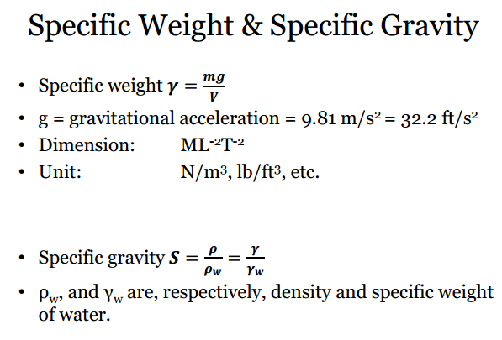
Different temperature units

International system of units
Kevlin= 273+ degrees celcius

English Units
Rankin (R)
R = 460+ degrees Farenheit

0 degrees celcius = 32 degress farenheit

°F to °C Deduct 32, then multiply by 5, then divide by 9
°C to °F Multiply by 9, then divide by 5, then add 32

Concentration (C)

The mass of a mat divided by volume of both materials A and B making up a mixture is called the concentration of A in the mixture

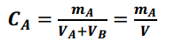

Concentration can all be expressed as ppm (parts per million)

Consider 1mg of a substance in 1 liter of water to be

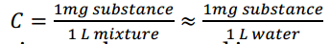

Concentration can be expressed as a percentage too

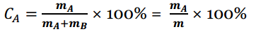

Gases and parts per million

The air and other gases ppm is based on volume (volumetric ppm)

X cubic meter of the pollutant divided by X cubic meter of air gives you the PPM

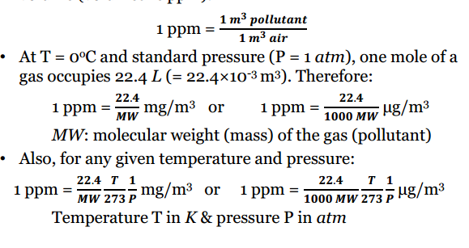

Flow rate

Flow rate is defined as Q

That is Volume over Time or V/t if this fluid is over a surface
But with mass its Qm would be mass/time or m/t passes a given surface in the fluid flow
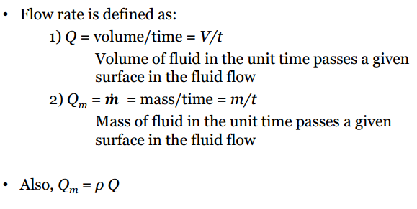

Flow rate continued

Dimensions and units of flow rate:
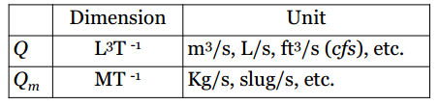

Mass flow rate of some material A with a concentration of A in a mixture is:

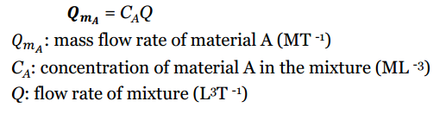

Chapter 3

Conservation of Mass Law
Matter is neither created nor destroyed
Materials balance equation applied to a control volume

Inflow rate = outflow rate + accumulation rate + reaction rate
During a chemical/biological/nuclear reaction materials are converted to other substances

Materials Balance Equations is when a substance is conservative and no reactions affect control volume, decay or generation is zero

When flow rates densitites and other pamaremters do not change with time (meaning it’s a steady-state system) for which accumulation is zero

For a steady-state, conservative system materials balance equation is expressed as:

Inflow rate = outflow rate

This is because there is no accumulation rate and no reaction (decay) rate

Decay Rate

Method for Non-conservative mats is First Order Reaction Model

This model assums that the rate of loss of substance is lineralry proportional to the ramount of substance at any time

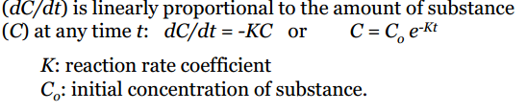

Air pollution and water pollution that are dealing with non-conservative substances that are homogenously mixed through the system

Steady state method for non-conservative substances that are homogenously mixed through the system.

Inflow rate = outflow rate + decay rate

All terms of this equation are depending on time

The decay rate = KCV
K reaction coefficient, Control volume
The mass balance equation for a non-conservative substance decaying in a steady-state system can be expressed as

Inflow rate = outflow rate + KCV

The decay rate is predicted using the first-order reaction model

Chapter 4

The first law of thermodynamics

Energy is neither created no destroyed

There are various forms of energy

Kinetic, potential, flow, thermal, electric, magnetic, chemical, nuclear..etc

Heat is actually a form of energy transferred between two systems or between a system and its surroundings due to a temperature difference between the two mediums

Work is also a form of energy transferred between two systems or between a system and surroundings

Energy

Unit of energy/heat/work

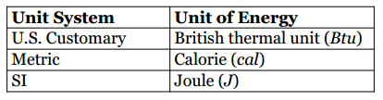

To apply the first law of thermodynamics a system is required to be considered and studied
A system could be a room, a car, a powerplant

Energy System (Control Volume)
A system can neither be open or closed

An open system is one that energy and matter can flow across its boundary
- A pan of boiling water with the lid open

A closed system is one in which matter cannot flow across its boundary but energy can
- A pan of boiling water with the lid closed
  - Water cannot escape through steam
  - But energy can through Heat
Energy Balance Equation

Energy In = Energy Out + change in energy system

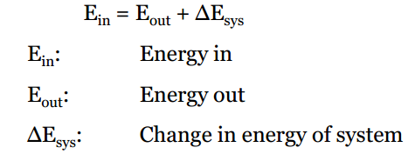

Energy Change

On of the most common energy systems change 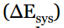 is through heat (temperature) 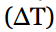 where change in this energy is expressed as

Another common way of change in energy is phase change of the substance

Such as Liquid to Steam or liquid to solid

Energy Change 2

If the temperature of a mat changes, the change in energy of said system can obtained through this formula

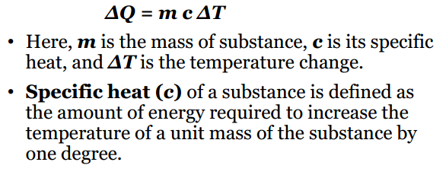
Specific Energy Units

The amount of Energy required to increase the temperature in 1 gram of water from 15 to 16 degrees C is defined as 1 cal

The amount of energy required to increase the temperature of 1lbm water from 59 to 60 degrees F is defined as 1 Btu
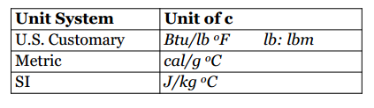

Phase change of a substance
The energy required to cause a phase change
-from solid to liquid is called the laten heat of fusion (melting)
-liquid to vapor (latent heat of vaporization)

For a particular substance
-Latent heat of fusion = latent heat of freezing
- latent heat of vaporization = latent heat of condensation

In the case of phase change

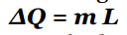

This means that to calculate the delta of phase change to cause this material to change you would look at the mass (m) times the Latent (L) heat

For water at 1 atm preassure
- latent heat of vaporization is
  - 970 Btu/lb = 2256 kJ/kg = 539 cal/g
- Latent heat of fusion
  - 143 Btu/lb = 333 kJ/kg = 79.5 cal/g
- Heat to vaporize 15 degrees C (59 degrees F)
  - 1060 Btu/lb = 2465kJ/kg = 624 cal/g

