Origins of Christianity

Lesson 1: earliest christian writings
- Christianity is the faith based on my negro Jesus Christ’s life, teaching, death & resurrection. Bible contains OT, NT & gospels written 40-50 years after JC’s death. A gospel refers to ‘good deeds’ and actions Jesus performed, also refers to his ‘life story’ & mission (birth, age 12, life around 30).
- Jesus was born in year 0.
- John the baptist, baptist people for the forgiveness of their sins. Jesus’s baptism by John has been seen as: consecration (associate with the sacred) to god as the chosen one, john publicly announcing that the chosen has arrived, Jesus shows that he is part of the sinful humanity. After the baptism, J undergoes 40 days of retreat in the desert, gathers disciples #Simon, #Peter, #Andrew, #James, #John.
- Miracles are seen as signs that god exists. Miracles include: witchcraft, turning water into wine, restoring life to death #necromancy, casting devils out of possessed, multiplication of bread #magic.
- Is J the chosen one? J is like shy to say he’s the chosen one but then fire bender Elijah & water bender Moses appear to seal the deal.
- J teaches good ethics to people #nohate. he: touched a bleeding woman & lepers (ew) to heal them. welcome women as disciples (and then realized it was a mistake). preaches ‘’turn the other cheek’’ instead of ‘’an eye for a eye’’. taught love your enemies. offered forgiveness to the repentants. challenged the Jewish authorities
- Timeline:
1 J returns to Jerusalem + has supper.
2 Judas betrays J for 30 piece of silver #rude. J is arrested
3 Caiaphas on the trail asks J if he is the Messiah, J says that by saying so he is #blowmind.
4 Caiaphas says it’s blasphemy because he’s butthurt
5 Romans have to crucify J
6 Crucifixion
7 Resurrection, women visit tomb, can’t see J ‘cause dumb
- After death, NT is written, Holy Spirit (shows them it’s really him, no games) descends after J goes to heaven @ the Pentecost (7th sunday after easter).
- After J comes back, Paul tries to convert Jews & Gentiles (not belonging to a community) into Christianity
- anti-Christian feelings among Jews grows, leads to same thing with anti-Jewish feeling among Christians.
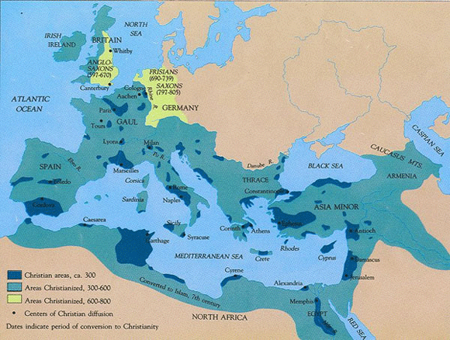
- New msg: salvation is by faith in Christianity, not by cutting your dick off.
☝︎Spread of Christianity

