Chapter 1: MARKETING FUNDAMENTALS
- Understanding consumer trigger points is vital to marketing success
- Marketers need to integrate new technology into products and marketing programs
- Challenge is to stay relevant to changing customer expectations
- Marketers are challenged to stay current
- Marketers’ ultimate objective is to drive profits for a company
- Promotion and marketing are two different things
- “Essence of marketing” is focusing on the customer
- Customer Value: a unique combination of benefits received by targeted customers that increases quality, price, convenience, delivery and both before-sale and after-sale service
- Marketing Mix: product, price, place, promotions
- Creating products with added value is often achieved through a combination of product design, pricing strategies, and service elements
- Target Market: specific group of existing and potential consumers to which marketing efforts are directed to
- Marketing Process involves: identifying consumer needs, managing the marketing mix, and realize profits for the company
- Marketing: process of planning and managing goods and services or ideas to meet consumer needs and organizational objectives
- Exchange: the trade of things of value between buyers and sellers so that each benefits money for product or service
- Product: encompasses goods, services, and ideas
- Good: a product you can touch and own
- Service: an intangible product you cannot touch
- Idea: a concept that typically looks for support
- Market: potential consumers that have both the willingness and ability to buy a product
- Production Orientation: occurred up until the 1930’s, this stage focused on the manufacturing of goods, manufactured goods tended to sell regardless of their quality because they were in short supply and consumer needs were not a priority
- Sales Orientation: occurred from the 1930’s to the 1960’s, this stage focused on selling as many products as possible, market had become more competitive, production had become more efficient, and products were in abundance, consumer needs were not a major consideration
- Marketing Orientation: evolved in the 1960’s, focused on the idea that an organization should strive to satisfy the needs of consumers whiles trying to achieve an organizations’ goals
- Relationship Marketing: when organizations create long-term links with their customers, employees, suppliers and other partners to increase loyalty and customer retention
- Social media can be used in four ways to market a product:
  - Engage and connect with consumers
  - Monitor real-time consumer engagement and brand buzz to provide customer service
  - Measure the impact of specific promotional programs
  - Identify informal brand advocates that can spread positive messages about a brand
- Customer Relationship Marketing (CRM): overall process of building and maintaining profitable customer relationships by delivering superior customer value and satisfaction
- Marketing focuses not only on meeting short-term consumer needs, but also on the long-term viability of its business and meaningful customer relationships
- Increased internet usage is changing the ways that marketers market their product and services
- Experiential Marketing: an approach where marketers create opportunities to interact directly with a brand
- Partnership Marketing: creating formal associations between brands that will result in incremental business for both brands that could not have been achieved separately
- Strategic Alliance: involved long-term arrangements between companies with similar values and objectives that extend beyond short-term promotional offers into long-term business agreements
- Metrics: area of measure that monitors business performance
- Marketers are responsible for bringing profits and revenues into the company
- Important areas of the relationship marketing stage are customer relationship management (CRM) and corporate social responsibility (CSR)
- New and evolving marketing practices have surfaced in the areas of digital marketing, partnership marketing, experiential marketing, and metrics
- The Canadian Marketing Association (CMA) is the professional body for the marketing industry that responds to legislative issues and sets guidelines on responsible business practices

- Chapter 2: THE MARKETING ENVIRONMENT
- Marketers work to understand consumer concerns and motivations and adjust products and programs to meet evolving needs
- A marketing environmental scan helps marketers identify what changes affect their consumers
- Marketers scan the marketing environment and review six key areas of focus
  - Demographic forces
  - Competitive forces
  - Regulatory forces
  - Economic forces
  - Socio-cultural forces
  - Technological forces
- Marketing Environmental Scan: the process of continually acquiring information on events occurring outside an organization to identify trends and pinpoint opportunities and threats to a business
- SWOT Analysis: (Strengths, Weakness, Opportunities, and Threats) involves assessing an organizations internal strengths and weaknesses as well as external opportunities and threats
- Demographics: statistical study of populations which looks at characteristics such as age, gender, ethnicity, income, education and occupation of a group of people
- Baby Boomers: born from 1946 to 1964
- Generation X: born from 1965 to 1974 (becoming a key influence in the market)
- Generation Y: born from 1975 to 1991 (children of baby boomers)
- Generation Z: born from 1992 to 2010 (most disruptive of generations) also known as the net generation
- Socio-cultural Forces: refers to cultural values, ideas, and attitudes that are learned and shared among a group of people
- Online platforms have become one the building blocks of communication campaigns
- Most notable socio-cultural changes in Canada is the evolving roles of women and men in society
- Economic Forces: important in terms of a target market’s disposable income, and the general health of the economy including consumer confidence
- Economy: the collective income, expenditures, and resources that affect the cost of running a business or household
- Macroeconomic Forces: the state of a country’s economy as a whole
- A country’s key economic indicators are its inflation rate, unemployment rate, and economic growth rate
- Inflation: a period when the cost to produce and buy products and services gets higher as prices rise
- Recession: a time of slow economic activity with two consecutive periods of negative growth
- Microeconomics: directly refers to the supply and demand of goods and services and how it is impacted by individual, household, and company decisions to purchase
- Gross Income: total amount of money made in a year before taxes
- Disposable Income: after-tax income, used for the necessities
- Discretionary Income: after-tax income, not necessities, used for going to movies, eating a restaurant, or going on vacation
- Technological Forces: inventions or innovations that stem from scientific or engineering research
- Cloud Computing: ability to access and use programs on the internet without knowing the software (Google Docs, Blogger, Google Analytics, Facebook, YouTube, Twitter)
- Competitive Forces: direct and indirect competitors as well as the competitive nature of the market in which they function
- Direct Competitors: head-to-head competitors, refers to very similar products sold in the same category
- Indirect Competitors: products that compete for the same buying dollar but in a slightly different category
- Monopoly Competition: exists when there is only one company in the selling market
- Oligopoly Competition: occurs when a few companies control a market
- Monopolistic Competition: large number of sellers compete with each other, offering customers similar or substitute products
- Perfect Competition: many sellers with nearly identical products and little differentiation (pricing plays a key role in securing business)
- Regulatory Forces: restrictions placed on marketing practices by different levels of government and industry associations
- Key groups that regulate marketing practices in Canada are:
  - Competition Bureau
    - Responsible for the administration and enforcement for Acts, promotes and maintains fair competition
  - Advertising Standards Canada (ASC)
    - Self-regulatory non-government association run by advertising media, and marketing professionals with the purpose of setting and regulating standards of professional practice in the advertising industry
  - Canadian Radio-television and Telecommunications Commission (CRTC)
    - Government agency that sets guidelines and enforces a clear set of regulations on Canadian businesses, sets guidelines for broadcast standards
  - Better Business Bureau (BBB)
    - Voluntary alliance of businesses whose members are committed to being fair and honest in their dealings, to promoting self-regulatory practices and to collecting and dispensing information to help businesses and consumers make sound decisions. Provides businesses with guidelines for building trust in the workplace
  - Canadian Marketing Association (CMA)
    - Backbone of the marketing industry in Canada, provides guidelines for its members through its Code of Ethics and Standards of Practice, it is mandatory for all members to abide by these policies

- Chapter 3: CONSUMER BEHAVIOUR
- Consumer behaviour: the actions a person takes when purchasing and using products and services
- Consumer behaviour plays a big part in market segmentation
- Market segmentation involves dividing buyers into groups that have common needs and who are similar in terms of their consumer behaviour
- When a consumer buys a product, it is not an act, but a process
- Purchase decision process: the stage that a consumer passes through when making choices about which products and services to buy
- There are 5 stages to the purchase decision process
  - Problem recognition
  - Information search
  - Evaluation of alternatives
  - Purchases decision
  - Post-purchase behaviour
- Businesses also go through a purchase decision process when considering products and services from suppliers
- Problem recognition: the initial step in the purchase decision, occurs when a person realizes that the difference between what he or she has and what he or she would like to have is big enough to actually do something about it.
- Information search: after recognizing a problem, consumers begin to search for information about what product or service might satisfy the newly discovered need. This stage clarifies the problem for the consumer by suggesting criteria, or points to consider, for the purchase and developing consumer value perceptions.
- Evaluation of alternatives: considering all the factors you may consider when evaluating a product. They represent both the objective attributes of a brand (example: number of applications available to iPhone vs. Blackberry) and the subjective ones (example: status of a business executive owning a Blackberry) you use different products and brands.
- Purchase decision: 3 decisions remain: the chosen brand, from whom to buy, and where to buy.
- Post purchase behaviour: after buying a product the consumer compares it with his or her expectations and is either satisfied or dissatisfied.
- Use of the internet can accelerate the consumer purchase decision process because it puts information at consumers’ fingertips
- Evoked set: the group of brands that a consumer would consider acceptable from among all the brands in the product class of which he or she is aware
- Internal search: scanning your memory for knowledge of or previous experiences with products or brands
- External search: needed when one does not have much past experience or knowledge, the risk of making a bad decision is high, and the level of interest in the product is high. The primary sources of external information are personal sources, public sources, and marketer-dominated sources
- Marketers understand what influences consumers’ purchase decisions
- Effective marketer keep an eye on their target market, and work to understand them and satisfy consumers’ wants and needs
- Internet is one of the primary information-gathering and search tools used by Canadian consumers
- Consumers are also relying on social media for information on products and are paying close attention to what others are saying about various brands on these social media sites
- Firms try to identify and make the most of both types of evaluative criteria to create the best value for consumers, these criteria are often emphasized in advertisements
- Companies are hiring employees to exclusively monitor sites such as Twitter and interact with unsatisfied customers right on the post
- Happy consumer’s will tell 3 people about their new purchase, but unhappy consumer’s will tell 9 people about how they are dissatisfied
- The voice of the consumer on the web is very powerful
- Cognitive dissonance: the feeling of post-purchase psychological tension or anxiety “Should I have purchased this phone?”
- Consumers do not always engage in the 5-step purchase decision process. Sometimes they skip or minimize one or two steps depending on their level of involvement
- Involvement: personal, social, and economic significance of a purchase to the consumer
- High-level purchases occasions typically have at least one of the three characteristics
- Item being purchases is expensive
- Item is bough infrequently
- Item could reflect on one’s social image
- Marketers who sell high-involvement products such as cars must understand the information-gathering and evaluation process of consumers
- Researchers have identified three general variations in the consumer purchase process based on consumer involvement and product knowledge
- Routine problem solving is typically used in the case for low-prices, frequently purchased products (example: milk)
- Marketers strive to attract and maintain habitual buying behaviour by creating strong brand relationships with the consumer
- Limited problem solving is characterized by low consumer involvement but significant perceived differences among other brands. Consumers rely on past experience more than external information but they may pay attention to new varieties shown in advertising and point-of-purchase displays (example: where to go for dinner or buying new jeans, situations in which they have little time or effort to spend researching options)
- Marketers of leading brands should focus on getting consumers to shift routine problem-solving behaviour by dominating shelf space and running advertisements that remind consumers of the benefits of their brands
- Extended problem solving uses each of the five stages of the consumer purchase decision process when making a purchase, including considerable time and effort on external information search and identifying and evaluating alternatives. This exists in high-involvement purchase situations for items such as cars, houses, or financial investments
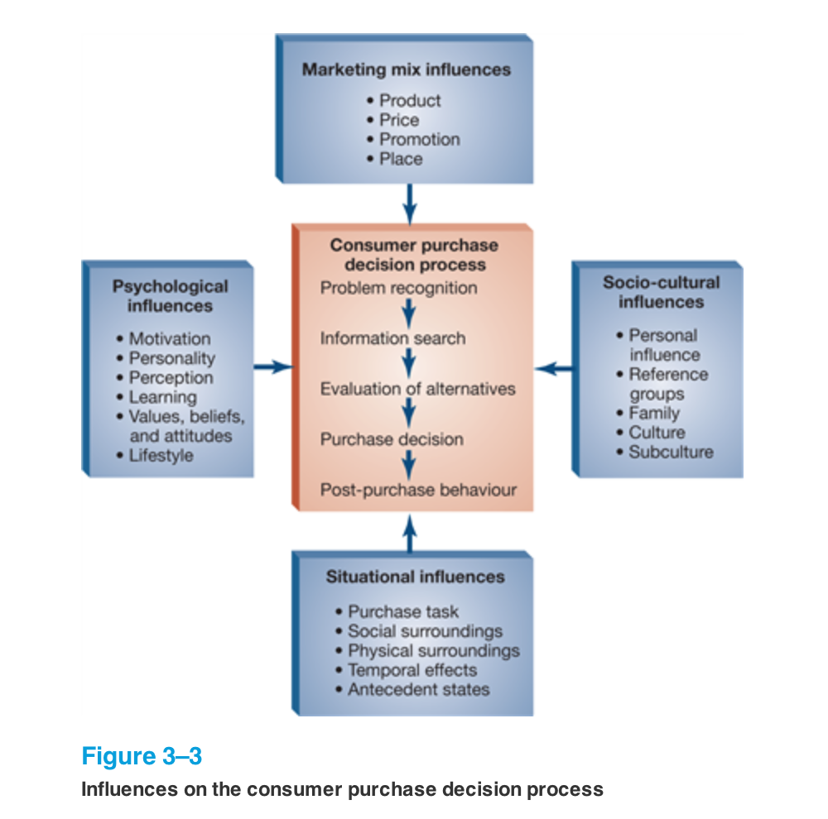
- Purchase situations will affect the purchase decision process
- There are 5 situational influences that have an impact on your purchase decision process
    - Purchase task
    - Social surroundings
    - Physical surroundings
    - Temporal effects
    - Antecedent states
- Purchase task: the reason for engaging in the decision in the first place
- Social surroundings: including the other people present when the purchase is being made, may also affect what is purchased
- Physical surroundings: such as décor, music, and crowding in retail stores may alter how purchase decisions are made. Crowding for example works both ways, if people see a store full of people they may be eager to enter the store and be a part of the experience, but on the other hand some people may be turned off because they don’t like shopping in a crowded environment
- Temporal effects: such as time of day or the amount of time available, will influence where consumers have breakfast and lunch and what is ordered
- Antecedent states: includes consumer’s mood or the amount of cash on hand, can influence purchase behaviour and choice
- Psychology helps marketers understand why and how consumers behave as they do
- There are 5 concepts useful for interpreting buying processes and directing marketing efforts
  - Motivation and personality
  - Perception
  - Learning
  - Values, beliefs, and attitudes
  - Lifestyle
- Motivation: the energizing force that stimulates behaviour to satisfy a need
- Psychologist Abraham Maslow developed a theory that characterized needs and arranged them into a hiearchy
- He argued that people take care of their lower-level needs first, then are motivated to satisfy their higher-level needs
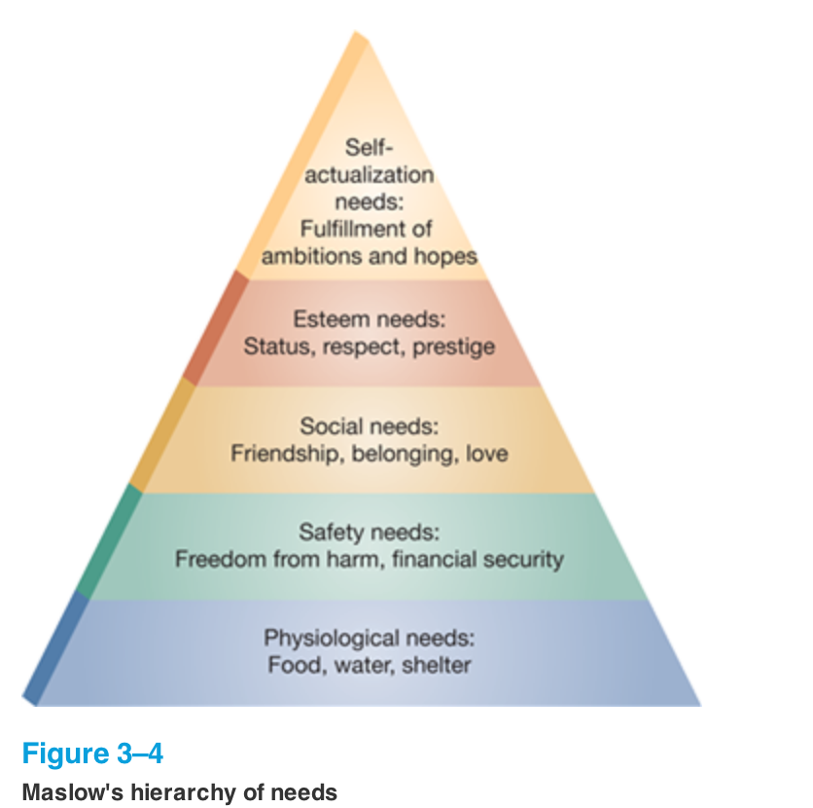

- Psychological needs: basic for survival and must be satisfied first (food, water, shelter)
- Safety needs: involve preservation and physical well being (smoke detector, burglar alarm manufacturers)
- Social needs: concerned with love and friendship (eHarmony, fragrance companies)
- Esteem needs: represented by the need for achievement, status, prestige, and self-respect (using AMEX Gold card and Holt Renfrew)
- Self-actualization needs: involve personal fulfillment (travel providers offer specialized educational exotic trips)

- Personality: refers to a person’s character traits that influence behavioral responses (assertiveness, extraversion, compliance, dominance, aggression)
- Personal self concept: the way people see themselves and they way they believe others see them

- Perception: the process by which an individual selects, organizes, and interprets information to create a meaningful picture of the world
- Selective perception: a process that filters the information so that only some of it is understood and remembered or even available to the conscious mind. Occurs when people pay attention to messages that are consistent in the post-purchase stage of the consumer decision process
- Selective comprehension: involves interpreting information so that it is consistent with your attitudes and beliefs
- Selective retention: means that consumers do not remember all the information they see, read, or hear, even minutes after being exposed to it. This affects the internal and external information search stage of the purchase decision process

- Perceived risk: represents anxieties felt because the consumer cannot anticipate the outcomes of a purchase but believes that there may be negative consequences. This affects the information search step of the purchase decision process: the greater the perceived risk, the more extensive the external search is likely to be
- Smart marketers have developed strategies to make consumers feel more at ease with their purchases
- Obtaining seals of approval: the Good Housekeeping seal that appears on many brands
- Securing endorsements form influential people: Reebok’s products endorsed by Sidney Crosby
- Providing free trials of the product: samples of perfumes offered at The Bay
- Providing illustrations: photos of different colors and hairstyles on Clairol Canada’s website
- Providing warranties and guarantees: BMW’s two year, unlimited-mileage warranty on all of their automobiles

- Learning: refers to those behaviors that result from repeated experience and reasoning
- Behavioral learning: the process of developing automatic responses to a type of situation built up through repeated exposure to it. Four variables are central to how one learns from repeated experience: drive (a need such as hunger), cue (stimulus or symbol that one perceives), response (action taken to satisfy the drive), and reinforcement (the reward)
- If what the consumer experiences upon responding to a stimulus is not pleasant, negative reinforcement has occurred.
- Stimulus generalization: occurs when a response brought about by one stimulus is generalized to another stimulus
- Stimulus discrimination: refers to ones ability to perceive difference among similar products
- Cognitive learning: involves making connections between two or more ideas or simply observing the outcomes of others’ behaviours and adjusting your own accordingly
- Brand loyalty: favorable attitude toward and consistent purchase of a single brand over time, results from positive reinforcement

- Values, beliefs, and attitudes: play a central role in consumer decision-making
- Attitude formation: attitude is a “learned predisposition to respond to an object or class of objects in a consistently favorable or unfavorable way.” Attitudes are shaped by our values and beliefs, which we develop in the process of growing up
- Beliefs: one’s perception of how a product or bran performs on different attributes. Beliefs are based on personal experience, advertising, and discussions with other people
- Attitude change: marketers use three approaches to try and change consumer attitudes toward products and brands.
  - Changing beliefs about the extent to which a brand has certain attributes:
  - Changing the perceived importance of attributes
  - Adding new attributes to the product
- Marketers mainly focus on personal values because they affect attitudes by influencing the importance assigned to specific product attributes or features.

- Lifestyle: a way of living that is identified by how people spend their time and resources, what they consider important in their environment and what they think of themselves and the world around them
- Psychographics: the analysis of consumer lifestyles
- Self-orientation: describes patterns of attitudes and activities that help a person reinforce his or her social self-image

- Socio-cultural influences have an impact on consumer behaviour. These include personal influence, reference groups, family, culture, and subculture
- Personal influence: a consumer’s purchases are often influenced by the views, opinions, and behaviours of others. Two aspects of personal influence are important to marketing: opinion leadership and word-of-mouth activity
- Opinion leadership: individuals who have social influence over others. They are more likely to be important products that provide a form of self-expression. Automobiles, clothing, and club memberships are products affected by opinion leaders, but appliances are usually not
- Word of mouth: people influencing each other during conversations. It is perhaps the most powerful information source for consumers, because it typically involved friends or family who are viewed as trustworthy
- Buzz marketing refers to a brand becoming popular as a result of people talking about it to friends and neighbors. Another way a company can create buzz is by hiring an outside agency
- Product seeing consists of hiring people to talk up a brand to others
- The online version of word of mouth is called virtual marketing
- A specific type of personal influence exists in the form of reference groups
- Reference groups: a group of people who influence a person’s attitudes, values, and behaviour. Consumers have many reference groups, but three groups have clear marketing implications
  - Membership marketing: one to which a person actually belongs, including frats, social clubs, and the family. Such groups are easily identifiable and are targeted by firms selling insurance, insignia products, and vacation packages
  - Aspiration group: one that a person wishes to be a member of or wishes to be identified with. An example is a person whose dream is to play in the NHL
  - Dissociative group: ones that a person wishes to maintain distance from because of differences in values or behaviours
- Family influence: family influences on consumer behaviour result from three sources
  - Consumer socialization: the process by which people acquire the skills, knowledge, and attitudes necessary to function as consumers
  - Family life cycle: describes the distinct phases that a family progresses through from formation to retirement, each phase bringing with it identifiable purchasing behaviour.
  - Family decision-making: joint decision-making style most decisions are made by both husband and wife. Spouse dominant decisions decisions are those for which either the husband or the wife has more influence on the purchase decision.
- Roles of individual family members in the purchase process are another element of family decision-making. 5 roles exist
  - Information gatherer
  - Influencers
  - Decision maker
  - Purchaser
  - User
- Culture: refers to the set of values, ideas, and attitudes that are learned and shared among the members of a group.
- Subculture: can be defined by regions, demographic groups, or values. The most prominent types of subcultures are racial and ethnic
- Cross-cultural analysis: involved the study of similarities and differences among consumer in two or more nations of societies. A thorough cross-cultural analysis involved an understanding of and an appreciation for the values, customers, symbols and language of other societies.
- Values: represent socially preferable models of conduct or states of existence that tend to persist over time
- Customs: what are considered normal and expected about the way people do things in a specific country or culture.
- Cultural symbols: objects, ideas, or processes that represent a particular group of people or society. They play an important role in cross-cultural analysis because different cultures attach different means to things
- Language: global marketers should know not only the basics of the native tongue of countries in which they market their products and services but also subtleties and unique expressions of the language
- Back translation: where a translated word or phrase is retranslated back into the original language by a different interpreter to catch errors
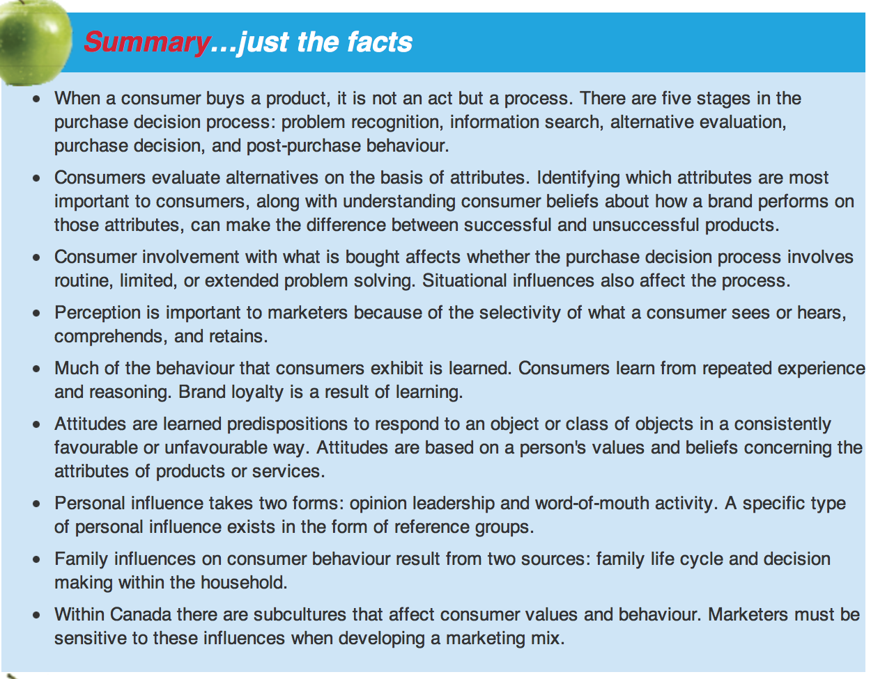
- Within Canada there are subcultures that affect consumer values and behaviour. Marketers must be sensitive to these influences when developing a marketing mix
- OECD: Organisation for Economic Co-operation and Development is an international body whose goal is to foster democratic government and a market-driven economy

- Chapter 4: MARKET RESEARCH
- Market research: the process of defining a marketing problem or opportunity, systematically collecting and analyzing information, and recommending actions to improve an organizations marketing activities
- Market research is an area used by marketers to reduce the risk of making poor business decisions and drive decision making using clear, accurate, and actionable insights
- Internet has made role of the market researcher even more crucial
- Internet makes data more easily available to marketers
- Consumer insights can stimulate new marketing programs
- Market research helps marketers understand their consumer and make fact-based decisions
- Information presents itself to companies in two ways:
  - A marketing information system
  - Market research studies
- Marketing information system: a set of procedures and processes for collecting, sorting, analyzing, and summarizing information on an ongoing basis
- MIS collects information on elements such as market conditions, competitive marketing actions, and local sales figures and then analyzes it to provide a current market assessment
- Market research: the process of planning, collecting, and analyzing information in order to recommend actions to improve marketing activities
- Market research can reduce the risk of uncertainty of making poor decisions
- Information can be an important competitive advantage for firms as well as a key marketing took
- Market research is a tool that clarifies marketing problems and opportunities and provides information for marketing decision-making
- Market research can be classified into three basic areas
  - Exploratory research
  - Descriptive research
  - Casual research
- Each area serves a different function, uses different techniques and can be used in conjunction to better solve a research program
- Exploratory research: preliminary research that clarifies the scope of a marketing problem
- Generally provides researchers with a better understanding of the dimensions of the marketing problem before focusing on areas that require further research
- Descriptive research: designed to describe characteristics of a given population or to clarify its usage and attitudes
- The researcher has a general understanding of the marketing problem and is seeking more conclusive data that answers particular questions
- Casual research: designed to identify cause-and-effect relationships among variables
- There is usually an expectation about the relationship to be explained such as predicting the influence of price change on product demand
- The six step market research approach
  - Define the problem/issue/opportunity
  - Design the research plan
  - Conduct exploratory and qualitative research
  - Collect quantitative primary research
  - Compile, analyze, and interpret data
  - Generate reports and recommendations
- Objectives: specific, measurable goals that the decision maker seeks to achieve
- Sampling: the process of gathering data from a subset of the total population rather than from all members of that particular group
- Probability sampling: involves precise rules to select the sample so that each element of the population has a specific known chance of being selected
- Non-probability sampling: the use of arbitrary judgment by the market researcher to select a sample so that the chance of selecting a particular element of the population is either unknown or zero
- Exploratory research: preliminary research conducted to clarify the scope and nature of a marketing problem
- It is done to ensure that research is often conducted with the expectation that subsequent and more-conclusive qualitative research may follow
- Can either collect exploratory primary or secondary data
- Qualitative research: forms of research such as focus group research, in-depth interviews, online communities, online bulletin boards and social listening
- Provides insightful and directional information to the researcher, with the understanding that although the data is not gleaned from a large consumer base, it provides useful direction to the research study and may in fact thoroughly answer the questions at hand
- Secondary data: facts and figures that have already been recorded by a third party
- Secondary data can come in two forms
  - Internal data: exists within a company and includes data such as sales reports, profitability data, and costing information
  - External data: comes from published sources outside the organization
- Secondary data is lower in cost and easier to obtain than primary data
- Secondary data can also help illuminate further data requirements
- Disadvantages of secondary data include:
- Data may be out of date
- The definitions or categories may not be right for the project
- The data may not be accurate or specific enough for the study
- Primary data: data that is original and specifically collected for the project at hand. Consists of qualitative or quantitative studies. Qualitative studies include:
- Focus group: an informal interview session in which six to ten people are brought together in a room with a moderator to discuss topics surrounding the market research problem
- In-depth interviews: detailed individual interviews where the researcher discusses topics with an individual at length in a free-flowing conversation in order to discover information that may help solve a marketing problem
- Online research communities: involve the use of consumer groups, brought together privately in an online environment to answer questions, respond to ideas and to collaborate with researchers in real time
- Online research bulletin boards: private online forums where respondents can post their responses to questions
- Social listening: monitors public online consumer conversations on social media sites such as social networks, blogs and forums
- Quantitative research: statistically reliable information that uses observational techniques and/or questioning methods such as surveys or experiments to deliver statistically significant results
  - Observations
  - Surveys
  - Experiments
- Market researchers have to make important tradeoffs to balance costs against the expected quality of information
- Observational research: obtained by watching how people behave either in person or by using a machine to record event
- Syndicated studies: a hybrid of primary and secondary research conducted by a research company, spreading the cost across many clients to reduce the price
- Panel: includes a large sample of respondents that voluntarily completes questionnaires on a regular basis so that researchers can asses changes in behaviour and attitudes
- Omnibus survey: also includes the voluntary participation of respondents in routine surveys, allowing individual marketers to add a small number of questions to an existing survey to receive cost-effective data on their questions
- Experiment: involves changing a variable involved in a purchase to find out what happens
- Test market: an in-market localized regional approach, or short-term online destination used to test the success of promotional offers, new services, or new product launches
  - Can provide a more realistic evaluation of product or promotional success other than research options
  - Can also be time-consuming, costly, and visible to the competition
- Technology is facilitating the gathering of this information with more and more individuals having easy access to the internet
- Marketers need to remember that market research needs to be actionable and that decisions to purchase a study, or embark upon a market research project should be evaluated as an investment decision
- Privacy policies need to be instituted by marketers and research companies to protect consumer information and to adhere to legal privacy legislation
- Chapter 6: SEGMENTATION, TARGETING, AND POSITIONING
- Target marketing, market segmentation, and product positioning are basic driving forces in the world of marketing
- Strong marketing programs are grounded in gaining insights into what drives consumers to purchase particular products
- Simply, a market segment is a piece of the market
- There are two main market segments:
- Consumer Market: consists of goods, services, and ideas that a person can purchase or support for his or her own personal use
- Business Market: involves products that are purchased either to run a business or to be used as a component in another good or service
- How a product is classified depends on its usage
- Market Segmentation: involves aggregating prospective buyers into group that have common needs and respond similarly to marketing programs
- Product Differentiation: involves positioning a product apart from the competition in the eyes of the consumers
- Mass Marketing: involves a product being marketed to the entire market with no differentiation
- Segment Marketing: involves designing specific products and services to meet the needs of different target groups
- Also followed by companies in the business-to-business market
- Nice Marketing: allows a company to focus its efforts on a limited segment in the market
- Individualized Marketing: enables marketers to customize offers and in some cases products to fit individual needs
- Developing an accurate target market profile is crucial to the success of all marketing initiatives as it drives all elements of the marketing mix
- Marketers define their target market by looing at four main variables
- Geographic’s
- Where a target market lives using variables such as country, region, province, city size, and type of location such as urban, suburban, or rural
- Demographics
- Profile of a target market, includes identifying ranges for age, gender, family life cycle, income, occupation, education, ethnic background, and home ownership for the main target market
- Psychographics
- One of the most difficult variables to identify for marketers, involves understanding consumer’ attitudes to life, their personalities, general interests, opinions, and activities
- Behavioristic
- Directly refers to how consumers use the product, it looks at why consumers buy a product, the product benefit, how the product is used, and whether consumers are brand loyal in their purchase behaviour
- Product Positioning: refers to the impression of the product you want to establish in consumer’ minds relative to their needs and also in contrast to the competition
- Image
- Product attribute
- Price
- Positioning Statement: outlines the positioning of a product in the market mix (simple, clear, and focused)
- Positioning statements identify two key areas:
- How the product meets consumer needs
- How the product is differentiated in the market versus the competition
- Positioning statements identify four elements:
- Product name
- Category in which the product competes
- One or two main reasons that they target market buys the product (product benefits)
- What sets the product apart from the competition
- Repositioning: revamping a product and its marketing mix to more accurately reflect consumer needs
- Positioning Maps: also known as perceptual maps, are visual representations of how products or product groups are positioned within a category to consumers/customers
- Segmentation, target markets, and positioning are fundamental concepts to how marketers run their businesses
- Market segmentation analysis allows a marketer to identify gaps in the market and determine where future opportunities may lie
- Chapter 7: PRODUCTS AND BRANDS
- Meeting customer needs is central to successfully marketing a product
- Product is a term used in marketing to designate non-durable foods, durable goods, and services that are marketed. Some products are a combination of both goods and services
- Products are divided in three main categories
  - Non-durable Goods: items that do no last and that are consumed only once, or for a limited number of times (food, fuel)
  - Durable Goods: product that lasts for an extended period of time (appliances, automobiles, stereo equipment)
  - Services: intangible activities, benefits or satisfactions (banking, conducting an online search, visiting a doctor, taking a vacation)
- It is important to distinguish between a company’s primary service and its supplementary services
- Supplementary services often allow products to differentiate their offerings from the competition while also adding value to consumers (product updates, free delivery, order-taking)
- Most products cannot be defined as pure goods or pure services
- Firms often combine goods and services to offer a more competitive product to consumers
- Virtual Services: services that exist online only and have no form of face-to-face interaction or tangible components (social media sites, online gaming sites)
- Service Continuum: a range from tangible goods to intangible services
- There are four unique elements to services:
  - Intangibility: services are intangible, cannot be tried before purchase
  - Inconsistency: quality is dependent on the people who provide it, therefore can vary in consistency
  - Inseparability: consumer cannot differentiate the deliverer of the service from the service itself (surgeon having poor beside manner immediately reflects poorly on the hospital, which may in fact be excellent)
  - Inventory: problems exist because services cannot necessarily be stored and accessed when in demand
- Perishability: arises when a product cannot be stored for long periods of time for use at a later date
- Not all services are perishable
- Idle Production Capacity: a situation when the supply of a service exceeds its demand
- Marketers view products as having three different layers:
  - Core Product: the fundamental benefit that a customer derives from having the product (bike transportation)
  - Actual Product: the physical good or the service that the purchases (bike piece of equipment, directly associated with a brand name)
  - Augmented Product: additional features and attributes that accompany a product (bike warranty, delivery options)
- There is not necessarily always an augmented product layers. Generally they exist for more expensive purchases such as cars, computers, TVs
- For online products it is more difficult to differentiate the core, actual, and augmented components of the product
- Packaging and labeling decisions are of paramount importance to a products success
- Product Line: a group of similar products with the same product and brand name (Gatorade G Series)
- Product Mix: refers to the array of product lines marketed by a company
- Product Width: refers to the number of different categories offered by the company
- Product Depth: refers to the variety of product lines and products sold within its product categories, groups, and lines
- Products are classified as either consumer or business products depending on their usage
- Consumer Products: purchased by the ultimate consumer for their own personal use
- Business Products: (also called industrial goods or organizational goods) are purchased either to run a business or to be used as a component in another product or service
- Some products are both consumer and business products depending on their usage
- There are four different types of consumer goods:
  - Convenience Products: inexpensive items that a consumer purchases frequently with minimal shopping effort (bread, newspaper)
  - Shopping Products: items for which the consumer comparison shops, assessing the attributes and prices of different products and brands (jeans, books, TV)
  - Specialty Products: items that require considerable time and effort to purchase, tend to be more expensive branded products needed for special occasions (Rolex watch, taking a cruise)
  - Unsought Products: products that the consumer either does not know about or is not interested in purchasing (diapers for a person who does not have a baby, epilepsy medication for someone who does not suffer from seizures)
- The manner in which a consumer good is classified depends on the individual
- Although many products are clearly separated into one category, people in different stages of their life will classify products differently
- Business products may be classified as production goods and services, or support goods and services
- Production Goods and Services: items used in the manufacturing process that become part of the final product, can include raw materials such as grain or lumber, or component parts such as door hinges
- Support Goods and Services: items used to assist in producing other goods and services, can include installations, accessory equipment, supplies and services
- Brand: a name or phrase uniquely given by a company to identify its product(s) and to distinguish product(s) from the competition. Designed to virtually represent the brand to consumers and to build brand recognition
- Brand Equity: the value of a brand that results from the favorable exposure, interactions, associations, and experiences that consumers have with a brand over time
- Brand Extension: launching new goods or services under an existing flagship brand
- Brand equity is the result of considerable marketing investment and needs to be protected
- Brands are classified as either individual brands or family brands depending on whether their name has been extended to cover more than one product category
  - Individual Brand: when a company uses a brand name solely for a specific product (Yop yogurt drink, Twitter)
  - Family Brand: when a company uses a brand name to cover a number of different product categories (Crest, Google,
- Pros to using an established family brand name for new goods or services is that brand equity is quickly transferred from the flagship brand to the new product, thus saving the company from the marketing funds needed to build this brand equity from scratch
- Cons to using an established family brand is that if the new product does not live up to the image of the flagship brand, or share in its values, then the brand equity built up over time can be eroded for all products under this brand name
- Brand equity is the result of considerable marketing investment and needs to be protected
- Patents, copyrights, and trademarks are used to protect products, brands, and processes form unethical infringement
- Patents: used to legally protect new technologies, unique processes or specific formulations from other companies that may wish to benefit from their use (in Canada, protect for 20 years)
- Copyrights: used to legally protect the written word, a sound recording, or a form of communication from being copies by others. It covers music, literature, and performances, and can include slogans
- Trademarks: used by people or organizations to protect brands images, names, and designs from usage by others (limited to 15 years but can be renewed)
- For a brand to be trademarked a company needs to first conduct a trademark search to ensure that the trademark is not already owned by another company
- Brand Loyalty: the degree of attachment that consumer have to a particular brand
- Global Brand: well-entrenched brands that are often marketed around the world
- Brand Responsibility: a set of human characteristics associated with the brand
- There are three types of brands:
  - Manufacturer’s Brands: one that is owned and produced by the manufacturer (Tylenol)
  - Private Label Brands: otherwise known as store brand, is owned by a retailer that contracts its manufacturing to major suppliers and then sells the product at its own retail stores, under its own store brand name (very popular in Canada, Life Brand, President’s Choice)
  - Generic Brands: has no branding at all and is sometimes produced as a cheap alternative to a manufacturer’s brand and to a private label branded product (Apotex)
- Companies may restrict a brand name for use with a single product line, thus using an individual brand, or may extend a brand name to encompass a number of different product categories, resulting in the creation of a family brand
- The world of marketing is dynamic and ever-changing
- Marketing plans review each element of the marketing mix to itemize when marketing programs will be put in place, and their expected impact on sales, revenues, and profits
- In marketing, nothing remains the same
- The managing of a product requires marketers to intimately understand the dynamics of the marketplace and to quickly assess the financial impact of recommendations that are needed to boost the business
- Marketers need to use their analytical skills, creativity, and strategic thinking to keep the business moving forwards
- A marketer is responsible for marketing products and brands to bring revenue into an organization
- Chapter 1: STRATEGIES, TRENDS, AND CHALLENGES
- We rely on people to generate, develop, and implement ideas and the “human resource function as an important role in ensuring that organizations have the people capacity to execute strategic objective”
- Human resource management (HRM): centers on practices, policies, and systems that influence employees’ behaviour, attitudes, and performance.
- There are several important HRM practices that support the organization’s business strategy:
  - Analyzing and design of work
  - Workforce planning
  - Recruiting
  - Selection
  - Training and development
  - Performance management
  - Compensation and rewards
  - Employee and labor relations
- An organization performs best when all these practices are managed systematically.
- Companies with effective HRM have employees and customers who tend to be more satisfied and the company itself tends to be more innovative, have greater productivity, and develop a more favorable reputation in the community
- People are crucial to organizational success and the human and intellectual capital of an organization’s workforce provides an opportunity for substantial competitive advantage
- Human capital: and organizations employee’s described in terms of their training, experience, judgment, intelligence, relationships and insight
- Employees in today’s organizations are not interchangeable
- Human resource management is critical to the success of organizations
- An organization can succeed if it has a sustainable competitive advantage
- Human resources are:
  - Valuable high quality employees
  - Rate a person with high levels of the needed skills and knowledge is not common
  - Cannot be imitated to imitate, you would have to figure out which employees are providing the advantage and how
  - No good substitutes when people are well trained and highly motivated, they learn, develop their abilities, and care about customers. It is difficult to imagine another resource that can math committed and talented employees
- High-performance work system: an organization in which technology, organizational structure, people and processes all work together to give an organization an advantage in the competitive environment.
- Maintaining a high-performance work system might include development of training programs, recruitment of people with new skill sets, and establishment of rewards for such behaviours such as teamwork, flexibility, and learning.
- In all but the smallest organizations, a human resource department is responsible for the functions of human resource management
- On average, an organization has 1 HR staff person for every 93 employees
- There are three responsibilities of HR departments
  - Administrative services and transactions handling administrative tasks
  - Business partner services developing effective HR systems that help the organization meet its goals for attracting, keeping and developing people with the skills it needs
  - Strategic partner contributing to the company’s strategy through an understanding of its existing and needed human resources and ways HR practices can give the company a competitive advantage
- No two human resource departments have precisely the same roles
- Job analysis: the process of getting detailed information about jobs
- Job design: the process of defining the way work will be performed and the tasks that a given job requires
- Recruitment: the process through which the organization seeks applicants for potential employment
- Selection: the process by which the organization attempts to identify applicants with the necessary knowledge, skills, abilities, and other characteristics that will help the organization achieve its goals.
- Responsibilities of HR Departments:
  - Analysis and design of work
  - Recruitment and selection
  - Training and development
  - Performance management
  - Compensation and rewards
  - Employee and labor relations
  - Strategy
  - Human resource policies
  - Compliance with legislation
- Top 5 qualities employers look for in employees
  - Interpersonal skills
  - Work ethic
  - Initiative/flexibility
  - Honesty/loyalty
  - Strong communication skills (verbal and written)
- Training: planned effort to enable employees to learn job-related knowledge, skills, and behaviour
- Development: involved acquiring knowledge, skills, and behaviour that improve employees’ ability to meet the challenges of a variety of new or existing jobs, including preparing employees to work in in diverse teams.
- Performance management: the process of ensuring that employees’ activities and outputs match the organizations goals
- The pay and benefits that employees earn play an important role in motivation, and is especially true when rewards such as bonuses are linked to the individual’s or team’s strategy
- Workforce planning: identifying the numbers and types of employees the organization will required in order to meet its objectives
- Evidence-based HR: demonstrating that human resource practices have positive influence on the company’s profits or key stakeholders
- Corporate social responsibility: describes an organization’s commitment to meeting the needs of its stakeholders
- Stakeholders: the parties that have an interest in the company’s success. Typically include:
  - Shareholders
  - The community
  - Customers
  - Employees
- Productivity: the relationship between an organizations outputs and its inputs
- Companies are finding that to survive and prosper they must compete in international markets as well as fend off foreign competitors’ attempts to gain ground in Canada
- For an organization to operate in other countries, its HR practices must take into consideration differences in culture and business practices
- 20th and 21st century have been years of significant immigration
- Expatriates: employees who take assignments in other countries
- Outsourcing: refers to the practice of having another company provide services
- Outsourcing gives the company access to in-depth expertise and is often more economical as well
- Offshoring: setting up a business enterprise in another country (e.g. setting up a factory in China)
- Increasingly organizations are offshore outsourcing
- Merger: two companies becoming one
- Acquisition: one company buying another company
- Six competencies for the HR professional
  - Credible activist: being so well-respected in the organization that you can influence the positions taken by managers
  - Cultural steward: involved understanding the organization’s culture and helping build and strengthen or change that culture
  - Talent manager/organizational designer: knows the ways that people join the organization and move to different positions within it
  - Strategic architect: requires awareness of business trends and an understanding of how they might affect the business
  - Business ally: know how the business achieves its success, knows who its customers are, and why customers support what the company sells
  - Operational executor: at the most basic level carry out particular HR functions such has handling the selection, training, or compensation of its employees
- You have to start from the bottom competencies in order to get to the top
- All these competencies require interpersonal skills
- Successful HR professional must be able to share information, build relationships, and influences persons inside and outside the organization
- Ethics: the fundamental principles of right and wrong, ethical behaviour is behaviour that is consistent with those principles
- For human resource practices to be considered ethical, they must satisfy the three basic standards
  - HRM practices must result in the greatest good for the greatest number of people
  - Human resource practices must respect legal requirements including human rights and privacy
  - Managers must treat employees and customers equitably and fairly
- HR responsibilities of supervisors and managers:
  - Help define jobs
  - Forecast HR needs
  - Train, coach, and develop employees
  - Provide motivational environment
  - Communicate policies and comply with legal requirements
  - Interview (and select) candidates
  - Appraise performance
  - Recommend pay increases and promotions
- CHRP (certified human resource professional) is the nationally recognized designation that recognizes individuals who have met the standards of professional knowledge and competencies defined by the Canadian Council of Human Resources Associations.
- Labor force: general way to refer to all the people willing and bale to work
- Internal labor force: consists of the organization’s workers, its employees and the people who work at the organization. Drawn from the organization’s external labor market
- External labor market: individuals who are actively seeking employment
- HR professionals need to be aware of trends in the composition of the external labor market because they trends affect the organizations options for creating a well-skilled, motivated internal labor force
- Canada’s population and labor force are aging
- Canadian workforce and population is growing more diverse
- Social system: people and how they interact
- Technical system: equipment and processes
- Knowledge workers: employees whose main contribution to the organization is specialized knowledge, such as knowledge of customers, a process, or a profession.
- They are especially needed for jobs in health services, business services, social services, engineering, and management
- Knowledge workers are in a position of power
- There is a greater shift on general cognitive skills from specific skills
- Employee engagement: the extent that employees are satisfied, committed to, and prepared to support what is important to the organization
- Teamwork: the assignment of work to groups of employees with various sills who interact to assemble a product or provide a service
- This is one of the most popular ways to increase employee responsibility and control
- Virtual teams: teams that rely on communications technologies to keep in touch and coordinate activities
- Human resource information system (HRIS): a computer system used to acquire, store, manipulate, analyze, retrieve, and distribute information related to an organization’s human resources
- HR dashboard: a display of a series of HR-related indicators, or measures, showing human resource goals and objectives and the progress toward meeting them
- Electronic human resource management (e-HRM): processing and transmission of digitalized HR information
- It has the potential to change all traditional HRM function
- HR information is confidential
- Self-service: employees have online access to information about HR issues such as training, benefits, compensation, and contracts; go online to enroll themselves in programs and services, and provide feedback through online surveys
- Psychological contract: a description of what an employee expects to contribute in an employment relationship and what the employer will provide the employee in exchange for the contributions
- It is not formally put into words, it describes unspoken expectations that are widely held by employers and employees
- To stay competitive, modern organizations must frequently change the quality, innovation, creativeness, and timeliness of employee contributions and the skills needed to make those contributions
- Companies demand excellent customer service and high productivity levels
- Key to survival in a fast-changing environment is flexibility
- Alternative work arrangement: methods of staffing other than the traditional hiring of full-time employees
  - Independent contractors
  - On-call workers
  - Temporary workers
  - Contract workers
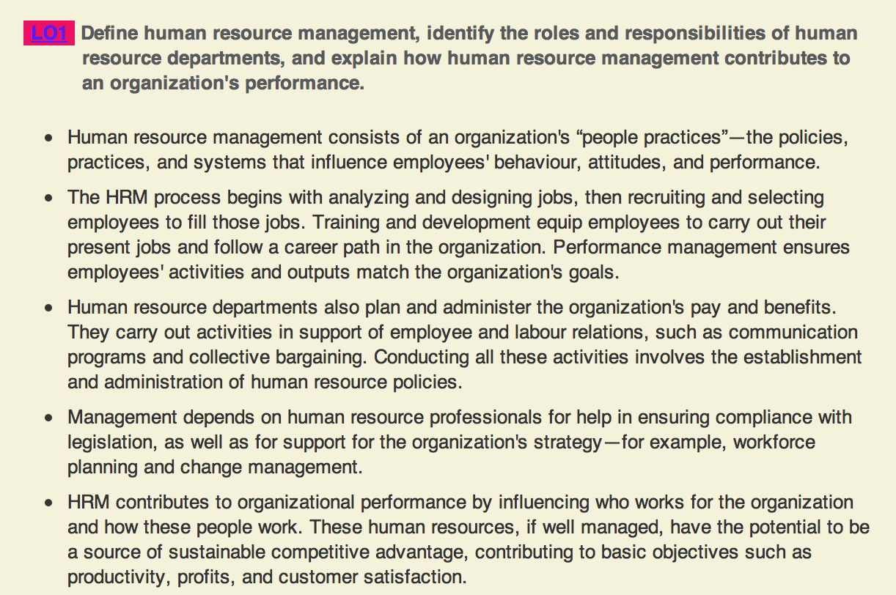

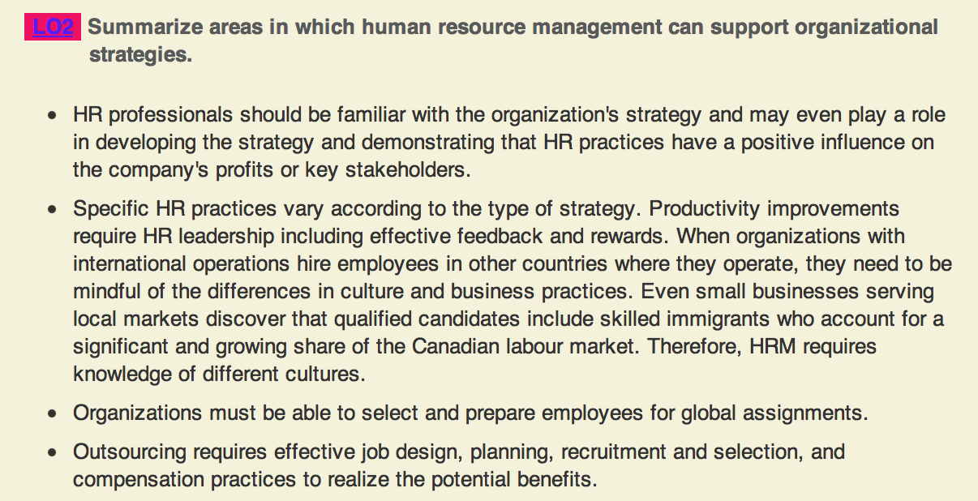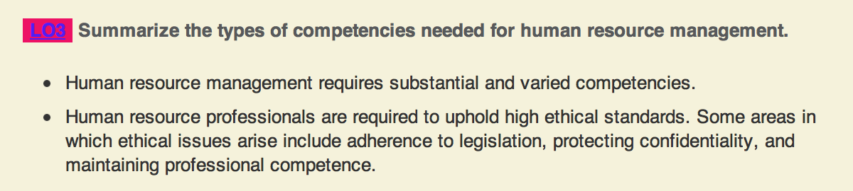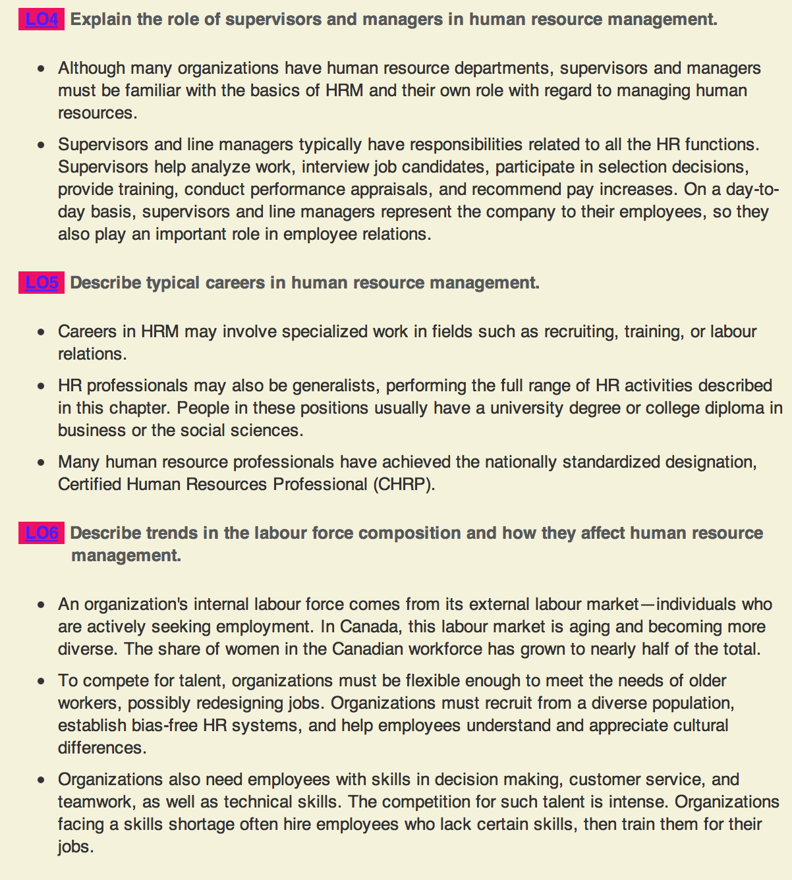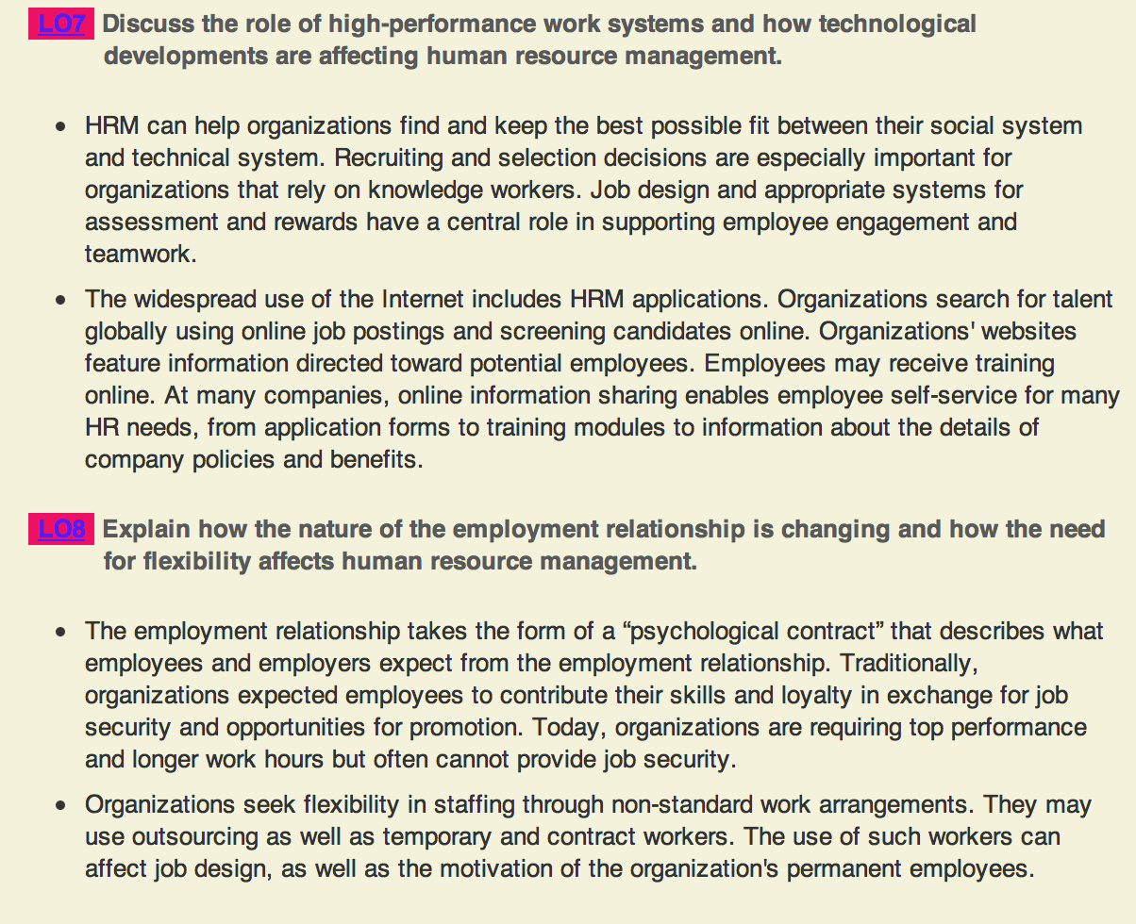
- Chapter 4: Planning for and Recruiting Human Resources
- Organizations should carry out workforce planning
- Organizations need a clear idea of the strengths and weaknesses of their existing labor force
- They must also need to know what they want to do in the future
- Workforce planning compares the present state of the organization with its goals for the future, then identifies what changes it must make in its HR to meet these goals
- The overall goal of workforce planning is to ensure the organization has the right people with the right skills in the right places at the right time
- The process consists of three stages:
  - Forecasting: The attempts to determine the supply of and demand for various types of human resources to predict areas within the organization where there will be labour shortages or surpluses.
- Trend analysis: constructing and applying statistical models that predict labor demand for the next year, given relatively objective statistics from the previous year
- Leading indicators: objective measures that accurately predict future labor demand. They might include measures of the economy, actions of competitors, changes in technology, and trends in the composition of the workforce.
- Statistical planning models are useful when there is a long, stable history that can be used to reliably detect relationships among variables. However, these models almost often have to be completed with subjective judgments of experts
- Transitional matrix: a chart that lists job categories held in one period and shows the proportion of employees in each of those job categories in the future period. It answers, “where did people who were in each category go” and “where did people now in each category come from?”
- Matrices are extremely useful for charting historical trends in the company’s supply of labor
- Issues related to a labor surplus or a shortage can pose serious challenges for the organization
  - Goal setting and strategic planning: the purpose of setting specific numerical goals is to focus attention on the issues and provide a basis for measuring the organization’s success in addressing labor shortages and surpluses.
- For each goal, the organization must choose one or more human resource strategies
- Planning stage is critical
- Downsizing: the planned elimination of large numbers of employees with the goal of enhancing the organization’s competitiveness
- The primary reason organizations engage in downsizing is to promote future competitiveness. They do this by meeting four objectives:
  - Reducing costs
  - Replacing labor with technology
  - Mergers and acquisitions
  - Moving to more economical locations
- Evidence suggests that it hurts long-term organizational effectiveness if you downsize
- Disadvantages of downsizing include:
  - only a temporary boost to profits
  - loss of talent, motivation drops
  - negative publicity
- Alternatives to downsizing include:
  - Reducing hours
  - Early-retirement programs
  - Phased-retirement retain older employees and benefit from them and then slowly grade down
- Ways to avoid a shortage:
  - Employing temporary and contract workers popular with employers because it gives them the flexibility they need to operate efficiently when demand for their products changes rapidly
    - Flexibility
    - Brings objective point of view to the organization
  - Outsourcing contracting with another organization to perform a broad set of services
    - Use outsourcing as a way to operate more efficiently and save money
    - Poses problems such as quality control, security violations, and poor customer service
  - Overtime and expanded hours organizations may try to garner more hours from the existing labor force, asking them to go from part-time to full-time or to work over-time
    - Downside of overtime is that the employer must pay non-management employees additional pay above or beyond their normal wages for work done overtime
  - Program implementation and evaluation: when implementing the HR strategy, the organization must hold some individual accountable for achieving the goals.
    - Most obvious step is checking whether the organization has succeeded in avoiding labor shortages or surpluses
    - Evaluation should identify which parts of the planning process contributed to success or failure
- Organization looks at the representation of subgroups in its labor force
- Employment equity plans forecast and monitor the proportion of employees who are members of various protected groups
- Workforce utilization review: a comparison of the proportion of the employees in protected groups with the proportion that each group represents in the relevant labor market
- If the work force utilization review indicates that some group makes up 10% of the relevant market for a job category but that this same group constitutes only 5% of the employees actually in the job category at the organization, this is underutilization
- Steps in the workforce utilization review are identical to the steps in the workforce planning process
- The planning process may identify new strategies for recruitment for selection
- The aging of the workforce means a greater share of employees are reaching retirement age
- Succession Planning: the process of identifying and tracking high-potential employees who will be able to fill top management positions or other key positions when they become vacant
- There are 7 steps for succession planning:
  - Identify positions to plan for
  - Identify employees to include
  - Define job requirements
  - Measure employee potential
  - Review and plan to meet development needs
  - Link succession planning with other HR systems
  - Provide feedback to employees
- Succession planning offers several benefits
  - Forces senior management to regularly and thoughtfully review the company’s leadership talent
  - Assures top-level management is available
  - Provides a set of development experiences that managers must complete to be considered for top management positions
  - Helps attract and retain ambitious employees by providing development opportunities
- Succession planning focuses on high-potential employees, that is, employees the organization believes can succeed in higher-level business positions such as general manage of a business unit, director of a function, or CEO
- The role of recruitment is to build a supply of potential new hires that the organization can draw on as the need arises
- Recruiting: any practice or activity carried on by an organization with the primary purpose of identifying and attracting potential employees
- All companies have to make decisions in three areas of recruiting
  - human resource policies
  - recruitment sources
  - characteristics and behavior of recruiter
- An organizations HR policies are its decisions about how it will carry out human resource management, including how it will fill job openings
- Several policies are especially relevant to recruitment:
  - Internal vs. external recruiting Policies to promote from within makes an organization more attractive
  - Lead-the-market pay strategies Meeting or exceeding the market rate of pay to compete for applicants
  - Employer branding strategic approach of attaching a visual, emotional, or cultural brand to an organization
- Internal sources: employees who currently hold other positions in the organization. They are recruited though job postings or referrals
- Advantages of internal sources include:
  - Creates an atmosphere of career progression
  - Generally cheaper and faster than external
  - Generates applications who are well known
  - Enhanced employee morale
- External sources: organizations may not have available internal candidates to fill positions. Usually for entry level and specialized jobs
- Sources including:
  - Direct applicants, referrals, passive job seekers
  - Advertisements, electronic recruiting
  - Public employment agencies, staffing services companies, universities/colleges
- Direct applicant: people who apply for vacancy without prompting from the organization
- Referrals: people who apply because someone in the organization prompted them to do so
- Largest share of new employees hired by large companies came from referrals, and the next came from direct applicants made at the employer’s website
- Passive job seekers: individuals who are not actively seeking a job, but present a significant source of top talent
- Advantages of direct applicants include:
  - To some extent, direct applicants already “sold” on the organization. Most have done research and concluded that there is enough fit between themselves and the vacant position to warrant submitting an application
  - Costs much less
- Disadvantages of referrals:
  - Limit the likelihood of exposing the organization to fresh viewpoints
  - Sometimes referrals contribute to hiring practices that are or that appear unfair
- Nepotism: practice of hiring relatives
- Realistic job preview: background information about a job’s positive and negative qualities

- Chapter 5: Selecting Employees
- Hiring the right person is perhaps the most important decision a manager can make
- There are 5 steps in the selection process:
  - Screening applicants and resumes
  - Testing and reviewing work samples
  - Interviewing candidates
  - Checking references and background
  - Making a selection
- The criteria for evaluating selection methods include: reliability, validity, ability to generalize, practical value, and legal
  - Reliability: the extent to which a measurement generates consistent results
  - Validity: the extent to which performance on the measure is related to what the measure is designed to do
- There are 3 ways to measure validity including: criterion-related, content, and construct validity
- Criterion-related validity: based on showing a substantial correlation between test scores and job performance scores
- Two kinds of research are possible for arriving at criterion-related validity:
  - Predictive validation: uses the test scores of all applicants and looks for a relationship between the scores and future performance
  - Concurrent validation: administers a test to people who currently hold a job, then compares their scores to existing measures of job performance
- Predictive validation is more time consuming and difficult, but it is the best measure of validity
- Content validity: consistency between the test items or problems and the kinds of situations or problems that occur on the job. A test that is “content valid” exposes the job applicant to situations that are likely to occur on the job.
- Construct validity: consistency between a high score on a test and a high level of a construct such a intelligence or leadership ability, as well as between mastery of this construct and successful performance on the job
  - Ability to generalize: valid in other contexts beyond the context which the selection method was developed
  - Practical value: not only should selection methods such as tests and interview responses accurately predict how well individuals will perform, they should produce information that actually benefits the organization
- Utility: the extent to which the selection method provides economic value greater than its cost
  - Legal: the selection process needs to be conducted in a way that avoids human rights and privacy complaints
- Applications: an inexpensive way to gather basic data from many applicants
- Resumes: the usual way applicants introduce themselves to a potential employer
  - Biased in favour of the applicant
- Applicant Tracking System (ATS): a software application that streamlines the flow of information between job seekers, HR staff, and hiring managers
- Negligent hiring: refers to a situation where an employer may be found liable for harm an employee causes to others if references and background checks were not performed adequately at the time of hiring
- Background check: a way to verify that applicants represent themselves to be
- There are 6 types of employment tests:
  - Cognitive ability
  - Job performance
  - Physical ability
  - Medical examinations
  - Personality
  - Honesty, drug, and alcohol
- There are 2 categories of employment tests:
  - Aptitude tests: Tests that assess how well a person can learn or acquire skills and abilities
  - Achievement tests: Tests that measure a person’s existing knowledge and skills
- Physical ability: Evaluates one or more physical or psychomotor abilities
- Cognitive ability tests: sometimes called “intelligence tests” are designed to measure such mental abilities as verbal skills, quantitative skills, and reasoning ability
- Assessment center: a wide variety of specific selection programs that use multiple selection methods to rate applicants or job incumbents on their management potential
- Meiorin Test: Used to determine if a violation of human rights legislation can be justified as a bona fide occupational requirement
- There are 4 interview techniques:
  - Nondirective interview: the interviewer has great discretion in choosing questions
  - Structured interview: establishes a set of questions for the interviewer to ask
  - Situational interview: a structured in which the interviewer describes a situation likely to arise on the job as asks the candidate what he or she would do in this situation
  - Behavioral interview: a situational interview in which the interviewer asks the candidate to describe how he or she handled a type of situation in the past
- Panel interview: selection interview in which several members of the organization meet to interview each candidate
  - Gives the candidate a change to meet more people and see how people interact in that organization
- Interviewing is not necessarily the most accurate basis for making a selection decision
  - Interviews can be unreliable
  - Low in validity
  - Biased against a number of different groups
  - They are costly
  - They are subjective
- Multiple-hurdle model: Process of arriving at a selection decision by eliminating some candidates at each stage
  - Usually process for arriving at a selection decision
- Compensatory model: All candidates evaluated with all methods
  - A very high score on one type of assessment can make up for a low score on another
  - More expensive
- Who makes the selection decision?
  - Immediate supervisor or manager
  - Human resource professional
  - Work team or other panel of decision makers
  - Communicating the decision:
  - HR department is often responsible for notifying applicants
  - Need to keep accurate records
  - Close communication required between HR and the immediate supervisor
- Chapter 6: Training and Developing Employees
- Workplace training and employee development are key ingredients in the competitiveness of firms and ultimately of national competitiveness
- Canadian firms continue to under-invest in learning and that Canada lags the U.S. and other countries in employee training
- It is important to provide training that is effective
- Instructional design: a process of systematically developing training to meet specified needs
- Instructional design process:
  - Assess needs for training
  - Ensure readiness for training
  - Plan training program
    - Objective
    - Trainers
    - Methods
  - Implement training program
  - Evaluate results of training
- Evaluating the results of the training provides feedback for planning future training programs
- Learning management system (LMS): a computer application that automates the administration development, and delivery of a company’s training programs
- Needs assessment: the process of evaluating the organization, individual employees, and employee’s tasks to determine what kinds of training if any are necessary
- There are three areas of needs assessment
  - Organization
  - Person
  - Task
- Organization analysis: a process for determining the appropriateness of training by evaluating the characteristics of the organization
- Person analysis: a process for determining individual’s needs and readiness for training
- Task analysis: the process of identifying the tasks and competencies that training should emphasize. Usually conducted along with person analysis
- Readiness for training: a combination of employee characteristics and positive work environment that permit training
- Readiness for training depends on two broad characteristics of the work environment:
  - Situational constraints: the limits on training’s effectiveness that arise from the situation or the conditions within the organization
  - Social support: refers to the ways the organization’s people encourage training
- Effective training objectives have three components:
  - State expectations of employees
  - Performance standards that are measurable
  - Identify the resources needed to carry out the desired performance or outcome
- Methods of training:
  - Classroom instruction
  - Audiovisual training
  - Computer based training
    - E-learning: involves receiving training via the internet or the organization’s intranet
  - On-the-job training
    - Apprenticeship: work-study training method that teaches job skills though a combination of on-the-job training and technical training
    - Internship: on-the-job learning sponsored by an educational institution as a component of an academic program
    - Cooperative education: a plan of higher education that incorporates paid work experience as an important component of academic studies
  - Simulations: training method that represents a real-life situation with trainees making decisions resulting in outcomes that mirror what would happen on the job
    - Avatars: computer depictions of the trainees which they can manipulate onscreen to play roles as workers
    - Virtual reality: a computer based technology that provides an interactive three-dimensional learning experience
  - Business games and case studies
  - Behaviour modeling: one of the most effective ways to teach interpersonal skills
  - Experiential programs: training programs in which participants learn concepts and apply them by simulating behaviors involved and analyzing the activity, connecting it with real life situations
    - Adventure learning: uses challenging, structured outdoor activities
  - Team training: coordinates the performance of individuals who work together to achieve a common goal
    - Cross training: team training in which members understand and practice each other’s skills so that they are prepared to step in and take another member’s place
    - Coordination learning: trains the team in how to share information and decisions to obtain the best team performance
  - Action learning: teams or work groups get an actual problem, work in solving it, and commit to an action plan, and are accountable for carrying out the plan
- Employees are most likely to learn when training is linked to their current job experiences and tasks
- Readability: the difficulty level of written materials
- Organizations should ensure that the training is meeting objectives
- There are 4 ways in order to measure the results of training
  - Reaction: satisfaction with the program
  - Learning: knowledge and skills gained
  - Behavior: behavior changes
  - Results: improvements in individual and organizational performance
- Transfer of training: on the job use of knowledge, skills and behaviors learned in training
- Orientation: (also onboarding), training designed to prepare employees to perform their jobs effectively, learn about the organization and establish work relationships
- 90% of newly hired employees decide whether they will remain with the company during the first 6 months
- Diversity training: designed to change employee attitudes about diversity and develop skills needed to work with a diverse teams
  - These programs generally emphasize either attitude awareness and change of behavior change
- Employee development is future oriented, development implies learning that is not necessarily related to the employee’s current job
- In a traditional view, a career consists of a sequence of positions within an occupation or organization
- Change such as downsizing and restructuring have become the norm, so the concept of a career has become more fluid
- Protean career: one that frequently changes based on changes in the person’s interests, abilities, and values and in the work environment
- The many approaches to employee development fall into 4 categories
  - Formal education
  - Assessment: collecting information and providing feedback to employees about their behavior, communication style, or skills
  - Job experiences
  - Most companies use upward, downward, and lateral moves as an option for employee development
    - Transfer: the organization assigns an employee to a position in a different area of the company
    - Downward move: occurs when an employee is given less responsibility and authority
    - Promotion: involves moving an employee into a position with greater challenges, more responsibility, and more authority than a pervious job
  - In some cases an employer may benefit from the skills an employee can learn at another organization
    - Externship: a full-time temporary position at another organization
    - Sabbatical: a leave of absence from an organization to renew or develop skills
  - Interpersonal relationships
    - Mentor: an experiences, productive senior employee who helps develop a less experiences employee called a protégé or mentee
    - Coach: a peer or manager who works with an employee to provide a source of motivation, help him or her develop skills and provide reinforcement and feedback.
- There are 4 steps in the career management process
  - Data gathering
    - Self assessment: refers to the use of information by employees to determine their career interests, values, aptitudes, behavioral tendencies, and development needs
  - Feedback: employees receive information about their competencies and where these assets fit into the organizations plans
    - Career paths: the identified pattern r progression of jobs or roles within an organization to provide clarity about how an employee may progress into more senior positions
  - Goal setting
  - Action planning and follow up
- Glass ceiling: circumstances resembling an invisible barrier that keep most women and other members of the employment equity groups from attaining the top jobs in organizations
- Dysfunctional managers: Behaviors that make an otherwise competent manager ineffective

Chapter 11: Creating and Sustaining High-Performance Organizations
- Organizations that introduce integrated high-performance work practices usually experience increases in productivity and long-term financial performance
- High performance work system: the right combination of people, technology, and organizational structure to make full use of resources and opportunities in achieving organizational goals
- In a high performance work system, the elements that must work together include
  - Organizational structure: the way the organization groups its people into useful divisions, departments and reporting relationships
    - In a high performance work system, organizational structure promotes cooperation, learning, and continuous improvement
  - Task design: determines how the details of the organization’s necessary activities will be grouped, whether into job, or team responsibilities
  - People (the selection, training, and development of employees): the right people are a key element of high performance work systems
  - Reward system: contribute to high performance by encouraging people to strive for objectives that support the organization’s overall goals
  - Information systems: manager’s make decisions about the types of information to gather and the sources of information
- HR management plays an important role in establishing all these
- In a high performance work system the outcomes of each employee and work group contribute to the system’s overall high performance
- Employee empowerment: giving employees responsibility and authority to make decisions regarding all aspects of product development and customer service
- Learning organization: an organization in which the culture values and supports learning enabling all employees to continually acquire and share knowledge
- People are the essential ingredients in a learning organization
- A learning organization has several key features:
  - Continuous learning: each employee’s and each group’s ongoing efforts to gather information and apply the information to their decisions
  - Knowledge is shared
  - Critical, systemic thinking is widespread
  - The organization has a learning culture
  - Employees are valued
- Job satisfaction: when employees experience their jobs as fulfilling or allows them to fulfill one’s important job values
- It is related to a person’s values
- Employee job satisfaction and job performance or related
- Organizations can contribute to job satisfaction in several ways:
  - Hiring employees predisposed to being satisfied
  - Designing complex, meaningful jobs
  - Reinforcing shared values
  - Setting satisfactory pay levels
- Employee engagement: the extent that employees are satisfied, committed to, and prepared to support what is important for the organization
- The usual way to assess satisfaction and engagement is with some kind of survey
- Job Descriptive Index (JDI) emphasized specific aspects of satisfaction like pay, the work itself, supervision, co-worker and promotions
- Exit interview: a meeting of the departing employee with the employee’s supervisor and/or HR specialist to discuss the employee’s reason for leaving
- Stay interview: a meeting with an employee to explore his or her thoughts and feeling about the job and to uncover issues in the effort to prevent that employee from becoming disgruntled
- In the long run, a high performance organization fosters the kind of work culture that encourages high levels of motivation, satisfaction, commitment and engagement
- The newer generations in the workforce are much more likely to speak up about issues they have within the work place
- HRM contributes to high performance through
  - Job design
  - Recruitment and selection
  - Training and development
  - Performance management
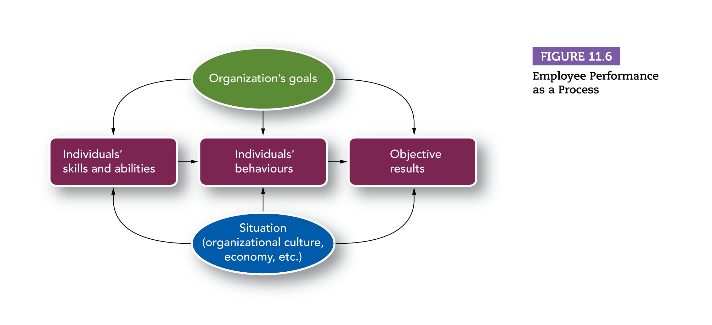
  - Compensation and rewards
  - Managing turnover
    - Involuntary turnover: turnover initiated by an employer (often with employees who would prefer to stay)
    - Voluntary turnover: turnover initiated by employees (often when the organization would prefer to keep them)
      - Organizations try to avoid the need for involuntary turnover and minimize voluntary turnover, especially among top performers
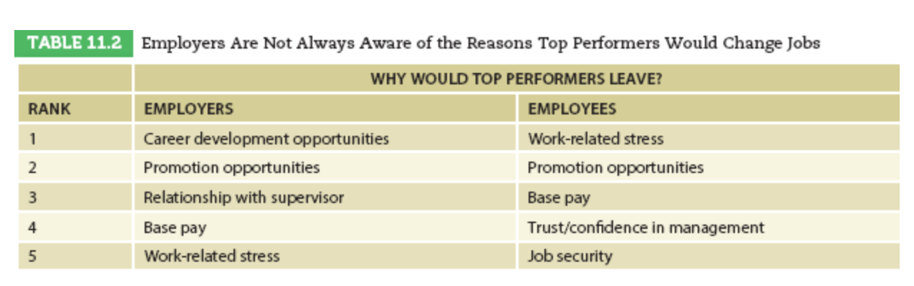
      - Discharging employees can be a very difficult but potential important way to maintain a high performance and engaging work culture
    - Outplacement counseling: a service in which professional try to help dismissed employees manage the transition from one job to another
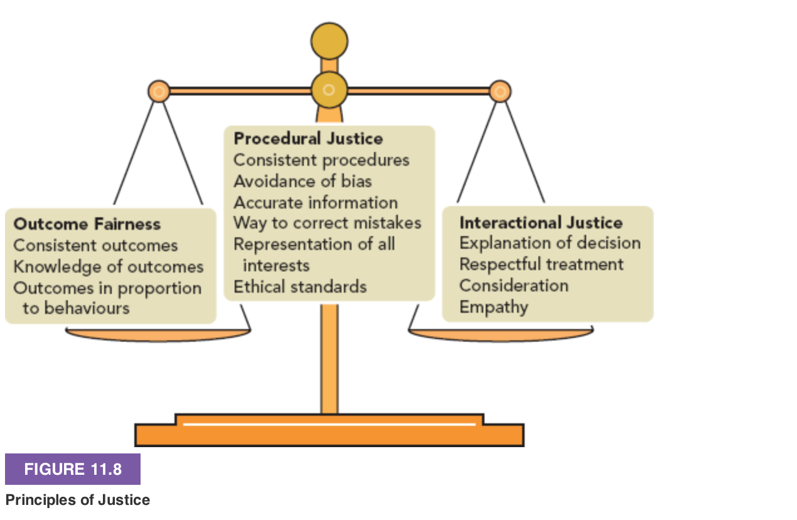

Sa
  - Appropriate discipline
    - Progressive discipline: a formal discipline process in which the consequences become more serious if the employee repeats the offence
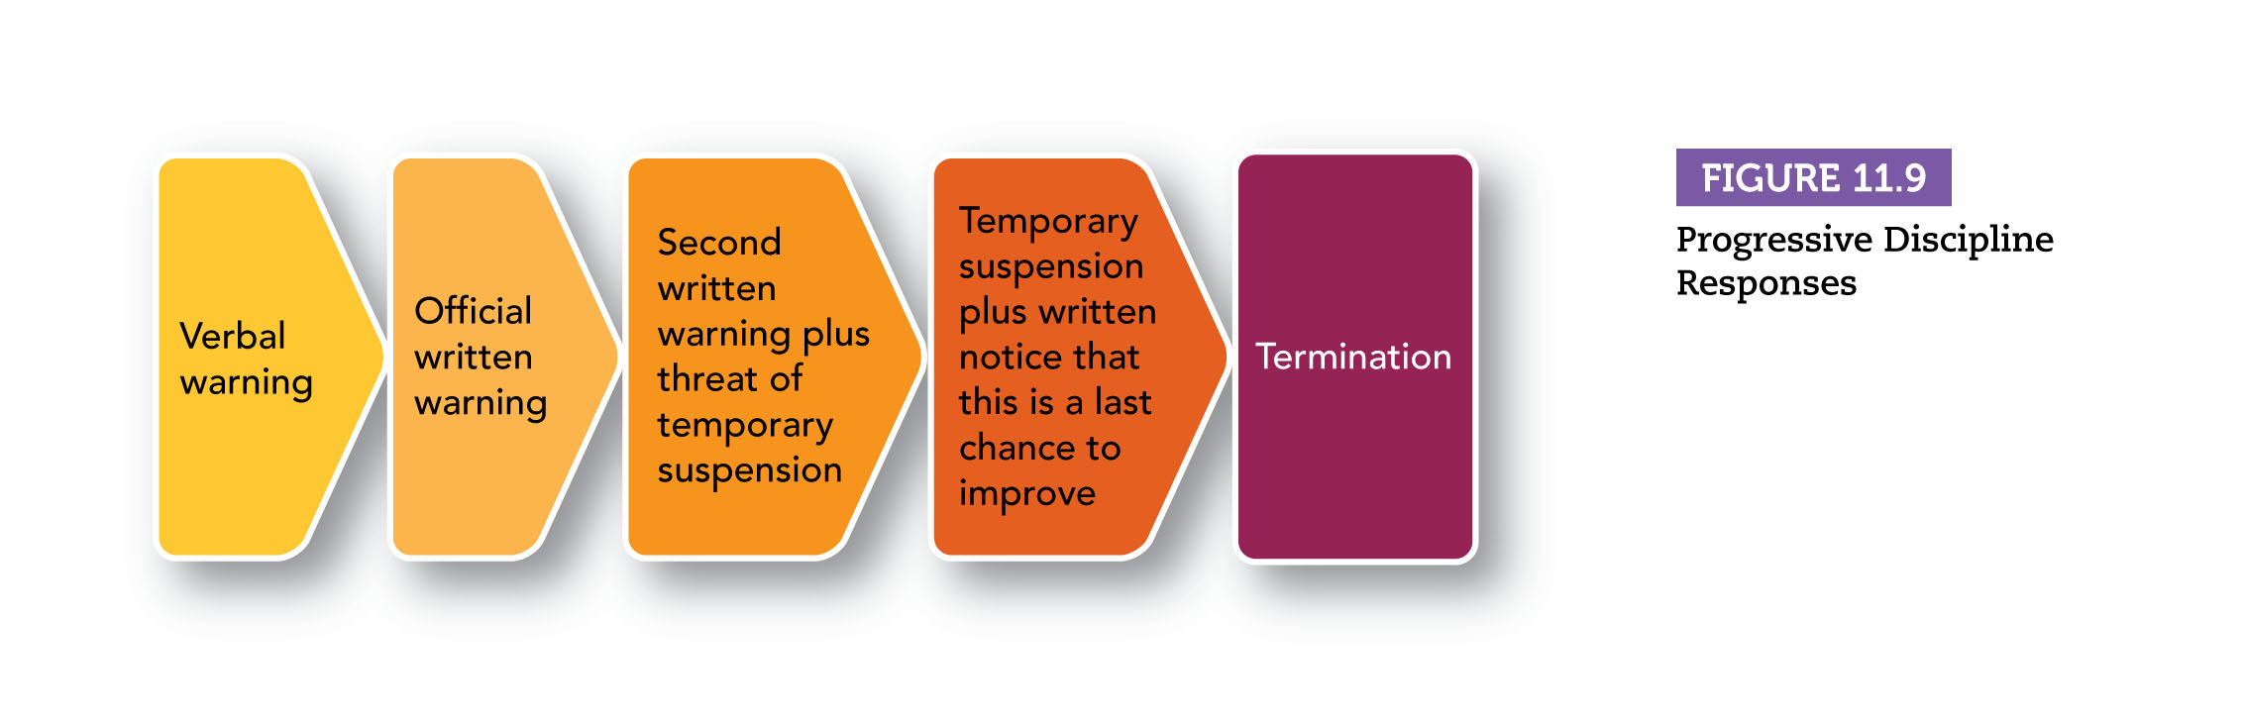

- Corporate social responsibility (CRS) is an evolving concept, integrating social, environment and economic concerns into an organizations values, culture, decision making, strategy, and operation sin a way that creates wealth and improves society.
- Canada is recognized as a leader in social responsibility
- Demonstrating corporate social responsibility such as sustainability, promoting volunteerism, providing meaningful work, and having high ethical standards are important factors to retain and engage employees.
- Mergers and acquisitions dominate the business landscape, but the risks are high
- Mergers and acquisitions reduce shareholder value
- Reasons for failure include:
  - Combining strategic weaknesses rather than strategic strengths
  - Top management conflict
  - Failure to win employee support
  - Loss of competitive position due to extended time to complete the deal
- HR departments can improve their own and their organizations performance by appropriately using new technology
- New technology usually involves automation using equipment and information processing to perform activities that had been performed by people
- Over the last few decades automation has improved HRM efficiency by reducing the number of people needed to perform routine tasks
- HRM applications include:
  - Transaction processing: refers to computations and calculations involved in reviewing and documenting HRM decisions and practices
  - Decision support systems: computer software systems designed to help managers solve problems
  - Expert systems: computer systems that incorporate the decisions rules used by people who are considered to have expertise in a certain area
  - Human resource information systems:
    - Relational databasesstore data in separate files that can be linked by common elements
    - Applicant tracking maintaining and retrieving records of job applicants
- Measuring the effectiveness of HRM
  - HRM Audit: a formal review of the outcomes of HRM functions. Based on identifying key HRM functions and measures of organizational performance
  - Analyzing the effect of HRM programs: the analysis can measure a program’s success in terms of whether it achieved its objectives and whether it delivered value in an economic sense
    - Were the objectives achieved?
    - Was economic value delivered: i.e. ROI?
    - Difficulty valuing an organizations human capital

