CHEM 112 Winter Study Guide

Physical and Chemical Equilibrium

Related Formulae
$$∆G_{rxn}^{°}=-RT ln⁡(K)$$
For the reaction as follows: $aA+bB↔gG+hH$, $K_{c}=\frac{{[G]}^{g}{[H]}^{h}}{{[A]}^{a }{[B]}^{b}}$
For the reaction in gas phase, $2 SO_{2}\left(g\right)+O_{2}(g) ↔2 SO_{3}(g)$, $K_{p}=\frac{{(P_{SO_{3}})}^{2}}{{\left(P_{SO_{2}}\right)}^{2}(P_{O_{2}})}$
$P_{x }=\left[X\right]RT$ and thus $K_{P}=K_{c}{(RT)}^{∆n}$

Definitions

$∆G_{rxn}^{°}$ is the change in Gibb’s free energy
R is the ideal gas law constant, 8.314 $\frac{J}{mol*°K}$
T is the temperature in Kelvins
[ ] is the concentration in mol/L
P is the partial pressure
K is the equilibrium constant
$∆n$ is the stoichiometric difference between products and reactants

Key Concepts

Equilibrium
A chemical equilibrium displays all of the following characteristics:
- The system is closed
- The system shows no macroscopic evidence of change
- Equilibrium is reached through a spontaneous reaction
- A dynamic balance of forward and reverse reactions exists
- When temperature is constant, the same equilibrium constant will be obtained, regardless of the direction from which it was approached
When K is large, almost 100% of limiting reagent is consumed and thus the reaction is considered to go to completion. Similarly, when K is very small, the reaction is considered not go at all.

Types of Equilibrium Systems
- Homogenous gas phase systems
- Heterogenous mixtures of solid/gas, solid/aqueous, aqueous/gas
- Reactions involving substances such as acid/base reactions or redox reactions

Relationship of ‘K’ to the Balanced Chemical Reaction
- Inverting the BCE causes inversion of K
- Multiplying by coefficients by a common factor raises K to that common factor
- Dividing coefficients by a common factor causes K to be taken to that factor’s root

Le Châtelier’s Principle
When an equilibrium system is subjected to a change in temperature, pressure or concentration of reacting species, the system responds by attaining a new equilibrium that partially offsets the impact of the change.
- Raising the temperature of the reaction causes the reaction to shift in direction of the endothermic reaction to consume the heat energy
- Lowering the temperature of the reaction causes the reaction to shift in the direction of the exothermic reaction to produce the lost energy

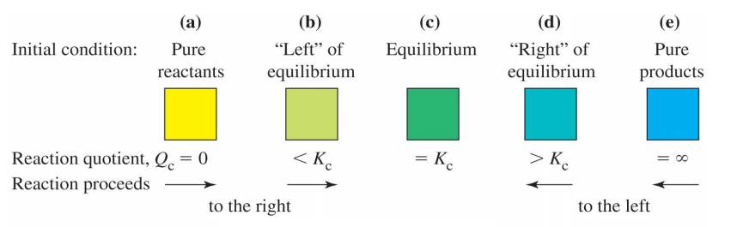

Example
Consider the system as follows:
$$H_{2}+I_{2}↔2 HI$$
A mixture contains 2.0 x ${10}^{-2}$ mol of HI, 1.0 x ${10}^{-2}$ mol of $H_{2}$, and 3.0 x ${10}^{-2}$ mol of $I_{2}$ in a 2.0L container at 721 K. The equilibrium constant is $K_{c}=50.5$ for this system at 712 K.
- Is this system at equilibrium?
$$Q_{c}=\frac{{[HI]}^{2}}{{[H_{2}]}^{ }{[I_{2}]}^{}}= \frac{{({2.0 x {10}^{-2} mol}/{2.0 L} )}^{2}}{({1.0 x {10}^{-2} mol}/{2.0 L})({3.0 x {10}^{-2} mol}/{2.0 L})}=1.33$$
Since $Q<K$, this system is not at equilibrium.

- If it is not at equilibrium, which way will the system shift to reach equilibrium?

Since $Q<K$, the system will shift to the right to reach equilibrium.

Electrochemistry

Related Formulae

$$Q=It$$
$$w_{elec}=-Q∆E$$
$$∆G_{}^{°}= -nF∆E$$
${E^{°}}_{cell}= \frac{RT}{zF}ln⁡(K)$, standard conditions
$E_{cell}={E^{°}}_{cell}-\frac{RT}{zF}ln⁡(Q)$, non-standard
$$E_{conc cell}= -\frac{RT}{zF}\left(ln\frac{\left[low\right]}{\left[high\right]}\right)$$

Definitions

Q is the charge in Coulombs
I is the current in Amperes ($1A=1C/s)$
$∆E$ is potential difference in volts (J/C)
$w_{elec}$ is the electrical work
$∆G_{}^{°}$ is the change in Gibb’s free energy
$F$ is Faraday’s constant, 96 485 C/mol of electrons
Q is the reaction quotient in Nernst eq’n
‘z’ is the # moles of electrons transferred in the redox reaction

Key Concepts
Electrochemistry links oxidation-reduction reactions to the production of electrical current. When a chemical loses an electron (LEO), it is oxidized and is termed the reducing agent. When a chemical gains an electron (GER), it is reduced and is termed the oxidizing agent. Disproportionation occurs in redox reactions, when a single substance is both the reducing agent and oxidizing agent.

Balancing Redox Reactions

Oxidation Number Method
- Eliminate spectator ions, $H^{+}$, ${OH}^{-}$and $H_{2}O$
- Identify elements which change oxidation numbers
- Determine increase in oxidation number in reducing agent and decrease in oxidation number in oxidizing agent.
- Equalize increase in oxidation number with decrease in oxidation number
- Balance charge by adding $H^{+}$
- Balance hydrogen by adding $H_{2}O$
- Replace spectator ions.

Half-Cell Method
- Eliminate spectator ions, $H^{+}$, ${OH}^{-}$and $H_{2}O$
- Divide skeleton equation into two half-cell equations, one for species that are oxidized and the products and one for species that are reduced and the products.
- Balance all other atoms other than hydrogen and oxygen in each half-cell reaction.
- Balance oxygen in each half-cell reaction by adding $H_{2}O$
- Balance hydrogen in each half-cell reaction by adding $H^{+}$
- Balance charge in each cell by adding electrons to whichever side requires additional negative charge.
- Balance electrons in each half-cell reaction so that the number of electrons consumed in one half-cell reaction is equivalent to the number of electrons produced in the other half-cell reaction.
- Add two half-cell reactions to eliminate electrons.
- Replace spectator ions and simplify.

The Galvanic Cell
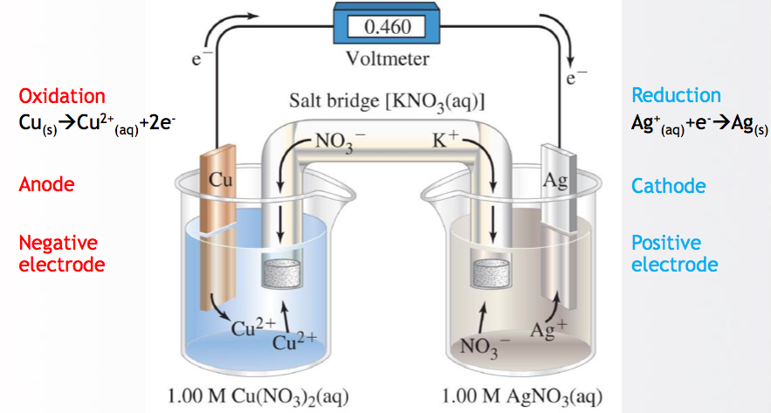
This can be represented schematically by ${Cu}_{(s)}\left| {{Cu}^{2+}}_{\left(aq\right)} \left(1.0 M\right)\right|\left| {{Ag}^{+}}_{\left(aq\right)}\left(1.0 M\right)\right| {Ag}_{(s)}$ where the double line represents the salt-bridge, that enables net flow of positive ions through it in the right-hand beaker, and of negative ions into the left-hand beaker to preserve charge neutrality in each solution.

If the electrochemical reaction occurs spontaneously, it is a galvanic cell. If the reaction operates opposite to spontaneous direction, it is an electrolytic cell capable of recharging.

Standard Cell Potentials
The standard cell potential measures the tendency for reduction to occur at an electrode. To determine cell potential for an electrochemical cell:
- Find two half-cell reaction making up a redox reaction and find E value for half reactions from table of standard reduction potentials.
- Reverse cell reaction with lower reduction potential. This will be the oxidation half-reaction.
- Balance electrons in two half-cell reactions. (note: E values will remain unchanged)
- Find sum of two half reactions and $ΔE$ value for the cell.
- For a redox reaction to be spontaneous, ${ΔE}_{cell}$ must be positive.
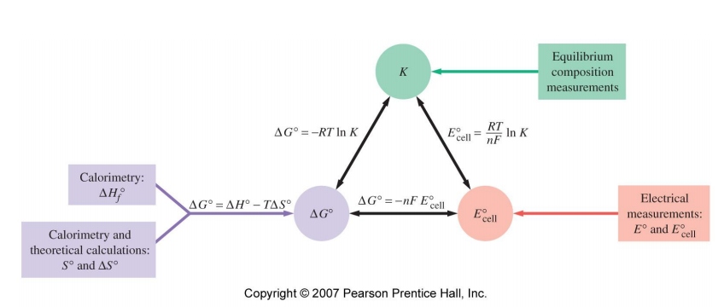

Acids and Bases

Related Formulae
For the reaction $CH_{3}CO_{2}H+H_{2}O↔C{H_{3}CO_{2}}^{-}+{H_{3}O}^{+}$, $K_{a}=\frac{\left[C{H_{3}CO_{2}}^{-}\right][{H_{3}O}^{+}]}{[CH_{3}CO_{2}H]}$

$$K_{w}={(K}_{a})(K_{b})$$
$$pH=-log⁡[H_{3}O^{+}]$$
pH + pOH = 14
$$\% ionization=\frac{\left[H_{3}O^{+}\right] from HA}{\left[HA\right]orginally}$$

$$pH=pK_{a}+log\frac{[A^{-}]}{[HA]}$$

Defintions
$K_{w}$: ion product of water, 1.0 x ${10}^{-14}$
$K_{a}$: acid ionization constant
$K_{b}$: base ionization constant

Key Concepts

Arrhenius suggested that an acid is a substance that when dissolved in water increases hydrogen ion concentration. A base by this definition would increase hydroxide concentration when dissolved in water. Bronsted-Lowry proposed that acids are proton (hydrogen ion) donors and bases are proton (hydrogen ion) acceptors. Acids are bases by this definition exist as conjugate pairs that differ only in one hydrogen atom.
- Strong acids: HCl, HBr, HI, $H_{2}SO_{4}$, $HNO_{3}$, $HClO_{3}$, $HClO_{4}$
  - Conjugates of these compounds are weak bases and will not dissociate fully in water, but rather to the point of equilibrium determined by the base ionization constant
- Strong bases: NaOH, KOH, RbOH, CsOH, $Ca({OH)}_{2}$,$Sr({OH)}_{2}$, $Ba({OH)}_{2}$
  - Conjugates of these compounds are weak acids and will not dissociate fully in water, but rather to the point of equilibrium determined by the acid ionization constant

Hydrolysis
- Salts of strong acids and strong bases do not hydrolyze
- Salts of weak acids and strong bases hydrolyze in basic conditions
- Salts of weak bases and strong acids hydrolyze in acidic solutions
- Salts of weak bases and weak acids hydrolyze
  - Cations are acidic, anions are basic, solution acidity/basicity depends on relative values of Ka and Kb

Common Ion Effect
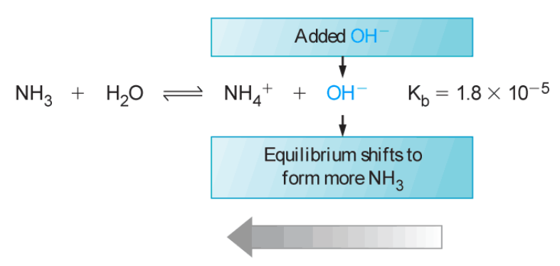
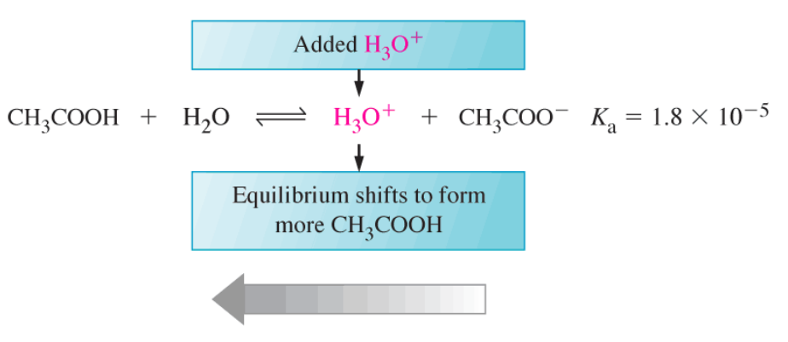

Buffer Solutions
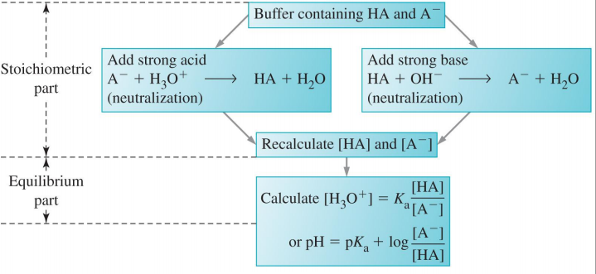

A buffer solution is any solution that resists changes in pH even with small additions in acid or base. A buffer solution is made by adding weak acid to a salt containing its conjugate base or by adding a weak base to a salt containing its conjugate base. Optimal buffers have the concentrations of the weak acid and conjugate base (or vice versa) as equal as possible and contain an acid with a $pK_{a}$ value close to the desired pH.

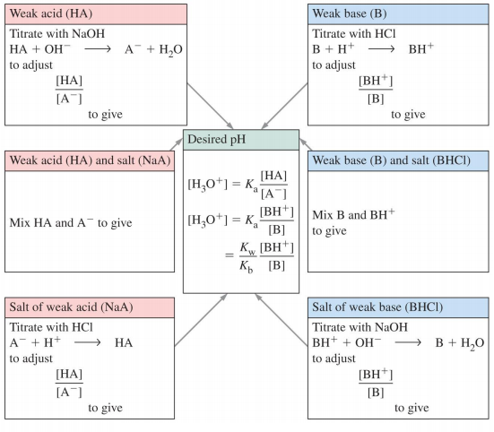

Titration
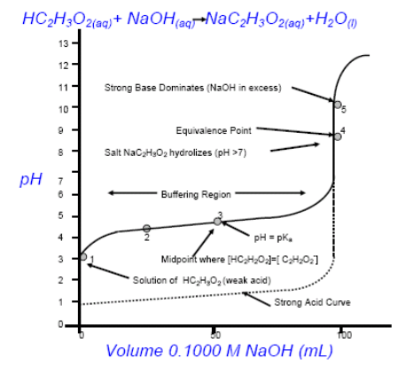
Endpoint occurs when the acid-base indicator changes colour indicating that the stoichiometric amount of first reactant has been added to the second reactant. The equivalence point is the point at which the concentration of titrant is stoichiometrically equivalent to that of the unknown solution. At the equivalence point, the pH is not necessarily 7, as the salt of produced can be acidic or basic.

In this titration curve, a weak acid is being titrated with a strong base. At each point, the pH can be calculated using the Henderson Hasselbach equation with the knowledge of what concentrations are present.

Solution Equilibrium

Related Formulae
For the reaction, $AgI_{(s)}↔{{Ag}^{+}}_{(aq)}+{I^{-}}_{(aq)}$, $K_{sp}=\left[{Ag}^{+}\right]\left[I^{-}\right]$ Note: the AgI is not included in the equilibrium expression, as it is in solid phase.

Definitions
$K_{sp}$ is the solubility product

Key Concepts
As with previous equilibrium concepts, precipitation will depend on the reaction quotient, Q, in relation to the solubility product constant, $K_{sp}$.

Ion | Solubility | Exceptions
$$N{O_{3}}^{-}$$ | Soluble | None
$$Cl{O_{4}}^{-}$$ | Soluble | None
$${Cl}^{-}$$ | Soluble | ${Ag}^{+}$, ${Pb}^{2+}$, ${{Hg}_{2}}^{2+}$
$$I^{-}$$ | Soluble | ${Ag}^{+}$, ${Pb}^{2+}$, ${{Hg}_{2}}^{2+}$
$$S{O_{4}}^{2-}$$ | Insoluble | ${Ca}^{2+}$, ${Ba}^{2+}$, ${Hg}^{2+}$, ${Sr}^{2+}$, ${Ag}^{+}$
$$C{O_{3}}^{2-}$$ | Insoluble | Group IA, ${NH_{4}}^{+}$
$$P{O_{4}}^{3-}$$ | Insoluble | Group IA, ${NH_{4}}^{+}$
$${OH}^{-}$$ | Insoluble | Group IA, ${Ca}^{2+}$, ${Ba}^{2+}$, ${Sr}^{2+}$
$${Na}^{+}$$ | Soluble | None
$${NH_{4}}^{+}$$ | Soluble | None
$$K^{+}$$ | Soluble | None

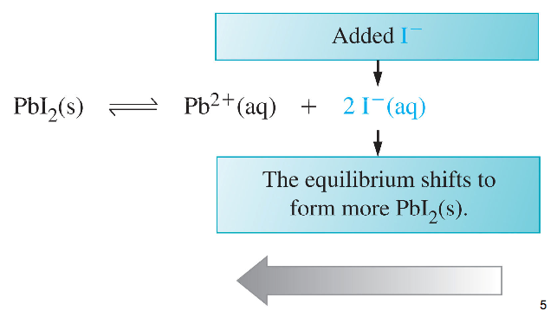
Common Ion Effect

The common ion effect in solutions causes the equilibrium to shift in the direction of the consumption of the added substance.

Complex Ions
A complex ion is a polyatomic cation or anion composed of a central metal ion and one or more ligands. Coordination compounds are substances that contain complex ions. The formation of complex ion depends on the formation constant, $K_{f}$.

Kinetics, Mechanisms and Catalysts

Related Formulae
For the reaction, $aA+bB→gG+hH$, $rate=k{[A]}^{m}{[B]}^{n}$
Overall order of reaction = m + n

$$k=Ae^{{-E_{a}}/{RT}}$$
$$ln\left(\frac{k_{2}}{k_{1}}\right)=\frac{-E_{a}}{R}\left(\frac{1}{T_{2}}-\frac{1}{T_{1}}\right)$$

Definitions
k is the rate constant, specific to each reaction
$E_{a}$ is the activation energy
A is the pre-exponential factor

Key Concepts

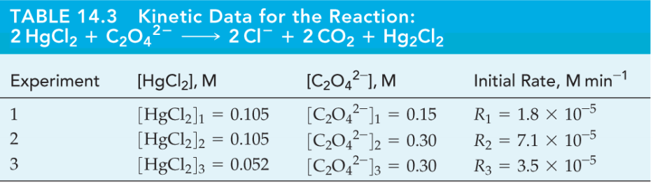
Using table data above, find the exponents ‘m’ and ‘n’ by using two rates where other species’ concentration is held constant.
- Doubling the initial concentration of a particular reactant will have no effect on the initial rate if the reactant is zero order
  - $R_{rxn}=k$
  - ${[A]}_{t}=-kt+{[A]}_{0}$
- Doubling the initial concentration of a particular reactant will double the initial rate if the reactant is first order
  - $R_{rxn}=k[A]$
  - $ln{[A]}_{t}=-kt+ln{[A]}_{0}$
- Doubling the initial concentration of a particular reactant will quadruple the initial rate if the reactant is second order
  - $R_{rxn}=k{[A]}^{2}$
  - $\frac{1}{{[A]}_{t}}=kt+\frac{1}{{[A]}_{0}}$

Collision Theory
Kinetic-Molecular theory can be used to calculate the collision frequency. If each collision produced a reaction, the rate would be much higher than is found in experimental settings. Orientation of a molecule in a collision and the energy of the molecules in the collision also determine the rate of reaction.

Pseduo Rates
$$R_{rxn}=k{[A]}^{n}{[B]}^{m}{[C]}^{p}$$
- [B] and [C] are very large and remain relatively constant throughout the reaction
- $R_{rxn}=k{[A]}^{n}{[{B]}_{0}}^{m}{{[C]}_{0}}^{p}$
- $pseudo rate=k^{*}{[A]}^{n}$
  - experimentally determine n and k* , which can be used to calculate m and p because ${[B]}_{0}$ and ${[C]}_{0}$ are known

Activation Energy and Transition States

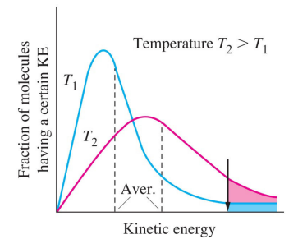
For a reaction to occur, there must be a sufficient amount of energy to break bonds in the reacting molecules. Activation energy is the minimum amount of energy above the kinetic energy that molecules must bring to their collisions for a reaction to occur. As temperature increases, the fraction of molecules colliding with energy greater than activation energy greatly increases, thus so does reaction rate.

Elementary Processes

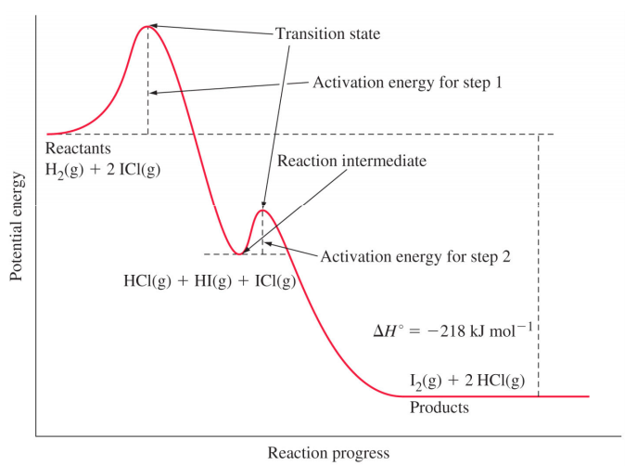
Reaction mechanisms are step-by-step descriptions of the reaction where each step is an elementary process. An elementary process refers to any molecular event that significantly alters a molecule’s energy or geometry or produces a new molecule. The reaction mechanism must be consistent with the stoichiometry of the overall reaction and the experimentally determined rate law. Elementary processes are reversible and intermediates produced in one elementary process are consumed in another. One step is usually slower than all the others and is known as the rate-determining step. In this figure, the rate-determining step is the first step, as it has the greatest activation energy barrier.

Catalysts & Enzymes
Catalysts are substances that increase the rate of reaction by decreasing the activation energy barrier and are not consumed in the reaction process.
- Homogenous catalyst: compound in (same) gas phase or liquid phase
- Heterogeneous catalyst: compound in separate phase from reaction (usually solid)

Organic Chemistry: Structures and Reactions

Organic Structures
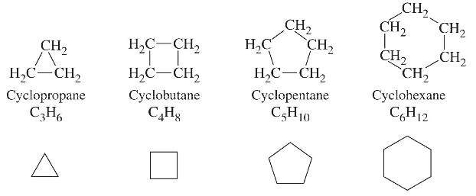
Carbon structures can be classified by the order of the bonds in the structure. Alkanes contain only single bonds and are completely saturated with hydrogen (or other substituents), alkenes contain one or more double bonds, and alkynes contain one or more triple bonds. Cycloalkanes are a form of alkane that are contained in a ring.

The extra energy that must be inputted in order to achieve cyclic configurations is termed ring strain and is calculated by the difference between experimental and estimated change in enthalpy of combustion. In cyclohexane, the ring strain is zero.

Isomers: Same chemical formula, different structures and properties
- Constitutional isomers: The same chemical formulas, but different connectivity
- Stereoisomers: Same chemical formula, same connectivity, different spatial arrangements of substituents
  - Enantiomers: non-superimposable mirror images
  - Diastereomers: stereoisomers that are not enantiomers (includes geometric ‘cis/Z or trans/E’ isomers)

Conformations and their Potential Energy
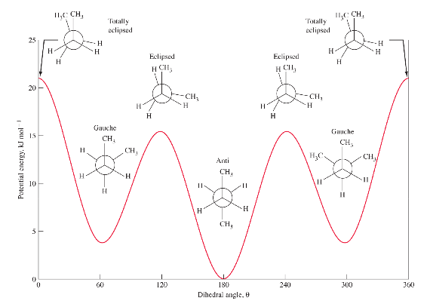

Steric hindrance refers to the higher energy price due to the approach of larger atoms or groups compared to a similar reaction involving smaller atoms or groups.

Naming Enantiomers
- Highest priority group has the highest atomic number directly bonded to the chiral carbon
  - If the first atoms is the same, move to the next atom in the group.
  - Double/triple bonds are considered multiple single bonds.
- Orient molecule with lowest priority in the back.
- Determine if highest-to-lowest ranking goes clockwise (R) or counter-clockwise (S).

Functional Groups and Nomenclature
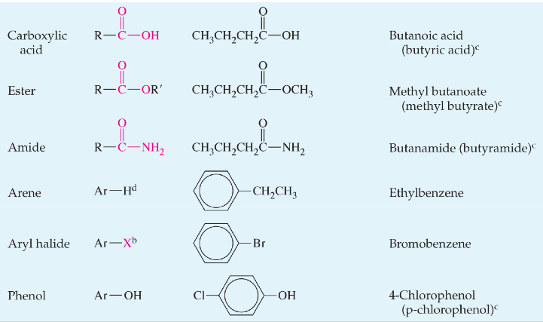
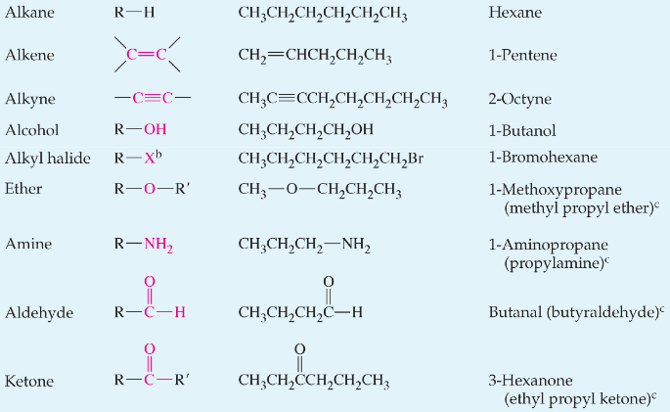

Organic Reactions

Substitution Reactions
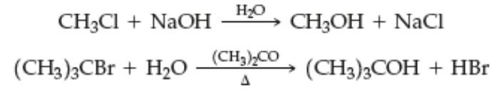
A portion of a molecule is replaced by something else. There are usually two reactants and two products (or more). Text above the arrow considers the conditions of the reaction. $∆$ represents heat being added to the reaction for it to proceed.

Addition Reactions
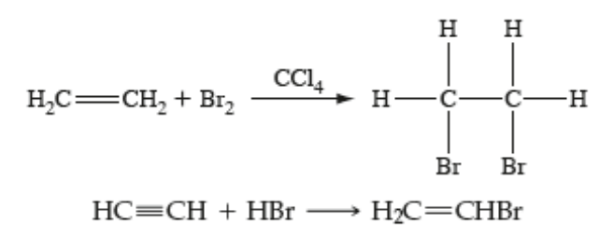
A reactant molecule is added to another molecule, usually two reactants and one product. The addition usually occurs at a multiple bond. In this case, the double bond becomes a single bond or the triple bond becomes a single bond. In this first reaction pictured, we say bromine has been added across the double bond.

Elimination Reaction
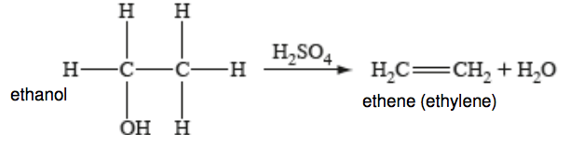
In elimination reactions, a molecule is produced from another molecule. Usually, one reactant forms two products and is sometimes the reverse of an addition reaction. In this case, a single bond becomes a double bond or a double bond becomes a triple bond.

Rearrangement (isomerization) Reaction
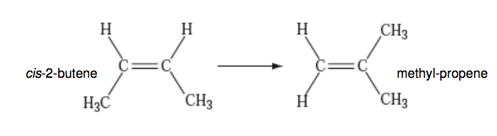
A molecule is changed to another molecule that is an isomer. There is usually one reactant and one product. The reactant could change between constitutional isomers, geometric isomers, stereoisomers etc.

Nucleophilic Substitution Reactions
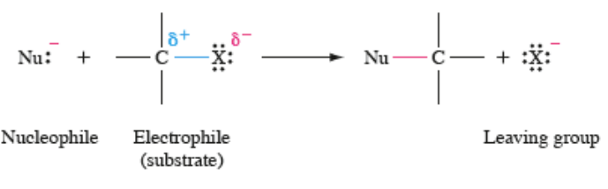
The reactants contain nucleophile reactant and molecules with leaving groups. Nucleophiles usually have lone pairs and may be negative or neutral. Most nucleophiles are also bases, can have competing behaviour. Reactions are often not in water, and thus the behaviour is different than would be in water. The electrophile will be a carbon with an electronegativity difference to a bonded group creating a polar bond. The leaving group will have a negative charge in the products and is slightly negative in the reactants.

SN1 Reaction
SN1 reactions also involve nucleophiles, but are usually weaker or the electrophilic carbon is sterically hindered. The reaction thus needs a reactant with ‘better’ leaving group than the product. This mechanism is a two-step process in which the leaving group is lost first and the nucleophile attacks. The rate law is first order and does not depend on the concentration of the nucleophile.

SN2 Reaction
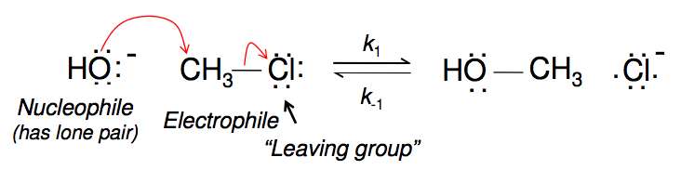
In an SN2 reaction, the kinetics are second order (and thus the 2). This reaction happens in a single step, as determined by kinetic analysis. Note that both the forward and reverse reactions are possible. In this reaction however, the equilibrium lies to the right.

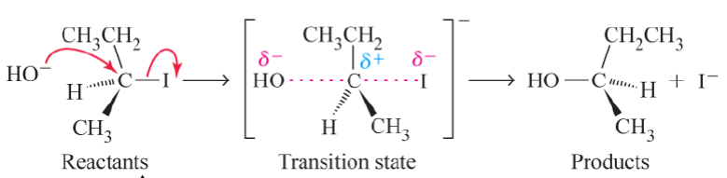
SN2 reactions will affect chiral sites by inverting orientation of groups. The highest priority group will be replaced by the nucleophile to create the products. Proving that the mechanism is SN2 can be done either via kinetics or with enantiomer analysis.
Nature of Substrate |  | Nature of reagent | Mechanism
Primary alkyl halide | Sterically hindered strong base | E2
Primary alkyl halide | Sterically unhindered base | SN2
Secondary alkyl halide | Strong base | E2
Secondary alkyl halide | Weak base and aprotic solvent | SN2
Tertiary alkyl halide | Strong base | E2
Tertiary alkyl halide | Weak base and aprotic solvent | SN2/E1

Some Polar Aprotic Solvents
Protic solvents stabilize anions and cations, can reduce strength of h-binding nucleophiles, and favour the intermediate in SN1
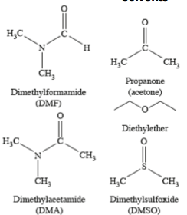
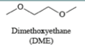
Aprotic solvents do not stabilize ions, nucleophiles are not affected and SN2 mechanisms are favoured

Functional Group Transformations
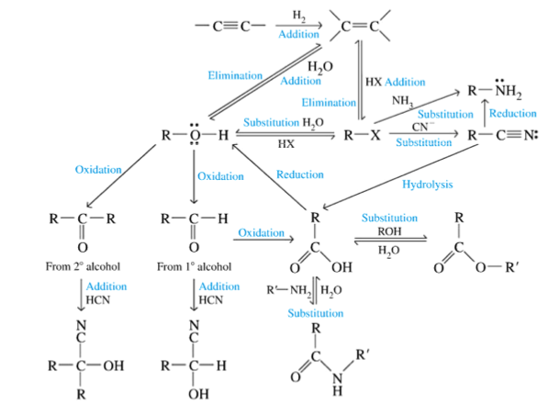

Electrophilic Aromatic Substitution
When a benzene ring is a substituent it is called a ‘phenyl’. Alternating single/double bonds results in conjugation: electrons in pi orbitals can transfer from one to another. In benzene, there is mixing of p-orbitals into one continuous ‘delocalized’ p-orbital where the electrons are shared around the whole ring. Each C-C bond looks like 1.5 bond strength, which gives the molecule a special stability from being ‘aromatic’.
- Ortho: substituents of benzene are in 1,2 positions
- Meta: substituents of benzene are in 1,3 positions
- Para: substituents of benzene are in 1,4 positions

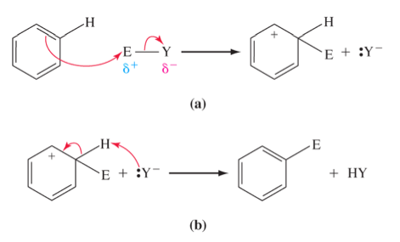
Benzene Reaction Mechanisms
Because of aromatic stability, benzene does not undergo standard addition reactions across double bond. Instead, benzene reacts by electrophilic substitution.
- Double bond electrons form new bond with electrophile.
  - Aromaticity is momentarily lost.
- Leaving group behaves as a base and abstracts a proton off the carbon where the new bond is.
- Electrons from the C-H bond re-form the double bond.
  - Aromaticity is restored
  - All carbons back to neutral
In multiple substitutions, we can expect ortho, meta, para patterns.

