CHAPTER 11
ENZYME KINETICS
- What is kinetics: Kinetic is the rates (change overtime) at which a chemical reaction occurs.
- In an irreversible reaction the rate of equation is related by a constant k (rate constant) to the concentration of the reagents elevated to the exponent that reflects their contributions to the reaction. (Please note that in real life that is a very gross overrepresentation and more often than not, reactions that would be more than 2nd orders are not following this rule and can even have non-integer exponents in the rate equation).
- Therefore, the only solution is often to perform experiments and determine these exponents
- The order of the reaction is defined as the sum of the exponents in the rate equation
- Please note that the rate constant changes depending on the reaction. As well, the units of the rate constant are different depending on the order.
- 1st order -> k has units of s -1
- 2nd order -> k has units of M -1 s-1
- 3rd order -> k has units of M-2 s-1

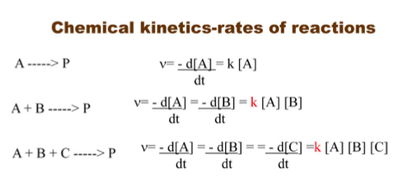
FIRST-ORDER REACTIONS
- For unimolecular reactions where S -> P, the rate (or velocity) of the reaction V – representing the amount of S that reacts per time unit – is expressed by a rate equation
  - V = K[S]
- This is a FIRST-ORDER reaction because the rate depends only on the concentration of S. The factor k is a first-order rate constant and has units of reciprocal time (s-1).
- AP
- Rate = k[A]
- The half-life for a first order equation is equal to 0.693/k, because t1/2= 0.693/k
Please note that ln [A] versus time is linear in a first order reaction
- However, 1/[A] vs time is not linear, but an exponential.
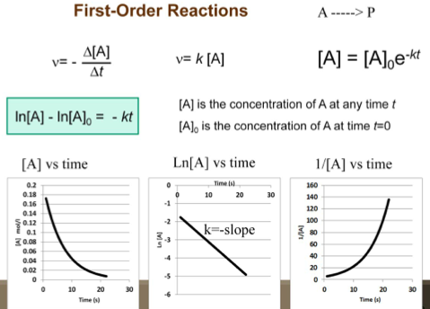

- Note that the halftime in a first order reaction only depends on k, where you need k to determine t⁻_{1/2} .
- Graph ln[S] vs. time (mins) and determine slope equation and k=-slope(m)
- Substitute [S] for [S]₀/2 (substrate half life) in equation ln[S]=ln[S]₀-kt
- Ln([S]₀/2)/[S]₀ = -kt_{1/2}
- Finally, t_{1/2} = ln2/k(-slope)

SECOND-ORDER REACTIONS
- If the reaction rate depends on the concentration of two different substrates, then the reaction is second order and K is a second-order rate constant with units of M-1s-1,
  - V = K[S1][S2]
  - V = k[A]²
- The relationship between the rate constant (K) and the activation energy Delta G is inverse and exponential. Thus, a lower activation energy (Delta G) means a faster reaction rate.
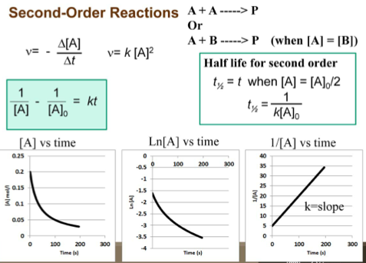
- [A] is the concentration of A at any time t
- [A]0 is the concentration of A at time t=0
- Please note that ln [A] versus time is not linear in a second order reaction. However, 1/[A] versus time is linear
- Also note that the reaction between two different molecules (A+B) only follows this set of equation when the [A] is equal to [B] or the difference is not significant (<1%).
- k=slope using 1/[A] vs. time graph – from experimental data
Transition State Theory
- Ea represents the energy of activation. The higher the energy of activation is the slower the reaction, and conversely the lower the Ea is the faster the reaction.
- Uncatalyzed reaction = larger Ea – slower reaction
- Catalyzed reaction = lower Ea – faster reaction

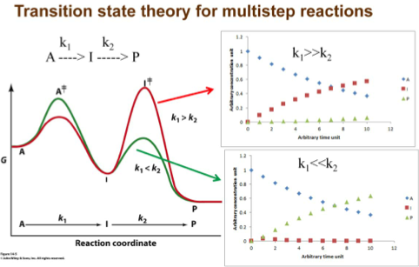
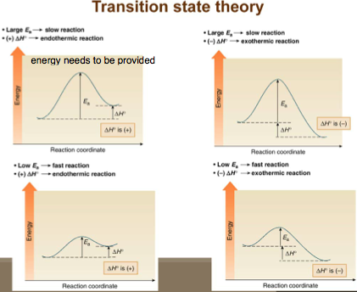

Michaelis-Menten Equation
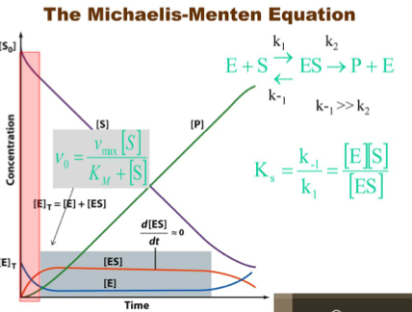
- Here a small k means rate constants where large K means dissociation constant
- Michaelis and Menten postulated:
- Enzyme first combines reversibly with its substrate to form an ES complex in a relatively fast reversible step
- The ES complex then breaks down in a slower second step to yield free enzyme and the reaction product P
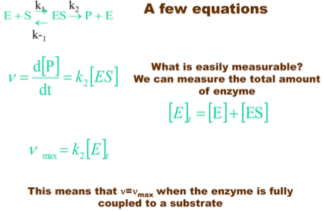
- Bc the slower second reaction must limit the rate of the overall reaction; the overall rate must be proportional to the concentration of the species that reacts in the second step (ie. ES)

Total amount of enzyme is measurable!
- Where v represents the velocity (ie. Rate) of the reaction
- Proportional to the change in concentration of the product overtime which is also proportional to the concentration of [ES]
- k₂ is a determinant factor
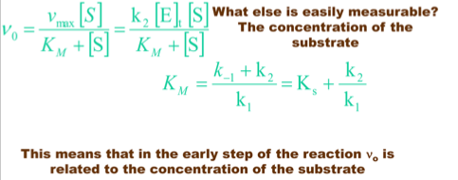
Concentration of substrate is measurable!
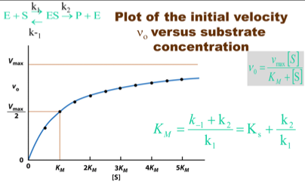
- Vmax is the maximum rate of production of P under these specific conditions
- Although the curve on graph does not reach Vmax, if you were to draw a curve of best fit, you would notice that further down [S] would reach the Vmax
- At y = Vmax/2, the x coordinate corresponds to Km (equilibrium constant)
To measure the initial velocity V₀:
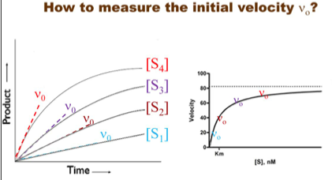
- Need to first measure the concentration of the product over time for different concentration of substrates
- V₀(change in product P over time) is measured at early time points in the reaction, prior to the [S] decreasing significantly
- V₀ is measured immediately after mixing E + S at the beginning of the rxn and is measured experimentally
- Once you measure V₀, you can make a plot of different V_{0’s} vs. the concentration of substrates
- From this graph you can deduce the Vmax as well as the Km (a concentration of substrate corresponding to a velocity that is half of Vmax)
- If Km is small then V₀=Vmax
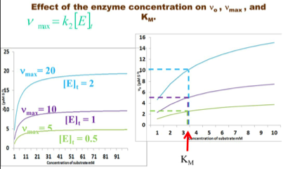
- Increasing [E] has a direct effect on Vmax because Vmax= k2 [E]t .
- And V₀ and (Vmax/2) will also be affected
- It will have no effect whatsoever on Km
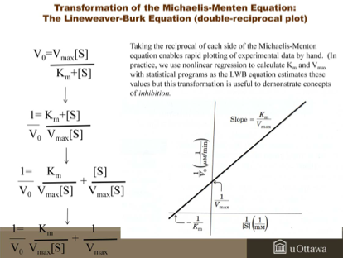
- To determine Km and Vmax for enzyme using lineweave-burk equation
- Step 1: Calculate 1/[S] and 1/V₀
- Step 2: Graph LWB plot where X= 1/[S] and y=1/V₀
- Step 3: Calculate Km by using the x-intercept = -1/Km
- Step 4: Calculate Vmax using y-intercept = 1/Vmax
INHIBITORS AND INHIBITION
- A substance can alter the activity of an enzyme by combing with it in a way that influences the binding of substrate and/or its turnover number.

Competitive Inhibition
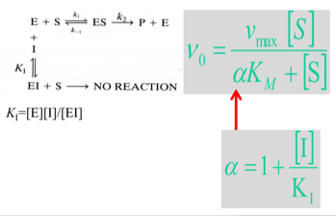
- alphaKm = Apparent Km
- When alpha = 1, inhibitor doesn’t work
- Large Km means it has a bad enzyme affinity to substrate
- Fast on-rate/slow off-rate
- Substance that competes directly with a substrate for an enzymatic binding site
- Usually resemble the substrate and thus binds to active site of enzyme but are themselves unreactive – therefore bind but are not acted upon by the enzyme
- Reducing the concentration of free enzymes available for binding to a substrate
- Can reversibly bind to the same site as the substrate so its inhibition can be entirely overcome by using a very high concentration of substrate
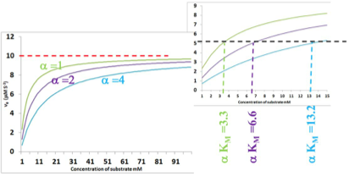
- Alpha = 1, no inhibition
- Alpha = 2/4, shifting curve down, slows the concentration to reach Vmax
- Km changes when inhibiters are introduced

- The Vmax does not change but the observed Km increases (now really the alphaKm)
- When you plot a LWB plot, the y-int(1/Vmax) stays the same but the x-int changes such that the apparent Km increases and you know you are working with a competitive inhibitor
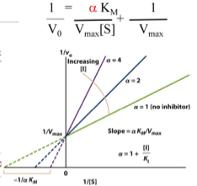
Slope increases when alpha increases
Alpha is modulating the slope
Y-intercept are the same
X-intercepts are different
Larger slope = better inhibition

Uncompetitive Inhibition
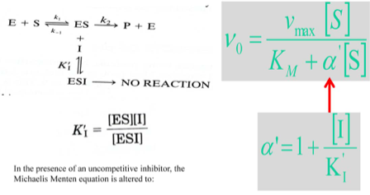
- Binds at a site distinct from the substrate’s active site and, unlinke the competitive inhibitor, binds ONLY to the ES complex
- Effects of an uncompetitive inhibitor cannot be overcome by increasing substrate concentration
- Uncompetitive inhibitors lowers both the Vmax and the Km (Bc the [S] required to reach one-half of the Vmax decreases by the factor of alpha’)
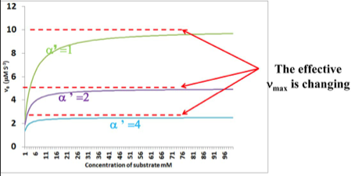
- When alpha’ = 1, no effect is seen and apparent Vmax changes when alpha’ increases
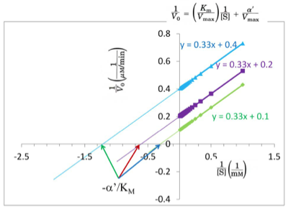
- In a LWB plot it reduces both Vmax and Km of substrate
- Appears as a series of parallel lines in LWB plot (slopes are the same but different x and y intercepts)

Mixed Inhibition
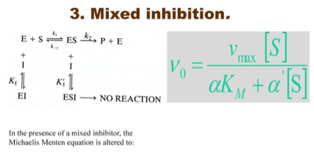
- Binds to a site distinct from the substrate’s active site but can bind to either E or the ES complex
- Usually affects both the Vmax and the Km
- Special case of mixed inhibition known as NONCOMPETITIVE INHIBITION where alpha=alpha’ and here, Vmax decreases but Km stays the same
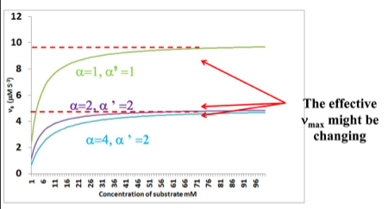
  - Same x-intercept as the enzyme but will have a different slope and y-intercept in LWB plot

Effective Vmax will be changing from the experiment done with no inhibitors to the experiments done with inhibitors. However it might not be changing between inhibitors.

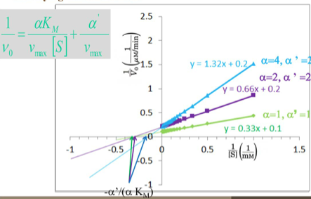
- Inhibitor curve intersects the substrate alone
curve on -1/[S] axis
- Usually both Vmax and Km will be reduced
- If vmax is reduced but Km does not change, this
is a noncompetitive inhibition (alpha=alpha’)
- Slopes will be different w/ no inhibitors
- Slopes of inhibitor might or might not be diff.
from each other depending if they have the same
alpha factor or not
- y-intercepts are different
- x intercepts are different except when x has an
identical alpha/alpha’ ratio

