Topic 7: Antibiotics

- 1900
  - 44 years
  - Main causes of death
  - Pneumonia
  - Tuberculosis
  - Influenza
- (this lasted until 1950’s)

- 2004
  - 82 years
  - Main causes of death
  - Heart disease
  - Cancer
  - Stroke
  - Lower respiratory infection
  - Traffic accidents

- Data for Canada
- life expectancy has doubled in last 100 years
- changes also in quality of life
- causes of death have shifted from infectious disease to “wear and tear”
- historically people lived entire lives in an unhealthy state
- constantly sick (parasites)
- this condition still exists in many developing countries

Plagues were common throughout history
- *1/4 of the population would die
- Life expectancy about 35 years
- *antibiotics only been around for 60 yrs, changed the world, increased life expectancy, changed people attitude (eg. Infections not a big deal these days)

Cures and treatments failed
- *because they had no clue what they were dealing with
- *special masks with flowers that smelled good > thought that small would protect you from disease

Cause of disease was unknown

Post natal infections – 30 % death rate
*women died at childbirth

Maternal mortality rates
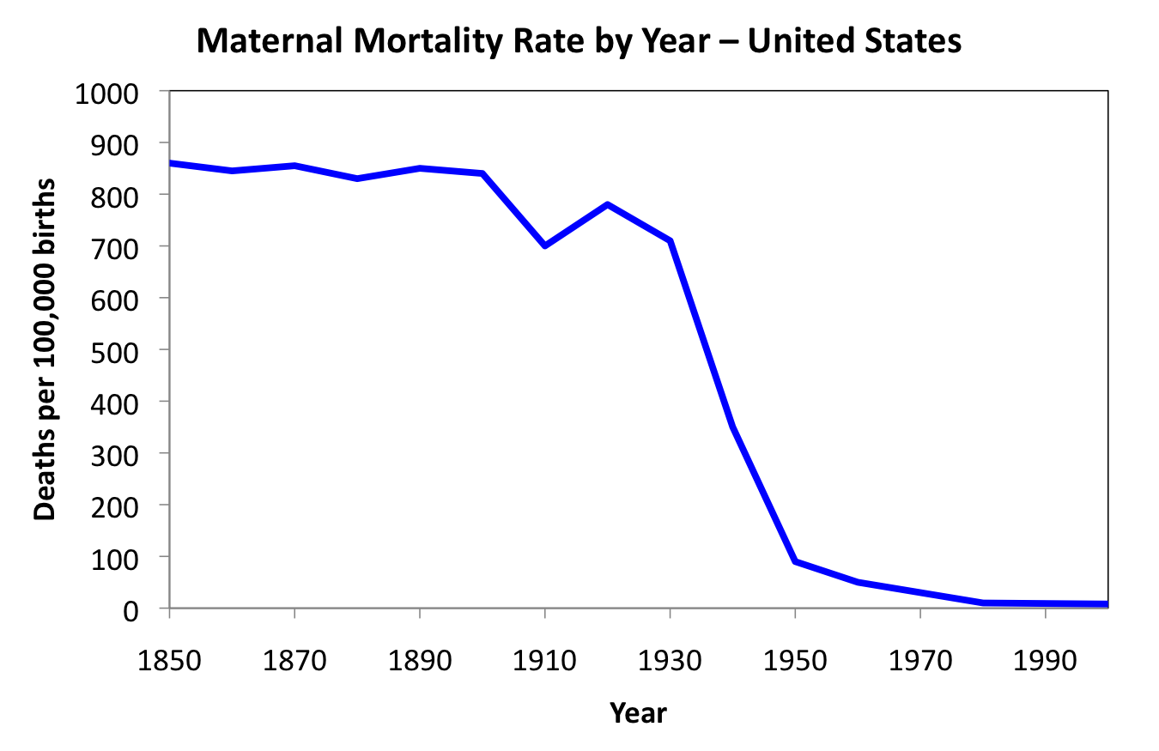
- *800 deaths per 100000 births.. Dramatic impact from the development of penicillin

Surgery survival rate less than 30 %

WWI and WWII – more deaths due to infection than combat
- *It was STIs that killed more soldiers than anything else - #1 fatal disease that you would get in WWII more than cholera and plague
- This idea of miasma (disease that were caused by bad smells) was ? – snow decided to use sci investigation to see cause of the outbreak – created a map of the number of cases – the lines represented a case of cholera – they were all centered along a water pump – reasoned that it was the water from the pump that was the source of the disease, not bad smells
- Removed handle from the pump the cholera outbreak went away
- Created science of epidemiology

John Snow disproved miasma theory 1854

Map of cholera infections identified the source

Collect statistics about disease = use it to figure out what causes it

Water pump is a historical landmark
- Water pump was the cause of the disease,
- Pump removed, disease outbreak gone away

Agostino Bassi showed microbes cause disease
- *microbes were root cause of diseases
- Experimented with silk worms
Atharva-Veda identifies living animals causing disease
*can use substances from plants to kill these animals and cure disease

Louis Pasteur develops pasteurization 1864:
- Bacteria and microscopic organisms can cause disease
- Investigated Food spoilage and disease, found that bacteria eating the food was causing the problem = causes disease in you if eaten bacteria
- *Pasteurization = kills bacteria

Lister develops antisepsis
*took Pasteur's idea that microscopic organisms can cause disease

H. C. Gram stains bacteria in 1884
- *animals are too microscopic/too small
- Have to use chemical that can poison these things and not poison the patient, dying the bacteria, gram stain = some bacteria can be colored blue and certain bacteria didn’t like to be covered (blue dye didn’t stick)
- *Gram positive = easily dyed (blue)
- *Gram negative = cant be dyed (red)
- *chemical difference in two kinds of bacteria

Paul Erlich and the magic bullet 1907
*can easily shoot the chemical
- Thought Chemical would leave body alone and target the animal inside it = caused disease

Trypan red selectively colors trypanosomes
- Trypanosomes = cause sleeping sickness , can be colored purple using this dye

Erlich knew As was similar to N but more poisonous
- *tried to find toxic variant
- He wanted to engineer a more poisonous form of the dye
- Interested in the linkage (2 N atoms)
- *columns have similar chem properties in periodic table
- *he realized that using this knowledge he could displace N atoms with any of the atoms in the same column,
- *selected arsenic (great poison) = made poisonous form of this compound became known as salvarsan 606

Salvarsan 606
*first ever antibiotic
- Affective against syphilis (great pox)

Salvarsan 606 for Syphilis - the great pox
- 140,000 deaths per year
*affective drug
*not very drug like = not convenient for the patient to take, required a whole year of treatment, toxicity only allowed one injection per week, not very soluble in water..
- Procedure too about an hour, painful, if needle went beyond vein into muscle kills limb, had to have arm cut off
- Can be life threatening
- BENEFITS OUTWEIGHED THE RISKS

Erlich wins Nobel in Medicine 1908
*salvarsan wasn’t very selective

Gerhard Domagk at IG Farben 1932
*looked at different dye to see if they were good to kill bacteria

Prontosil only worked in vivo
*prontosil = was affective in killing some bacterial type of infections
Only worked in living animal, didn’t work in cultural plate

Why was prontosil only effective in vivo?
- Metabolized from protosil to sulfanilamide led to development of commercial product
- Prontosil is red, tends to color your skin a bright red color, affective but not popular
- Better to convert to real drug = sulfanilamide
- *prodrug (prontosil) = does not have biological activity, gets into body easier than actual drug

Sulfanilamide becomes first sulfa drug 1932
*standard issue in first aid kits

Sulfa drugs save lives in WWII

Sulfa drugs inhibit bacterial growth

- *bacteriostatic.. Stop the infection and allow your immune system to recover from it
- *need coenzyme F to allow the bacteria to grow, need dihydropteroate synthase and other agent to make coenzyme F

Sulfa drugs mimic natural substrate
Drug gets “jammed” in the enzyme
- *has to fit into right pocket to hold natural substrate of enzyme
- *similar shapes
- *as long as the drug is occupying the position, the drug cannot get in there, shut down the bacteria's ability to make coenzyme F

Gerhardt Domagk wins Nobel in medicine 1939
- Wasn’t allowed to accept nobel prize b/c of politics in germany

Alexander Fleming contaminates culture in 1928
- *first ever antibiotics = salvarsan, not succesfull
- *Fleming gets credit for penicillin
- *noticed that mold prevented growth of bacteria on this culture… remembered the story 10 years later

Mold prevented bacterial growth
*penicillin secreted into plate and prevents bacteria from growing
*flemmings plate ^ = interested in purifying bacteria… small dots = same species of bacteria… large dots = different species
*species that grow close to penicillin and other species grow farther away
- He thought it was an enzyme that was killing one bacteria but not the other

Fleming publishes his results in 1929
*this paper changed the world
- Its boring
- Monotonous way of writing
- No body read it
- Disappeared into the void for 10 years

Fleming used penicillin to purify bacteria
- *didn’t know what he found
- Used extract from mold to purify the bacteria
- On top = both types of bacteria grow
- Bottom = only one grows

Fleming did not do the key experiment
*he didn’t do the key experiment, took extract and fed it to mice = safe to use
*attitude prevented experiment = fleming thought it would be an artificial experiment and wont reflect a natural infection (1920s)

Howard Florey & Ernst Chain isolate penicillin in 1941
*started searching for antibiotics
- Discovered Flemings paper
- Fleming didn’t isolate the substance in the mold
- They spent 2 years trying to isolate the substance from the extract… penicillin
Penicillin first produced in milk bottles
- 1000 Kg mold gave 1 g penicillin
*penicillin was the active ingredient
*penicillin mold has to breath oxygen

Home built machines to isolate penicillin
- Built extraction machines (eg. Milk cans)

Florey & Chain publish their discovery
1940..
- Gold discovery of penicillin
- Key experiments that fleming hadn't done..
- Gave half mice penicillin, half mice nothing.. The control mice were dead, penicillin mice lived
- First human trial = police officer cut himself (scratch developed into infection; in coma with pus out of head, administered penicillin and was revived, but did not have enough penicillin to keep him alive for long – 1 month
- Not enough penicillin to cure the person

Britain not best place for research
- *govt did not believe penicillin was worth investing in
- *researchers faced some challenges, contacted America to seek help
- *british were making it from milk, had to have big SA bc mold needed oxygen to survive, hard to grow this stuff
- *americans figured out they could feed it a waste product (corn steep liquor) which acted as a perfect nutrient to grow the mold
- *manufactured in large quantities – better production equipment

Penicillin production moves to corn steep liquor

Peoria, Illinois becomes penicillin capitol

Drug companies develop better extraction technology

Merck isolation method
- 12000 gallon reactors

Penicillin production became war priority
- Became secret war priority for US govt

Penicillin stockpiled for D-day

Penicillin used by U.S. forces in the Pacific

Penicillin available to the public
*Gonorrhea = used to be serious infection, today can be cured within 4 hrs with penicillin

Fleming, Florey and Chain share Nobel in 1945

Bacterial cells are different from human cells
- Bacterial cell wall: rigid outer layer, imparts structure, resists internal pressure
- *80% of our antibiotics are based on penicillin
- *penicillin = only real miracle drug
- Kill bacteria but leave person untouched, operate on part of bacteria that doesn’t exist in humans
- *bacteria have extra structure called cell wall, surrounds bacteria, gives them structure and resists internal pressure.. Pressure in bacterial cell > P in human cell

Penicillin prevents cell wall synthesis
*penicillin – prevents bacteria from making cell walls
- When bacteria divide & cannot build cell walls cells explode

Secret to activity is the b-lactam ring
- B-lactam (red) = makes compound highly selective and reactive against bacteria
- Penicillin binds to inside of membrane that is responsible for making cell walls

Penicillin destroys enzyme that makes cell walls
*permanently deactivates enzyme, can no longer build cell wall

Antibiotics only work on bacteria:
- *penicillin = only work on bacteria because only bacteria has cell walls
- Humans can drink it and it wont harm them

Most antibiotics today are artificial
- Natural penicillin is not drug-like
  - Unstable
  - Must be injected
  - Only works against some bacteria
- Artificial penicillin drugs are drug-like
  - Can be stored for long times
  - Can be taken orally
  - Work against most bacteria
- 95% of penicillin antibiotics are artificial = designed by humans to make it a more drug like substance

Design better antibiotic drugs by semi-synthesis

- Semi synthesis: Penicillin 6-APA (can now be converted into any antibiotic you want) artificial drug
- *6-APA manufactured more than 20000 tonnes a year

Major penicillin side effect is allergy
- *allergy uncommon <1%
- *occasionally you may have an enzyme in your body to react with the penicillin, changes the protein in your body, produces allergy affect
- *reaction to penicillin happens 2nd or 3rd time, NOT 1st time

Cephalosporin found in Italian sewer
*found from fungus growing in Italian sewer

Cephalosporin similar to penicillin

Streptomycin found in chicken throats
*very different chem architecture, doesn’t work on cell wall synthesis
- Inhibits bacterial ribosome

Streptomycin inhibits protein synthesis
- *comes from species of bacteria
- Not as good as other antibiotics

Tetracycline inhibits protein synthesis

Tetracycline is semi-synthetic
- *natural form is too toxic to give humans
- Natural = OH group
- Semi synthetic = Cl or other group

Tetracycline may make you photosensitive
- *not as nice to take as penicillin
- *photosensitive = cant go out in sunlight, can last for years

Tetracycline interferes with calcium metabolism
*can turn peoples teeth grey

Antibiotic resistance is a growing problem
- *over 80% of antibiotics we have today = penicillin based
- *the more you use them reduce effectiveness; some bacteria become resistant
- *doctors would prescribe antibiotics as placebo to make patients go away

Prophylactic use may promote resistance
- *factory farms
- *feed antibiotics to livestock, prevents disease in crowded conditions
- *healthier animals = safer food supply, cheaper BUT increased risk of bacterial infections
- *Human exposure is limited and recent usually those people who work on farms, not an issue in general population

Biggest problem is patient compliance
*mostly patient creates the problem

The reason for the instructions
Take a pill, start with zero drug in body, body takes over and gets rid of drug (metabolism); body protects you from foreign chemicals
- Target amount of drug that gets into the blood
- need to get amount of drug that stays above certain amount which makes it affective
- When you take 2nd pill, dose from 1st pill goes down and dose of 2nd pill goes up = total amount of drug doesn't’t go below threshold amount (reason for taking drug on regular intervals)

Missing doses creates resistant bacteria
- *take first pill, it increases, well above threshold amount
- *forget to take next pill on time created certain amount of time in which there is not enough drug to kill bacteria = creates resistance

Only the tough survive

- *bacteria aren't created equally, some are tougher
- *antibiotics kill weak bacteria first
- *survivors are less susceptible
- *survivors can grow in amount of time that antibiotic is low in blood if you miss a dose
- *natural selection

Important to kill all the bacteria
- Survivors are less susceptible
- After several generations can become resistant
- Will not be killed by antibiotics
- *important to take whole bottle of antibiotics

Most dangerous bacteria are found in hospitals
- Nosocomial infection

Necrotizing fasciitis

Staphylococcus aureus
- Very common bacteria
- 20,000,000 to 30,000,000 infections each year
- Small number – 1500 – become dangerous

Kill the bacteria by debridement
*bacteria produce wall around them to protect themselves of antibiotics
- Have to put cream (antibiotic) on inside of skin

Lucien Buchard 1994
*premier of quebec, lost a leg from necrotizing fasciitis

Clostridium difficile in hospitals
- 1,000,000 per year (North America)

Methicillin resistant Staphylococcus aureus
- MRSA
- 130,000 cases per year

Antibiotics are commodity chemicals
*antibiotics – most not covered by patent
Have to sell tons of this stuff to make money

Developing new antibiotics is not cost effective

Antibiotic have huge impact on human life
- Longer life span
- Improved quality of life
- Very safe drugs
- Very effective drugs

*Doctors are reluctant to use new antibiotics, they want to save and preserve activity of antibiotic leads to reduction of antibiotic production

Preserve the value of antibiotics
- Follow the directions

