- Assignment 2:
  - Name, email, phone number and affiliation of researcher
  - What are the challenges of their research? What is the info that is not published?

- What is a marine mammal?
  - Mammal – main characteristic is having mammary glands
  - Major groups of animals that are considered marine mammals:
    - Seals
    - Whales
    - Dolphins
    - Porpoises
    - Sea otters
    - Manatees
  - Animal that requires the sea for survival (what about river dolphins?)
  - Marine mammals are not a monophyletic group
- Marine Mammal diversity:
  - SMM = Society for marine mammology
  - Three main orders in marine mammals: Sirenia, Carnivora, Cetartiodactly (used to be cetacea)
    - This indicates whales dolphins and porpoises are more closely related to terrestrial relatives than fish
  - Sirenia:
    - Manatees and dugong
    - Have muzzle, short flippers, tail stock and tail
    - Family – Trichechidae (3 spp) and dugongidae ( 2 spp )
  - Carinvora:
    - Family – Urisidae (1 spp – Polar bear)
    - Family – Mustelidae (2 spp – Sea otter)
      - Weasels, otters, ect
    - Suborder?: Pinnipedia
      - Sealions, fur seals, seals, walrus?
      - Another group under carnivore
      - 2 major body forms:
        - Eared seals: One sits more upright and can waddle on land, have small external ear, swim with hind flippers
        - True seals: tiny ear hole, no external ear, body shape considered to be “sea maggot” described, swim with front flippers, cannot sit upright
      - Otariidae – eared seals, 13 spp (1 extinct)
      - Phocidae – true seals, 19 spp (1 extinct – European monk seal)
      - Odobenidae – walrus, 1 spp
        - Have strong anterior flippers that allow them to swim
        - 2 large tusks
  - Cetartiodactyla:
    - Artiodactlys and cetaceans
  - Cetacea:
    - Whales, dolphins, porpoises
    - 90 Spp, 1 extinct
    - 2 major groups: Mysticeti (baleen whales) and odontoceti (toothed whales)
    - Mysticeti – lower jaw is smooth on outside, rostrum, palatte is roof of mouth with baleen on the inside
      - Famlies:
      - Balaenidae – right whales, 4 spp
      - Neobalaenidae – pygmy right whale, 1 spp but issues with its taxonomy
      - Balaenopteridae – rorquals, 8 spp
      - Eschrichtiidae – gray whales, 1 spp
    - Odontoceti – Number of teeth vary across spp, number of teeth can help ID the spp, most diverse group
      - Families:
      - Physeteridae – sperm whale, 1 spp
      - Kogiidae – pygmy and dwarf sperm whales, 2 spp
      - Ziphiidae – beaked whales, 22 spp

    - Major characteristics separating these 2 groups is if they have one blow hole or 2 blow holes
      - Toothed whales have 1 blow hole, baleen whales have 2 blow holes
    - Whale, dolphin or porpoise?
      - Whales are large, dolphins smaller and porpoises are smallest
      - Dolphin vs porpoise – all about the teeth
        - Porpoises have rounded teeth and dolphins have pointed/coned shaped teeth
        - Regardless of body shape/external morphology, teeth will indicate if it is a dolphin or a porpoise

- Assignment 1 – Due Jan 29 by 4 pm

- Peer review system in science
  - Seek out peers of scientists to review article
- Important responsibility of scientists
  - Receive no money, but do it to contribute to the good of science
- Problematic can still get published
  - Sometimes the scientists may not take their role seriously or they do not have time to make sure study is good
- Papers that are published in prestigious journals are not always the best
- Cannot believe everything you read! You need to read things critically and decide for yourself
- Look for:
  - Logical flaws
    - Did the study follow a good method? Remember that sometimes the study is limited by their data
  - Limitations of data and methods
  - Conclusions that overextend the results
    - Keep conclusions within the study
  - Violations of assumptions (explicit or implicit) in the study
    - Eg: looking at mta DNA but analyzing paternal DNA (mta comes from mom not dad)
  - Some papers may require reading more papers
  - If you consult another paper that gives you ideas or data supporting your comments, make sure you cite that work properly so the

authors that came up with that idea get credit

- Format of review:
  - Give citation of paper you are reviewing
  - 4-5 sentences to introduce/describe the paper
  - Your recommendation: Reject, accept with major revisions or accept with minor revisions
    - If accepting say what revisions they need to make
  - Address the main issues of the paper (DN worry about editorial or minor issues)
  - 2-3 pages in length
  - Be concise but have logically supported arguments
  - 1.5 spaced

- 1987 Dolphin – M. Novaeangliae prey density and foraging *****

- O2 deficiency – water has a lot less oxygen available
- Heat retention – water draws heat away from your body really quickly
- Adaptations to sound – sound travels faster under water
- Visibility/ sight diminished
- Water is more dense than air – harder to move through water than on land
- Higher salinity (marine) – osmoregulation
- Reproduction – breeding and giving birth under water can be difficult
- Walking vs swimming in depth
  - Essentially marine mammals are living in a 3D space
    - Pressure as you go deeper in the water

Breathing:
  - Blowholes/nostrils have moved from the front of their head to the top of their head
    - As evolution continues blow hole gets closer to top of head
    - Seals that are still semi terrestrial and not as far along in evolution, have nostrils on tip of snout
    - Dolphins and whales that are farther along in evolution have blow holes on top of head
    - Manatees have nostrils on top of snot – signifies it is moving closer to the top of their head
- Locomotion:
  - Flukes and webbed limbs
  - Streamlining and loss of hair – reduces drag
  - Massive musculature
  - Hind limbs of seals and sealions no longer have digits but webs
  - Some marine mammals (like river dolphin) still have small whiskers – thought to be used for sensory
- Thermoregulation:
  - Reduced surface area : volume (ratio)
    - Reduced limbs and streamlining
    - Large size
    - Shorter neck, round large bodies
    - Reduced surface area = reduced energy loss
  - Insulation – blubber and fur
    - Blubber = specialized tissue that indicates animal is in good condition
      - Compartmentalized to the outside of tissue for insulation
    - Counter-current heat exchange
      - Maintaining heat in cold water/on ice
      - Blood vessels are very close together
      - As warm blood moves out of heart, it looses heat to cold blood in veins
      - This allows body temp to be maintained and heat loss to be reduced
      - Veins suck heat back into blood
  - “Hot balls” – testicular thermoregulation
    - Terrestrial mammals have testes on outside because sperm DN like warm conditions
    - Further the testes are away from the body, the cooler they are
    - In marine mammals:
      - They need to be streamline
      - But they also have very large testes
      - Testes are internalized, otherwise they would not be able to swim
      - Testes are inside blubber and inside muscle of marine mammal
      - Animals must cool down the testes since they are inside of the body
        - The cold blood coming back from the extremities bypass through the testes instead of going right back to the core
        - As the warm blood goes from the aorta to the testicular artery, the cold blood from the extremities passes (fluke veins) to cool down the testes so sperm production can continue
        - Female pregnant marine mammals also have a similar system so their babies DN get too hot
- How does being large help?
  - Increasing length by one unit, makes you decrease SA by 50%
  - By being large, this can change/decrease volume: surface area
  - Volume increases more rapidly than surface area
  - Small size – not much diff bw volume and SA but as you get larger this difference becomes more pronounced
- Osmoregulation:
  - Reniculated kidneys
  - Harbour porpoise – 300 reniculi
  - Fin whale 6000 – reniculi
  - More salt = more reniculi
- Vertebral Column:
- Cervical – first 7 vertebrae
- Thoracic – vertebrae with rib attached to it
- Cetaceans DN have pelvic region
  - They have chevron
    - 1st chevron : first tailbone/caudal vertebrae
  - Everything behind first chevron = lumbar
  - Everything after first chevron = caudal
- Ce7 + T12 + L10 + Ca22 = 51
- Marine mammals have very developed chevrons compared to other mammals

Skull:
- Blowhole at top of head
- In cetacean skull: all bones at front of face have pushed backwards and have started to overlay each other (maxilla and pre-maxilla)
- Telescoping: bones on face are being collapsed into each other
- Ears: in bottlenose dolphin, ear bone is separated from the skull vs a cat the ear bone is fused to the skull
- Skull of dolphin is concave and looks indented, but irl they have a bulbous head
  - Inside that dent there is a “melon” – fatty deposit that takes up that space
    - Acts a lens for acoustics
    - Made of rich lipids
- Cranial asymmetry:
  - Blowhole leans towards the left
    - This is because in the skull, the right side is larger than the left side
  - Asymmetry is thought to help the animals with location
- Hollow manidibles (mandibular fossae)
  - Hollow lower jaw
  - Lower jaw is filled with oil
  - Thought that cetaceans listen with lower jaw
    - Sound goes into lower jaw, then magnified by oil
    - Sound is therefore magnified before it reaches the ear
    - Ear are behind lower jaw and similar type of oil surrounds the ear
- Meso-rostral canal:
  - Not sure what canal does
  - Believed to have to do with sound transmission
  - Hollow, filled with cartilage

Auditory bullae:
  - Unique to all cetaceans
  - Ear bones are free floating in oil
  - Pachyosteosclerotic bone
- Teeth – shape, size and numbers:
  - Carnivores:
    - Heterodont
    - Single and multi rooted
    - Diphyodont – two sets of teeth (“baby teeth” and adult teeth)
  - Cetaceans:
    - Polydont – Not for all cetaceans
      - In beaked whales, only males have teeth
    - Single-rooted
    - Homodont – shape of teeth is consistent
      - Except for amazon river dolphin, have back teeth that look like molars
    - Monphyodont – one set of teeth, no baby teeth
  - Sirenians:
    - Homodont – in most cases, tend to be grinding teeth (since they are vegetarians)
      - Exception: dugons, have tusks
    - Multirooted
    - Deciduous
      - Teeth grow from back and as they are being used they fall and grow in the front
  - Hyoid apparatus:
    - Developed in cetaceans where they have lost teeth so they can use this apparatus to suck things out of the water
    - Tends to be more common in animals that eat squid

On drawings, label: 5 bones and 5 structures

Bones:
  - Premaxilla (e)
  - Maxilla(e)
  - Nasal(s)
  - Frontal bone
  - Tympanic (auditory) bulla(e)
  - Zygomatic arch/jugal
  - Lacrimal
- Structres:
  - Orbit
  - Temporal fossa
  - External naris (nostrils)
  - Teeth alveolus (sockets)
  - Pterygoid sinus
  - Foramen Mangnum
- Scientific names:
  - Spelling counts
  - Latin – italics or underline
- If you get taxonomy clear, you understand what goes along with the name of the spp
- Systematics = study of the comparative and evolutionary relationships of diversity in organisms
- Classification = ordering and grouping of organisms
- Taxonomy = The study of the principles and procedures of classification (alpha, beta, gamma), description and identification

European medicinal leeches:
  - Many biomed and research uses for Hirudo medicinalis
  - USFDA approved medical device
  - Protected in Europe; lucrative farming industry
  - Study showed at least spp have been used
    - People thought they were using a certain type of leech but they were actually using something else (H. Verbana)
  - Only H. medicinalis protected and USFDA approved
- Tuatara:
  - Lizard like creature ancient in lineage
  - Can live to be up to 120 years old and still active and reproductively active
  - Only 1 spp, Sphendon punctatus was recognized
  - NZ red data book – it was neither rare or endangered
  - Study showed: 2 spp, one spp included 3 subspp
- Conservation of biology:
  - IUCN Red list of threatened SPECIES
  - CITES (Convention on international trade in endangered spp of wild fauna and flora)
  - CMS
  - SARA
  - ESA
  - Taiwans WCA
- What is a species?
  - Different species concepts:
    - Biological spp concept
    - Phylogenetic spp concept
    - Evolutionary spp concept
    - Unified spp concept
    - Typological spp concept
    - Recognition spp concept
    - Cohesion spp concept
    - Ecological spp concept
    - + > 10 other concepts
    - Biologists cannot agree on one concept
  - The few that tend to get agreement:
    - Biological spp concept: Groups of interbreeding or potentially interbreeding pops that are naturally reprod isolated from other such groups
      - Problem: How do you know spp of the same group that live in diff areas can interbreed and only applies to sexually reprod spp, not asexual
        - “How do you test this concept?” is a major problem of this concept
    - Evolutionary spp concept: An entity made of organisms that maintains its ID from other such entities through time and over space and has its own independent evolutionary fate and historical tendencies
      - Favored by paleontologists
      - For people studying in the present, this is a problem because we do not know the future of the spp
    - Phylogenetic spp concept: The smallest aggregation of (sexual) populations or (asexual) lineages that is diagnosable by a unique combo of character states
      - Problem: How finely do you have to diagnose something before it’s a spp
        - Difficult concept to deal with
  - Each concept has their pros and cons but none of the concepts covers EVERYTHING
  - Biological and phylogenetic spp concept are the most commonly used concepts
- Phylogenetics:
  - Every single phylogeny is a hypothesis, it’s a best hypoth that we have that CN be rejected at that point
  - You come up with the best hypoth that CN be rejected with your data
  - Certain phylogenies are so well supported that they have lasted through time
  - Cladistics (vs phonetics) – looking at characteristics
  - Plesiomorphic (symplesiomorphic)
  - Apomorphic (synapomorphic)
  - Monophyly – all spp have to share a common ancestor to be monophyletic
    - In evo terms, we assumed one ancestor branched into all these separate spp
    - Marine mammals are not monophyletic
  - Paraphyly – Grouping has common ancestor and some of its descendants
  - Polyphyly – Grouping has multiple common ancestors
- Are whales, dolphins or porpoises fish?
  - Are sharks fish?
  - Sharks salmon and humans:
    - Looking at phylogeny or vertebrates it depends on what you think sharks are
- Phylogenetic brush:
  - Happens during periods of rapid radiation and organisms speciate like crazy
  - Things happen so rapidly that there wasn’t enough time for a fossil record/for these changes to be “documented” in the fossil record
- Character polarization:
  - When looking at characters, you have to figure out if the characters are recently evolved or primitive
  - Determining which character states are plesiomorphic or apomorphic
  - Teeth in cetaceans?
  - DNA:
    - Only 4 character states (base pairs) – A G C T
    - Bias towards transitions over transversions
    - Relatively high rate of reversals
- What about hybrids:
  - Hybrids occur a lot in cetaceans
- Three forms of Neophocaena: Finless porpoises
  - Wide
    - Has a pointed angle towards the tail
  - Narrow
  - Sunameri (narrow) – found in Japanese waters, same as narrow form but creamy white in colour
  - Rare to see any form of these porpoises, they are shy of boats and have no dorsal fin so it can be hard to spot them
  - Has a very shallow groove on dorsal side that leads into a long ridge
- Taxonomic history:
  - Some believe there are three diff spp
  - Some believe they are 1 spp with 3 subspp
  - Some believe 2 spp
  - How do you determine weather or not they are a spp?
    - The main problem with previous studies done on these animals
    - Subjective determination of spp
    - Studies were not designed to test hypoth based on conceptual framework of a spp concept
- 2 studies measuring tubercules and the cranium of these porpoises:
- 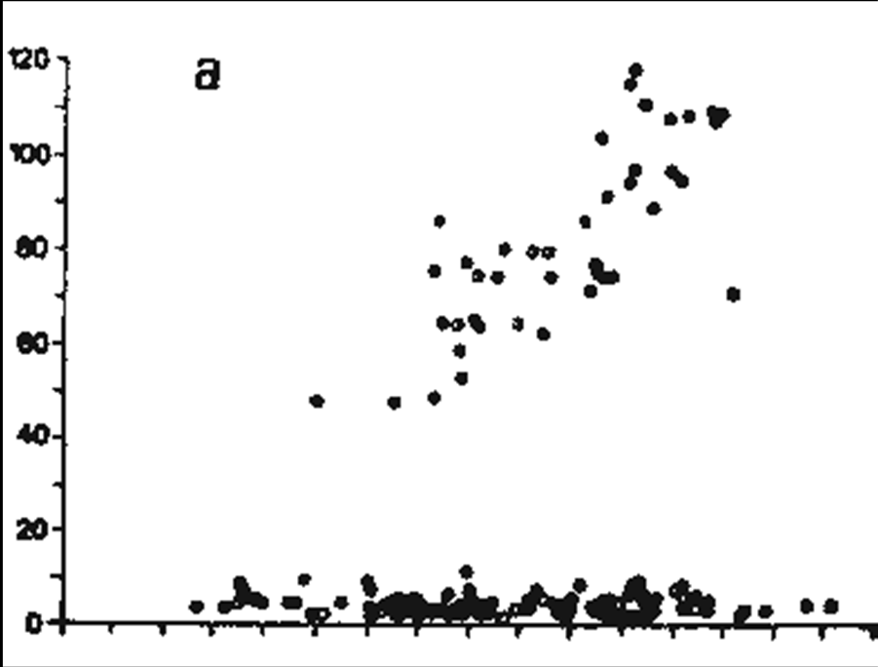
- 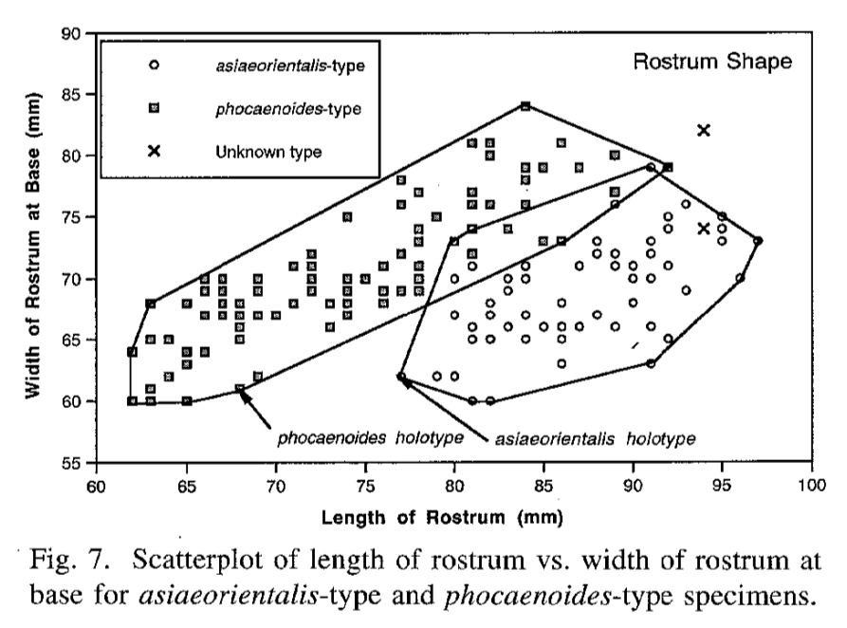

- First study concludes 1 spp and second study concludes 2 spp

Taiwan Strait: sympatric occurrence of two forms

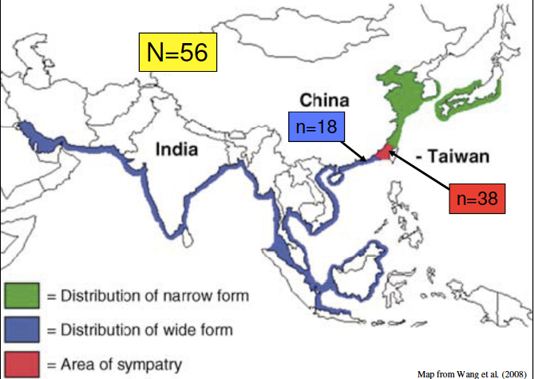
  - Area of wide form vs area of narrow form distribution

- Conservation = The preservation of wild populations so they can continue in the long term to function in their natural roles in their ecosystems
  - For conservation biologists its usually for wild populations
  - Under this definition what does it mean to have animals in zoos, parks, DNA banks ect and conservation
- Cost of conservation:
  - Artificial cost
  - Improperly valued – we DN value wild life and their habitats as much as we should, we DN know how to value and spp and their life
  - Cost to other economic opportunities not considered
    - For marine mammals its eco tourism
    - Adding up all the economics of these it’s a huge industry
  - Real cost is to “clean up” human activities
    - Not the cost of conservation
  - Responsibility is forced onto the public
    - Public elect the officials who allow things to happen, but then the cost is put back on the tax payer to clean up what the officials have done
  - Exploiters, developers ect should bear the costs

Why conserve cetaceans?
  - Biocentric, economic and ecological perspectives
    - Intrinsic value
    - Ecological value
    - Animal welfare and rights
      - Dolphins being considered “non-human persons” in some places
    - Biodiversity
    - Human-centric reasons (food, recreation, cultural and spiritual significance to natives, ect)
    - Charismatic spp to help other spp in the exosystem and symbolic value

Tools of conservation:
  - Science
    - No one really cares if a science goes out and conducts research
    - You cannot bring awareness and knowledge of conservation without research
  - Public awareness/education
    - Everyone supports public awareness of conservation
  - Rescue/rehab of stranded cetaceans
  - Captive breeding/artificial enhancement
    - Marine mammals are not easy to maintain in captivity
  - Reserves/Marine Protected areas (MPAs)
    - When you set up these areas you begin to limit what humans can do in these areas
    - This makes some people like fishermen very upset
  - Technological fixes (eg modify fishing gear)
    - This generally upsets fishermen too
  - Environmental impact assessments (EIAs)
  - Legal protection/enforcement (bans, ect)
  - International status (RL, CITES, ect) bi- and multi lateral agreement (IGOs)
    - Get spp on certain lists to help protect them
  - “Environmental terrorism”
    - Sea Shepherd
    - Green Peace
  - Economic pressure
    - Boycotts, sanctions ect
    - Most effective method
- Things to consider in conservation:
  - Political system and will
  - Cultural and societal nuances (past, present)
    - Japan claiming dolphins are part of their culture
  - Resources (wealthy vs poor nations)
  - Legal protection (local and international)
  - Public awareness
    - Important for what you are trying to conserve
    - Without public awareness nothing will get done
  - Local and foreign NGOS (non-governmental organizations)
- International laws, conventions ect
  - IWC – International whaling commission
    - Large centaceans – regulates and controls whaling
    - Set up by all the large whaling commissions (Iceland, Norway ect)
    - Deals with sperm whales and all the baleen whales
    - It was never set up for conservation, but to keep enough whales in the water so all countries can hunt them while keeping the whale pop stable
    - Set up to regulate everyones quota so they could market their whale products at a profitable price
  - CITES (aka Washington convention)
    - Convention on the trade of endangered spp of fauna and flora (regulates wildlife international trade)
    - Purpose is to make sure international trade DN harm the conservation of these animals or the use of these animals
    - Has nothing to do with weather or not a spp will be managed a certain way in a country
    - Its that countries government decision what to do with that animal
    - BUT CITES gets involved when countries want to ship a certain animals products to another country
  - IUCN (The world conservation Union) Red list
    - Scientific criteria for understanding extinction risks and assessing conservation status
  - Bonn Convention or convention on migratory spp (CMS)
    - Agreement on conservation of small cetacean in Baltic and North Seas (ASCOBANS)
    - Agreement on conservation of cetaceans of black sea, Mediterranean sea and contiguous Atlantic Area (ACCOBANS)
  - Pelly Amendment (also FCMA)
    - US domestic law
    - International wildlife agreements
    - Fishery imports
- Role of scientists:
  - Conduct credible scientific research
  - Understand basic biology of spp (especially poorly known spp)
  - Identify issues
    - If you go out and study something, youll probably be one of the few people studying it, therefore you need to inform people about the issues
  - Make issues public; communicate with the public/ disseminate info
  - Increase scientific knowledge of issues
  - Long term monitoring population parameters, demographics, ect
- MIDTERM
  - Multiple choice
  - True/False
  - Short answer
  - Long answer
  - Spelling of scientific names and family names count

- Science and identification:
- 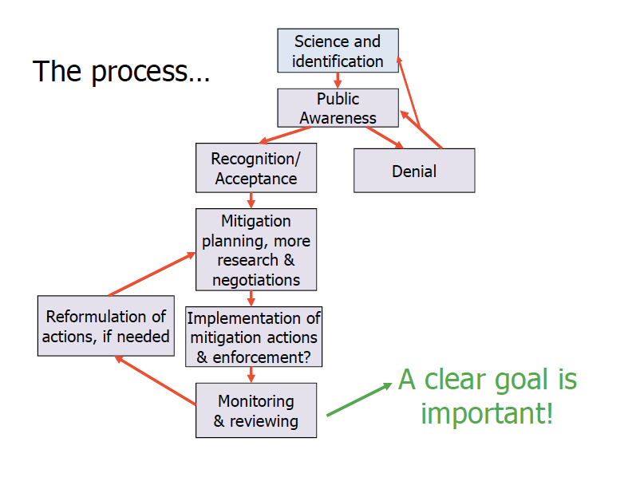

- Scientific information needed for cetacean conservation status:
  - High priority for assessment of status:
    - Taxonomy
    - Distribution
      - If you DN know taxonomy, you cannot know where they are found
    - Pop abundance
    - Pop trends
    - Threats
  - Other information:
    - Reprod biology
    - Demographics and genetics
    - Threat trends
    - New and impending threats
    - Distributional changes
    - Behavioural changes
- Threat vs Animal based approaches:
  - Threat based:
    - ID threat
    - Assess threat in cetacean habitat
    - Evaluate effect on individuals (short and long term)
    - Evaluate threat on populations
    - How to ameliorate threat (if serious)
  - Animal/Population-Based
    - Examine population
    - Are animals having problems? Is population at risk?
    - If yes, what are the threats?
    - How can threats be removed or reduced?
- Threats to cetaceans:
  - Fisheries and hunting (whaling)
  - Habitat degradation and loss
  - Pollution
  - Disease outbreaks
    - Mass mortalities of cetaceans periodically because of disease, but the cause of the disease is unknown
  - Climate change
  - Noise
  - Ship-strikes
- Main types of fishing gear:
  - Gillnets and entangling nets:
    - Very thin nets that fish swim through and they get caught in the fishes gills
    - Smaller cetaceans tend to get caught in these nets
  - Surrounding nets:
    - Used to capture schools of fish, and they surround the school from the bottom
    - The bottom is then drawn up so they cant escape
  - Trawl
    - Triangular/conical shaped net in the water
    - Different from TROLL
    - Trawl is a net while trolling is when youre luring something with bait
  - Traps
    - Large whales like humpbacks and right whales can get caught in these traps
  - Longlines
    - Long lines with a lot of tiny hooks with bait attached
    - Can be drifting in the ocean or fixed in certain spots
- Possible exam question:
  - Challenges to estimating marine mammal populations
  - How to measure marine mammal pops

- IWC is a great collective group to prevent whaling but they still have limited power to enforce and inspect
  - Each country must have legislation to protect whales
  - IWC CN interfere with government legislation of diff countries

CITES:
  - Ensure international trade in specimens of wild animals and plants that DN threaten their survival
  - Regulate trade of threatened and endangered plants and animals

- Shift in top predators:
  - Expansion of pinnipeds and penguins
  - Is the “trophic space” still available
- Killer whale prey shifting?
  - Changed nutrient cycles (ie faecal output)
  - Whales as detritus
- How many whales were there before whaling?
  - How do we estimate historical pop sizes?
    - Looking at catch data from the past
      - Log books, import/export records
      - Number of whales killed
        - Spp ID
      - Barrels of oil
        - Oil can be made from whale fat, so it can be determined how many whales were killed based off how much oil was produced
      - Baleen
  - Errors around catch data
    - Struck and lost whales (2-50%)
    - Missing records
    - Interpretation error
  - Using current levels of genetic variation in a pop, you can measure historical pop sizes
    - Hard since you DN know how much variation can occur
    - Use mta DNA, generation time of the spp and mutation rate of the region studied
    - You need a good evaluation of pop size, selection/mutation rates and huge confidence limits
  - Results are far higher than estimates based off catch records
  - Have calculated historical pop sizes 6-20 times higher than other estimates
  - Implications for recovery and management
- If resources are scarce, the first thing to go is reproduction, since in order to have OS and be able to sustain them, food and energy is needed

North Atlantic right whale: Past, present, future
  - Get caught on a lot of ropes and traps, since whales expend a lot of energy, moving through water should be the least costly for them. Getting caught on ropes creates a lot of drag which means little E is left over for reprod
    - Cannot tell fishermen not to set out traps anymore, therefore it’s a bit of a political issue
  - Vessels also strike the whales a lot so energy goes into self repair
  - Right whales hang out and feed where a lot of shipping routes are
- Stats about right whales:
  - No dorsal fin
  - Large head (1/4 to 1/3 total body length)
  - Strongly arched jaw
  - Short paddle shaped flippers
  - A “V-shaped” bow
  - Only ~350 individuals representing the ENTIRE spp (one of the most endangered large mammals)
  - Extremely low genetic diversity:
    - Compared to cheetah since cheetahs have no genetic diversity
- Questions:
- 1) What caused right whale to become so endangered:
  - Unnatural human causing
  - Whaling took a big hit to right whales

- Heavy metals:
  - Methyl mercury and dimethyl mercury are dangerous, mercury is found everyone but those 2 are the dangerous ones
  - For heavy contaminants it depends on what state its in, problem is when it methylates
- Hydrocarbons:
  - Gasoline by products can be dangerous
- Organic contaminants:
  - Anything with a carbon bond
- Debris
- Noise pollution
  - Sonic disturbances imposed by humans
  - Whales cannot communicate with each other when humans are making noise in the waters
- POPs:
  - Persistent organic pollutants
- Lipophilic nature of blubber:
  - Chemicals like water or they like fat
- Biomagnification:
  - Methyl mercury gets translated up the food chain and can pass the blood brain barrier
  - In order for something to be toxic you must be exposed to it and it has to have a toxic effect
  - Toxic compounds usually have a higher affinity for fat than water
- Bioaccumulation
- Adsorption: attaches to skin

Types of impact:
  - Direct/indirect: POSSIBLE EXAM QUESTION ID IF EFFECT IS DIRECT OR INDIRECT
    - Oil slick:
      - Gets stuck on skin of marine mammals and slows them down (direct effect)
      - Marine mammal eats fish that is directly effected by it (indirect)
      - Fish population dies off because of oil (indirect)
  - Chronic/Acute:
- Types of exposure:
  - Breath it
  - Eat it
  - Absorb it (through the skin)
    - Adsorb it (attach to the skin)
- Types of effects:
  - Reproduction:
    - Organ, skeletal anomalies
    - Impaired reproduction/function
  - Mortality
  - Lesions
  - Problems with comparing contaminant levels and incidence of disease
- Areas of concern:
  - Arctic
  - Antarctic
  - Coastlines
  - Long-distance transport
  - Atmospheric and oceanic currents
- Animals of concern **** EXAM****
  - First born:
    - Contaminant load of POP onto first born
    - Females accumulate toxins until reproductive age and then transmit toxins to first born
    - But the time between first born and second born is a lot shorter (say only 2 years) therefore there is less time of accumulating contaminants between first and second born
  - Females vs males:
    - Male contaminant load increases with age
      - Gradually see more contaminants as they increase with age
    - Female increased with age until calving, sharp decline, followed by increasing and decreasing with subsequent birth
      - Female lipids containing contaminant goes into milk and goes into calf
- How to measure effects of contaminants:
  - Measure blood, DNA, skin cells, do necropsy
- Potential effects:
  - Habitat loss
  - Changes to foraging
  - Interruption of social structures
  - Skin necrosis
  - Chemical burns
  - Immunological
  - Important to consider short term high concentration effects (eg hydrocarbons)

- Marine mammals have a large size and high E requirements
  - Therefore NOT primary productivity feeders
- Diet varies depending on season
- Difficulties in analysis/ how to study feeding:
  - Under water hard to see
  - Direct observation of what they are eating is hard to see
  - Stomach content analysis also difficult
  - Stomach lavage
  - Fecal remains
    - In sperm whales you can clearly see beaks of squids
  - Stable isotope deposits in teeth
  - Mta and nuclear DNA markers of prey in identified fecal matter
- How do we know what they eat?
  - Distribution and migration are determined by feeding and reproduction
    - To increase chance of encountering prey, marine mammals spend time foraging where prey abundance is high

Foraging location:
  - Productivity is high
    - Continental shelves
    - Shallow banks
    - Regional upwelling
    - Areas that are cool in winter months
  - Higher trophic levels congregate where diet is located
    - Photic zone surface, sea surface/floor, thermocline, open ocean eddies/fronts, current boundaries
  - Marine mammals can be opportunistic feeders:
    - Eg polar bears
    - Large mysticetes – high latitude summer feeding, low latitude in winter body fat patterns similar to terrestrial hibernating spp
- EXAM: Know examples from each of the slides that say what groups eat

- Content:
  - All lab, lecture, reading, seminar, guest lecture material
  - ~25% first half of the course
  - ~75% second half of the course
  - Variety of questions:
    - MC, true/false, fill in blanks, short/long answer with limited choice
  - Bonus marks could be anything
  - JW lectures: conservation and legislation in conservation issues
  - Know latin names of commonly discussed spp

- Guest lectures:

- Shiva Javdan – Assessing hybrid data collection approaches
- Data collection
  - Marine mammal research: distance sampling, theodolite tracking, biopsy sampling (dead/alive), tagging, acoustic recording, photography, videography (in cleaner water, so you can get info on behavior and social grouping)
- Distance sampling:
  - Line transect sampling
  - Series of transects over survey area
  - Cover transects -- sighting
  - Perpendicular distance
    - Distance to detected animals
    - Angle
  - Abundance
    - Density
- Photography:
  - Photographic identification
  - Photographing natural markings to ID individuals
  - Non-invasive, non expensive (cheaper than tagging)
  - Catalogue, capture history
    - Catalogue = capture history of pop
    - Can give info on pop size, reprod and life histories, how long calves are with moms ect
  - Population size, survivorship, reproductive parameters, dispersal
  - Not appropriate for all animals
    - If there are no natural occurring marks on study spp, there is no real way to ID the individuals therefore you cannot get the parameters you need
  - One of the ways to ID: dorsal fin shape, deformities or scars
  - Disadvantage: Not all pictures taken of the same individual will show the same markings that are used to ID it in other pictures
    - Spotting patterns change over time
- Idealness for photo ID:
  - Assumptions:
    - Individuals can be reliably distinguished
      - Naturally occurring mark that is complex
      - Unique to individuals
      - 74 ETS, 600+ PRE
    - Individuals can be re-identified over time
      - Trends
      - Survivorship, reproductive parameters, social groupings
        - These parameters require ID of individuals over time rather than just one instance
- Proposed project:
  - Idealness of Sousa for photo ID
  - Idealness of Sousa for line transect sampling
  - Effectiveness of hybrid data collection approaches
    - Photo ID with line transect sampling

- Lauren Dares – Habitat modeling of the indo-pacific humpback dolphin in Hong Kong and Taiwan

- Habitat modeling:
  - Model: A simplified representation of a real system
  - Mechanistic models
    - Based on knowledge of spp physiology
    - System broken down into individual parts to learn about processes contributing to outcome
  - Simulation models
    - Use defined relationships in data allw for hypoth testing and model evaluation with knowledge
  - Empirical models
    - Investigate correlations in complex ecological data to make conclusions about the system
- Simple models:
  - Multiple linear regression
  - Y= B0 + B1X1 + B2X2 …. + E
  - Y = depend variable
  - X= independent variable
- Models in ecology:
  - Many applications: worldwide spp distrib models, local scale “landscape models”
  - Widely used in ecology for variety of habitats and taxa
- Research questions:
  - What is the best model type for the data?
  - Where are humpback dolphins found? Why are they found there?
  - How can we use this info to direct conservation efforts?
- Model type evaluation:
  - Ecological data is inherently noisy:
    - How do we know the true relationships?
    - How do we know if a model is representing the true relationships accurately?
  - Data simulation:
    - Define spp response curves
    - Generate surfaces of environmental variables and maps of relative abundance
    - Build models on some data, test model accuracy, and precision with the rest
      - Predictive power
  - Traditional models: generalized linear models (GLM), generalized additive models (GAM)
  - Machine learning: boosted regression trees, random forest, maximum entropy
  - Challenges:
    - Presence vs absence vs abundance data
    - Multicollinearity
    - Missing data
- Sousa distribution and ecology:
  - Coastal, estuarine spp:
    - Proxies for prey abundance: Sea surface temp, Salinity, Productivity (ChA)
    - Turbidity, water depth, seabed slope
  - Anthropogenic impacts?
    - Land reclamation
    - Vessel traffic
    - Artificial coastline
  - Model selection criteria used to determine which variables most important
    - Explain importance based on ecology:
      - Distribution primarily determined based on prey abundance?
      - Turbidity facilitates foraging due to acoustic advantages for dolphins?
- Environmental data:
  - Remotely sensed data used:
    - Available even in unsurveyed areas
    - Numerous free online data bases (NASA, NOAA, Worldbath ect)
- Sousa distribution data:
  - Line transect data:
    - Long term monitoring program (1996-present)
    - Year-round surveys, primarily in Hong Kong waters
  - Taiwan – Formosa Cetus research and conservation group
    - Most surveys conducted in summer (2007-present)
- Conservation management:
  - Models can predict in space and time:
    - Space – determine distribution of animals in unsurveyed habitats
    - Time – investigate changes in distrib and density over time
  - Conservation management prediction:
    - Determine western boundary of PRE souse
      - Direct future survey effort
    - Impact planned land reclamation
      - Chek Lap Kok Airport (third runway)
      - HK-Zhuhai-Macau Bridge
      - Other projects planned in the future

Jordan Hoffman – Marine mammal acoustics

Study areas:
  - Ambient/anthropogenic noise
    - Ambient: noise in environment that is not man made eg: wind, rain, sand moving
    - Anthropogenic noise: Shipping vessels
  - Impacts of noise
  - Cetacean sounds
  - Passive acoustic monitoring
- Ambient and Anthropogenic sound:
  - Level and frequency characteristics

- Impacts of noise:
  - Masking
  - Behavioral disruption
  - Hearing loss, discomfort, injury
  - Cumulative effects
  - Mitigation of noise effects
- Cetaceans and sound:
  - Sound E propagates efficiently in water
  - Cetaceans have developed specialized means of sound production/receiving
  - Sounds used for communication
- Methods:
  - Use different types of hydrophones
    - Underwater microphones
  - Toe hydrophone behind boat and record any noise that passes by
    - Keep in mind hydrophone will pick up noise from boat
  - Drop hydrophone:
    - Drop HP off dock or boat to record whats in water
  - Look at max frequency (kHz)
  - Duration (s)
  - Start/end frequency (kHz)
- Issues:
  - Noise masking vocalizations hinders analysis
- Whistles of indo-pacific humpback dolphins: comparisons among pops
  - Humpback dolphins and sound:
    - Sound production:
      - Clicks
      - Pulsed sounds
      - Whistles
        - Used to communicate with conspecifics
        - Diversity in clicks easily detected
- Factors promoting within pop whistle variation:
  - Group size
    - Whistles evolved along with sociality
  - Individual variation:
    - Inter individual variation in tonal modualation and duration
    - Use tawain data
      - Extensive photo-ID catalogue and reliable ID at sea
  - Background noise:
    - Whistles will be assessed with and without vessel noise in the PRE
    - Adaptations to avoid masking
- Passive acoustic monitoring:
  - C-POD
    - Detects echolocation clicks and click trains
    - Detects presence/absence of most toothed cetaceans (except sperm whales)
    - Left on ocean floor for up to 4 months
    - Can differentiate spp (sometimes)
  - Addressed questions related to presence and occurrence dolphins
  - Log cetacean click trains (>5 clicks/train)
  - Habitat usage when surveys not feasible (ie night and bad weather)
  - Interested in diel and daily patterns
- PAM – North atlantic right whales
  - Acoustic detection via real time acoustic buyous

