Lecture 3:

- What is Mental Health?
  - WHO definition: mental health is a state of well being in which an individual realizes his or her own abilities, can cope with the normal stresses of life, etc.
- What is Mental illness?
  - mental disorders are health conditions characterized by alterations in thinking, mood, or behavior associated with distress and/or impaired functioning
- 3 D’s that help define abnormality
  - Distress to self or others
  - Dysfunctional for person or society
  - Deviant: violates social norms
- Prevalence
  - 26% current prevalence
  - 50% lifetime prevalence
  - Psychological disorders 2nd leading cause of disability
  - Anxiety and depression drugs are the most commonly prescribed drugs in North America.
  - every 90 seconds, an adolescent commits suicide
  - 1 million students withdraw from university annually because of emotional problems
- History of perspectives on psychological disorders
  - Trephination: in which a hole in the skull was placed in order to release the evil spirit thought to be causing the abnormal behavior
- Causes of Psychological disorders
  - Biology
    - First hypothesized by Hippocrates
      - Targeted the brain as responsible
    - First evidence from syphilis patients
      - Advanced stages lead to ataxia, cognitive impairments, dementia, seizures.
        - Known as general paresis
  - Psychology
    - psychodynamic: Freud internal conflicts causes excessive use of defense mechanisms
    - Behaviorists: the environment and learning
    - cognitive theorists: thoughts and perceptions about self and environment
    - humanistic: experience $≠$ self-concept
  - CURRENT THEORY Vulnerability- Stress Model
    - Vulnerability: predisposition to develop psychological disorders
      - biological, learned, personality, environment..
    - Stressor: event poses a threat and requires coping
      - psychological stressors are potent triggers
    - Stress vulnerability
    - 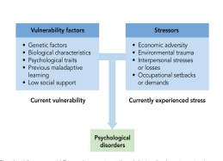
    - 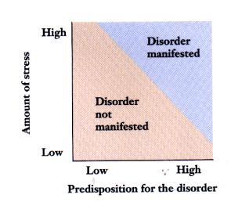
      - High stress, high predisposition: manifested disorder
      - High stress, low P.D= not manifested
      - Low stress, high predisposition= small chance of manifestation
      - low stress, low P.D = not manifested
- Diagnosing Psychological Disorders
  - Classification must meet two criteria
    - Reliability: extent to which diagnosticians can independently reach the same conclusion.
      - requires strict guidelines, observable behaviors
    - validity: extent to which categories are clinically meaningful – right diagnosis or not?
  - Diagnostic and Statistical Manual of Mental Disorders: DSM
    - developed by American psychiatric association
    - first edition was released in 1952
    - evolved from Kraeplins classification system in 1883
    - Current edition is DSM 5 – no longer carries AXIS structure
- DSM- 5
  - Based on research and consensus
  - Defines disorders
    - symptoms: characteristics of persons thoughts, feeling and actions
    - syndrome: set of interrelated symptoms
    - does not suggest treatments
    - cautious on causation
  - DSM-5 focuses more on reliability than validity
- Criticisms?
  - Controversial
  - Carries a more dimensional view
    - blurring the lines with normal?
  - Categorical vs. Dimensional
    - categorical: fit into a category or not ( all or nothing)
    - dimensional: considers severity along certain dimensions of a disorders (range from typical disordered)
- Social and Legal consequences
  - Social Concepts
    - labels can become our perception of the individual
    - loss of rights may be associated with mental illness- harm to self or others
  - Legal concepts
    - competency: defendants mental state at time of hearing
      - can the defendant understand the legal proceedings
    - insanity: defendants state of mind at the time of crime
      - could they comprehend wrongful behavior?
- Medical Students Disease
  - tendency to find symptoms from textbooks/courses
  - first described by humourist Jerome Jerome
  - similar disorders: introductory psychology students disease
  - demonstrates power of suggestion
- Anxiety Disorders
  - What makes it a disorder? Frequency and intensity of anxiety responses that are our of proportion to situations that trigger them
    - interferes with daily life dysfunction
  - Anxiety Responses Multiple Components
    - Emotional Symptoms
      - tension and apprehension
    - Cognitive
      - worry and thoughts about inability to cope
    - physiological
      - increased heart rate, muscle tension, other autonomic arousal symptoms
    - behavioral
      - avoidance of feared situations
      - decreased task performance
      - increase startle response
  - Prevalence:
    - more commonly occurs in women than men
- Specific Phobias
  - strong, irrational fear of specific object or situation
  - most develop during childhood, adolescence, young adulthood
  - seldom go away on their own
  - can intensify and generalize over time
  - degree of impairment
    - depends on how often condition is encountered
  - adults know fear is irrational
- Generalized Anxiety Disorder
  - free-floating anxiety
  - continuous worrying about multiple issues
  - onset usually during childhood/adolescence
- Panic Attacks
  - Threat alarm bell heart rate increase physical symptoms of anxiety occur thoughts that something is wrong symptoms get worse safety behavior occurs
- Panic Disorder
  - intense fear of discomfort= panic attack
    - variety of physiological arousal symptoms
    - usually unpredictable but some are cued
  - Panic disorder:
    - recurrent unexpected panic attacks
    - plus concern about future attacks
  - Agoraphobia: fear of being in places where escape is not possible if panic occurs
    - it is its own disorder in DSM 5
  - onset during late adolescence/ early childhood
- NOTE: OCD and PTSD are in their own categories in DSM 5
- Causes of Anxiety Disorders
  - Biological
    - genetic: identical twins concordance- 40%, fraternal is 4%
    - physiology: arousal, ANS overreacts
    - Neurotransmitters: low GABA receptors- GABAergic drugs are used to treat anxiety
    - More common in females – why?
      - biological preparedness: they are born with predisposition to fear certain stimuli.
  - Psychological
    - Cognitive
      - result of maladaptive thought patterns
        - catastrophize: “worst case scenario”
      - over attentive to threatning stimuli
      - 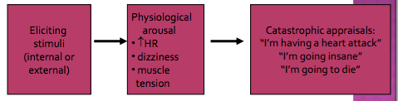
    - Behavioral
      - anxiety is a learned response
      - conditioned emotional responses
        - prior traumatic experience
      - observational learning
        - no prior traumatic experience
      - operant learning
        - negative reinforcement prevent extinction
    - Fear and Learning

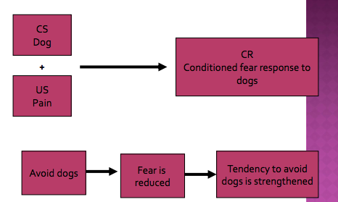
  - Sociocultural Factors
    - Evident from culture bound disorders
      - Examples:
        - KORO (SE Asia): fear that penis will retract into abdomen causing death
        - Taijin kyofushu: fear of offending others
        - windigo: feat of becoming possessed by monsters, cannibalism
        - anorexia nervosa: fear of being fat
- Eating Disorders: prevalence of 4%

- Anorexia Nervosa
  - intense fear of gaining weight, although under weight
  - restricted food intake
  - significantly low body weight in the context of age, sex, developmental trajectory and physical health
  - 90% females, adolescents and young adults
    - view themselves as overweight
  - Effects
    - absence of menses, strain on heart, bone loss, malnutrition.
    - risk of death
- Bulimia nervosa:
  - recurrent episodes of binge eating
    - large food intake in short period of time
    - lack of control over eating during episode.
  - recurrent in-appropriate compensatory behavior to prevent weight gain
    - self induced vomiting; misuse of laxatives, diuretics, enemas, or other medications
    - fasting, excessive exercise
  - Associated health problems = gastric problems, eroded teeth
  - Threshold for symptoms lowed in DMS-5 – less symptoms required to be categorized so that people aren’t missed that do have the disorder because not all symptoms are visible
  - Binge eating disorder is a separate category
- Causes
  - Role of societal values
    - Culture – western culture phenomena
    - media?
  - Personality factors
    - Anorexia: perfectionist and high achievers
      - control may play a role
      - family dynamics
    - Bulimia: depression/anxiety is more common
      - less impulse control, poor coping
  - Biological Factors
    - Genetics
    - serotonin, dopamine- cause of effect?
      - question whether serotonin and dopamine is a cause or an effect
      - does changes in levels cause eating disorder or does eating disorder cause changes in levels of serotonin or dopamine

