Lecture 1

- Stress
  - many people report high levels of stress
    - stimulus is a stressor
    - response is the experience
  - interaction between the two person-situation interaction or transaction
    - pattern of cognitive appraisals, physiological responses and behaviors that occur when situational demands are perceived to outweigh ability to cope
- Model of Stress
  - 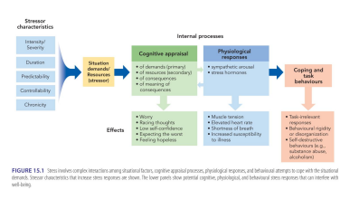
- Stressors
  - place demands on us and threaten our well being
  - Range from micro stressors (daily hassles) to catastrophic events (tsunami) and major negative events
  - This is measured through the life events scale
    - Even positive events can increase stress (wedding, grad)
    - Negative events linked to adverse health
  - Positive events can cause stress but don’t decrease health, negative events causes stress but does decrease health.
- Stress Response
  - Starts with appraisal our perception of stressors- how do we see the stressor? (Primary appraisal) and our ability/resources available (secondary appraisal) to cope with the stress.
    - Primary appraisal- may overestimate the seriousness of the situation
    - Secondary appraisal: underestimate the resources they have to cope with the stress
    - May also exaggerate the seriousness of the consequences
    - May have irrational beliefs about themselves – “I’m stupid”
  - Consider potential consequences and personal meaning
    - If I fail, what will happen and what does it mean about the world and me?
  - Lots of individual variability
  - Physiological responses to appraisals
    - Affect reappraisals/ perception
- Chronic Stress- stress that occurs everyday
    - Chronic stress can be associated with the work place
    - Abusive Relationships
    - School
  - Study: described General Adaption Syndrome (GAS)
    - Alarm Reaction- fight or flight response
      - sudden activation of sympathetic nervous system
      - endocrine response- hypothalamus to pituitary gland to adrenal gland
      - cortisol increases blood sugar, suppresses immune function
        - Good in short term, bad over the long term
      - Parasympathetic system tries to return body to homeostasis- But if stressors continue (chronic stress), then stage 3 and 4 occur
    - Resistance:
      - Body can stay aroused for longer periods if needed but eventually becomes depleted.
    - Exhaustion: risk of illness, collapse
      - Weakest body systems likely to be affected.
      - 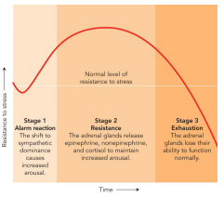
- Stress and Health
  - Stress affects both physical and psychological health
  - Psychological distress
    - Catastrophic events (not chronic but intensity and severity is a lot higher): combat, rape concentration camp survivors, Chronic: stressful life events
    - Catastrophic events can have long lasting psychological effects, depending on how we appraise the situation, how we cope, etc. ( Ex: not everyone who experiences a bad event has PTSD)
  - More negative life events are associated with more distress
    - but it is correlational only
    - Neuroticism( Praise things as more threatening, more anxious) may play an important role. They experience emotions as more negative.
    - 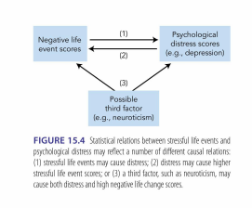
  - Physical Effects
    - Immediate and delayed effects
      - Heart attacks - Immediate
      - Chronic illnesses: arthritis, ulcers, cancer, etc. - Delayed
    - Current medical conditions can get worse
    - Physiological Stress responses are hard on the body – heart, immune system, etc.
    - Stress linked to negative behaviors such as substance abuse, poor sleep, etc.
    - Effects on the brain: prolonged stress affects learning and memory
    - Mild stress early in life may be protective/helpful, like an immunization
- Vulnerability and Protective Factors
  - Vulnerability:
    - lack of support, poor coping skills, tendency to be anxious/pessimistic
    - weak social ties/isolation is strong predictor of poor health
      - Especially for women
  - Protective factors:
    - Social support, coping skills, personality factors
    - Social support enhances immune function
- Social Support
  - How does it work? Two possible explanations
    - Acts as a buffer- less reactive to stressful events
    - Alleviates impact of stress-
      - Ex: Talking about stressful life events improves immune functions
      - More efficient recovery after stressor.
- Neural Responses and Social Support
  - brain regions involved
    - Amygdala:
      - important for appraising and mediating response to threat
      - connections to HPA- release of cortisol
      - Social support may help reduce activity in amygdala
    - Anterior Cingulate Cortex
      - involved in responding to aversive stimuli
    - Prefrontal Cortex
      - role in regulating negative affect and response to stress
      - helps control HPA and decrease physiological response
  - 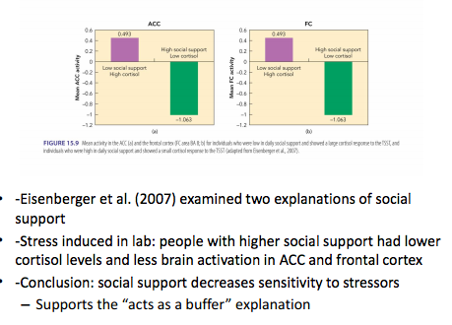
- Cognitive Protective Factors
  - Hardiness:
    - ability to thrive in stressful setting
    - commitment ( to work)
    - control- strongest buffer against stress ( can control work)
    - Challenge ( when you have a stressor, viewed as a challenge not threat)
  - Coping Self Efficacy
    - belief that we can cope successful
    - learning plays an important role
      - past experiences and observations of others
    - increased self-efficacy can boost immune function.
- Optimism
  - Belief about the future
    - Optimists
      - View themselves as less helpless
      - Better adjustment to negative life events
      - Less illness compared to pessimist
      - Why? Pessimism seems to decrease immune function and long-term health.
- Stress and Personality
  - TYPE A AND B
    - When looking at stress, there are usually two different types of personalities that people when have when coping with stress.
  - Type A:
    - Demanding of self and others
    - High level of motor activity
    - Perceived time pressure- DONE NOW
    - Aggressive
      - Likely to live under pressure, workaholics, etc.
      - Type A has 2 X higher heart disease, higher negative emotions
        - Create more stress for themselves, alienate others, overact physically to events
    - Good: Link between conscientiousness and good health
      - Conscientiousness: less likely to be in risky behavior
  - Type B
    - Relaxed
    - Agreeable
- Finding meaning in stressful events:
  - Human need
  - Psychological benefits: meaning can be attached to major stressors, better long term outcomes
  - Religious beliefs can lead to better or worse outcomes- depends on type of stress.
- Physiological Reactivity
  - Variability in physical responses to stress across people depends on:
    - Physiological toughness is a protective factor
      - low resting levels of cortisol
      - low levels of cortisol in response to stressors
      - quick return to baseline level of cortisol after stressor
      - Low resting levels of catecholamine’s (adrenaline)
      - Quick and strong catecholamine (adrenaline) response to stressor
      - Quick decline when stressor is over
    - Provides maximum short-term response and prevents exhaustion
    - Interesting that exercise involves catecholamine-induced arousal.
- 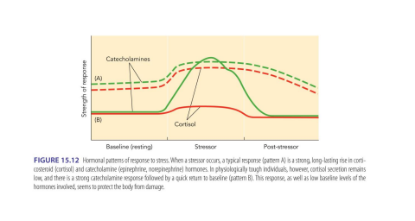
- Solid Lines: protective ( low levels resting, quick peak and recovery), Dashed line: (High levels at resting, quick peak slow recovery)
- Stress and Working Memory
  - Mild to moderate stress can impair cognitive abilities
    - planning, attention, organization, working memory, etc.
  - Animal studies suggest: chemicals released due to stress response impair working memory and functions of frontal lobe

