FRE 460: Advertising
Generic Advertising Programs
Generic food advertising has evolved in two fundamental ways over time
- from local and regional to national scope
- have evolved from voluntary to mandatory participation
  - While voluntary programs are generally successful, they have often plagued with free-riders over time

Check-off program: an industry-funded generic marketing and research program designed to increase domestic and/or international demand for an agricultural commodity. This can be done through promotion, research and new product development, and a variety of other marketing tools. These programs are similar to businesses funded by shareholders (producers, processors, handlers, importers, etc.) with a board of directors that is accountable to the shareholders.
Mandatory check-off programs have uniform assessment rates on producers within the industry, levied at the same price
- eg. $1 per head of cattle
- Once it passes a referendum held by government, everyone is required to pay
- Works best for industries that produce highly homogeneous commodities that have little ability for product differentiation among producers
  - Thus as agricultural commodities become more differentiated, the use of mandatory check-off becomes less popular

Why would members agree to mandatory check-off programs?
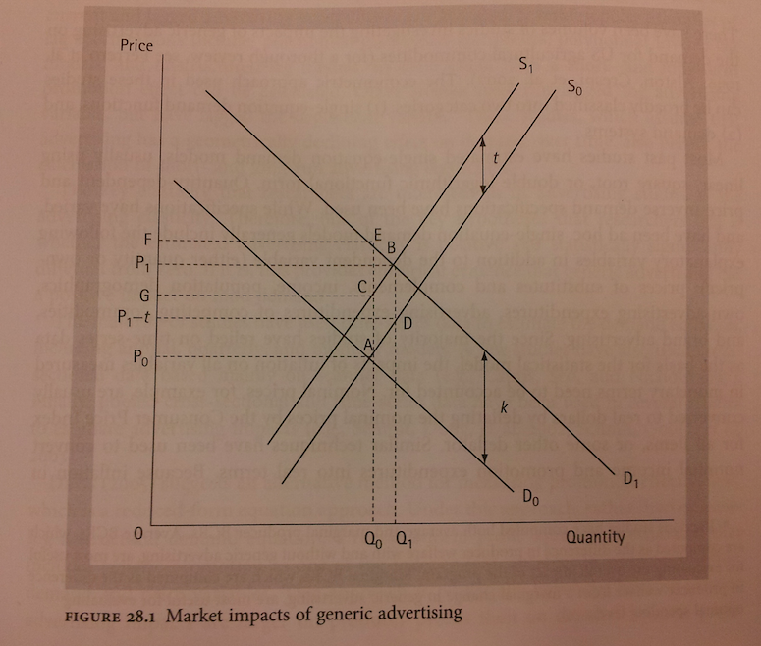
Let $D_{0}$ and $S_{0}$ = market demand and supply without mandatory genetic advertising

Let $P_{0}$ and $Q_{0}$ = initial equilibrium levels for price and quantity

The introduction of mandatory advertising programs impacts market demand by shifting the demand curve to the right from $D_{0}$ to $D_{1}$ (assuming advertising is effective/ consumer’s willing to pay more for the commodity )
Producers must pay a tax of $t per unit, the mandatory generic advertising program also shifts the supply curve to the left from $S_{0}$to $S_{1}$
It is now more expensive to produce each unit of the commodity
Advertising raises the equilibrium price from $P_{0}$ to $P_{1}$, with consumers paying $P_{1}$ and sellers receiving a net price of $P_{1}$-t
In the graph, it assumes demand increases by more than the decrease of supply
- Equilibrium quantity increases from $Q_{0}$ to $Q_{1}$
- Market impact of mandatory generic advertising is to raise equilibrium quantity and price (both consumer and net seller price) in the market

P$S^{0}$ = area under a
P$S^{0}$ with advertising = area GCBEF

Producer benefits + consumer benefits = net national benefits from check-off funded promotion programs compared to those with an absence of advertising programs (area GCBEF)

Some mandatory programs will exempt some segments of the industry
- eg. Smaller producers
- eg. Organic milk farmers: want to differentiate their products from conventionally produced milk

Most empirical studies only focus on the benefits of check-off programs for producers
- Rarely measure the consumer benefits and costs

