Feb 13, 2014
Price Policy

Price policies use tax and subsidies to alter relative prices
- May focus on nutritional content (eg. Sugar) of a product or on specific food groups (eg. junk food)
1994 -Kelly Brownell first proposed that junk food be taxed to subsidize healthier food
- Now- the public health sector has seen taxes and subsidies as an appropriate tool for intervention in nutritional choices
The effectiveness of the price policy depends on the choice of products whose prices are targeted
- Energy-dense foods that are substitutes for “junk food” must not be left out of the tax
- Substitutions for food are country and culturally specific: optimal tax base must be country-specific
food related chronic disease
The main normative goals for price policies:
1. Committing consumer to rational choices if they have self-control problems or are “naively addicted” to food
2. Solving the ex ante moral hazard problem faced by public insurance
(taking more risks because there is insurance)
A person eat junk food and become obese. They already pay into insurance that takes care of their health care treatment, which is a private cost. The person continues their lifestyle ( a risk) because there is continued protection.
However, the money used to treat this preventable disease could be used on more meaningful and non-preventative ventures for example cancer research. A preventable illness taking funds for non-preventable illness is the external social cost.

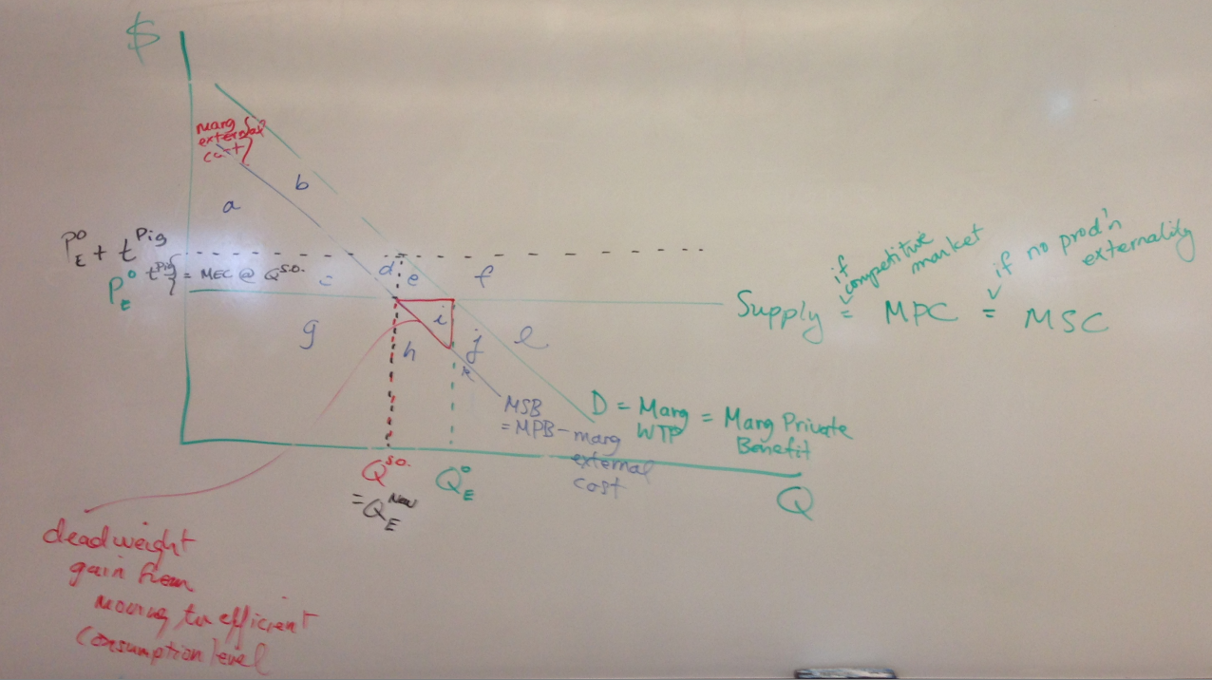
Possible Solution? Pigouvian tax
Charge people a tax equal to the dollar value of external damage generated by their consumption of the harmful product
Change in CS ( - [c + d + e] ) + change in PS (0) + change in tax revenue ( c + d) - change in external costs ( - [e + i] )
= change in welfare = i > 0
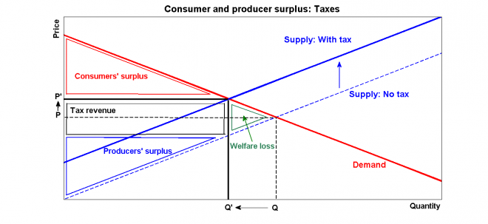
Effect of a consumption tax w/o and w/ consumption externality
Consumption externality: when consuming a good causes either a positive or negative externality to third parties.
1. Consumption tax without consumption externality

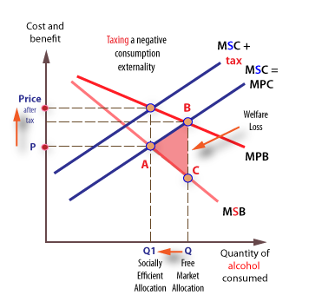
2. Consumption tax with consumption externality
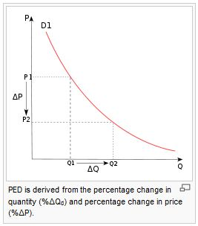
Graphical equivalent of demand elasticity
Elasticity of demand = $\frac{∆ Q}{∆ D}$
If |εD| > 1 ↔ _elastic demand i.e. quantity is very responsive to price.

If |εD| < 1 ↔ _inelastic demand i.e. quantity unresponsive to price.
Usually true of necessities (e.g. milk, eggs, rice)

Perverse case: εD> 0 ↔ _giffen goods (product that people consume more of as the price rises
Effect of P coffee ↑ when coffee and tea are substitutes (and consumer willing to spend whatever it takes to get to a fixed utility level)
Missing graph
Effect of p hot chocolate ↑ when have Leontief preferences for hot chocolate and biscotti – see Q biscotti ↑
Missing graph
In Search of an Optimal Price Policy
An optimal tax needs both efficiency and equity!
Generally, evidence on the effectiveness of price policies are mixed
- Need to find a price policy that is high enough to be effective and fits in the cultural-social environment

