Food and the Environment- April 1, 2014

Omnivore vs Vegetarian

Claim: – “eliminating meat [and eggs and dairy] one day a week would have the same global warming benefit as buying only local food”

Reason:

There is a lot waste that goes into meat protein verses vegetable protein
- Vegetable to meat protein conversion rates
- Chicken: 18%
  - i.e. need 100g vegetable protein to make 18g chicken protein
- Pork: 9%
- Beef: 6%

Additional Resource requirements
- Compared to soy protein, “meat protein production requires
- “About six to seventeen times more land...
- “Twenty six times more water...
- “Six to twenty times more fossil fuel ...
- “Seven times more phosphate...

However, this argument also depends on the production method of choice! Meat protein will not always be worse than vegetable protein.
- Must look at the context

Organic

Canadian Definition: General principles and management standards that must be verified by a third party
- Thus, even if you use organic methods and do not get it certified ( costly.. ), then the product is not considered organic

“When producing or handling organic products, it is forbidden to use any of the following substances or techniques:
- “All materials and products produced from genetic engineering...
- “Synthetic pesticides (e.g. defoliants and desiccants, fungicides, insecticides and rodenticides), wood preservatives (e.g. arsenate) or other pesticides,...
- “Fertilizer or composted plant and animal material that contains a substance prohibited by par. 1.4.1 ...
- “Sewage sludge, in any form, as defined in this standard, as a soil amendment
- “Synthetic growth regulators
- “Synthetic allopathic veterinary drugs, including antibiotics and parasiticides...
- “Synthetic processing substances, aids and ingredients, and food additives and processing aids including sulphates, nitrates and nitrites... – “ionizing radiation and forms of irradiation on products destined for food or their inputs...
- “Equipment, packaging materials and storage containers, or bins that contain a synthetic fungicide, preservative or fumigant
- “Substances that are not included in CAN/CGSB-32.311, Organic Production Systems - Permitted Substances Lists...
- “Cloned farm animals and their descendants. A producer shall know the lineage of any non-organic animal brought under organic management
- “Intentionally manufactured nano-technology products, or nano-processes...

Environmental impact of Organics

Hole et al (2005) reviewed 67 studies of organic vs conventional
- 99 species comparisons
  - 68: organic sig better than conventional
    - e.g. – increased bacterial/fungal abundance and activity
    - “Increased nematode abundance,
“Increased earthworm, spider, and beetle abundance
    - Increased biodiversity
  - 8: organic worse
    - Organic doesn’t always equal better

Does organic farming need more land?

Against:
- Cannot tell from first few year, need a few years to reach soil equilibrium
-Some evidence that organic yields = conventional yields after a few years

For: -
-“organic lands suffer about 15 percent less erosion compared to conventional agriculture”
- also better “soil structure, aggregate stability,...air and available water capacity...and carbon and nitrogen mineralization”

Energy Use

The amount varies depending on which crop is being grown ( corn vs soybean)
- Pimental et al (2005): “energy use for organic corn production was about 30 percent less than conventional...but there was no difference between organic and conventional soybean production.”

Healthiness of Organic vs Conventional

There are only minor health differences between organic and conventional produce

- Williams 2002
- Reviews extant literature, concluding
  - “Evidence that can support or refute such perception is not available in the scientific literature. ...
  - “Very few compositional differences [between organic and conventional foodstuffs] have been reported
  - “Although there are reasonably consistent findings for higher nitrate and lower vitamin C contents of conventionally-produced vegetables, particularly leafy vegetables.”

Pesticide Use

1 in 20 (4.7%) conventional items tested has excessive pesticide presence residues exceeding allowable limits
- Yet they are still have to be sold... so perhaps the limit doesn’t mean anything

1.8 % of organic items violated Canada’s maximum allowable limits for the presence of pesticides

Conclusion

Organic ≠ sustainable
There needs to be better stewardship attitude to the soils
Nothing in the definition of organics says anything about recourse sustainability (amount of oxygen in soil, animals get to walk around, animals get a personal name not just a number )

Many organic brands now owned by major corporations
eg. Odwalla now owned by Coke
May not adhere to the level of sustainability before the purchase (less profit to be made if it happened )
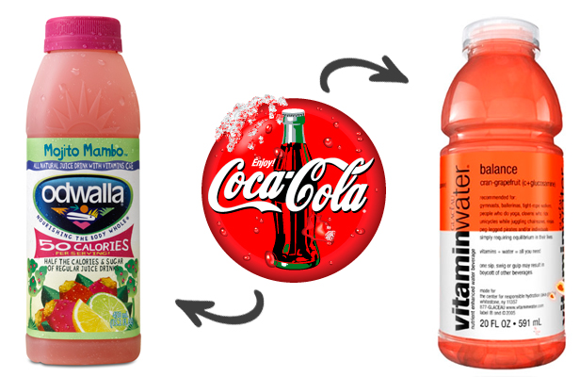
Policy Solution?
Brand differentiation
“Krav, a major Swedish organic certification program, allows produce grown in greenhouses to carry its “organic” label only if the buildings use at least 80 percent renewable fuel”
- However it becomes harder for consumers to understand the different types of labels

GMOs

Define: refer to the plants or animals created through the gene splicing techniques of biotechnology

Benefits

“GM crops have been shown to increase yields...meaning less land needs to be used for food production, preserving land for other uses.”
“Development of biotech crops that are tolerant to herbicides has increased the adoption of conservation tillage and no-till practices”

Concerns

Contamination
-Gene transfer to non-GMOs of same species

Harm to non-target species
- Mixed results
  - Some types of GM corn pollen appear “to consistently demonstrate high activity against non-target Monarch butterfly while [others] have proven largely innocuous”
- Note: If farmers instead apply more pesticide to regular seed crops, there may be greater potential effect on butterflies

