Ethics/ Tastes – April 3, 2014

Public Goods definition:
A product that one individual can consume without reducing its availability to another individual and from which no one is excluded.
Economists refer to public goods as "non-rivalrous" and "non-excludable"
Eg. National defense, sewer systems, public parks and basic television, radio broadcast, lighthouse, clean air

Non-excludability: once the goods are produced, there is no way to exclude anybody from consuming them
Non-rivalrous: once the good is provided it cannot be depleted
Eg. If one person doesn't pay his taxes, he still benefits from the government's provision of national defense by free riding on the tax payments of his fellow citizens.

Also public bads including: pollution, species loss

If, when you purchase organic produce, there are fewer pesticide poisonings of birds etc
• This generates a public good
-Everyone who cares about bird’s benefits
-The happiness you receive from the reduction in dead birds doesn’t reduce anyone else’s happiness from that same outcome

**If there are external benefits from your public-good provision and you can’t capture these benefits, will private consumers provide enough of the public good? **

Lighthouse example
- There are many privately provided lighthouses
- Individual citizens will benefit from getting a lighthouse without government intervention even if other boats will benefit as well without chipping in (private benefits are high and provision costs are low)

Green markets example
Individuals pay a price premium for “impure public goods”
- These are products that bundle private and public attributes
E.g. low carbon rose
Public attribute: fewer emissions/rose
Private attribute: a pretty flower

Labeling to confirm credibility of attributes

Companies need accreditation to tell people what their contributes means
Consumers need to properly understand what these labels mean
Some countries even fight over this it
Many different labels that companies are choosing to use
Consumers get easily confused
-Brand and label similarity
- Ambiguous Information
200+ different eco-labels in the US alone
  - Some very vague

Spillover effect: “tarnish the credibility of well-defined labels that follow diligent procedures of meaningful product and process definitions”

Errors in the Certificaton Process

Type I error = false positives
Some firms that aren’t actually following organic practices get falsely certified
Eg. BC sockeye fishery has received Marine Stewardship Council’s certification as “sustainable” the same year the salmon stock collapsed!!
- used data from a few years ago

Type II error = false negatives
A firm with a low-carbon footprint doesn’t get labeled as such because of coding error in the input-output tables

Some firms that should qualify might eschew certification entirely
Too small
Not enough units across which to cover certification costs

Negative market effect
- When consumers see organic wine, usually they’ll believe the cost of organic processing is already in the price of the wine
- Believe they need to purchase higher priced organic item to get the same taste as conventionally produced wine
  - Thus will not purchase as much organic wines

Fair Trade Certification

Definition: make sure that producers get a “fair” portion of retail price
- Production and distribution need to be audited by third party certifiers for certification

No Fair Trade

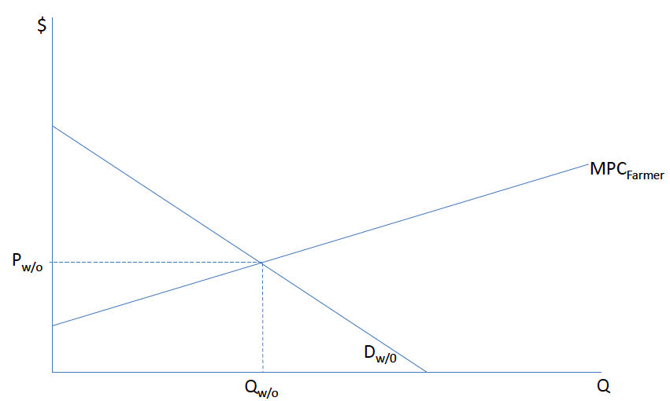

Introduction of Fair Trade

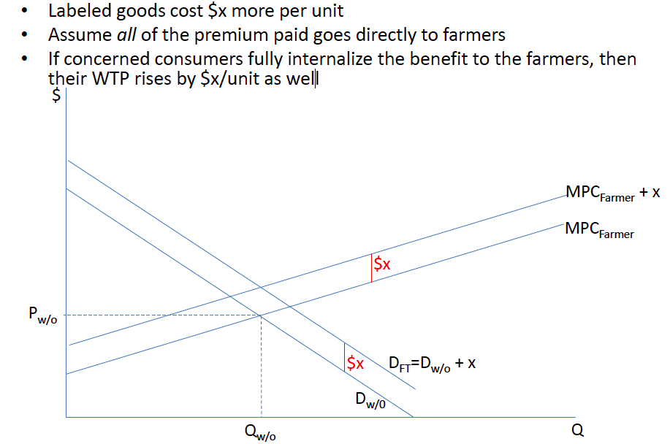

How Do Outsiders See Above Graph?

Consumer price rises to PFT = P w/o + x
Consumer surplus stays the same
Farmers’ Surplus rises by x*Q w/o
Win-win
- Consumers have to pay the extra dollar, but they get a warm feeling! :D

In Reality

Not that much of what you pay for the fair trade premium actually goes to the farmer
- Valkila, Haaparanta and Niemi (2010)
  - “consumers in Finland paid considerably more for Fairtrade-certified coffee than for alternatives, but that only 11.5% of the extra paid went to the exporting country.”

Despite all these barriers, do fair trade products still improve welfare?? NO



