Environment & Food Part 1: Waste & Foodmiles

There are a lot of resources that go into consuming and producing food
- eg. the “food system” accounts for “over 70 percent of the world’s use of water”
- “Refrigeration, cooking and washing food account for about 10 percent of a household’s energy use.”
- “50 percent of all eutrophic emissions come from agriculture”
- “about one-third of a household’s environmental impact is related to food consumption”

Where is the waste coming from?

Farm
-Pest damage
- Poor storage
- Over-production

Pre-consumer
-Trimmings from meat
-Blemished and undersized fruit removed from sale

Grocery stores/restaurants
- Spoilage before preparation
- Overstock foods, even at end of day to create an image of freshness
- Plate scraps and leftovers discarded (donations have liability risk)
- Contacted catering often has over-production
  - Eg. Even if the grocery store does not want full amount of sandwiches on a particular day, the contractor must still be prepared to make the full order

Households
- Waste & Resources Action Programme (WRAP) suggests 2/3 of household food waste could be avoided with better shopping and meal planning
- Lots of waste from water bottles!
- Contamination is very possible in both streams ( bottled water and tap water)
- Sometimes it may be a necessity to buy water bottles

Possible Solutions for Waste Management

Irradiation: treatment with ionizing radiation to kill harmful bacteria from food
- Icke (2008) estimates “electron beam process could save 175 million liters of water, 2 million kilowatts of electricity, and over 300,000 liters of chemicals annually in a PET bottling plant.”
- Can deliver “energy reductions of up to 90 percent compared to conventional pasteurization of food
-Eliminates water and chemicals in the sterilization process...allowing for thinner-walled, lighter weight bottles

Surprisingly recycling may NOT be a great option
-Based on estimates from WRAP, Recycling aluminium can reduce energy consumption by as much as 95%
-However savings for other materials are lower but still substantial: about 70% for plastics, 60% for steel, 40% for paper and 30% for glass
- Is it even worth recycling glass?? Only reduction of 30% of energy consumption

- First should try to reduce consumption, reuse items then lastly recycle them

Food Miles

Idea: label products according to how far they’ve travelled
Motive: the farther something has traveled, the more emissions associated with its transport, other things being equal

Problems: GHG emissions vary considerably across different transport modes
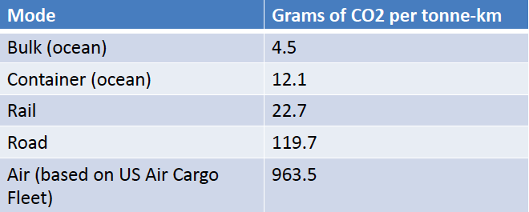

Shipping the food item by boat gives off fewer emissions than driving to the Okanagan to buy “more sustainable” local options

Thus need to be open minding in deciding the sustainability of an item

Other Factors

Production techniques matter a lot!
- The right season in a country across the world may have require less energy verses a hot house production of the same item locally
- Fertilizers & pesticides
  - Producing and shipping organic wheat from the United States to the United Kingdom has a lower environmental impact than growing conventional UK wheat
  - In contrast, producing and trucking Italian organic wheat to the United Kingdom by truck does not

Storage
- An apple produced and transported from New Zealand in August could have less of an environmental impact than a UK (local) apple that was produced in the preceding year and stored

Potential Solution

Tax resource use ( “Tax me, don’t nag me”):
Garbage disposal
Water use
GHG emissions (social cost of green house gases)
Antibiotic use in livestock
Nutrient depletion in soils** (may not need... the farmer is internalizing the benefits of nutrient usefulness)

Make people pay the pay for the externalities and they will make the right choice on the margin

Consumers don't have to feel too guilty as long as the price they are paying reflects the social cost of producing it

