FRE 460
Lesson #1: Rational Choice Theory Vs Behavioral Economics
“Axioms of choice”: Statements that are self-evidently true regarding choice
1. Reflexivity (circular relationships between cause and effect) – A consumer likes basket A at least as much as she likes basket A.
2. Completeness – For any two consumer baskets A and B, a consumer either likes basket A better or likes B better, or is indifferent.
3. Transitivity – If a consumer likes basket A better than basket B, and likes basket B better than basket C, then she also prefers basket A to basket C.
4. Closure – The set of baskets that the consumer likes at least as much as she likes basket A is a closed set (and similarly for the set of baskets she doesn’t like more than basket A)
When these four axioms are fulfilled, then an economist can represent the consumer’s preference ordering by a “continuous, real-valued utility function u(x)” (Handbook p.10) where x is drawn from the set of all possible consumption baskets
other known axioms

5. Non-Satiation – More is never worse (i.e. either more is always better, or there is free disposal)
6. Convexity – Interpret as follows: If a consumer likes basket A at least as much as she likes basket B, then there’s some mixture of the two baskets that she likes strictly more than basket B (e.g. 90% basket A + 10% basket B)
The axioms of choice not only provide the logical and mathematical foundation for neoclassical consumer choice theory, but also provide means to justify constrained utility maximization. So should someone ask how an economist defends the use of a utility function, one answer is that it is equivalent to ranking preferences for bundles of good.
Note: do not need to memorize these axioms, just need to understand some of the assumptions underlying neoclassical economics.

This versus That
Food is usually a choice between food and evil
Hedonic (characterized by pleasure) cake or utilitarian (designed to be useful or practical rather than attractive) cemetery
-Leads individuals to view goods (or choices associated with them) in terms of moral structure- classifying objects as “wants” or “should”

Habits, additions and rationality

Richards, Patterson, and Tegene estimate a model that accounts for increasing obesity and over eating by using Becker and Murphy’s (1988) rational addiction model
- Individuals choose to consume addictive substances with full knowledge of how it will alter their temporal preferences for the food in the future
- Never be surprised to find themselves addicted to a substance; rather it would be the expected result of a planned consumption profile
Time inconsistent preferences: A decision-maker's preferences change over time, in such a way that a preference, at one point in time, is inconsistent with a preference at another point in time.
-Observed in individuals who continually procrastinate
eg. Would probably not pay $10 to change the final date now, but would pay $10 to change it the day before

Discounting (Present discounted value): The process of determining the present value of a payment or a stream of payments that is to be received in the future. Given the time value of money, a dollar is worth more today than it would be worth tomorrow given its capacity to earn interest. Discounting is the method used to figure out how much these future payments are worth today.
To do this, we will simply solve the above formula for P. We get $P= \frac{F}{{(1-r)}^{t}}$ where P now equals the present discounted value, F is the future value, R is the interest rate, and t is the number of years from today.
Quasi-hyperbolic discounting: individuals discount consumption in the next period (t=1) by some amount y, in addition to discounting every period by $δ^{t}$ so that time (not just consumption) in the immediate term is more costly than time in the future
- eg. An individual who desires to lose weight may compare future utility of weight loss to the forgone utility of eating fatty foods today
- if the same utility additionally discounted by y is less than the utility forgone by current consumption, then the individual will not go on a diet in any period t, thus putting off the diet for one more period t
  - This behavior is found mostly in drug abusers

A rational individual who understands the process of procrastination and how it relates to time discounting will look for an opportunity to pre-commit their future self to a better diet
Eg. Using social groups and weigh-in comparisons to increase the future cost of being overweight
- the goal is to increase the cost to the point that the individual’s diet preferences today will match those of tomorrow

Other examples include: individuals receiving food stamps
- Tend to use them all within the first few days of receiving it
- The individual may simply value trade-offs in the near-term consumption too highly to consider saving that is necessary for longer-term consumption
Discounted Utility: the future discounted value of a good in its present value. This can be thought of as the idea of impatience, or the valuing of future enjoyment less than present enjoyment.
References and Defaults
Loss aversion (prospect theory): A theory that people value gains and losses differently and, as such, will base decisions on perceived gains rather than perceived losses. Thus, if a person were given two equal choices, one expressed in terms of possible gains and the other in possible losses, people would choose the former.
- 1. Individuals evaluate outcomes in relation to reference points- defining anything better than the reference point as a gain, and anything worse as a loss
- 2. Individuals display a much larger marginal utility of pain from loss than marginal utility of pleasure from gain by a 2:1 margin

Eg. If one always orders a bacon cheeseburger, they may consider the cheeseburger without bacon to be a loss. Whereas if a regular cheeseburger excludes bacon, the bacon cheeseburger may be seen as a gain.
People would much rather get the second option.
eg. Menus adding nutritional information will affect how people buy their food
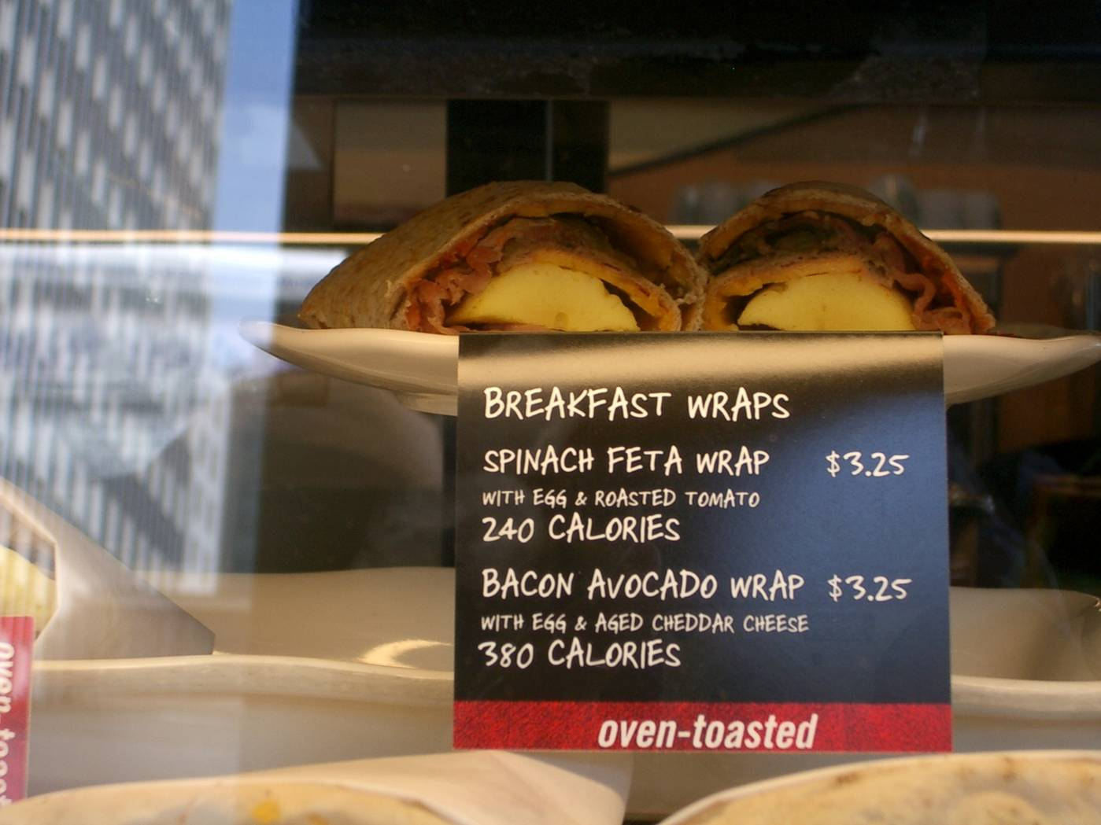
Mental Accounting and Food
Mental accounting: supposes behavior is determined by three components: 1. Transaction utility, 2. Categorization of income for spending purposes 3. The frequency with which accounts are balanced
Transaction utility: refers to whether the individual feels they received more or less than they paid for
Eg. People who eat at expensive pizza buffets will eat more slices of pizza compared to a less expensive buffet
Even if people don’t like pizza, if they paid for it, they will still eat more

Categorization of income for spending purposes: use mental accounts as a type of self-control device, to enforce forward-looking behaviors on themselves
Eg. Limiting the amount of money one will spend on a single occasion of dining out

Frequency with which accounts are balanced: income sources that are seen as one-time events are viewed as more frivolous (tax return)
-----------------------

# 2 : Food Risk

People generally have a misperception from the risk of foods
- Consumers do not get proactive about learning about their food safety, thus resulting in the misperceptions
- eg. 27% of people in a survey said they sometimes or usually forgot to wash their hands after handling raw meats

Ellis and Tucker (2009) found that females, individuals with lower educational achievement and incomes, individuals with children in households, and ethnic minorities tend to perceive higher levels of risk from food
Newer and unfamiliar hazards also had higher perceived levels of risk
Eg. Swine flu
Systematic bias in perceptions

The reductions in the objective level of risk will be underestimated, and thus undervalued, by the general public
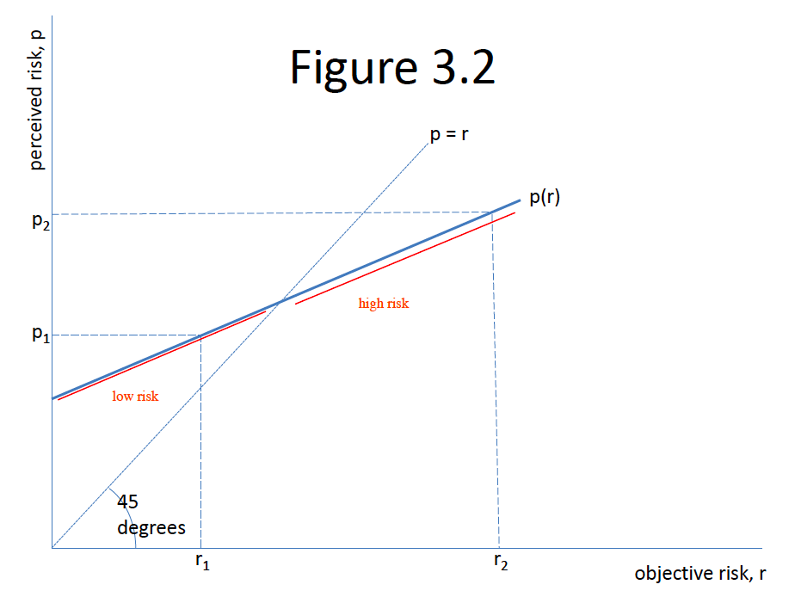
The line p=r represents unbiased risk perception
eg. Where the perceived risk, p, measured on the vertical axis, corresponds to the actual risk, r, on the horizontal axis

The p(r) line represents biased perceptions where low levels of actual risk are perceived to be higher than they are, and high levels perceived to be lower

If the perceptions are biased in the manner represented by the p (r), a reduction in the objective level of risk from r1 to r2 will be perceived as a smaller reduction from p1 to p2
This error in risk perception may explain by food irradiation, a technology virtually all scientists agree can greatly reduce the incidence of foodborne illnesses have not gained wider public acceptance.

Why do we get the wrong perception?
- Bayesian Updating
- Probability dyslexia
  - People are not good at counting statistics
  - 12% of respondents wrongly identified which of two people had the higher risk of death when the probability for each were both explicity written as “five in 1000” and “ten in 1000”

Certainty Equivalent: A guaranteed return that someone would accept, rather than taking a chance on a higher, but uncertain, return. If you've ever thought about leaving your job to start your own business, and potentially make more money, but decided to stay and continue drawing a salary instead, then the amount of your salary is your certainty equivalent. You might need to come up with a business idea with a higher potential payoff to be convinced to leave the security of your existing job.

Conclusion: there is sound theory for including both risk preferences and risk perceptions as determinates of the value consumers place on food risk reduction
Researchers need to be consistent in controlling for both factors when attempting to explain consumer behavior in the context of food risk
--------------
#4: Food Consumption, Health & Obesity
Cross- and within- country comparisons
It is temping to compare the different countries directly. However, the relationship is not that straightforward.
Ex. France has a higher level of calorie and fat supply than Australia, but lower and overweight rates.
Thus, there is no clear deterministic pattern in the cross-country comparison

