The Reproductive System
Lecture Objectives
- What are the purposes of the male and female reproductive systems?
- What do you need to already understand before approaching the anatomy and physiology of the male and female reproductive systems?
- The female system is cyclical whereas the male system is not. What does this really mean? What important differences will allow one system to be cyclical and the other to maintain fairly steady production of hormones and gametes?
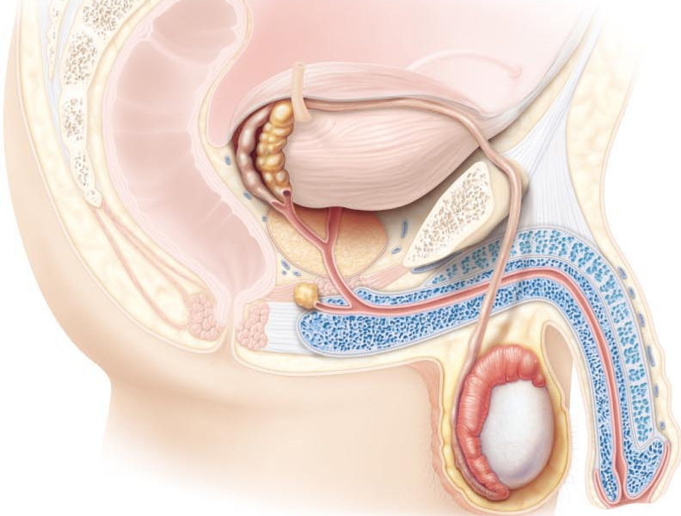
Describe the Anatomy of the Male Reproductive System
Describe the Gross Anatomy & Microscopic Anatomy of the Testes
- Testes located in scrotum: sac of skin + superficial fascia outside abdominopelvic cavity at root of penis
  - Sparse hairs, more heavily pigmented
- Midline septum provides one compartment/testis
- Exterior position provides essential (why?) temp 3⁰ C lower than core
- What are the roles of the dartos & cremaster muscular in testicular temperature regulation? (Fig 27.1)
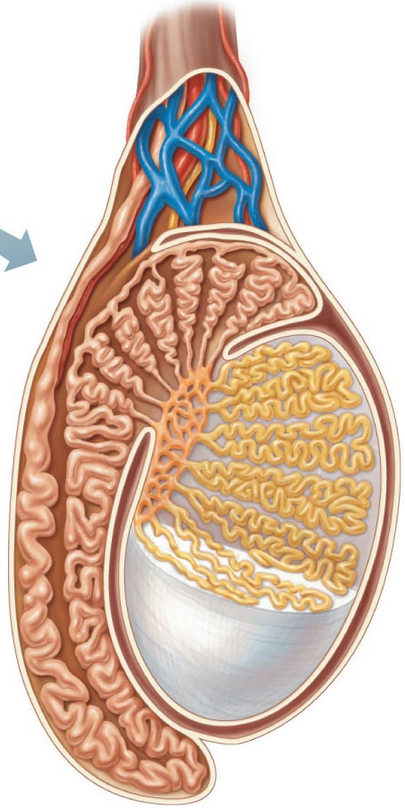
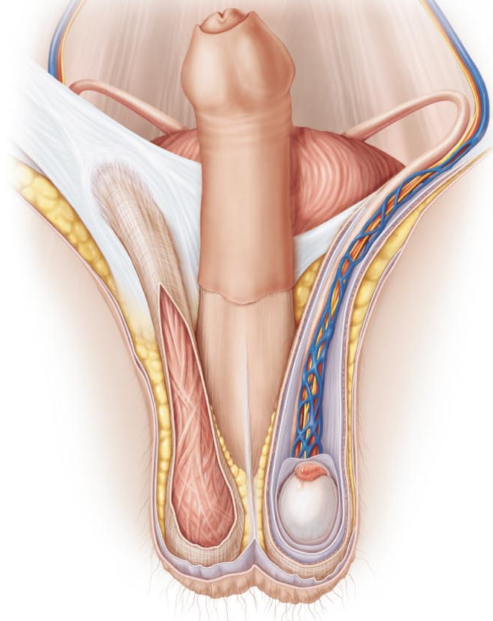
Two Tunics
- Tunica Vaginalis: outer, 2-layered. Derived from?
- Tunica Albuginea: fibrous capsule of testis (white coat); septal extensions divide each testis into 250-300 wedge-shaped lobules
  - Each lobule = 1 to 4 coiled seminiferous tubules (Fig 27.2)
  - Fig 27.3a – seminiferous tubules tubulus rectus rete testes efferent ductules epididymis

- Leydig cells: interstitial cells that produce androgens (testosterone) interstitial means what?
- Blood supply
  - Testicular arteries (branch from abdominal aorta)
  - Testicular veins from papiniform plexus (role?0
  - Spermatic cord: blood & lymph vessels, nerves, vas deferens
- Where are the leydig cells?

Describe in detail the pathway followed by sperm from the epididymis to the exterior of the body
Epididymis (~3.8cm)
- Head caps superior part of the testis (receives sperm from?)
- Body and tail contain highly coiled duct of epididymis (uncoiled =6cm)
- Sperm that enter epididymis are immature, nonmotile
- ~2- days to traverse epididymis gain ability to swim
- What happens to the epididymis during ejaculation?
- What happens to sperm that do not get ejaculated for a long period of time?
- How long can sperm be stored in the epididymis?

Ductus (Vas) Defferens (1/testis)
- ~45 cm long
- Describe the pathway taken by the vas deferens to the point where it becomes the ejaculatory duct
  - Ejaculatory duct passes into prostate gland, then into urethra
  - Each vas deferens propels sperm out during ejaculation
- What is a vasectomy? Are there any risks associated with this procedure?
The Urethra
- Terminal portion, serves both urinary & reproductive system
- What is the prostatic urethra?
- What is the membranous urethra?
- What is the spongy (penile) urethra?

Localize & describe the structure of the male reproductive accessory glands
- Produces secretion that, along with sperm, make up semen

Seminal Vesicles (2)
- Posterior wall of bladder; about size & shape of little finger
- Contribute ~60% of semen volume (yellow, viscous, alkaline; fructose, ascorbic acid, coagulating enzyme, prostaglandins)
- Sperm + seminal fluid in ejaculatory duct

Prostate Gland (1)
- Single gland, size and shapes of chestnut; encircles urethra inferior to bladder
- Milky secretion (~1/3 semen volume; contains enzymes; role in activating sperm)
- Secretion to prostatic urethra via several ducts during ejaculation

Bulbourethral Glands (2)
- Pea-sized, inferior to prostate thick, clear mucus to spongy urethra before ejaculation
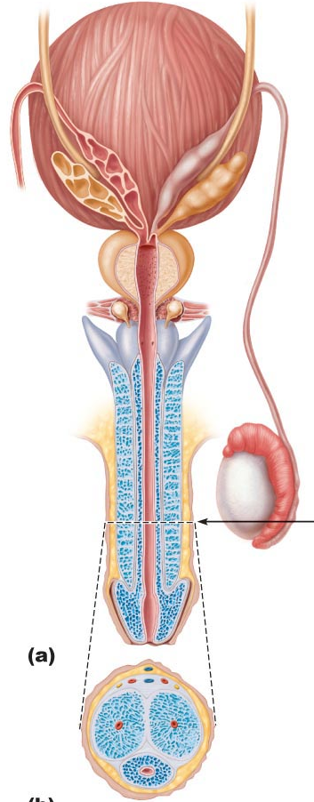
- Purpose?

Describe the structural organization of the penis as a copulatory organ
- Delivers sperm into female reprod tract
- External genitalia = penis + scrotum. Penis = attached root + free shaft or body; enlarged tip = glans penis. Foreskin or prepuce = cuff of skin around glans (circumcision)
- Internally, penis contains:
  - Spongy urethra
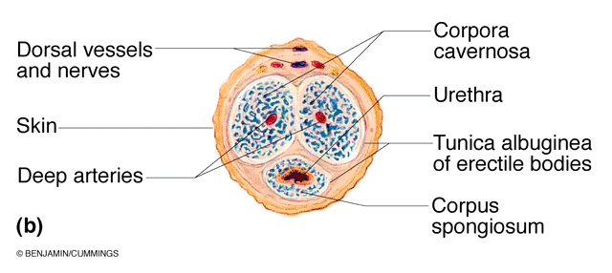
  - 3 corpora of erectile tissue, 2 corpora cavernosa, 1 midventral corpus spongiosum (expands distally glans; proximally expands bulb of penis) Fig 27.4

Describe the composition of semen
- Secretions provide
  - Transport medium
  - Nutrients (eg. fructose)
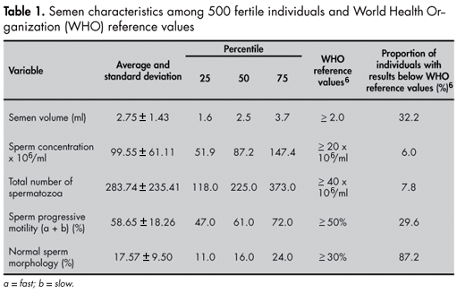
  - Chemicals (eg: PGs) protect/activate sperm
- pH 7.2-7.6 neutralizes pH 3.5-4 of vagina
- Semen: 2-5 ml/ejaculation; sperm = 50-100 million/ml

Semen Analysis

Describe the regulation of male reproductive function- differentiate functionally between Sertoli & Leydig cells
- Normal rate of sperm production 2x10^8 sperm/day
- Testis is a source of both germ cells & hormones
- Testis is composed of:
  - Seminiferous tubules = sertoli cells + spermatogenesis intermediates; 80% of testicular mass
  - Leydig cells: synthesize androgens (testosterone)

Distinguish steroid hormones (both structurally and functionally) from amino-acid based hormones
- Cholesterol progesterone androstenedione testosterone
- What cell type in testis synthesizes testosterone?
Steroids are lipid soluble, derived from cholesterol. Can go across plasma and nuclear membranes

Actions of Testosterone
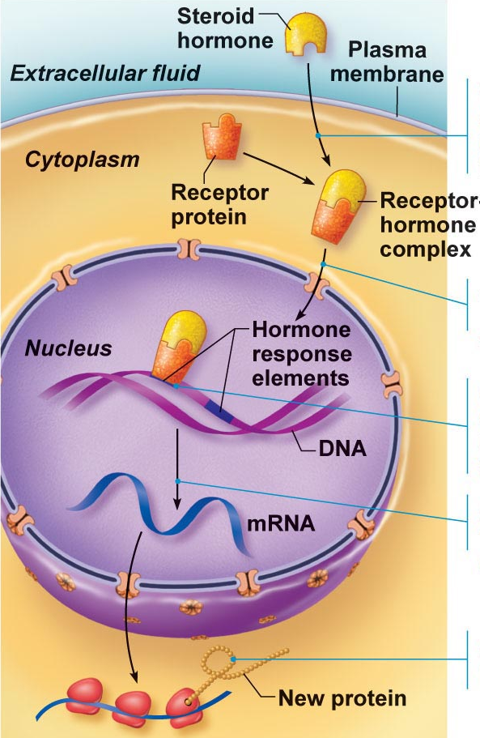
- Gonadal:
  - Growth/maturation of gonads & accessory organs (puberty)
  - Essential for spermatogenesis
- Somatic:
  - Adolescent growth spurt (start and stop – how?)
  - Growth of larynx and vocal cords
  - Secretion of sweat
  - Hair (face, chest, armpits, groin)
- Metabolic:
  - Anabolic: hematopoiesis, BMR
- CNS:
  - Maintenance of libido
  - Aggression

- Steroid hrmones are lipids – significance in terms of their interaction with cells?
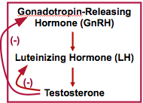
- Testosterone synthesis stimulated by LH (luteinizing hormone) from the anterior pituitary
Steroid hormone going into nucleus and is acting on the DNA

Describe the hypothalamic & pituitary regulation of steroidogenesis in the male
Anterior Pituitary Hormones
- Gonadotropins are glycoproteins
- Water soluble- significance? Cell surface receptors; 2nd messenger > regulate activity of enzymes
- Follicle stimulating hormone (FSH): stimulates sertoli cells to support spermatogenesis (T required)
- Luteinizing hormones (LH): stimulates leydig cells to secrete testosterone
Posterior pituitary is produced of cell endings: oxytocin and another hormone (ADH, NDH?). Made from neurons in hypothalamus. Posterior pituitary is a storage site
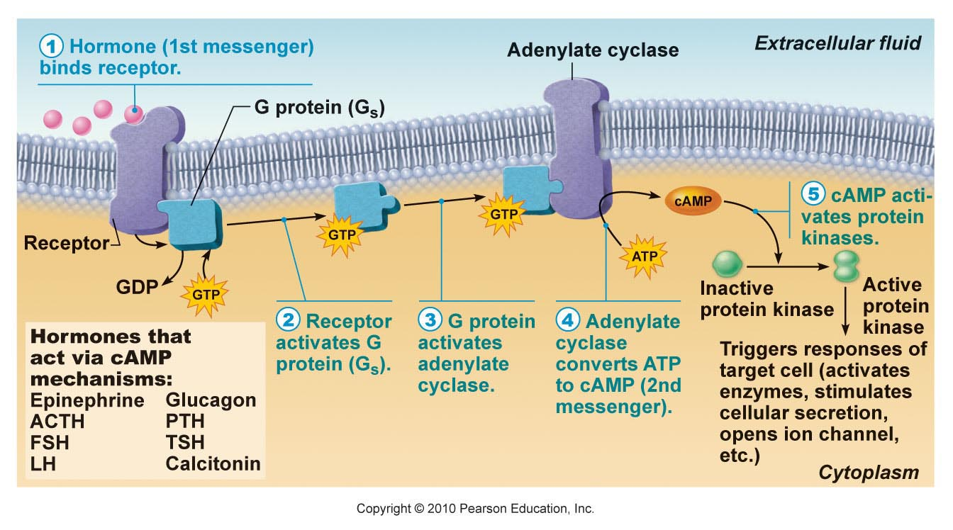
GnRH not a neurotransmitter.

Cyclic AMP second messenger mechanism of water-soluble hormones

GnRH: gonadotropin releasing hormones – pulsatile secretion by hypothalamic neurons
Inhibin: released by sertoli cells, inhibits secretion of only fish
GnRH Frequency of pulses
Inhibin in both sexes, inhibitory effects on FSH, not LH
Rate of release of LH and FSH
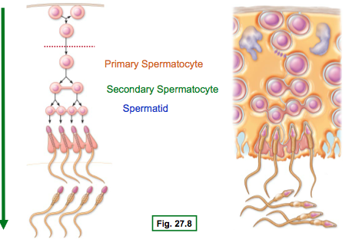
Outline the main steps in spermatogenesis
- Starting point is spermatogonium (diploid)
- At puberty, 6x10^6 spermatogonia per testis; self-perpetuating
  - What does this mean?

From Spermatogonium to Spermatozoan
- Spermatogonium (2N):
  - Starting point; supply constantly maintained
  - First step: spermatogoium B undergoes 2 mitotic divisions
- Primary spermatocyte (2N):
  - Starting point of meiotic divisions
  - First round yields 2 secondary spermatocytes/primary spermatocyte
- Secondary spermatocyte:
  - 2 copies of each of 23 chromatids (eg. if boy, you would have 2 Y chromatids)
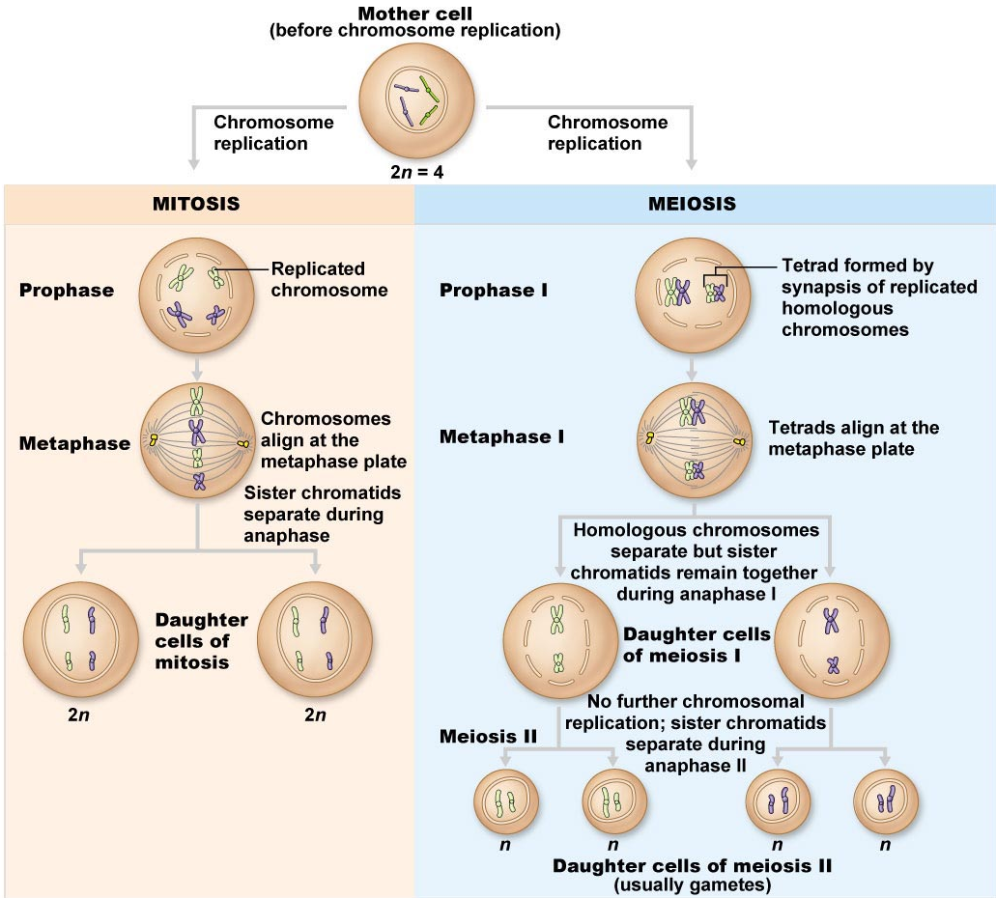
  - 2nd division 2 haploid (N) spermatids
- Spermatid:
  - 22 autosomal chromatids + X or Y – still a round cell

Myotic divisions, make up of cell in mitosis 1 and 2, stem cell population. Don’t need to know the steps (high school)

Spermiogenesis
- From 1 spermatocyte to spermatoxoan takes ~ 70 days
- Spermatozoan: Conversion of spermatid to spermatozoan requires structural reorganization
  - Reorganization of nucleus & cytoplasm
  - Development of a flagellum
- Spermatozoa then released into lumen; still not completely mature
- In epididymis will acquire ability: (2 answers!)

Define Blood-testis barrier & outline the dunctions of sertoli & leydig cells in supporting spermatogenesis
Role of Sertoli Cells
- Spermatids & spermatocytes at various stages embedded in sertoli cells
- Sertoli cells sit on basement membrane; tight junctions create 2 compartments
  - Basal compartment
  - Adluminal compartment
- Tight junctions create blood-testis barrier; all stages after inititaiton of meiosis occur in avascular environment
- Sertoli cells:
  - Nourish developing spermatozoa
  - Secrete fluid into seminiferous tubule lumen
  - Digest cytoplasm discarded by spermatozoa
  - Bind FSH and testosterone
  - Produce inhibin

Role of Leydig Cells
- Located between seminiferous tubules
- Vascuralized – why important?
- Receptors for LH – stimulated by LH to secrete testosterone to:
  - Support spermatogenesis
  - Support accessory organs

Describe the functional contributions of the epididymis and the accessory organs to the production of semen
Epididymis
- Sperm spend ~ 20 days here
- Further maturation – membrane & enzyme changes to permit
  - Sustained motility
  - Binding to egg

Seminal Vesicles
- Secrete vicious, yellow fluid rich in fructose
  - Why fructose?
- Also contains PGs what do they do?

Prostate Gland
- Secrete thin, milky fluid to neutralize acidity of male urethra & female vagina
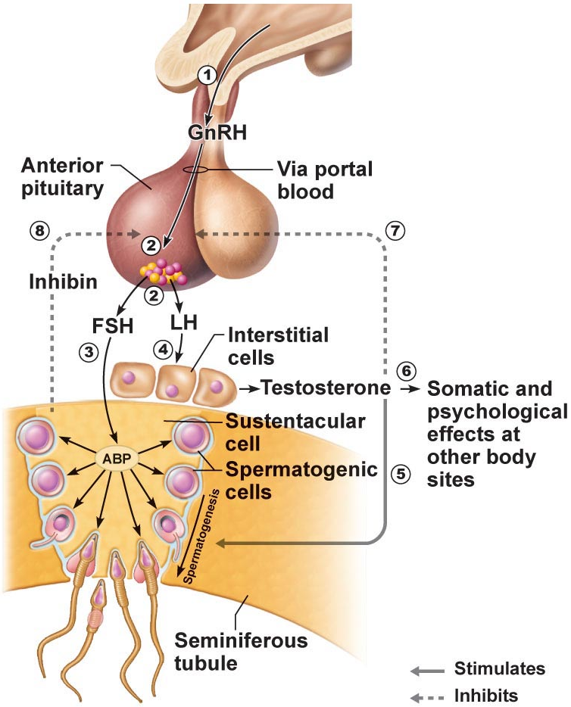
Bulbourethral Glands
- Thick, clear mucus
- Neutralizes traces of acidic urine in urethra

Know the roles of
- GnRH, FSH, LH, testosterone, inhibin
Have an understanding of
- Hypothalamus, anterior pituitary, gonadotropin, sterol cell, leydig cell

1. A chromosome count in a spermatogenic cell within the adluminal compartment of the seminiferous tubule shows it to be diploid. The cell could be a:
a) spermatogonium
b) spermatid
c) Sertoli cell
d) primary spermatocyte
e) b and d
2. Seminal vesicle secretions have:
a) a low pH
b) fructose
c) prostaglandins
d) sperm-activating enzymes
e) b and c
3. Which of the following statements about gonadotropins is FALSE?
a) secreted by the pituitary gland
b) LH and FSH
c) hormones with important functions in both ♂ and ♀
d) the sex hormones secreted by the gonads

FEMALE
Describe the anatomy of the female reproductive system – describe the gross and microscopic anatomy of the ovaries
- Female reproductive system more complex must
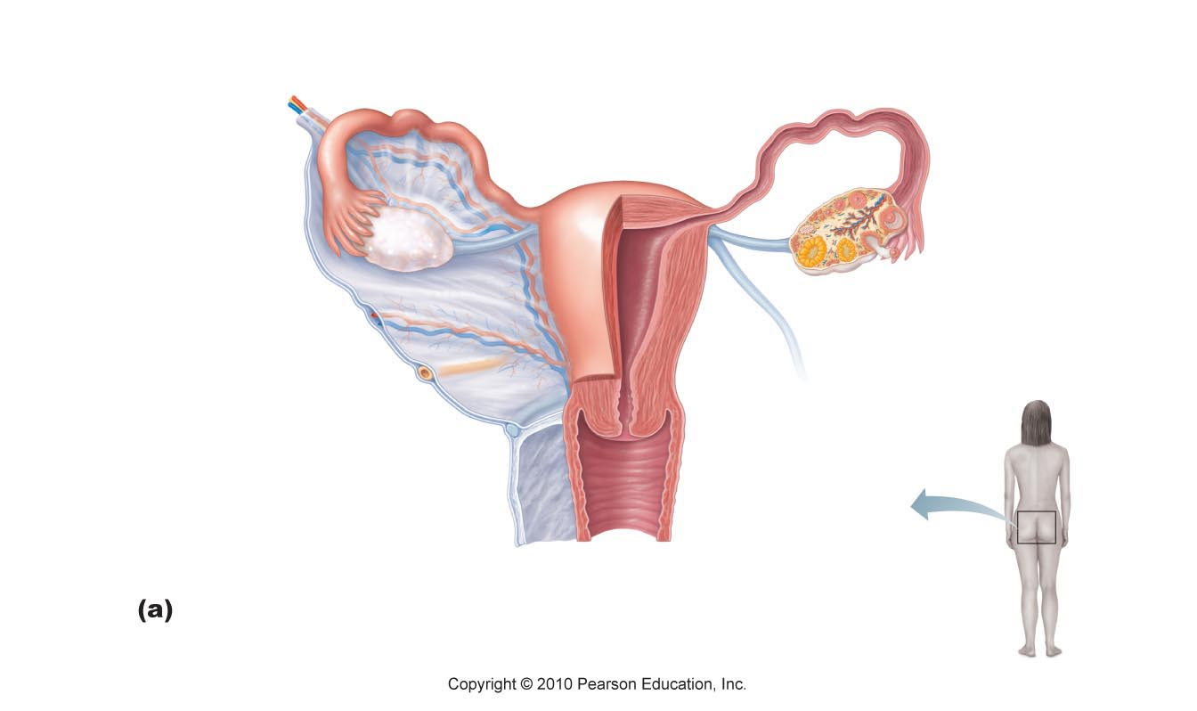
  - Produce gametes

  - Prepare to nurture developing embryo
- Internal genitalia: ovaries
- Accessory ducts: uterine rubes (oviducts), uterus, vagina
- External genitalia: vulva

Ovaries
- Anchored by ligaments (ovarian, suspensory, mesovarium)
  - Suspensory/mesovarium ligaments are part of broad ligament that supports uterine tubes, uterus, vagina
- Ovarian arteries (branches of ???) and ovarian branch of uterine arteries
- Exterior surface covered by tunica albuginea
- Final outer covering is germinal epithelium
- Ovarian cortex contains follicles at all stages of development (oocyte, granulosa cells, theca cells)
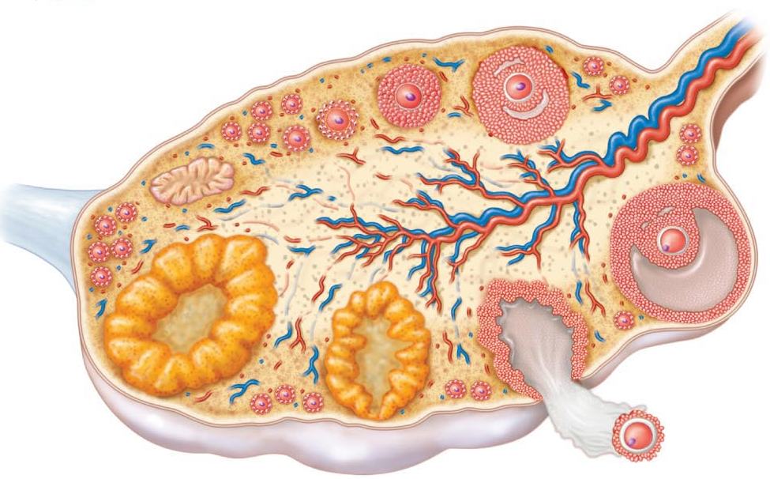
- Corpus luteum formed from ovulated follicle each month

Describe the gross and microscopic anatomy of the oviducts
- Receive egg and provide site for fertilization ; ~ 10 cm long
- Ampulla, infundibulum, fimbriae: oocyte released into peritoneal cavity fimbriae direct it into ampulla of oviduct
- Structure of wall of oviduct also helps oocyte move towards uterus (2 answers)
- Ext covering = visceral peritoneum; supported by mesosalpinx
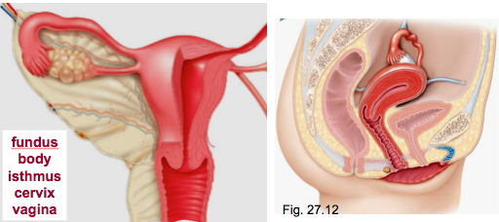
  - What is the isthmus?

Describe the gross and microscopic anatomy of the uterus
- Anterior to rectum & postero-superior to bladder
- Receives, retains, nourishes embryo
- Inverted pear in nulliparous women
  - Internal os: uterus to cervix
  - External os: cervix to vagina
- Cervical glands: mucus fills cervical canal & covers ext os prevents infection; less viscous at midcycle – why??

Supports of Uterus
- Mesometrium: laterally (borad ligament)
- Lateral cervical ligaments: inferiorly; from cervix and upper vagina to lat walls of pelvis
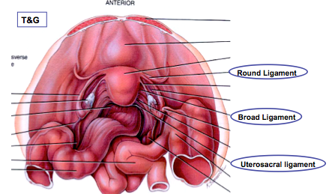
- Uterosacral ligaments: to acrum posteriorly
- Round ligaments: to anterior body wall
  - Supports allow mobility (eg during??)
  - Principal support by muscles of pelvic floor (urogenital & pelvic diaphragms)

Uterine Wall:
- 3 layers
- Perimetrium = visceral peritoneum
- Myometrium = middle, interlacing bundles of smooth muscle
- Endometrium: simple columnar epithelium + thick lamina propria
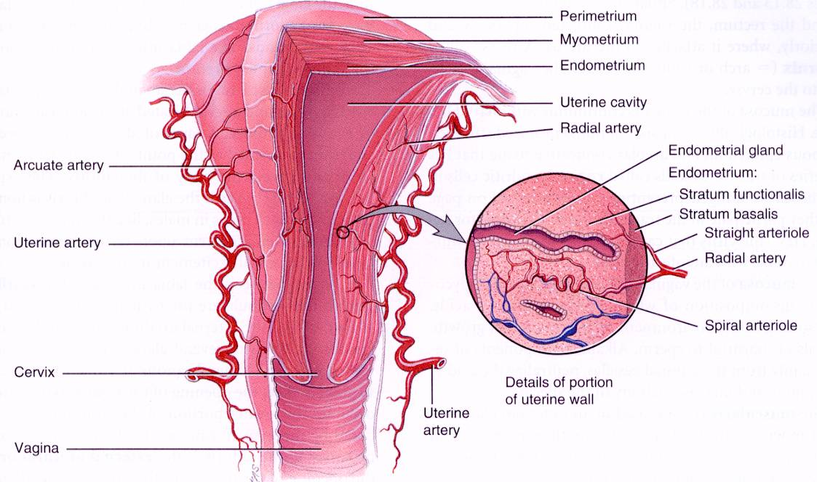
- Stratum functionalis: spiral arteries
- Stratum basalis: straight arteries

Vascular Supply
- Uterine arteries (from iliacs) to arcuate arteries radial arteries within myometrium straight arteries (stratum basalis) or spiral arteries (dtratum functionalis)

Describe the anatomy of the vagina and the external genitalia
- Thin walled tube, 8-10 cm long
- Urethra embedded in anterior wall
- Passageway for: entry of sperm, exit of menstrual flow, delivery of infant
- 3 layers
  - Adventitia: outer, fibroelastic
  - Muscularis: smooth muscle
  - Mucosa: inner, transverse rugaw; stratified squamouous epithelium (why?)
- No glands; lubrication provided by cervical glands
- Epithelial cells store glycogen metabolized to lactic acid by resident bacteria acidic pH deters infection, but is hostile to sperm
- Hymen: incomplete vascular partition of mucosa near vaginal orifice in virgins
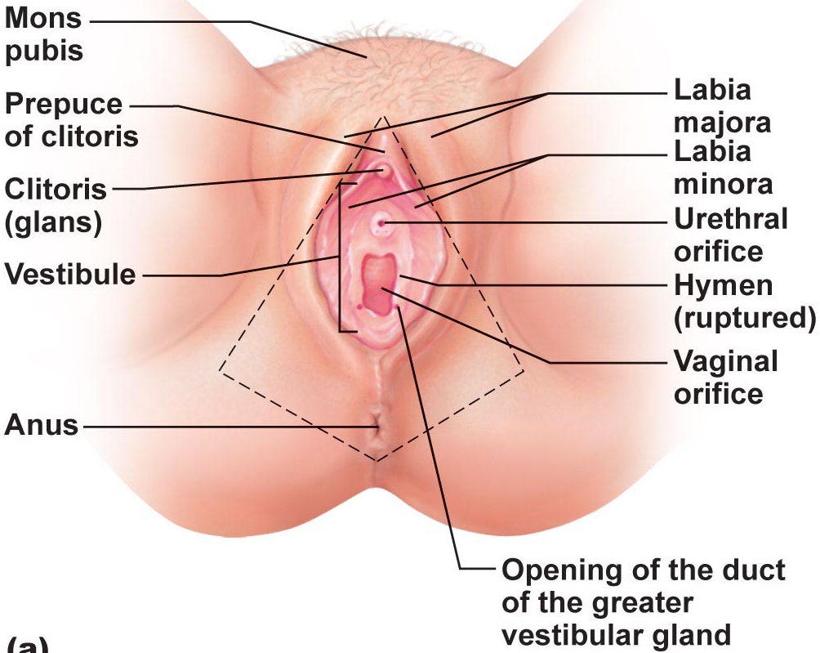
External Genitalia
- Vulva: mons pubis, labia, clitoris, structures associated with vestibule
- Mons pubis: fatty, rounded area overlying pubic symphysis; covered with hair
- Labia majora: elongated, hair-covered fatty skin folds (homologue of scrotum)
- Labia minora: thin, hair-free skin folds enclosed by labia majora
- Vestibule: recess between labia minora - contains external opening of urethra & vaginal opening; greater vestibular glands
- Clitoris: erectile tissue (homologous to penis); hooded by skin fold; richly innervated; corpora cavernosa but no corpus spongiosum

Describe the regulation of female reproductive function – describe ovarian steroidogenesis as a compartmentalized process
General Function
- Ovaries have two key functions:
  - Produce oocytes
  - Produce reproductive hormones (estradiol, progesterone)
- Remember: the hormones a cell can produce depends on the enzyme it has
- Steroids are lipids – can easily traverse PMs
- Cholesterol progesterone; androstendione testosterone estradiol

Describe the hypothalamic and pituitary regulation of steroid hormone production in the female
- There are 3 types of steroid hormones produced in the ovarian follicle
Progestins (eg. progesterone – all have 21 carbons)
- Produced by all major ovarian cell types: follicular granulosa cells, theca cells, corpus luteum
- Most important as a product of the corpus luteum – during luteal phase of menstrual cycle & for maintenance of pregnancy
Androgens (eg. testosterones – all have 19 carbons)
- Most important as a precursor for synthesis of estradiol in developing follicle
- Synthesized by follicular theca cells and by corpus luteum
- Too much testosterone is associated with follicular atresia

Estrogens (eg. estradiol – all have 18 carbons)
- Synthesized by follicular granulosa cells and corpus luteum
- Essential for stimulation of follicular development, onset of puberty etc

Hypothalamic-Pituitary Axis: Anterior Pituitary Hormones
- FSH
  - Stimulates ovarian follciles to grow and produce estradiol
- LH
  - Stimulates testosterone production by theca cells
  - Stimulates ovulation, secretion of steroid hormones by corpus luteum
- Hypothalamus
  - The secretion of both FSH and LH is stimulated by GnRH

Describe ovarian follicular development and its hormonal regulation
- What is the goal of each menstrual cycle?
Primordial Follicle
- Starting point – oocyte surrounded by single layer of flattened granulosa cells
- Oocyte (primary oocyte) arrested at prophase of meiosis I
- By 6 mo postpartum, ovary has full complement of primordial follicles
- ~2 million at birth; gradual loss (degeneration); ~400 000 remain by puberty
- Primordial follicle = oocyte + single layer of flattened granulosa cells
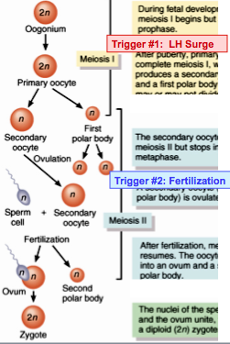
  - Initiation of development of primordial follicles does not require gonadotrophic stimulation – some follicles can and do begin developing at any time

- Oogonia to primary oocytes accomplished by birth
- At what stage are oocytes arrested? What would they look like under the microscope?
- What triggers the resumption of meiosis?
- What is the fate of most primary oocytes?
- What is the fate of most oocytes in which resumption of meiosis was initiated by trigger #1?

From Primordial to Primary Follicle
- Gonadotropin-independent
  - Oocyte increases in size and acquires a zona pellucida
  - Granulosa cells start to divide and form several layers outside oocyte
  - Outside bm ovarian interstitial cells closest to growing follicle differentiate to form theca cells
- Now called a primary follicle – continued maturation of this follicle requires what?

Secondary (Antral) Follicle
- What is an antrum? Why is it important to have an antrum ina maturing follicle?
  - Basement membrane divides follicle into 2 compartments:
- I) Inner granulosa cell compartment
  - Nonvascuralized
  - FSH- responsive – granulosa cell proliferate (E), granulosa cell E production, more FSH receptors
- II) Outer theca cell compartment
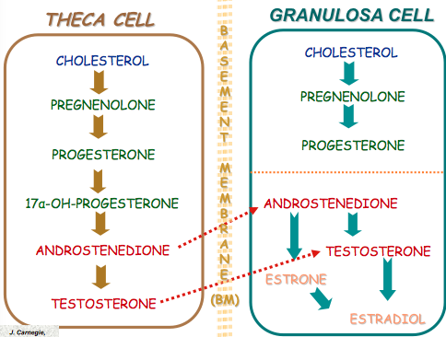
  - Vascuralized
  - LH-responsive – T production for use by granulosa cells

Timing Is Everything!
- If development coincides with rising FSH levels at beginning of cycle development will be supported – otherwise: atresia!
- For one follicle to become dominant, must convert potentially androgenic environment to estrogenic environment – otherwise: atresia!

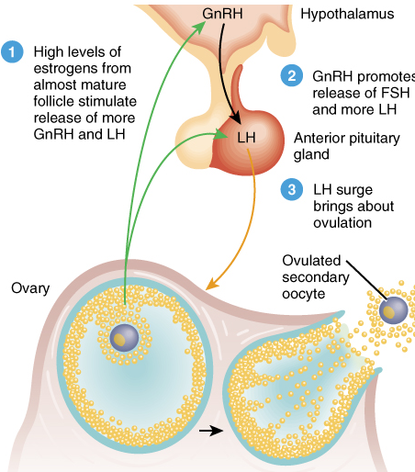
Emerging Dominant Follicle Becomes the Preovulatory Follicle
- E levels continue to rise – FSH switches to inducing receptors for LH LH stimulates further S and P production
- Stage is set for LH surge to trigger ovulation

Describe ovulation and its regulation
LH Stimulates
- Resumption of meiosis- extrusion of PB#1
- P production by granulosa cells
- Increase in antral fluid volume
- Release of hydrolytic enzymes
Minor FSH Surge:
- Ensures sufficient LH receptors for luteal phase
- Stimulates synthesis of hyaluronic acid – important in cumulus expansion
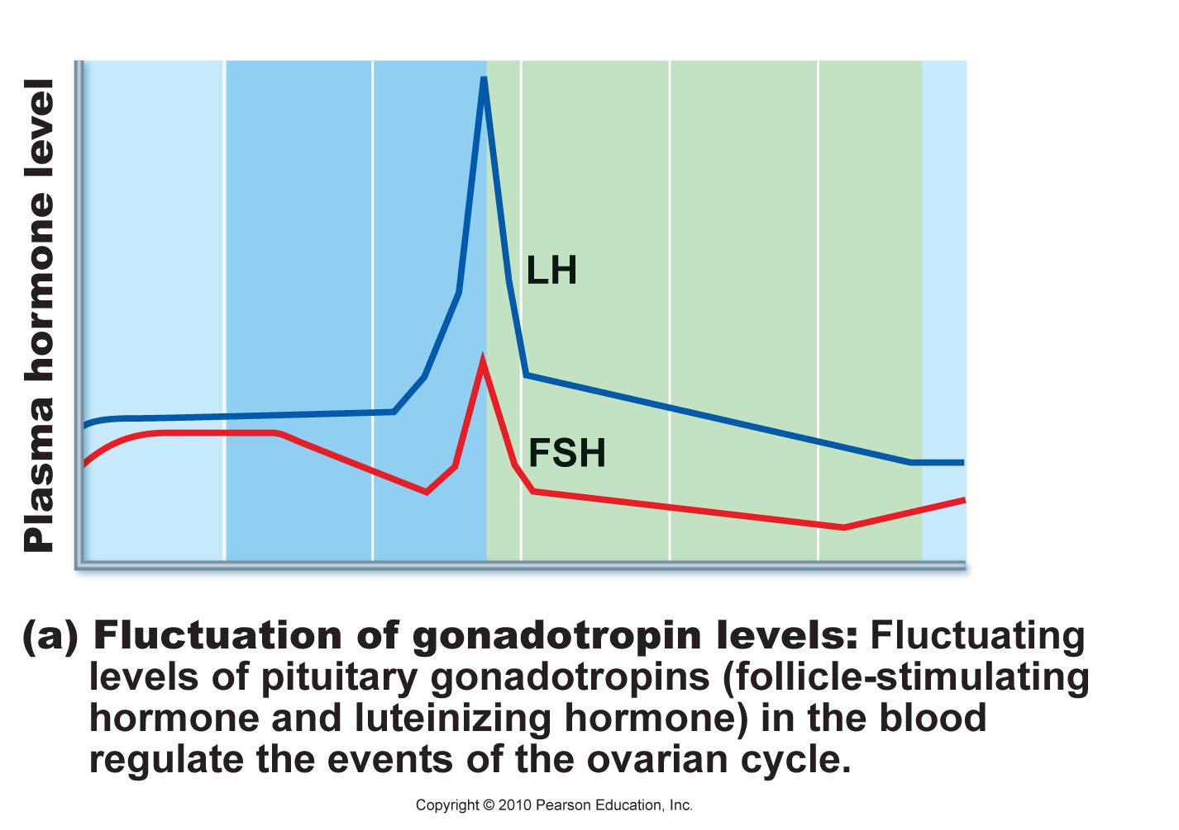
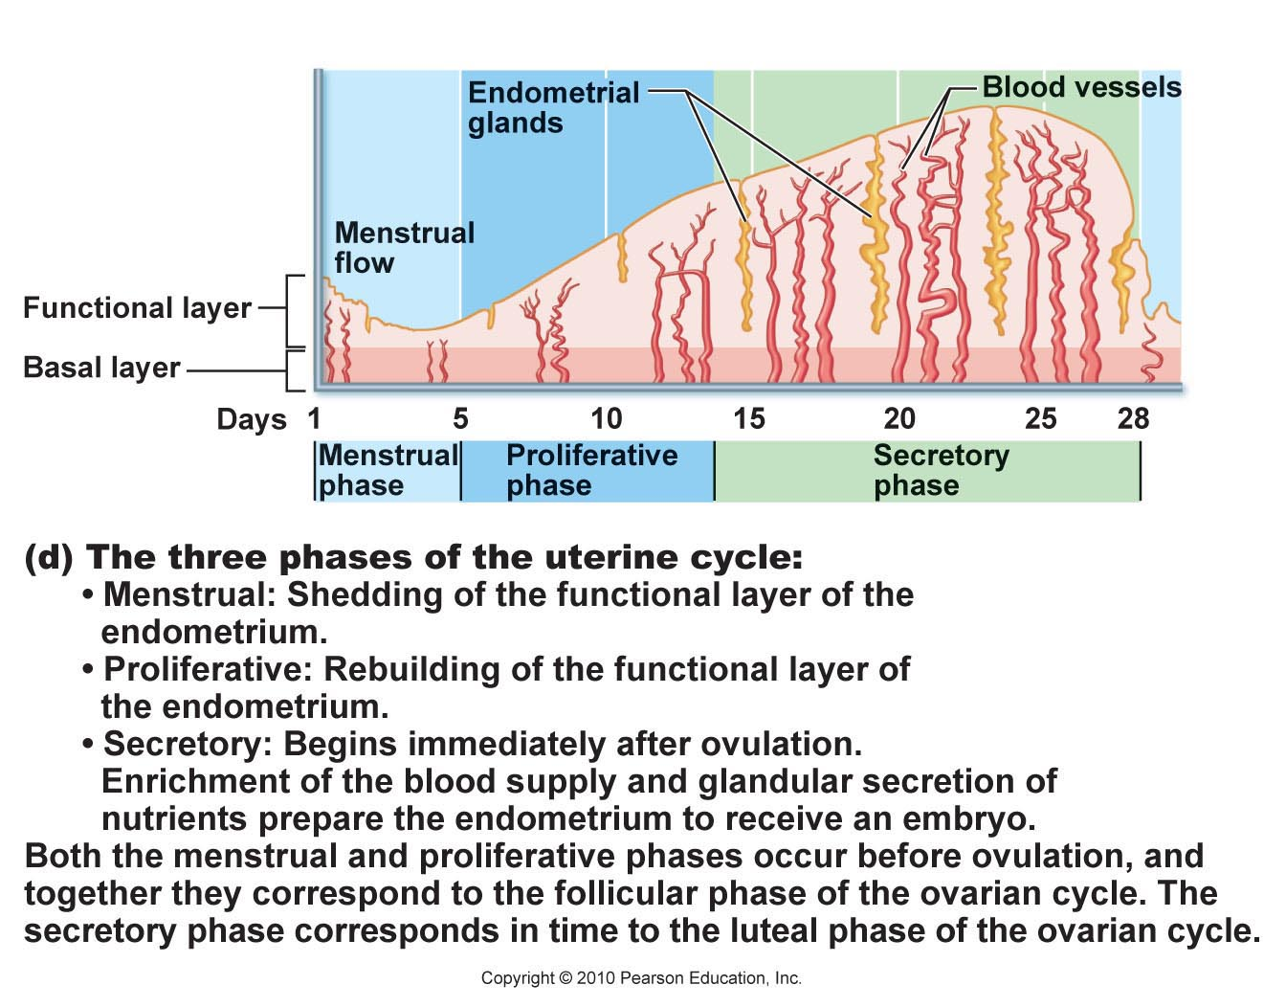
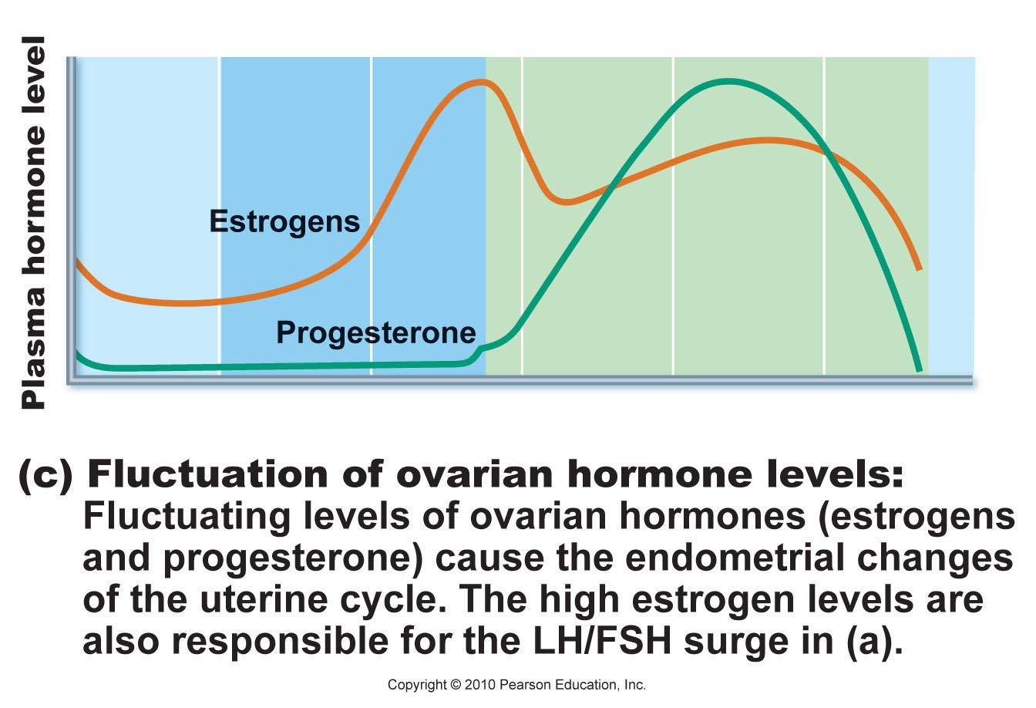
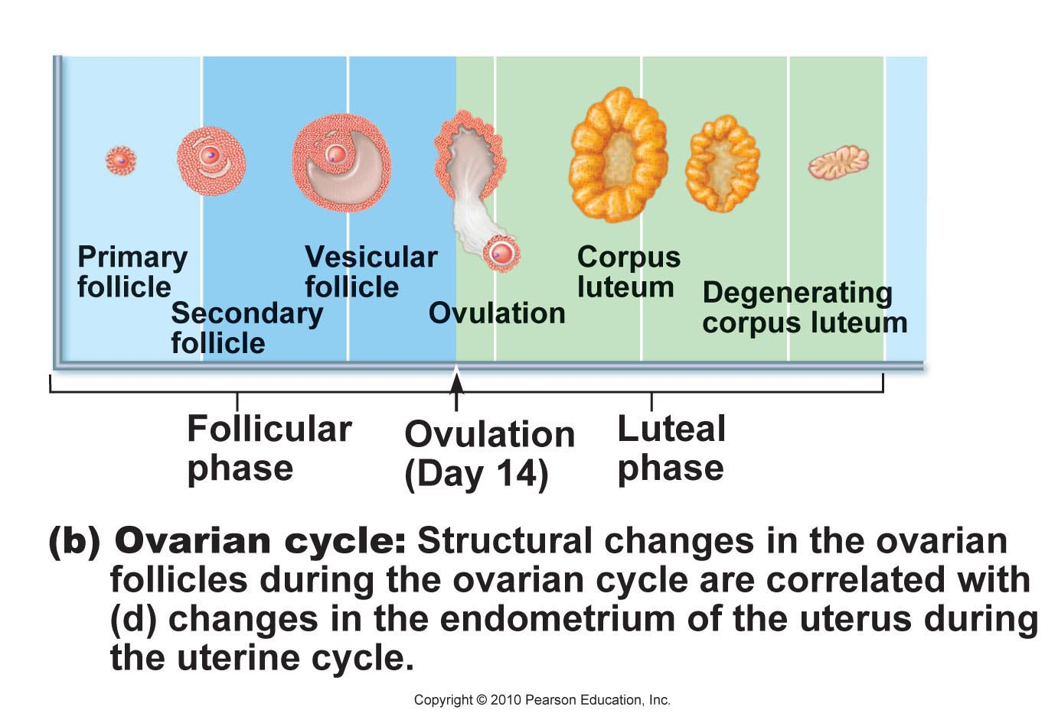
- What are cumulus cells?
- What is a COC?

OVULATION/PREGNANCY
Describe the corpus luteum as a transient endocrine structure
- Corpus luteum = yellow body
- Capillaries bring cholesterol to follicle
- Corpus luteum = lutenized granulosa + theca cells + capillaries
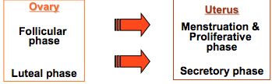
- Unless a pregnancy intervenes, lifespan of CL is < 14 days – what is required to maintain CL?

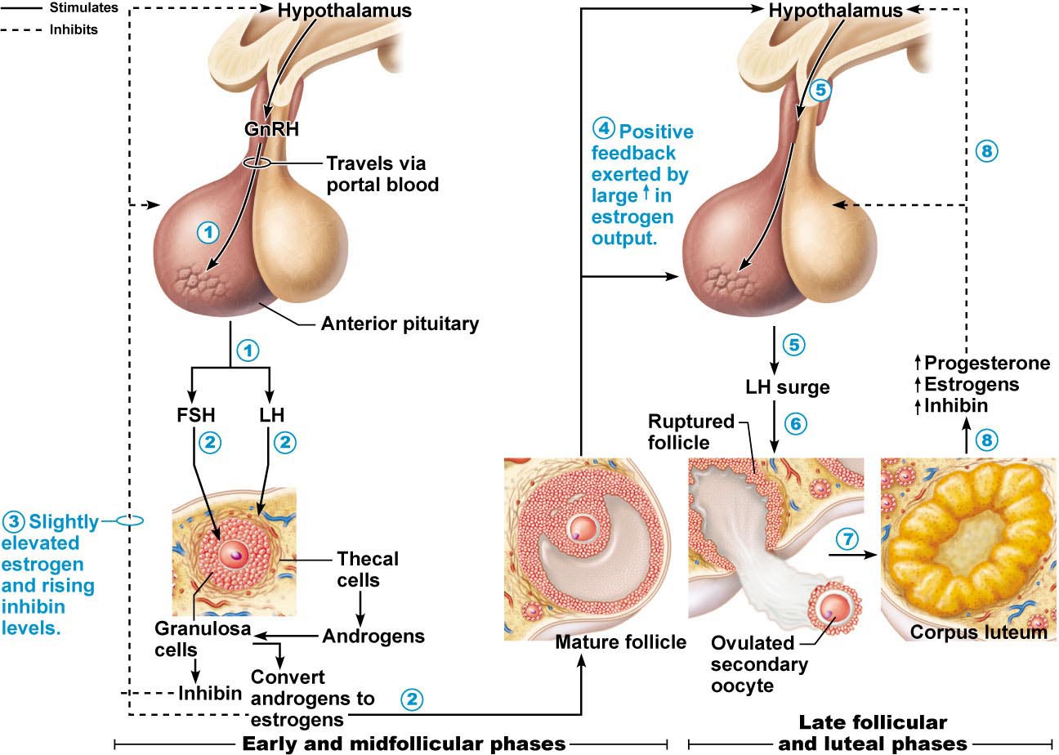
Describe the cyclical regulation of the uterine endometrium
Proliferative Phase
- Resurfacing of epithelium
- Cell proliferation in response to ovarian E
- Development of spinal arteries and uterine glands

Secretory Phase
- Thickening of whole layer due to cell growth and fluid retention
- When is endometrium maximally receptive to embryo implantation? Why is this called the secretory phase?
- As LH levels decline, CL begins to degenerate (~D24) in absence of P secretion, uterine endometrium is shed and cycle beings again
- If oocyte is fertilized: hCG is produced in increasing amounts beginning D9-13 after ovulation; hCG rescues CL until placental P can maintain pregnancy

Outline briefly the hormonal regulation of puberty
- Initial hormonal events are the same in males & females
- In females, FSH stimulates E secretion by ???? cells (LH stimulation provides T precursor from ???? cells)
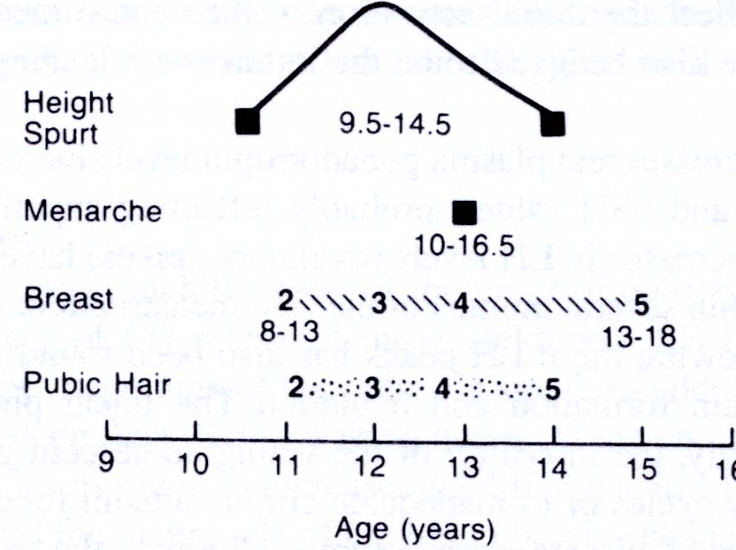
- Estradiol responsible for
  - Growth & maturation of brests, reproductive organs
  - Fat redistribution
  - Bone maturation (growth closure of epiphyseal plates)
- All processes gradually completed over a ~4 year period)
- Cycles of proliferation and regression until sufficient growth occurs that withdrawal of steroid support (due to atresia of what?) results in first menstruation (menarche)
- First ovulatory cycle often may not occur until a few months later
- Concept of a critical weight to reach before menarche: specifically, a critical ratio of fat to lean – why?

Define menopause and summarize its effects on female physiology
- Definition: cessation of menses for at least 12 months
- In north America, occurs at mean age of 51.4 years
- Primary cause is depletion of ovarian follicles

Perimenopause
- Extends from early 40s onward – transitional years
- Ovarian function begins to wane – deprivation of estrogen (and its effects on FSH/LH secretion) can result in: hot flushes, insomnia, irritability, fatigue, headaches, depression/mood changes, loos of libido, poor mental performance/nervousness, loss of skin elasticity
- Menopause: median age of 51.4 years; can live 1/3 of life after ovaries have ceased functioning

Describe the process of oocyte fertilization & summarize the main features of early embryonic development up to implantation
- For how long after ovulation is an egg capable of being fertilized?
- How long do sperm remain viable in the female reproductive tract?
Defined sperm capacitation & indicate its relevance to fertility
- A further maturation sperm must undergo to be capable of fertilizing an egg
- Occurs following ejaculation once sperm in female tract
- Seminal fluid contains capacitation inhibiting factors
- After capacitation, sperm:
  - Have increased rate of flagellar beat and accelerated motility pattern
  - Plasma membranes are more fragile facilitates acrosome reaction
- IVF: can induce capacitation by washing sperm or running them through a Percoll gradient. What is this process accomplishing?

Describe the acrosome reaction
- Zona pellucida can bind many sperm but only 1 sperm fertilizes the egg
- Of ~300 M sperm in ejaculate, only few hundred get close to oocyte (where is it?)
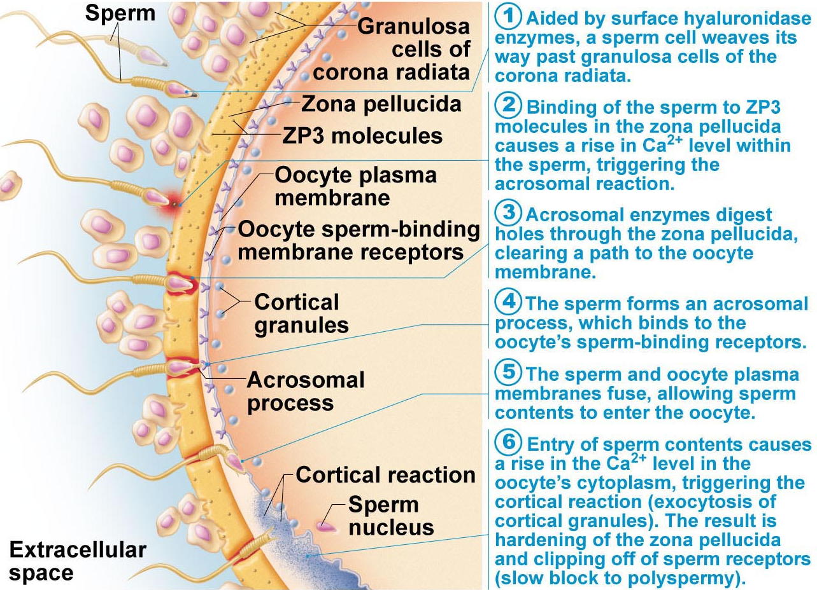
- Binding of sperm to zp induces acrosome reaction: what happens and why is this important?
- Why is it important that this happens only after sperm has bound to zp?

Define polyspermy & briefly describe the fast & slow block to polyspermy
- As soon as first sperm penetrates perivitelline membrane:
  - Fast block to polyspermy:
  - Slow block to polyspermy:
  - Resumption of meiosis, extrusion of 2nd PB, formation of female pronucleus
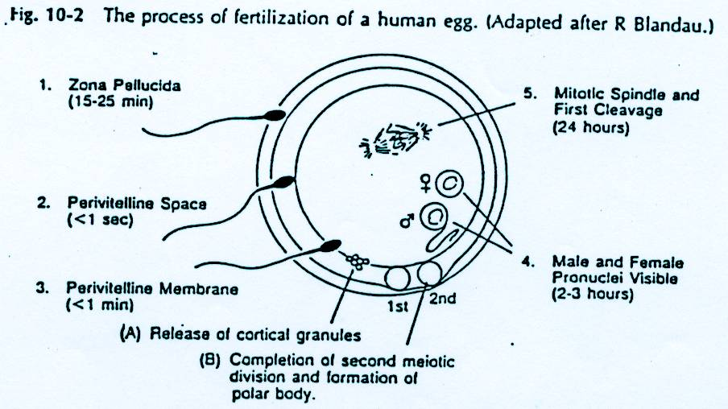
  - Sperm nuclear material forms male pronucleus; male and female pronuclei fuse to from 2N nucleus of zygote

Define zygote; summarize the developmental steps that occur while the embryo is traversing the oviduct
Define morula, lastocyst, hatching
- Implantation beigns on ~6th day following fertilization:
  - Blastocyst burrows into endometrium
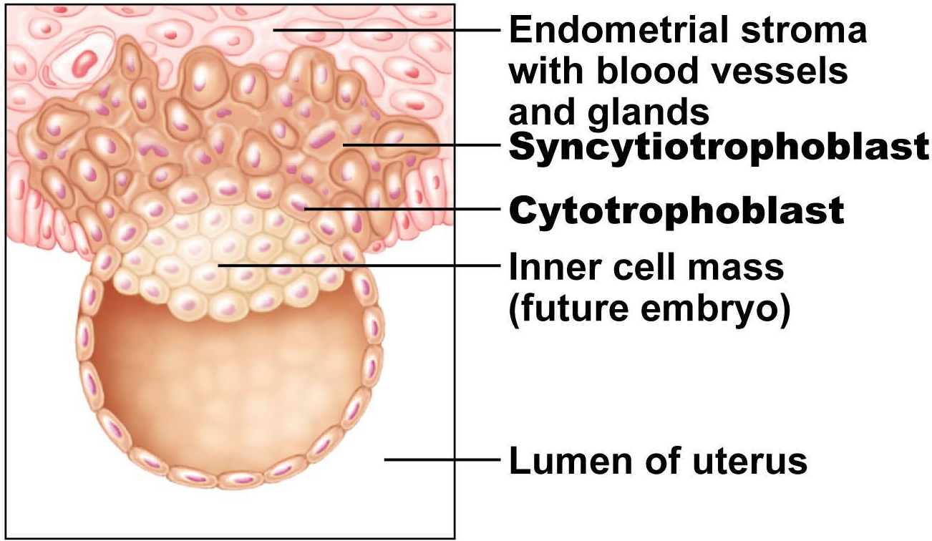
  - Trophoblast cells grow out toward mat blood vessels
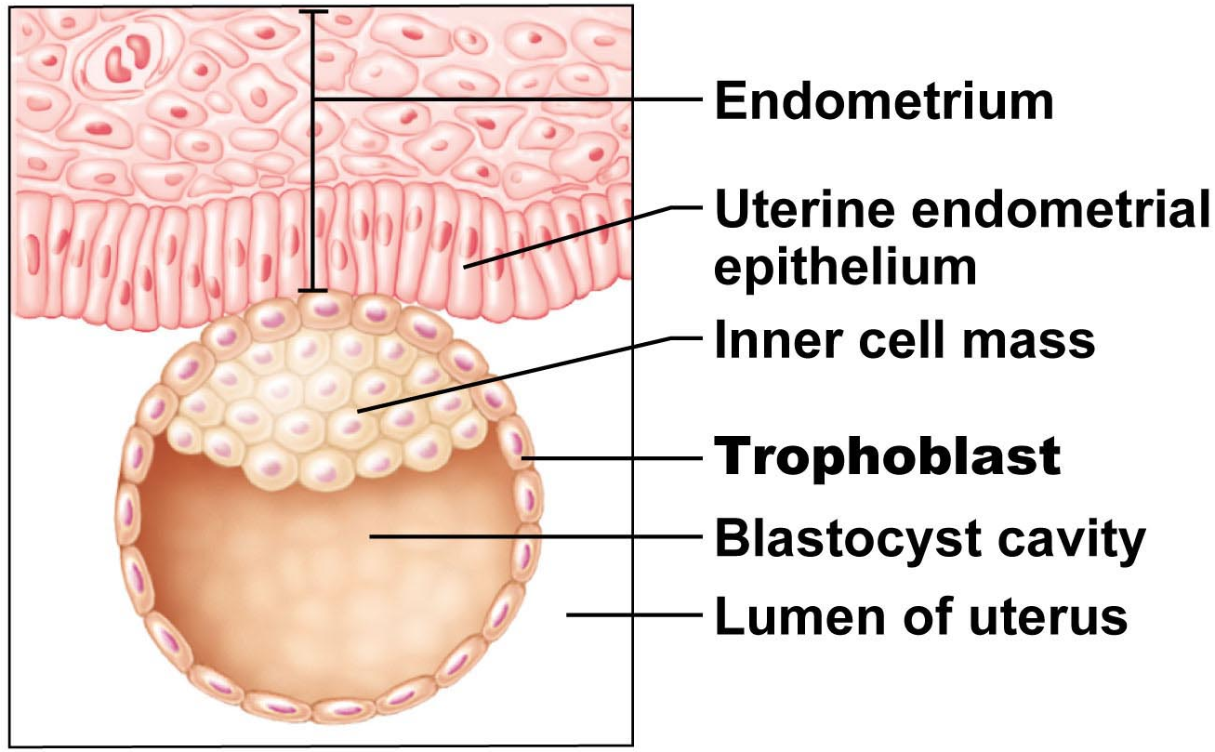
Conception to 2 weeks – Germinal Period
3 to 8 weeks – Embryonic Period
9 weeks to term – Fetal Period
3-8: critical weeks. All the fundamental systems are developed. When embryo is most susceptible to the environment. Fetal period a lot of growth to live outside, embryonic about development

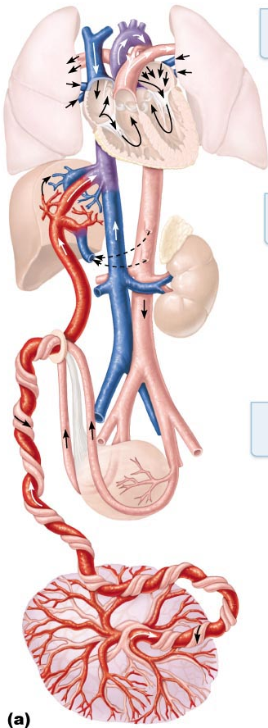
Summarize the hormonal regulation of pregnancy, parturition and lactation
Placentation
- Maternal and fetal blood supplies not in direct contact; nutrients, gases, wastes diffuse through
  - Trophoblast
  - Mesenchyme
  - Fetal capillary endothelium
- Normal term placenta is ~500 g, measures 15-20 cm diam, 2-3 cm thick
- Umbilical cord usu 50-70cm in length; contains 2 umbilical arteries, 1 umbilical vein
- What is the foramen ovale? What is the ductus venosus?
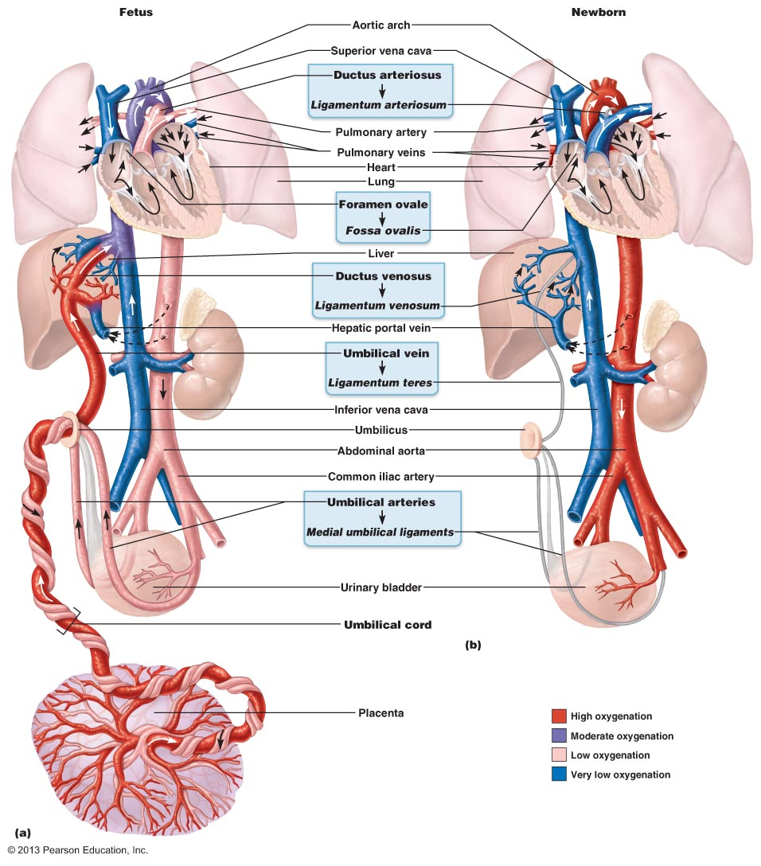
3 cell layers to separate fetus and maternal, fetal in origin. Placenta blood system a lot like pulmonary.
No oxygen circulation because lungs are not developed. Hepatic and polmunary circulation is developed once it is needed.
Foramen ovale - direct pathway between left andright atria. Closes over after birth (fosa novale?)
Ductus venous- Blood bypasses the liver, blood to keep going to other areas of the body. Will regress and have hepatic circulation that travels from digestive to liver. GI tract and lungs arent functional and change after birth to allow for circulation
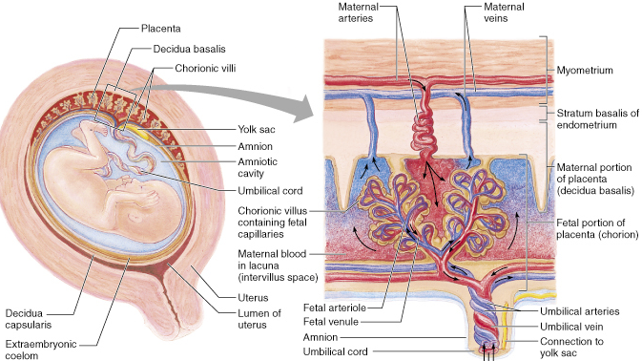
Describe the dual functions of the placenta: endocrine and exchange
Exchange occurs by difusion, oxygena nd nutrient rich blood will travel back to fetus and all through fetus circulatory pathway.

Hormones: Human Chorionic Gonadotropin (hCG)
- Present in maternal serum by 8th day after fertilization; levels peak by ~60-80 days, then begin to decrease
- What is the primary function of hCG? How does this relate to the timing if its production and secretion by the developing embryo/fetus?
- Can detect pregnancy by 3 days after missed period
- Based on detection of hCG in blood or urine
HCG structurally similar to LH to bind and rescue corpus suetyium ?

Human Placental Lactogen (hPL)
- Structurally similar to GH & prolacting (human chorionic somatomammotropin, hCS)
- Placenta begins to secrete hPL during 1st trimester; levels increase until delivery
  - Stimulates breast development in preparation for postnatal lactation
  - Supports fetal bone growth
  - Makes glucose available to fetus = diabetogenic or anti-insulin effect

Estrogen
- Initially come from corpus luteum; function gradually assumed by placenta
- Placenta converts circulating androgens (fetal and maternal adrenal glands) to estrogen
- Initially estrone and estradiol-17 then estriol
  - Maintains uterine endometrium
  - Contributes to breast development
Not produced as early in pregnancy, developed in first trimester.

Progesterone
- Initially from corpus luteum; function gradually assumed by placenta
- Levels gradually increase over the course of the pregnancy
- A relaxing effect on smooth muscle
  - Uterus: relaxes, reacts by contracting and pushing back
  - Blood vessel walls: vasodilation, blood volume increases but maintain bp
  - Ureters: slow urine flow, increased risk of UTI
  - GE sphincter: heartburn
  - Intestines: constipation, more fiber
Progesterone, really important, supports pregnancy. Not specific to uterus, will have relaxing effect on all smooth muscles

Outline briefly the influences of pregnancy on the CV< digestive, urinary and reproductive systems of the mother
Cardiovascular
- Bp decreases slowly to nadir @ 24 weeks; then slowly back up to NP values
- Pulse slowly increases to max of 15-20 beats/min above NP in 3rd trimester
- Myocardinal hypertrophy, increased contractility
- Overall increase in blood volume (~40%): plasma by ~45% and RBCs by 20-30% what is the physiological anemia of pregnancy?

GI Tract
- Nausea: increase progesterone, hCG, both?
- When severe: hyperemesis gravidarum; if untreated can lead to dehydration, ketosis, electrolyte derangements, liver and kidney damage
Heart will get slightly larger

Urinary Tract
- Kidneys increase in length by 1-1.5 cm (increased renal blood flow)
- Bladder tone decreases; bladder capacity nearly doubles
- Glomerular filtration rate (GFR) increases by 30-50% in first trimester
- High progesterone promotes renal Na (and water) loss; but increased aldosterone and estrogen promote salt and water retention
- Increased risk of urinary tract infections – why?
UTI= slower flow of kidney in urether and urethra, high blood glucose level.

Cervix
- Softening and increased vascularity from early in 1st trimester
- Increased production of mucus by endocervical glands

Vagina
- Cervical secretions increase in quantity; decrease in pH (high estrogen)
- Increased susceptibility to vaginal candidiasis (fungal infection, high estrogen, high glycogen)

Uterus
- Enlarges by hypertrophy from 50-70 g (NP) to ~1000 g at term (effects of estrodiol & progesterone)
- During 2nd trimester, uterus moves out of pelvis & begins to displace intestines up
- By 36th week, intestines pushed up to just beneath diaphragm discomforts experienced by mother include short of breath, heart burn and constipation
- Blood flow to uterus at term ~500-750 ml/min (10x NP level); = 10-20% total CO
- Contracts every 5-20 min during pregnancy; irregular contractions that are not coordinated = Braxton Hicks contractions
Short of breath because no room in diaphragm
Contraction occurs in isolation events, different areas of uterus. Not coordinated, painful or everywhere its nothing (just practice)

Reminder of the importance of good nutrition during pregnancy
- Balanced diet (protein, carbs, fats, vitamins, minerals, fiber)
- Important vitamins include vitamin D (absorption of Ca, bones), folic acid (spinal cord, cell replication), vitamin K (blood clotting)
- Important minerals include iron (hemoglobin in RBC) and calcium (skeleton)

List the 3 stages of parturition
- Whole process is not completely understood – esp. what is the signal to initiate parturition and how can we stop premature labour and delivery??
- Estrogen levels highest toward time of parturition:
  - Lots of oxytocin receptors on myometrial cells
  - Antagonizes relaxing effect of progesterone
- Two hormones important during labour and delivery:
  - Oxytocin – source? Posterior pituitary, important for contractions
  - Prostaglandins – source?
- Stages:
- DILATION: uterine contractions dilate cervix up to 10 cm; variable in duration
- EXPULSION: complete cervical dilation to birth (minutes to few hours)
- PLACENTAL: delivery of placenta;15 min after birth
Estrogen overcomes progesterone for removal of fetus. Estrogen levels, stimulates up regulate oxytocin receptors to interact with cells and overcome relaxing effect of progesterone. Stored pituitary, made in hypothalamus
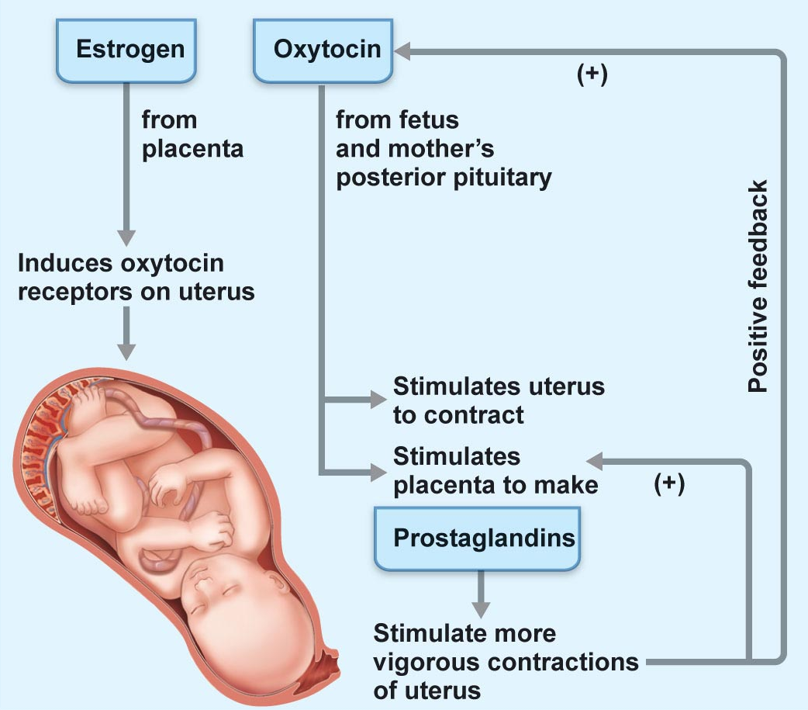
Prostagladings produced in uterus, act in uterus wall for contraction

Summarize the neuroendocrine regulation of the onset and completion of parturition
- Baby moves into birth canal; pressure of head on cervix neuroendocrine reflext – result?
- Oxytocin stimulates uterus to synthesize prostaglandins effects?
- Oxytocin levels are high during latter part of pregnancy, but labour not initiated because
  - Progesterone levels also high
  - Insufficient oxytocin receptors
No homeostasis of labour, positive feedback with hormonal and neural component

Describe pregnancy-associated preparation for lactation and the roles of prolactin and oxytocin in supporting production of milk let-down
Hormonal Regulation of Breast Development
- During pregnancy
- Alveolus: glandular structure involved in milk production; lined by a single layer of milk-secreting epithelial cells
- Each mammary gland divided into 15-20 lobes; subdivided into lobules; basic component of each lobule is the alveolus
- Estradiol and progesterone levels increased during pregnancy stimulate further growth and development of alveoli and ducts also permissive actions of glucocorticoids, prolactin, human placental lactogen
- Prolactin stimulates milk production; actual secretion during pregnancy inhibited by high levels of prolactin and oxytocin
- Postpartum: levels of estradiol and progesterone drop, allow full expression of ? now can have both production and secretion

Explain how lactation is maintained
Classical Milk let-down reflex and hormonal maintenance of lactation
- Two important hormones
  - Prolactin secretion of casein, lactose, fatty acids
  - Oxytocin contraction of myoepithelial cells
- Both of these hormones required for continued lactation
Prolactin increases in pregnancy, birth, then decreases. Increases again when it suckles, burst of prolactin secretion to produce more milk. Baseline gradually goes down so 3 months after its low


