- What is information?
  - Information is “that which reduces uncertainty”
  - Data is only information if conveys knowledge that was otherwise unknown
  - There must be an element of uncertainty involved for a message to contain information
    - If an outcome is known for certain, than knowledge of that outcome does not provide any information
  - The greater the element of uncertainty, the greater the potential for a device to store information

- Quantitating Information
- Uncertainty = log₂M
  - where M is the # of possible symbols
  - log “base 2” is arbitrary, by using base 2 the units of information is in ‘bits’
    - bits are generally used as it provides the minimum number of characters that would have to be designated to each symbol in order to have an unambiguous representation of the code, when using only 0s and 1s (binary)
- Maximum information content of any sequence = L*[log₂M]
  - where L is the length of the sequence

- Example:
- For DNA, there are 4 possible symbols (A, T, G, C)
- Uncertainty = log₂4 = 2 bits

- For the insulin gene, the DNA sequence is 1789 nucleotides long
- Information = 1789 * [log₂4] = 1789 * 2 = 3478 bits

- DNA carries biological information
  - It was found that a heat-degraded cell (reduced to debris of cellular components) was able to convey information to other cells
    - When chemically analyzed, it was found that this mixture contained ~99% DNA, and ~1% of lipids, proteins, RNA, and other compounds
  - When treated with enzymes to selectively degrade proteins, lipids, RNA, or DNA, it was only when DNA was degraded that the ability to convey information was hindered
    - This suggests that it is DNA itself that carries and conveys biological information
  - A separate experiment that used colonies of phage with either radioactively-labeled DNA or radioactively-labeled protein showed that when a phage infects a host cell, it is the DNA that carries the genetic information that is injected

- Chemical Structure of DNA
  - DNA consists of:
    - phosphoric acid
    - 2-deoxyribose sugar
    - a nitrogenous base
      - purines: adenine (A) and guanine (G)
      - pyrimidines: thymine (T) and cytosine (C)
  - 3’ hydroxyl attacks the alpha-phosphate attached to the 5’ carbon of a dNTP to form phosphodiester linkages, creating an ordered DNA sequence
  - In the DNA double-helix, there is a vertical distance of 3.4 angstroms between each base pair, and 34 angstroms in a full turn of the double-helix (from major groove to major groove, or minor groove to minor groove)
  - The natural structure of the double-helix forms an alternating sequence of major and minor grooves
  - Chargaff’s Rule: for nearly every organism, the ratio of A:T and G:C are both approximately 1 (accounting for experimental error)
    - A can only base-pair with T, forming two hydrogen bonds
    - G can only base pair with C, forming three hydrogen bonds
  - This means that with only one strand of DNA, the other strand can be accurately derived, with no uncertainty, by complementary base-pairing rules
    - This is how DNA replicates itself in cellular division

- The Flow of Information in Biological Systems
  - 1-dimensional DNA -> 3-dimensional protein -> 4-dimensional cells (neurons) -> 4-dimensional human brain
  - the conversion of DNA to proteins, by the processes of transcription and translation, is fairly well-understood
  - the subsequent transfers of information, from proteins to neurons and from neurons to the brain, are not as clearly understood
  - we do know, however, that all the way up to the brain processing (learning, memory, consciousness, and development) the information for these functions can be derived from the initial 4-base genetic code in DNA

- An Appreciation of Scale
  - While DNA is approx. 2 nm in width, the length of individual chromosomes is on the order of centimeters; the entire human genome would be approx. 2 m if all the DNA in a single cell were stretched from end to end
  - 1 angstrom = 10⁻¹⁰ m = 10 nm
  - the angle between the glycosidic bonds forms the major and minor grooves
    - angle for minor grooves is 120 degrees
    - angle for major grooves is 240 degrees
  - B-DNA represents only one of the possible conformations that a DNA double helix can form
    - B-DNA is a right-handed helix
    - Z-DNA is a left-handed helix
  - B-DNA and Z-DNA are the two most prevalent naturally occurring forms of DNA
    - B-DNA is predominant form in vivo
    - Z-DNA forms in vivo, but only transiently
    - A-DNA only exists in vitro

- Biological Function of Z-DNA
  - The biological role of Z-DNA is not yet fully understood, but there is evidence to suggest Z-DNA may have a functional role in cells
  - Z-DNA is formed transiently in association with transcription
  - Several proteins identified with highly specific Z-DNA binding activities
  - Antibodies to Z-DNA bind transcriptionally active regions

- Flexibility in Helical Structure
  - The double helix is able to separate into two individual strands without disrupting covalent bonds
    - Makes it possible for strands to separate and reform under physiological conditions
    - Important for DNA replication, transcription, and also for DNA repair mechanisms
  - Base Flipping
    - enzymes involved in DNA repair may scan for DNA lesions by flipping out bases
    - important in base mismatch repair
  - Topology
    - In the absence of topological constraint, the DNA strands can be freely separated
    - Topological constraint prevents the two strands of a DNA double helix from being separated (they are fixed together in some way)
      - Can be by being wound into a complete circular double helix, or by a linear strand being held together by proteins
    - In a constrained double helix, torsional stress induces supercoiling
      - Supercoiled DNA an be overwound (+) or underwound (-)
      - Relaxed (non-supercoiled) DNA has approx. 10.5 bp per turn of the double helix
        - Number of turns = linking number
      - Overwinding or underwinding induces extra energy into the double helix, which can be dispersed in two ways
        - Partially serrate the strands
        - Introduce supercoils
      - Living organisms store their DNA with negative (-) superhelicity (underwinding), since there are many instances in which it is advantageous to drive the unwinding of the double helix
        - E.g. DNA replication, transcription
        - Very few organisms (mostly found in hot springs) that can store energy with (+) positive superhelicity, used in order to prevent DNA denaturing at the high temperatures
      - Prokaryotes use negative (-) supercoiling to compact their DNA

- Chromosome Structure
  - Chromatin is the complex of DNA, chromosomal proteins, and other chromosomal constituents isolated from nuclei
  - Composed of DNA, protein, and some RNA
    - Proteins can be histones or non-histone proteins
    - RNA is only present as a product of transcription; it does not have a structural role
  - Histones are small proteins with basic, positively-charged amino acids (lysine and arginine)
    - Bind to and neutralize negatively-charged DNA
    - Make up 50% of chromatin protein by weight
    - 5 types of histones: H1, H2A, H2B, H3, H4
      - octamer of 2x H2A, H2B, H3, and H4 make up nucleosome core
    - DNA and histone synthesis are regulated so that they are both synthesized together during the S phase
    - Histone proteins are very highly conserved throughout many organisms
  - Non-histone proteins are a diverse group of proteins
    - Make up the other 50% of chromatin proteins
    - Large variety of functions, including:
      - Scaffold (backbone of chromosome)
        - These are structural non-histone proteins
      - DNA replication (e.g. DNA polymerases)
      - Chromosome segregation (e.g. motor proteins of kinetochores)
      - Transcriptional regulation
      - Unknot and disentangle DNA molecules (topoisomerases)
  - The nucleosome is the fundamental unit of chromosomal packaging that arises from the association of DNA with histones
    - 10 nm bead is a nucleosome that contains ~160 bp of DNA wrapped twice around the nucleosome core particle (octamer of histones)
      - H1 keeps the DNA wrapped tightly; without H1 only ~140 bp would wrap around the nucleosome core
      - Additionally, with H1 present the chromatin further condenses itself into a 30 nm chromatin fiber
    - ~40 bp of DNA link individual nucleosomes together
  - The wrapping of DNA around the histone core stores negative superhelicity
    - This means that removing nucleosomes will increase access to DNA and promote the unwinding of nearby DNA sequences
  - Formation of ‘strings-on-a-bead’ chromatin results in a 7-fold compaction; condensing into a 30 nm fiber results in another 6-fold compaction
  - Models of higher-level compaction seek to explain extreme compaction of chromosomes at mitosis
    - Hypothesized radial-loop scaffold suggests that the 30 nm chromatin fiber is organized into loops organized to a scaffold to form ‘rosettes’, which are then stacked upon each other to further condense DNA
      - Supported by electron micrographs, which show that the edges of condensed DNA never have a ‘loose end’ but do have loops that are anchored to a central scaffold
  - There were 2 main theories to chromosome structure
    - Multineme model: there are many DNA molecules that run in parallel throughout the chromosome
    - Unieme model: there is just one DNA double helix extending from one chromosome end to the other
  - Existing evidence supports the unieme model
    - When DNA was carefully unpackaged, a singular long strand of DNA was observed
    - The recoil time of ‘stretched’ DNA was found to be linearly related to the size of the DNA molecule

- Central Dogma of Molecular Biology and Genetics
  - DNA stores the biological information to create a diverse range of proteins cell types tissues organisms
    - Ease of storage for a very large quantity of data
    - Since it is 2-dimensional, it can be copied reliably
  - DNA stores information ‘digitally’ using the bases A, C, T, and G
  - The central dogma proposes that biological information flows from DNA to RNA to functional proteins

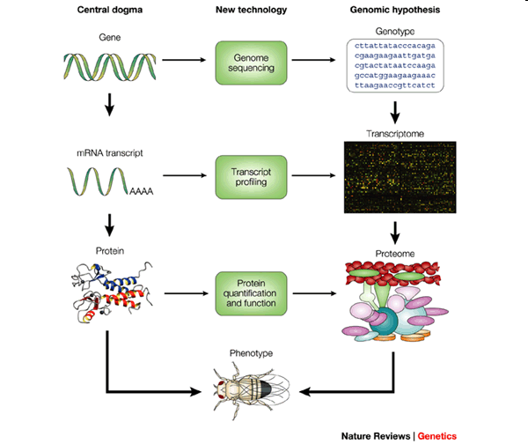

Anatomy of a Gene
  - A gene is the basic unit of biological information; it is a specific segment of DNA at a specific location on the genome (on a region of a chromosome) that serves as a unit of function
    - Encodes RNA or protein
  - Anatomy of a eukaryotic gene
- 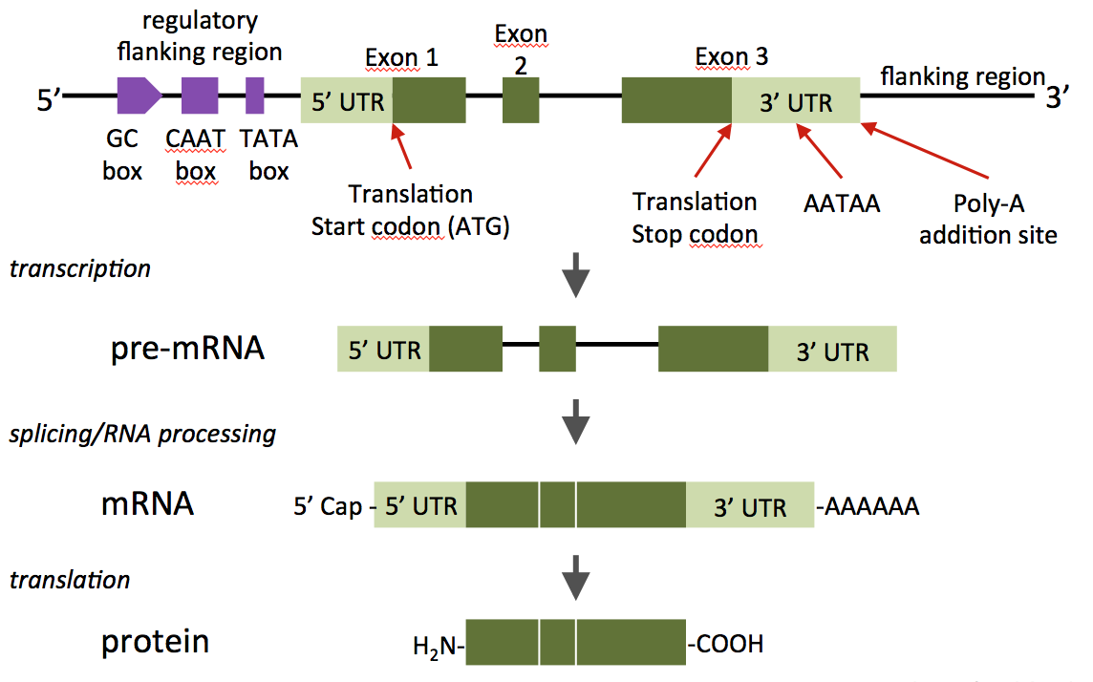
  - Introns have consensus sequences (at the beginning and end) that fuse together to form a contiguous sequence after splicing
    - GT at the beginning
    - AG at the end
  - In the original DNA double helix, one strand is known as the coding strand and the other is known as the non-coding strand
    - The coding strand has a similar 5’ 3’ sequence as the produced RNA strand
      - Also known as the sense strand, non-template strand, or Crick strand
    - The non-coding strand is used as a template to transcribe complimentary RNA
      - Also known as the anti-sense strand, template strand, or Watson strand
  - Genes between species can very considerably in both complexity and size
    - Can have different promoters, different splicing, etc
  - The open reading frame (ORF) is an in-frame sequence (in triplets) that starts with the start codon (ATG) and ends with any of the three stop codons (TAA, TAG, TGA)
  - The coding sequence (CDS) is only the region of DNA that is known to be translated to form proteins
  - Redundancy in the genetic code exists for two primary functions
    - Genetic variation and codon bias in organisms
    - Protects against mutation (changing a single nucleotide base may not change the protein sequence)
  - The amino acid sequence of a polypeptide determines its three-dimensional shape
    - Determined by the interactions between amino acids
  - Protein shape determines its biological function

Anatomy of a Genome
  - A genome is the sum total of genetic information in a particular cell or organism
  - As you compare organisms of less-complexity to more complex organisms, certain trends appear
    - Increasing genome size
    - Increasing number of genes
    - Decreasing gene density (% of DNA that is coding sequence)
    - Increasing complexity of gene structure
      - More and large introns
      - More complex gene regulation
    - Increase in repetitive elements
  - The genome is separated into individual chromosomes (giant linear DNA molecules) and stored in the nucleus
    - Storing this much genetic information in such a confined area requires extremely efficient packing
  - Genetic information is transmitted in the form of chromosomes by meiosis
    - Involves the ‘Law of Segregation’ and ‘Independent Assortment’
  - Chromosomes are self-replicating genetic structures of cells containing the DNA
    - Carries the linear array of genes in its nucleotide sequence
  - Chromatids are one of two identical copies of a chromosome that exist immediately after DNA replication
    - Sister chromatids are joined at the centromere
  - Homologous chromosomes are a pair of chromosomes containing the same linear gene sequence
    - each homologue of the pair is derived from one parent
    - same centromeric position
    - same approximate size (at chromosome level)
    - same genes/loci in the same order
    - the alleles present may be different
  - Alleles are the alternative forms of a single gene
  - A locus is a designated location on a chromosome
    - Can be coding or non-coding sequence
  - A wild-type allele is a form of a gene whose frequency is more than 1% in a population
    - Often denoted by “a+”, “A”, or “+”
  - A mutant allele is a form of a gene whose frequency is less than 1% in a population
    - Often denoted by “a-“, “a”, or “-” (recessive)
  - Note: many genes are named after their mutant allele phenotype
  - Not all genes can be described as having ‘wild-type’ (+) and mutant (m) forms; many genes are polymorphic
    - Many forms exist in nature
    - E.g. humans have 3 blood group alleles: i^{A}, i^{B}, and i
      - All are common
      - No ‘wild-type’, so no ‘+’ symbol
  - Mendel’s Law of Segregation: during meiosis, the copies of a gene separate so that each gamete receives only one copy (allele)
    - A gamete will only receive one copy or the other

Mendel’s Law of Independent Assortment: unlinked genes for different biological trains will sort independently of other traits
- Mendelian Ratios
  - Monohybrid cross of Aa × Aa results in a 3:1 phenotypic ratio
  - Dihybrid cross of AaBb × AaBb results in a 9:3:3:1 phenotypic ratio

Deviations from Mendelian Ratios (Traits Determined by 1 Gene)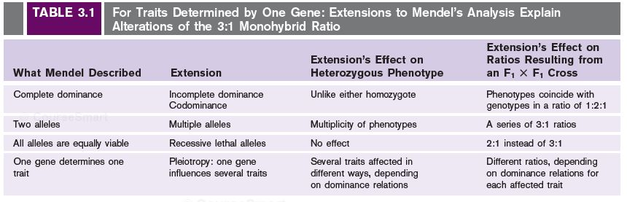
  - Single gene inheritance: traits determined by allelic variations if a single gene
    - Extensions to Mendelian genetics for single gene inheritance:
      - Lethal alleles
      - Incomplete dominance
      - Codominance
      - Dominance series
      - Penetrance/Expressivity
  - Lucien Cuenot conducted a genetics experiment involving the coat color (agouti or yellow) of progeny mice
    - A^{Y} (yellow) is dominant to A (agouti)
    - Was unable to isolate a homozygous A^{Y}A^{Y} mouse; any time he bred a yellow mouse with an agouti mouse there was a 1:1 ratio of yellow and agouti progeny
      - Means that the yellow parent mouse was heterozygous A^{Y}A
    - Mating yellow mice with each other resulted in a 2:1 offspring ratio of yellow to agouti, rather than the predicted 3:1 ratio
    - It was found that being homozygous for the yellow A^{Y} allele was lethal, which is why no offspring were born with this genotype
      - A^{Y} is recessive to A with respect to viability
  - Types of lethal alleles:
    - Early onset: the gene is necessary for cellular function, death at embryogenesis or early on in life
    - Late onset: the gene is essential for survival, but not until the individual has matured
    - Semi-lethal: kills some mutant individuals in the population, but not all
    - Conditional: the mutation is only lethal under certain environmental conditions (e.g. temperature)
  - Pleiotropy is the phenomenon in which a single gene determines a number of distinct and seemingly unrelated characteristics
  - The chi-square test is a statistical procedure to determine if the difference between an expected result and an observed result is due to sampling error, or if there is a real (i.e. biological) factor involved to explain the difference
    - Calculate test statistic by summing (Observed - Expected)²/(Expected) and comparing it with the critical test statistic for the desired significance level (using a table and degrees of freedom)
  - Incomplete dominance results when one allele is not completely dominant over the other, resulting in a blend of phenotypes
    - Heterozygote expresses a phenotype that is different than either of the homozygous parents
  - Codominance results when both alleles are simultaneously observable in the offspring phenotype
    - Heterozygote expresses a trait in which both traits are equally observable
  - Dominance relationships are only meaningful when considering two specific alleles
    - When there are many different alleles for a specific gene, you can perform multiple crosses to determine which alleles are dominant to others, and which alleles have codominance/incomplete dominance to construct a dominance series
  - Penetrance: proportion of members of a population with a given genotype showing the expected phenotype
  - Expressivity: intensity with which a particular genotype is expressed

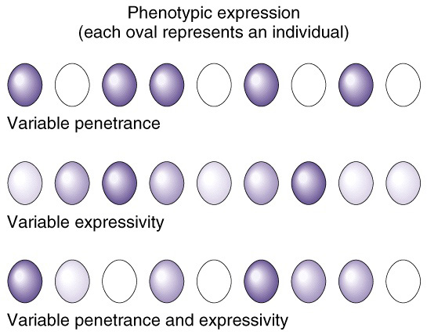
  - E.g. neurofibromatosis is a dominant disease that shows 50-80% penetrance and variable expressivity
    - Only 50-80% of people with the genotype for the disease actually express it, and of those that do, there are varying levels of severity

- Gene Interactions (Traits Determined by 2+ Genes)
- 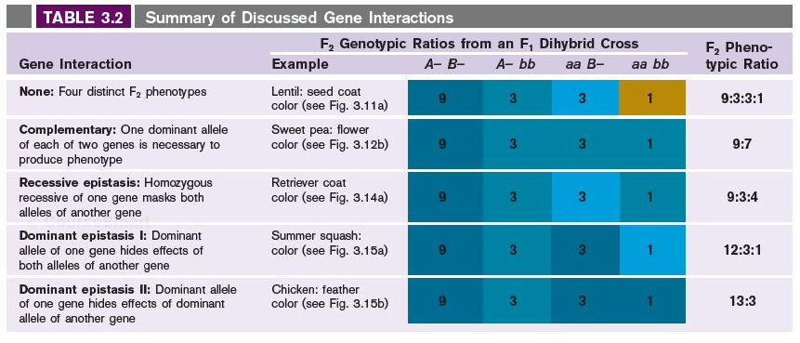
  - Multifactorial inheritance: traits determined by the action of two or more genes
  - No gene interaction would result in 4 phenotypes at a 9:3:3:1 ratio
  - Complementation: interactions between genes can result in seeming non-Mendelian ratios
    - If there is failure to complement between the genes (non-complementation), then the trait will not be expressed
      - Generally results in a 9:7 wild-type to mutant phenotypic ratio
    - There may be an interaction when no wild-type allele is present for either gene, resulting in a new phenotype
      - Can result in a 9:6:1 phenotypic ratio
  - A complementation test is conducted to determine if two individuals who carry the same recessive phenotype are a result of mutations in the same gene, or a different gene
    - Cross the two individuals to produce offspring
    - If the offspring has the same phenotype as the parents, there is no complementation present
      - In the parents, mutation has occurred in the same gene
      - All children are homozygous recessive at the affected gene
    - If the offspring does not have the same phenotype as the parents, there is complementation present
      - In the parents, mutations occurred in different genes to produce the same phenotype (mutant)
      - In the offspring, a functional copy of each gene is present producing the wild-type phenotype
  - Recessive epistasis occurs when genes are complementary in a pathway, but the gene required for an earlier step in the pathway is not functional
    - Genes at later points in the pathway are masked by non-functioning recessive genes earlier in the pathway
    - Can result in a 9:3:4 phenotypic ratio
  - Dominant epistasis occurs when a dominant allele of one gene masks the effects of another gene
    - Dominant, non-functioning genes earlier in the pathway mask the effects of genes later in the pathway
    - Two types:
      - Dominant epistasis I can result in a 12:3:1 phenotypic ratio
        - Occurs when one dominant gene masks the trait of another gene, and in the trait-producing gene, homozygous recessives have a unique phenotype
      - Dominant epistasis II can result in a 13:3 phenotypic ratio
        - Occurs when one dominant gene masks the trait of another gene, and in the trait-producing gene, homozygous recessives still do not exhibit the trait
        - Requires the epistatic gene to be recessive (turned off), and the trait-producing gene to have at least one dominant allele in order for the phenotype to be expressed
  - Continuous variation occurs when multiple genes contribute to the same trait, creating a ‘blend’ of many different phenotypic classes in subsequent generations

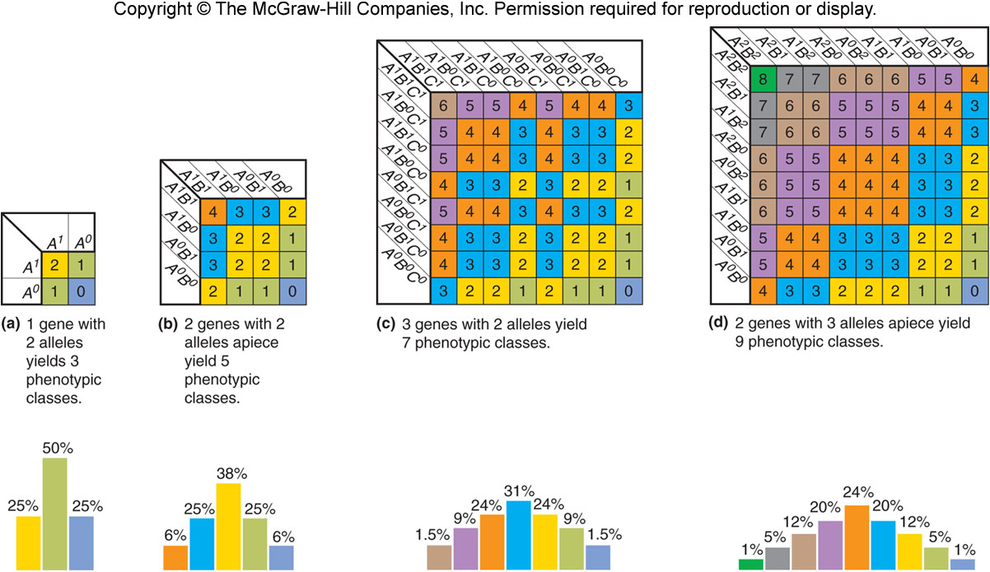

- Genetic Linkage
  - Recombination is the sorting of alleles into new combinations
    - Gametes produced can be different than those received from the parental generation
- 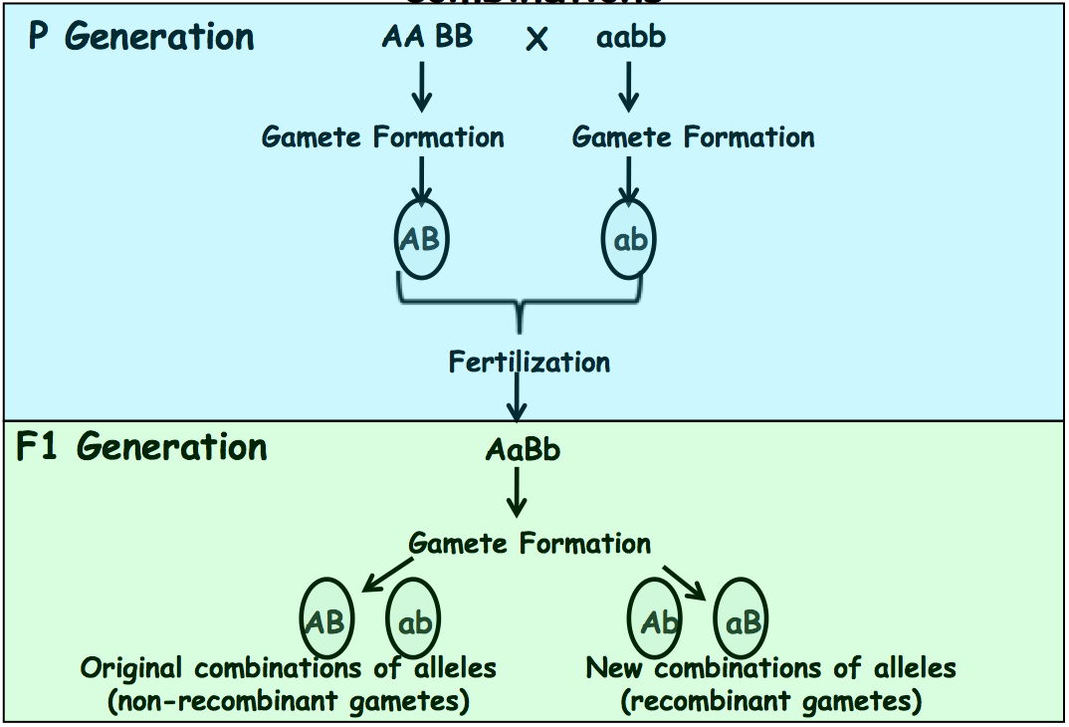
  - Gene linkage is a deficit of recombinant progeny (from the expected value of 50% by independent assortment) that arises due to the physical proximity of loci on the same chromosome
    - In this case, recombination occurs due to crossing over
    - Can explain deviations from expected genotypic ratios in progeny
  - Crossing over allows the recombination and rearrangement of alleles that are present on the same chromosome
    - Occurs between alleles at nearby loci on chromosomes of a homologous pair
    - The point at which the chromosomes overlap each other in the crossing over process is called a chiasma
    - Occurs during prophase I of meiosis in a process called synapsis (not well understood)
      - homologous chromosomes are aligned in close proximity to each other
      - the number and location of recombination nodules corresponds to where cross-over occurs later in the process

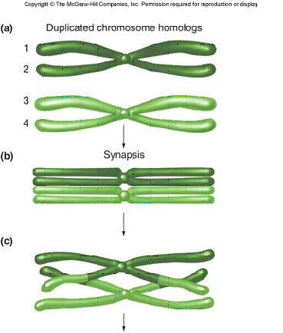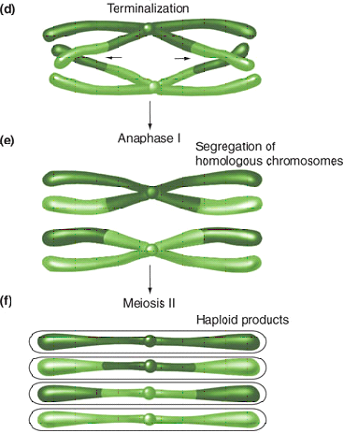
  - Experimentation by Curt Stern using drosophila (flies) demonstrated that recombination can result from reciprocal exchanges between homologous chromosomes
    - Isolated individuals with chromosomes containing physical abnormalities (i.e. a discontinuity) that were visible by a light microscope
      - Parental genotypes were heterozygous with the dominant alleles arranged in cis
    - Chromosomes in progeny were examined and discovered to have cases of crossing-over and no crossing-over
      - Crossover chromosomes had wild-type car with mutant Bar, and vice versa (trans)
      - Non-crossover chromosomes had only wild-type with wild-type, and mutant with mutant (cis)
  - Genotypically identical parents will produce different genotypic proportions of offspring based on their original allelic arrangement on chromosomes
    - The recombinant gametes, which are more rare for genetically linkage than parental gametes, will be different depending on the original allelic arrangement on the chromosomes

- Recombination Frequency
  - Recombination frequency is related to the distance between loci
    - As the distance between loci increases, the probability of a crossover occurring between them increases
    - Recombination frequency between loci can be calculated by the formula: % Recombinaton = # of Recombinant Gametes / Total # of Gametes
      - 1% Recombination = 1 map unit = 1 centiMorgan (cM)
  - A genetic map can be created by calculating distances between many different genetic markers
    - When mapping larger distances, there will generally be an underestimation of the map distance due to increasing the possibility of a double-crossover
    - To improve the accuracy, make the event of a double-crossover detectable by using a marker in between
  - A three point test-cross is used to determine parental and recombinant classes
    - Test cross with a organism that is homozygous recessive at all loci
    - The most likely event (and most prevalent progeny) is no crossover between any loci
    - The least likely event (and least prevalent progeny) is a double-crossover (between first and second marker, and between second and third marker)
    - To determine which allele is in the middle, compare the parental and double-crossover classes and identify the allele that changes its cis/trans configuration
    - Once the allele order is determined, map distances can be calculated using the recombination frequency formula (given above)
      - Make sure to include the appropriate single crossover class AND the double crossover class when calculating number of recombinant gametes

- Interference
  - Mathematical analysis demonstrates that crossing over does not occur randomly along a chromosome; a crossover event decreases the likelihood of subsequent crossovers in adjacent regions
    - The number of double-crossover events is less than that predicted by comparing probabilities of single crossovers
    - Coefficient of coincidence (c) = observed # of DCOs / expected # of DCOs
      - If the observed # is the same as the predicted #, the coefficient of coincidence is 1 (100%)
    - Interference = 1 – c
      - Any difference between the observed # and expected # is due to interference

- Double-Strand Break Model of Recombination
  - Double-strand break formation
    - Spo11 protein creates a double strand break in one of the chromatids of a chromosome belonging to a homologous pair
  - Resection
    - 5’ to 3’ exonuclease chews off parts of the strand with a break to create single strand tails
  - First strand invasion
    - Since there is complementarity, the broken chromatid is able to invade a chromatid of the other chromosome in the homologous pair and form base pairs
      - This process is assisted by single-strand binding proteins and DMC1 proteins (help the invasion process)
  - Formation of Double Holliday Junction
    - The other chromatid (that got invaded out) can attack the chromatid of the other chromosome of the homologous pair as well
    - Each location where a
  - Branch migration
    - The entire structure can randomly migrate over some base pairs by unzipping/re-zipping outwards along the double helices
  - Resolving the Holliday Intermediates
    - There are two ways to ‘cut’ or resolve each Holliday junction
    - One way (horizontal) will reconstitute the original chromosome arms, whereas the other way (vertical) will result in a flipping of the chromosome arms
    - If both Holliday junctions are resolved in the same plane, then crossover will be aborted
    - If the Holliday junctions are resolved in opposite planes, then crossing over results in a recombinant gamete

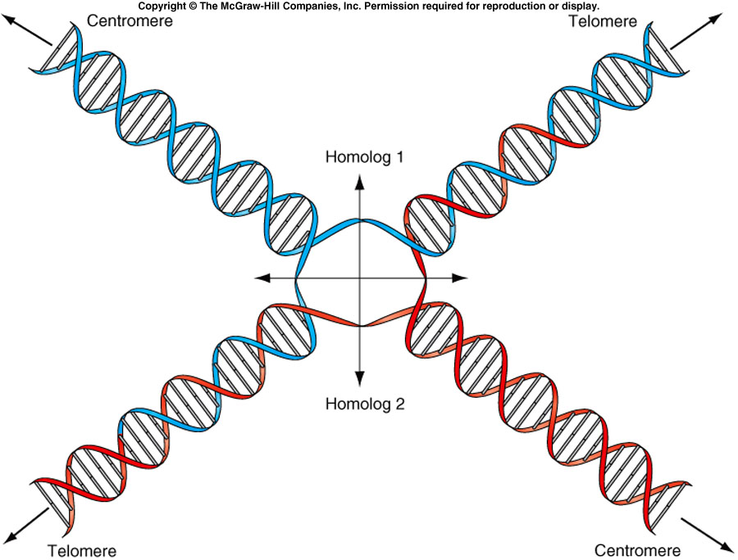

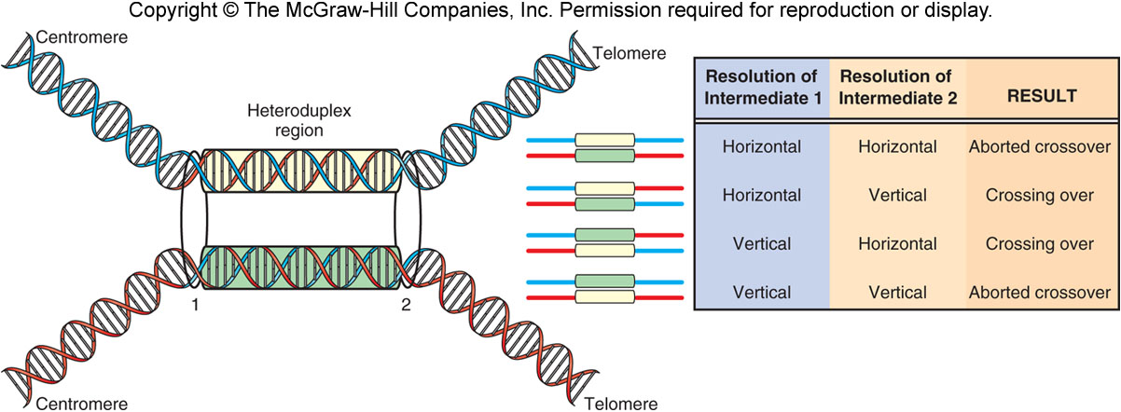
- Types of Mutations
  - A mutation is a inheritable change in the DNA sequence of an organism
    - Single-strand mutations may not be incorporated into the genome in the long term (may be repaired)
  - A mutant is an organism which experiences a change in DNA sequence
    - There are different ways of classifying which is the mutant and which is the wild-type
      - What is considered to be the norm? (wild-type)
      - What is more frequent? (wild-type)
      - Who was first? (wild-type)
      - Who displays a negative effect? (mutant)
    - Mutations can be good or bad
      - Most mutations do not have any effect
      - Can cause neutral changes
      - Some cause problems
      - Some are lethal
      - Very few are beneficial
    - Mutations can be though of as good or bad depending on the conditions used to observe their effect
  - It is much easier to investigate mutations if they confer a phenotypical change that can be observed
    - Altered appearance
    - Altered growth conditions
    - Altered behavior
    - Altered molecules

  - Base pair substitutions involve the change of one nucleotide to another
    - Transitions are the change of a purine to purine, or a pyrimidine to pyrimidine
      - Same molecular structure
      - 2 different ways to have a transition
    - Transversions are the change of a purine to a pyrimidine, or pyrimidine to a purine
      - 4 different ways to have a transversion
  - Insertions involve the addition of new nucleotides into the DNA sequence
  - Deletions involve the removal of nucleotides from the DNA sequence
  - Inversions involve the substitution of a short DNA fragment with its reverse complement
    - E.g. TCTA mutates into TAGA
    - Essentially flips with the complementary strand, but keeping the same 5’ to 3’ sequence (a 180 degree rotation)
  - Translocations involve the movement of a small DNA fragment to another section in the sequence
  - All the above mutations can occur as large-scale changes, affecting entire chromosomes or parts of chromosomes
    - Chromosome rearrangements include duplication, deletion, insertion, inversion, translocation, reciprocal translocation, and entire genome duplication
      - Reciprocal translocation involves sections of 2 non-homologous chromosomes changing places

  - Mutations are:
    - Rare events
      - 2-12 × 10⁻⁶ per gene per gamete
      - Gene dependent (different genes develop mutations at different rates)
    - Can happen all the time (spontaneously)
    - Occur randomly
    - Can occur for a variety of reasons
      - E.g. errors during replication, free radicals, UV damage

- Spontaneous vs Induced Mutations
  - Many mutations occur spontaneously – that is, they occur randomly and happen all the time
    - Not as a response to environmental stimulus
  - Experiments to test for spontaneous mutation involved exposing identical cultures to the same stimulus and observing different numbers of mutants in each culture
    - If the mutation occurred as a response to stimulus, there would be similar numbers in each culture
    - Random spontaneous mutations that occurred earlier resulted in more mutants in some colonies than others
  - Another experiment used replica plating in which a culture was imprinted onto a velvet membrane, and then identically re-plated onto multiple penicillin plates
    - The exact same colonies were able to grow on each of the different penicillin plates, suggesting that the mutation occurred before exposure to the medium
  - Spontaneous mutations occur randomly, while induced mutations are caused by a mutagen
  - Endogenous mutagens are those that originate from a source within the organism body, while exogenous mutagens are from external sources
    - E.g. sunlight is a spontaneous exogenous mutation, but it may be induced if the level of UV-radiation is artificially increased

- Spontaneous Mutations
  - Depurination
  - Deamination
    - C (base pairs with G) mutates into a U (base pairs with A)
    - C-G to U-A, which then turns into T-A
    - Transition
  - Breaking of DNA backbone (X-ray damage)
  - Formation of pyrimidine dimers (UV light)
  - Mistakes during replications
    - Insertion of the wrong base by DNA polymerase occurs approx. once every 10⁶ nucleotides
    - Proofreading activity of the 3’-to-5’ exonuclease fixes these mistakes before they are integrated as mutations in the DNA
  - Unequal crossovers
  - Sippage
    - When there are many of the same nucleotide in a row, DNA polymerase may ‘slip’ one nucleotide
      - If slippage occurs on the template strand, a deletion occurs ; if slippage occurs on the newly synthesized strand, an insertion occurs
    - Repeating triplets (trinucleotides) can also be inserted or deleted by slippage
      - DNA polymerase slips 3 nucleotides

- Induced Mutations
  - Involves different types of mutagens that alter DNA
  - Base analogs structurally mimic bases, but do not function exactly the same when they are inserted into DNA
  - Some mutagens alter a base structure or property
    - Add a hydroxyl (OH) group
    - Add a methyl (CH3) group
    - Remove an amino (NH2) group
  - Intercalating agents can insert between bases
  - Radiation (e.g. X-ray and UV) cause DNA mutations
    - Causes pyrimidine dimers
  - Biological agents such as transposons and viruses can cause DNA mutations

DNA Repair Mechanisms
  - Proofreading activity by 3’-to-5’ exonuclease
  - Base excision repair fixes mutations such as base mismatches
    - Glycosylase removes mutated base (i.e. U) to leave an apurinic/apyrmidinic (AP) site
    - AP endonuclease cuts the backbone to make a nick at the AP site
    - DNA exonuclease removes nucleotides near the nick, creating a gap
    - DNA polymerase synthesizes new DNA to fill the gap
    - DNA ligase seals the nick
  - Nucleotide excision repair is used to repair pyrimidine dimers
    - UvrB and UvrC endonucleases recognize the pyrimidine dimer and nick the DNA around the site of damage
    - Damaged fragment is removed from the DNA
    - DNA polymerase synthesizes new DNA to fill the gap
    - DNA ligase seals the nick
  - Methyl-directed mismatch repair is used to distinguish the newly-synthesized strand from the template strand, in order to correctly determine how to repair the damage
    - Methylation patterns in DNA can be inherited
    - Newly synthesized does not undergo methylation for some time after replication
    - Detection of the methylated strand can indicate the original, hopefully error-free strand, and use that as a template to fix the mismatch correctly
      - Damaged DNA is removed from the non-methylated strand
      - DNA polymerase synthesizes new DNA using the methylated strand as a template
      - DNA ligase seals the nick

- How to Classify Mutations
  - Mutations can be classified in a variety of way:
    - Based on their origin
      - Spontaneous or induced
    - Based on the molecular change
      - Base substitution, insertion, deletion, etc.
    - Based on their effect on translation
    - Based on their effect on gene function

Classifying Mutations by Effect on Translation
  - Silent mutations are those that change a codon to another that codes for the same amino acid
    - Amino acids can be encoded by up to 6 different codons
    - Usually the first two positions are constant, with the last position being wobble (prone to fluctuation)
    - Don’t have an observable effect
  - Missense mutations are those that change a codon to one that codes for another amino acid
    - Severity depends on what substitution occurs, and where
      - If it swaps with a structurally similar amino acid there may not be a sever effect on function
      - If the swap happens on an amino acid that is very sensitive (e.g. a detector region) the effect may be more severe
  - Nonsense mutations are those that change an amino acid codon to one of the stop codons (UAA, UAG, UGA)
    - Results in a prematurely truncated protein
    - Severity depends on where (generally the closer to the original stop codon, the less severe)
  - Frameshift mutations result from the insertion or deletion of 1-2 nucleotides
    - Results in all subsequent amino acids being read incorrectly
    - Severity of the effect depends on where the insertion or deletion occurs

- Classifying Mutations by Effect on Gene Function
  - Mutations in non-coding regions of the DNA sequence do not confer a change that will be translated in the protein product, but they can still affect the gene expression
    - Increased/deceased protein levels
    - No functional protein produced
    - Mis-expressed protein (wrong time or wrong place)
- 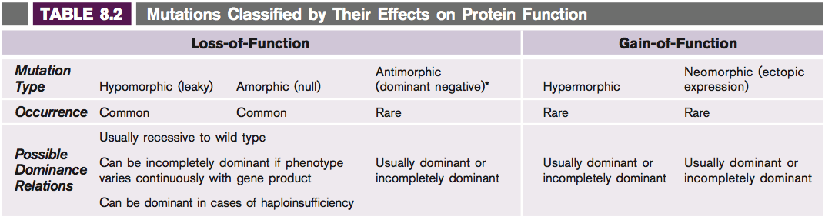
  - Loss of function mutations
    - Null mutations result in no protein synthesis
    - Amorphic mutations results in a deformed protein being synthesized, but it cannot function
    - Hypomorphic mutations result in either reduced protein synthesis, or partial deformation such that function is weaker (but not completely void)
    - Various types of dominance relationships between wild-type and mutant alleles
      - Most are recessive to the wild-type allele
      - Can be incomplete dominance relationships if different phenotypes are expressed depending on the amount of functional protein produced
    - If the gene is haplo-insufficient (it cannot function with only wild-type copy) then the mutant will appear dominant to the wild-type
      - Dominant loss of function occurs a mutant allele is present with a wild-type allele, and the protein levels expressed with only one wild-type allele are not enough to exhibit the normal phenotype
        - The mutant allele in itself does not the mutant phenotype, but rather the loss of the normal phenotype gives rise to the mutant phenotype
    - Antimorphic (dominant negative) mutations occur when one copy of the mutant allele blocks function of the working wild-type allele
      - Generally occurs because the wild-type allele product must form a multimer with itself, and the product formed from the mutant allele disables the multimer
  - Gain of function mutations
    - In general, these are much more rare than loss of function mutations
    - Hypermorphic mutations are those that enhance an existing function
      - If they occur in the coding region, they produce a protein that functions better
      - If they occur in a regulatory region (e.g. promoter), they increase levels of protein synthesis
    - Neomorphic mutations are those that give rise to new functions
      - These are extremely rare
      - Ectopic expression is where an existing protein is expressed in a new location
  - Note that the type of mutation that occurs is not based on the gene that is affected, but rather the changes that occur in the allele
    - A single gene may have a variety of different types of mutant alleles (some gain of function and others loss of function)
  - The effect of a given mutation is hard to predict, it must usually be analyzed in progeny to determine the phenotypic consequences
    - Prediction are easier if background information on the structure/function gene product is known
  - Mutants used in research and in labs were often obtained randomly through spontaneous or induced mutagens; more recent technologies allow us to specifically generate some desired mutants by introducing specific changes in specific places in DNA
- Restriction Enzymes
  - Restriction enzymes recognize and cut specific sequences of DNA
  - Once cut, the DNA can produce 3’ sticky ends, 5’ sticky ends, or blunt ends with no overhang
  - The sequence detected, cut performed, and ends produced are all specific to the restriction enzyme used
    - Different enzymes can recognize different sequences and produce identical overhangs
    - Different enzymes can recognize the same sequence and produce different overhangs
  - Digested fragments can only re-anneal if they have the same type of overhang with complementary sequences
    - Blunt ends can be ligated to any other blunt end
  - Depending on the length of the recognition site, DNA can be digested to yield different results
    - Longer recognition sequences will be found less frequently, and so will result in fewer but larger fragments
  - Digestion of DNA takes time, and so if it is treated with a restriction enzyme for less time you can yield incomplete digests

Gel Electrophoresis
  - Gel electrophoresis is used to separate DNA fragments on the basis of size
  - DNA is negatively charged, with a uniform mass-to-charge ratio
  - In gel electrophoresis, DNA is placed on an agarose gel containing pores and an electric current is applied to the system
  - DNA fragments will begin moving through the gel to the positive terminal
    - Shorter fragments will navigate through the pores easier and move towards the positive terminal faster than large fragments
  - Digested plasmid DNA has few fragments, so a gel electrophoresis yield distinct lines
  - Digested genomic DNA has many fragments and so they are less discrete, appearing as a smear after gel electrophoresis

  - Restriction enzymes can be used in combination with gel electrophoresis in genetically mapping locations of specific DNA cut sites

- Recombinant DNA
  - A plasmid is extra chromosomal DNA found in bacterial species
  - A vector plasmid is a self-replicated DNA molecule that can be used to transfer DNA between host cells and whose presence can be detected
    - Requires a origin of replication, a selectable marker, and a restriction site where DNA can be inserted
  - DNA of interest and plasmid vector are cut with restriction enzymes that produce compatible ends, are mixed, and then ligated together
    - DNA of interest can come from a genomic DNA or cDNA library
  - Transformation of plasmid vector into E. coli involves salt and electroporation
  - Selection for transformed cells involves using the selectable marker in the plasmid vector to differentiate between transformed and non-transformed cells
    - Generally, the selectable marker used confers resistance to a certain antibiotic
    - If the bacteria has the selectable marker, it likely obtained it from the plasmid vector and would therefore have the DNA of interest as well

- Polymerase Chain Reaction (PCR)
  - PCR is used to exponentially amplify (duplicate) target DNA fragments
    - After 33 rounds, millions of copies of the target DNA are present
  - Specificity is conferred by the use of primers that anneal to the template DNA and flank the target region to be amplified
    - Primers are small (~18-25 bp)
  - First DNA is heated to 94 degrees C to denature the DNA
  - Then primers are annealed at 50-6 degrees C
  - Finally polymerization (synthesis of new DNA) occurs at 72 degrees C and the process is repeated
  - Thermocyclers make it easy to automate this process by changing the temperature
    - Makes use of a temperature stable Taq DNA polymerase
  - Any DNA or RNA sequence can be amplified with the use of the correct primers
  - Changes in the DNA sequence can be introduced by using primers with a mismatch
    - Wont perfectly anneal, but will be enough for synthesis to occur

- Reverse Transcription
  - Reverse transcriptase can be used to synthesize DNA from an RNA fragment, resulting in a hybrid molecule of cDNA and mRNA
  - Involves the use of a primer detected by the reverse transcriptase enzyme
  - A cDNA library can be constructed by denaturing the hybrid molecule, using DNA polymerase to synthesize a double stranded DNA molecule from the template cDNA strand, and inserting the new DNA fragments into plasmid vectors

- Genomic and cDNA Libraries
  - Genomic libraries contain an equal representation of all the DNA in the organism genome
    - Approximately equal number of fragments for each portion of the genome, with overlaps that can be used to construct nearly all of the genomic information
  - cDNA libraries only contain protein-coding regions and are constructed by reverse transcribing mRNA
    - proteins that are expressed more frequently in certain tissues are represented more

- Hybridizations
  - A Southern blot is when a DNA template is probed with DNA
    - Template DNA is digested and then separated by gel electrophoresis
  - A Northern blot is when an RNA template is probed with DNA
    - RNA does not need to be digested (already fragmented as mRNA) so it is only separated by gel electrophoresis
  - After the unlabeled template is separated by gel electrophoresis, it is soaked in a alkali solution to denature (separate) the DNA strands and then blotted onto a nitrocellulose membrane
  - The membrane is then probed with a radioactively-labeled DNA probe that will anneal to the complementary regions
    - Does not need to be a perfect match for annealing to occur
    - Labeling of the probe allows its visualization
    - Probes are large DNA fragments (100+ bp)

- Sanger Sequencing
  - In Sanger sequencing, identical copies of single-stranded DNA are treated with a primer to initiate synthesis
  - A small amount of dideoxy-nucleotides are added to the reaction which, when incorporated into the growing strand, halt synthesis
    - Generally carried at in 4 separate reaction vessels, each one containing a different dideoxynucleotide
  - This process will yield new DNA molecules of varying length; when these fragments are separated by gel electrophoresis, the presence of a fragment of a certain size will indicate the base present at that position
  - This process can be automated to require only one reaction vessel by using fluorescently-labeled dideoxy-nucleotides and having a laser read the resulting chromatogram
- Positional Cloning
  - Positional cloning is the process of finding the chromosomal location of a gene based on its phenotype
    - Can be performed with or without mapping information
  - The gene responsible for hemophilia A was found without mapping information
    - From a pedigree, it was determined that the trait was controlled by a single X-linked gene, and the mutant allele responsible was recessive
    - Background information on the disease suggested that the responsible gene was for a clotting factor, and it was the inactivation of this factor that caused hemophilia A
    - An enzyme cascade of the clotting factors required for normal function was compiled, and then compared with the clotting factors present in hemophilia A patients
      - Found that the absence of Factor VIII is what causes hemophilia A
    - Factor VIII was purified and the amino acid sequence was derived
    - The amino acid sequence was reverse translated to predict a DNA sequence
      - Many amino acids are encoded by multiple codons (especially due to wobble), so there are actually many possible coding sequences
      - Usually performed by a computer
    - Synthesize degenerate complimentary oligonucleotides that will function as probes
      - Many different degenerates because there are many possibilities for the original nucleotide sequence
    - Probe a genomic DNA library to find a vector that contains the gene
      - Compare imprint of colonies to those that appear on an autoradiogram to find which ones contain the gene
      - Grow cultures from colonies that contained the gene
    - Sequence the fragment that contains the gene
      - Was a very complicated gene, 186 kb long with 26 exons
    - To prove that this was the correct gene that caused hemophilia A, primers were designed to amplify the gene by PCR and copies of the gene were sequenced for healthy and diseased individuals
      - In healthy individuals, the wild-type allele was found
      - In diseased individuals, mutations were found; these mutations were recorded
        - Base substitutions, splice mutations, small deletions, large deletions, etc.
  - The gene responsible for cystic fibrosis was found with mapping information
    - Knew it is a recessive autosomal gene
    - The symptoms could be controlled by 100s of different proteins, so it was impractical to begin by trying to identify the function of the mutated gene
    - Researchers found the location of the gene by building a linkage map of the gene to known markers
      - If the gene has a recombination frequency with a marker of significantly less than 50%, then it is likely to be located on the same chromosome as the marker at a nearby loci
        - Recombination frequencies of 50% are formed by independent assortment (genes are on different chromosomes) or unlinked genes
      - Once the general location of the gene was known, new markers that were closer together to further resolve its position with greater precision
    - The region of DNA that the gene was narrowed down to was sequenced by both chromosome walking and chromosome jumping
      - Jumping allows one to move along longer stretches of sequence
      - Jumping is especially useful to get around sequences that are difficult to clone or sequence
      - Walking is continuous and does not miss any sequences
    - The genes located within this region were the identified by sequence analysis, and the gene that was found to be mutated between healthy and disease individuals was identified as the gene responsible for the disease
    - Once the gene was located, its function could be identified
      - It is a protein in the ATP-binding cassette (ABC) family
      - It is a transport channel for chloride ions and is important for the creation of sweat and mucus

- Whole Genome Sequencing
  - Original method was a primer based approach that involved slowly walking down the genome
    - Very time consuming
  - Shotgun sequencing method involves randomly fragmenting the DNA and then sequencing without respect to the order of the fragments
    - The sequenced fragments can then be computationally arranged in the correct order by identifying overlaps
    - The hierarchical shotgun method starts off with smaller areas of the genome at a time, sequences and orders them by the shotgun method, and then orders these areas by finding overlaps at that point
  - Once the sequence is obtained, analysis must be formed to identify gene coding regions, UTRs, promoters, etc. from the ATCG sequence data
- Inducing Mutations
  - Early mutations were often produced morphological (shape) mutants, and were typically spontaneous in nature
    - Spontaneous mutations occurred too slowly
    - Mutants other than morphological mutants were required
      - E.g. for biochemical pathways
  - Induced mutations had an increased frequency and produced a larger variety of mutation types

Inducing Mutants by EMS
  - A popular mutagen used is ethyl methanesulfonate (EMS), a type of alkylating agent
    - Introduces point mutations, in which GC base pairs transition to AT base pairs
    - Easy to use because it is soluble and can be taken up by cells
    - Once exposed, you can start screening populations for mutants
      - Assume 1 mutant for every 1000 individuals
    - can screen for any type of mutant
      - morphological phenotypes, biochemical mutants, developmental mutants, behavior patterns, reactions to environmental stimulus, etc
    - problems with inducing mutations by EMS include
      - mutations still occur randomly
      - can’t select for the mutation, have to individually screen mutants
      - often more than one mutation per mutant
      - mutations are often due to a single base pair change somewhere to change; difficult to track on a molecular basis
  - Test for complementation between genes
    - When you can built a collection of mutants, some of the mutants may express the same mutant phenotype
    - You want to know if the phenotype is caused by mutations in the same gene, or by mutations in different genes
    - To test, cross the homozygous mutants with each other
      - If the offspring display the mutant phenotype, it is the same gene (no complementation)
      - If the offspring display the wild-type phenotype, they are different genes (complementation)

- Transposon Mutagenesis
  - Transposable elements are sections of DNA that move around the genome
    - “jumping genes”
    - Retroposons are TEs that move around the genome via an RNA intermediate
    - Transposons are TEs that move directly as DNA
  - TEs insert themselves randomly into the genome
    - If their DNA is inserted into the middle of a gene, it can modify the gene
  - In transposon mutagenesis, transposons are used to induce mutations in organisms
    - Engineered to transfer a known DNA sequence from the plasmid into the genomic DNA
    - Modified so that they only jump once (to get from the plasmid into genomic DNA), so that they don’t keep moving around once incorporated
    - Since the transposon still inserts randomly into the DNA, different mutants will that the transposon at a different location in the genome
    - Often uses a selectable marker to allow the selection of mutagenized organisms
      - E.g. resistance to an antibiotic
      - Screening populations for mutants becomes much easier
  - Since a known piece of DNA is inserted, the screening process can also involve the use of molecular tools
    - Multiple transposons can jump into a single organisms; this can be detected by digesting the organism DNA, separating by gel electrophoresis, and creating a Southern blot to probe for the known transposon DNA
      - If multiple transposons are present, there will be multiple radioactive bands
    - Can determine where the transposon inserted itself by using a primer-based strategy to identify the surrounding DNA
      - Can correlate the molecular basis to the phenotype much quicker
    - If you have the sequence information of a specific gene, you can use PCR and primers to determine if a transposon inserted itself into that specific gene
      - Use a primer for the gene sequence and one for the transposon sequence
      - If the transposon primer is too far from the gene sequence primer (meaning mutagenesis did not occur at that gene), then PCR will not be able to amplify the bounded region
  - Since transposons insert themselves randomly into the genome, transposon mutagenesis cannot be used to target an insertion to a specific gene

- Targeted Mutations
  - Targeted mutations are those where one designs the mutation locus
    - Can mutate specific, predetermined genes
    - Uses recombination constructs
    - Does not work in all organisms
  - Gene knockouts are used to destroy a specific gene
    - Requires the DNA sequence for the gene of interest
    - Works well in S. cerivisae (yeast)
    - Involves creating a construct with a new gene, usually for a selectable marker, in the middle of an existing gene
      - Knocks out the old gene in place of the selectable marker
    - If the recombinant construct interacts with a homologous gene in the genomic DNA, it will knock out the original functioning gene
- How Individuals Differ Within a Species
  - Not all individuals within a species have identical genomes
  - Generally, an allele is labeled as the wild-type is more than 1% of the population express that allele
  - A polymorphic locus is one that has 2 or more alleles that are present in more than 1% of the population
    - Alleles of a polymorphic locus are called genetic variants, rather than mutant or wild-types
  - A locus is any location within a genome that has a defined chromosome location
  - By sequencing entire human genomes, we have found millions of single nucleotide substitutions and thousands of amino acid changes between individuals
    - Most of these do not have any affect on function
    - There are also thousands of insertions and deletions, both large and small
    - Entire genome sizes can vary by as much as 1%
  - Polymorphic loci can have
    - Single nucleotide polymorphisms (SNPs)
    - Insertions and deletions (InDels or DIPs)
    - Simple sequence repeats (SSRs)
    - Copy number polymorphisms (CNPs)
    - Complex variants
- 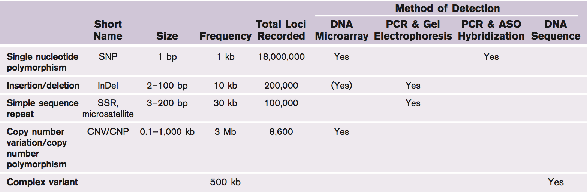

- Single Nucleotide Polymorphisms (SNPs)
  - Most common genetic variation
    - Single base pair substitutions
  - Can be spontaneous (occur during replication) or be induced (by a chemical mutagen)
  - SNPs that alter a restriction enzyme cut site can be detected by Southern blot analysis
    - Design a probe that detects a known region between cut sites of a gene
    - Separately digest the alleles, apply the probe, and separate digestion fragments by gel electrophoresis
    - If a SNP changes a cut site such that it is no longer recognized by a specific restriction enzyme, the hybridized probe will appear on a fragment that is much larger than the wild-type allele
  - Restriction site altering SNPs can also be detected by PCR
    - Using primers that flank the restriction cut site, PCR amplify the DNA sequence of the two alleles
    - After digesting the PCR products, separation by gel electrophoresis can reveal if the restriction cut site was altered in one allele
    - E.g. individuals with sickle cell anemia have two copies of a mutant allele, with the mutant allele missing a restriction cut site that is present within the wild-type allele
      - The mutant allele also happens to confer resistance to malaria
  - SNPs can also be detected by using allele-specific oligonucleotide hybridization
    - At high temperatures, DNA denatures (separates), while at low temperatures, DNA anneals
    - Probes and primers can bind with less specificity at lower temperatures, while at higher temperatures they require perfect complimentary sequences to anneal
      - Probes are longer and thus can non-specifically anneal at higher temperatures
    - Designing a probe to a known SNP sequence and seeing how it anneals to different alleles at different temperatures can provide information on any differences between the two alleles
      - Need to use short probes, as probes that are too long will appear to bind specifically to mismatched DNA even at high temperatures

- Simple Sequence Repeats (SSRs)
  - Simple sequence repeats (SSRs) are short repeating sequences in DNA
    - Single nucleotide repeats (e.g. AAAAAAA)
    - Two nucleotide repeats (e.g. CACACACACACA)
    - Triplet repeats (e.g. CAGCAGCAGCAGCAG)
  - can be highly polymorphic in length (different number of repeats at a given locus)
  - are the result of slippage during DNA replication
  - SSRs can be detected by PCR using primers that flank the repeating region
    - The length of the PCR products indicates the number of repeats
  - Different numbers of repeats can result in different (mutant) phenotypes
  - Minisatellite DNA are a subcategory of SSRs that contain a much longer repeating sequence
    - Occur at a small number of specific loci
    - Differ from individual to individual, so they are used for fingerprinting
    - 37.5% chance that two individuals will have the same number of repeats at two unlinked minisatellite loci
- very low probability that individuals will have the same number of repeats at many different loci

