- What is computation?
- The tool is the computer…the action is computation

- Computers carry out actions on information
  - Think of a recipe...
    - Place butter in pan
    - Add eggs
    - If you like them cooked all the way
      - Flip over
    - If not, keep cooking while they aren't done yet
    - Eat!!
  - A recipe is a set of steps done on edible components by a cook
  - A computer carries out a set of steps based on what the programmer tells it
    - It can do any set of basic instructions
    - It performs the instructions on information (data)

- What is Computer Science?

- The design, analysis, and implementation of algorithms (recipes)
- that solve problems.

Roles of Computer Science in our society:
- Maintaining the technical infrastructure…
  - i.e. network, software
- But also many algorithmic challenges
  - Artificial Intelligence (AI) for games
  - search or auction algorithms (Google, Bing)
  - medical imaging
  - cryptology (RIM)
  - low-power chips

Engineering ----(Software Eng, etc.)---- Computer science -------- Math

- What's in a computer?

- Memory
  - Hard drive
    - Disk-Based (Physical disk which has to move like a record player to do anything)
      - Slow, cheap and huge (Terabytes)
      - Items on the disk get loaded into memory and then the cache if its being executed
    - Solid State Drives (SSD)
      - Somewhat fast, fairly expensive, large
      - Like disk-based hard drives, Items on the disk get loaded into memory and then the cache if its being executed
  - RAM
    - The main memory
      - Random access memory
    - Faster, BUT holds less
    - Disappears when you shut off the computer
    - Made of switches that are either 0 or 1
    - Holds programs currently executing

  - Cache
    - In the CPU
    - Small BUT fast

  - Registers
    - Very few, nothing faster
    - Called “working registers”
    - Say you run a program... gets loaded to RAM, first part goes to cache, then current items go to registers

- CPU – Central processing unit = The Workforce

- MAIN COMPONENTS:
  - ALU → Arithmetic and Logic Unit
    - Arithmetic: add, subtract, multiply, divide, etc.
    - Logic: AND, OR, NOT, Shift, etc.
  - Control unit
    - Interprets instructions
    - Controls the flow of information within the CPU
    - Works with a “program counter” (next instruction)
  - Cache, registers, ...
    - The “clock speed” of CPU is much faster than RAM/disk, thus we need registers and cache in CPU
- 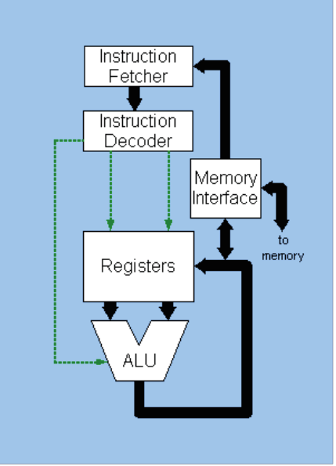
- Peripherals (i.e. keyboard)

- I/O and secondary memory

- 

