Session 7 - Human Resource Management:

Human resource management: The function of attracting, developing, and retaining employees who can perform the activities needed to meet organizational objectives.
Three main objectives:
- Providing qualified, well-trained employees for the organization.
- Maximizing employee effectiveness in the organization.
- Satisfying individual employee needs through monetary compensation, benefits, opportunities to advance, and job satisfaction.

Ultimate Goals of HR Management
- Locate - Make sure you have the people who are best suited to the company and job.
- Develop - Train & provide employees with the necessary knowledge & assets to do the job efficiently & effectively.
- Retain - Continually motivate employees to improve the company in any way possible.

HR Management Responsibilities
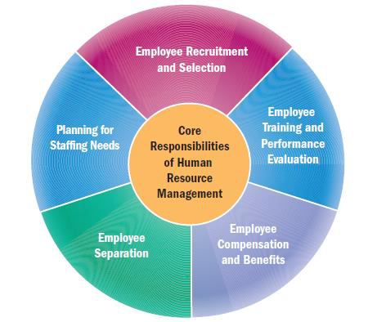

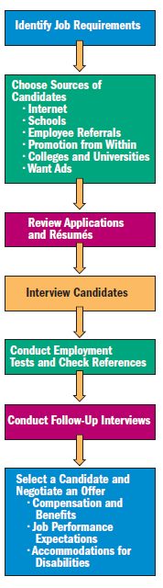
1. RECRUITMENT & SELECTION
- Recruitment and selection
- Recruiting techniques continue to evolve as tech advances
- Internet recruiting is quick, efficient, and inexpensive.
  - Find recent graduates in their 20’s and 30’s

SELECTING AND HIRING EMPLOYEES
- Must follow legal requirements.
- Failure to follow these exposes company to risk of litigation, bad publicity, and poor employee morale.
- Recruiting and hiring is a costly process for employers.
- Some employers require employment tests (e.g., mechanical, computer, language skills).

SALESPERSON SELECTION TEST
- In uncertain times, I usually expect the best.
- If something can go wrong for me, it will.
- I'm always optimistic about my future.
- hardly ever expect things to go my way.
- I rarely count on good things happening to me.
- Overall, I expect more good things to happen to me than bad.
Possible answers (agree) (neutral) (disagree)

OPTIMISM & HAPPINESS TEST
- In uncertain times, I usually expect the best. (agree)
- If something can go wrong for me, it will. (disagree)
- I'm always optimistic about my future. (agree)
- I hardly ever expect things to go my way. (disagree)
- I rarely count on good things happening to me. (disagree)
- Overall, I expect more good things to happen to me than bad. (agree)

Give yourself 2 points for every answer that matches the above (1 points for neutral) and (0 for opposite answer).

2. TRAINING & PERFORMANCE EVALUATION
TASKS OF PERFORMANCE APPRAISAL
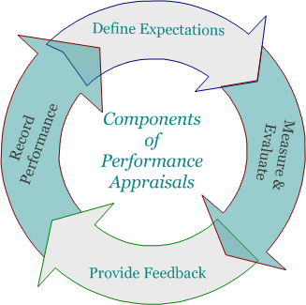

ORIENTATION, TRAINING, AND EVALUATION
- Newly-hired employees often complete an orientation program
  - Inform employees about company policies
  - Employee manuals
  - Describe benefits/programs
  - Training
- Training programs
  - On-the-job training
    - Performing tasks under the guidance of experienced employees
    - Variation: Apprenticeship, usually focuses on blue collar careers
  - Classroom and computer-based training
    - Videos simulating work environment
    - Learn at their own pace
    - May work with an instructor or mentor
  - Management development
    - Training may be aimed to at increasing specific technical knowledge or more general knowledge in leadership and interpersonal skills

PERFORMANCE APPRAISALS
- Performance appraisal: Evaluation of and feedback on an employee’s job performance
- Effective performance reviews:
  - Take place several times a year
  - Are linked to organizational goals
  - Are based on objective measures
  - Take place in the form of a two-way conversation
- Some firms conduct peer reviews (assess performance of co-workers).
- May conduct a 360-degree performance review, a process that gathers feedback from a review panel that includes co-workers, supervisors, team members, subordinates, and sometimes customers.

3. COMPENSATION & BENEFITS
- Compensation: the amount employees are paid in money and benefits
- Wage: Pay based on an hourly rate or the amount of work accomplished
- Salary: pay calculated on a periodic basis, such as weekly or monthly
- Most firms base compensation decisions on five factors:
  - What competing companies are paying
  - Gov’t regulation
  - The cost of living
  - Company profits
  - Employee’s productivity

FOUR FORMS OF INCENTIVE COMPENSATION
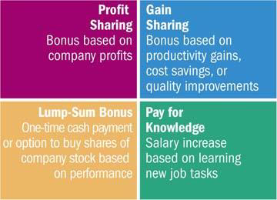

EMPLOYEE BENEFITS
- Employee Benefits: Additional compensation – such as vacation time, retirement savings plans, profit—sharing, health insurance, gym memberships, child and elder care, and tuition reimbursement – paid entirely or in part by the company
  - Could reach 30% of total employee compensation
- Some benefits required by law
  - Canada Pension Plan
  - Unemployment Insurance
  - Worker’s Compensation Programs

FLEXIBLE WORK
- Allow employees to adjust their working hours and places of work to accommodate their personal needs.
- Flextime allows employees to set their own work hours within constraints specified by the firm.
- A compressed workweek allows employees to work the regular number of weekly hours in fewer than the typical five days.
- A job-sharing program allows two or more employees to divide the tasks of one job.
- A home-based work program allows employees, or telecommuters, to perform their jobs from home instead of at the workplace.
  - More than 70 percent of Generation Y professionals are concerned with balancing career and their personal lives.

4. SEPARATION
EMPLOYEE SEPARATION
- Voluntary turnover: Employees may leave firms to start their own businesses, take jobs with other firms, or retire.
  - Some firms ask employees who leave voluntarily to participate in exit interviews to find out why they decided to leave.
  - Successful companies are clearly focused on retaining their best workers.
- Involuntary turnover: Employers may terminate employees because of poor job performance, unethical behaviour, or the need for downsizing.
  - Employers must carefully document reasons when terminating employees.
  - Human resource managers must be educated in employment laws so the termination is handled properly.

DOWNSIZING/OUTSOURCING

Downsizing: The process of reducing the number of employees within a firm by eliminating jobs
Downsizing has negative effects:
Anxiety, health problems, and lost productivity among remaining workers
Expensive severance packages paid to laid-off workers
A domino effect on the local economy

Outsourcing: Using outside vendors to produce goods or fulfill services and functions that were previously handled in-house or in-country
To save expenses and remain flexible, companies will try to outsource functions that are not part of their core business.
Although outsourcing might work on paper, the reality might be different.

5. PLANNING STAFFING NEEDS PLANNING

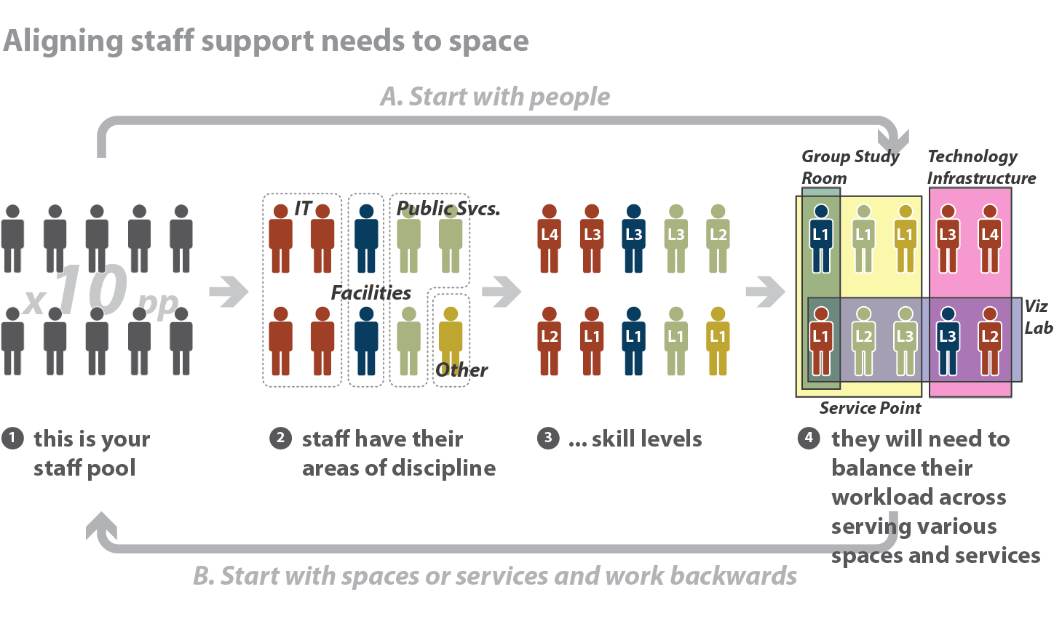
MOTIVATING/ENGAGING EMPLOYEES
MOTIVATING EMPLOYEES
- Motivation starts with good employee morale (the mental attitude of employees toward their employer and jobs).
- High employee morale occurs in organizations where workers feel valued, heard, and empowered to contribute what they do best.
- Poor morale shows up through absenteeism, voluntary turnover, and lack of motivation.
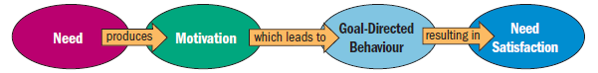
MASLOW’S HIERARCHY OF NEEDS THEORY
- People’s needs depend on what they already possess.
- A satisfied need is not a motivator; only needs that remain unsatisfied can influence behaviour.
- People’s needs are arranged in a hierarchy of importance; once they satisfy one need, at least partially, another emerges and demands satisfaction.
- People have five levels of needs that they seek to satisfy:
  - Physiological needs
  - Safety needs
  - Social (belongingness) needs
  - Esteem needs
  - Self-actualization needs

HERZBERG’S TWO-FACTOR MODEL

Hygiene factors – result in satisfaction
Salary
Job security
Working conditions
Status
Interpersonal relations
Technical supervision
Company policies

Motivator factors – can produce high levels of motivation if present
Job responsibilities
Achievement
Recognition
Growth opportunities

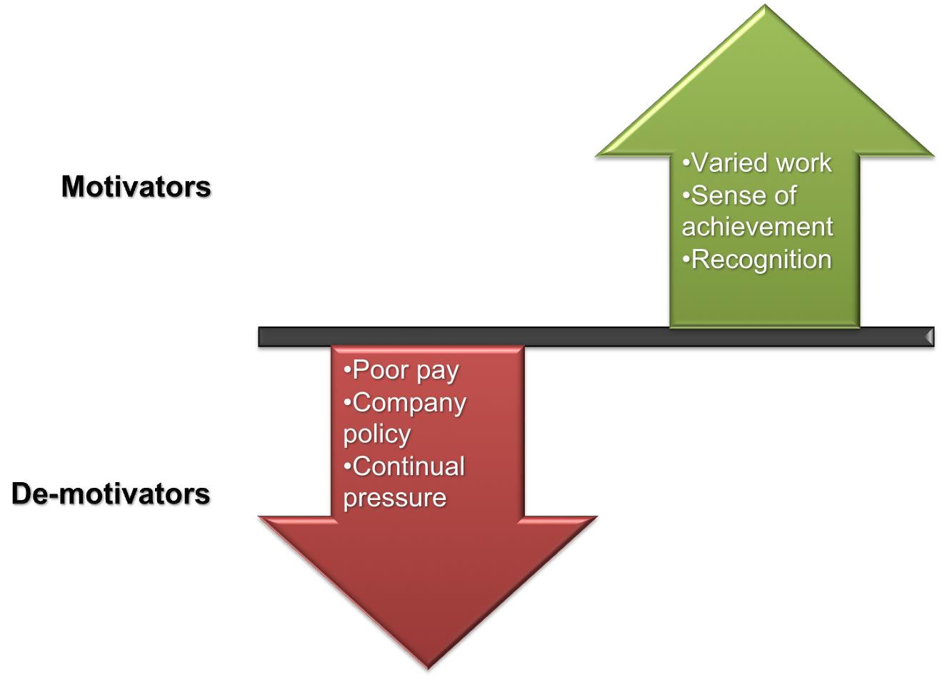

EXPECTANCY THEORY
Expectancy theory: The process people use to evaluate the likelihood that their efforts will lead to the results they want
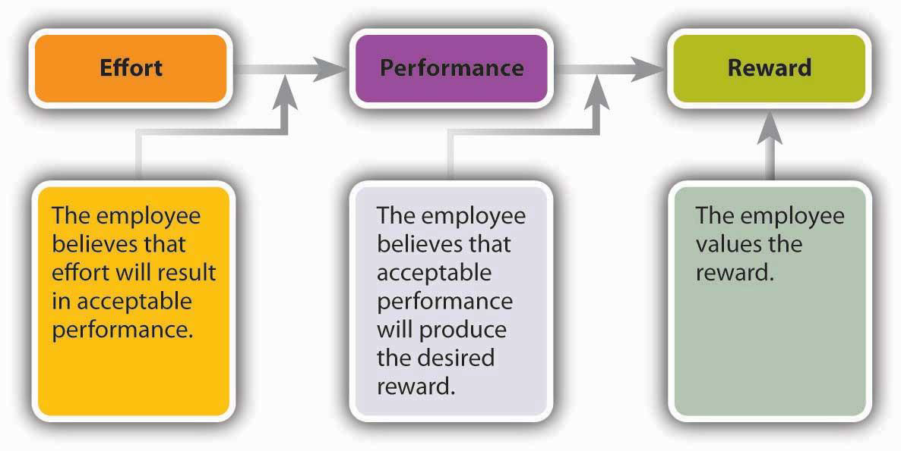

EXPECTED EFFORT, PERFORMANCE & REWARD
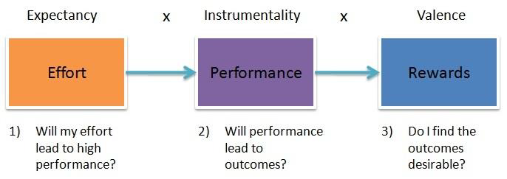
EQUITY THEORY
- Equity theory: an individual’s perception of fair and equitable treatment
- Compared to fiends, others in profession, others in company working about as hard, etc.

Are My Inputs Giving Me Expected Outputs?
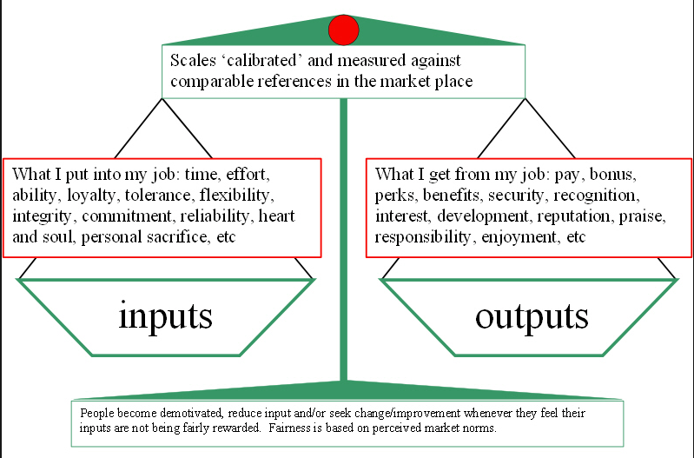

GOAL-SETTING THEORY
A goal is a target, objective, or result that someone tries to accomplish
Goal-setting theory: The idea that people will be motivated to the extent to which they accept specific, challenging goals and receive feedback that shows their progress toward goal achievement

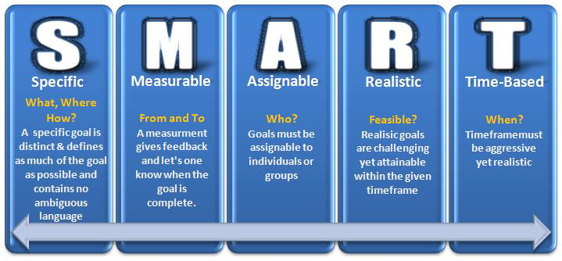
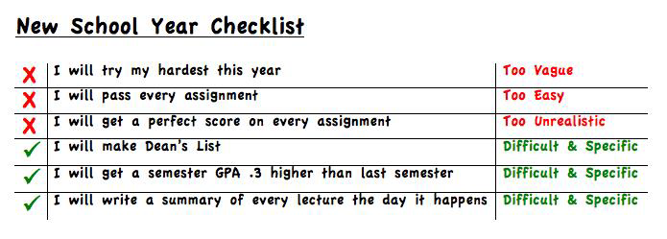
APPROACHES TO MANAGING EMPLOYEE BEHAVIOR IN FIRMS

MANAGEMENT BY OBJECTIVES (MBO)
- A structured approach that helps managers to focus on reachable goals and to achieve the best results based on the organization’s resources
- MBO helps motivate individuals by aligning their objectives with the goals of the organization, increasing overall organization performance.
- MBO principals:
  - A series of related organizational goals and objectives
  - Specific objectives for each person
  - Participative decision-making
  - A set time period to accomplish goals
  - Performance evaluation and feedback

OBJECTIVES INTEGRATED THROUGHOUT ORGANIZATION
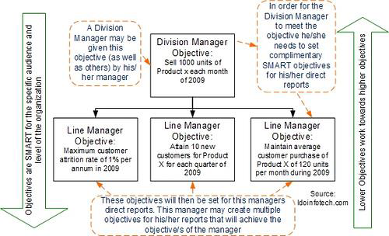

KEY ELEMENTS OF MBO
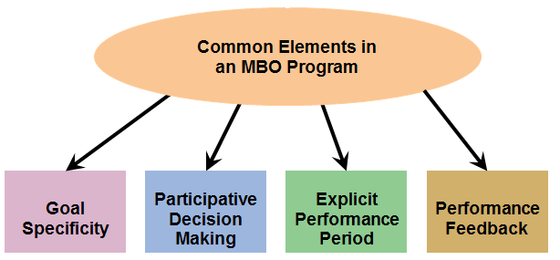

Job Design and Motivation
- Job enlargement expands an employee’s responsibilities by increasing the number and variety of tasks assigned to the worker.
- Job enrichment expands an employee’s job duties to empower an employee to make decisions and learn new skills leading toward career growth.
- Job rotation involves systematically moving employees from one job to another, increasing their range of activities.

THEORY X, Y, & Z
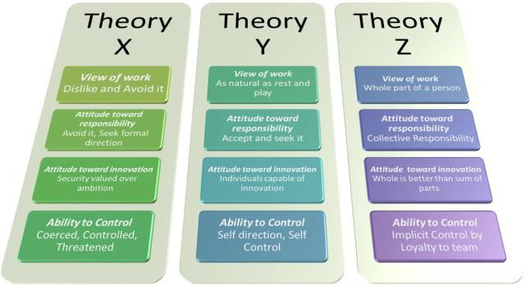

MANAGERS’ ATTITUDES AND MOTIVATION
- Two assumptions managers make about employees affect management styles, according to psychologist Douglas McGregor:
- Theory X assumes that employees dislike work and try to avoid it whenever possible, so management must coerce them to do their jobs.
- money and job security are motivators (Maslow ’s lower order of needs)
- Theory Y assumes that the typical person actually likes work and will seek and accept greater responsibility.
  - self-control and self-direction are motivators (Maslow’s higher order of needs)
- A third theory from management professor William Ouchi:
- Theory Z views worker involvement (i.e., involvement in culture and group) as key to increased productivity for the company and improved quality of work life for employees.

