Session 8: Intro to Marketing, Customer-Driven Marketing

What is marketing?
- Marketing: An organizational function and set of processes for creating, communicating, and delivering value to customers and for managing customer relationships in ways that benefit the organization and its stakeholders
  - Discover unmet customer needs; research potential market; produce a good/service capable of satisfying targeted customers; promote, price, and distribute good/service.
  - Successful organizations focus on building customer relationships throughout.
  - Best marketers give consumers what the want and anticipate consumers’ needs before they surface.
- Exchange Process: an activity in which two or more parties trade something of value (such as goods, services, or cash) that satisfies each other’s needs
- Marketing Concept: a companywide consumer focus on promoting long-term success

MARKETING STRATEGY PROCESS
Research Marketing
-> Segment & Choose Target Market
-> Understand Targeted Customer Behaviour
-> Develop Marketing Mix
[Product, Distribution (place), Promotion, Price]

MARKET SEGMENTATION
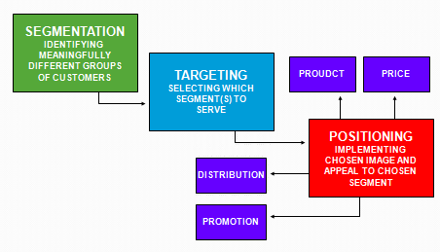

MARKETING STRATEGY
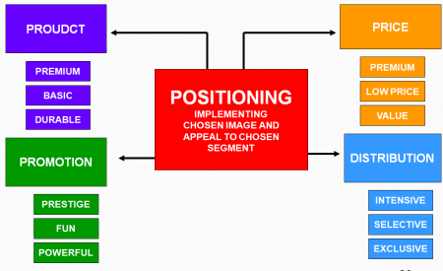
CUSTOMER UTILITY
Customers must perceive value in products

HOW MARKETING CREATES UTILITY (OR VALUE)
- Utility: The power of a good or service to satisfy a want or need
  - Create time utility by making a good or service available when customers want to purchase it.
  - Create place utility by making a product available in a location convenient for customers.
  - Create ownership utility through an organized transfer of goods and services from the seller to the buyer.
- Value Proposition: value customer gets out of product or service based on purchasing it.

MATCHING TARGET MARKET TO PRODUCT
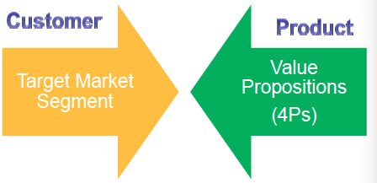

DEVELOPING A MARKETING STRATEGY
- Study and analyze potential target markets and choose among them.
- Create a marketing mix to satisfy the chosen market (product, distribution, promotion, & pricing)

CHOOSING TARGET MARKET
MARKET SEGMENTATION
SEGMENT OPTIONS (BANKING)
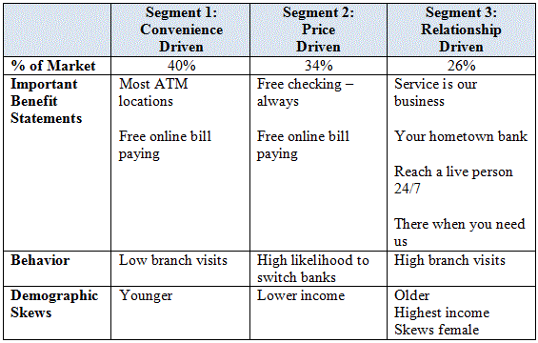
SELECTING A TARGET MARKET
- Target market: A group of people that an organization markets its goods, services, or ideas toward, using a strategy designed to satisfy this group’s specific needs and preferences
- Types of markets
  - Consumer (B2C) product: A good or service that is purchased by end users
  - Business (B2B) product: A good or service purchased to be used, either directly or indirectly, in the production of other goods for resale

MARKETING RESEARCH
- Marketing research: The process of collecting and evaluating information to support marketing decision-making
- Internal data is generated within the organization; includes financial records, inventory levels, sales, profitability
- External data comes from outside sources; includes trade associations, advertising agencies, national marketing research firms
- Secondary data is previously published data.
  - Low-cost and easy to obtain.
  - Government publications provide data sources (e.g., census statistics).
- Primary data is collected through observation, surveys, and other forms of observational study.
- Focus groups gather 8 to 12 people in a room or over the Internet to discuss a specific topic.
  - Can lead to new ideas, address consumer needs, and point out flaws in existing products.
- Business intelligence: A field of research that uses activities and technologies for gathering, storing, and analyzing data to make better competitive decisions
- Data mining: The use of computer searches of customer data to detect patterns and relationships.
- Data Warehouse: a customer database that allows managers to combine data from several different organizational functions.
MARKET SEGMENTATION
- Market segmentation: The process of dividing a total market into several relatively similar groups
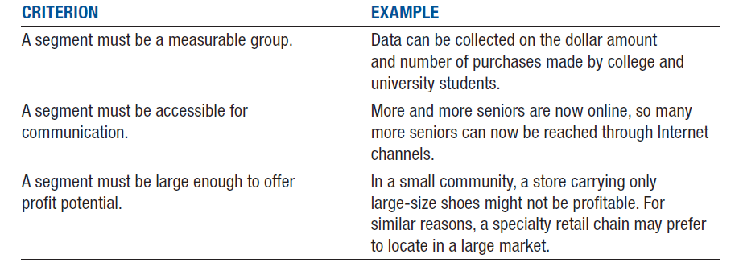
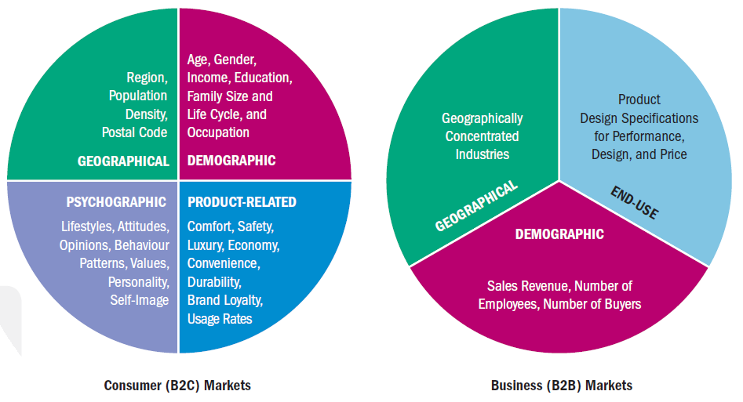
SEGMENTING CONSUMER MARKETS
- Geographical segmentation: Dividing an overall market into similar groups on the basis of their locations
- Demographic segmentation: Dividing markets on the basis of various demographic or socioeconomic characteristics, such as gender, age, income, occupation, household size, stage in family life cycle, education, or ethnic group
- Psychographic segmentation: Dividing consumer markets into groups with similar attitudes, values, and lifestyles
  - AIO statements are people’s verbal descriptions of various attitudes, interests, and opinions
- Product-related segmentation: Dividing consumer markets into groups that are based on benefits sought by buyers, usage rates, and loyalty levels
  - Benefits Sought: focus on the qualities people look for in a good or service and the benefits they expect to receive.
  - Product usage: defines categories as heavy users, medium users, light users
    - 80/20 principle: roughly 80% of a products revenues come from only 20% of its buyers.
  - Brand Loyalty: the degree to which consumers recognize, prefer, and insist on a particular brand.
    - Brand sends these devoted people premiums, from t-shirts with the logo on it, to tickets to a concert or sporting event.

GEOGRAPHIC SEGMENTATION
- REGIONAL ADVERTISING
- Geographic location doesn’t guarantee that consumers in a certain region will all buy the same kinds of products, but it provides some info about needs
  - Growth and immigration patterns are important

DEMOGRAPHIC SEGMENTS
- Dividing markets on the basis of various demographic or socioeconomic characteristics, such as gender, age, income, occupation, household size, stage in family life cycle, education, or ethnic group
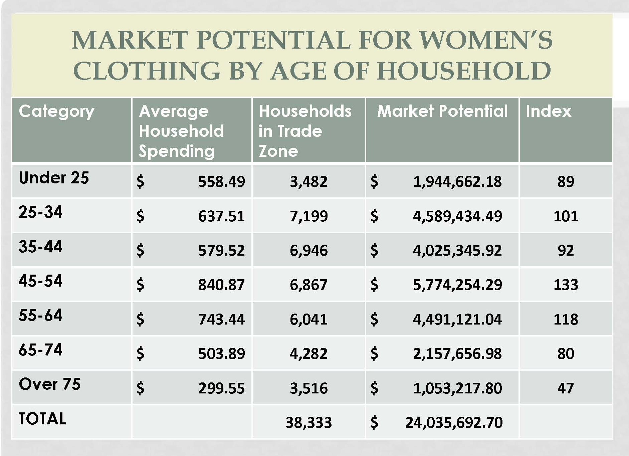

Product Segments
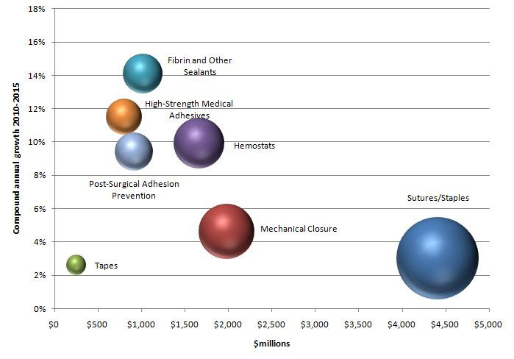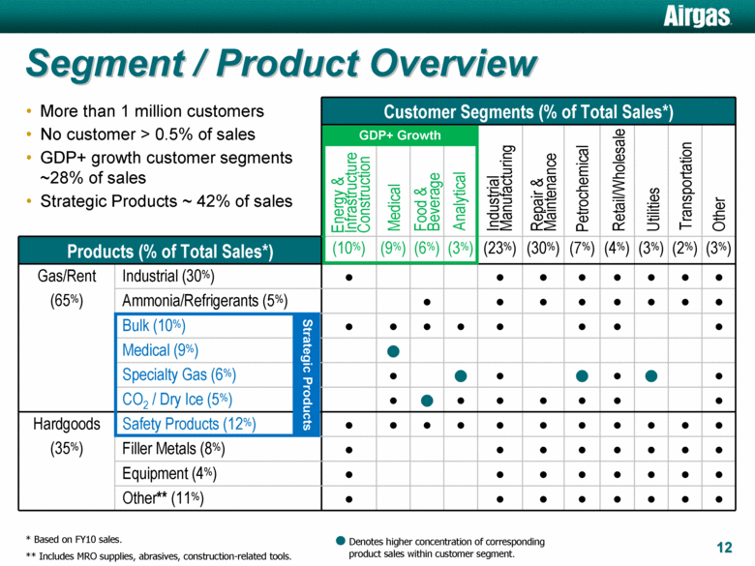

SEGMENTING BUSINESS MARKETS
- Geographic segmentation targets geographically concentrated industries. Demographic, or customer-based, segmentation designs a good or service intended for a specific organizational market (e.g., healthcare institutions).
- End-use segmentation: A marketing strategy that focuses on the precise way a B2B purchaser will use a product
CUSTOMER BEHAVIOR
- Consumer behavior: End consumers’ activities that are directly involved in obtaining, consuming, and disposing of products, and the decision processes before and after these activities.
  - Personal factors: needs and motives, perceptions, attitudes, learned experiences, self-concept
  - Interpersonal factors: cultural, social, and family influences
  - External factors: economic events
- Business buying behavior often includes a variety of influences from multiple decision makers within the organization.

STEPS IN THE CONSUMER BEHAVIOR PROCESS
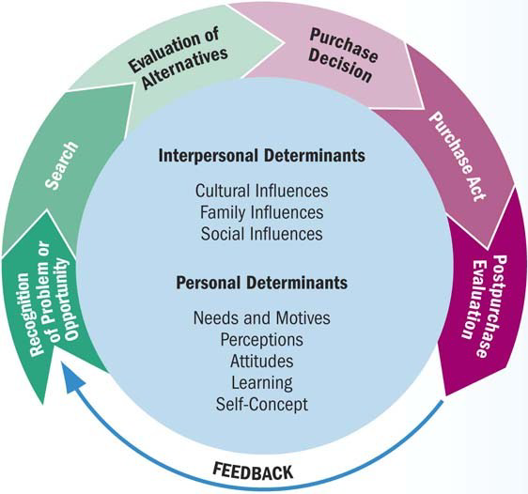

CONSUMER BEHAVIOR MODEL
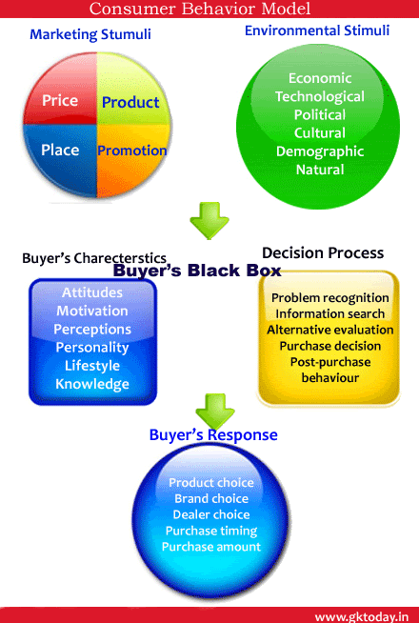
CHOOSE TARGET MARKET
- Understand customer characteristics – demographics, attitudes, etc.
- Understand buying patterns (i.e., customer behavior) – when purchase, where purchase, how purchase, etc.
- Does your product provide value to target customer?
Selecting a target market
- Marketing mix: A blending of the four elements of marketing strategy to fit satisfy chosen customer segment(s)
  - Product strategy involves the nature of the product and its package design, brand names, trademarks, and product image.
  - Distribution strategy ensures that customers receive their purchases in the proper quantities at the right times and locations.
  - Promotional strategy blends advertising, personal selling, sales promotion, and public relations to achieve its goals of informing, persuading, and influencing purchase decisions.
  - Pricing strategy sets profitable and justifiable prices for the firm’s product offerings, sometimes subject to government scrutiny.

DEVELOPING A MARKETING MIX FOR INTERNATIONAL MARKETS
- Standardization means offering the same marketing mix in every market.
- Adaptation means developing a unique marketing mix to fit each market’s local competitive conditions, consumer preferences, and government regulations.
- Mass customization allows a firm to mass-produce goods and services while adding unique features to individual or small groups of orders.

RELATIONSHIP MARKETING
- Relationship marketing: Developing and maintaining long-term, cost-effective exchange relationships with partners
  - Consumers enter into relationships only if there is some benefit to them.
  - Relationship marketing seeks to achieve customer satisfaction as its ultimate goal.

BENEFITS OF RELATIONSHIP MARKETING
- Lower costs, higher profits, and protection against competitors for the business.
- Lifetime value of a customer: The revenues and intangible benefits (such as referrals and customer feedback) from a customer over the life of the relationship, minus the amount the company must spend to acquire and serve that customer
- Stronger relationships with business partners and opportunities to combine capabilities and resources to better accomplish goals.

TOOLS FOR NURTURING CUSTOMER RELATIONSHIPS
- Frequency marketing: A marketing initiative that reward frequent purchases with cash, rebates, merchandise, or other premiums
- Affinity programs: A marketing effort sponsored by an organization that targets people who share common interests and activities
- Co-marketing: A cooperative arrangement where two or more businesses jointly market each others’ products
- Cobranding: A cooperative arrangement where two or more businesses team up to closely link their names on a single product

ONE-TO-ONE MARKETING
- Customizing products and marketing and rapidly delivering goods.
- Customer relationship management (CRM) software helps companies gather, sort, and interpret data about specific customers.
NON-TRADITIONAL MARKETING
NOT-FOR-PROFIT AND NONTRADITIONAL MARKETING
- Approximately 20 million not-for-profits exist worldwide.
  - Canada leads the world in contributions to its gross domestic product by not-for-profit organizations.
- Apply marketing tools to reach audiences, secure funding, and accomplish their overall missions.
- Not-for-profit organizations operate in both public and private sectors.
- Sometimes partner with a profit-seeking company to promote a message.
- Person marketing: efforts that are designed to attract the attention, interest, and preference of a target market towards a person
- Place marketing: an attempt to attract people to a particular area, such as a city, region, or country.
- Event marketing: marketing or sponsoring of short-term events such as athletic competitions and cultural and charitable performances.
- Cause Marketing: promotes a cause or social issue, such as preventing child abuse, anti-littering efforts, and stop-smoking campaigns.
- Organization Marketing: strategy that influences consumers to accept the goals of an organization, receive the services of an organization, ot contribute in some way to the organization
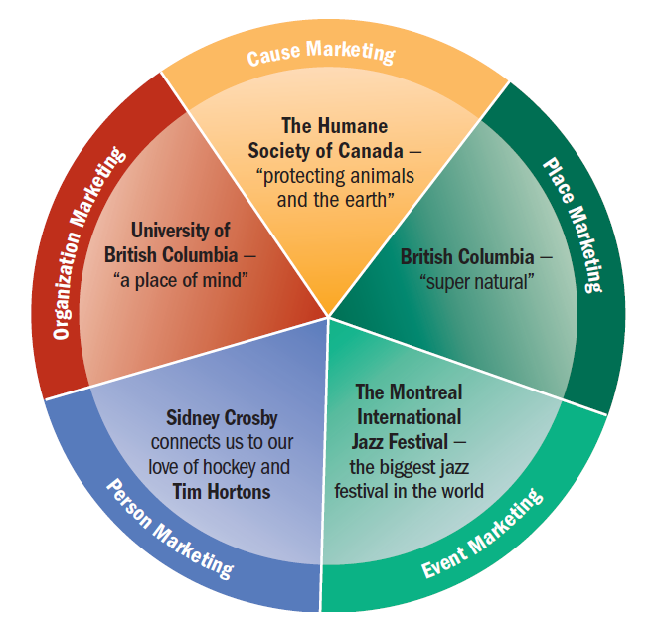
MARKETING MIX OF STRATEGIES
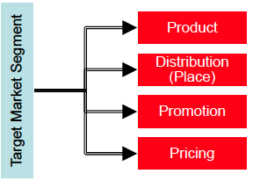
- Product & Distribution are about providing an appropriate product to the right place.
- Promotion & Pricing are about attracting and sustaining customers.

PRODUCT CHARACTERISTICS
Marketing Mix – Promotion and Pricing
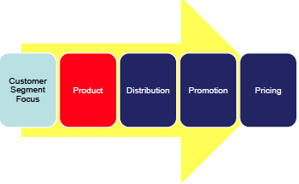
PRODUCT STRATEGY
Product: A bundle of physical, service, and symbolic characteristics designed to satisfy consumer wants

CONSUMER GOODS: CONVENIENCE PRODUCT
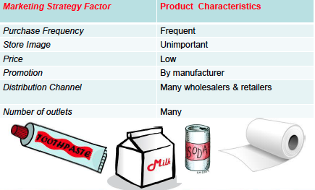
Items that consumers purchase frequently immediately and with little effort

CONSUMER GOODS: SHOPPING PRODUCT
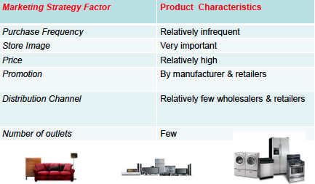
Items usually purchased after the consumer has compared prices and benefits with competitors.

CONSUMER GOODS: SPECIALTY PRODUCT
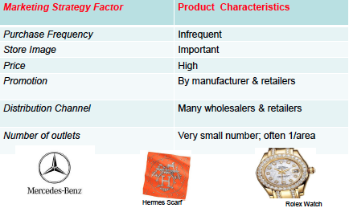
Products consumers buy with special consideration and effort. Consumer is already familiar with the product and understands that there is no considerable substitute.

Classifying Business Goods
- Business products: goods/services such as paycheque services and huge multifunctioning copy machines used in operating an organization.
  - Also includes machinery, tools, raw materials, components and building used to produce other items meant for resale
- Capital Items: products that are long-lived and relatively expensive
- B2B Products:
  - Installations: major capital items
    - factories, heavy equipment, machinery, custom-made equipment
    - Purchase approval must go through production specialists, purchasing department reps, members of top management, etc.
  - Accessory equipment: less expensive capital items and shorter lived – hand tools, fax machines
    - Doesn’t go through as much approval decision-makers
  - Component parts and materials: Finished business goods that become a part of the final product
    - disk drives to be sold in computers, batteries purchased by automakers.
  - Raw materials: farm and natural resources used to created the final product
  - Supplies: Expense items often used to in the firms daily operations and doesn’t end up in the final product
    - MRO (maintenance, repair, operating supplies) i.e. paper clips, light bulbs, copy paper.
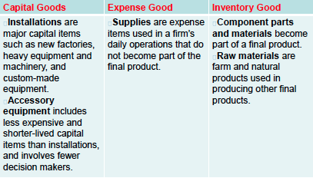

CLASSIFYING SERVICES
- Either B2C or B2B
- Like childcare/eldercare centres

PRODUCT LINES AND PRODUCT MIX
- Product line: A group of related products that share by physical similarities or are targeted toward a similar market
- Product mix: The assortment of product lines and individual goods and services that a firm offers to consumers and business users

PRODUCT LIFE CYCLE
- Product life cycle: The four basic stages in the development of a successful product—introduction, growth, maturity, and decline
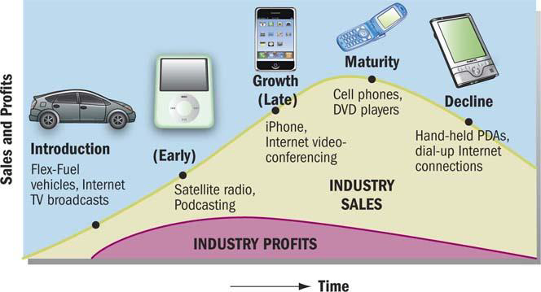

Life Stage Introduction Growth Maturity Decline

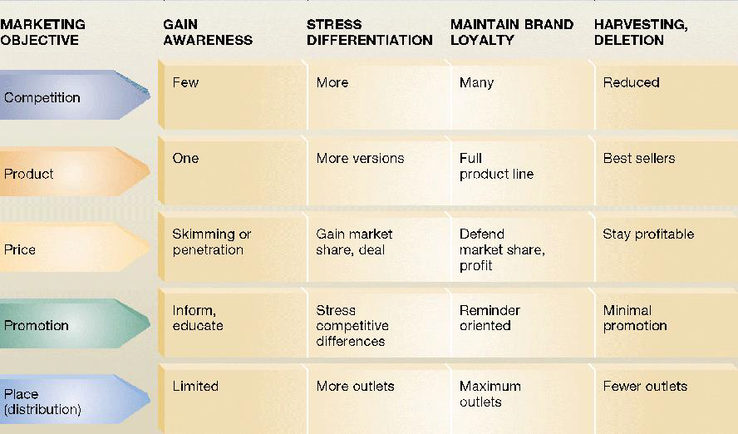

STAGES OF THE PRODUCT LIFE CYCLE
- In the introduction stage, the firm promotes demand for its new offering; informs the market about it; gives free samples to entice consumers to make a trial purchase; and explains its features, uses, and benefits.
- In the growth stage, sales climb quickly as new customers join early users who are repurchasing the item. The company begins to earn profits on the new product.
- In the maturity stage, industry sales eventually reach a saturation level at which further expansion is difficult.
- In the decline stage, sales fall and profits decline.
STAGES IN NEW-PRODUCT DEVELOPMENT
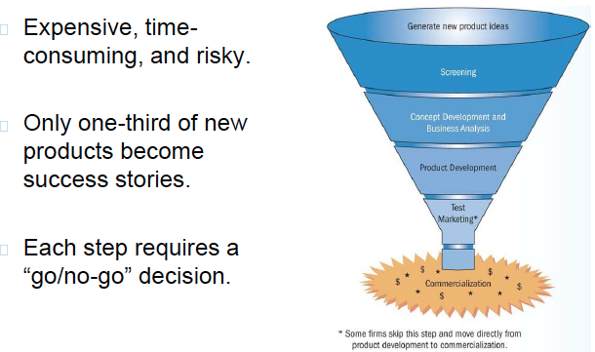
Product Development Stages
Stage 1: Generating ideas for new offerings
Stage 2: Strategically screen
Stage 3: Concept development and business analysis
Stage 4: Product development
Stage 5: Test marketing
Stage 6: Commercialization

PRODUCT IDENTIFICATION
- Brand: A name, term, sign, symbol, design, or some combination that identifies the products of one firm and shows how they differ from competitors’ offerings
- Brand name: The part of the brand that is made up of words or letters that form a name
  - Used to identify a firm’s products and show how they differ from the products of competitors.
- Trademark: A brand that has been given legal protection

BRAND CATEGORIES
- A manufacturer’s (or national) brand is offered and promoted by a manufacturer.
  - Tide, Cheerios, Windex, Fossil, Nike
- A private (or store) brand is not linked to the manufacturer but instead carries a wholesaler’s or retailer’s label.
  - Loblaw ’s President ’s Choice foods, Sears’ Craftsman tools
- A family branding strategy uses a single brand name for several related products.
  - KitchenAid, Johnson & Johnson, Hewlett-Packard, Arm & Hammer
- An individual branding strategy gives each product within a line a different name.
  - Procter & Gamble products Tide, Cheer, and Dash

BRAND LOYALTY
- In brand recognition, the consumer is aware of the brand but does not have a preference for it over other brands.
- In brand preference, the consumer chooses one firm’s brand over a competitor’s.
- In brand insistence, the consumer will seek out a preferred brand and accept no substitute for it (the ultimate degree of brand loyalty).

BRAND EQUITY
- Brand equity: The added value that a respected and successful name gives to a product
- In brand awareness, the product is the first one that comes to mind when a product category is mentioned.

Brand Equity or Value
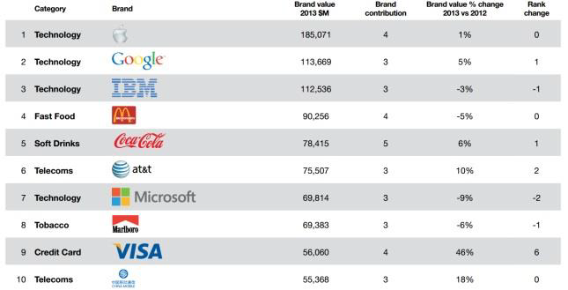

PACKAGES AND LABELS
- Packaging affects the durability, image, and convenience of an item and is responsible for one of the biggest costs in many consumer products.
- Packaging is important in product identification and play is an important role in a firm’s overall product strategy.
- Choosing the right package is especially important in international marketing.
- Packing must meet legal requirements of all countries in which product is sold.
- Universal Product Code: bar code read by optical scanner; link UPC to product

DISTRIBUTION STRATEGIES
- Product & Distribution are about providing an appropriate product to the right place.
- Promotion & Pricing are about attracting and sustaining customers.
- Distribution channel: The path that products—and their legal ownership—follow from producer to consumers or business users
- Physical distribution: The actual movement of products from producer to consumers or business users
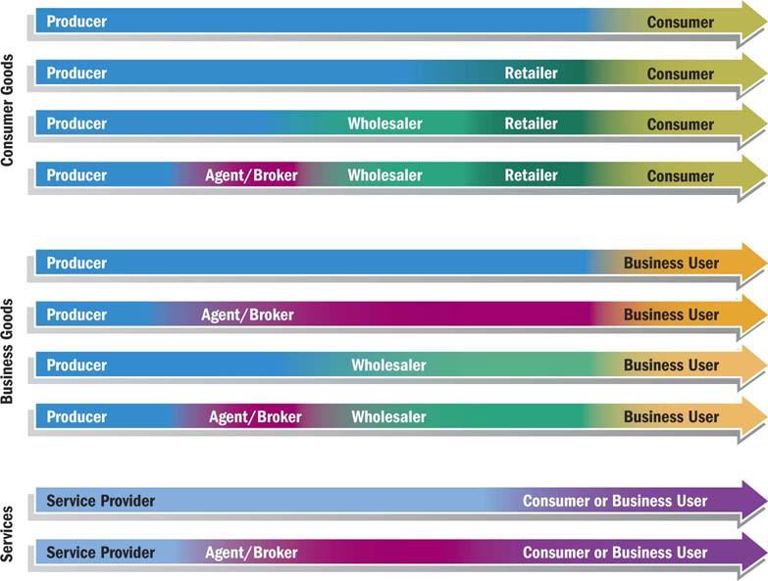

Distribution Channels
- Direct distribution
  - Direct contact between producer and customer.
  - Most common in B2B markets.
  - Often found in the marketing of relatively expensive, complex products that may require demonstrations.
  - Internet is helping companies distribute directly to consumer market.
- Distribution channels using marketing intermediaries
  - Producers distribute products through wholesalers and retailers.
  - Inexpensive products sold to thousands of consumers in widely scattered locations.
  - Lowers costs of goods to consumers by creating market utility.

REDUCING TRANSACTIONS THROUGH MARKETING INTERMEDIARIES
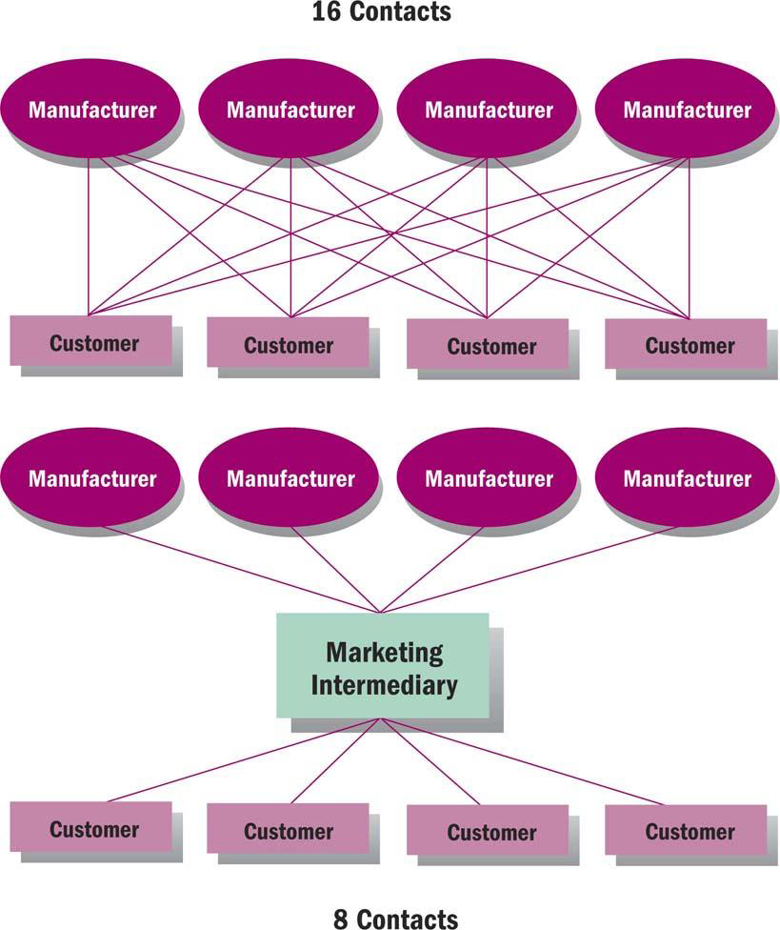
Wholesaling
- Wholesaler: A distribution channel member that sells primarily to retailers, other wholesalers, or business users
- Manufacturer-owned wholesaling intermediaries
- Owned by the manufacturer of the goods or products to control distribution or customer service
- Sales branch stocks products and fills orders from inventories
- Sales office takes orders but does not stock the product

RETAILING
- Retailers: Distribution channel members that sells goods and services to individuals for their own use, not for resale
- Final link of the distribution channel; deal directly with customers
- Two types: store and nonstore

NON-STORE RETAILING
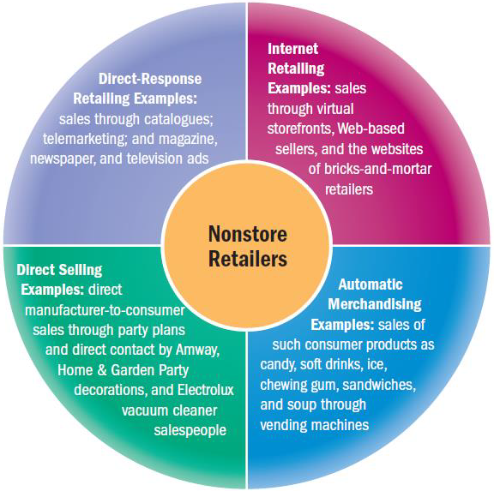
TYPES OF RETAIL STORES
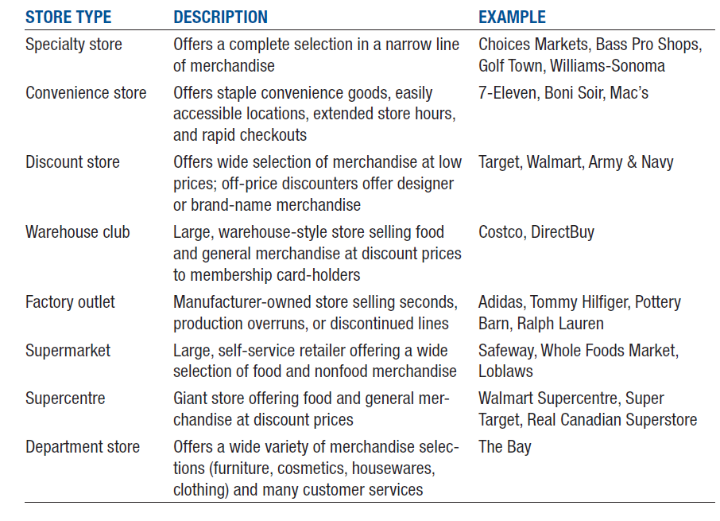

THE WHEEL OF RETAILING
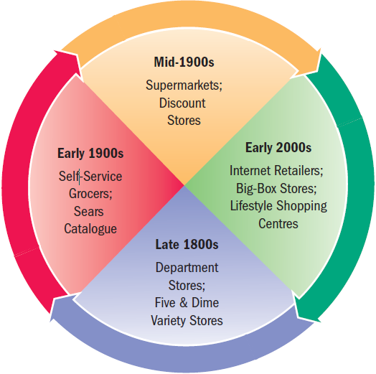

HOW RETAILERS COMPETE
- Identifying a target market
- Selecting a product strategy
- Selecting a customer service strategy
- Selecting a pricing strategy
- Choosing a location
- Building a promotional strategy
- Creating a store atmosphere

DISTRIBUTION CHANNEL DECISIONS AND LOGISTICS
- What specific channel will it use?
- What will be the level of distribution intensity?
- Selecting distribution channels
  - Complex, expensive, custom-made, or perishable products move through shorter distribution channels involving few—or no—intermediaries.
  - Standardized products or items with low unit values usually pass through relatively long distribution channels.
  - Start-up companies often use direct channels because they can’t persuade intermediaries to carry their products, or because they want to extend their sales reach.

SELECTING DISTRIBUTION INTENSITY
- Intensive distribution involves a firm’s products in nearly every available outlet, and requires the cooperation of many intermediaries.
- In selective distribution, the manufacturer selects a limited number of retailers to distribute its product lines.
- Exclusive distribution limits market coverage in a specific geographical region that will enhance a product’s image.
LOGISTICS AND PHYSICAL DISTRIBUTION
- Supply chain: The complete sequence of suppliers that help to create a good or service and deliver it to business users and final consumers
- Logistics: The process of coordinating the flow of goods, services, and information among members of the supply chain
- In physical distribution, activities are aimed at efficiently moving finished goods from the production line to the consumer or business buyer.
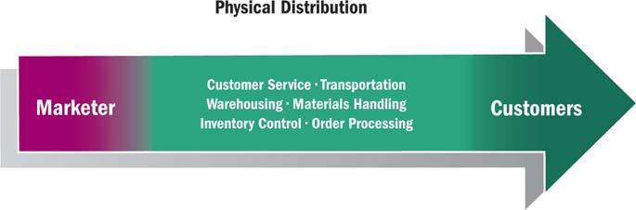
Comparison of Transportation Modes
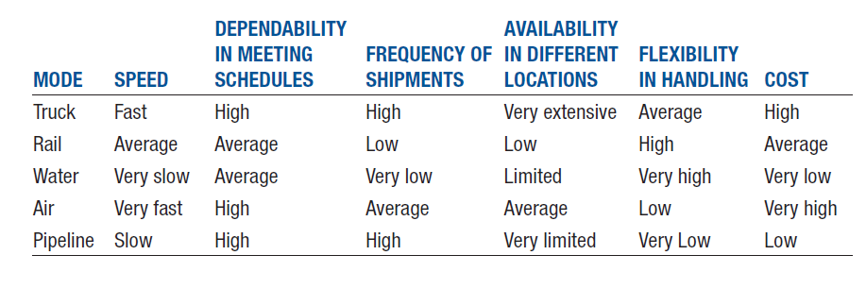CUSTOMER SERVICE
- Customer service standards measure the quality of service a firm provides for its customers.
- Warranties are a firm’s promises to repair a defective product, refund money paid, or replace a product if it proves unsatisfactory.
- Internet retailers have worked to humanize their customer interactions and deal with complaints more effectively.

CHOOSING A DISTRIBUTION
- Ask customer
- Is there a strategic fit between this channel & your marketing strategy?
- Is there is a product fit?
- Does it make financial sense?

PROMOTION STRATEGIES
MARKETING MIX – PROMOTION & PRICING
- Product & Distribution are about providing an appropriate product to the right place.
- Promotion & Pricing are about attracting and sustaining customers.

PROMOTION STRATEGIES
- Promotion: The function of informing, persuading, and influencing a purchase decision.
- Integrated marketing communications (IMC): The coordination of all promotional activities—media advertising, direct mail, personal selling, sales promotion, and public relations—to produce a unified, customer-focused promotional strategy

THE PROMOTIONAL MIX
- Promotional mix: The combination of personal and non-personal selling that marketers use to meet the needs of a firm’s target customers and to effectively and efficiently communicate its message to them
- Personal selling: The most basic form of promotion: a direct person-to-person promotional presentation to a potential buyer
- Non-personal selling: Forms of selling such as advertising, sales promotion, direct marketing, and public relations

COMPARING THE ELEMENTS OF THE PROMOTIONAL MIX
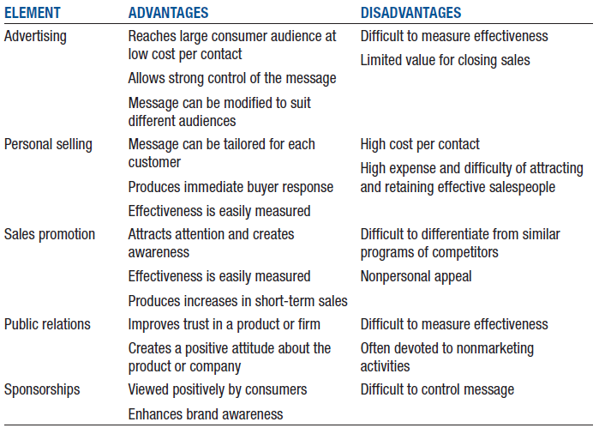
OBJECTIVES OF PROMOTIONAL STRATEGIES
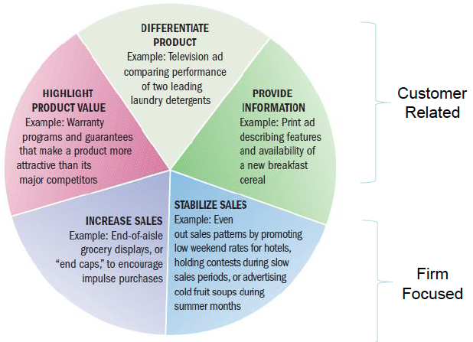
ADVERTISING
- Advertising: Paid non-personal communication usually targeted at large numbers of potential buyers
  - Advertising expenditures are great; automotive, retail, and telecommunications firms spend the most on advertising in North America
    - Carmakers spend $20 billion on advertising yearly
  - Consumers are bombarded with many messages
  - Firms need to be more and more creative and efficient at attracting customers’ attention

TYPES OF ADVERTISING
- Product advertising: Messages designed to sell a particular good or service
- Institutional advertising: Messages that promote concepts, ideas, or philosophies. It can also promote goodwill toward industries, companies, organizations, or government entities
  - Government advertising economic plan
- Cause advertising: A form of institutional advertising that promotes a specific viewpoint on a public issue as a way to influence public opinion and the political process
  - Example – Cancer Research

ADVERTISING AND THE PRODUCT LIFE CYCLE
- Informative advertising is used to build initial demand for a product in its introductory phase.
- Persuasive advertising attempts to improve the competitive status of a product, institution, or concept, usually in its growth and maturity stages.
- Comparative advertising compares products directly with their competitors, either by name or by inference.
- Reminder-oriented advertising maintains awareness of the importance and usefulness of a product in its late maturity or decline stages.

ADVERTISING & LIFE CYCLE
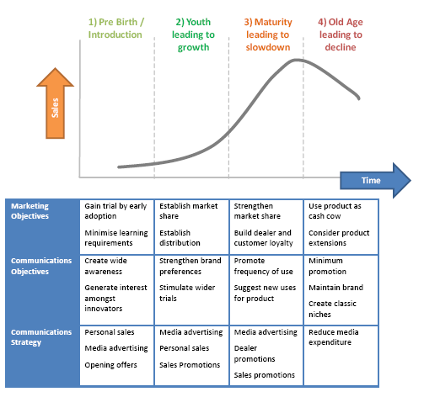
STAGE OF PURCHASING PROCESS
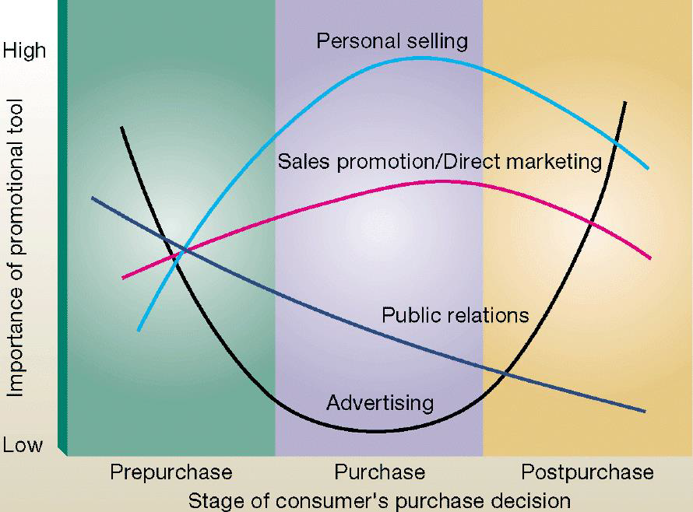
SELECTING AN ADVERTISING MEDIA
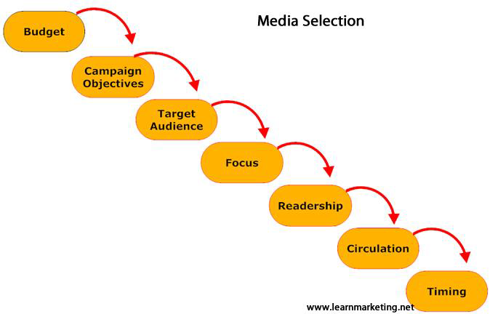

TYPES OF ADVERTISING

- Television
  - Easiest way to reach a large number of consumers
  - Leading, but most expensive, advertising medium
- Newspapers
  - Dominate local advertising
  - Relatively short life span
- Radio
  - Commuters in cars are a captive audience
  - Internet radio offers new opportunities
- Magazines
  - Consumer publications and trade journals
  - Can customize message for different areas of the country (local ads, wraparounds)
- Direct Mail
  - Average North American receives 550 pieces annually
  - High per person cost, but can be carefully targeted and highly effective
- Outdoor Advertising
  - Billions spent annually in North America
  - Requires brief messages
- Online and interactive advertising
  - Widgets (or gadgets) are small television screen images carrying marketing messages; contain embedded links to home sites.
  - Viral advertising creates a message that is novel or entertaining enough for consumers to forward it to others
- Sponsorship: Providing funds for a sporting or cultural event in exchange for a direct association with the event
  - Exposure to target audience
  - Association with image of the event
- Other media options
  - Marketers look for novel ways to reach customers
  - Infomercials: A form of broadcast direct marketing; 30-minute programs resemble regular TV programs, but sell goods or services
  - ATM commercials/receipts
  - Directory advertising

GLOBAL TRENDS FOR ADVERTISING
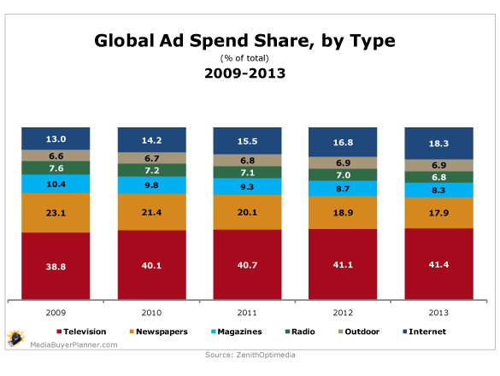
SALES PROMOTION
- Sales promotion: Forms of promotion such as coupons, product samples, and rebates that support advertising and personal selling
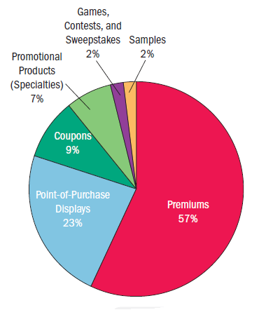
CONSUMER-ORIENTED PROMOTIONS
- Premiums, coupons, rebates, samples
  - Marketers generally choose free/reduced price premiums likely to get consumers thinking and caring about a brand and product.
  - Coupons attract new customers, but focus on price rather than brand loyalty.
  - Rebates increase purchase rates, promote multiple purchases, and reward product users.
  - Three of every four consumers who receive a sample will try it.
- Games, contests, sweepstakes
  - Introduction of new products.
  - Offer cash, merchandise, or travel as prizes to participating winners.
  - Subject to legal restrictions.
- Specialty advertising
  - Promotional items that prominently display a firm’s name, logo, or business slogan.

TRADE-ORIENTED PROMOTIONS
- Sales promotion geared to marketing intermediaries, note to final consumers
- Encourage retailers
  - To stock new products
  - To continue carrying existing ones
  - To promote both new and existing products effectively to consumers
  - Point-of-purchase (POP) advertising
  - Trade shows

PRODUCT PLACEMENT PROMOTION
- Product placement: A form of promotion where marketers pay placement fees to have their products featured in various media, from newspapers and magazines to television and movies

GUERILLA MARKETING PROMOTION
- Guerilla marketing: Innovative, low-cost marketing efforts designed to get consumers’ attention in unusual ways.

PERSONAL SELLING
- A person-to-person promotional presentation to a potential buyer
- Many companies consider personal selling the key to marketing effectiveness.
- A seller matches a firm’s goods or services to the needs of a particular client or customer.
- Businesses often spend five to 10 times as much on personal selling as on advertising.

WHEN PERSONAL SELLING IS ADVANTAGEOUS
- Firms focus on personal selling under four conditions:
- Few, geographically concentrated customers
- Product is technically complex, involves trade-ins, or requires special handling
- Product carries a relatively high price
- Product moves through direct-distribution channels

SALES TASKS
- Order processing: A form of selling used mostly at the wholesale and retail levels; involves identifying customer needs, pointing out products that meet those needs, and completing orders
- Creative selling: A persuasive type of promotional presentation
  - Promotes a good or service whose benefits are not readily apparent or whose purchase decision requires a close analysis of alternatives
- Missionary selling: An indirect form of selling in which the representative promotes goodwill for a company or provides technical or operational assistance to the customer
- Telemarketing: Personal selling by telephone, which provides a firm’s marketers with a high return on their expenditures, an immediate response, and an opportunity for personalized two-way conversation

The Sales Process
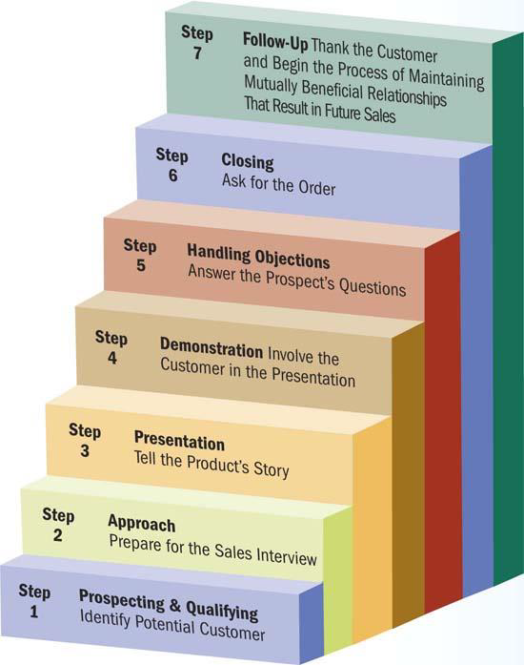
PROSPECTING, QUALIFYING, AND APPROACHING
- A good salesperson varies the sales process based on customers’ needs and responses.
- Prospecting is identifying potential customers.
- Qualifying is identifying potential customers who have financial ability and buying authority.
- Done through direct mail responses, personal visits from sales representatives, email, electronic social media
- Approaching is analyzing available data about a prospective customer’s product lines and other pertinent information.

PRESENTATION AND DEMONSTRATION
- Presentation: Salespeople communicate promotional messages. They may describe the major features of their products, highlight the advantages, and cite examples of satisfied consumers.
- Demonstration: Reinforces the message that the salesperson has been communicating.
HANDLING OBJECTIONS AND CLOSING
- Use objections as an opportunity to answer questions and explain how the product will benefit the customer.
- The closing is the critical point in the sales process; asking the customer to buy.
- Even if the sale is not made, the salesperson should regard the interaction as the beginning of a potential relationship.

FOLLOW-UP
- An important part of building a long-lasting relationship.
- May determine whether the customer will make another purchase.

Pushing and Pulling Strategies
- Pushing Strategy: Personal selling to market an item to wholesalers and retailers in a company’s distribution channels
  - Companies promote the product to members of the marketing channel, not to end-users.
- Pulling Strategy: Promote of a product by generating consumer demand for it, mainly through advertising and sales promotion appeals
  - Potential buyers will request that their suppliers – retailers or local distributors – carry the product, thereby pulling it through the distribution channel
- Most marketing situations require combinations of push and pull strategies
- Cooperative Advertising: Allowances that marketers provide to share with channel partners the cost of local advertising of their firm’s product or product line

PRICING STRATEGIES
MARKETING MIX – PROMOTION & PRICING
- Product & Distribution are about providing an appropriate product to the right place.
- Promotion & Pricing are about attracting and sustaining customers.

PRICING OBJECTIVES IN THE MARKETING MIX
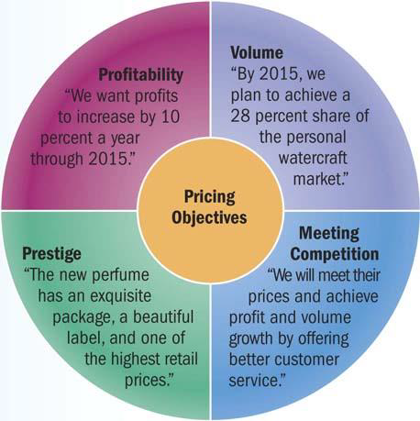

PRICING OBJECTIVES IN THE MARKETING MIX
- Price: The exchange value of a good or service
- Profitability objectives: Common goals that are included in the strategic plans of most firms
  - Maximize profits by reducing costs.
  - Maintain price while reducing package size.
- Volume objectives: Pricing decisions that are based on market share, the percentage of a market controlled by a certain company or product

THREE BROAD PRICING APPROACHES
- Customers – Price based upon what the customers will pay given quality/feature perceptions.
- Competition – Price to be able to sell relative to competitors price.
  - Competitors cannot legally work together to set prices.
  - Competition can result in a price war.
- Cost – Price based on cost plus profit margin.

PRESTIGE OBJECTIVES
- Prestige pricing: Establishing a relatively high price to develop and maintain an image of quality and exclusiveness
- Recognition of the role of price in communicating an overall image for the firm and its products.
- Products that are limited in distribution or so popular that they become scarce generate their own prestige.
PRICE DETERMINATION IN PRACTICE
- Cost-based pricing: Calculating total costs per unit and then adding markups to cover overhead costs and generate profits
- Totals all costs associated with offering a product in the market, including research and development, production, transportation, and marketing expenses
- Markup is added to cover any unexpected or overlooked expenses and provides a profit.
- Total is the selling price.
- Actual markup used varies by such factors as brand image and type of store.

BREAKEVEN ANALYSIS
Breakeven analysis: The pricing-related technique used to calculate the minimum sales volume a product must generate at a certain price level to cover all costs
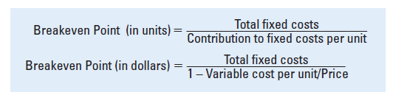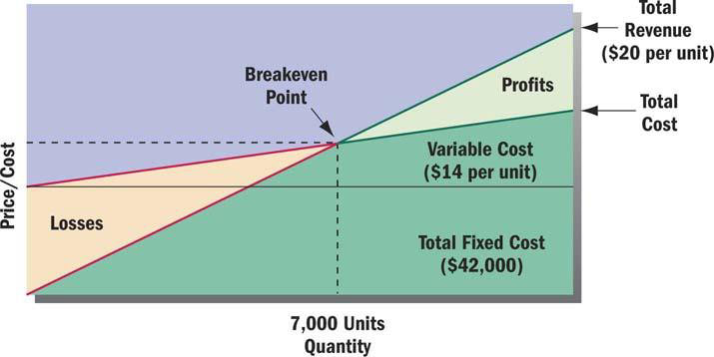
ALTERNATIVE PRICING STRATEGIES
- Skimming pricing: A strategy that sets an intentionally high price relative to the prices of competing products
  - Helps marketers set a price that distinguishes a firm’s high-end product from those of competitors
- Penetration pricing: A strategy that sets a low price as a major marketing tactic
  - Often used with new products
- Everyday low pricing (EDLP): A strategy of maintaining continuous low prices instead of using short-term price-cutting tactics such as cents-off coupons, rebates, and special sales
  - Discount pricing is used to attract customers by dropping prices for a set period of time.
- Competitive pricing: A strategy that tries to reduce the emphasis on price competition by matching other firms’ prices and by focusing their own marketing efforts on the product, distribution, and promotional elements of the marketing mix

CONSUMER PERCEPTIONS OF PRICES
- Price–quality relationships
  - Consumers’ perceptions of quality closely tied to price
  - High price = prestige and higher quality
  - Low price = less prestige and lower quality
- Odd pricing: A pricing method that uses uneven amounts to make prices appear to be less than they really are
  - Examples: $1.99; $9.95

