Biology Study Outcomes
LECTURE 2-EVOLUTION IN ACTION: HUMAN IMMUNODEFICIENCY VIRUS
- General mechanisms by which vaccines protect against diseases.
- Vaccination is the administration of antigenic material (a vaccine) to stimulate an individual's immune system to develop adaptive immunity to a pathogen
- Dormant form of the disease is introduced into the immune system so that individual produces antibodies against it
- When actual disease enters, person’s body is equipped with the antibodies to attack it before it becomes established

- Why developing a vaccine against HIV is relatively challenging, compared to other diseases.
- It is engulfed by the helper T-cells of the body, hard to detect, hard to attack it without attacking the bodies own cells
- HIV and other retroviruses store their information in RNA form
- Retroviruses go through the extra step of reverse transcription (highly error-prone) which uses enzyme “reverse transcriptase”
- It does not have proof reading enzymes like most living organisms
- The mutations rate (probability of making a mistake) is a million times higher than in regular organisms
- ASTRONOMICAL rates of mutation
- HIV evolves; no single one viral phenotype that we can target; many strands; need many vaccines
- Mutates because of reverse transcriptase; this process is more error prone

- Why people are encouraged to get a flu vaccine each year (as opposed to one time only).
- Because the flu virus mutates each year into different strands
- The seasonal flu vaccine protects against three influenza viruses that research indicates will be most common during the upcoming season

- General global distribution of HIV infections/
- Most common is Sub-Saharan Africa (accounts for 60% of all people infected by HIV, and 90% of infected children under the age of 15); no sex ed, no birth control etc. ; more genetic variability in Africa; more SNPS and CNVs
- Scandinavians are most likely to see resistance to HIV
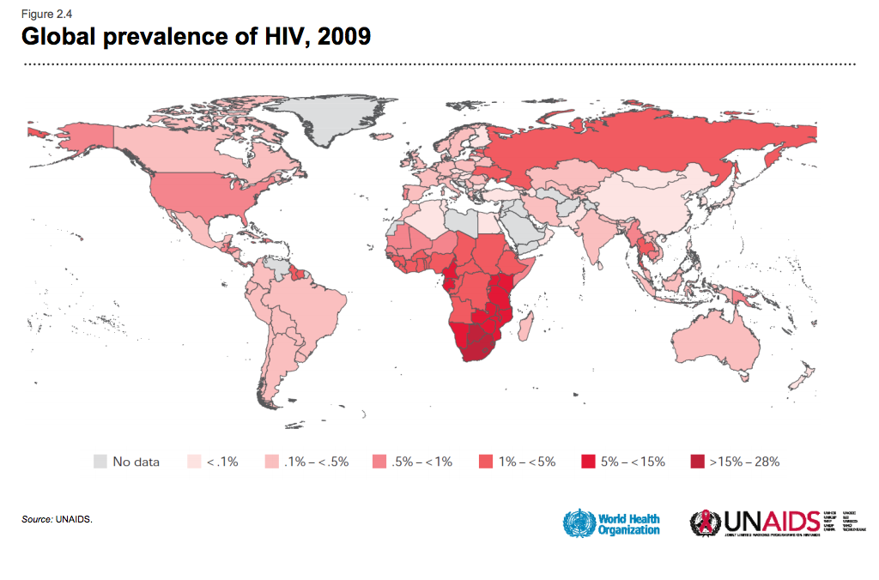

General temporal trends in HIV infection rates.
- Deaths from HIV are plateauing (recent advances in anti-AIDS medications are causing less death)
- Orphans are increasing from HIV

- Factors that explain why no cure or universal vaccine has been developed for HIV/AIDS.
- HIV is constantly mutating
- HIV consists of many strands that cannot be targeted by a single vaccine

- Reasons why viruses are not considered “alive”.
- They don’t self-reproduce
- They are not consisted of cells
- Don’t undergo metabolic processes
- They don’t have ribosomes
- Viruses must integrate themselves/ parasitize other living cells (hosts) in order to propagate themselves

- Reasons why anti-viral drug therapies often have serious side effects.
- Although they succeed in killing the virus they attack the host-cell as well

- Major steps in life cycle of HIV.
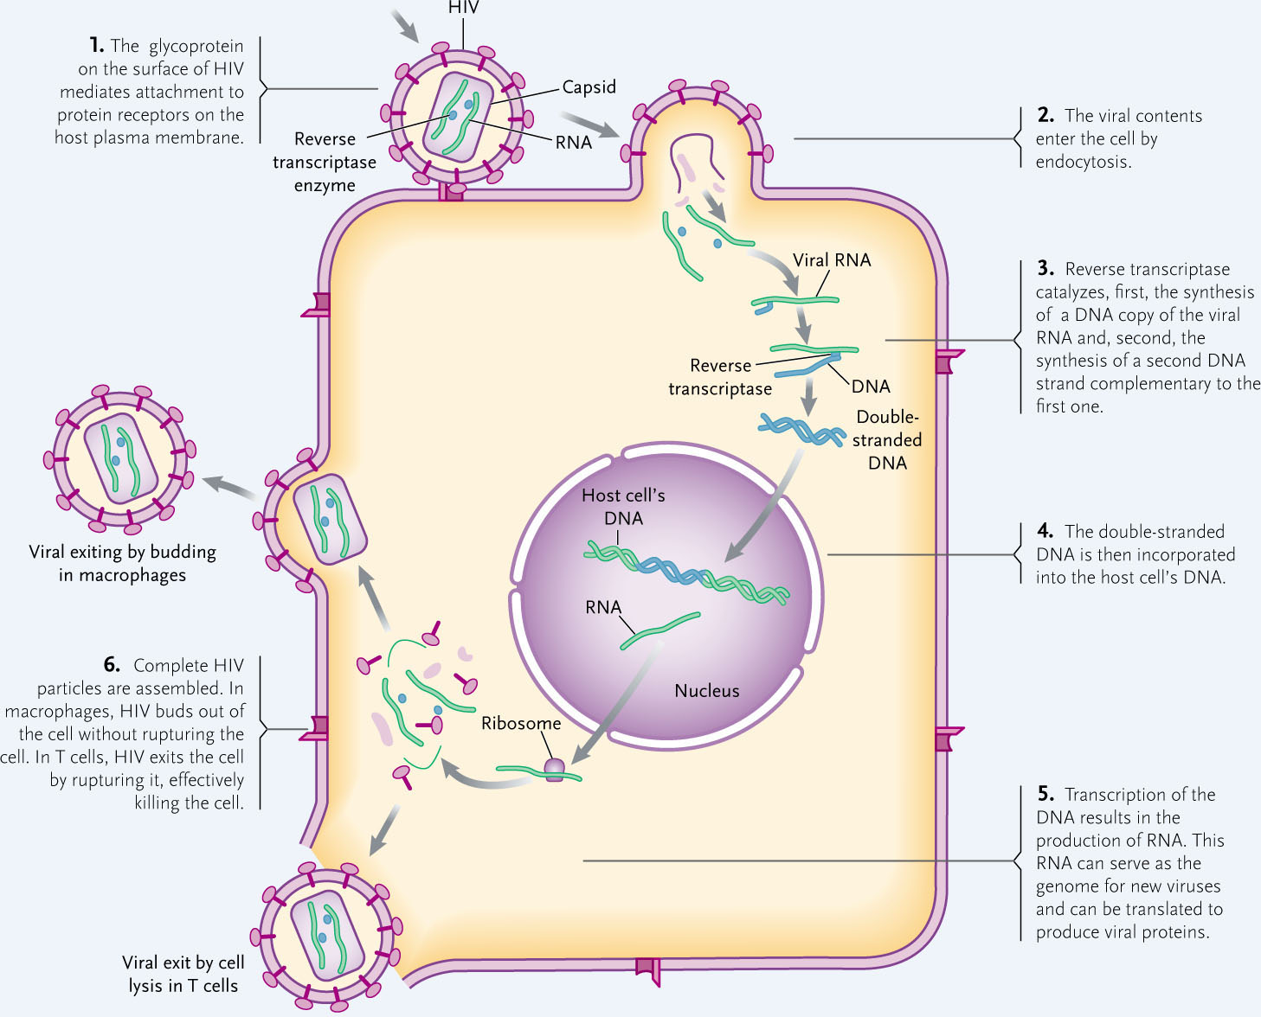
- HIV attaches to protein coat of main cell
- Enters thro endocytosis
- Once it enters the cell, the virion opens and its genetic information and reverse transcriptase
- Reverse transcriptase converts RNA into DNA
DNA replicates and enters nucleus of host cell
- Using intergrase it splices itself into the host cell DNA
- Leaves the cell by rupturing it (T-cells)
- Leaves macrophage cell by budding out

- Specific role of integrase and reverse transcriptase in retroviral life cycle.
- Reverse transcriptase reverse transcribes virsus’ RNA into DNA; why? Next step is to enter next chromosome, has to be DNA to do that
- Integrase splices/inserts/snips the viral DNA into the host chromosome

- Mechanism of action of AZT.
- 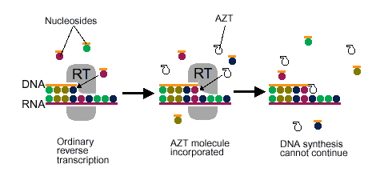
- Has similar chemical structure to thymidine
- mimics thymidine and inhibits reverse transcriptase
- reverse transcripts gets fooled, grabs AZT instead of thymidine, reverse transcription cannot proceed; no attachment site for the next nucleotide in the chain
- slows progression to full blown AIDS, but after a few months it stops working

- Reasons why effectiveness of AZT decreases over time.
- eventually AZT stops working in a few months (approx. 6)
    - Some virions are more resistant and through “natural selection” the resistant mutations get passed on into the next set of virions so resistant frequency increase

- Rationale for multi-drug (drug cocktail) approach to treating viral infections.
- Mutations produce virions that vary in resistance
- This is passed from “parents” to “offspring” so not all virions reproduce
- Resistant forms are more likely to reproduce so viral population changes over time
- Different drugs can inhibit different stages of the life cycle
- Much less likely that any single virion would simultaneously have resistance to different drugs that target different aspects
  - Resistance may not appear for extended periods of time
  - If many drugs are used simultaneously it is difficult for the virus to mutate

- Principles of evolution of HIV: variation, heritability, differential reproduction, and change in genotype of population. Role of CCR5-Δ32 mutation in human resistance to HIV infection.
- mutations produce virions that vary in drug resistance
- resistance passed from ‘parents’ to ‘offspring’
- not all virions reproduce
- in the presence of the drug, resistant forms are more likely to reproduce than susceptible forms (i.e. AZT resistant forms)
- A portion of people are resistant despite high risk & repeated exposure
- This is a deletion on the immune cell membrane where the receptors for the HIV virus are smaller; people with two copies of the allele are almost impervious to the disease

- Global distribution of CCR5-Δ32 allele
- Allele where you are missing 32 amino acids on protein coat that accepts HIV virus
- It is incomplete dominance; if you have one allele you are a little protected,
- Not spread uniformly
- Mostly in Scandinavian countries/Ashkanzi Jews/ Western Europe (14-18% of population)
- Virtually non-existent in Sub-Saharan Africa

- Likely explanations of modern distribution of CCR5-Δ32 allele.
    - Selection pressure?
    - Selectively favoured in North Europe during historical epidemics such as small pox
    - Chance and history?
    - It is unknown
    - Key point: Evolution is very fast, do not have to be alive to evolve,
    - LECTURE 3- THE ORIGIN OF LIFE
- Characteristics shared by all life.
- Display order
- Harness and utilize energy
- Reproduce
- Respond to stimuli
- Exhibit homeostasis
- Growth and development
- Evolve
- Way in which properties of life are "emergent"
- A hierarchy of interactions that continues up in complexity, it is emergent because they come from many simpler interactions that do not have the properties found at the higher levels
  - Eg. The ability to harness and utilize energy is not a property of molecules or proteins or biological membranes in isolation
- Characteristics of the "habitable zone" of a solar system.
- Region around star where water would exist in a liquid state and thus be conducive to development of life
- Conditions of a primitive Earth.
- Reducing atmosphere (low amount of oxygen); lots of reactions
- No ozone, UV rays provide lots of energy to produce macromolecules
- Lots of thunderstorms
- Abundance of hydrogen
- All forms of life are composed from nucleic acids, proteins, lipids and carbohydrates
- Synthesis of polymers is necessary for life
- Atmosphere needs methane and ammonia to be reducing & reactive

- Types of molecules that were, and were not, synthesized by the Millar-Urey experiment.
- Synthesized= amino acids, fatty acids, purine and pyrimidine components (nucleotides) MONOMERS
- Not synthesized = nucleic acids, proteins POLYMERS

- Importance of liposomes in evolution of first cells.
- liposomes: lipid vesicle in which lipid molecules form a bilayer very similar to a cell membrane (selectively permeable)
- Protobiont (abiotically produced organic molecules surrounded by a membrane)
- Liposomes could be produced spontaneously without any input of energy on primordial Earth
- Process took place in clay
- Clay particles could get inside in liposomes; this could be the start of genetic processes
- This is thought to be the origins of the first living cell

- Characteristics of mimivirus that suggest it should be considered to be alive.
- GIANT VIRUS (initially characterized as bacteria because of their size)
- Susceptible to other infections
- HGT suggest a viral family (similar genes)
- Mama virus can be infected by sputnik;
- More than 900 coding proteins and is part of a much larger family
- They have ~21 genes
- Could be major players in oceanic ecosystems and climate, they are commonly found in plankton buds and so they are thought to be more like parasites and therefore, are alive
- It can get sick
- Mimivirus has a large and complex genome compared with most other viruses.
- Mimivirus, short for "mimicking microbe", is so called to reflect its large size and apparent Gram-staining properties
- Characteristics of virophage.
- A virophage is a subviral agent that uses a virus' reproductive machinery to propagate itself, and in doing so, inhibits the reproduction of the host virus.
- As of 2012; only three known virophages, called the sputnik virophage, the mavirus virophage, and Organic Lake Virophage (OLV).
- Like bacteriophage in that it infects and sickens a “factory”
- Exploits the host
- Performs horizontal gene transfer between viruses

- Age of the Earth
- Earth is 4.6 billion years old

- Age of start of life on Earth
- Geological evidence of life dates to 3.5 billion years ago; life had to be around before that though (4 bya)
- Eukaryotes at 2.1 billion years ago

- Domains of life
Eukaryotes
- 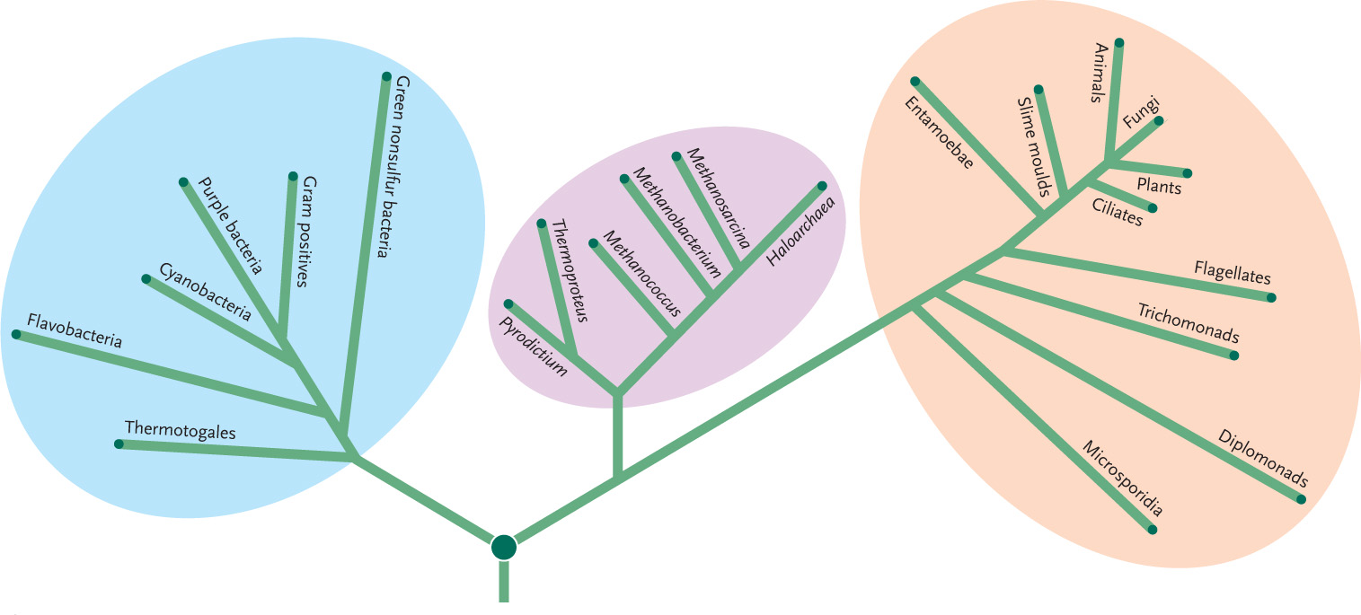
Archaea
Bacteria
- Characteristics of LUCA
- Luca does not mean one form of primitive life; just means it’s the LAST form
- Many initial forms of life were produced;
- Some may have had RNA instead of DNA
- Did not all necessarily have lipids
- LUCA did, and all the other ones died off leaving only LUCA

- Characteristics shared by all domains of life.
- Universal currency of energy transformation is ATP
- Cell made of lipids
- Genetic system based on DNA
- DNA to RNA to Protein transfer of information (central dogma)
- Common system of protein assembly (by ribosomes)
- ATP
- Glucose and Glycolysis

- Reason why the term “prokaryote” is inappropriate.
- Archaea and Bacteria have nothing in common
- Archaea is more related to Eukaryotes than Bacteria
- Prokaryotes are not a group; do not group Bacteria and Archaea together; DO NOT use the word prokaryote
- Suggests simple to complex ....misconception
- No single group of organisms
- “pro” means anteriority; there is no evidence that prokaryotes came before eukaryotes
- Suggests directionality; simple complex
- This is FALSE; evolution does not always run in that direction, it is a misconception

- Reductive evolution explanation for rise of bacteria and archaea.
- LUCA may have been a Proto-eukaryotic cell
- As a result, bacteria and archaea may have developed from REDUCTIVE EVOLUTION –”streamlining” and getting rid of the extra features

- Advantages of evolutionary simplification (streamlining).
- Increase energy efficiency
- Faster reproduction
- Ability to inhabit and grow rapidly in extreme environments (e.g. Extremophiles)

- Relationship between homochirality and life
        - Life is NOT chiral
          - Essential for evolution
          - L amino acids & D glucose
          - Takes more energy to build both isomers within the cell, as a result life chose one
          - Miller-Urey RACEMIC (50/50 LD)

- Reasons why we think RNA were the first of the three molecules of the Central Dogma to evolve.
- Has fundamental role in evolution (transfer of information)
  - Structure & function
  - Messenger, Ribosomal, Transfer
- Could serve as a carrier of information (due to nucleotide sequence), a structural/functional molecule similar to a protein (due to its ability to form unique three-dimensional shapes)

- Force that drives RNA folding.
- Molecular interactions ; base pairing and hydrogen bonding

- Characteristics of a ribozyme.
- 3D shape
- hydrogen bonds
- can catalyze

- Special RNA molecules that can catalyze reactions on the precursor RNA molecules that lead to their own synthesis as well as on unrelated RNA molecules
- Have catalytic properties
- Single-stranded molecules can fold into specific shape based on intramolecular hydrogen bonding or base pairing
- Specificity in folding imparts specificity in function; common with proteins

- Mechanism whereby a ribozyme cleaves RNA.
- formed by folding on itself and cleaving off the proton on the 2’ creating a free oxygen that can bind to phosphate
- Ribozyme binds to messenger RNA
- Ribozyme-mediated cut introduced into RNA message
- Result: Cut(cleaved messenger RNA molecules

- Characteristics of amino (peptidyl) transferase activity.
- Ribosome links DNA to protein
- Ribozyme has this peptidyl transferase activity; ribosome function depends on this
- tRNAs are recruited to the ribosome and they transfer the amino acid to the growing peptide chain
- reaction of transferring an amino acid from a tRNA to a growing polypeptide chain

- Reasons why a ribosome is considered a ribozyme.
- Ribosome plays key role as an intermediate between RNA and protein
- Composed of two-thirds RNA and one-third protein
- RNA component of the ribosome catalyzes the incorporation of amino acids onto a growing peptide chain
- Thus, ribosome=type of ribozyme
- * a protein that has RNA associated with it; ribonucleoprotein
- A ribosome is a good illustration of a ribonucleoprotein (when proteins and RNA function together)

*RNA transcription is error prone and thus drives the process of evolution
*Ribonucleoprotein comes from transition of RNA into proteins

- Advantage that protein has over RNA as a catalyst.
- Rate of catalysis of most ribozymes is 1/10th to 1/100th that of enzymes (FASTER)
- Number of ribozymes is very small (HUGE ARRAY OF DIFFERENT PROTEINS; 20 amino acids, different arrangements vs. different combinations of only four nucleotides)
- Amino acids can interact chemically with each other in bonding arrangements; not possible in nucleotides

Diff between DNA and RNA

- Advantage that DNA has over RNA as a repository for genetic information.
- More structurally complex (double-stranded, sugar deoxyribose (harder to synthesize)
- More stable with the OH removed
- Used thymine instead of uracil

- Chemical basis for the advantage that DNA has over RNA as a repository for genetic information.
- Each strand of DNA=chemically more stable and less likely to degrade than strand of RNA
- Uracil from RNA replaced with Thymine in DNA ; conversion of cytosine to uracil is common mutation in DNA; any uracil is recognized as damaged cytosine and replaced
- DNA=double stranded; in case of mutation to one of the strands, info from other strand can be used to repair the damage
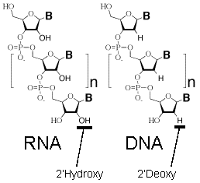

-OH group is very unstable; reacts with ribozymes and causes RNA degradation
- Removal of that oxygen in DNA allows it to form a double helix (two copies)

LECTURE 4 – BIODIVERSITY

- Approximate times by which the first cells, and the first eukaryotic cells, had appeared.
- first organisms may have been single-celled methane-producing bacteria that existed more than 3.5 bya
- Cells with nucleur membranes and organelles (eukaryotic cells) arose 2.5 bya
- Two-kingdom, five-kingdom and three-kingdom (three domain) systems for classifying living things.
- Two
  - Plantae and Animalia
    - Photosynthesis vs Consumption
    - Cell walls & vacuoles
- Five
  - Prokaryotes, Protists, Fungi, Plants & Animals
  - Two domains are best represented by 5 kingdoms
  - 1959 – Whittaker
- Three
  - Eubacteria, Archea and Eukarya
    - Eubacteria – earliest forms and major forms of bacteria
  - Archaea
    - Unicells with cells walls made of different molecules
    - Extreme habitats
  - Eukarya
  - Multicellular organisms

- Main characteristics distinguishing members of the Eubacteria, Archaea, Eukaryota domains of life.
- Eubacteria (bacteria)= major forms of bacteria and cyanobacteria, the latter being the earliest organisms known as fossils
- Archaea (Archaebacteria)= unicells with cell walls made of diff molecules than those found in Eubacteria live under more rigorous environmental conditions, as in hot sulfur springs or extreme salt concentrations
- Eukarya: include some unicellular organisms (e.g. slime moulds) and the three groups of multicellular organisms; membrane-bound organelles
- Meaning of horizontal gene transfer and why this makes it challenging to recreate the universal tree of life.
- Transfer and incorporation of one’s organism’s or species DNA into the DNA of a different organism or species; can go from domain to domain
- Between genes of individuals contrasts dramatically with the vertical transmission of genes from generation to generation
- Effected by virus or small, circular DNA (plasmid) that contains a foreign gene
- It is hard to recreate the tree of life because the match ups of separate lineages is infinitely small
- Horizontal Gene Transfer (HGT) is important and beneficial
- detrimental if the gene has no function, if it is incompatible with existing genes, or if it is a selfishly replicating mobile element.
- NON-beneficial= if there is a antibiotic resistant gene
- WHY IS IT CHALLENGING TO RECREATE TREE OF LIFE?
- because HGT rates are high, and organisms are becoming very similar to one another… its hard to differentiate between them
- HOWEVER…
- Only when the HGT rate began to fall, lineages begin to emerge with their own distinct sets of genes. Evolution would then become more tree-like. This phenomenon has been called the Darwinian Threshold.
- Monophyletic vs. polyphyletic groupings of organisms.
- MONO
  - Literally one origin
  - Lineage of organisms that share a single common ancestors
- Poly
  - Many origins
  - Independent origins or different origins
  - Unicellular organisms are not related to one another

- Most recent common ancestor (MRCA) for a given group(s), given a phylogenetic tree.
- Each pair of organisms has a MRCA
Reverse Tour Through Human’s MCRAs

- Rendezvous 1: Chimps & Bonobos
- Next closest relation to humans
- We are not descendents of chimps, we are cousins due to a common shared ancestors
- Rendezvous 2: Gorilla
- Only 700 left worldwide
- 7 mya there is an MCRA for humans & gorillas
  - MCRA of African Great Apes
- Rendezvous 3: Orang-utan
- Great apes that evolved in Asia
- MCRA of all great apes
- Primates in general are intelligent
- Rendezvous 4: Gibbons
- ~18 mya
- Much smaller & master athletes
- Monogamous for life
- MCRA of all apes
- Rendezvous 5,6: Old & New World Monkeys
- ~100 species of old world (Africa/Asia)
  - Baboons
- ~100 species new world (South America)
  - Howler
- Rendezvous 7: Tarsiers
- ~58 mya
- 5 species
- Rendezvous 8: Lemurs & Lorises
- ~50 species
- Mostly in Madagascar
- MCRA of all primates

- End-Cretaceous Mass Extinction, 65 mya
- Rendezvous 10: Rodents & Rabbits
- >2000 species (40% of all mammals)
- Rendezvous 11: Laurasiatheres
- ~85 mya
- Bats, insectivora, carnivora, perissodactyls
  - Eg. Whales, hippos, dogs, cats…
- North Super Continent
- Rendezvous 14/15: Marsupials (Australia) & Monotremus
- MCRA of all mammals
- Rendezvous 16: Reptiles
- Birds too
- Rendezvous 17: Amphibians
- MCRA of tetrapods
- Rendezvous 18-25: Lungfish, Coelacanth, Ray-finned fish, sharks, jawless fish
- MCRA of all vertebrates
- Rendezvous 26: Protostomes
- >1 million species
- Mostly insects
- MCRA of all animals
- Rendezvous 34,35,36: Fungi, Amoebozoans, Plants
- We are more related to fungi than plants
- Multi-cellularity has evolved more than once
- MCRA of eukarya
- Rendezvous 38: Archea
- Bizarre environments
- Adaptations to extreme environments
- Rendezvous 39: Bacteria
- Crotch of the tree of life

- Why the idea that “humans are descended from chimps” is inaccurate.
- We are not descendents of chimps, we are cousins due to a common shared ancestors

- Order of main branching events in tree of life (dates not testable).
- *see above

- Cause of global catastrophe associated with mass extinction 65 mya.
- Meteorite ?

- Relative proportion of protostome vs. deuterostome species.
- Characterizes how we form (we form butt first vs. they form mouth first)
- We are deuterostomes
- So many more protosome species than deuterosomes
- Protostomes include anthropods (insects) mollucks etc.
- > 1 million described species
- “at first glance we are all insects”

- Information provided by genetic relatedness vs. traditional groupings of organisms (“reptiles”, “fish”)
- Birds are a type of reptile
- Snakes and lizards have a more recent common ancestors with birds than with turtles
- Reptiles is one of the many groupings of organisms which is wrong
- Fish is another stupid name for a group of organism that are not more closely related to each other than with other organisms
- E.g. one type of fish is no more closely related to a shark than it is other vertebrates (eg. Reptiles)

- Distribution of multi-cellularity in tree of life.
- Multi-cellularity has evolved more than once; only in eukaryotes
- It has evolved in fungi, ambozoea, plants, animals etc.

- Why estimating numbers of species is uncertain.
- Haven’t found all the species yet
- HGT makes it challenging to accurately figure out the ancestor-descent relationships
- Sometimes things are similar because of MRCA or sometimes they are similar because of HGT
- Role of similarities due to common descent (DNA genome) vs. convergence (eyes) in constructing a phylogenetic tree.
- Some similarities do reflect about of shared ancestry
- Some similarities come about because of independent adaptations to a shared environment (e.g. eyes have evolved multiple times, using sonar vision (e.g. bats, dolphins etc.)

LECTURE 5 – GENOMIC VARIATION

- A genome is all of the DNA sequence in one copy of an organism’s chromosomes.
- Plant has a nuclear genome, a mitochondrial chromosome and chloroplast genomes
- Genome usually refers to nuclear genome

- 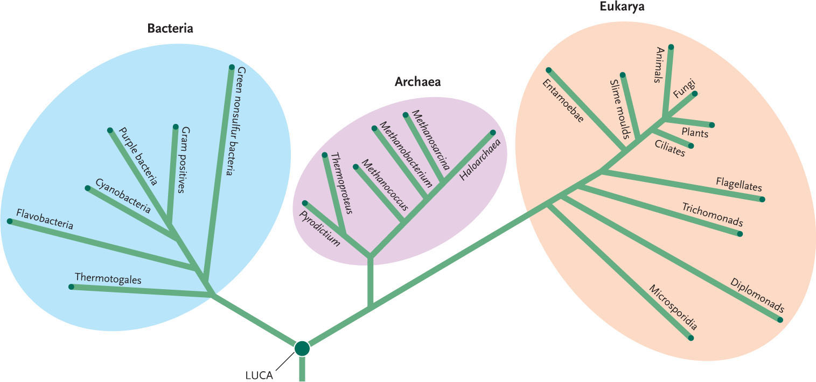
- Almost all prokaryotic cells have circular chromosomes (mitochondria, chloroplasts etc. have circular genomes)

- Meaning of "C-value".
- The term C-value refers to the amount of DNA contained within a haploid nucleus (e.g. a gamete) or one half the amount in a diploid somatic cell of a eukaryotic organism, expressed in pictograms

- "Paradox" or "enigma" associated with C values
- # of chromosomes and C value does not relate to complexity of organisms
- The C-value enigma or C-value paradox is the complex puzzle surrounding the extensive variation in nuclear genome size among eukaryotic species.
- At the center of the C-value enigma is the observation that genome size does not correlate with organismal complexity; for example, some single-celled protists have genomes much larger than that of humans.
- Possible explanation: more intron activity occurs in more complex organisms and as a result one gene results in the production of multiple proteins
*Paradox: Seemingly contradictory statement that may nonetheless be true.
Enigma: a mystery.
- Meaning of haploid (n) and diploid (2n)
- DIPLOID CELLS: have 2 sets of chromosomes (46 chromosomes in humans). (2n)
- HAPLOID CELLS: (such as sex cells) have only 1 set of chromosomes (23 chromosomes in humans). (n)

- Relationship between C and n as measures of genome size.
C-value and genome size are used interchangeably= they can be interchanged in DIPLOID ANIMAL CELLS (eukaryotes)
In some cases (notably among diploid organisms), the terms C-value and genome size are used interchangeably, however in polyploids the C-value may represent two or more genomes contained within the same nucleus
- Proportion of the human genome that codes for protein.
- haploid human genome contains approximately 20,000 protein-coding genes
- Protein-coding sequences account for only a very small fraction of the genome (approximately 1.5%), and the rest is associated with non-coding RNA molecules, regulatory DNA sequences, introns, and sequences to which no function has yet been assigned
- Analysis of the human genome based on gene expression in 147 cell types indicated that there are 20,687 protein-coding genes

- Non-nuclear genomes in typical plant and animal cells.
- Mitochondrial genome (circular) in animals and chloroplast chromosome (circular) in plants
- Plant cells have a chloroplast genomes

- Trend in C value from prokaryotic vs. eukaryotic cells.
- Larger C value in eukaryotic cells
- In prokaryotes C value does increase with complexity; no introns
- NOT true for eukaryotes

- Relationship between C value and organismal complexity
- None!

- Relationship between C value and ploidy
- “Ploidy” refers to the number of sets of chromosomes.
- Ploidy refers to the number of sets of chromosomes
  - Eg. Diploid, haploid
- Eg. In most flowering plants the endosperm of the seed is triploid (3n) cells. What would be the C-value?
  - 3c. This is because 1c is one copy of the genome, so if you have 3 copies of your genome then you have 3c.
- Distribution of linear vs. circular chromosomes in the various domains of life.
- Only eukaryotes have linear chromosomes (they have circular ones as well)
- All prokaryotes have circular chromosomes

- Role of nucleosomes in DNA packaging in chromosomes
- Helps condense DNA during replication;
- DNA strands wrap around histones

- General trends in costs of DNA sequencing
- Dropping
- About $10 000

- Relative distribution of various component of genome sequence ("junk" vs. essential DNA)
- 55%
    - lots of transposons, viruses & a few dead genes (varying elements that move)JUNK
    - It isn’t you
  - 10%
    - IntronJUNK
  - 10%
    - Essential ONLY 2% CODING FOR YOU
  - 25%
    - Unknown Likely junk

LECTURE 6- GENOMIC REPLICATION

- **Chromosome number does not increase during S-phase, n- value does not change but the c-value doubles (amount of DNA)
- DNA is replicated during S phase
  - Chromosomal proteins duplicated
- Most of our cells are in G₀ (cell cycle arrest) they are not cycling most of the time
- Actively cycling cells are

- Purine and pyrimidine base-pairing in DNA/RNA
- purine = A,G
- pyrimidine= C,T
- PAIRS: A-T (2 H bonds) , G-C (three H bonds)
- Pyrimidine (RNA) = C-U
- Outcome of the classic Meselson and Stahl experiment
- prove that DNA replication is semi-conservative

- Direction of movement of DNA polymerase on the template strand
- from 3’ to 5’
- DNA polymerase adds to free 3’ OH
    - Incoming nucleotide binds to 3’
    - Every one of polymerase known only extends 3’ ends

- Meaning of semi-conservative, semi-discontinuous, leading and lagging strand
- semi-conservative: parental strand with synthesized strand.. each double helix has 1 old strand paired with 1 new strand
- semi-discontinuous: DNA replication is this because the leading strand is continuous and the lagging strand is discontinuous
- leading strand: new strand of DNA that is synthesized continuously, built towards the replication fork
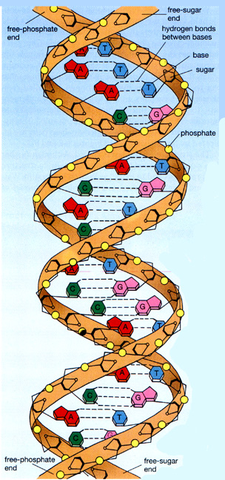
- lagging strand: New strand of DNA that is synthesized in short fragments, built away from the fork
- General action of proteins in Fig. 12.15.
- Helicase: unzips the genes
- T: twisting at the end
- DNA polymerase III:
- DNA polymerase I:
- Primase:
- Ligase: seals the nicks
There is no gene expression (RNAProtein) in G₀ phase. It’s a resting phase of stable parenchymal cells
- Basic structure of double-stranded DNA
- Anti-parallel
- Each of the single strands of DNA has a 3’ and a 5’ end
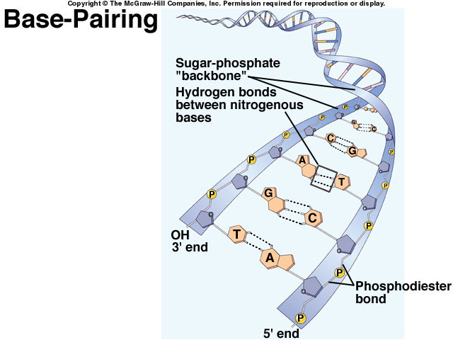
- the two strands fit together in an opposite direction (one starts at 3’ end, on starts at 5’ end)
- 3’ end has a hydroxyl, 5’ has a phosphate

- Components necessary for DNA synthesis
REPLISOME
- Substrates
- Four deoxyribonucleotide triphosphates (dNTP's) are required for DNA synthesis (note the only difference between deoxyribonucleotides and ribonucleotides is the absence of an OH group at position 2' on the ribose ring) dATP, dGTP, dTTP and dCTP (high energy phosphate bond between the a and b phosphates is cleaved and the deoxynucleotide monophosphate is incorporated into the new DNA strand)
- Ribonucleoside triphosphates (NTP's) are also required to initiate and sustain DNA synthesis. NTP's are used in the synthesis of RNA primers and ATP is used as an energy source for some of the enzymes needed to initiate and sustain DNA synthesis at the replicating fork.
- Template
- The nucleotide that is to be incorporated into the growing DNA chain is selected by base pairing with the template strand of the DNA (template = DNA strand that is copied into a complementary strand of DNA)
- Primer
- The enzyme the synthesizes DNA, DNA polymerase, can only add nucleotides to an already existing strand or primer of DNA or RNA that is base paired with the template.
- Enzymes
- An enzyme, DNA polymerase, is required for the covalent joining of the incoming nucleotide to the primer.
- To actually initiate and sustain DNA replication requires many other proteins and enzymes which assemble into a large complex called a replisome. (thought that the DNA is spooled through the replisome and replicated as it passes through)

- Direction of elongation of a given DNA strand
- It extends in the direction of the 5’ to 3’ ONLY place elongation occurs

- Structure of a replication bubble
- 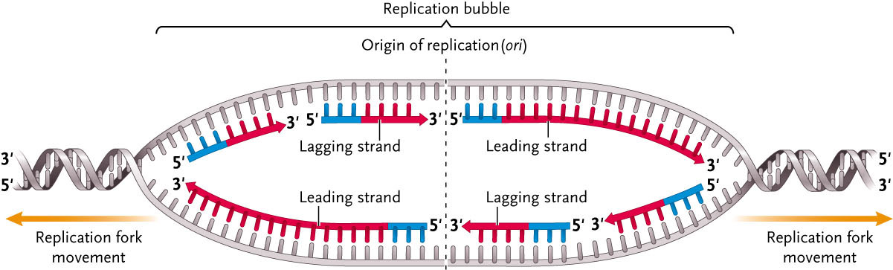

- Relationship between replicated DNA and metaphase chromosomes
- N value doesn’t change, C value doubles
- Chromosome line up at the metaphase plate during metaphase, one strand of identical DNA lined up toward each pole

- Reason why chromosomes shorten at each replication
- DNA polymerase requires short RNA primers to initiate replication
- Extends the primers in a 5'-to-3'-direction
- Replication fork moves along the chromosome, one of the two daughter strands is synthesized continuously
- Other daughter strand, known as the lagging strand, is synthesized discontinuously in short fragments known as Okazaki fragments, each of which has its own RNA primer.
- The RNA primers are subsequently degraded, and the gaps between the Okazaki fragments are then filled in by the DNA repair machinery
- Problem arises at the end of the chromosome because the DNA repair machinery is unable to repair the gap left by the terminal RNA primer new DNA molecule is shorter than the parent DNA molecule by at least the length of one RNA primer.
- Without a solution to this end-replication problem, chromosomes would progressively shorten over many cell divisions, a process that would bring about catastrophic consequences

- Mechanism by which telomerase adds telomeres to chromosomes
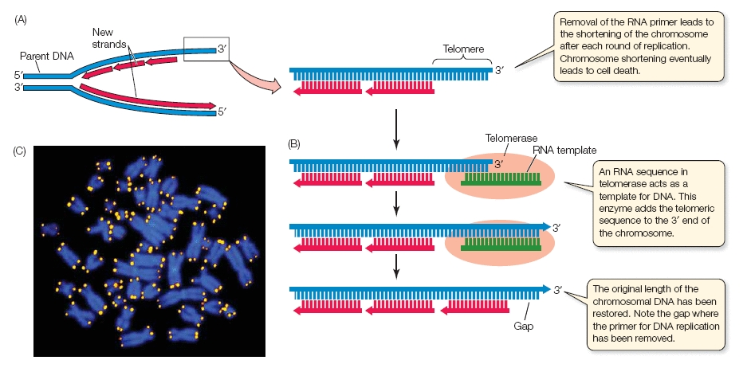
Figure 4 : Telomeres and telomerase.
(A) Removal of the RNA primer at the 3' end of the lagging strand leaves a region of DNA - the telomere - unreplicated. (B) The enzyme telomerase binds to the 3' end and extends the lagging strand of DNA. An RNA sequence embedded in telomerase provides a template so that, overall, the DNA does not get shorter. (C) Bright fluorescent staining marks the telomeric regions on these blue-stained human chromosomes.

- Brings its own embedded RNA template so it can extend the 3’ end
- A telomere is a repetitive sequence of DNA
  - Like a virus, uses reverse transcription
- Keeps moving down and adds the same sequence multiple times
- Result
  - Chromosome is elongated so that it can get shorter at each replication
LECTURE 7 – INHERITANCE OF SAMENESS
- Stages and main characteristics of the stages of mitosis.
Stages of Mitosis
- Prophase
  - Chromosomes condense into compact structures
  - Nucleolus becomes smaller and disappears
  - Shutdown of RNA synthesis
- Prometaphase
  - Nuclear envelope breaks down
  - Spindle microtubules grow from centrosomes at opposing spindle poles toward the center of the cell
  - Attach the sister chromatids of each chromosome to the spindle
- Metaphase
  - Spindle reaches its final form and chromosomes align at spindle midpoint
  - Complete collection arranged according to size and shape forms the karyotype of a given species
- Anaphase
  - Sister chromatids separate and move to opposite spindle poles
- Telophase
  - Spindle disassembles and the chromosomes at each spindle pole decondense and return to the extended state of interphase

- Stage of cell division, given a micrograph of a dividing cell.

- 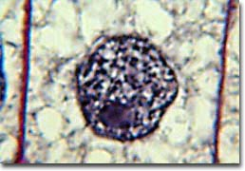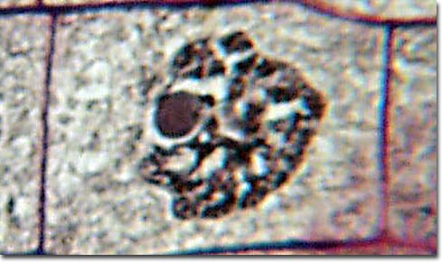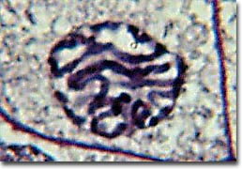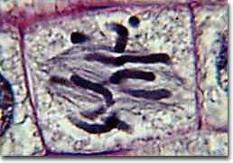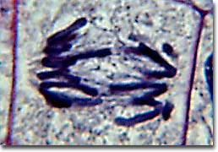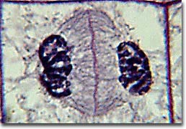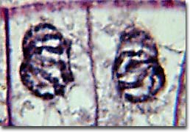
- In order from left to right : cell at rest, early prophase, late prophase, metaphase, early anaphase, late anaphase, telophase

- Role and mechanism of the mitotic spindle.
- The microtubules made of tubulen are grabbed by the motor proteins as they pass by
- Pacman eats the spindle

- Role of cell cycle check points.
Cell Cycle Checkpoints
- Checkpoints prevent critical phases from beginning until the previous phases are completed
- Cycling-dependent kinases (CDKs) are enzymes that add phosphate groups to target proteins
  - Combinations regulate cell cycle transitions at different checkpoints
  - Overall effect is to speed, slow or stop progress of cell division
- Contact triggers internal reaction pathways that inhibit division by arresting the cell cycle, usually in the G-1 phase
- Mice engineered to lack telomerase are cancer resistant
- CHECKPOINTS
- G-1(S phase): makes sure DNA is all repaired before replication
- G-2: makes sure chromosomes are ready to go into mitosis
- Metaphase checkpoint: cell will not proceed to anaphase until all the chromosome are hooked up to tubules
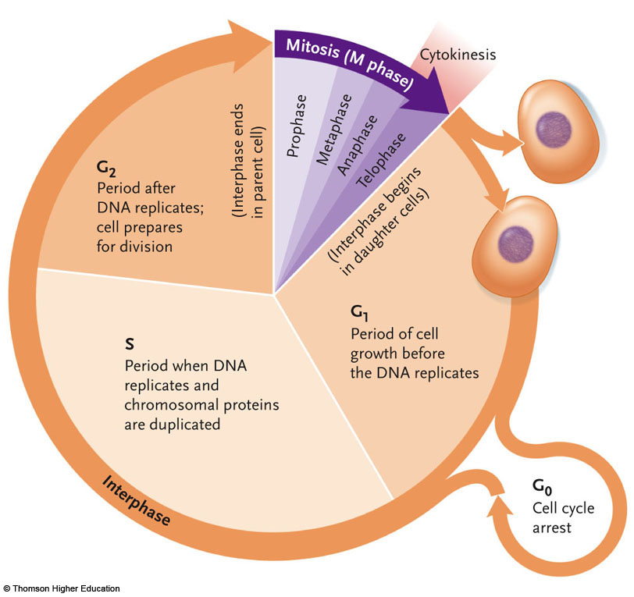
- Changes in amount of DNA throughout the cell cycle
- 2n in mitosis the whole time, amount of DNA doubles during S phase and halves again at telophase
- in G1 you have a cell with 46 chromosomes
- In S-phase, the DNA replicates, so by the end of S-phase, the quantity of DNA has doubled (So if it had one unit it now has two units).
- In G2, here there are no changes in DNA composition, so you remain having 2 units.
- Now onto mitosis. You continue having two units of DNA until the completion of cytokinesis, where two new daughter cells are produced. Now you again have one unit of DNA per cell because the chromosomes split at the centromere, each daughter cell getting half of that DNA.
- * at metaphase you have 4 C

- Mechanisms that ensure "inheritance of sameness"
- Complimentary base pairing during replication
- Old cells die
- Cell cycle checkpoints
- Telomerase enzyme
- Proof-reading mechanisms
- Repair mechanisms
- Spindle fibers

- Location of actively cycling cells in multicellular animals/plants
- Humans
  - Early development, bone marrow, injury repair, gametes
- Plants
  - Pollen cells, shoots, roots, fruits, trunk
- Most cells in mature multi-cellular organisms aren’t cycling

- Function of rapid cycling cells at various stages of the life cycle
- Early development, wound repair, etc.

- Examples of situations in which cells would be programmed to die by apoptosis
- Cells that are programmed to die
- Surplus of cells,
  - Eg. Webbed toes are programmed to die invitro
- Xylem pipes in plants
- Mutations that need to die
- Viruses or infection are killed
- Old cells suffer from too many mutations
- Cycling causes shortening of telomeres at every replication
  - Cells know how many times they have divided
  - Division occurs a specific number of times and then they die
  - * cells know how old they are by knowing how long their telomeres are
  - once the telomeres reach a certain length, the cells realize their telomeres are too short and that it is time to die
  - telomeres need to shorten each time so cells know how many times they divided and when to die
  - *if telomerase is over-expressed cells do not live longer, they die from cancer
- since you need to your telomeres to shorten in order for cells to know how old they are then the expression of telomerase is very high regulated and is essentially turned off in somatic tissue; gene is there but isn’t expressed
- telomerase is more expressed in actively cyling cells (e.g. early in development) and during gametogenesis; nice long telomeres on your chromosomes so that your babies are born young

- Main features of each stage of mitosis with respect to cytoskeleton and chromatin

- Main features of chromosome anatomy

- Composition of microtubules, intermediate filaments and microfilaments/
- microtubules: made of tubulin
- intermediate filament: made of keratin and intermediate filament protein (keep shape of the cell and cytoplasm)
- microfilament (cytokinesis): actin (pull cell apart)

- Interaction between spindle fibers and kinetochores
- Centromere:
- DNA sequence that attracts binding of proteins that give rise to kinetochore
- Kinetochores:
- protein complex attached to the centromere with which spindle interacts
- Microtubules (which make up spindle fibres)
  - Bind to & interact with spindle and kinetochores
  - Motor proteins are present
- Kinetochores pull themselves along the spindle fibres; however, cohesion prevents separating, resulting in metaphase
  - When cohesion lets go, kinetochores crawl down spindles and drag the chromatid with it
- Cytoskeleton partitions chromosomes
  - Actin filaments pinch all the cell
  - Intermediate filaments maintain shape
  - Microtubules interact with kineotchores
    - Cells will not divide or proceed into anaphase until all chromosomes are properly attached to the spindle

- Role of motor proteins in chromosome segregation
- Chromosomes “walk” themselves to the poles along stationary microtubules, using motor proteins in their kinetochores
- Microtubules become shorter as the movement progresses

- Implications for cell division if various components malfunction (ie. what if drugs prevent microtubule polymerization?)
- E.g. Chromosomes cannot be pulled apart; mitosis not complete
LECTURE 8 – ORIGINS OF VARIATION

- Mechanism of proofreading and likely result of proofreading defects
- depends on ability of DNA to polymerase to back up and remove mis-paired nucleotides
- if newly added nucleotide is mismatched, DNA polymerase reverses using a built in deoxyribonuclease to remove newly added incorrect nucleotide
- DNA polymerases can proofread their work in this way (ex in bacteria when reverse of polymerase is working, error rate is 1 miss pair/ 1 million nucleotides)

- Mechanism of mismatch repair
  - misplaced bases will have too large/small distances between sugar-phosphate chains can’t form H-bonds
  - this distorts the helix – recognition site for repair catalysts
  - repair enzymes: move across double helix “ scanning” for distortions,
- if they encounter a distortion, they remove a portion of the chain
- ligase/polymerase fill the gap (also remove distortions by radiation/chemicals)

- Differences among insertion sequences, transposons and retrotransposons
- INSERTION SEQUENCEsimplest TE – code for their own transposition (mobility), i.e. transposase: a recombinase enzyme that catalyzes insertion/removal of TE from DNA; makes cuts in DNA backbones
  - inverted repeat sequence: DNA sequence on both ends of IS (enables transposase to find ends)

- TRANSPOSON has an inverted repeat sequence at each end enclosing a central region with one or more genes (often coding for bacterial resistance)
- inversion repeat sequences are insertion sequences which provide the gene for transposase for movement of the element
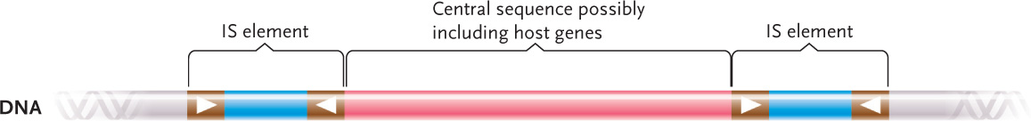
- RETROTRANSPOSON transpose by copy and paste mechanism
- occurs via intermediate RNA copy of the TE (transcription/translation/insertion
- DNA element integrated into the chromosomal RNA copy of the TE

- 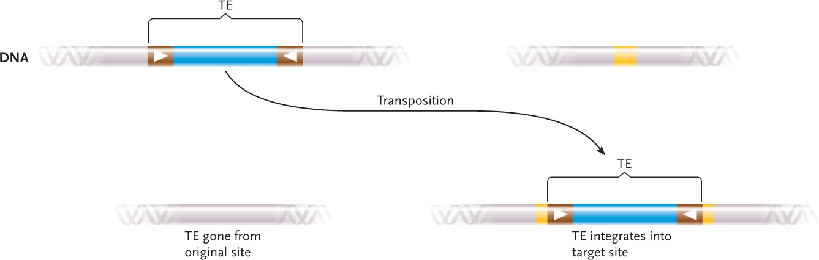

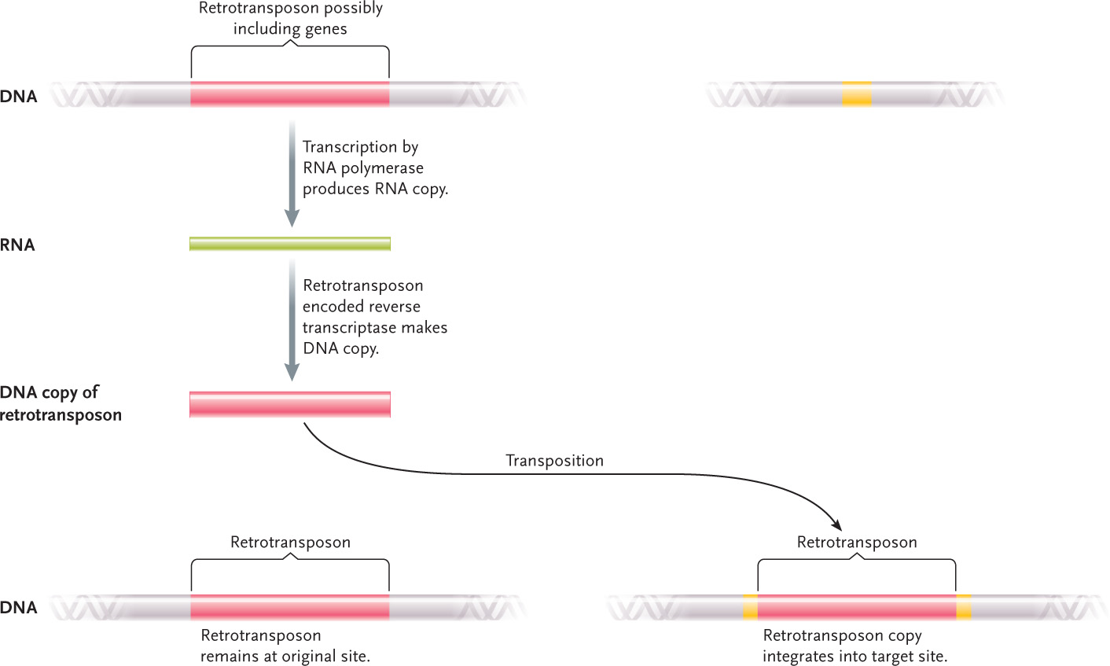

- Implications of insertion of mobile elements into DNA
- produce mutations
- Some mobile elements result in diseases
  - ALU elements
  - Interferes with normal gene function
  - Abnormal activation of genes regulating cell division due to TEs is associated with various forms of cancer in humans and animals
- change gene expression by changing regulatory genes increase genetic variability
- Reasons why transposons are not actually "jumping" genes
- They move from place to place within the genome of a given cell
- But they are never in the air between one location and another; always in contact with target site

- Basic structure of retrovirus genome
  - direct repeat at either end contain sequences (enhancer/promoter/termination) – central sequences: coding genes

EXTRA RESEARCH:
- dimer formed by two identical copies of (+) sense RNA diploid
- viral genome is flanked by two long terminal repeat sequences (LTRs) at both the 5`- and 3 `- ends. These LTRs contain the signals required for viral gene expression including the enhancer, promoter, 5`- capping, transcription terminator, and poly (A) signal
- The retroviral genome also includes a primer binding site (pbs), which is used to bind the primer tRNA to begin reverse transcription.
- The basic translated region consists of four main genes: gag, pro, pol, and env. Each gene encodes unique proteins that facilitate the viral life cycle.
- The gaggene encodes three main structural proteins: NC, CA, and MA.
- The pro gene encodes a protease that is responsible for the cleavage of gag-pol precursors during virus maturation.
- The pol gene encodes the enzymes reverse transcriptase, which converts the viral RNA genome into a DNA intermediate, and integrase, which allows the DNA intermediate to be incorporated into the host cell genome.
- the env gene encodes the SU and TM subunits of the glycoproteins displayed on the viral surface that are used in recognition and binding of host cell receptors

- when a retrovirus infects a host cell, a reverse transcriptase carried in the virus particle is released and copies single stranded RNA to double stranded DNA
- RNA to DNA reverse transcription associated with the retrotransposon movement is strikingly similar to that of retrovirus
- retroviruses are found in a wide range of organisms (most so far identified in vertebrates)
- we contain several retroviruses and proviruses in genome
- Retrotranspons and retroviruses of all types occupy 40% of genome
- retroviruses do not produce infectious virus particles, but can cause DNA rearrangements (deletions, translocations)
- alter relative position of DNA sequences on the chromosome and in turn disturb normal regulation of expression
- retroviruses sometimes pick up host eukaryotic genes and move them to recipients

- Different types of genomic variation among humans
- 1.2 million variants
  - from Venter sequence
- ¾ are copy number variations (CNV)
- ¼ are single nucleotide polymorphisms (SNP)
- Each person has ~1000 CNV affecting 35% of their genes
- African people are most diverse MORE unique/new SNPs -> 2 Africans very diverse from each other ( in comparison to me/you)
- 300 variants in insertion of retro elements (lines & sines) per person
  - mobile elements

- Structure of IS elements, transposons, retrotransposons and retroviruses
- Insertion sequence element: simple, transposase gene – code for own movement
- IN BACTERIA: MOST COMMON MOBILE ELEMENTS: transposase = recombinase (makes cuts in DNA backbone)
- Transposon (carries genes for antibiotic resistance): genomic sequence flanked by IS on either side
- RetrotransposonsMove via RNA
- Reverse transcriptase from one place in the genome to another
- Many in human genome from evolution
  - Virus gets stuck in the genome and moves around
  - Cannot make a protein sheath

- SNPs
- Distribution of SNPs is highly variant
- African people have much more diversity than other ethnic groups
- African pair of people are more diverse from each other than a Caucasian & an Asian
- Spontaneous tautometric shifts change base pairing partners
  - Normal is A – T and C-G
  - A & C are amino – single bond
  - T & G are keto – double bond
- Hydrogen bonding
  - In base pairs
  - 3 in G-C
  - 2 in A-T
  - Acceptor atoms
    - Receive hydrogen
  - Donor atoms
    - Give hydrogen

- Types of evidence that might be useful in determining how long the human genome have been infected by a given mobile element.
  - frequency of genome; compare with related animal species
  - *In plants, these are pigmentation genes

- Mechanism by which tautomeric shifts in DNA bases leads to alternative base pairing
NORMALLY…
- G-T and A-C can’t form because the donor and acceptor atoms do not line up appropriately, prohibiting the formation of hydrogen bonds
- acceptor atoms: accept H, donor atoms: donate H need acceptor + donor for form a H-bond
- steric repulsion: pushes 2 bases apart – normally, A-C can’t form H-bonds, G-T can only form one
- Tautomerism: swapped position of double bond allows A-C and G-T to form
- 2 tautomers: keto and enol
- - e.g. keto form of G (normal form = can’t bond with T), enol form (can bond with T)
- equilibrium favours one tautomer over another more stable
- One mismatch is damage, two mismatches (one per strand) is a mutation
  - SNP mutation
  - Takes two rounds of cell division/ DNA replication

- Mechanism by which alternative base pairing gives rise to mutation during replication
- anomalous base pair undergoes semiconservative replication ->wrong base is paired->becomes transition mutation

- Difference between DNA damage and mutation
- mutations are double-stranded change
- damage(lesion) is only in one strand thus other strand can correct

- Characteristics of STR loci that make them useful for forensic DNA analysis (DNA fingerprinting)
- Several loci in noncoding regions of the genome are used for analysis
- Each locus= short tandem repeat (STR)
- Short sequence of DNA repeated in series, each about 3-5 bp
- Each locus has a different repeated sequence and the number of repeated sequence and the number of repeats varies among individuals in a population
- E.g. one STR locus has a sequence AGAT repeated between 8 and 20 times;
- Furthermore, a given individual is either homozygous or heterozygous for an STR allele
- DNA fingerprint for this locus is different from others
- BECAUSE EACH INDIVUDAL HAS ESSENTIALLY A UNIQUE COMBINATION OF ALLELES (except identical twins) analysis of STR loci can discriminate between DNA of different individuals

- Mechanism of DNA recombination
- requires: 2 diff DNA molecules, mechanism to bring them together, enzymes to cut/paste DNA
  - homologues are paired, enzyme breaks covalent bond, free ends of each backbone exchanged/reattached (cut/paste 4 backbones)

  - Stage of meiosis when recombination occurs
- Prophase I of meiosis

- Reason why incorrect tautomers of bases are not recognized as mismatches and removed by excision repair
- The pairing does not distort the DNA helix

- Mutagenic mechanism of action of base analogues such as 5 Bromouracil
- DNA polymerase has a tough time distinguishing 5 bromouracil from thymine
- 5-bromourcil= base analogue
- Gets incorporated into DNA by mistake (e.g. across from A)
- Problem: while thymine is stable, 5 bromouracil is very tautomerically unstable powerful mutagen; results in tautomeric shifts and mispairing
*chemicals are not necessary, tautomeric shifts also happen naturally
- Mutagenic mechanism of action of UV radiation
- Photons of UV light has the right amount of energy to absorbed the rings of pyrimidine bases
- That reorganizes the electrons and the bonding hooks the two Thymines together in a way that is unusual
- Dimer is formed with the thymine bases themselves are hooked together as a result of a hit by a photon of UV
- Very common + distort the helix like crazy
- Very difficult for DNA polymerase of RNA polymerase to replicate through a dimer (H bonds not in the right places)

- Mechanisms of repair of UV photodamage
- in some organisms DNA polymerase relaxes its pairing rules to get through the dimer sticks any base across from the damage to move on
- Can lead to mutation and cause more damage but at least the cell survives because it can replicate
- Photolyase (enzyme; NOT FOUND IN MAMMALS (except placental ones) ): breaks/repairs dimer powered by a photon white/blue light
- Excision repair: nuclease cuts damaged DNA backbone (both sides) DNA polymerase/ligase repairs missing nucleotides

- Mutagenic mechanism of insertion/deletion damage during replication
- wherever there is a long stretch of repetitive DNA it is possible for some of it to loop out
- remaining ones are still stably bound enough that the polymerase does not notice
- new strand ends up with extra base; if template strand loops new strand ends up with not enough bases
- Triplet repeat diseases: exhibit genetic anticipation; meaning “gets worse in successive generations” e.g. Huntington’s arises because of expansion of the number of repeats in the Huntington gene; each successive generation replicates that gene and the number of repeats expands, increasing the severity of the disorder
- ONE OF THE WAYS YOU GET COPY NUMBER CHANGES; changes in # of base pairs passed on to kids
- *Slippage during replication can result in adding or deleting of base pairs *

- Mutagenic mechanism of ionizing radiation
- creates ROS (reactive oxygen species – looking for e’ -> damaging to DNA and can break backbones)
  - decay of radioactive iodine (half life 1 wk)/cesium (30 yr) = ionizing radiation

- Radioactivity if a characteristic of unstable isotopes
- Particularly radioactive idodine (half like 1 week) or cesium (30 years) produce very powerful ionizing radiations
- iodine isoptopes are dangerous because it is bioaccumlated in your thyroid and can radiate you
- When ionizing high energy radiation ( photons) pass through your cells (mostly water) it rips electrons from various molecules, particularly oxygen creating reactive oxygen speciesROS
- Oxygen atoms scavenging for electrons; makes them very reactive and very damaging to everything in your cell and DNA
- Reactive oxygen can BREAK DNA BACKBONES!
- If both are broken broken chromosome
- Your cells have double-stranded repair mechanisms; can repair double-stranded breaks
- But sometimes they make mistakes; can leave out a gene; results in deletion or duplication or inversion or translocation
- CNVs caused by repair of double-stranded breaks

- Various types of chromosomal rearrangement resulting from attempts to repair double strand breaks possible
- 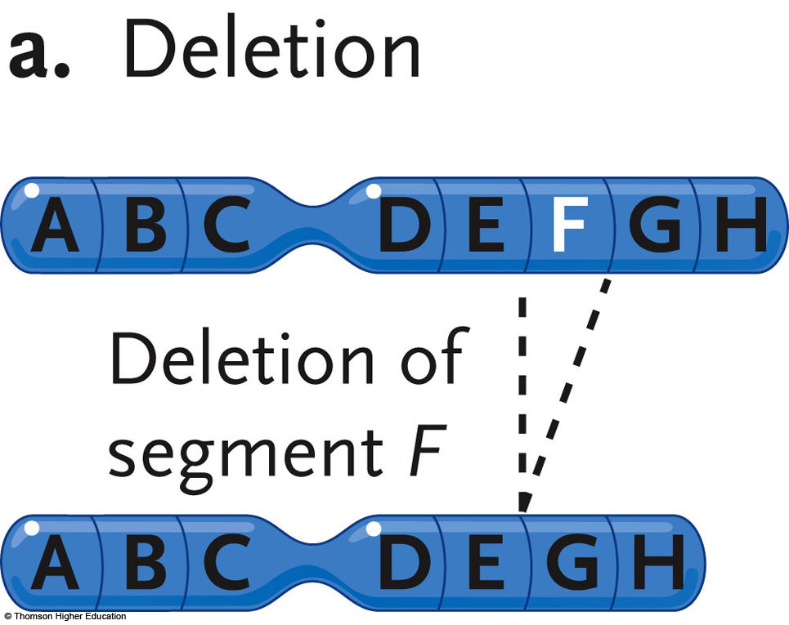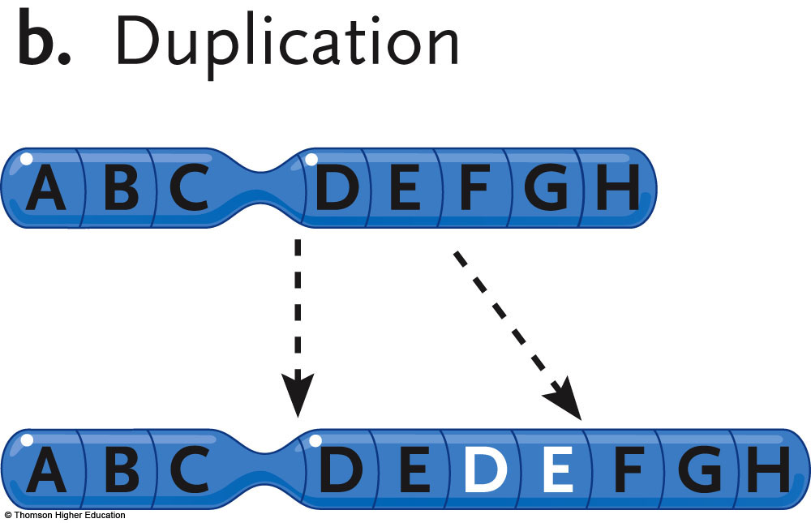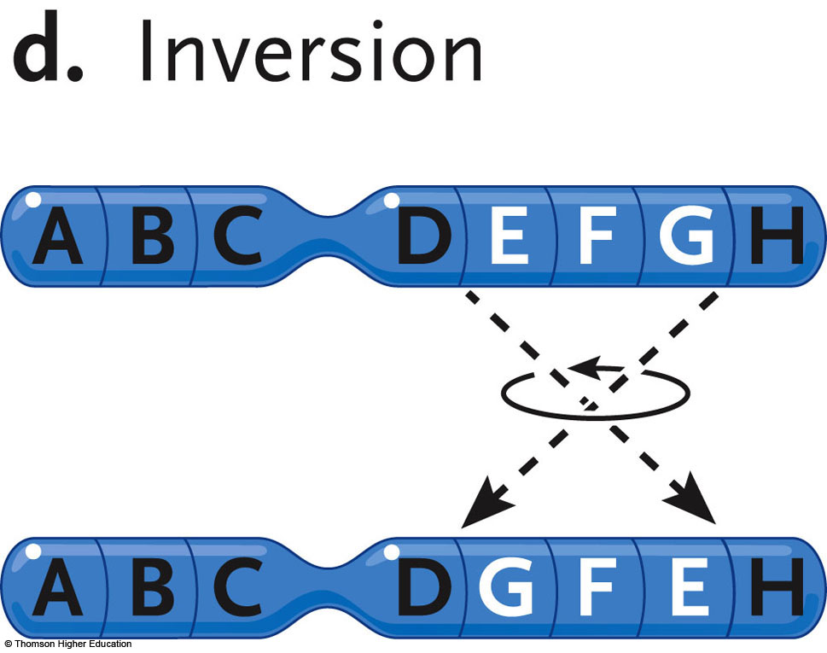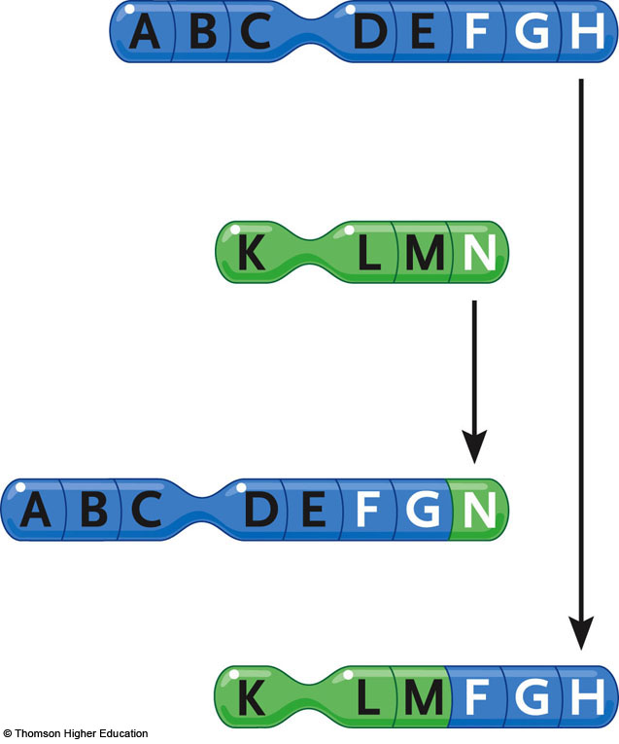
e. Translocation

- Consequences of relocation of DNA sequences within or between chromosomes
- Genes in the wrong places can end up messing up gene regulation
- E.g) Burkitt’s lymphoma, translocation deregulates cancer genes

***Repairing double-stranded breaks is one of the ways copy number variations arise in a genome

- Possible advantages of gene duplication
- if one gene is damaged/duplicated wrong – 2 copies = one correct gene
- two copies of gene coding for protein= twice as much stuff!
- Gene can diverge; you can be more complex

General use of gene families to create phylogenetic trees
- Same genes in totally different organisms can be expressed in the same order-> evolutionary motif
- Can go back and find common ancestor
- CNV have enable groups to differentiate and diverge from one another
- One reason explaining the branches in the tree of life is CNV

Products of meiosis in animals vs. plants, fungi and algae
- Only gametes that are made by meiosis are in animals
- The products of meiosis in plants are not gametes, they are spores, they reproduce by mitosis and they make a multicellular haploid body called a gametophyte
- That gametophyte makes gametes by mitosis
- Gametes fuse and develop the zygote which also develops by mitosis!
- In fungi and algae, meiosis makes spores that divide by mitosis to make a multi-cellular haploid body that makes gametes by mitosis, the zygote goes through meiosis immediately
- * in these organisms their single-celled stage of their lifecycle is diploid
- the single celled stage of OUR lifecycle is haploid

- Timing of meiosis in vertebrate life cycles
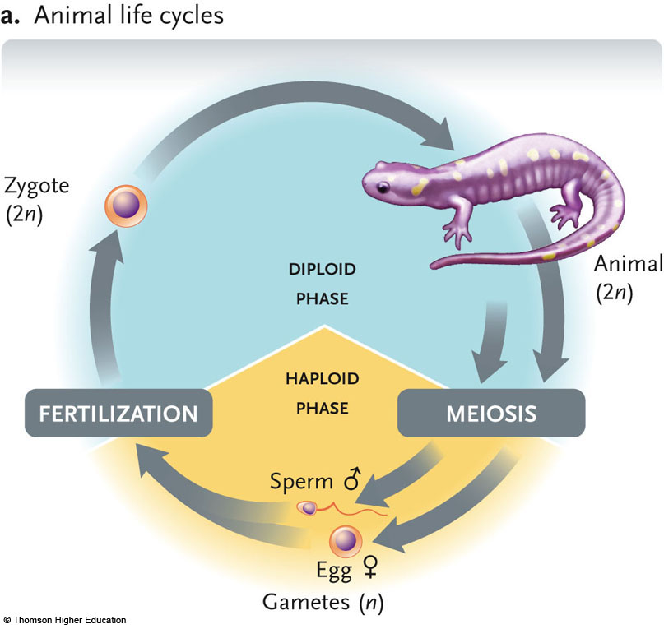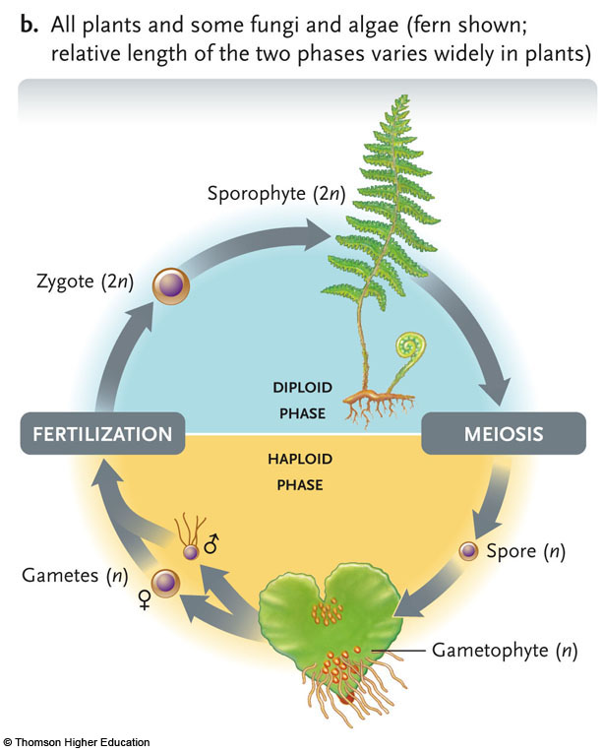
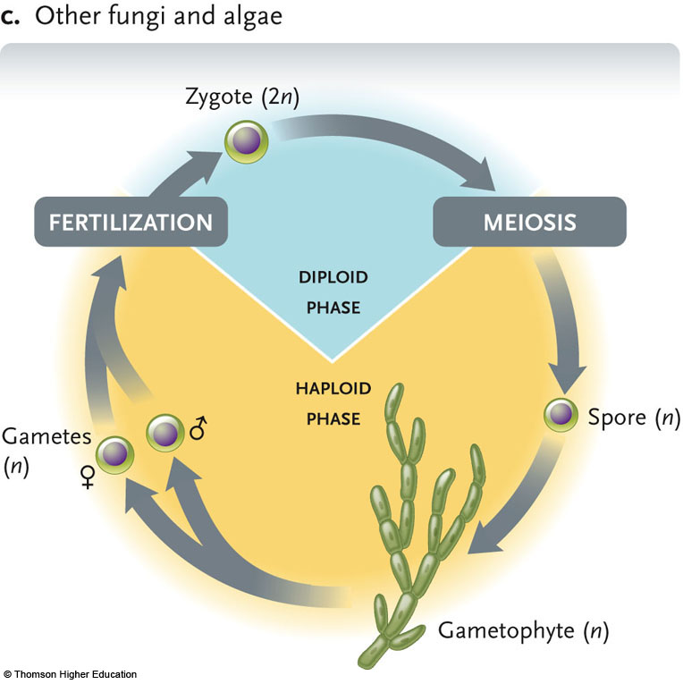
- Main differences between meiosis and mitosis
Mitosis | Meiosis
Takes place in somatic cells | Takes place in gametes (sex cells)
Single division of mother cells results in 2 daughter cells | Two division of mother cells results on 4 meiotic products or haploid gametes
Mother cell can be haploid or diploid | Mother cell must be diploid
Number of chromosomes remains the same after division | Products contain a haploid (n) contrast to 2n in mother cell
Preceded by a s-phase in which the amount of DNA is duplicated | Only meiosis I is preceded by s-phase
There is no pairing of homologous chromosomes | During prophase I, complete pairing of all homologous chromosomes take place
There is no exchange of DNA (crossing over) or recombination, between chromosomes | At least one crossing over (recombination) per homologous pair
Centromeres split during anaphase | Centromeres split during anapahse II but not I
Genotype of daughter cells are identical to mother cells | Products differ in genotype from mother cell
After mitosis, each daughter cell has exactly same DNA strands | After meiosis, each daughter cell has only half the DNA strands

Stage | Meiosis | Mitosis
Prophase I | Duplicated chromosome condense  Homologous chromosomes pair up and exchange segments by recombination  2n, 4C | Duplicated chromosomes (sister chromatids) become visible and attach to a developing spindle  2n, 4C
Metaphase I | Each maternal chromosome (a pair of sister chromatids) and its paternal homologue align randomly at the spindle midpoint  2n, 4C | Duplicated chromosome line up individually at the spindle midpoint  2n, 4C
Anaphase I | Homologous chromosome, each as a pair of sister chromatids, separate and move to opposite poles  2n, 4C | Sister chromatids of each chromosome move to opposite spindle poles  2n, 2C
Telophase I | Two haploid (n) nuclei form  n, 2C | Two diploid (2n) nuclei form. Cytokinesis produces two daughter diploid cells  2n, 2C
Prophase II | Each pair of sister chromatids attaches to a newly formed spindle  n, 2C
Metaphase II | Chromosomes line up individually at the spindle midpoint  n, 2C
Anaphase II | Sister chromatids of each chromosome move to opposite poles  n, 2C
Telophase II | Four haploid (n) nuclei form. Cytokinesis produces four haploid cells.  n, C

- Characteristics of homologous chromosomes
- same size and same shape
- same banding shape
- same genes in the same places, different versions of those genes (different alleles)

- Reason why meiosis I is "reductional" and meiosis II is "equational"
- Meoisis I reduces the chromosome number
- Homologous pair and go to opposite poles and resulting cells have half the chromosome number
- Cells go from diploid to haploid
- At meiosis II the amount of DNA in a cell is reduced (1 x C amount of DNA) but chromosome number is not
- So second division is called equational

- Changes in C and n during meiosis
Stage | Meiosis
Prophase I | 2n, 4C
Metaphase I | 2n, 4C
Anaphase I | 2n, 4C
Telophase I | n, 2C
Prophase II | n, 2C
Metaphase II | n, 2C
Anaphase II | n, 2C
Telophase II | n, C

- Mechanism of recombination during prophase
- Homologues recombine
  - Recombination enzymes cut & paste DNA backbones
  - Precise & controlled mutation
  - Crossing over MEANS sexual recombination

- Role of cohesin and synaptonemal complex
- Cohesin: holds together chromatids in a chromosome
- As homologous chromosomes pair, they are held tightly together by a protein framework called the synaptonemal complex
- Supports homologous chromatids when they exchange segments, producing new combinations of alleles
- The exchange process is very precise (breaking and rejoining of DNA molecules by enzymes)
- Toward end of prophase I, the synaptonemal complex dissembles and disappears

- How homolgues pair in order for all non-sister chromatids to participate in recombination
  - Homologues pair back-to-back not side-to-side or “one on top of the other” so any two of the four sister chromatids can participate in the recombination event

- Mechanism by which recombination creates new combinations of alleles
- Crossing over cutting/pasting DNA
- Generates new combinations of alleles
  - Genes still the same but
  - Females
    - Only as a fetus
  - Males
    - After puberty

- Mechanism by which recombination creates copy number variation (CNV)
- When homologous sequences pair up during meiosis one if there is a region of repetitive sequences the pairing can slip and become unequal after recombination
- CNV results from error in recombination
- Meiosis is a very powerful generator of variation !

- Randomness of alignment of homologous pairs at metaphase I
- Independent assortment homologous alignments independent of each other

- Relationship between distance separating genes and the likelihood of recombination between them
- The shorter the space between 2 gene sequences, the less likely the are to undergo recombination
- Recombination frequency is relatively low between genes that are nearby and relatively high between genes that are farther apart

- Way in which meiosis can be thought of as a kind of DNA "repair". That is, how can you inherit mutations on both homologues of chromosome 6 but give a chromosome 6 with no mutations to your offspring?
- Arrangement of homologues on metaphase plate orient independently of each other
  - Mendel’s Law of Independent Assortment
  - You inherit bad/good alleles and a fraction of gametes will have only good alleles
- By recombination perfectly healthy homologues can be produced
  - Fifty-fifty chance of a homologous chromosome of going to one side or another when splitting between poles
- Chromosomes your kids inherit will not be the same as your parents due to recombination
  - Positive

- Mechanism by which errors in MI or MII give rise to aneuploid products of meiosis arrangement of genes and alleles on homologous chromosomes in a dihybrid organism
- In MI: non-disjunction results when homologous chromosomes fail to separate (problem with the spindle); M2 would proceed normally but gametes would be aneuploid (containing more or less chromosomes)
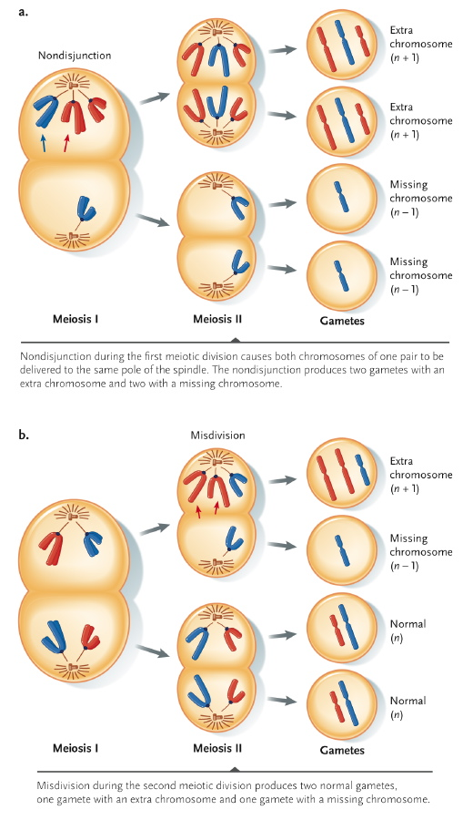

- In M2: mis-division, failure of the chromatids to divide and go to opposite poles; also results in aneuploid gametes
  - Eg. Down syndrome

- Arrangement of genes and alleles on homologous chromosomes in a dihybrid organism
- dihybrid: heterozygous for 2 different alleles of interest

- How independent assortment creates 4 different products of meiosis from a dihybrid parent

- Application of the sum and product rule of probability
  - product rule: 2 independent events probabilities multiplied
  - sum rule: different events give the same outcome probabilities added

- Way in which inheritance of polygenic traits show that inheritance is not "blended"
  - polygenic traits: determined by several genes – show continuous variation
  - when crossing intermediates -> extremes can be produced

- Characterisitics of Mendel's work that set him apart as a genetic researcher
- Mendel was able to figure out particularness of inheritance
- He was thinking like a modern scientist by doing controlled experiments and being very quantitative about his results
- He was very revolutionary by counting his results and deducing the ratios that were produced
- He had idea that alleles are tossed randomly in gametes
- Did not have any idea of meiosis etc.
- Organisms that have two different factors and one of them determines the phenotype
- The allele that determines the phenotype of a heterozygote is the dominant one

- Components of Mendel's explanatory model distribution of progeny
- Variation in traits due to different alleles
- Alleles segregate randomly into gametes
- Organisms inherit two alleles for each trait
- Appearance of heterozygotes determined by dominant alleles

- Given parental genotypes in monohybrid, dihybrid and sex-linked crosses parental genotypes
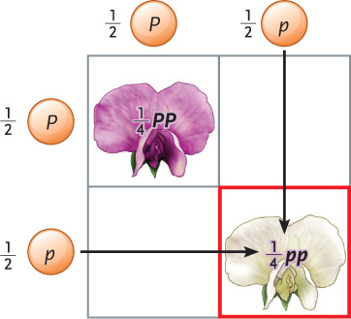

- Given distribution of progeny in monohybrid, dihybrid and sex-linked crosses
  - monohybrid (heterozygous for 1 character) : Pp xPp = pp, Pp, Pp, PP; XX x XY = ½ XX, ½ XY
  - RrYy x RrYy = 4 gametes -> 9:3:3:1

- Genetics of human ABO blood groups
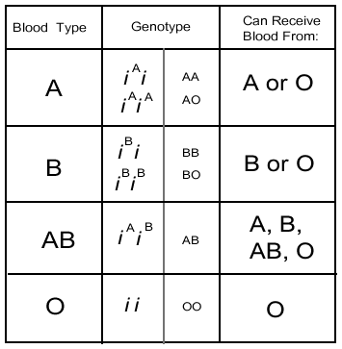
- Location of various alleles on homologues segregation of various alleles during meiosis
  - alleles segregated independently: 4 gametes with equal probability (Ry, rY, RY, ry,)

- Number of different gametes produced, given parental genotype
Practice*

LECTURE 12: INHERITANCE OF TRAITS IN POPULATIONS

- Textbook:
Incomplete Dominance | Codominance
- Effects of recessive alleles can be detected to some extent in heterozygotes  - E.g. pink flowers | - Alleles have approximately equal effects in individuals, making the two alleles equally detectable in heterozygotes  - E.g. MN blood type both glycoprotein types are present and can be detected
Pleiotropy: condition in which single genes affect more than one character of an organism
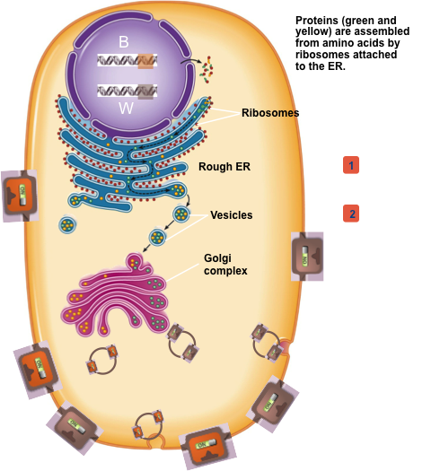
- E.g. sickle cell disease is caused by recessive allele on single gene that affects hemoglobin structure and function phenotypic change of altered hemoglobin protein leads to blood vessel blockage which can damage many tissues and organs in the body fatigue, abdominal pain, heart failure, paralysis, pneumonia, etc.

- Conditions under which Hardy Weinberg Equilibrium is possible in a population.
- No mutations are occurring
- The population is closed to migration from other populations
- The population is infinite in size
- All genotypes in the population survive and reproduce equally well
- Individuals in the population mate randomly with respect to genotypes; no preferences
Lecture:
General production pathway of eukaryotic membrane protein.
- Protein synthesis occurs in ribosomes (translation of amino acids)
- Proteins enter lumen of the RER (rough endoplasmic reticulum)
- Vesicles carrying the proteins bud off from the RER
- Vesicles enter the Golgi Apparatus to modifies the proteins
- Vesicles then bud off from the Golgi apparatus
- Proteins are carried to the plasma membrane
- Exocytosis: vesicles fuse with the plasma membrane and the contents are expelled out of the cell

Two receptors on the surface of the cell (cell memebrane) because there are two alleles in the nucleus;

General physiology/composition of skin/hair pigmentation.
- Results from production of melanin (black melanin and red melanin; brown is a mixture or red and black melanin)
- Melanin produced by melanocytes
- Melanocytes pack melanin into organelles called melanosomes and these are exported into skin cells (keratinocytes) and hair follicle cells pigmentation
- Gene product: protein called MC1R membrane receptor: which normally sits in membrane
- Inside the cell; high cyclic AMP levels make black melanin (eumelanin)
- In response to hormones, cyclic AMP can fall and red melanin (pheomelanin) is produced instead
- Brown allele can switch on and off; can make black and red
- Black allele: on all the time, making cyclic AMP levels always high; therefore it is indifferent to hormones in the external environment
- In a heterozygote some of the brown allele and some of the black allele are in the same cell; black is always on even if brown isn’t brown hair
- In a homozygote with red alleles; low cyclic AMP levels
- Black/red heterozygotes; black colour
- Dominance and recessiveness happens between any two particular alleles at any given time
- Brown is recessive to black but brown is dominant to red; allele dominance depends on what other allele it happens to be with

- Characteristics of dominant alleles.
- Dominance happens because of the interaction of gene products
- Occurs on level of biochemistry
- Dominant alleles code for gene products that are expressed
- Dominant alleles do not inhibit the production of recessive alleles
- Allele that is on all the time is the one that determines the phenotype of the offspring dominant allele

The Molecular Basis of Dominance
- Character is called dominant if it is expressed in the homozygous and heterozygous genotypes
- Called recessive if it is observed only in a single homozygous genotype
- Phenotypes are a consequence of the activities of proteins produced by the alleles of a gene.
- Dominance of one allele over another is determined by the manner in which the protein products of alleles work to produce the phenotype.

Allele frequencies (p & q), given genotypic frequencies.
- Need to know starting allele frequencies; there is nothing inherent to a dominant allele that will cause it to increase in frequency
- Dominant allele is not necessarily going to increase in frequency
- Inheritance itself; diploidy itself not in themselves sufficient to drive changes in allele frequency

Genetics of human ABO blood groups
- Multiple Alleles: more than two different alleles of a gene are present
- I^{A}I^{A}=type A blood
- IAIi=type A blood
- I^{A}I^{B}=type AB blood
- I^{B}I^{B}=type B blood
- I^{B}Ii= type B blood
- IiIi=type O blood

*can use product rule to predict genotype frequency of offspring

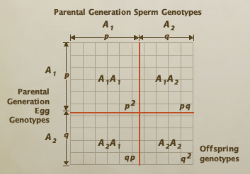
Hardy-Weinburg principle: p²+ 2pq + q²= 1

- Function of various MC1R alleles.
- MC1R locus goes beyond simple Hardy-Weinberg principle
- Many different alleles
- Multiple alleles at a locusResults in many possible genotypes

LECTURE 13: SELECTION AND FITNESS

Textbook:
Deme | Local population of interbreeding organism of the same species; population if modern humans are deems
Population | Group of specific organisms occupying a defined geographical region and exhibiting reproductive continuity
Allele frequency | The proportion/ratio of different alleles in a population
Genotype frequency | The proportion/ratio of a particular genotypes in a population
- Allele frequencies will never change when given the genotypic frequency

Genotype frequencies in the next generation, given the allele frequencies and assuming Hardy-Weinberg equilibrium
- Allele frequencies do not depend on dominance or recessiveness;
- Remain essentially unchanged from one generation to another
- Limited attention just to alleles; traits remain in equilibrium

- Assumptions of Hardy-Weinberg equilibrium
- Parents represent random sample of gene frequencies in population
- Heterozygotes produce two kinds of gametes in equal frequencies
- Parents are equally fertile (gametes produced according to frequency of parents)
- Gametes are equally fertile (same chance of becoming a zygote)
- Population is very large
- No interbreeding
- Mating between parents is random (no preferences of genotypes)
- Gene frequencies same in male and female
- All genotypes have equal reproductive ability
*In natural populations, can determine genotype frequencies and Hardy-Weinberg equilibrium for single genes far apart on the chromosome; number of alleles is limited

Lecture:
- Conditions necessary for Hardy-Weinberg equilibrium
- Population is large
- No mutations occurring (or rare enough to be ignored)
- No immigration or emigration (no gene flow)
- Individuals in the population mate randomly with respect to genotypes
- All genotypes in population survive and reproduce equally well; no selection

*If all conditions are met: allele frequencies can be used to calculate genotype frequencies
F(A1,A1)= p²… F(A1A2)= 2pq.. F(A2A2)= q²

- Whether a population is in HWE, given observed genotype or phenotype frequencies
- Use observed phenotype or genotype frequencies to calculate allele frequencies.
- Use product rule to calculate expected genotype frequencies (under HWE).
- Compare observed vs. expected genotype frequencies.
- To recognize evolution, we need to know what a non-evolving population looks like
- If genotype frequencies can be predicted from allele frequencies, population is in Hardy-Weinberg equilibrium at this locus.
- Allele frequencies will not change while this is true
- If not, one or more assumptions of HWE are violated
- The population may be evolving

- Effect of selection on changes in allele frequency
- The allele with higher average fitness increases in the population

- Relative vs. absolute fitness
- For each genotype we can estimate its:
  - Average absolute fitness (W) (e.g. absolute fitness for this genotype is 8 offspring per genotype)
  - Average relative fitness (w) (i.e. relation to other genotypes of that population)

- How to calculate relative fitness
Calculate w by figuring out what big W is
  - By definition, fittest genotype(s) has w = 1
  - All others; w = W/W_{max}

- How to quantify strength of selection
  - how great the difference in w between genotypes reflects strength of selection
  - the greater the difference in w the stronger the strength of selection and the faster the evolution

Relationship between dominance/recessiveness of alleles and response to selection.
- When selection is going on dominance relationships can constrain selection
- If a new beneficial mutation in a population may become important depending if it is dominant or recessive
- If it is a dominant beneficial allele it will increase in frequency overtime pretty fast; because even with just one copy of that allele the trait is exhibited
- The harmful recessive allele is still persisting in the population because it is hidden in the heterozygote state
- If a beneficial recessive allele arises in a population it may take a long time to get established in a population
- But over enough time it can completely beat the dominant allele in frequency
- Hardly no genetic disorders are due to dominant alleles because natural selection would weed them out the population fast to ensure highest fitness of offspring

Heterozygote Advantage: both alleles will be maintained in at equal frequencies in population Genetic variation is maintained!
- Population can be violating Hardy-Weinberg equilibrium assumptions… but not evolving (selection without evolution)
- When heterozygote genotypes are favored by natural selection over homozygote members of population
- The most famous example of heterozygote advantage is sickle-cell anemia in humans
- Involves two forms of the gene for making β-globin: the alleles are usually referred to as A1 and A2.
Genotype A1A1 is susceptible to malaria
Genotype A1A2 is malaria-resistant and is a carrier of sickle cell (does not express symptoms)
Genotype A2A2 is malaria-resistant but will also suffer from sickle-cell anemia

Why the amount of genetic variation (polymorphism) in a population is important
- If a population lacks genetic variation cannot adapt to a changing environment, thus will be weeded out
- Can be important as well on the individual level in terms of individual fitness (e.g. song sparrows exhibit inbreeding depression; offspring of close relatives often have genetic disorders because they lack genetic variation and instead inbred harmful alleles)

Types of selection and effects:
Type | Definition | Effect on Mean Value of Distribution (vertical line) | Effect on Genetic Variation
Stabilizing (most common) | - Individuals with in-between trait (tend to be most common) are favoured  - Individuals with extreme phenotypes tend to die off | Does not shift | Less and less variation
Directional | - Individuals at one extreme of the spectrum are favoured  - Eventually becomes stabilizing distribution | Shifts in direction of favoured trait | Less variation
Disruptive (least common) | Favours both extremes | Does not shift | More variation (two extremes)

- Majority of traits are not actually governed by a single locus
- Most traits exhibit a more continuous/quantitative distribution: small incremental differences (body weight)

Lecture 14: Selection vs. Other Evolutionary Forces

Textbook
- Batesian Mimicry: similarity in appearance of a harmless species (the mimic) to a species that is harmful or distasteful to predators (the model); maintained because of selective advantage or relatively rare mimic
- Mullerian Mimicry: sharing of a common warning pattern among a number of species that are all dangerous or toxic to predators; resemblances maintained because of common selective advantage

Inbreeding reduces frequency of heterozygote individuals because it reduces genetic variation

- Meaning of genetic load and genetic death
- Genetic load: loss in average fitness of individuals in a population because the population carries deleterious alleles or genotypes
- Genetic death: the removal of an allele or genotype from the gene pool of a population or from a given familial descent because of the sterility, failure to reproduce, or death before sexual maturity of all individuals bearing that allele or genotype

Lecture:

- Examples of stabilizing, directional, disruptive.
- Stabilizing: birth weight of human child
- Directional: in male widow birds directional selection imposed by female birds because females favour long tailed males
- Disruptive: Finches in the Galapagos Islands; during draught years there is no food available for individuals with medium sized beaks; lots of large and hard seeds for birds with big beaks and fair amount of small soft seeds for individuals with long skinny beaks

- Reasons why directional selection does not remove all genetic variation from a population.
- Huge amount of genetic variation in natural populations
- Selection pressures are not always uniform; can vary at different times (time-related variation)
- Many environments have conditions that are not uniform over the entire range of the population (spatial-related variation)
- E.g. Industrial Melanism in the Peppered Moth: industrial revolution in England changed most common tree bark colour (light) to darker colour; so black moth became more dominant than pale moth in some areas (however not all of England was equally affected by industrialization so in some areas light-colored moths still prevailed)

Frequency dependent selectionFitness of a certain trait depends on its relative frequency in a population
- Negative frequency dependent selection Advantage to being rare
- E.g. predators that hunt visually often learn to recognize which types of prey are most profitable and they form search images; disadvantage to prey that have the most common phenotype in the population because predators hunt that phenotype
- Results in both alleles in the selection being maintained
- Positive frequency dependent selection Advantage to being common
- E.g. certain prey are brightly coloured etc. indicating that they are toxic or badly tasting, predators learn this and avoid eating that prey

- Reasons why all living things are not perfectly adapted to their environment.

- Selection is limited by genetic variation
- Selection does not always choose the most perfect allele because it has not yet appeared as a mutation in the population
- Selection is limited by dominance relationships
- Difficult for natural selection to weed out harmful recessive allele because it hides in heterozygote genotypes
- Selection has to play catch-up after environment changes
- Adaptation is always one generation behind environmental change
- Environment is changing faster than ever
- Selection involves traits that result in compromises between competing demands
- Sometimes there are trade-offs in evolution
- Trait may be beneficial in one context and harmful in another context
E.g. long tails on male birds attract females but is this is not convenient; or the sickle cell/malaria trade off

- Selection is not the only evolutionary force operating gene flow and genetic drift

- Effect of genetic drift on allele frequencies within a population, particularly in the case of bottlenecks etc.
Genetic drift: random, unpredictable changes in allele frequencies due to sampling error (bad luck)
- Drift is strongest in small populations and populations that suddenly become small (bottlenecks, founder effects)
- Increases differences among populations
- E.g. cheetahs went through terrible epidemic that reduced their population size
- All cheetahs are virtually genetically identical now; low genetic diversity
Founder effect: small number of founders of a population allele frequencies in new population may not be representative of the original population
- Drift often opposes selection; outcome depends on strength of selection, and population size
- Genetic drift decreases the amount of variation; may cause one allele to go to fixation (frequency of one) and all the other alleles will be lost

- Mechanism that explain why mutation is NOT directed toward the needs of the organism.
- Mutation creates new alleles
- Mutations are always happening if they happen to be beneficial, natural selection may cause them to increase in frequency
- E.g. reverse transcriptase mutations that enables HIV to resist AZTthis mutation is always occurring, does not occur just because virus is being treated with AZT, the mutation increases in frequency when AZT is consumed due to selection, the mutation itself is not designed for the organisms needs

- General fitness effects of mutations.
- Most mutations have nearly-neutral/impartial effects on fitness
- Of those that do affect fitness, most are harmful because it is easier to break something then improve it (at random)
- Mutation often opposes selection, but also provides raw material for adaptive evolution

Gene flow/migration: movement of alleles between populations
- Changes allele frequencies
- Like mutation, can introduce new alleles from one population into another
- Like mutation, often opposes selective forces (selection-migration balance), prevents local populations from becoming perfectly adapted to their local environment

- Characteristics of adaptive vs. non-adaptive mechanisms affecting allele frequency.
- Adaptive: natural selection
- Non-adaptive: mutation, gene flow and genetic drift

Lecture 15: Why Evolution is True

- How Darwin's theory of evolution differed from that proposed by Lamarck
Darwin | Lamarck
- Theory of Evolution by Natural Selection  - Individuals within populations exhibit variability in characteristics (for which there is genetic basis)  - Individuals within a population compete for limited resources  - Organisms with favourable traits would survive to reproduce more offspring  - Favourable hereditary traits would become more common in next generation  - E.g. Some giraffes were born tall and others shorter  - Taller giraffes were able to reach highest leaves; survived to reproduce and pass of their genes more often than shorter giraffes; resulted in more taller giraffes in next generations | - Theory of evolution by Acquired Characteristics  - Characteristics that an organism developed through use and disuse could be passed of to its offspring  - Believed that evolutionary changes in animals were caused by their need to changes in the environment  - E.g. giraffes needed to be taller to reach the leaves in the tallest trees; during their lifetime they continually stretched; changes passed on

- Meaning of catastrophism, gradualism, uniformitarianism
Term | Definition
Catastrophism | Theory that Earth has been affected by sudden, violent events that were sometimes worldwide in scope
Gradualism | View that earth and its living systems changed slowly over its history
Uniformitarianism | Concept that the geologic processes that sculpted Earth’s surface over long periods of time - such as volcanic eruptions, earthquakes, erosion and formation and movement of glaciers- are exactly the same as processes observed today

- Difference between relative versus absolute ages of rock formations and the fossils they contain
Relative | Absolute
- Sediments found in any one place form distinctive layers (strata) that differ in colour, mineral composition, particle size and thickness  - Fossils discovered in particular sedimentary stratum represent organisms that lived and died around the same time  - Each stratum was formed as a specific time and sequence of fossils from lowest (oldest) to highest (newest) strata reveals their relative ages  - Geologists used the sequence of strata and their distinctive fossil assemblages to establish the geologic time scale | - Uses method called radiometric dating  - Involves determination of the amount of certain isotopes that are present in a rock or mineral  - Age is based on the half-life of the isotopes

- Principle behind radiometric dating of rock strata
- Use of isotopes
- Isotopes decay from the moment they form at steady rates
- Rocks containing isotopes can be dated when the amounts of isotopes can be measured and the rates of decay are known

- Why most living things never form fossils
- They decompose before they are covered with sediment or preserved in a certain fashion

Lecture:
- Types of non-random mating
- Males and females have preferences with who they mate with
- Inbreeding (some organisms preferentially inbreed) OR inbreeding avoidance (avoiding mating with relatives; found in many populations of animals and plants)
- Assortative mating “like mating with like”; like inbreeding. e.g. white geese preferentially mate with white geese; most likely mode in nature
- Effects: Increases homozygotes and decreases heterozygosis for the genes controlling the trait.
- Disassortative mating “opposites attract” e.g. in white throated sparrows there are differences in plumage (white stripes vs. dull tan stripes on their head); plumage dimorphism is genetically linked to a behavior dimorphism (white striped individuals are more aggressive and sing a lot more and tan stripped birds are more nurturing); never ever see a white striped male mate with a white striped female because they would just rip each other apart
- Effects: increases heterozygosis for genes controlling the trait.

- Effect of non-random mating on HWE and on evolution
- If a population begins mating assortatively for a certain trait, but all genotypes have the same fitness, what will happen?
EXAMPLE:
- 2 alleles, 3 genotypes (AA, Aa, aa)
- Start with equal frequencies (250 AA, 500Aa, 250 aa)
- 250 AA individuals mate only with AA individuals produce 125 AA offspring
- 250 aa individuals mate only with aa individuals produce 125 aa offspring
- heterozygotes are only going to mate with other heterozygotes
- they will produce offspring
- 125 AA, 250 Aa, 125 aa
- Fewer heterozygotes (genotype frequency changed) than we would predict with Hardy-Weinberg but does not change allele frequencies; NO evolution

- Inbreeding (mating between relative) reduces heterozygosis for all genes in the genome
- The most extreme form of inbreeding is self-fertilization, which occurs naturally in many plants and some invertebrate animals
- Begin by considering a population that consists exclusively of self-fertile heterozygotes of genotype Aa. The initial frequency of the A allele (p) is 0.5.
- After one generation of self-fertilizing, the population would consist of 1/4 AA, 1/2 Aa, and 1/4 aa individuals
- Proportion of heterozygotes has gone from 1 to 1/2 in a single generation of self-fertilization.
- However, the allele frequency remains p=0.5.
- In the next generation, only heterozygotes can produce heterozygous offspring, and only half the offspring of any heterozygote will also be heterozygotes.
- So the heterozygosis after two generations is now 1/2*1/2=1/4, and the frequency of the two homozygous genotypes is 3/8.
- Three generations reduce the heterozygosis to 1/8, and so forth.
- So, the primary effect is that it reduces the heterozygosis by ½ every generation.
- NOTE: allele frequency does not change, only the proportion of heterozygotes.
- Non-random mating therefore causes deviations from Hardy-Weinberg proportions, but does not change allele frequencies.
- In weaker forms of inbreeding, such as mating between cousins, the same thing happens, only more slowly.
- Also because inbreeding inclines to homozygosis, potentially harmful recessive alleles — invisible in the parents — become exposed to the forces of natural selection in the children more diseases as a result of inbreeding

- Components of the theory of evolution
- Evolution happens.
- Change in allele frequencies in population, between generations
- Most evolution is gradual many tiny changes overtime that can accumulate, expect to see transitional forms
- Speciation happens.
- All life is related through common ancestry.
- Much of evolutionary change is caused by selection.
- Evolution occurs in populations, not within individuals.
- Populations change but individuals do not adjust in response to selection.

- Evidence for "descent with modification"
- Homologies (any similarity between two species not explainable by shared function (or shared environment)reflects shared ancestry)
- Intermediates in fossil record (transitional forms)
- Earth must be old
- Vestigial traits
- Fossil evidence that lineages split (speciate)
- Direct observation of evolution in real time

- Examples of homology and why they support the idea of evolution
- Structural; morphological e.g. vertebrate forelimb have same arrangements of bones but different functions in different species
- Developmental: E.g. embryonic early on in dolphin development the baby dolphin has little hind limbs)
- Molecular: why would you expect that cyanobacteria have the same genetic code as human and animals do? We all inherited the same genetic code from a common ancestor
- Reflects shared ancestry

- Examples of vestigial traits and why they support the idea of evolution
- Vestigial traits (and vestigial genes) only make sense in the context of evolution
- E.g. cave salamander has rudimentary eye buds despite the fact that it lives its entire life in the dark (does not need eyes)makes sense if the salamander is descended from a salamander that occupied light environment and had functional eyes
- E.g. species of dandelion has anthers and pollen despite the fact that it produces asexually; perhaps it evolved from an ancestor that needed those structures to reproduce sexually
- Vestigial traits can also be molecular
- e.g. functional gene in the human genome (makes protein); throughout the human genome there are pseudo genes that have similar sequence to functional genes but are not needed; genes can sometimes be duplicated and sometimes it takes on a new function but other times that gene just drifts around through random processes and develops no function and becomes disabled
- Genome = graveyard due to presence of pseudogenes

- Role of fossil record as evidence for evolution
- Transitional forms serve as evidence for decent from a common ancestry “link” related groups
- E.g. more evidence that whales and dolphins evolved from four-legged organisms found on land seen through fossils, evidence that birds evolved from dinosaurs
- Modification: fossil evidence of change
- E.g. evolution in changes in morphologies of organisms over evolutionary time (e.g. horse evolution)

Lecture 16: Why Sex?

- Relationship between sexual reproduction and genetic variation
- Sexual reproduction two important sources of new genetic variation
- Recombination/genetic exchange produces different combinations of genes along a chromosome
- Sex may have originated as a way of overcoming DNA damage by using recombination DNA repair mechanisms (e.g. removing deleterious mutations)
- Therefore genetic variation can be regarded as a by-product

- Different modes of genetic sex determination
- Penis Fencing in Flatworms
- Hermaphrodite marine flatworms of species Pseudobiceros hancockanus hunt and fight for mates (first to pierce their opponent determines their sex)
- Temperature-Dependent Mechanisms
- Sex of alligators and many other reptiles is set during embryonic development by the temperature at which the eggs develop
- Fish That Change their Sex as Adults
- Majority of tropical reef fish change sex during their lifetimes (could be within hours)
- Compensatory Mechanisms in Chickens
- Female chickens have left and right gonad rudiments similar to males
- If functional ovary of a chicken is removed, rudiment develops into an ovary, sometimes into a testis and sometimes into an “ovotestis” with features of both sexes
- Fertilized Versus Unfertilized Eggs
- Male honeybees develop from unfertilized eggshaploid
- Females develop from fertilized eggs diploid
- HAPLODIPLOIDY facilitates the evolution of sociality in which only one female becomes queen and lays eggs

- Different modes of environmental sex determination

- Meaning of haplodiploid
- Reproductive system found in some animals, such as bees and wasps, in which males develop from unfertilized eggs and are therefore haploid, while females develop from fertilized eggs and are therefore diploid

- Meaning of hermaphrodite, and whether hermaphroditism is generally rare or common in plants
- Hermaphrodite: individual possessing both male and female reproductive systems
- Most plants are hermaphrodites

- Relationships among sexual reproduction, meiosis and genetic variability
- Sex=recombination (not always reproduction)
- Recombination creates and maintains genetic diversity (new combinations of alleles; new genotypes) crossing over and independent assortment in meiosis
- This produces offspring distinct from either parents and (usually) each other (twins are an exception)

- Mechanisms of asexual reproduction
- Can reproduce without having sex; can have sex without reproduction
- Most biodiversity occurs in form of bacteria and Archaea
- Main way of reproducing for single-celled organisms binary fission
- Mother cell divides and gives rise to two genetically identical daughter cells
- Vegetative propagation: plants can send out runners along the ground and give rise to new clones of themselves
- E.g. quaking aspen colony: facultatively sexual; can reproduce sexually or asexually
- Amazon molly: obligately asexual; evolved recently from a sexual ancestor because their eggs needs to be in close contact with sperm in order to develop properly
- Sexually reproducing organisms may be:
- Dieoecious (e.g. humans, some trees (ash); male function and female function are housed in separate individuals) in plants this is rare though
- Monoecious: hermaphroditic; each individual has both male and female function (e.g. rose produces pollen and anthers)
- Sequential monoecy (sex change); male at one point in their lives and female at another point e.g. tropical reef fish; bluestreak wrasse changes from female to male when it reaches a certain body size in a matter of hours and clownfish change from male to female when they reach a sufficiently large body size

- Examples and predictions of size-advantage model of sex change
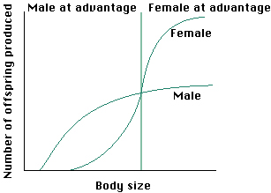
- Relationship between body size and fitness
- General rule: more fit if you are a bigger individuals; slope of the fitness function is different for the two sexes (fundamentally different selection pressures on males and females)

- Graph: reproductive success vs. size
- Bigger males will have higher reproductive success than smaller males not constrained by amount of sperm they produce
- Females have steeper function with body size females can produce more eggs
- Very large female has more to gain from being large than a very large male
- This empirically predicts that all individuals should start off life as a male
- When you are small it is better to be a male than a female
- Later in life; a the point where the curves for these two fitness cross it is more efficient for the male to turn into females protandry
- Every individual in this population should be born male (protandry)
- Tiny females can’t lay eggs
- Born female then changed to male.. why?
- if there are a lot of competition between males, there needs to be a dominant one e.g. if male protects the eggs instead of females
- Distribution of sexual reproduction among all life forms, and particularly among animals
- Asexually:
- First life forms
- Most things, except plants and animals, reproduce asexually (bacteria, archaea) (HGT genetic exchange allows for recombination)
- Sexually:
- Dominant mode of reproduction in animals
- Most plants: can be both sexual and asexual
- Sex= derived state, asexual=ancestral state

- Costs of sexual reproduction
- Need to find a mate; takes up a lot of time and brain energy, might expose organismto predators
- Might break your heart if they already have a mate (lol)

- Cost of meiosis
- Passing on only half of your genes or alleles; diluting your own genome everytime you are producing sexually
- Inefficient way of getting your genes to the next generations

- Cost of sons
- Evolutionary dead end in terms of growing the population
- Compare the production of children/grandchildren for a woman that reproduces sexually and produces half females and half males vs. a female who produces only females asexually
- Asexual female outcompetes sexual one

- "Muller's Ratchet" mutational load explanation for advantage of sexual reproduction
- Sexual recombination benefits the species by speeding up evolution
- Discarding harmful mutations, combining beneficial mutations
- This decreases the likelihood of extinction
- MULLER RATCHET: asexual lineages accumulate harmful mutations

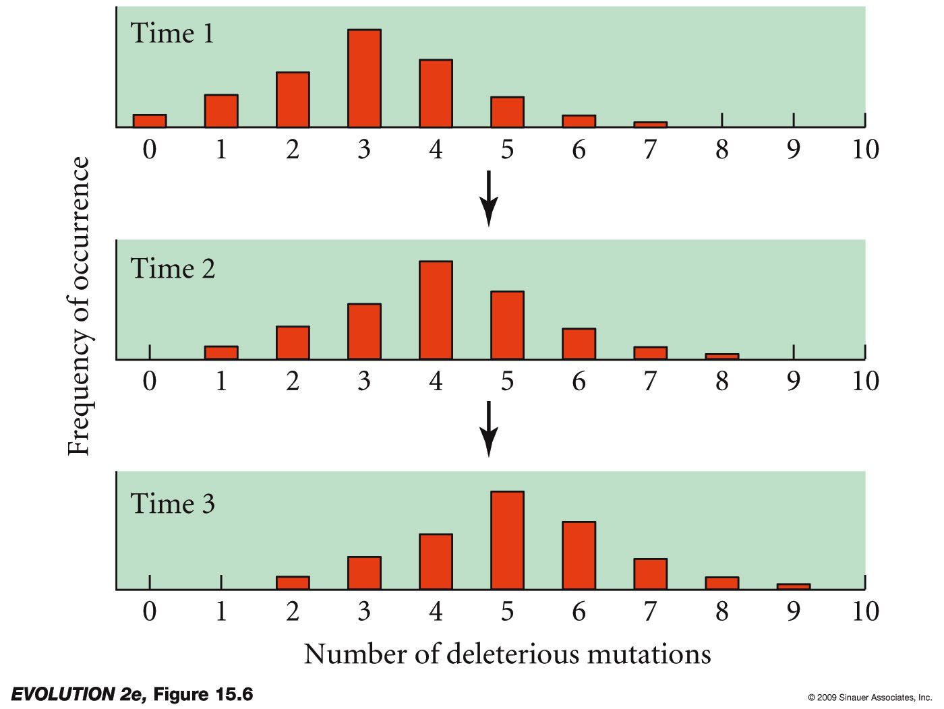

- "Ruby in the Rubbish" hypothesis explanation for advantage of sexual reproduction
- Some offspring will have more harmful mutations than their parents RUBBISH
- Some offspring will have fewer harmful mutations than the parents RUBY

- Combination of beneficial mutations for advantage of sexual reproduction
- Not all mutations are deleterious; some are advantageous
- Sex can speed up the rate at which beneficial mutations occur in the same individual
- Beneficial mutations are rare
- As beneficial mutations accumulate in a population there is more of a chance that individuals in subsequent populations will have more combinations of beneficial mutations
- Relationship between extinction rate and sexual reproduction sex prevents species from going extinct
- Almost all of the obligately asexually reproducing animals have a very recent evolutionary origin; suggests that asexually reproducing species do not last really long; go extinct very fast
- Only exception: bedalyte rodipher; one type of animal in which obligate asexual reproduction has persisted for a very long evolutionary time
Lecture 17: Sexual Selection

Textbook:

- Meaning of monogamy, polygamy, polygyny, polyandry, promiscuity, lek
- Monogamy: mating system in which one male and one female form a long-term association
- Prevails when young require a great deal of care that both parents can provide
- Occurs in species where males indirectly feed the young by bringing food to the mother
- Polygamy: mating system in which either males or females may have many mating partners
- Polygyny: a polygamous mating system in which one male mates with many females
- Males contribute nothing to reproduction but sperm
- If males have high-quality territories, females living there may be able to raise young on their own male just serves as sperm donor and protector
- Prevalent among mammals because females make much larger investment in raising young
- Polyandry: polygamous mating system in which one female mates with many males
- Females contribute nothing to reproduction but eggs
- Promiscuity: a mating system in which individuals do not form close pair bonds, and both males and females mate with multiple partners
- Females are only with males long enough to receive sperm
- Male makes no contribution to raising young
- Both species form leksdisplay ground where males each possess a small territory from which they court attentive females

- Conditions favouring the evolution of monogamous versus polygynous mating systems
- When young require a great deal of care that both parents can provide
- Occurs in species where males indirectly feed the young by bringing food to the mother
- E.g. in mammals mother feeds young with milk, father feeds mother

- Handicap explanation for why females prefer males with extravagant ornaments
- A male’s extravagant ornaments (e.g. large size, bright feathers, or large horns) may indicate he is particularly healthy
- Could indicate he can harvest resources efficiently
- Could mean that he has managed to survive to an advanced age
- E.g. feathers are signals or male quality, and if they reflect male’s genetic makeup, he is likely to fertilize a female’s eggs with sperm containing successful alleles
- Large showy males may hold large, rich territories females that choose these males gain access to the resources their territories contain

- Meaning of sexual dimorphism, intersexual selection, intrasexual selection
- Sexual dimorphism: differences in size or appearance of males and females (males tend to be more physically attractive)
- Intersexual selection: selection based on interactions between males and females
- E.g. males produce useless structures as a result of females finding them irresistibly attractive in the past
- Intrasexual selection: selection based on interactions between members of the same sex
- E.g. males use their large body size, antlers or tusks to intimidate, injure or kill rival males

*selection does not favour traits that benefit long-term persistence of “the group” at the expense of immediate individual fitness beneficial mutations is not the best explanation
Selection on populations is slow and weak, compared to selection on individuals. Sexual recombination benefits the population by increasing speed of evolution
  - rate at which disadvantageous mutations can be discarded
  - rate at which advantageous mutations can be brought together
*This explanation is not sufficient because sexual reproduction costs a lot more for females then reproducing asexualy because they don’t have to compete with other females for male attention. Realistically sexual reproduction isn't attractive because an individual will ultimately do what's best for them in the short term rather then the long term advantage for their off springs generations away.

Relationship between environmental stability and benefits of sexual vs. asexual reproduction
- Ecological explanations for persistence of sex
- Operate on a much shorter term and view sex as an adaptation that may potentially benefit the individual and not the group/species
- Fundamentally come down to the idea that the environment is often changing/unpredictable
- LTH: if I am a female and I have survived to reproductive age in a certain environment then I am well adapted; if environment is stable makes sense to reproduce asexually and clone myself so that my offspring can have my beneficial traits
- However, if the environment is unstable/ changing fairly soon then just because I am well adapted to my conditions it does not mean that clones of me will be adapted to future environmental conditions
- In the real world, environments are always changing thus it makes more sense for an individual to produce sexually because chances are higher that the offspring will be able to adapt better with allele combination from two parents rather then one.
- This explains why the majority of species produce sexually
- Entirely asexual lineages are very rare, and more importantly, very young. Suggests higher extinction risk then sexual lineages. Evidence shows that asexual lineage arose from sexual ancestors.
- Organized diploid sex probably first appeared about 1.5 bya.

LOTTERY TICKET HYPOTHESIS:
- By producing a diversity of offspring genotypes/phenotypes you are maximizing the chance that at least some of your offspring will be well-suited to the new environmental conditions (ie. Buying multiple lottery tickets with different sets of nmbers)
RED QUEEN HYPOTHESIS:
- When the environment is changing then sexual reproduction should be advantageous to the individual
- Sex is favoured when your environment (natural enemies) is continually evolving
- in red queens domain everyone is running very fast to keep up with everything else
- the other things that influence you (e.g. diseases, parasites, etc.) are continuously evolving
- it benefits the individual to rapidly produce a diversity of offspring genotype
- e.g. Fresh water snails factitively sexual ; some live lakes that are infested by parasite that eats their gonads
- when total infection risk very high, then we see a high rate of sexual reproduction
- being able to produce a diversity of offspring genotypes when parasites are evolving

Long-term vs. short term advantages to sexual vs. asexual reproduction

Long term | Short term
- Removing harmful mutations, and combing helpful mutations | - Bet-hedging in a changing environment  - *reduced extinction risk may be just a consequence of sex, not an explanation
*Short term (ecological models) advantages are more important in maintaining sex because they are immediate and benefit the individuals.
- Why sex places different selective forces on males vs. females
- Sexual selection depends on a struggle between males for the females
- Fitness of a male driven by how many females he can copulate with
- Females physiology limits the amount of offspring they can produce, females cannot continually increase their fitness by mating with more and more males typically focus on maximizing offspring quality not quantity

- Relationship between sexual selection and investment in offspring
- Higher investing sex is more likely the choosy sex

- Role of parasites as an explanation for the persistence of sexual reproduction
- Red Queen Hypothesis:
- In an environment where parasites are rapidly evolving it is beneficial to reproduce sexually to keep up with the rate of evolution of the parasite

- How sexual selection maintains traits seemingly incompatible with natural selection
- Many traits are useless and sometimes even disadvantageous for the survival of the individual
- E.g. male frog singing out loudly to attract a female results in the frog exposing himself more to predators as well does not ensure the frog’s own fitness; natural selection would not favour this

- Examples of traits favoured by intra vs. inter sexual selection
- INTRA: convergent evolution of horns in many taxa, or evolution of very large body size in mammals (e.g. male elephant seals)
- INTER: “female choice”, e.g. bright feathers, ornaments, song loudness

- Why males are more usually competing for access to females (rather than vice versa)
- Male can maximize his fitness by mating/copulating with more females generally true in most species, number of mates male has access to limits his fitness
- Females are limited by the number of offspring they can produce, fitness does not increase with rate number
- Female cannot do a lot to maximize her fitness/offspring quantity
- Hence females focus on increasing offspring quality
- Males can sometimes provide direct benefits: e.g. shelter, protection, food e.g. in house finches males that have more red feathers are better fathers (better able to forage)
- Sometimes males can provide indirect (genetic) benefits: genetic quality difference, sometimes males that are more extravagantly ornamented produce offspring that survive better

Relationship between parental investment and which sex is choosy vs. competing
- Anisogamy: unequal gamete size
- Individual sperm is a lot less energetically costly to produce than an egg
- Furthermore, in mammals, females not only produce the egg, but gestate the eggs, provide resources to the developing embryo and provides more parental care after birthmust take on the higher the parental investment
- “Sperm is cheap” Batmann’s principle
- sex differences in parental investment and potential fitness determine which sex is choosy and which sex competes
- high investing sex becomes a limiting resource for the low investing sex
- low investing sex spends a lot more time for access of the high investing sex

What happens (in terms of sexual selection) when both sexes invest heavily in offspring
- Monogamy
- Both sexes are under strong sexual selection
- Have to distinguish before long-term and short-term mating partnerships

Average vs. potential fitness of males vs. females
- Potential fitness is mostly higher for males than even the most fit female: because males invest less time in offspring and more time mating
- Males and females have the same average fitness because in most sexually reproducing populations we have a 50/50 sex ratio
- More variation around that average for males

Limiting factors on male vs. female fitness
- Fitness of a male driven by how many females he can copulate with therefore can fertilize multiple females
- Females physiology limits the amount of offspring they can produce, females cannot continually increase their fitness by mating with many males typically focus on maximizing offspring quality not quantity
- Females can only really mate with a few males because they are limited by the amount of eggs they have, time and resources

*Sex-role reversed species; females compete for males because males are more invested (e.g. red phalaropes and sea horses)
-Females compete for males because the males invest more in offspring because they raise them after they are born
-Gender that invests more in offspring tends to be competed for and pickier
- Potential fitness is higher for females then males
-This is rare but still occurs

Valued traits by males vs. females
- Males are not as selective in short-term mating opportunities
- But in long-term mating partnerships both males and females are very picky

Males value: | Both value: | Females value:
- Indication of youth, fertility and health of a potential mate (e.g. bigger eyes/full lips, as well as waist to hip ratio (small waist relative to hip size) indicates estrogen/fertile  - Being betrayed sexually is worse than being betrayed emotionally (may have to raise someone else’s offspring) | - Physical attractiveness  - Facial symmetry: indicates resilience to various stressors in early development. More symmetrical faces generally mean the person is healthier.  - In evolutionary terms someone who has developed symmetrically has high developmental stability  - Physical attractiveness is more important in populations subject to a strong selection pressure from infectious disease (e.g. populations that live close to the tropics where infectious disease because of the climate are the ones that put the highest premium on physical attractiveness) | Athletic ability of a potential mate for protective benefits  Kindness to children  Resource-holding potential (wealth; probably successful)  Being betrayed emotionally is worse than being betrayed sexually (male in love with someone else would withdraw material resources and stop raising the first woman’s offspring and invest most of his time raising the second women’s offspring)

Sexual Selection:
- Sex puts different selection forces on males vs. females
- Low-investing sex will be competing for access for the high investing sex (relative parental investment)
- Sexual selection can operate on both sexes at the same time (ie. in humans)

Lecture 18: Textbook:

Kin selection: individuals are more likely to help close relatives because increasing a close relative’s fitness means that the individual is helping to spread some of its own alleles.
E.g grey wolf help rear four pups (they each share 0.5 of his genes)
0.5 x 4 = 2 copies of shared alleles o If he had reproduced two offspring instead, 0.5x2=1 copy of allele
This is NOT altruism
Altruism: A behavioral phenomenon in which individuals appear to sacrifice their own reproductive success to help other individuals
Reciprocal altruism: individuals will help nonrelatives if they are likely to return the favour in the future
Eusocial: form of social organization, observed in some insect species, in which numerous related individuals- a large percentage of them sterile female workers- live and work together in a colony for the reproductive benefit of a single queen and her mates

Relationship | Degree of Relatedness
Parent-child | 0.5
Siblings  Identical-siblings | 0.5  1
Half-siblings | 0.25
Nephew/Niece | 0.25
First cousins | 0.125

Identify why haplodiploidy can favour high levels of cooperation in social insects
- Sex is determined through halodiploidy (female diploid, male haploid, unfertilized eggs)
- All sperm carried by a drone is genetically identical b/c he has one set of chromosomes
- Queen bee mates with one male, all of her worker offspring will inherit exactly same set of alleles from the male parent, ensuring 50% degree of relatedness among them
- Workers are related 50% through the queen bee (mom)
- Workers are related 50% through their drone (dad)
- Therefore, half of the workers are 100% related and the other half is 50% which explains exceptional level of cooperation
- The average degree of related in eusocial is 75%
- Workers devote their lives to caring for their siblings because a few of those siblings, may become future queens

- Examples of different types of social interaction
 | Actor benefits | Actor is harmed
Recipient benefits | Cooperation  (two individuals interact and each of them has their fitness boosted as a result) | Altruism  (by performing a behavior the actor’s fitness is reduced)
Recipient is harmed | Selfishness | Spite  (Extremely rare in nature)

- Behaviours that are, or are not, "altruistic"
ARE | ARE NOT
- When someone sacrifices themselves/risks their fitness for the benefit of someone else who isn’t their direct offspring  - E.g. adult squirrel gives alarm call to notify baby squirrels of predators approaching makes them more susceptible to being caught or when birds stay with parents and help to raise siblings instead of producing their own offspring | - parental investment/care to offspring  - E.g. defending offspring against predators etc.; parent is increasing his/her fitness by increasing the contribution of their alleles in the next generation fundamentally cooperative/selfish

- How kin selection theory explains selection for altruistic traits
- More than one way to get copies of your genes into the next generation
- Can do it indirectly by performing behaviors that increase the ability of your relatives to produce
- Any additional reproduction that your relatives are able to due to your altruistic act contributes to your fitness indirectly relatives carry alleles of your genes
- Kin selection favours traits that will increase the individuals indirect component of fitness
- More to “fitness” than simply producing direct descendants
- Benefit received by donor’s relatives b
- Weighted by degree of relationshipr
- Does this outweigh costs to donor’s direct fitness?c
- When r x b is greater than c then the benefits of indirect fitness are high enough to outweigh the costs of direct fitness
- e.g. saving nine cousins over two brothers

- Direct vs. indirect vs. inclusive fitness
- Direct: personal reproduction
- Indirect: additional reproduction by relatives, due to your “altruism”
- Inclusive: Direct + Indirect

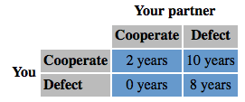
- Reasons why cooperation can evolve in face of prisoners' dilemma
- Each player can either :
- Cooperate with partner (stay silent)
- Defect on partner (implicate them in crime)
- Payoff depends on partner’s choice:

- No way of knowing what a particular individual would do
- Always the rational choice to defect
- You do better by defecting on them than cooperating with themminimize amount of time you spend in jail
- BUT payoff for mutual defection is worse than payoff for mutual cooperation (8 years vs. 2 years)
- If both players can trust the other player they can be better off
- Thus cooperation can evolve between unrelated individuals
- Selection can favour “altruisim” if it is later reciprocated
- Most likely when groups are small and stable, and when individuals can recognize and remember helpers and cheaters

- Role of human emotions in support of reciprocal altruism
- Human emotions (trust, resentment, guilt, gratitude) are adaptations for score-keeping
- We can hold a grudge or harbor gratitude for long amount of time results in altruistic or non-altruistic acts

- Conflicting interests of parents vs. offspring
- Notion of inclusive fitness can explain a lot of parent self-sacrifice
- Also explains conflicts between relatives
- Parent-offspring conflictHow much and how long to invest in a particular offspring?
- The longer a parent provides care to an individual offspring:
- Benefits to parent and offspring increased offspring fitness
- BUT leads to diminishing returns
- Costs to parent and offspring (lost opportunity of parent to produce more offspring)
- Parent is equally related to all offspring, so “should” cut the offspring loose once benefits exceed the costs
- CONFLICT: asymmetry
- Offspring is twice as related to itself as to siblings, so “should” demand care until the costs are twice as high as the benefits
- Fetus selected to “demand” more resources than the mother selected to give
- E.g. Fetal tissue in placenta secretes allocrine hormones to manipulate maternal blood pressure and blood sugar (fetus is attempting to get more resources than the mother is selected to provide); maternal sensitivity to these signals drops
- Conflict of interest endangers both parties (gestational diabetes, pre-eclampsia etc.)

- Unrelated individuals may have similar but not overlapping interests
- Tragedy of the Commons: social dilemma (conflict) over use of shared resources
- E.g. 10 farmers each own their own cows, but all share “the commons” (field the cows are on)
- As more cows are added, cost of over-grazing shared by all the farmers
- Benefits of owning another cow are not shared (benefits of adding another cow are unique only to the owner that adds it)
- Rational decisions by individual is to defectoverexploitation of shared resource
- Cooperation is best for the group as a whole

Summary: Cooperation and Conflict
- All cases may not be truly altruistic (individual may benefit somehow)
- Many altruistic traits can be explained by shared genetic interests; others by reciprocity; but rational decisions by individuals may deplete shared resources
- Even when genetic interests overlap (family groups) they can be difficult enough to induce conflict
- ACTUAL altruism may not exist
- Potential for conflict whenever interests of both parties disagree

Lecture 19: Textbook

Morphological | Biological | Evolutionary Species
- Assemblages of individual with shared structural features that separate them from other assemblages  - Uses comparative anatomy and comparative embryology | - Biological species is a sexually interbreeding group of individuals normally separated from other species by the absence of genetic exchange through barriers | - Definition of a species based on isolation from other species, often identified from ancestor-descendant populations

 | Strengths | Limitations
Morphological | - Careful anatomical dissection and comparisons provided criteria for constructing detailed evolutionary trees  - Early embryos of related species bear more common features than do later, more specialized stages | - Comparisons complicated by:  - change in form and/or function of organs within a group (e.g. flippers of whales)  - loss of a feature over time (e.g. loss of limbs in snakes)  - persistence of vestigial organs
Biological | - Such groups exist in nature and are separated by gaps across which interbreeding does not occur  - Allows taxonomists to unify different groups into a single species that has been separated into distinct species on the bases of morphological/geographical criteria | - cannot be determined whether fossil species interbred or not, so they are classified as morphological species  - may not apply to all animals with asexual reproduction; each clone of individuals is genetically identical but genetically isolated from every other clone (however not a separate species)  - species that have been isolated geographically may still be able to interbreed if brought into contact
Evolutionary | - Incorporates change over time rather than static featuresconsiders changes resulting from competition and interaction among species | - As speciation is an evolutionary process, defining the stage when groups of organisms have reached complete separation is subjective

Lecture:
Term | Meaning
Parent-offspring conflict | - Parent and offspring are expected to disagree over how long the period of parental investment should last, over the amount of parental investment that should be given, and over the altruistic and egoistic tendencies of the offspring  - Parent is equally related to all offspring, so “should” cut the offspring loose once benefits exceed the costs  - Offspring is twice as related to itself as to siblings, so “should” demand care until the costs are twice as high as the benefits
Tragedy of the commons | - The depletion of a shared resource by individuals, acting independently and rationally according to each one's self-interest, despite their understanding that depleting the common resource is contrary to their long-term best interests  - e.g. when individual farmers add more of their own cows, they contribute to the over-consumption of the shared resources that is the field
Morphological species concept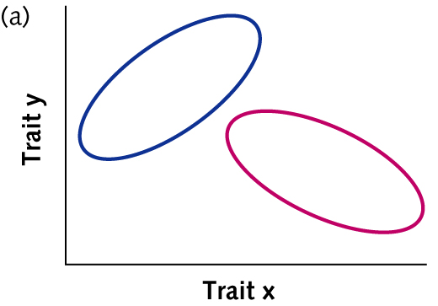 | - Looking at the phenotype of the individual (aspects of morphology, size, shape)  - Categorizes species as a cluster of individuals that look more similar to one another than another cluster  - Species don’t overlap  - LIMITATIONS:  - Runs into problems when males and females of a species look very different (sexual dimorphism)  - Vestigial traits  - Similar traits that evolved for different uses
Biological species concept | - Defines species not on how similarly they look but on whether they interbreed with one another  - Organisms may appear to be alike and be different species. For example, Western meadowlarks (Sturnella neglecta) and Eastern meadowlarks (Sturnella magna) look almost identical to one another, yet do not interbreed with each other—thus, they are separate species according to this definition.  - A species is a group of organisms that can interbreed and produce fertile offspring; however this definition does not relate to asexual species or species that hybridize to produce fertile offspring  - Species: interbreeding group of individuals, reproductively isolated from other groups  - Relies on reproductive isolation  - Appeals: more testable and arbitrary  - LIMITATIONS:  - Hybridization poses difficulty  - Sometimes organisms that would not usually mate in the wild mate and produce hybrids (e.g. liger or tigion offspring is an evolutionary dead-end because they are sterile, therefore they are still members of different species)  - Difficult to apply when things do not occupy the same geological area it is difficult to see whether they would normally interbreed  - Impossible to apply to species that are now extinct  - No way of applying to asexually reproducing organisms
Pre-zygotic vs. post-zygotic isolating mechanisms | Pre-zygotic = factors preventing individuals from mating (ecological, temporal, behavioural, mechanical)  Post-zygotic = after fertilization occurs; zygote is formed but problems arise (hybrid inviability and sterility)
Ecological Isolation | - Individuals only mate in their preferred habitat. They do not encounter individuals of other species with different ecological preferences.  - E.g. some toads breed in forest habitat and other breed in the meadows
Temporal isolation | - Differences in timing of the breeding season  - E.g. some spotted skunks breed in spring, some in summer
Behavioural (courtship) isolation | - Individuals of different species may meet, but one does not recognize any sexual hints that may be given. An individual chooses a member of its own species in most cases  - e.g. mating display one bird of paradise gives may not be attractive to the female bird in another population
Mechanical isolation | - Copulation may be attempted but transfer of sperm does not take place. The individuals may be incompatible due to size or morphology.
Hybrid Inviability | - Hybrid offspring dies in embryo or at young age because hybrid individuals have two sets of developmental instructions, one from each parent which may not interact properly for successful completion of embryonic development
Hybrid sterility | - Hybrid may survive but will be sterile when parent species differ in the number or structure of chromosome, which are unable to properly pair during meiosis  - Hybrids have 0 fitness as they leave no descendants  ex. horse (2n=64) + donkey (2n=62) = mule (sterile)
Allopatric speciation | - Something happens to cause the two populations to be geographically isolated from one another  - If barrier lasts for a sufficient number of generations populations are no longer connected by gene flow and they will diverge  - They will experience genetic drift; gene frequencies will be different on both sides of barrier  - Sometimes barrier may disappear and populations come back into contact; secondary contact, if it occurs, may either reinforce reproductive isolation or re-establish gene flow (depends on how much the populations diverged while apart)
Peripatric speciation | - Small group of individuals is barriered off from the larger group
Parapatric speciation | - May not be a real hard fast barrier between the two populations; can still be some gene flow across the barrier; less likely to result in true speciation
Sympatric speciation | - No geographic isolation; species diverge while inhabiting the same place into different niches  - One way we can get sympatric speciation occurring is through mutations associated with polyploidy:  - Polyploidy “instant” sympatric speciation
Isolation | - Can occur through:  - colonization of a new habitat  - cuts off gene flow  - possible change in natural selection  - Vicariance – species range is divided  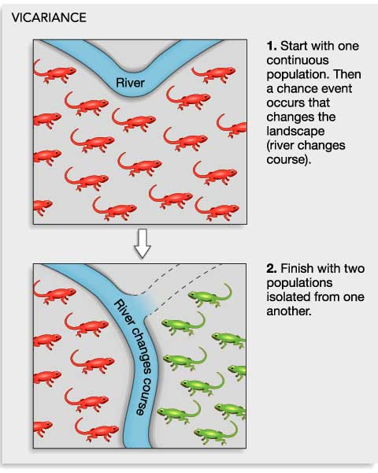  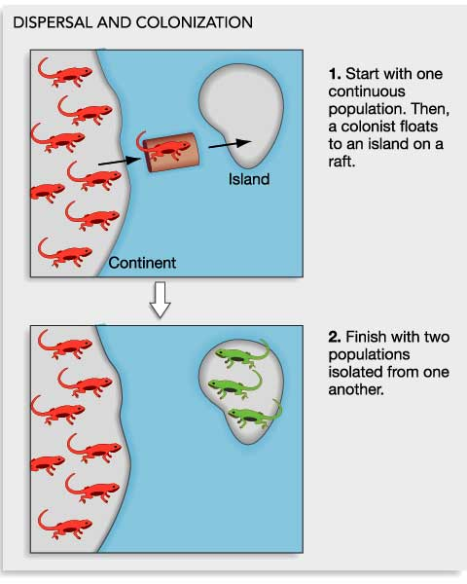  - e.g. sinking/rising of land bridge, separation of continents
Divergence | divergence by  genetic drift  is likely  - after isolation, no gene flow, so populations can diverge  - originally thought divergence was primarily by genetic drift  Divergence by genetic drift  - most pronounced in small populations  - small groups of colonizers  - small isolated peripheral populations
Secondary contact/reinforcement | - Sometimes barrier may disappear  - If little divergence has happened, the populations would resume interbreeding (hybrid swarm)  - But, if barrier has been there long enough or selection pressures have driven the population to sufficient divergence, populations may have become reproductively isolated  - Evolved differences in courtship, etc.  - Unfit hybrids  - Direct selection favouring prezygotic isolating mechanisms (reinforcement); selection pressure to only mate with your population  - Uncertain whether postzygotic or prezygotic isolation usually happens first
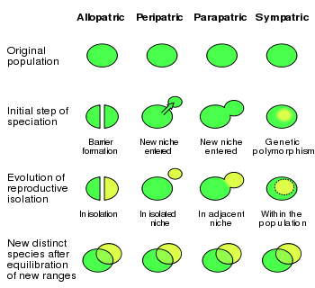

Why coming into secondary contact is not required for speciation to occur, but can promote prezygotic isolation
- Secondary contact not required if prezygotic reproductive isolation evolves independently
- Not required if the new species never come in contact
- But is after divergence in isolation, populations come back together
Hybrid mating take place, but offspring are unfit
Reinforcement natural selection for avoiding hybrid mating
Reinforcement completes reproductive isolation
Prezygotic reproductive isolation – hybrid matings don’t occur

- Role of islands in speciation
- Because islands are isolated; total breakdown of gene flow there
- Islands can have different selection pressures on different parts of the island and on the island relative to the mainland (different predators and food sources etc.)
- Genetic drift is larger on the island; smaller populations

- Why most speciation occurs in allopatry (ie why parapatric and sympatric speciation are rare)
- Parapatric speciation occurs when populations are separated not by a geographical barrier, such as a body of water, but by an extreme change in habitat.
- Since reproductive isolation in these cases is not geographic but rather temporal or behavioral (e.g. plants that live on boundaries between very distinct climates may flower at different times in response to their different environments, making them unable to interbreed) it is less likely to result in true speciation
- Sympatric speciation is rare because the problem is how to avoid intermediate genotypes that will function as bridges for gene flow, which would eliminate the difference.
- Needed: polymorphism and assortative mating.
- Problem: if these two are not genetically coupled, recombination will eliminate the barrier to gene flow.

- How polyploidy can induce sympatric speciation
- Sympatric speciation formation of a new species within range of parent population species
- Polyploidy is a mutant cell condition formed as a result of improper cell division=extra set of chromosomes
- Polyploids become reproductively isolated from their non-polyploid parent speciese.g. tetraploid individual cannot mate with a diploid individual

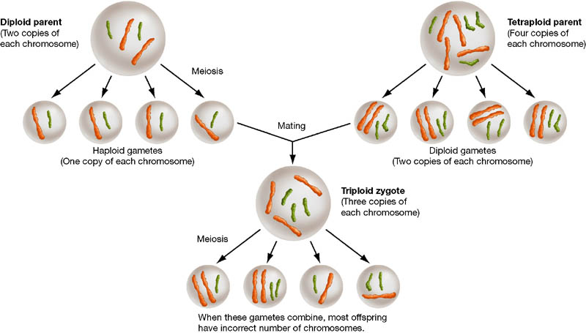

Speciation without allopatry?

- Allopatry: When there is a geographical barrier preventing two populations from mating with each othergene flow is broken off and speciation will happen
- Adaptations to a new food type can sympatric speciation
- Polyploidy mutations can instantaneously result in sympatric speciation
- Sympatric speciation can also be driven by new ecological niches (new sources of food becoming available)
- e.g. 1. Hawthorn maggots introduced to North America. 2. Subset of maggots began feeding (and mating) only on apples rather on Hawthornsbecame reproductively isolated
- Assortative mating facilitated by the fact that they only mate on the food sourcenever interbreed
- Within a population there is strong competition for limited food resourcesresults in disruptive selectionpromotes assorative mating gives rise to sympatric speciation
- e.g. sickle back species pairs; each lake has a benthic (larger) and a limnetic form (smaller)both have different food sourceclosely related but no longer interbreed because of the disruptive selection

Lecture 20:
- Meaning of systemics, phylogeny, phylogenic tree, classification, taxon, taxonomic hierarchy
Term | Definition
Systemics | Branch of biology that studies diversity of life and its evolutionary relationships
Phylogeny | Evolutionary history of a group of organisms
Phylogenic tree | Branching diagram (formal hypotheses) depicting the evolutionary relationships of groups of organisms
Classification | Arrangement of organisms into hierarchal groups that reflect their relatedness
Taxon | Name designating a group of organisms included within a category in the Linnaean taxonomic hierarchy
Taxonomic hierarchy | System of classification based on arranging organisms into ever more inclusive categories

Why similarities in morphology or lifestyle do not necessarily reflect close relatedness, using examples

Not all similarity reflects recent common ancestry. Not all similarities synapomorphies.
Convergence: misleading similarity despite distant evolutionary relationship
Divergence: misleading dissimilarity despite close evolutionary relationship

- There is a tendency among organisms living under the same conditions to develop similar body forms
- Parallel/convergent evolution
- Convergent evolutioninvolves phylogenically more distant related organisms, Parallelphylogenically more related organisms
- Examples:
- Aquatic vertebrates have fishlike bodies (sharks vs. tuna) but many different kinds
- Flowerlike structures are not always flowers (can be leaf modified by fungus)
- Carnivorous plants are not necessarily closely related
- Looking at a mammal’s tail may give you a different idea of its relationships than looking at its skull

- The major goals of systematics
- Reconstruct the phylogeny or evolutionary history of a group of organisms
- Taxonomy; the identification and naming of species and their placement in a classification.

- Principles underlying the Linnaean system of classification (species, family, etc.) and which groupings include which other groupings
- Taxonomic hierarchy; arranging organisms into every more inclusive categories
- Family Order ClassPhylumKingdomsDomain (most to least similar)

- Correct interpretation of evolutionary trees, close and distant relatives, and where extinct taxa would be placed in a tree
- A phylogeny, or evolutionary tree, represents the evolutionary relationships among a set of organisms or groups of organisms, called taxa (singular: taxon).
- The tips of the tree represent groups of descendent taxa (often species)
- the nodes on the tree represent the common ancestors of those descendants.
- Two descendents that split from the same node are called sister groups
- In the tree below, species A & B are sister groups — they are each other's closest relatives
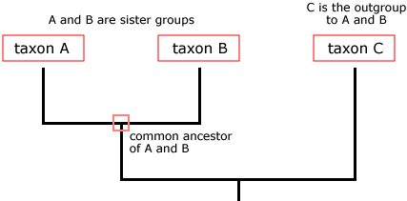
- Extinct taxa are included as terminal nodes as they are not ancestors for any other existing species
- Time passes from root to tips; reflects relatively how long its been since two organisms shared a common ancestor
- Amount of time is unknown in terms of years/generations; only relative information about the order of branching events is known
- D/E and C/F splits did not necessarily happen at the same time; can only infer the branching order within a single lineage

- Some phylogenies convey more information than branching order
- Some lineages can evolve quicker than other lineages do
- Sometimes when u have a molecular clock

- Rotating nodes changes nothing
- All these internal nodes can be rotated and it doesn’t change what the phylogeny is telling us; relative order still preserved

- The question of higher and lower life forms and which species are more highly evolved is not answered by phylogenies!
- Everything has been evolving for the same length of time

- Phylogenies are like pedigrees; Family-tree metaphor

- You are not descended from your cousins, you guys just share a common ancestor

**FOCUS ON SEQUENCE OF NODES; sequence of branching events

- Homology vs. misleading similarities due to convergence of unrelated taxa or misleading differences due to divergences among closely related taxa, and examples of each
- Homology: similarity that reflects recent common ancestry
- E.g.
- 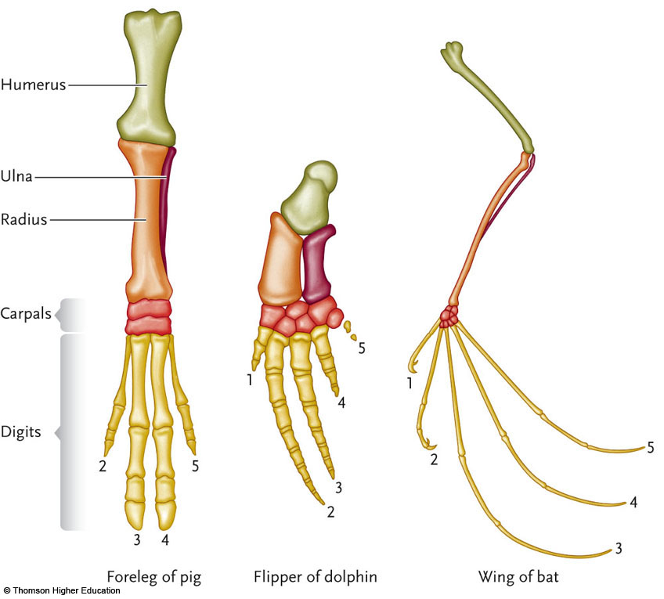

- Each of the species uses the forelimb for a different function but have the same bones arranged in the same order
- Similarities are there because these groups are closely related to one another
- Problem
- Homoplasy: misleading similarity, OR misleading dissimilarity
- E.g. as a result of convergent evolution; trait is similar in two groups but doesn’t reflect their evolutionary relationships
- E.g. alligators and hippos have the same placement of eyes on the top of their head; however it has independently evolved in both groups; they are not closely related
- E.g. divergence in species can be a misleading dissimilarity such as below:
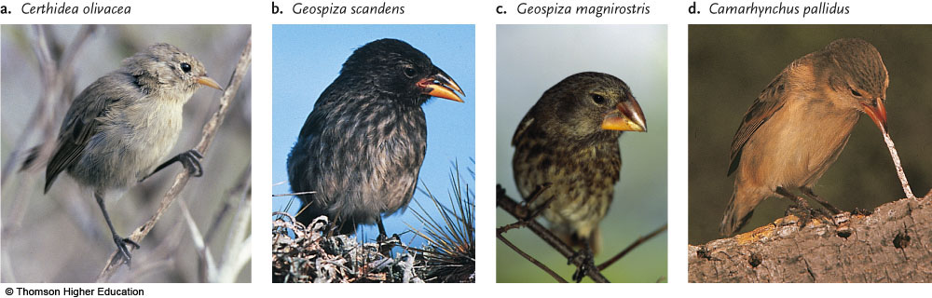
- Divergence is another source of homoplasy

- Synapomorphy
  - shared by two or more groups
  - derived (from a common ancestor)
- Symplesiomorphy
  - shared by two or more groups
  - ancestral (trait was also already present before the groups diverged)
- Autapomorphy
  - unique to a single group
  - derived within the group

- The significance of outgroup analysis
- Outgroup analysis provides clues to which traits derived, which ancestral
- Which is the derived state and which is the ancestral state?
- The best way to figure this out is to use an outgroup
- Outgroup close relative of the group of interest but does not belong to the group of interest
- Evolution does not always proceed toward greater complexity (E.g. Butterfly example: 6 legs 4 legs)

Lecture 21: Phylogeny II and Evolutionary Ecology

- What happened to the dinosaurs
- End if Cretaceous 65 Mya dinosaurs and other large marine reptiles and various vertebrates died out
- Cause impact of an asteroid (element iridium found world wide, quartzes, Chicxulun crater etc.)
- Relative severity of the end-Cretaceous mass extinction, compared to other mass extinction events

Details of Five Major Mass Extinction Events Since the Cambrian

 |  | Estimated % of Extinction of Marine Animals
Extinction Period | Date (Mya) | Genera | Species
Late Ordovician | 440 | 61 | 85
Late Devonian | 365 | 55 | 82
Late Permian | 245 | 84 | 96
Late Triassic | 208 | 50 | 76
Late Cretaceous | 65 | 50 | 76
*major extinction of land plants and animals happened during the Late Cretaceous period

- Meaning of orthogenesis
- Orthogenesis: the concept that evolution proceeds in a particular direction because of internal or vitalistic causes
- Just as individuals grow old and die, suggests that species and other classification categories follow a similar life history driven by internal factors that cause evolution to proceed in a direction unrelated to selection and adaptation
- Appearance of bizarre and nonadaptive charactersevidence

- Factors that enabled mammals to diversify after the end-Cretaceous mass extinction
- opening up niches vacated by dinosaurs
Facilitated mammalian evolution, variation, distribution and adaptive radiation
- origination of new ecosystems as consequence of earlier continental drift
- evolution of other groups such as land plants

- Evidence supporting the collision theory regarding the end-Cretaceous mass extinction
- Iradium rare element found often in asteroids and meteorites
- Worldwide presence of iridium in Cretaceous-Tertiary boundary strata +high-impact particle (glasslike spherules, fractured quartz)indicate collision with extraterrestrial body
- May have occurred after extinction of dinosaurs began though leads to gradual and catastrophic explanations (stressful environments AND extraterrestrial impact)
- Chicxulub Crater
- Off coast of Yucatan Peninsula in Mexico
- Diameter of about 195 km

- Whether a particular trait is probably ancestral or derived, given a phylogeny and a suitable outgroup
- EXAMPLE: Is this trait ancestral or derived?
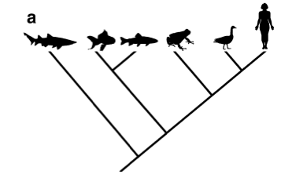
- Shark is an outgroup species
- Trait:
- Present in outgroup and ALL of ingroup? Ancestral (more likely everyone has that trait because of homology)
- Present in outgroup and SOME of ingroup? Ancestral
- Absent in outgroup, present in SOME of ingroup? Derived
- Present in outgroup, but NONE of ingroup? CANT TELL IN THIS CASE (two equally likely possibilities; common ancestor did not have the trait, trait is derived OR trait is ancestral and in a single evolutionary step that trait was lostboth involve ONE evolutionary step (one in outgroup lineage one in ingroup lineage)
- Absent in outgroup, present in ALL of ingroup? CANT TELL IN THIS CASE (two equally likely possibilities; common ancestor did have the trait, trait is lost in outgroup OR trait is not ancestral and in a single evolutionary step that trait was derived in ingroup both involve ONE evolutionary step (one it outgroup lineage one in ingroup lineage)

- Whether or not a particular trait is a synapomorphy, given its distribution among the outgroup and the ingroup

- Using parisomy to evaluate candidate trees
- Outgroup: Shark
- Ingroup: Chicken, Bat, Chipmunk

Which tree is more likely to be correct?
First identify which traits are synapomorphies
Outgroup
- Shark: No milk. No fur. No wings. No beak.
Ingroup
- Chicken: No milk. No fur. Wings. Beak.
- Bat: Milk. Fur. Wings. No beak.
- Chipmunk: Milk. Fur. No wings. No beak.

Milk: synapomorphy (shared and derived)
Wings: synapomorphy (shared and derived)
Fur: synapomorphy (shared and derived)
Beaks: not synapomorphy (derived but not shared)

- Why similarity does not always imply relatedness
- “related to” ≠ “descended from”
- every modern species is related to every other modern day species but is not descended from them
- more complex ≠ “more evolved”;
- modern day species has been evolving for the same amount of time
- relatedness ≠ similarity;
- not all similarities are homologies
- not all homologies are synapomorphies
Parsimony:
- The simplest explanation is usually the best
- Whichever tree requires the smallest number of evolutionary changes (gains or losses of a trait) is probably correct

- The importance of monophyletic groups
- In cladistics systematics, only monophyletic groupings are recognized
- Does the group include all the descendants of the group’s MRCA?

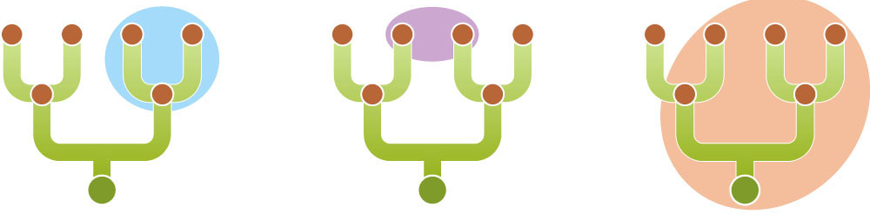

- Blue circle is monophyletic
- The other two are NOT; ovals do not include all of the descendants of the MCRA of both groups

- Natural vs. unnatural groupings of taxa, given a phylogeny
- Many traditionally-recognized groups are not monophyletic
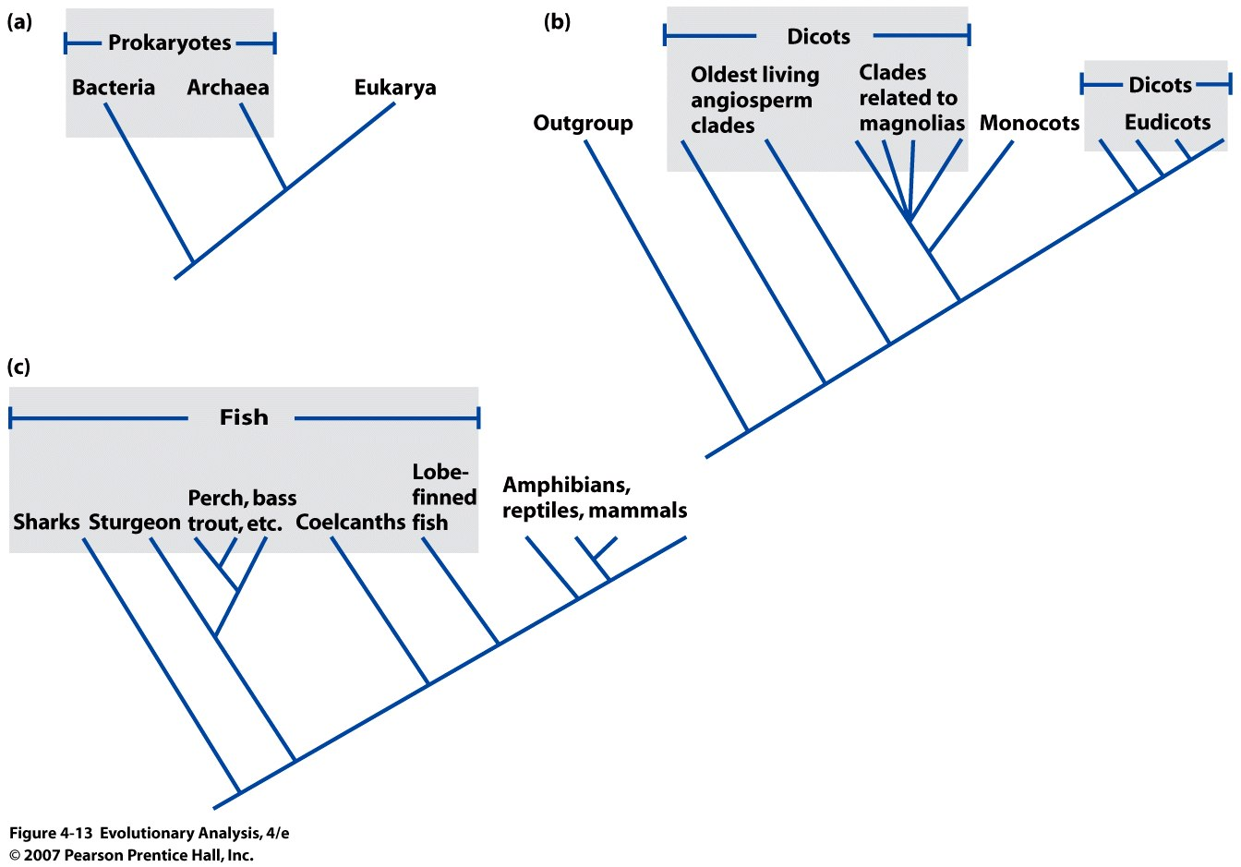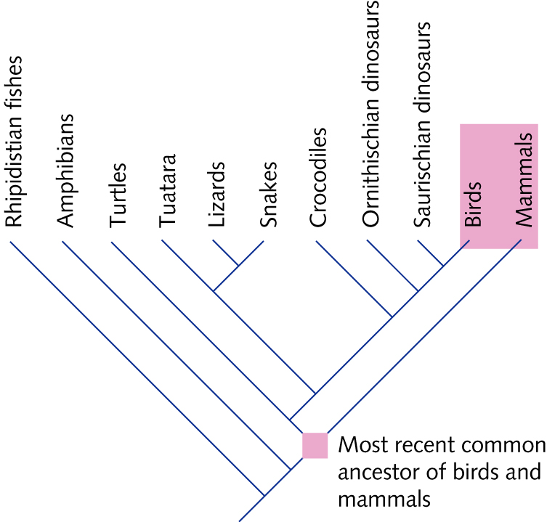
*mistake to call prokaryotes, dicots, fish or endotherms a monphyletic group

- Why biodiversity changes over time
- Ecology: interactions between organisms and their environment
- abiotic (nonliving; temperature, climate, nutrients in soil etc.) vs biotic components (living organisms; members of same species, potential mates/competitors, predators, prey, parasites, pathogens)
- these interactions affect evolution, origin and demise of species (rates of speciation, extinction)
- Evolutionary ecology and biodiversity
- most species that have ever existed are now extinct (99%)constant turnover and replacement
- biodiversity (number species alive on the planet) varies over time, reflecting the balance between speciation and extinction
- rates of extinction vary among lineages

- Adaptive radiation: rapid speciation into many descendant lineages (finches)

- Factors that may trigger an adaptive radiation
  - Competitive release
- E.g. small population moves to new environment where there are no competitors
  - Evolutionary innovation
- E.g. innovation by angiosperms to produce flowers that attracts animals and insects to pollinate thempollen donor plant, pollinator, pollen recipient plantgave rise to adaptive radiation because flowers that are different colours/shapes/different blooming times will become reproductively isolated from other plants because they attract different pollinators (pollinator attraction becomes a prezygotic barrier)

Lecture 22: Arms Race

Textbook:
- Factors influencing why some pathogens evolve towards greater virulence (harmfulness)
- Pathogens that are transmitted by water are more harmful
- Vector born diseases (an organism, typically a biting insect or tick, that transmits a disease or parasite from one animal or plant to another) like malaria are more harmful than non-vector born diseases

- Predicted relationship between virulence and antibiotic resistance
- Increased virulence leads to increase in antibiotic resistance
- Decreased virulence leads to decrease in antibiotic resistance

- Mutualistic, competitive and antagonistic relationships between species, given 'real world' examples
 | Description | Real World Example
Mutualistic relationship | both species benefit from each other | - E.g. pollinator + plant relationshipPlant gets to exchange gametes with another plant and pollinators get food reward out of the interaction  - Another example is domestication of animals
Competitive relationship | both species suffer from each other | - E.g. species coexisting in same area competing from some limiting resource; cheetah competing with lions for food resources, zebra and giraffes competing for water, plants competing for space, light, rainfall, soil nutrients etc.  - Sometimes one species is a better competitor than the other; e.g. lion wins over cheetah
Antagonistic relationship | one species may benefit at the expense of the other species; one exploits the other; natural enemies | - E.g. predator/prey relationships; predator benefits form having prey around, but prey’s survival is reduced by predator;  - e.g. insect eating a plant takes away resources from it,  - e.g. disease causing organisms (pathogens, parasites) benefits at expense of host individual’s fitness (e.g. HIV virus infecting human)

- Examples of Red Queen equilibrium
- Situations of an evolutionary arms race can become locked in red queen equilibrium (e.g. prey newt becoming more and more toxic, predator garter snake becomes better and better at breaking down those toxins)
- May keep escalating until costs outweigh benefits
- Have to keep evolving adaptions and counter-adaptations just to stay in the same place and keep up with the natural enemies

- Factors that advantage one side or the other in an evolutionary arms race
- Sometimes, one side has the advantageif one side can evolve faster
- Depends on:
- Generation time short generation time can evolve faster
- Population size selection is more effective in large populations; often harbor more genetic variation than small population
- Strength of selection Selection on one party in an arms race may be stronger than selection on the other party (life-dinner principle)
*Even species interacting in a mutualism can experience an arms race (e.g. sexual dimorphism)

- ‘Life-dinner principle'
- Prey has more to lose if predator catches them (their life); hence selection is typically stronger on prey species because they are “running for their life” while predator is just “racing for dinner”

Difference between prudent-parasite hypothesis and trade-off hypothesis, in terms of the evolution of virulence
- Parasite gets resources at the expense of host fitness
- Some parasites more virulent than others
- Prudent parasite hypothesis: Parasite that kills its host too soon, before colonizing a new host, is doomed
- Optimal virulence is low (parasite very harmful); parasite needs host to stay alive sufficiently long for parasite to spread to other host individuals
- High virulence (incapacitating effects; eg. HIV) suggests recent host/parasite interaction (have not been coevolving for very long; parasite hasn’t had time to become benign)
- Trade-off hypothesis:
How does having high replication rate benefit the parasite? | How does having a high replication rate harm the parasite?
- E.g. HIV virion  - Found in extremely high concentration in the blood stream, seminal fluid, etc. of the host  - Gives it an advantage in terms of speed of spreading; can jump from one host to the next | - If the host dies or is incapacitated before the virion is able to colonize a new host individual then there is a disadvantage
- Optimal degree of harm that a parasite does to its host depends on the ecology of the host and parasite; ideal virulence for one disease is not the same as that for another disease

- Factors that influence the optimal virulence of a given host/parasite relationship
- Optimal virulence depends on how the parasite spreads
- Requires direct contact? spreads most effectively if host individuals are healthy enough to walk around and interact with other individuals best interest to keep the host fairly mobile
- Low optimal virulence
- Can it spread indirectly? E.g. spread through dirty water, insect vector transports disease does not have an interest in keeping the host mobile and reasonably healthy for long (e.g. better for malaria if person is too weak to bat away mosquitoes)
- High optimal virulence

- Costs and benefits of being highly virulent (from the point of view of the parasite)
Benefits | Costs
spread quickly from host to host | if the host dies or is incapacitated before disease spreads to next host; parasite cannot propagate itself

- Why improving equipment for survival does not always translate into 'winning' an evolutionary arms race
- Any type of species relationships can give rise to evolutionary arms race
- Evolutionary arms race occurs between two species interacting closely with each other
- E.g. An adaption by species A improves its ability to interact with species B
- Selection pressure on B to evolve counter-adaptation
- E.g. garter snake has evolved the ability to detoxify the toxin produced by a very toxic newt so it can eat it, this puts pressure on the newt to become toxic, garter snake becomes better at resisting, etc. etc. costly adaptation; resources that could be used for reproducing are used towards adaptation (tradeoff of energy used by garter snake used to metabolize toxins)
- Evolutionary arms races results in each side evolving better and better equipment for survival however no relative change in produced;
- Predators and prey have been under long-standing directional selection for running speed
- E.g. Lion and wilder beasts both became faster, but that doesn’t result in more success because both sides are evolving; modern faster lion does not catch more wilder beasts than slower ancestral lion)
- E.g. Tallness of trees in competition for light/rainfall (biomass of trunk is a waste of space and energy, trees would better off being shorter because they would have more energy to devote to reproduction)

- Differences in virulence depending on mode of transmission
Water-borne, vector-borne diseases high virulence
Direct contact with host diseases low virulence
Virulence increases with horizontal transmission (between non-relatives) and decreases with vertical transmission (from parent to child)

- Disease management practices that might reduce virulence of parasites
- Barrier interception; e.g. condoms
- Condom use reduces the opportunity for sexually transmitted disease to spread
- Blocking opportunity for disease to be transmitted places selection pressure on the disease; reduce transmissibility of the disease causes the disease to evolve towards less virulent forms
- A lot of public health resources are encouraging the practice of safe sex because it causes the disease to evolve to less virulence!

- Predicted effects of given factors on virulence of parasites, given “real world” examples
- E.g.1) HIV-2 is a lot harder to transmit between host individuals than HIV-1 the reason it is harder for the disease to spread = it takes a longer time on average for the HIV-2 to successfully colonize a new host individual; best interest of the virus to keep the host alive for longer period of time therefore it has a lower optimal virulence;
- Highly transmissible diseases are more likely virulent diseases; not easily transmittable diseases are more likely not very virulent
- E.g. 2) A certain nematode parasite which is transmitted mainly vertically (form parent to offspring) is expected to evolve to be more benign (to a point where it is not even considered a parasite anymore)

Lecture 23: Evolutionary Medicine

- Examples of relevance of evolutionary principles to human health
All life is subject to selective pressure and has an evolutionary history
- Pathogens (viruses, parasites, microbes etc.) evolve
- evolve resistance to drugs, avoidance of vaccines
- By changing the ecology of parasites and pathogens can attempt to steer their evolution in a different direction
- Traces of our evolutionary history affect our health; we are subject to certain constraints
- Modern day environment we occupy now is radically different than environment/types of selective pressure to which we are historically adapted to;
- i.e. the conditions that we were adapted to through most of our evolutionary history (e.g. hunter-gatherer society)
- subject to certain constraints
- Natural selection does not design the best possible structure for the human body; tinkers/makes slight improvements to existing equipment; comes with cost of certain health concerns
- Trade-offs between competing demands
- E.g. sexual selection pressures vs. survival selection pressures
- Symptoms may be defenses, not defects;
- Uncomfortable and unpleasant symptoms associated with many diseases
- evolutionary take on this these symptoms exist to fight disease

- Trends in incidence of infectious vs. autoimmune disorders with respect GDP
- Gradual decrease in incidence of infectious diseases (e.g. measles, etc.)improvements in modern medicine
- Less of a threat in the developed world than they have historically been
- However another group of disorders that have been steadily increasingautoimmune disorders; e.g. multiple sclerosis, allergies, crow’s disease bodies immune system turns upon itself ( begins attacking itself or causes overly inflamed response to mild toxin (e.g. dust))
- All of these are on the rise despite the fact that medical care is a lot better
- Autoimmune disorders are happening at higher rates in rich countries (high GDP) than in poor countries (low GDP) (where medical care sis expected to be worse)

- Evolutionary basis of diseases of civilization
- Warming environment= more different types of pathogens
- We have to worry about
- Disease of civilization disorders that arise because of the fact that there is a mismatch between our current environment and our ancestral environment (that environment we are best adapted to)
E.g. starvation=serious risk for our ancestors, so getting enough calories and nutrition from food is something they would have to be worried about
So current prevalence of obesity disorder (diabetes, morbid obesity, etc.) can be explained by the fact that we never evolved in the environment that we currently occupy high fat/high sugar foods were never so readily available (wouldn’t have been a problem before don of agriculture)
Many metabolic disorders that plague modern people living in the western world= disease of civilization
Ancestral traits would include having very thrifty genotypes that conserve every calorie/ having a sweet tooth (urge to seek out high caloric food sources) to survive no longer an adaptation in current environment
Myopia (near-sightedness) disease of civilization
Seems to be a genetic component to it; e.g. if one twin has it, usually the other has itpartly heritable
Not hurting our fitness in our modern environment
But historically before the development of eye glasses; if you couldn’t see things that were approaching from far away that would have been a very mal-adapted trait ancestrally
Why has selection not removed all the alleles that are associated with increased risk of being near-sighted?
- Barrow Inuit study, 1970
- 42% of 6-35 year olds myopic (those that went to traditional formal schoolingmodern visual environment (e.g. reading under artificial light etc.)
- 5% if 36-38 year olds myopic (much fewer years of formal schooling (e.g. spent much less time reading under artificial lights etc.)
- Myopia was much rarer among individuals that occupied different visual environment
- Alleles predispose us to myopia in current environment would not have resulted in myopia in an ancestral environment
- Mismatch between current visual environment and ancestral visual environment good evidence that being near-sighted =disease of civilization
- Evolutionary basis of the "hygiene hypothesis"
- We are not adapted to current environmentour current environment is too clean!
- Historically, our ancestors would have been chronically infected with macroparasites in their guts etc. while we are typically not nowimprovements in sanitationantibacterial products, hand washing etc
- Hygiene hypothesis: we have evolved historically these highly active immune systems because we were consistently being challenged by bacterial and worm infection and now that we don’t need it, the immune system is reversing on itself because it has nothing to do resulting in autoimmune disorders
- Things that turn out to have a protective affect against development allergies
- Having older siblings (especially brothers) infecting you with little pathogens as a child
- Having a dog as a kid, living of a farm, growing up in dusty home
- Rarely washing hands as a child
- Having a childhood infection transmitted by fecal-oral contamination
works in your favor in terms of avoiding allergies and autoimmune diseases

- Evolutionary basis of diseases of civilization:
- Disease of civilization evolved from the fact that we have very different threats to our health now than we did historically
- Ancestral hunter-gatherer had to worry about: starvation, insect bites, predators, hazardous environments, accidents, infectious disease
- Not necessarily big concerns for modern people
- Modern people have to worry about: cancer, infectious disease (newly immerging),metabolic syndrome, cardiovascular disease, autoimmune disorders
- All of our traits have evolutionary history; raw material with which selection starts off
- Because of this we have evolutionary constraints the way certain structures and pathways have evolved sets us up for certain health concerns
- E.g. Having an eye has evolved multiple times through convergent evolution
- In invertebrates, the optic nerve is overlaid by the retina
- In humans because of historical contingencies, the retina is behind the optic nerve; little hole in retina through which optic nerve projects
- A blow to the human eye can result in a detached retinathe design of the human eye leads to a blind spot
- E.g. Appendix functionless structure, can become clogged and inflamed and infected by bacteria and cause problems
- Historically before development of good surgical techniques, 20% chance of dying if this happened
- Why hasn’t selection caused the appendix to disappear? Paradoxically, if the appendix was any smaller, it would increase the risk of it becoming clogged and infectedSelections to avoid appendicitis results in a fairly large appendicitis

- Reasons why harmful traits are maintained by trade-offs, antagonistic pleiotropy etc.
- There can be compromises between competing demands
- E.g. selection may maintain a “harmful” trait (sickle cell allele) because it benefits fitness in another context (malaria)
- E.g. hemoglobin-S allele two copies results in sickle cell disease, however 1 copy of that allele results in a heterozygote advantage that protects individual from malaria
- Some traits are beneficial in early life, but become costly later in life degenerative disorders body chooses to channel energy and resources into other processes rather than repair damaged tissues (e.g. reproducing a lot while you are young)
- Many traits have beneficial effects early in life but decrease fitness later in life This is an example of antagonistic pleiotropy (pleiotropy; more than one effect on the phenotype, e.g. single gene can have helpful and harmful effects/ antagonist; the same trait is beneficial at one life history stage and harmful at later one)
- Examples:
- Store fat to gain weight; increase speed at which you go into puberty (fat girl has higher estrogen levels and can start producing babies earlier, while later in life this can result in cardiovascular disorders)
- High levels of circulating sex steroids; increase fertility early in life (estrogen and testosterone result in development of features attractive to the opposite sex etc.), same trait may predispose you to having certain cancers later in life

THINK ON: If a trait is very helpful early in life, but very harmful during later life, should the trait spread?
- Selection will favor it because every single individual in the population starts off very young, so everyone gets the benefit of trait that increases fitness early in life while not everyone lives to old age
- So a trait that reduces fitness if you are fortunate enough to live to old age may not be enough of a selective disadvantage to outweigh the selective advantage to reproducing more early in life
- Selection is much stronger at early life history ages
- Traits that increase your fitness/survivorship/reproductive capacity when you are very young are favored by selection even if they reduce your fitness when you are old

Lecture 24
Why has evolution stopped?
Weaker natural selection due to medical advances in developing world
We are effectively immune to effects of natural selection due to modern medicine
Not true in all parts of the world; millions of children in developing world die every year
Weaker sexual selection, due to increased monogamy o Sexual selection is not important selective force on humans anymore
BUT... increased prevalence of sperm donation increases the reproductive success of the donor
Fewer mutations, due to decreasing reproduction by old men o
29 year old male; 300 cell divisions
50 year old male: >1000 cell divisions-contribute mutations
Average paternal age at reproduction is decreasing, thus less opportunity for new good mutation to arise

Decreasing randomness (drift)
Human populations are huge and super-connected from travel
Not many small, isolated human populations anymore
Assortative mating is now easier than ever: online dating

Evidence for Ongoing Human Evolution
Selective sweep; beneficial mutation rises quickly to high frequency, surrounding sequences consequently ‘dragged along’ with SNP, and increase in frequency
- Detect sweeps, and measure speed of adaptive evolution, by analyzing sequence variation around SNPs
−A few thousand years ago humans were evolving faster than ever before
−Indicated selection is acting Selectively favours more stout women, lower circulating cholesterol, lower age at first reproduction, later age of menopause
−Rate of evolution is normal compared to other natural populations
−This is evidence that human evolution is continuing to happen
Why so intelligent?
Big brains are costly
energetically (2% of mass, 20% of energy)
in children brains can account for over half of metabolic expenditure
logistics of childbirth o there must be big payoff in order for large brain to not be selected against possible advantages of large brains with the "utility hypothesis" vs. "mating mind hypothesis"
Why did ancestors need big brains?
Utility Hypothesis:
Ancestors needed a large brain in order to survive
Language, tool use, planning
But this seems like overkill....
Explanation: sexual selection
In human, both sexes choose mates
Assessing intelligence of a potential mate requires that you yourself are intelligent to raise offspring
Mating Mind hypothesis:
Word play, humour, art… Mating success
Intelligence is socially impressive trait to get a mate (cheesy puns, poems etc.)

