- Intracellular glycogen is the true substrate for anaerobic glycolysis in muscle, not blood glucose
  - That is breaking down glycogen into glucose is much faster than getting glucose from circulation

Glycogen is an optimum storage form of carbohydrates in cells
- Glycogen is a polymer therefore glycogen degradation releases several glucose units
- Breakdown of glycogen in muscle provides glucose-1-phosphate faster than glucose can be taken up from the blood (G-1-P converted to G-6-P)

Why store glycogen?
- Need a carbohydrate store; fatty acids cannot be converted to glucose
- Muscle cannot mobilize and use fat as quickly as glycogen
- Fat cannot be metabolized anaerobically

Stores of glycogen in a 70 kg person
30 kg of muscle @ 14g/Kg 420 g
1.5 kg of liver @ 54g/ kg 80 g

Glycogen is accumulated under favorable conditions; stored after meals and utilized at a later time

Glycogen Metabolism in Different Tissues

Muscle glycogen:
- Available for energy production for muscle contraction
- Muscle cannot release glucose to the blood (no glucose-6-phosphate phosphatase)

Liver glycogen:
- Used to maintain blood glucose levels between meals
- Glucose-6-phosphate phosphatase is present in liver

Other tissues:
- Have small glycogen stores for their own use, energy during fasting or anaerobic glycolysis during brief periods of hypoxia/anoxia

Glycogen Structure
- Glucosyl residues linked C1-C4, α 1-4 linkage
- Occasional C1-C6 (branch point) creating an α 1- 6 linkage (alpha 1-6)
- Branching provides a large number of ends to allow multiple sites for synthesis/degradation
  - Only one reducing end per glycogen molecule

- Non reducing ends: lack a C1-OH group
  - Synthesis and breakdown of glycogen occurs at the non reducing end

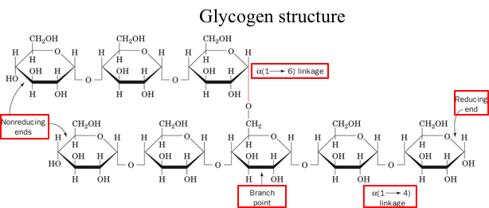

- Glycogen granule: has all the enzymes for synthesis and degradation of glycogen and glycogen molecules
- Glycogen molecule: glucose linked together

Synthesis and Degradation of Glycogen
- Synthesis and degradation are two distinct pathways
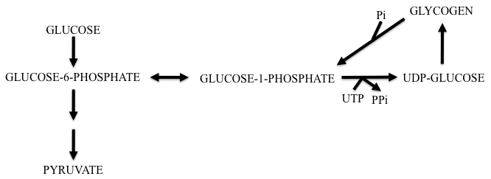

- Glucose pyruvate is the glycolytic pathway
- Glucose – 6- phosphate is converted to Glucose-1-phosphate with phosphoglucomutase
- UTP and G-1-P produces UDP-glucose
- Glycogen synthase adds UDP-glucose to glycogen granule
- Glycogen phosphorylase adds phosphate breaking glycogen into glucose units to G-1-P
- G-1-P back to G-6-P again with phosphoglucomutase
- In iiver, G-6-P can be converted back to glucose with glucose-6-phosphatase
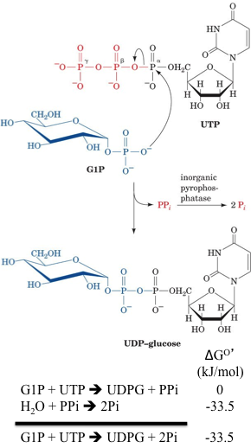
Synthesis of Glycogen requires 3 steps
  - Synthesis of UDP-glucose
  - Elongation of a pre existing glycogen chain using UDP glucose
  - Creation of new 1,6-glucosyl branch points

1) Synthesis of UDP glucose
- Done via UDP-glucose pyrophosphorylase
- This enzyme has a very negative delta G
- This consists of two steps the first one which has a ΔGº= 0 which means it runs at equilibrium and the second with a ΔGº= -33.5 which when coupled together results in a spontaneous irreversible reaction

2) Elongation of a Pre Existing Glycogen Chain
- Must have UDP glucose to add to chain
- UTP hydrolysis is energetically equivalent to ATP hydrolysis (UTP = ATP in terms of energy)
  - UDP + ATP UTP + ADP
  - Enzyme: Nucleoside diphosphate kinase
  - This reaction is used to remake UTP from UDP
  - Therefore UTP is
- Glycogen synthase is used for elongation
- UDP glucose is added to the non-reducing end at C4
- Also has a negative ΔGº= -13.4

3) Creation of New 1,6-glycosyl branch points
- Break an alpha 1-4 link and make an alpha 1-6 link
- Transfer of terminal chain segments consisting of ~7glucosyl residues to C6-OH groups of glucose residues on the same or another glycogen chain

- 2 Rules:
  - Each transferred segment must come form a chain of 11 residues
  - The new branch point must be at least 4 residues away from other branch point

- Enzyme: amyo-(1,41,6) -transglycosylase

- Initial synthesis of glycogen requires glycogenin attaches to itself a glucose residue then ~6 or 7 more which acts as a primer for glycogen synthase action
  - Autocatalytic mechanism

- Synthesis of glycogen from glucose costs 2 “ATP” per residue
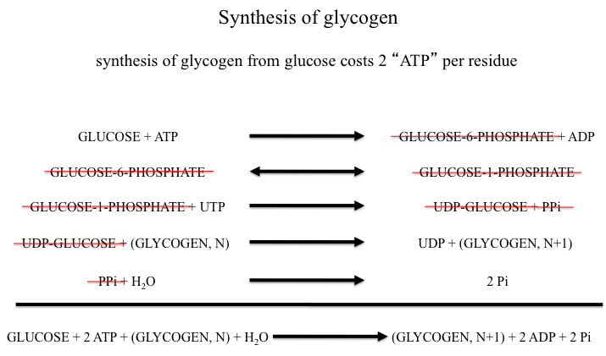

Degradation of Glycogen
- Generation of glucose-1-phosphate
- Debranching
- Conversion of glucose-1-phospahte to glucose-6-phosphate

1) Generation of Glucose-1-phosphate
- The enzyme used is glycogen phosphorylase
- The enzyme will release only glucose units at least five units form a branch point
- Generates G-1-P
- GLYCOGEN (N) + Pi GLYCOGEN (N-1) + GLUCOSE-1-PHOSPHATE

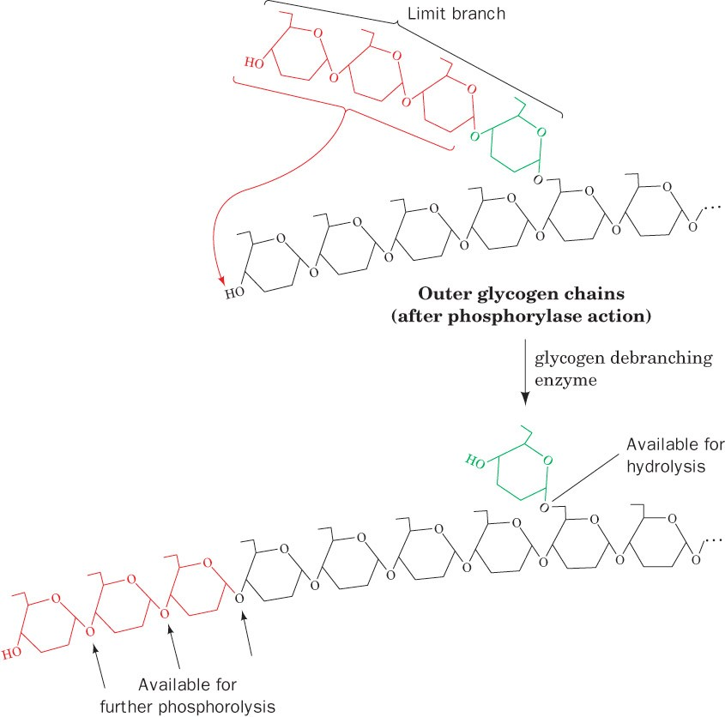
2) Debranching
α (1-4) glycosyl transferase
- Transfer an α (1-4) linked trisaccharide to the non-reducing end of another branch (new α (1-4) linkage)
- The 3 units are then available for phosphorylase reaction which only works on glycogen that are 5 units from branch point

α (1-6) glucosidase
- Remaining glycosyl residue in hydrolyzed to yield glucose and debranched glycogen
- ~92% of glycogen’s glucose is converted to G1P and ~8% converted to glucose
- 92% from 1-4 linkage molecules and 8% from 1-6 linkage branch points
- 1-4 breakage results in 16 units of energy and 1-6 breakage results in 7 units of energy
  - a 1-4 breakage has enough energy to produce a 1-6 bond, but the breakage of a 1-6 bond does not have enough energy to form a 1-4 bond
  - This is the reason why the branching glucose is left attached and the other 3 were debranched

3) Conversion of Glucose-1-phosphate to Glucose-6-phosphate
- Enzyme: phosphoglucomutase
- Muscle: G6P continues into glycolysis to generate ATP
- Liver: G6P is converted to glucose
- Phosphoglucomutase always needs a phosphate group, if it were ever to lose it, it can access a pool of G-1,6-bisphosphate
  - It places a phosphate on the glucose-6-phosphate at the C1 position and then removes the phosphate at the C6 position
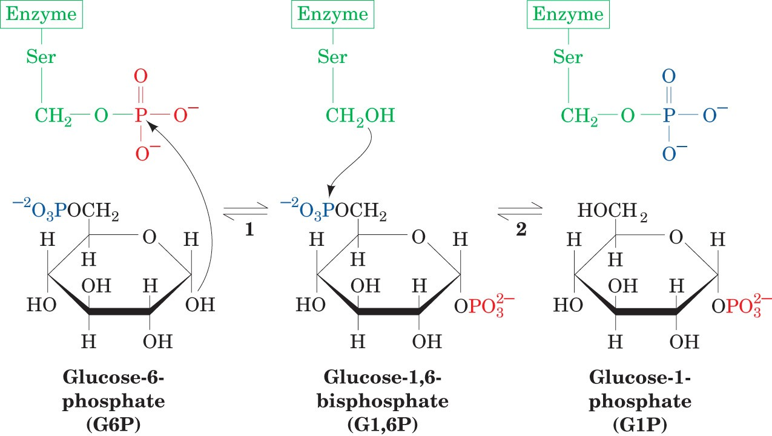
  - Phosphoglucokinase creates this G-1,6- bisphosphate from Glucose-1-phosphate + 1 phosphate

The Storage of Glycogen is an Efficient Process
- Efficiency of storage:
  - *39 – 2 = 37 ATP
  - 37 / 38 = 97%
- Glucose + 2 ATP + (Glycogen,N) + H2O (Glycogen, N+1) +2 ADP + 2Pi

- Glycogen enters glycolysis at G-6-P therefore already has a phosphate
- Glucose enters glycolysis must be phosphorylated by hexokinase/glucokinase to G-6-P
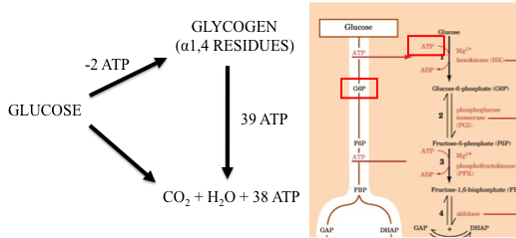
- Therefore Glycogen takes 1 less ATP than glucose for glycolysis
- If you start with glucose to make glycogen then break down glycogen into glycolysis you must subtract 2ATP it takes to form glycogen - so you must subtract 39 -2 for 37 total

