Lecture 18: Cancer
- President Nixon declared war on Canada in 1971
- In Canada, men are at higher risk for cancer than women
- In women, theres 40% chance of contracting cancer, and 27% chance of dying from it
- The top 4 cancers: breast cancer, prostate cancer, lung cancer, and colon cancer
- Rates among young people are rising
- We think cancer has something to do with genes and is genetic so how heritable is it?
- Heritability estimates from twin studies:
if twin starts smoking, theres a chance the other twin will too
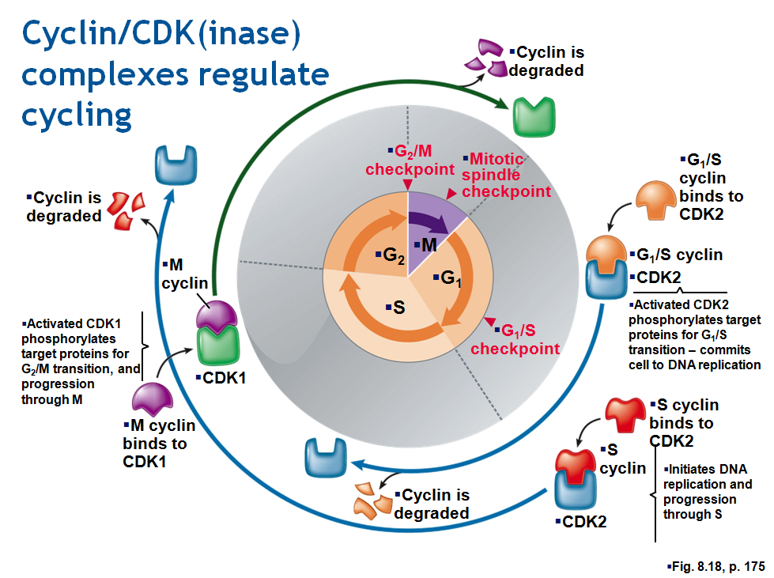
- But thing is, heritability depends on the kind of cancer, but still is on the low end
this could be because cancer rates have high environmental components as compared to other things that have a genetic heritability
- Embryology rapidly dividing cells
- There is a stage in the life cycle where cells need to divide fast

Cyclin/CDK(inase) complexes regulate cycling
- Pay attention to G1/S checkpoint which prevents cells from replicating their DNA if its damaged so they cant go through until everything’s repaired
- This checkpoint is monitored by CDK (cyclin dependent kinase) – kinases transfers phosphate groups (it phosphorolates)
- But CDK’s are only active when theyre bound to other proteins called cyclins
- Cyclins are called cyclins because theyre production cycles with the cell cycle
- This cyclin is produced early in cell cycle. It binds onto and activates CDK. CDK cyclin complex that phosphorolates a whole bunch of targets downstream and that releases the G1 checkpoint (post-translational regulation of protein function)
- The rest of the diagram is just another rest of cyclin CDKs to get through the next checkpoint and so on

EGFR (proto-onco genes)
- Cells need to be responsive to environment and need to know when they should divide
EGFR (epidermal growth factor receptor does this). So when there is EGF in environment, it binds onto this receptor, and then theres an internal signalling domain in this protein
EGFR is a normal protein and is essential for normal embryonic development
if EGFR becomes deregulated it can give rise to rapid cell growth
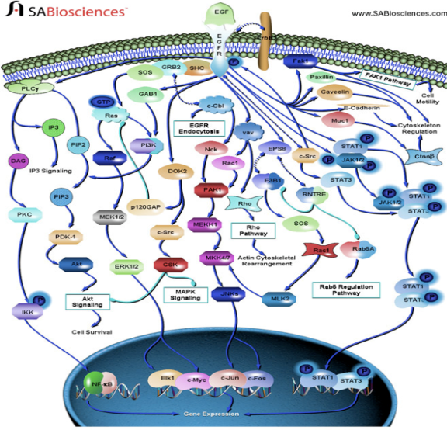
oncogenes (cancer genes) are just embryonic genes that have been deregulated

EGF Pathways
- This picture shows EGFR at the top and the signaling is on the inside
- The inside is just a bunch of signals that takes the signals from the surface of the cell (where EGFR is present) to the nucleus

Expression of tumour supressor genes slows cell cycling (p 53)
- “TP53” is a master tumour supressor gene, coding a transcription factor whose activity can result in
- Genes evolved to shut down that rapid cell growth during embryonic development
- At some point, organisms get large enough and they need to stop this rapid cell division so those genes evolved to be supressors
- P53 is this transcription factor that can be activated by dna damage, invoke repair and block CDK’s at the first checkpoint (its in charge if that first G1 checkpoint)
- Oncogenes are mutated forms of certain normal genes of the cell called proto-oncogenes. Proto-oncogenes are often genes that normally control what kind of cell it is and how often it grows and divides. When a proto-oncogene mutates (changes) into an oncogene, it turns on or activates when it is not supposed to be. When this occurs, the cell can grow out of control, leading to cancer.
- Tumor suppressor genes are normal genes that slow down cell division, repair DNA mistakes, or tell cells when to die (a process known as apoptosis or programmed cell death). When tumor suppressor genes don’t work properly, cells can grow out of control, which can lead to cancer.

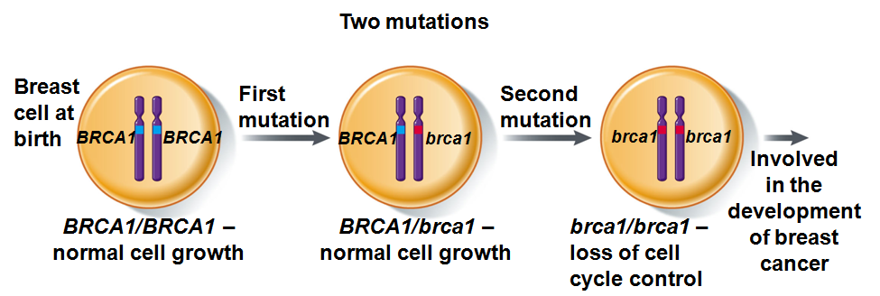
Sporadic Cancer
- Sometimes related people are more at risk for cancer
- BRCA1 is a breast cancer tumour suppressor gene whose normal function is to stop rapid cell division, but over life one may have suffered mutations on both those alleles and lost the tumour suppressor activity of BRCA1 and so the cells divide rapidly this is sporadic
- Sporadic cancer requires new loss function mutations in both alleles
- However, familial cancer requires a loss of function mutations in 1 allele
- If you inherit from your dad an already defective tumour suppressor allele than all you have is the functional one from your mom, then your at much higher risk of becoming homozygous in a certain cell because now all you need is 1 mutation instead of 2 in order to develop a tumour
- Even if you were born with healthy genes, some of them can become changed (mutated) over the course of your life. These mutations are known as sporadic or somatic, meaning they are not inherited. Sporadic mutations cause most cases of cancer. These mutations may be caused by things that we are exposed to in our environment, including cigarette smoke, radiation, hormones, and diet (although in many cases there is no obvious cause). More gene mutations build up as we get older, leading to a higher risk of cancer.

MicroRNA expression profiles classify human cancers
- Inappropriate expression of miRNA can promote cycling (ex. Oncomirs)
miRNA have turned out to be very integral in cell division/regulation researchers call them oncomeres but theyre just part of regulation
- The miRNAs are diagnostic
- miRNA overexpresed where its red (normal cell), and under expressed where its blue (in tumors)
- Each tumor has its own kind of fingerprint of miRNA expression
- It seems miRNAs are very important

Cancer is Deregulation
- Uncontrolled growth can arise from upsetting the balance between the activity of gene products that promote cell cycling vs. those products that supress cell cycling

Cancer is Progressive
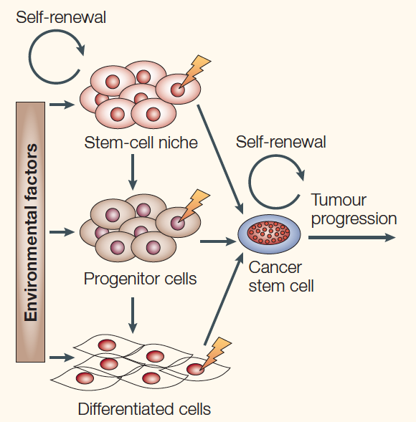
- Most cancers require several changes to occur before you get a tumour
- Accumulated deregulation gives rise to a tumour
- Cancer is progressive, we knew this, but we didn’t why and about these genes
- Probably all your tissues have stem cells that are plurypotent – these stem cells are able to differentiate into a wide range of tissue types
- Stem cells when they divide to make 2 daughter cells, one of them remains a stem cell and the other becomes a progenitor cell which goes on to differentiate into something
- Stem cells and progenitor cells and differentiated cells can all suffer mutation and become cancer stem cells
- It seems that tumours may be driven by cancer stem cells and if you don’t get the stem cells you don’t get the tumours
- Turns out cells are not the same in tumours

Some tumour cell nuclei can be re-programmed
- Above is mouse embryos cloned from brain tumours
- This is a mouse family at high risk for brain cancer because they're inheriting a defective tumor suppressor and over their lifetime they suffer another mutation that can give rise to a tumour
- On the left we have a brain tumour cell dividing out of control because of a loss of the tumour supressor gene
- And then we have this egg cell (mouse egg cell). We take the nucleus out of the egg cell and replace nucleus with the nucleus from the tumour cell and give it a shock so the egg thinks its going to fertilize and starts dividing under control of the tumour nucleus. That tumour makes a mouse, not a tumour
- That’s because the tumour gets reprogrammed and makes all the normal tissues of a mouse
- So maybe cancer is epigenetic
- Maybe this egg cell is epigenetically programming the nucleus

Human Pappiloma Virus
- DNA virus
- Many different strains cause increased growth (warts) in diff tissues in both men/women
- Some strains are oncogenic; particularly strong association of strains 16/18 with cervical cancer

Lecture 19: Molecular Homology
- Molecular and gene evolution
- The changes to genes which lead to evolutionary change can be summed up by: mutations, duplication, rearrangement, loss these can lead to changes in phenotype (but there could be some mutations that dont have an effect on phenotype at all)
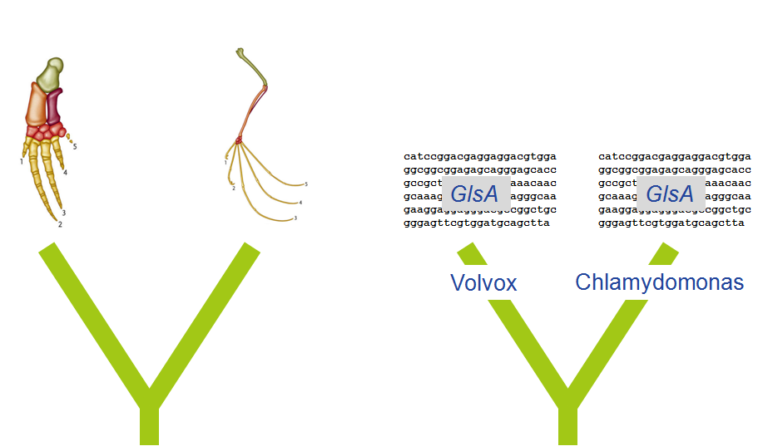
- The phenotype in turn is subject to selection
evolution selection acts on phenotype (not genotype)

Homology
- Homology means common ancestry
- Homology does not mean similar
- For instance, a dolphin flipper and bat wing as shown are homologous
- But how do we know that things are homologous and share a common ancestor??
- its the same gene in volvox as it is in chlamy (but actually the gene involved in asymmetrical division in volvox is homologous to the one in chlamy)
Clicker Question: If GlsA in volvox and GlsA in chlamy are homologous, what do they have in common??
- identical nucleotide sequence
- Identical amino acid sequence
- Identical length of polypeptide
- Same function
None of the above is the right answer (find out later in lecture why)

Comparative genomics
- We want to do comparative genomics and its useful because both chlamy and volvox are totally sequenced so we can compare the genomes and this is the pathway we could take
- Sequence Genomes Genome Annotation Protein Prediction Align Sequences Determine Homology
- Sequencing information is cheap and doesn't take any effort. You simply sequence the DNA
- But to ascribe biological function to that sequence is called “genome annotation” – we want to attach a biological meaning to the sequence
- Attach biological meaning:
- Gene prediction
- Regulatory elements
- Biological function through similarity searches
- Most of this is automated

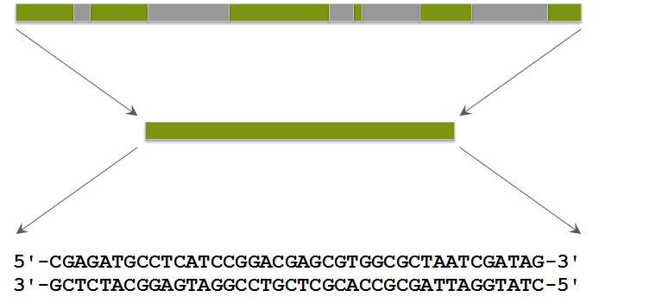
Protein-coding gene prediction
- We want to know protein coding genes
- So GlsA codes a protein so we want to, within the chlamy and volvox genome, look for the GlsA similar sequence (theres a computer algorithm you just plug in which can go through and detect regions or motifs common to genes, especially PCG, like promoter elements and intron/exon boundaries)
- So its easy now for computer algorithms to go through the genome sand predict the number of protein coding sequences
- Green – exon, grey – intron
So the computer just splices out the exons and then you have a deduced protein coding sequence and this is the predicted protein coding sequence (but you don't know the orientation, all you know is that there's a protein coding gene in there somewhere)
as mentioned, theres 6 possible reading frames
so which of those 6 is the most probably the actual open reading frame that encodes the protein??

Protein prediction – find longest ORF
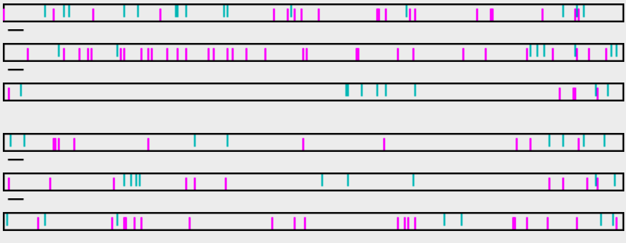
- To figure that question above out, all you do is translate all 6 protein coding sequences, which is what the computer does
- So you have a sequence of GlsA from chlamy
- If theres a green bar going down its start, purple going up is stop
- So you see frame 1, you have lots of starts and stops so all these frames dont really make sense
- So youre really looking for the longest open reading frame (whats the longest, that is the largest number of amino acids from the start to the stop)
- In this case its frame +3
- The green is longest open reading frame from start to stop and the computer just does this
- And based on this genome annotation (protein coding search algorithm, +3 gives longest reading frame which doesnt have many starts/stops so its the longest because the other start/stop more often)

National Center for Biotechnology Information (NCBI)
- NCBI
  - Genbank
  - Sequence database
  - 23,500 total genomes
- So that's how we get 15000 PREDICTED proteins
- We dont sequence proteins anymore cause its expensive so its so much easier to just predict genome annotations
- So what do we do with the 150,000 predicted proteins??
we look for similar sequences in a database and the database is at the NCBI
many sequences have been deposited here from different organisms (you're looking for sequences that are SIMILAR)
at NCBI, you do sequence alignments, 1 of those 15 000 will be similar to GlsA from Volvox so you search the database for sequences similar to chlamy
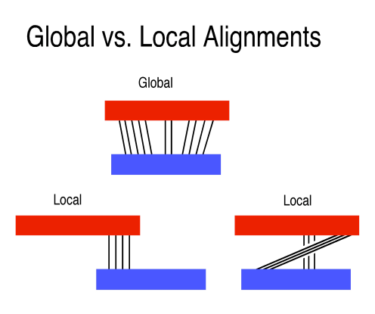
sequence similarity suggests evolutionary relatedness, structural/functional similarity, etc

Sequence alignment (DNA or protein)
- Arrange sequences to show regions of similarity
- From sequence similarity one can infer…
- BLAST – Basic local alignment search tool
  - local
- CLUSTAL
  - Global
- Theres 2 ways we can check for this similarity (2 algorithms)
- Lets say the picture above is the volvox gene and the other is the gene from chlamy
- Things like CLUSTAL look for global similarity, they start at the beginning of the gene (PCG) and try to align all the similar bases. If they dont align perfectly, a gap is introduced and work through
- BLAST doesn't do that (its more common tool). It looks for regions of high similarity, it doesn't force 2 sequences to align perfectly, only looks for smaller sequences of high similarity because its much faster this way
- What would it mean if the global alignment is weak but there are areas between 2 sequences that show high similarity??

155 BLAST hits against Chlamy gene (GlsA)
- 1 chlamy genes comes back similar to GlsA and the output form BLAST is shown above
- Theres 155 BLAST hits which means theres 155 sequences that are similar at NCBI to GlsA
- One of the red ones (very high similarity) is the volvox gene but there are many other genes which are weakly similar to the chlamy gene from a variety of species

Volvox vs Chlamy: Nucleotide alignment
- Part of the alignment between his protein form chlamy and GlsA from volvox is shown above and the subject you get back is the volxo asymmetric division gene
that gene is much more well characterized than the chlamy gene because the function of this gene is not well know in chlamy

Volvox vs Chlamy: Amino acid alignment
- First take home message is if they're homologous its not because they have the same nucleotide sequence, there's lots of differences
- Its similar but not identical
- They don't have the same protein sequence either
- So we have the dna sequence and we can compare that sequence to a database at NCBI or you can translate that and take the +3 reading frame and search a protein database with the translated sequence (if you do this, there's very high similarity, but they're not identical and the proteins are not the same length or do not have the same function)

Amino acid sequence comparisons are more informative than nucleotide
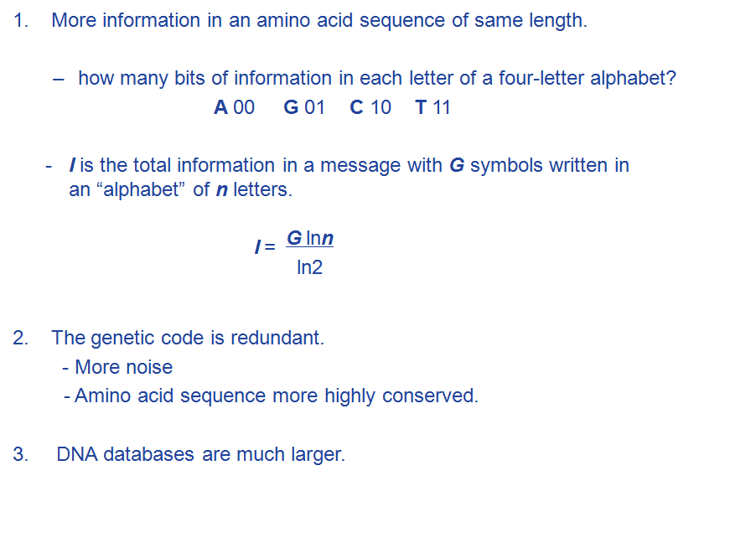
- Alot of genome annotation is information (its like words in a book, and the book/words make sense because we put the words in a certain order that we can understand and the alphabet is a certain length) – this is what call information theory
- Amino acid sequence is more powerful than nucleotide sequence of same length, you can get more info from it
given a string of 20 nucleotides or 20 amino acids, the amino acids have much more information
- A single piece of information is called a bit
- Nucleotides is a 4 letter alphabet (a, g, c, t), and if your going to convert that into bits of information than every base conveys 2 bits of information
- How many bits of information are there in a single amino acid??
- Another reason amino acids are more powerful is because theres more information
- The genetic code is redundant (redundant means you have 64 possible triplets but your only making 20 possible amino acids. So more than 1 codon can code for the same amino acid. That redundancy in the code)
it means there's noise in the amino acid sequence (lots of stuff that doesn't really matter when it comes to protein sequence)
- Amino acid sequence is more highly conserved. Why??
- DNA databases are much larger (which is a bad thing) because dna databases can have lots of junk in them (lots of repetitive junk dna) which makes it hard to search

Amino acid sequence vs nucleotide
- This is the nucleotide sequence that codes for the protein sequence
- Theres 10 nucleotide differences here because theres lots of mutations that cause these differences between chlamy and volvox (10 mismatches)
- But when you translate either one, the sequence still codes for the exact same section of the protein)

Homology determination is based on probability
- A conclusion that two or more genes are homologous is a conjecture
  - Decisions about homology are made based on similarity – numerical and correlated with probability
  - The higher the similarity between two sequences the lower the probability that they originated independently of each other and became similar just by chance.
- The E-value
  - The E-value describes the random background noise that exists for matches between sequences. For example, an E-value of 1 assigned to a hit can be interpreted as meaning that in a database of the current size, one might expect to see one match with a similar score simply by chance.
  - The lower the E-value, or the closer it is to “0”, the higher is the “significance” of the match.

- You can never say that 2 sequences are homologous with certainty (its just a conjecture, a proposition thats not proven)
- Its not based on any experimental fact
- We dont know because we dont know the common ancestor, we dont have the common ancestors sequence (of the GlsA sequence) – of we did then we could do an experiment and figure it out
- When you align 2 sequences and look at their similarity, highly similar sequences are probably homologous
- E-value : the lower the e value the greater likelihood of real homology

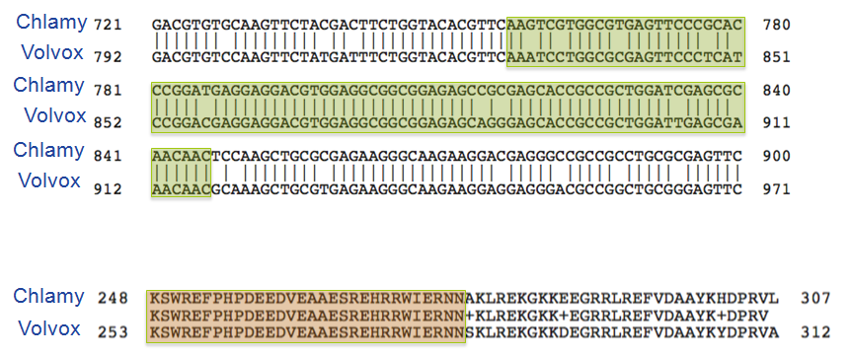
Lecture 20: Molecular Convergence
- This image shows some nucleotide sequences are highly conserved (same bases found in both), sometimes it isnt
- Synonymous mutations – if you have change in your nucleotide sequence but it doesnt change amino acid
- There are non-synonymous mutations that change the amino acid
- Although theres a lot of variation in nucleotide sequence, lots of mutations because its been a long time since volvox and chlamy shared a common ancetsor and over time the sequences have diverged, so these mutations they dont have any effect on the protein (its as if theyre neutral) but if selection acts on the phenotype then it should affect amino acids
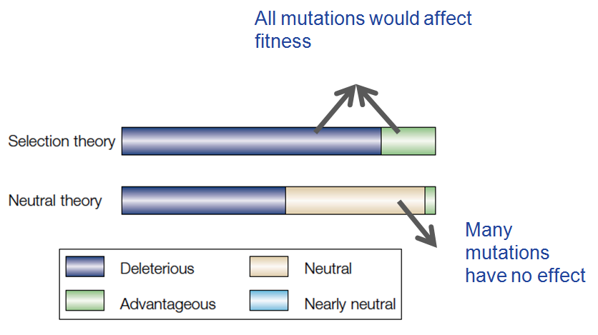
Neutral theory of molecular evolution
- The theory used to be selection theory
- Mutations will either be deleterious or advantageous, most are harmful (deleterious) and will be selected out of the population
- The neutral Thoery came in and said we see lots of mutations exist that really don’t affect the protein at all and so a fair number of the mutations are called neutral (no effect positive or negative, they just exist) and very few would be advantageous
- The number of differences between protein sequences of different species are proportional to the time since those species diverged
if they diverged a long time ago, you'd expect more differences than species which diverged recently

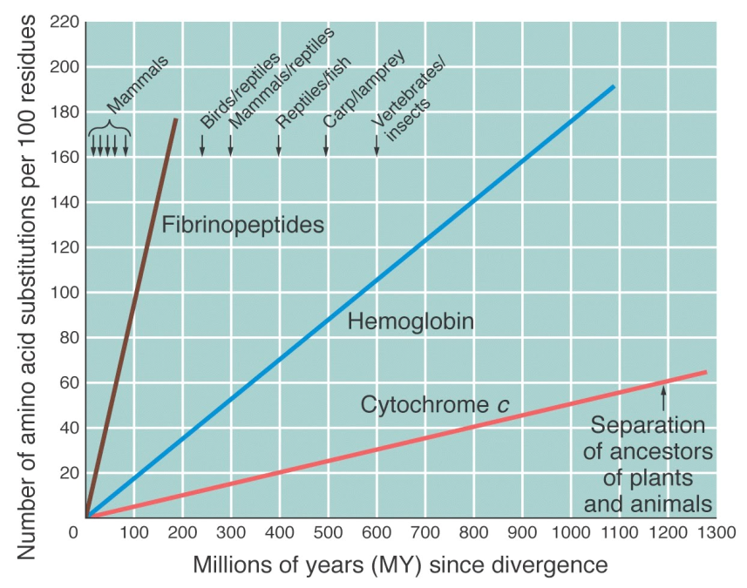
Neutrality and the idea of a molecular clock
- This is for 3 proteins (involved in blood clotting)
- Way back there was separation of plants and animals
- Theres more plant and animal cytochrome c than there are in organisms which diverged much more recently
- So theres fewer amino acid differences if the organisms diverged more recently
- But this graph suggests something very regular because the lines are all straight (change as a function of time is a rate) – the change isnt occuring at the same rate (rates are diff) but between all of them seems to be a constant rate
- Part of this neutral theory is that mutations ocurr at a constant rate because theyre neutral
- Mutations occur at a constant rate because theyre pretty neutral and have this straight line
- Important slide
- Substitution – swapping 1 amino acid for a different one
- Lets say you had 2 unknown organisms and sequenced fibrinopeptide and found you had about 110 amino acid substituions, it tells how long ago approx. The organisms diverged (you can calculate the rate since divergence)
- People have done this for the human-cimpanzee split (diverged about 5 mill. Years)
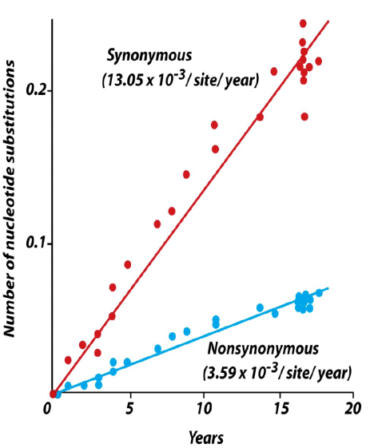

Synonymous vs nonsynonymous rate
- Synonymous mutation rate is higher than non synonymous silent substitutions and replacement substitutions
- A synonymous mutation is when there is a change in the genetic sequence of DNA, but the change results in the same genetic output. Nonsynonymous, obviously, changes the output enitrely, creating an authentic, observable mutation.
- This graph is looking at nucleotides as a function of years
- The slopes of these are diff. So the rats are diff
- Mutations that don't affect amino acid sequence occur faster than non-synonymous mutations
- The red doesnt change the amino acid sequence, the blue will

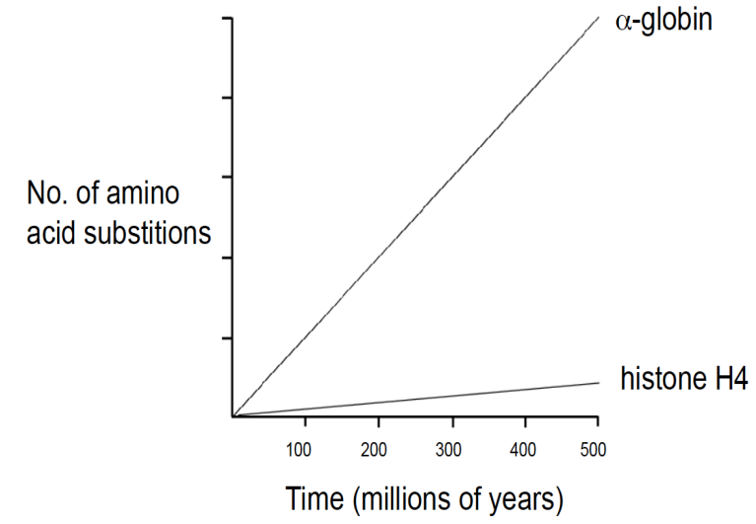
Degree of constraint dictates rate of evolution
- Alpha globin here is a protein required for hemoglobin the heme molecule binds to this and carried the molecule
- The rate of mutation of histone H4 is very slow , alpha globin can seem to change very fast
- Why would the mutation rate of these 2 proteins be so different?
maybe because ones more important
because histone smore sensitive to changes (some proteins if you change them, youll blow it up so you cant change the protein without changing the function. So histone H4 is constrained)
other proteins, you can change them a lot (ex. Fibronpeptides can mutate alot)
- Histone 14 is unchanged
- Some proteins are highly constrained, others are weakly constrained

Molecular convergence
- Phenotype can be similar because of homology or convergence
- This homology isnt just regard to wings and beaks, but also in terms of genes/proteins on the molecular level
- why is it not possible to have sequences that converge to be similar?

Functional convergence
- Takehome: there is no reason for 2 proteins to share high identity across their entire sequences...is there?
- So if you look at GlsA from volvox and chlamy its pretty similar across the sequence at the nucleotide level but you wouldnt expect that if the 2 proteins were distantly related and yet converged onto the same structure/functional phenotype
you would expect localized areas of similarity
because the functionality of a protein isnt represented by an entire sequence but by localized regions
- Ex, location of cysteins (disulfide S-S bonding) are important because they giver rise to sulfur bonding
- Amino acids necessary for catalysis
- Dna binding domains, receptor binding sites
- Proteins definitely converge, mutations and other processes cause nucleotide sequences to change but it doesnt have to be over the entire sequence
- If you see sequences similar across their entire length, theyre going to be homologous

Lysozyme: a case study of convergent evolution
- Small (130 aa) enzyme, antibacterial activity.
- Attacks peptidoglycan
- Found in blood, tears, mucus, egg white.
- Enzyme has been recruited as a stomach enzyme in ruminants (e.g. cows).
- Whats a ruminant?
- necessary to exploit cellulose
Enzyme must acquire new properites
- Lysozymes is a small enzyme =, antibacterial,
- Lysosomes function as the digestive system of the cell, serving both to degrade material taken up from outside the cell and to digest obsolete components of the cell itself.
- So in evolution, we want to protect ourselves from infection and so lysozoymes attack peptidoglycan wall (penicillin orevents formation of peptidoglycan)
- Theres antibacterial blood activity in blood, tears, etc
- BUT there was a gene duplication a while ago so now this other form of lysozoyme has evolved to have this very different function (its been recruited as a stomach enzyme in ruminants)
- Ruminant is an important evolutionary change
- Animals can eat cellulose (we cant break that grass down), but ruminants can break it down
- So cows can eat the grass and eat the cellulose. Theres bacteria in that mixture and the bacteria break that cellulose
- So cows eat the grass and bring in all this bacteria and the bacteria breaks down the cellulose into simple sugars (this is good)
- But now the cow wants to digest the bacteria. Its broken down the cellulose, it uses lysozyme in stomach to break down bacteria, because theres lots of nutrients in bacteria it doesnt want to lose that. So it has this stomach lysozyme that breaks down the bacteria
- BACTERIA BREAKS DOWN CELLULOSE LYSOZYME BREAKS DOWN THE BACTERIA
- So you have this stomach enzyme, you acquire new properties and these properties include:
its got to be catalytic at very low ph because its in stomach of cow
theres also pepsin (a protease) in stomach so lysozyme has t protect itself from the pepsin

Picture of a cow and a monkey
- Both the monkey and cow have evolved this form of lysozyme which enables them to eat cellulose then digest the bacteria but the animals are not related at all
they have acquired this ability independently
- According to phylogenetic tree, the cow and monkey arent closely related to each other

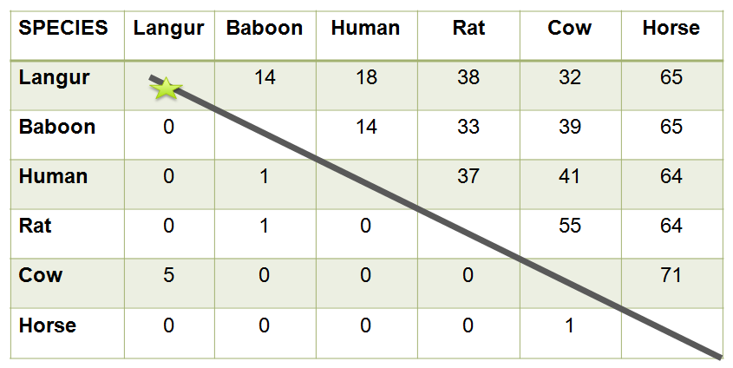
Lysosyme in different species
- Above is the comaprison of lysozyme amino acid sequences of diff species
- So weve lined them all up. The langur monkey has the digestive enzyme (lysozyme)
- So above line is the number of differences
- Humans and baboons are very closely related and baboons and langur monekys are also related (but theres 14 differences between langur and babboon but 18 differences between langur and humans)
- The lysozoyme amino acid sequence between langur and babboon is more divergent than you would predict based on the overall phylogeny
- The sequences are more divergent than you would predict
- Below the line is how many amino acids they uniquely share
cow and langur monkey arent related at all but they share 5 amino acids in common
the lysozymes dont share a common ancestor they diverged many years ago

Convergence to same amino acids
- The bird has the enzyme too
- So independent evolution occurred of this lyzosyme in bords, cows and langur monkeys through convergent evolution
- 3 unrelated organisms: there is a problem they need to come up with a lysozyme that can function at low pH and is resistant to pepsin but there was independent evolution of this digestive lysozyme function
- What natural selection has done is its kind of ended up that they all look similar (the enzyme)
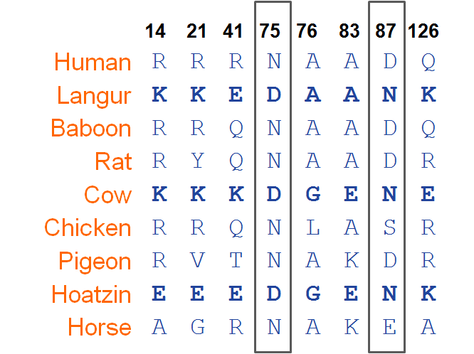
Amino acid substitutions at specific sites
The bold are the digestive enzymes and you can see at position 75 they have aspartic acid and a spare gene at position 87
You can see at the 2 position show the different organisms share the same amino acid

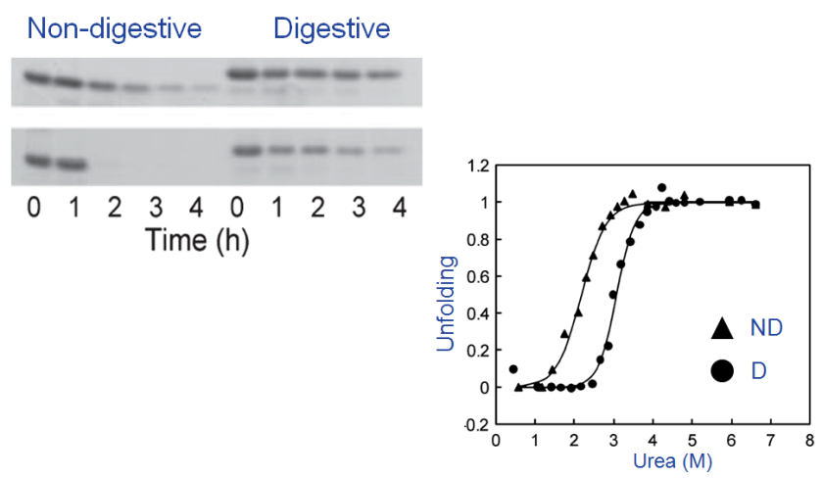
Biochemical consequences
- What does the changes in amino acids affect protein
- But its clear lysozyme is more resistant to pepsin
- Above is different concentrations of pepsin
- So you take the cow and human enzyme, incubate them with diff concentrations of pepsin and see how long it takes the lylsozyme to disappear
you can see digestive lysozyme is more resistant to pepsin than non-digetsive

Consequences....
- Digestive enzyme
- Greater structural stability (more rigid) prevents pepsin access
- Lack of aspartic acid – Proline bond (acid labile)
- Negative charged surface repels pepsin

Lecture 21: Experimental Evolution
- Model systems for Experimental Evoltuion
  - Viruses
  - Bacteria
  - Chlamydomonas
  - Drosophila
  - Yeast
- Testing hypothesis about evolution using controlled experiments
- What do the model systems above have in common??
- They dont all contain mitochondria/chloroplast
- They reproduce very quickly
The model systems all have very fast life cycles (short generation time) – enables you took look at evolution
- Long generation times arent helpful
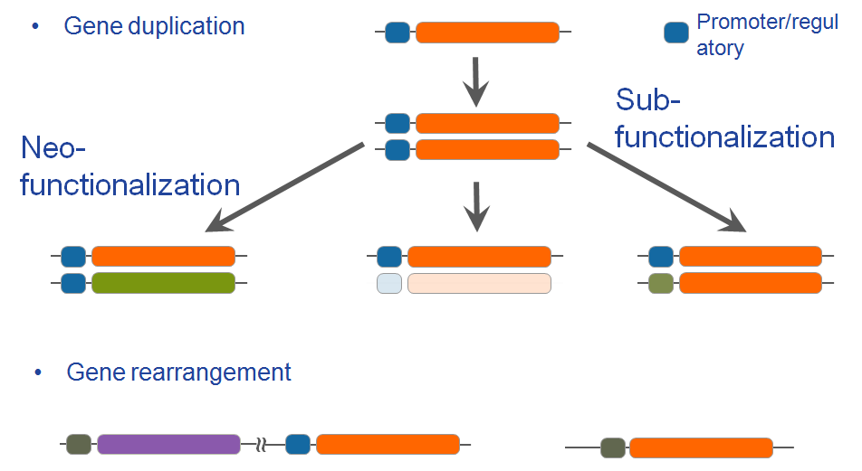
- So if you have system which divides quickly, then you can look at evolution in real time over the course of years and look at things like selection and changes in genome over time

Origins of Genetic Novelty
- Where does genetic novelty come from?
- Spontaneous random mutation to DNA (can be bad/neutral) – so you have a gene that now you have a mutation and theres a selective advantage if youre and organism that has that change. This can give rise to genetic novelty (its pretty rare)
- Gene duplication (amplification) – duplicating genome results in duplication of genes
- Most of the time 1 of the 2 copies that have duplicated gets lost (or deleted from genome) and youre back to having single copy (not much effect)
- But SOMETIMES, the copy gets retained – so now you have 2 genes doing the same thing, but only 1 copy is essential. When you have 2 copies, the selective pressure on that second copy is now reduced. If mutations occur theyre not lethal to the organism in which they reside because the original copy still exists (so theres freedom for the second copy to mutate/change) – this can lead to new function giving rise to neofunctionalization
- If you have a second copy of the same gene then the selective pressure on that copy is lower than on the original gene (one has to stay the same, but on the other one, selection can change it to give it a different function – neofunctionalization) – can also change promoter here
- Sub-functionalization – changing the regulatory element on the same gene (i.e promoter) – gene can be expressed in different conditions. This gives rise to genetic novelty
- Genome rearrangements – genome rearrange themselves (regulatory elements like promoters can change positions)

Long Term Evolution Experiment
- Can evolution produce adaptation if it depends on random mutations (most of which are harmful)?
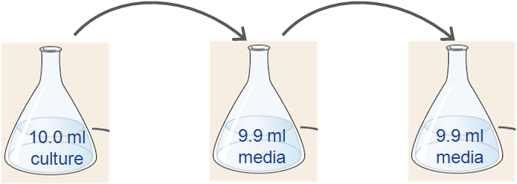
- Lenski group MSU
- E. coli
- Asexual (no recombination)
- Spontaneous mutation
- Population size is huge
- Generation time of e.coli is very short
- Hes taking a single cell of e.coli (no genetic recombination ) – population size is huge
- Any mutations occuring will be spontaneous as well as the rearrangements/duplications (no other things going on when you have 2 strains of opposite sex)
- Starts with 12 identical populations (large, which means new alleles can come about)
- He has 1 cell, lets it grow in a flask and starts 12 identical populations (from a single cell) that are isogenic (no variation, genetically identical)
- Let the populations evolve for thousands of generations. Over time he sees the evolution of these 12 independent populations
- Theres glucose in the medium in which theyre growing. Every day they have 10 ml of ecoli culture growing fast, and take 0.1 ml of this culture and transfer this to fresh media (do this for all 12 populations every day)
- In 10 ml you have 5 x10^8 cells so every day youre transferring about 5 million cells to fresh media
- Every 500 generations, starting with the first flask, you take 1 ml of the culture and freeze those cells and you can take that frozen sample whenever you want and thaw it to do comparative studied
- If the population evolves how do you know it evolves??
go to the freezer and thaw the ancestral strain and compare the 2 different strain(evolved vs. Ancestral)

50,000 generations of E.coli
- 6.6 generations/day =Generation time of 3.63 hours.
- Given human generation time around 20 years, how many years is 50,000 generations?
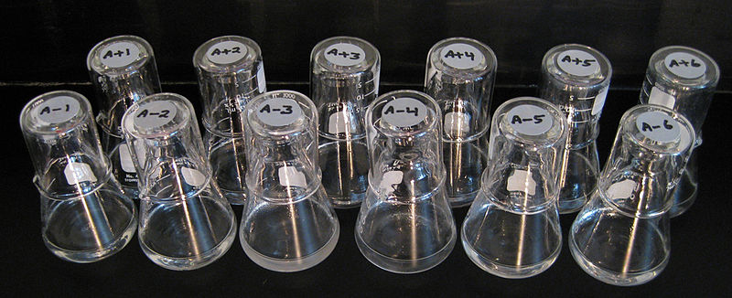
- 22 years of evolution
Evolution of citrate utilization
- After more than 30,000 generations
  - one of the 12 populations (Ara-3) changed...
  - After 30,000 generations, 1 population changed (ara-3) – its become more turbid - more cells per ml of culture rare
  - You see it because optical density, turbidity is different
  - This ara-3 line has acquired the ability to use citrate as a carbon source (cit+) (not unlike glucose)
  - Number of mutations over 30,000 generations??
  - billions of mutations (population sizes, mutation rate)
  - genome is only 4.6 million base pairs (so every mutations has arguably been tried)

Citrate = Ecological opportunity
- Medium contains citrate
  - Fe-citrate
- Inability to grown on citrate under oxic conditions
- 25 ug/ml glucose became depleted after about 8 hours remainder of the time in stationary phase.
- Theres citrate in that growth medium but its not used as a carbon source because ecoli shouldn't use it to grow
- The citrate is used to keep iron in suspension – there to hold iron in solution so the cells can take it up – the cells don't take up citrate (cells dont have the ability to bring citrate in under normal oxygen (oxic) conditions)
- The cells grow by respiring glucose, but theres not a lot of glucose so theres not a lot of cell growth
- And under oxic conditions, the gene coding for citrate transport is off
- Theyre growing on glucose – thats what the cells are using to grow/divide and theres just enough of it – when they run out of glucose (carbon source) after about 8 hours, the cells stop growing
- So if you can acquire the ability to take up citrate under normal oxygen conditions....There's an ecological opportunity here to sue citrate (to acquire it as a carbon source)
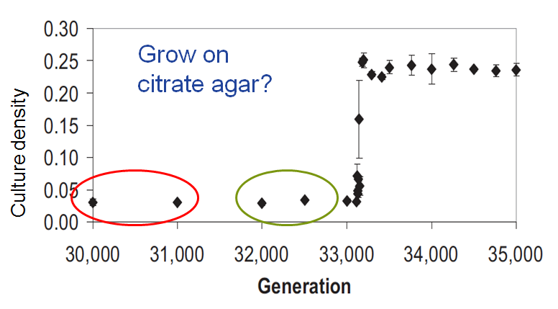
Rare mutation or contingency?
Was the Cit⁺ phenotype the result of a unusually rare mutation or contingent upon prior mutations?
- What contingent means is that maybe at 10,000 generations the mutation occured – it didnt lead to a cit+ phenotype but this mutations was required so that at 30,000 generations, it acquired another mutation that in addition to the mutation that occured at 10,000 the cit+ phenotype was realized – so the cit+ phenotype is contingent/dependent upon things that happened before
- So the cit+ phenotype is a more dense culture
- But were interested in thawing out and looking at cells at around 30000 generations
- Do they show any slight cit+ phenotype at around 30,000 generations? Can they grow on citrate agar?
- You plate an allocwate on agar that contaisn citrate....now do you see any hint that these cells can use citrate?
- At 30 and 31,000 NO but at 32 and 33 000 YES THIS IS CALLED ACTUALIZATION and its only after this that leads to another mutation leading in crazy growth on citrate

Replaying evolution in Ara-3 line
- Take cells from different generations and grow for 3,770 generations more and if its a rare mutation, some of them should acquire this citrate + phenotype
- Can you replay evolution and get cit+ cells again?
- When they replay the experiment, the cit+ phenotype appears after 20,000 (nothing happens before this) generations
- This suggests its not a single rare mutation, but that you need many generations (if it was random youd expect it to happen when you thaw the ancestor)

Potentiation, actualization, refinement
- The model is that at sometime in the past (before 20000) there was an unknown mutation, but the actualization and refinement of the cit+ phenotype was dependent upon this potentiation mutation
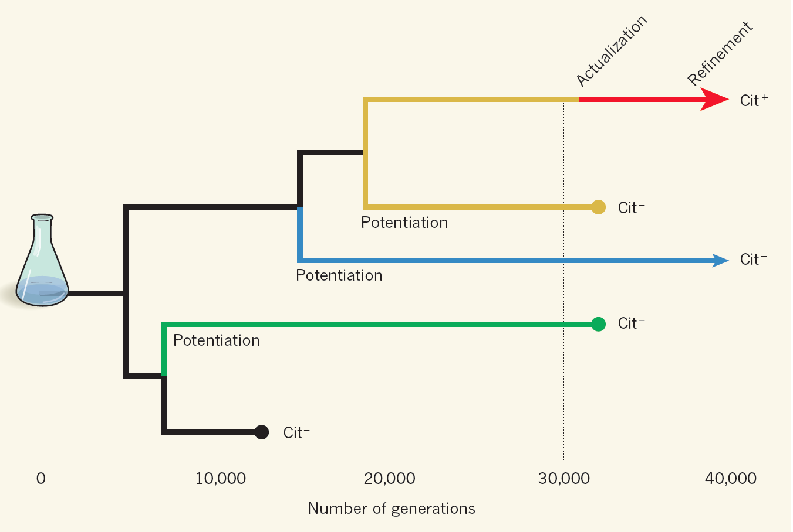
- This mutation that occured way back allowed for the potential to develop the cit+ phenotype
- And what you find at around 31,000 generations is that you can see their slightly cit+, this is the actualization, then full blown they can use citrate
- The model that the data fit is that there mustve been a potentiation mutation - some other unknown mutation occurs early on and then you can actually (actualization) get this very faint cit+ phenotype, and after that you have refinement
- The ability to use citrate in the presence of oxygen (a trait called the cit+ phenotype). When researchers replayed evolution of this cit+ trait they found that the cit+ phenotype appeared again only in populations derived from most recent cit – lineages
- This result suggested that genetic changes occurred in these lineages that made it possible for cit+ phenotype to evolve
- The step that made the cells weakly Cit+, the ‘actualization’ step — was easier to identify. The authors examined a genomic region that carries the gene citT, which encodes a protein (citrate transporter) needed for citrate to enter the cell. In the original bacterial strain, citT is located downstream of citG (another gene required for citrate utilization) and rnk, a functionally unrelated gene that participates in energy metabolism. In each of the derived Cit+ cells, Blount et al. found a distinctive genomic rearrangement that fused rnk to citG. As a result, expression of citG and citT came under the control of the promoter (regulatory sequence) of rnk, which allowed their expression in the presence of oxygen.

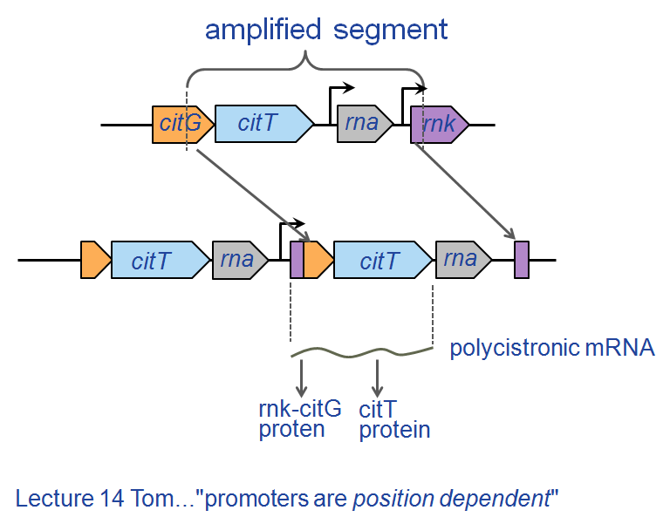
Actualization of Cit⁺
- Heres the genomic region that leads to actualization and then refinement...it all has to do with the expression of the citrate transporter
- citT is usually not expressed when theres oxygen around. Thats why cit- cells cant grow on citrate
- citT gene is the transporter and the expression of it id driven under conditions when theres no oxygen
- What happened in actualization step is gene duplication...this section got amplified (between dashed line) and there was a rearrangement (it got stuck back in another copy slightly more downstream)
they know this because they sequenced the genome
- Whats happened is this citT is now downstream of this promoter (the promoter that drives rnk)- purple
- citT id now driven by promoter of rnk and rnk shows strong expression when theres lots of oxygen around (constitutive all the time)
- Now citT is expressed when theres oxygen around and is under the control of a different promoter
- This is what they think explains the cit+ actualization – that you have genome rearrangement
- When the polysystronic mrna is processed, the citT protein gets synthesized
- purple, orange, blue

Refinement of Cit⁺
- Refinement comes from increasing the number of rnk-citT modules
- Increased cit transport
- The graph shows if you increase copy number of this module (red cit minus to black), you get better growth during that 24 hours after sub-culture and an increase in culture density
- Now you have a huge capacity to transport citrate under normal oxygen conditions – because of duplication
- These arent the ara 3 mutations, these are diff, but you still get the cit+ phenotype, so where else do you get the cit+ phenotype??
Theyre all around the region in the next slide

Mutations in replay experiments are similar but unique
Red box – boundary of amplification of original Cit⁺ line
Blue boxes boundary of amplifcation of 14 replay expts
- Red line is what was amplified in the original ara-3
- Different lengths, but all give rise to cit+ phenotype
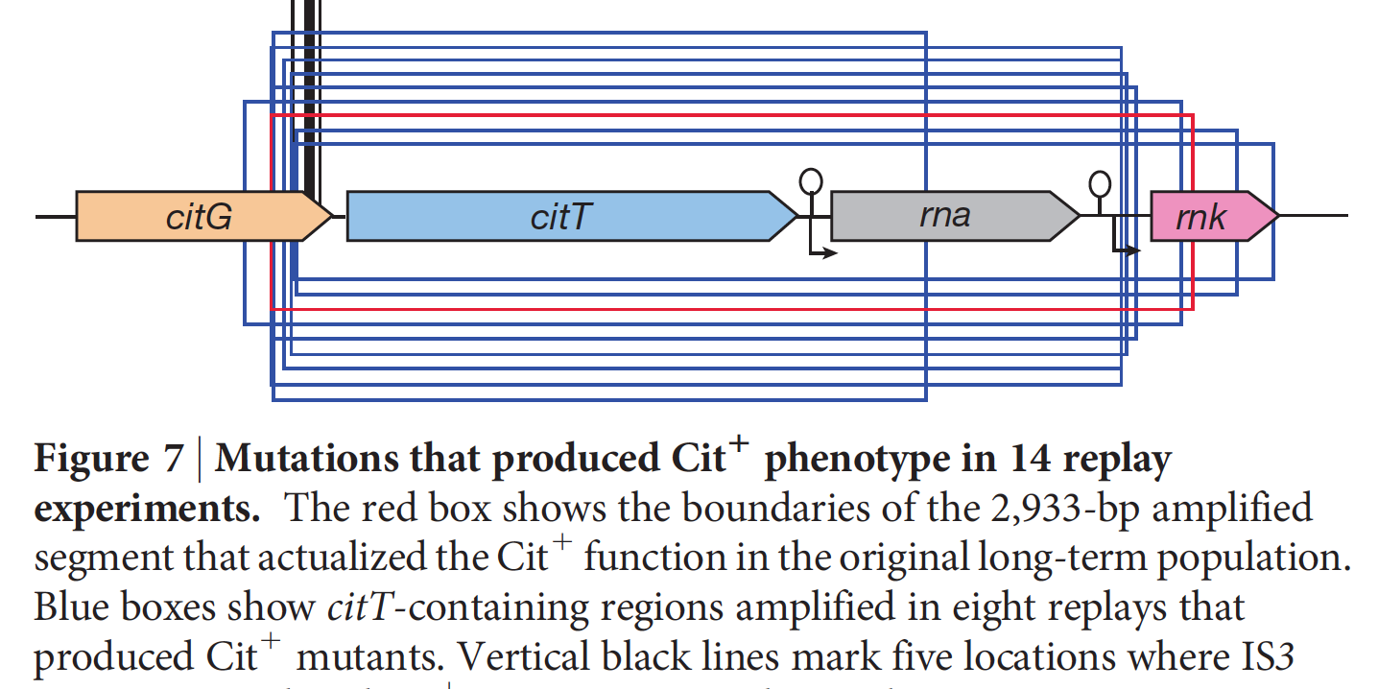

Evolution of a new species?
- Defining characteristic of E. coli is..
- The rise of Cit⁺ did not drive Cit⁻ to extinction
  - Cit- more efficient at glucose utilization.

Lecture 22: Elysia-Vaucheria System
- One of the reasons the elysia can hold the chloroplast for so long is due to horizontal gene transfer
Photosynthetic competency
- These chloroplasts are able to remain photosynthetic (about 70-80 days)
- Within hours in isolated chloroplast in spinach, photosynthesis declines very fast but in elysia it decline more slowly. The chloroplasts dont remain photosynthetically active for very long
- Why does photosynthesis decline at all??
- Even though photosynthesis is retained in elysia for a long time, it does eventually go down

Horizontal (Lateral) gene transfer
- Vaucheria is a eukaryotic algae (has chloroplast and mitochondria)
- It takes thousand of proteins for these organelles to work and most of the genes that code for those proteins are now found in the nucleus
- Most respiratory proteins are coded for by genes in the nucleus
- 99.9% of the genes are now found in the nucleus
- In elysia (no chloroplast), takes up the chloroplast from vaucheria, and the idea behind why it can retain its function for so long is that through lateral (horizontal) gene transfer genes transferred from organism to organism (primitive mitochondria to nucleus)
- In this case, they hypothesize horizontal transfer of a photosynthetic gene from nucleus of vaucheria to nucleus of elysia
- Since these chloroplast already have the genes they need why do they need more? Why does photosynthesis decline over time?
- PsbO is the gene transferred(according to the paper) from vaucheria to elysia (does elysia have this gene, and if it does is it expressed?)
the paper shows evidence that at sometime in the past the photosynthetic gene PsbO, moved from vaucheria to elysia
if you sequence the nuclear genome of elysia, according to the paper, youll find PsbO stably inserted
- This makes sense because elysia is chomping on a lot of dna and its exposed to vaucheria dna
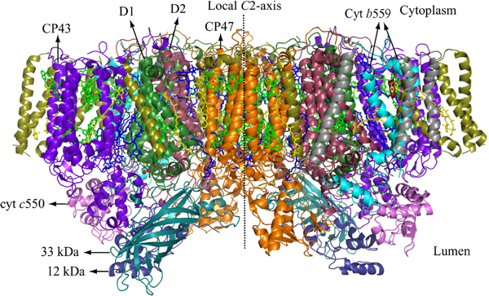
the actual mechanism by which it gets incorporated isnt clear, but elysia does get exposed to vaucheria dna

PsbO encodes a component of PSII
- Gene resides in the nucleus of all photoautotrophs
- Part of the oxygen evolving complex
- PsbO is a photosynthetic gene that resides in the nucleus
- Its part of the oxygen evolving complex
- The oxygen evolving complex sits on the lumen of PS2, required for electron donation from h20, leads to oxygen release
- One of the proteins on the oxygen evolving complex is PsbO
- So PS2 wouldnt work if you didnt have the PsbO gene being expressed and the protein being made
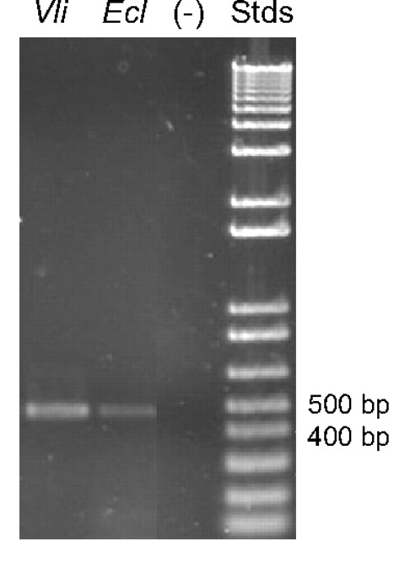
Expression of psbO in Elysia
- This is one of the driving results that supports the papers hypothesis
- This shows transcript (the presence of the mRNA) – they never look at the gene (ie introns/exons in dna)
this is because they know the mrna and they can infer the protein sequence given mrna
- In vaucheria you expect this transcript to be there, and you see it in elysia
- This shows evidence that these cells are actually making an mrna that corresponds to PsbO
- In elysia/vaucheria youre actually synthesizing the mrna corresponding to PsbO
- What are the bands if you were to isolate them?
- The slug feeds as a juvenile, then 5 months after feeding youre picking up this transcript – this transcript comes from the fact that vaucheria has PsbO (product of transcription in elysia) and not just contamination
- Agarose gel electrophoresis
- Amplified portion of psbO transcript
- 452 bp fragment.
- 5 months after feeding

Polymerase Chain reaction
- Polymerase chain reaction
- Kary Mullis

  - Nobel Prize Chemistry 1993
  - Amplification of specific DNA
  - Taq DNA polymerase
  - Two primers (1-30 bp long)
  - dATP, dGTP, dCTP, dTTP
  - Diagnostic
  - Forensic science
  - Phylogenetic studies
  - Disease testing

- Gene studies
- Allows small amounts of dna to be amplified
- The technique uses a thermostable polymerase
- So dna polymerase tack is isolated from a thermophile (organism that lives in high temperatures)
- You need gene specific primers
- If youre going to make dna the monomers for dna are written above (dATP...etc)

PCR reaction cycle
- *******important slide – know the technique – use video and look at pdf
- If you want to amplify the DNA you have to separate the 2 strands (high temperature)
- The method relies on thermal cycling, consisting of cycles of repeated heating and cooling of the reaction for DNA melting and enzymaticreplication of the DNA.
- Primers (short DNA fragments) containing sequences complementary to the target region along with a DNA polymerase (after which the method is named) are key components to enable selective and repeated amplification
- These thermal cycling steps are necessary first to physically separate the two strands in a DNA double helix at a high temperature in a process calledDNA melting. At a lower temperature, each strand is then used as the template in DNA synthesis by the DNA polymerase to selectively amplify the target DNA. The selectivity of PCR results from the use of primers that are complementary to the DNA region targeted for amplification under specific thermal cycling conditions.
- Almost all PCR applications employ a heat-stable DNA polymerase, such as Taq polymerase, an enzyme originally isolated from the bacterium Thermus aquaticus. This DNA polymerase enzymatically assembles a new DNA strand from DNA building-blocks, thenucleotides, by using single-stranded DNA as a template and DNA oligonucleotides (also called DNA primers), which are required for initiation of DNA synthesis.
- Break the H bonds by heating the dna and then cool it down which enables gene specific primers to anneal and h-bond to complementary sequences
- And then you amplify the dna between the primers
- The last step is to increase the temp to 72 degrees (temp when the polymerase is most active) and you get extension (like 1000 bases per min tag dna polymerase can extend off of that primer) – this is 1 cycle and it will cycle many times
- So you just put these little tubes with all this rxn mixture in a test tube and you cycle this
- The tac polymerase is going to be subjected to 94 degrees for a long time so it has to be thermostable
- After 30 cycles of doing this you get a billion fold amplification
- Whats powerful of PCR is that once you amplify the DNA so much now you can manipulate that DNA
- You can amplify the dna to the level where you can clone it, digets it, compare it, etc so many possibilities

PCR is incredibly specific
- PCR based on extreme specificity of the primers.
- In any DNA sequence
  - 1 in 4 chance of finding an A, G, C or T
  - 1 in 16 chance of finding any dinucleotide sequence
  - 1 in 256 chance of finding a given 4-base sequence.
  - 1 in 4¹⁶ chance of finding a given 16-base sequence.
- if i have a billion bases of dna from a human cell in a tube, i can have 2 short primers annealed to specific sequences in that billions of bases and theyll stick with specificity (PCR is based on specificity of primer binding)
- Theres 4 options above
- You have to know something about PsbO because you have to design primers specific for the PsbO transcript
how do you do this?? Hpw do you amplify PsbO specificlaly?
the s sequence of PsbO is not known from vaucheria/elysia

Amplification of psbO starts with primer design
- Align 5 psbO sequences obtained from GenBank.
- Look for regions of high similiarity.
- Degenerate primers - used when you do not know the exact sequence.
- So then how do you design primers against a sequence you dont know?? Like PsbO??
turn to NCBI
- Because PsbO HAS BEEN SEQUENCED IN OTHER ORGANISMS (PLANTS) and get back all the sequences that have been deposited that suggests that there is PsbO and then align the sequences
- Once youve aligned, you go after areas of high similarity to design specific primers
- So whats the sequence youre going to use?? Look for areas that are strongly conserved because this means its also most likely conserved in vaucheria (like the boxed sequence above)
- But some of the sequences arent necessarily conserved, so you make degenerate primers in this case (a machine to make every possible primer which accounts for any variations in the boxed sequence) – may not be perfectly correct
- You then need another area of high similarity to make the 2nd primer (degenerate primers)

Reverse transcription (RT) – PCR
- Not mrna, or rrna, or a protein
- ISOLATE TOTAL RNA AND REVERSE TRANSCRIBE IT INTO Cdna, THEN USING PCR, AMPLIFY THAT DNA
- We want to amplify the transcript but the tac polymerase is a dna polymerase, it wont polymerize mrna
- And so we need to use reverse transcription PCR (RTPCR)
- So you isolate total rna (grind up elysia cells) and reverse transcribe this and then you can amplify that
- In the first step above, reverse transcribe using a PolyT primer, the poly t primer will anneal to the poly a tail
- And then reverse transcriptase will extend in this direction off of this primer and then you have a strand of mrna and a strand of dna
- RIGHT NOW THOUGH THERES NOTHING SPECIFIC TO PSBO YET
- So we need 2 strands of dna
- The 1 gene specific primer can bind and give you strands of dna (you now have double stranded dna from an rna message – THIS IS A CDNA)
- Cdna – complementary dna thats synthesized from the information conveyed in mrna
- You can now use the 2 primers to amplify the dna

Identify PCR product
- The bands are the amplified dna from the last slide
- But how do you know this is PsbO?? Its just a band on a gel??
- Cut this out. Cut out that piece of agarose, get rid of the agarose and send the dna to get sequenced
- Theyll send a file which has all the agct, copy that put it into the ncbi and in a couple seconds, it will come back with all the similar sequences in the database

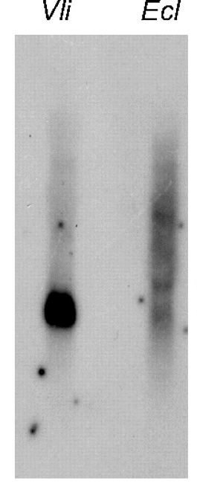
Northern blot analysis
- So you have this 452 bp fragment that you isolated from the gel. You can use that as a probe for northern blot because you want to look at the abundance of the transcript and presence of PsbO transcript
- Although its smeary in elysia, its good enough. Why its smeary and multiple hybridization we dont know. So there is some evidence you see the transcript in elysia (obviously you see it in vaucheria)

Obtain full-length protein-coding sequence
- Heres the 452 bp fragment
- Using PCR you can get the entire transcript sequenced
- Thats what they did in the end. You just need to design new primers to get the entire sequence
- The first 3 lanes are OCR the last one is RT PCR
- Whats the diff in the starting nucleic acid in pcr vs rtpcr??
- This pcr tell you that vaucheria has a genomic copy of PsbO
- Youre also picking up presence of psbo in the egg of elysia so the genome has psbo (its not something that happened upon feeding) its genetic – the gene corresponding to psbo is there in the egg of elysia

Protein import into organelles
- So how do you get proteins into diff compartments (after synthesis in the cytosol)??
- The genes have protein targeting signals and those signals are found on the amino acid end of the protein (the first end that comes out following translation)
- The signals are part of the gene sequence when you translate it, you get the targeting sequence – its not just added on
- So weve seen elysia has the gene and transcript but does it make a protein that goes to the chloroplast??

Secondary endosymbiosis
- Its not easy because of secondary endosymbiosis
- Heres the mitochondria and nucleus and primitive euk. On far left. Blue thing is cyanobacteria that gets engulfed into the primitive eukaryote
- One of the lineages led to plants (chlamy) and algae (these guys are all similar because they descended from the same event)
- But in 1 line that came off from this, secondary endosymbiosis occured
so you have a eukaryote with mito, nucleus, chloroplast
this in itself was engulfed by another eukaryote SECONDARY ENDOSYMBIOISIS EUK. ENGULFS ANOTHER EUKARYOTE
this secondary endosymbiosis only refers to chloroplasts. Mitochondria never underwent this stuff
The mitochondria gets deleted in the euk. That gets engulfed. Only thing retained is chloroplast
- The difference between chloroplast thats undergone primary vs secondary is the number of membranes around chloroplast
in primary theres only 2, secondary theres 4 membranes around chloroplast
So how do proteins get to the right compartment??

The problem of protein targeting
- So we have the total mrna sequence and can translate that into the protein
- It has a tripartitie singalling sequence and to get it through, all the layers in the vaucheria chloroplast
- The blue ones, every chloroplast has those and sec. Endosymbiosis just put on the red ones
- In elysia, when it digests the stuff of the vaucheria cell, the 2 outer ones are removed. So the chloroplast is like the one in chlamy/plants
- This tripartitie signal is required for the protein to get into the thylakoid membrane. The red sequence is recognized by transporters on the 2 outer membranes. Once it gets past that red leader sequence gets cleaved, exposing the next blue sequence which gets you through the inner and outer membranes (which every chloroplast has). Then blue gets cleaved exposing the green sequence which gets you into the lumen of the thylakoid
- 3 membranes must be passed. Once its in the lumen, chaperones help insert into PS2
- If this is actually the protein sequence made in elysia, then you cant get import because this outer membrane doesnt recognize the red sequence (it wants to recognize the blue sequence)
- Its the blue sequence thats recognized by chloroplasts inner and outer membrane
- This tripartite signal cant get into a typical chloroplast that only has 2 membranes, it only gets when theres 4
- So while elysia has the gene/transcript/chloroplast, evidence suggests that protein (if its made exactly as predicted from the mrna sequence) cannot get into the chloroplast that elysia has retained in its gut

PCR PROCEDURE
Typically, PCR consists of a series of 20-40 repeated temperature changes, called cycles, with each cycle commonly consisting of 2-3 discrete temperature steps, usually three (Fig. 2). The cycling is often preceded by a single temperature step (called hold) at a high temperature (>90°C), and followed by one hold at the end for final product extension or brief storage. The temperatures used and the length of time they are applied in each cycle depend on a variety of parameters. These include the enzyme used for DNA synthesis, the concentration of divalent ions and dNTPs in the reaction, and the melting temperature (Tm) of the primers.^{[10]}
- Initialization step: This step consists of heating the reaction to a temperature of 94–96 °C (or 98 °C if extremely thermostable polymerases are used), which is held for 1–9 minutes. It is only required for DNA polymerases that require heat activation by hot-start PCR.^{[11]}
- Denaturation step: This step is the first regular cycling event and consists of heating the reaction to 94–98 °C for 20–30 seconds. It causes DNA melting of the DNA template by disrupting the hydrogen bonds between complementary bases, yielding single-stranded DNA molecules.
- Annealing step: The reaction temperature is lowered to 50–65 °C for 20–40 seconds allowing annealing of the primers to the single-stranded DNA template. Typically the annealing temperature is about 3-5 degrees Celsius below the Tm of the primers used. Stable DNA-DNA hydrogen bonds are only formed when the primer sequence very closely matches the template sequence. The polymerase binds to the primer-template hybrid and begins DNA formation.
- Extension/elongation step: The temperature at this step depends on the DNA polymerase used; Taq polymerase has its optimumactivity temperature at 75–80 °C,^{[12][13]} and commonly a temperature of 72 °C is used with this enzyme. At this step the DNA polymerase synthesizes a new DNA strand complementary to the DNA template strand by adding dNTPs that are complementary to the template in 5' to 3' direction, condensing the 5'-phosphate group of the dNTPs with the 3'-hydroxyl group at the end of the nascent (extending) DNA strand. The extension time depends both on the DNA polymerase used and on the length of the DNA fragment to be amplified. As a rule-of-thumb, at its optimum temperature, the DNA polymerase will polymerize a thousand bases per minute. Under optimum conditions, i.e., if there are no limitations due to limiting substrates or reagents, at each extension step, the amount of DNA target is doubled, leading to exponential (geometric) amplification of the specific DNA fragment.
- Final elongation: This single step is occasionally performed at a temperature of 70–74 °C for 5–15 minutes after the last PCR cycle to ensure that any remaining single-stranded DNA is fully extended.
- Final hold: This step at 4–15 °C for an indefinite time may be employed for short-term storage of the reaction.

To check whether the PCR generated the anticipated DNA fragment (also sometimes referred to as the amplimer or amplicon), agarose gel electrophoresis is employed for size separation of the PCR products. The size(s) of PCR products is determined by comparison with aDNA ladder (a molecular weight marker), which contains DNA fragments of known size, run on the gel alongside the PCR products (see Fig. 3).

Lecture 23: Oxygen and Aging
- Most of the increase in life expectancy comes form drugs, antibiotics, fruits, sanitariness etc
- Our lifespan has definitely increased over the years
- You can separate the factors that influrnce aging into environmental, metabolic and genetic (lots of overlapping between these)
- Why is there a limit though on aging?? Why cant we live till 140

Reactive Oxygen Species (ROS)
- Understand ros
- ROS implicated in aging (theres data suggesting reactive oxygen is involved in aging, but its messy data)
- Know the pathway above
- 4 electrons required to reduce oxygen to h20 and reactive oxygen are the partially reduced forms which are highly reactive (superoxide hydrogen peroxide)
- The paradox of aerobic life is we need a lot of oxygen (oxygen diffuses into our cells into mitochondria, its terminal electron receptor of respiration), but then again oxygen can be harmful and can lead to cell death
- Your cells have a lot of catalase and superoxide dismutate (2 major enzymes that without them, aerobic life wouldn’t exist) – these enzymes are used to detoxify/get rid of oxygen

Mitochondria: major source of ROS
- Mitochondria in an animal cell (any eukaryotic cell) is a large source of ROS (specifically mitochondrial electron transport)
- This is electron transport
- So electrons flow down and cytochrome oxidase takes those electrons binds them to oxygen (the terminal electron acceptor)
- Cytochrome oxidase donates electrons to oxygen …(so where do we get these partially reduced forms of oxygen - ros??) – it makes sense you would get them at cytochrome oxidase
- If you donate 1 electron at a time then you get these partially reduced forms of oxygen (this would be a major source of ROS)
- You could also predict that if cytochrome oxidase actually did donate 1 electron at a time, aerobic respiration would have never evolved – we would produce so much ros (partially reduced oxygen) that the cytochrome oxidase complex and the whole cell would just explode
- Cytochrome oxidase actually donates 4 electrons at a time simultaneously so you get complete reduced forms of oxygen (it hold on to electrons until it has 4 of them and then donates them all) – this evolutionary feat occurred very early on
- The outcome of this is that cytochrome oxidase IS NOT a major source of reactive oxygen
- Most common site of ros is the ubiquinone pool (Q pool). Sometimes in the reduced form, oxygen is competing with the downstream electron carrier for that electron. You have so much oxygen in matrix of mitochondria and some of those electrons leak from thr Q pool and react with oxygen to produce superoxide (the 1 electron reduction of oxygen). Electron leak occurred when electrons don’t always pass down the chain, sometimes they get diverted and then reduce oxygen (occurs most commonly at the level of the Q pool)
- Humans have the sod1 enzyme which rapidly converts superoxide into hydrogen peroxide and catalase is the enzyme that gets rid of hydrogen peroxide
- Your cells have huge amount of catalase and superoxide dismutade (sod1)
- You have lots of superoxide dismutase in this compartment
- Electron leak lowers the efficiency of electron transport (efficiently in the sense that the electrons that enter drop down at cytochrome oxidase)
and so any change/mutation to any of the complexes could result in a slight increase in electron leak (your bound to have some electron leak and efficiency will never be fully 100%, even in newborn children)
- You can never have mitochondria that don’t produce any ROS – ros is unavoidable
- This paradox is unavoidable
- Whens someone's older do they have more ROS??
- There are many diseases that seem to be caused by mutations to one of the proteins that make up complex 1 (NADH dehydrogenase complex)
theres 40 proteins assembled in this complex
- Some forms of parkinsons are linked to a defect in complex 1 (NADH dehydrogenase) – electron leak occurs
- Some forms of ALS (amyotrohpic lateral sclerosis) are linked to defects in the SOD1 enzyme)
- Defects are linked to a shorter life span (theres higher levels of mitochondrial ros compared to individuals who wouldn’t have these defects)
- What if you intentionally make a mutation in the cytochrome complex in the middle?? – next slide

Cytochrome complex mutation
- What if you intentionally make a mutation in the cytochrome complex in the middle??
- Defect in the middle complex of electron transport?? This has been tried on c elegans a model system
- The mutation (in cytochrome complex) causes the cytochrome complex to not work as efficiently as it should (if it didn’t work at all, it would be lethal so this mutation doesn’t destroy the complex, the complex till works, just not as well as wild type)
- The consequence of having a cytochrome complex a little less efficient (too much oxygen around leading to more ros)
- The mutant is very susceptible to very high levels of oxygen (they don’t survive) compared to wild type
- The mutant form doesn’t live as long when the oxygen level rises
- Under normal oxic conditions (right picture), the mutants don’t last as long
- So anything that decreases efficiency of electron transport seems to decrease life span and the link seems to be higher levels of reactive oxygen in mitochondria

mitDNA genotype and longevity
- Theres something genetic about people who live over 100? – the idea that mitochondria evolved in aging also comes from work looking at the mitochondrial genome of japanese centarians
Answer to question is that THERE IS…theres messy data…but if you look at their mitochondrial genome they have a higher incidence of specific alterations to the genome – this incidence is higher in japanese centarians than regular folk
- Studies found in complex 1 and atp synthase and in RNA genes (genes that code for rna molecules which make the mitochondrial ribosomes)
they see changes
complex 1 – 40 proteins go into building complex 1 (changes occur here that are linked to Japanese centarians)
Complex 2 3 and 4 arent affected
- The genes which code for the rna which make the mitochondrial ribosomes – theres a 1 base change from a guanine to an adenine which is more common in a centarian – lots of work to be done here but data suggests this

The mitochondrial ROS theory of Aging
- Aging is linked to decrease in mitochondrial function
- Theres a reason that the reason we age is because mitochondria produce ros and this causes dna damage which leads to mutation to mitochondrial DNA (mitochondrial disfunction)
the dna damage that occurs is mitochondria dna (theres no evidence to suggest it affects nuclear genome)
- Theres lots of evidence that says this isnt true (its not as clean cut as this)

Mitochondrial role in PCD
- Mitochondria have a huge role to play in programmed cell death
- Theres this extrinsic pathway (above) where you need this extrinsic death signal which binds to the receptor and precipitates this PCD (genetic based program of cell death)
- Mitochondria are involved in an intrinsic pathway. So cell death can be caused by changes to mitochondrial function
theres very clear evidence that theres protein factors in mitochondria that under certain conditions are released and activate PCD
metabolic triggers and ros
- Mitochondria is the metabolic hub of the eukaryotic cell (a central depot where various signals converge)
- Mitochondria can cause cell death independent of any signal
- So whats the effect of just living under high oxygen?? Next slide

Effects of Hyperoxia
- So whats the effect of just living under high oxygen??
- What happens when you raise drosophila?? So grow drosophila both normal and under 100% oxygen, what do you see?
changes in mitochondria phenotype. So this is in wing cells (m = mitochondria). Theres these swirls in the mitochondria in cells grown under high oxygen (we don’t know what these swirls are but theyre linked to oxidative stress – reactive oxygen damaging stuff seems to be causing this swirling pattern)
- C- norm-oxic (drosophila grown under normal oxygen conditions) seems to be better than cells grown in high oxygen conditions (M). Whats weird is that the drosophila old flies show the same phenotype (they also have swirls in their mitochondria).
- This suggests Exposure to high oxygen seems to increase/accelerate aging (TAKE HOME)
- D-hyperoxic
- Swirl phenomenon - oxidative stress
- Old flies also show more swirls than younger (you also see them in older flies)
- Don’t go to oxygen bars (theres too much exposure to oxygen)

Caloric restriction (CR)
- Theres lots of data on extending lifespan
- The only thing thats linked to increasing lifespan is caloric restriction (this isnt messy data – its proven)
fewer calories (not malnourished) but you live to be longer
decreased rate of aging 30-50% but why??
- Everything from bacteria to mice (and humans)
- Absolutely caloric restriction increases lifespan, but why?? Next slide

Why does CR increase lifespan?
- Absolutely caloric restriction increases lifespan, but why??
- The most obvious suggestion is if you reduce your caloric intake you increase lifespan = lower rates of metabolism (lower rate of electron transport then amount of electron leak should go down)
NO THIS IS FALSE, caloric restriction often have HIGHER metabolic rates (we measure this using oxygen consumption)
often, oxygen consumption is higher in the caloric restricted organism)
- Reduction in oxidative damage
- Maybe...SOD knockouts live just as long
- Hormesis Hypothesis
- Low level stress leads to beneficial adjustments
- Humans that are caloric restricted increases cancer risk?? (not 100% sure but theres data)
- So whats the link between caloric restriction and lifespan??

Sir2 required for caloric restriction phenotype
- Work done in yeast has shown that this one gene, sir2 is required for caloric restriction to increase lifespan
- In yeast, longetivity linked to caloric restriction requires gene Sir2
- This gene is essential for caloric restriction to increase lifespan
- Caloric restriction is 0.5% (in yeast, put them on a 5% glucose diet- caloric restriction and they live longer as opposed to 2% - wild type)
- If we delete Sir2 in yeast, then theres no effect (you lose the increase in lifespan phenotype) – if you don’t have sir2, it doesn’t matter what diet youre on youre lifespan will not increase
- But what is sir2 doing to increase lifespan?? Next slide

Linking metabolism to lifespan
- But what is sir2 doing to increase lifespan??
- If you have enough oxygen you go to the mitochondria , if you don’t you stay in cytosol and pyruvate gets converted into ethanol lactate
- In humans, you can store that pyruvate in the form of fats/carbs
- You would expect yeast growing on a carb rich diet (2 percent glucose) would have higher rates of respiration BUT THAT’S NOT WHAT YOU SEE
- What you see is that yeast grown on calorically restricted diet actually have higher rates of metabolism (and thus higher rates of respiration), measured as oxygen consumption which is counter to the ros theory of aging because you would assume would lead to more mitochondrial ros but clearly in yeast calroic restriction leads to higher rates of electron transport/oxygen consumption
- If you consume lots of calories then the pyruvate can go down pathways we havent talked about
- Pyruvate builds up (some can be stored as carbs/fatty acids)
- Under caloric restriction you have lots of krebs/citric acid cycle activity but if you have lots of glucose then the rate of electrons flowing through electron transport declines
- Higher electron transport higher NAD+/NADH (represents energy state of cell) more NAD in the oxidized form which means the calorically restricted yeast have a higher NAD+/NADH ratio
- Youre consuming lots of NADH so youll have lots oxidized NAD+

Sir2 is NAD⁺ dependent
- It just so happens that sir2, this gene important for longevity in yeast, is activated by NAD+
- The activity of the Sir2 enzyme depends on NAD+ which is weird because theres of NADH dependent enzymes
- Sir2 is a deacetylase
- Ad libitum means lots of glucose/food (2? Glucose, not calorically restricted)
In this case the NAD/NADH ratio is lower – lower rates of oxygen consumption which inhibits the sir2 enzyme
- The amount of NAD+ in the cell is not as high then when the yeast are calorically restricted
- This has the effect/results in not activating Sir2
- When youre calorically restricted, oxphox goes up leading to an icnrease in the ratio and sir2 is acive and Sir2 deacetylates substrate
- UNDER NORMAL CONDITIONS, sIR2 is not activated, theres no deacetylation
- Increase in NAD/NADH ratio results in activation of Sir2 which leads to deacetylates

Sir2 is a histone deacetylase
- Sir2 deacetylates histones (so sir2 keeps certain areas og genome unaccesible)
- Sir2 affects chromatin packaging
Sir2 does Chromatin silencing – rDNA (speciific ribosomal genes in nuclear genes are most affected that seem to be silenced by sir2)
- Glucose can affect chromatin packaging (Take home)
- Sirtuins
- Decetaylases (all affect histome modification)
- Highly conserved
- Major regulators

Evolutionary basis of caloric restriction
- Why would caloric restriction increase lifespan??
Disposable Soma (body) Hypothesis
Do you invest energy in growth/reproduction or somatic maintenance?
you put lots of your energy in growth/reproduction (selfish gene- you want to make more of yourself so you restrict somatic maintenance)
- If your energy is invested in growth/reproduction maybe you die earlier because this leads to somatic damage, whereas if you invest in somatic maintenance, you inhibit somatic damage and increase your own lifespan
- This explains that evolution has built up to invest out energy in growth/reproduction (selfish gene) leading to degeneration and disease
were bound to get more age related diseases because weve invested our energy in growing older
- So what does caloric restriction do??
caloric restriction delays growth and reproduction and you put energy into somatic maintenance. You wait until food is more plentiful then you get into growth/reproduction investment

Lecture 24: Biological time-keeping
Diurnal phenomena
- Foraging/predatory behaviour
- Sleep-awake cycles
- Body temperature
- Hormone secretion
- phootsynthesis
- Diurnal is a pattern that reoccurs daily
- Rhythmic behavior
- When the peak occurs can change
- The time between any successive points – period

The value of keeping track of time
- Is there value in keeping track of time?( knowing when sun will come up and go down)
- What if organisms could anticipate environmental change? (think of advantages)
- Lhcb2 is a photosynthetic gene
- Here we look at mrna (transcript) abundance – using northern blot. Transcrption vs. mrna decay. Any transcript, the abundance, is dependent on transcription and the rate of mrna decay
- You don’t see the transcript at night, but you see it during the day. Even when you put the cells in constant light (white), the transcript appears again, its rhythmic. The rhythm of gene expression continues in constant light OR could be constant darkness. Its as if the cells know what time it is and have an endogenous biological clock.
how can you explain this?
- this is not a response to the light because expression comes up during the dark
- Transcript abundance starts to accumulate while the cells are still in the dark
- What would be the advantage of this?

Circadian rhythms
- A circadian rhythm is a biological rhythm with a period of 24 hours (roughly)
- What does it mean to be circadian? 2 major criteria
1) this clock can be set by the external environment (astronomical time). You can set this clock depending on whats going on outside, based on the sun. This is called entrainment (training clock) – set the clock when the light environment changes
2) set it, but youre not a slave to external environment. If environment becomes constant, your clock still works. This is called a free-running clock. Eventually this free running rhythm may start to decay and go crazy, but then it can be entrained again.
- Body temperature and hormonal secretion is diurnal, theyre under circadian contorl and will continue to oscillilate in a regular manner even though youre body isnt getting anything directly from the sun

Circadian phenomena
- Diurnal phenomenon can be circadian or non-circadian
- Photosynthesis as a process is non-circadian (ps2 cant work in dark, its light dependent)
- BUT photosynthetic gene expression is circadian (the genes responsible for building the photosynthetic apparatus are under circadian control)
- There are thousands of genes that show diurnal fluctuations (so during day you see high expression of these and during night you dont, vice versa) – most show circadian control

Questions about the clock
- This means you have a clock
- If we have a clock (which we do), how do you synchronize it to astronomical time??
- How is the molecular time linked to changes in physiology/behaviour??
- What is the nature (biochemical basis) of the clock
- Every clock oscilla
- What keeps clock oscilliates and so our biological clock must have something that oscillates too

Circadian Rhythms have a genetic basis
- This oscillating clock has a genetic basis
- This is looking at eclosion (larva turns into fly)
- And they were able to isolate mutants where the period (fluctuation in timing of eclosion) was different in wild type
- They were able to isolate mutants where the period was a little shorter/longer
- There is no circadian rhythm in an a-rythmic mutant (there is no dya/night)
- DNA replication has circadian rhythm (it tends to occur at night) – its under circadian control

A biological clock – Neurospora
- Heres a clock in a fungus called neurospa (model system)
- The clock gene is called frq
- This is the genetic basis of a bio clock – every living thing seems to have clocks
- The oscillaitor of a clock is the change in transcription/translation – that is whats oscillating in all biological clocks (that’s whats keeping time)
- The oscillator is a change in frq transcription/translation
- Wc1 and wc2 are transcription factors that are active and bind to promoter of frq
- Transcription and mrna decay account for the fact that the expression come sup
- Purple is protein abundance, orange is mrna
- The protein accumulation is slower than mrna
- When frq protein starts to accumulates, it inhibits its own transcription (function of 2 transcription factors gets switched off)
- This results in switching off transcription, the levels come back down, and the next day starts – this is the clock for neurospora
- You can entrain the clock because photoreceptors in neurospora affect wc1 and wc2
- Wc1 and wc2 are positive elements of the clock whereas frq is negative (it inhibits the positive elements that enable the clock to ossicilate)

FRQ function and regulation
- Frq protein comes back down, what accoutns for this decline?
it gets phosphorolated in cytosol of the cell by a specific kinase, causing frq to degrade over time till eventually theres none of it left to come back and inhibit transcription, so transcription comes back up and increases again

Circadian rhythms in cyanobacteria
- Bacteria have circadian rhythms, experiment was done above
- Pspa is a photosynthetic gene under circadian control
- What they’ve done is they’ve made a fusion gene (took promoter of pspa and fused it to this gene called lux) and they inserted that reportor gene into cyanobacterium
- The cyanobacteria alsready has normal pspa that makes protein, but in adddition to that they put in a second copy
- Lux is a protein coding gene that makes luciferase – it makes light
- You can monitor changes in pspa expression by measuring light (ie expose to camera and see when they glow vs when they don’t)
- But they have mutants where the rhythm is a little shorter or longer
- These mutations arent in pspa, pspa is just reporting circadian rhythm, these are mutations to cyanobacterium clock gene causing the short/long periods

Advantage to telling time
- Is there advantage to being able to tell time??
increase in fitness
- Mix 2 clocks together (normal and mutant)
- If you expose a culture having equal amount of both to a short period environment, then short period mutant outcompetes wild type (if its more closely to wild type though, wild type dominates)
- Having a clock that works more closely to external environment is a huge advantage (allows the closer one to dominate)
- If you just grow them one at a time then rate is the same

