The University of British Columbia
Sauder School of Business
COMMERCE 291 – Instructor: Dr. Jonathan Berkowitz

Midterm Exam, March 7, 2012, 7:00 – 9:00 pm

Name: _______________________________ Student Number: ________________
(Underline your family name)

Section Number in which you are registered (Check one)

__ 201 Tuesday/Thursday 11:00 -12:30

__ 202 Tuesday/Thursday 2:00- 3:30

__ 203 Tuesday/Thursday 3:30- 5:00

READ THIS FIRST!
- Write your name and student number in the spaces at the top of this page and check the section number you are registered in (even if you attend another section’s classes). One mark will be deducted for not giving your section number. We’re serious!
- This exam consists of 9 questions. Check that you have 12 pages, including this page. Check to ensure that your copy is complete.
- You have 2 hours to do this exam.
- This is an “open book, notes and calculator” exam. All printed material is allowed. Computers, cell phones and on-line connectivity are not allowed.
- You will be given a “one-minute left” warning at the end of the exam and must stop writing immediately upon its expiration.
- Hand in only this exam. Nothing else will be marked.
- Answer ALL questions.

Question | Maximum | Your Mark
1 | 10
2 | 8
3 | 14
4 | 16
5 | 12
6 | 10
7 | 10
8 | 10
9 | 10
Total | 100

Question 1 (Total 10 marks) “A sole practitioner”

ASW, a regional shoe chain, has recently launched an online store. Sales via the Internet have been sluggish compared to their brick and mortar stores, and management suspects that its regular customers have concerns regarding the security of online transactions. To determine if this is the case, they plan to survey a sample of their regular customers.

a) Suppose that ASW’s regular customers belong to a rewards program and have a customer rewards ID number. ASW decides to randomly select 100 numbers. This sampling plan is called:
__A. Simple Random Sampling
__B. Stratified Sampling
__C. Cluster Sampling
__D. Systematic Sampling
__E. Convenience Sampling

b) Suppose that ASW has an alphabetized list of regular customers who belong to their rewards program. After randomly selecting a customer on the list, every 25th customer from that point on is chosen to be in the sample. This sampling plan is called:
__A. Simple Random Sampling
__B. Stratified Sampling
__C. Cluster Sampling
__D. Systematic Sampling
__E. Convenience Sampling

c) “All regular ASW customers” is known as the ________ of the study.
__A. Parameter
__B. Statistic
__C. Target Population
__D. Sampling Frame
__E. Sample

d) Which of the following is the parameter of interest in the ASW study?
__A. All regular ASW customers
__B. % of regular ASW customers who have concerns about
online security
__C. ASW customers who belong to the rewards program
__D. % of ASW customers who belong to the rewards program
but don’t shop online
__E. None of the above

e) One member of the management team at ASW suggests that their survey could be conducted online. Customers logging on to the online store would be asked to take a few minutes to complete the survey and would be offered a coupon as incentive to participate. Which of the following statements is true?
__A. This is a voluntary response sample
__B. This would result in an unbiased random sample
__C. This would result in a biased sample
__D. Both A and B
__E. Both A and C

Question 2 (Total 8 marks) “Planning ahea
d”

A brokerage firm gathered information on how their clients were investing for retirement. Here is a small sample of the data they collected.

Respondent Number | Age | Gender | Household Income | Self-directed RRSP? | Book value of portfolio
1001 | 45 | Male | $155,000 | Yes | $750,000
1002 | 53 | Female | $160,000 | No | $500,000
1003 | 58 | Female | $210,000 | No | $1,000,000

a) Place an X in the space beside each variable that is best described as Quantitative.
__ Respondent Number
__ Age
__ Gender
__ Household Income
__ Self-directed RRSP
__ Book value of portfolio

Based on age, clients were categorized according to where the largest percentage of their retirement portfolio was invested and shown in the table below.

 | Age 50 or Younger | Over Age 50 | Total
Mutual Funds | 30 | 34 | 64
Stocks | 37 | 45 | 82
Bonds | 19 | 23 | 42
Total | 86 | 102 | 188

b) The percentage of clients who are over age 50 and invest in mutual funds is:
__A. 53.1% __B. 33.3% __C. 18.1% __D. 34.0% __E. 54.3%

c) Of the clients over age 50, the percentage who invest in mutual funds is:
__A. 53.1% __B. 33.3% __C. 18.1% __D. 34.0% __E. 54.3%

d) Of the clients who invest in mutual funds, the percentage over age 50 is:
__A. 53.1% __B. 33.3% __C. 18.1% __D. 34.0% __E. 54.3%

e) The percentage of clients over age 50 is:
__A. 53.1% __B. 33.3% __C. 18.1% __D. 34.0% __E. 54.3%

f) Consider the following side-by-side bar chart for the data below:

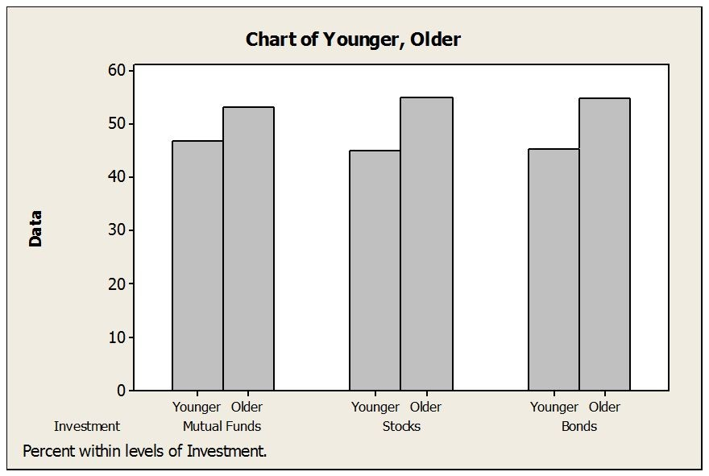

Does the chart indicate that mode of investment is independent of age?

Yes No

Explain in one short sentence only.

Question 3 (Total 14 marks) “Mmm – Marketing Manager Money”

Here is a histogram and the five number salary for salaries (in $) for a sample of 48 marketing managers.
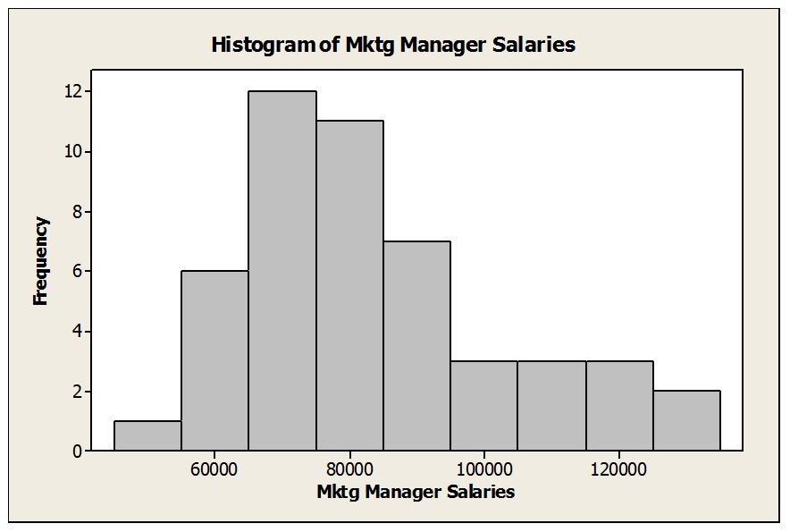

Min | Q1 | Median | Q3 | Max
46360 | 69693 | 77020 | 91750 | 129420

a) The shape of this distribution is:
__A. Symmetric
__B. Bimodal
__C. Skewed to the right
__D. Skewed to the left
__E. Normal

b) Which of the following is true?
__A. Mode < Median < Mean
__B. Median < Mode < Mean
__C. Mean < Median < Mode
__D. Mean < Mode < Median
__E. All three are equal

c) Which of the following is closest to the standard deviation?
__A. $ 3,676
__B. $ 13,843
__C. $ 20,765
__D. $ 83,060
__E. Can’t tell without the data

d) The IQR for these data is:
__A. $83,060
__B. $22,057
__C. $69,693
__D. $77,020
__E. $14,566

e) Compute the lower and upper inner fences:
Space for calculations:
Lower inner fence: ___________

Upper inner fence: ___________

f) Are there any outliers, as defined by the “inner fences” criterion?
__A. Yes, only on the left side of the distribution
__B. Yes, only on the right side of the distribution
__C. Yes, on both sides of the distribution
__D. No

g) Suppose the marketing manager who was earning $129,420 got a raise and is now earning $140,000. Which of the following statements is true?
__A. The mean would increase
__B. The median would increase
__C. The range would stay the same
__D. The IQR would increase
__E. The IQR would decrease

The next two parts are not related to parts (a) through (g) above.
The boxplots below show monthly sales revenue figures ($ thousands) for a discount office supply company with locations in three different regions of Canada (Atlantic, Central and West).

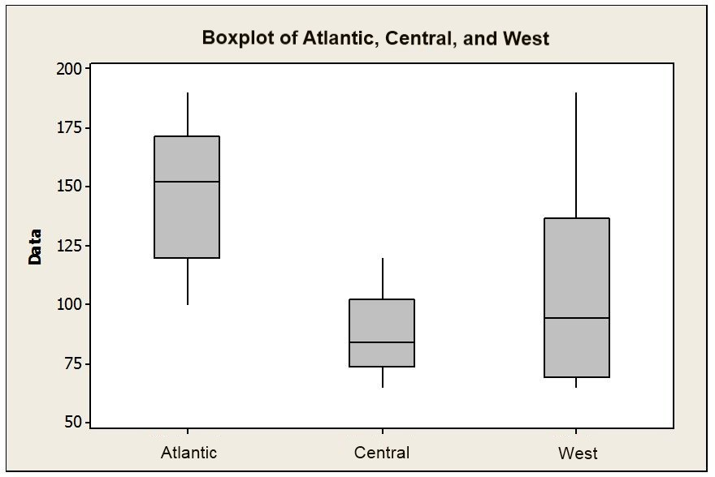

h) Which of the following statements is true?
__A. Central has the lowest sales revenues
__B. Central has the lowest median sales revenue
__C. West has the lowest mean sales revenue
__D. West has the lowest median sales revenue
__E. Atlantic has the lowest mean sales.

i) Which of the following statements is false?
__A. West has the most variable sales revenues.
__B. West has the largest IQR.
__C. Central has the smallest IQR.
__D. Atlantic has the most variable sales revenues.
__E. Central has the least variable sales revenues.
Question 4 (Total 16 marks) “OMG: A great place to work”

To determine whether the cash bonus paid by a company is related to annual pay, data were gathered for 10 account executives at Outstanding Management Group (OMG) who received cash bonuses in 2007. The data and summary statistics are shown below.

 | ANNUAL PAY | CASH BONUS
 | $ 70,609 | $ 11,225
 | $ 58,487 | $ 6,238
 | $ 104,561 | $ 14,194
 | $ 43,922 | $ 4,188
 | $ 82,613 | $ 11,863
 | $ 116,250 | $ 13,671
 | $ 76,751 | $ 7,758
 | $ 68,513 | $ 20,760
 | $ 137,000 | $ 55,000
 | $ 94,469 | $ 34,368
Mean | $ 85,318 | $ 17,927
Standard Deviation | $ 28,077 | $ 15,618
Correlation | 0.735

a) What percentage of variability in cash bonuses can be explained by pay?

b) What would the correlation be if the Dollars were converted to Euros at the current conversion rate of (1 Canadian Dollar = 0.76 Euros)?

c) Estimate the linear regression model that relates the response variable (cash bonus) to the predictor variable (annual pay).

Slope of the regression line: ________________ (Report to three decimal places)

Intercept of the regression line: ________________ (Report to nearest whole number)

Equation of the linear model: ___________________________

Space for work:

d) From the equation, in part c), estimate the cash bonus for an executive at OMG earning $82,613 a year, and compute the residual for this estimate.

Estimated cash bonus: ___________ Residual: ____________

e)Would you be confident in using your regression equation to estimate the cash bonus for an executive at OMG earning $200,000 a year?

Yes No Reason:

f) Below is a plot showing residuals versus fitted values for the estimated regression equation relating cash bonus to pay for the account executives at OMG.

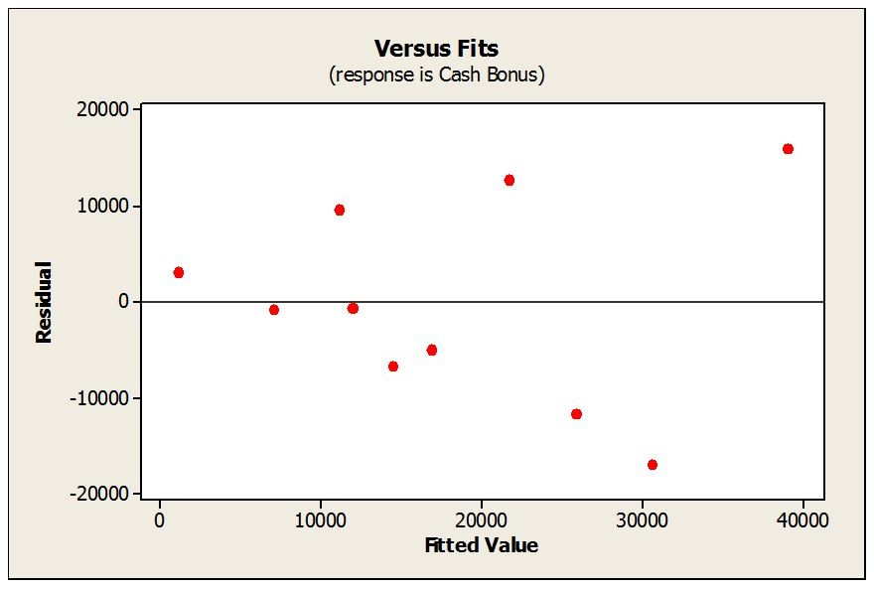

Circle the conditions for linear regression which are violated, if any.
None are violated
Linearity
Normality
Constant Variance (Equal spread)
Independence

Parts (g) through (i) are unrelated to parts (a) through (f):
g) In commenting on the increase in home foreclosures (i.e. banks repossessing homes), a news reporter stated “there appears to be a strong correlation between home foreclosures and job loss of the head of household.” Comment on this statement; use one sentence only.

h)A research study investigated the relationship between number of hours individuals spend on the Internet and age. Which is the predictor variable? Circle your choice.

Hours on Internet Age

i)The correlation associated with the following scatterplot is:

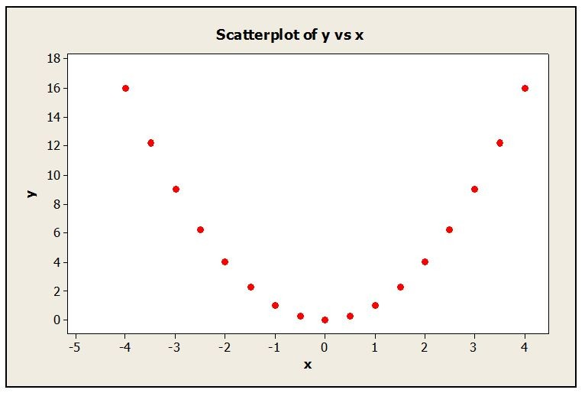

__A. 1.00
__B. -1.00
__C. 0.50
__D. -0.50
__E. 0.00

Question 5 (Total 12 marks) “Greater attitude, greater latitude”

The Survey of Study Habits and Attitudes (SSHA) is a psychological test that measures academic motivation and study habits. Females score higher, on average, than males. The distribution of SSHA scores among the female students at a university has mean 120 and standard deviation 28; the distribution among male students has mean 105 and standard deviation 35. Scores are normally distributed. Assume also that scores are independent.

a) What percentage of female students have SSHA scores greater than 162? Report your percentage to one decimal place only.

b) What SSHA score is exceeded by only 10% of female students? Round your answer to the nearest whole number.

c) Compute the lower and upper quartiles for the distribution of scores of female students. Round your answers to the nearest whole numbers.

d) Suppose you select a single female student and a single male student at random and give them the SSHA test. What are the mean and the standard deviation of the difference (female minus male) between their scores. Report to one decimal place.

Mean = __________ Standard Deviation = ____________

e) Using your answers from part d), compute the probability that the chosen female has a higher score than the chosen male.

f) Suppose Angelina (a female) scores 78 on the SSHA, while Brad (a male) scores 70 on the SSHA. Use an appropriate calculation to determine who did worse compared to the average for their gender. Circle the name of the person who did worse.

Angelina Brad

Explanation:

Question 6 (Total 10 marks) “A convenient truth”

Part I. A convenience store owner suspects that only 10% of the customers buy magazines and thinks that he might be able to sell something more profitable. In order to decide whether he should stop selling them, he tracks the number of customers who buy magazines on a given day.

a) On that day he had 300 customers. Assuming it was a typical day and that his estimate is correct, what are the mean and standard deviation of the number of customers who buy magazines each day? Report your answers to one decimal place.

Mean = ___________ Standard Deviation = ______________

b) What is the probability that 25 to 35 customers (inclusive) bought magazines that day?

c) How many magazine sales would you consider to be very strong evidence that his 10% estimate was too low. That is, what number of sales would be extremely unusually high? Hints: Use The Empirical (68-95-99.7) Rule. Remember to give a whole number answer.

Part II. Past records indicate that the magazines he sells on any day have an average revenue of $150 with a standard deviation of $30. Suppose he takes a random sample of 36 past days’ sales receipts and records the dollar value of magazine sales.

a) Describe the sampling distribution for the sample mean by naming the model and telling its mean and standard deviation.

b) Suppose the resulting sample mean is $130. Do you think that this sample result is unusually small? Explain.

Question 7 (Total 10 marks) “Talk about confidence!”

One division of a telecommunications equipment company reports that 12% of non-electrical components are reworked. Management wants to determine if this percentage is the same as the percentage rework for electrical components manufactured by the company. The Quality Control Department plans to check a random sample of the over 10,000 electrical components manufactured across all divisions.

a) The Quality Control Department wants to estimate the true percentage of rework for electrical components to within ±4%, with 99% confidence. How many components should they sample?
__A. 651
__B. 1000
__C. 344
__D. 438
__E. 579

b) They actually select a random sample of 450 electrical components and find that 46 of those had to be reworked. The 99% confidence interval is closest to:
__A. [ 0.0654 , 0.1390 ]
__B. [ 0.0432 , 0.1608 ]
__C. [ 0.0763 , 0.1277 ]
__D. [ 0.0541 , 0.1499 ]
__E. Cannot be determined with the given information.

c) The 95% confidence interval based on these data is 0.0742 to 0.1302. Which one of the following is the correct interpretation?
__A. The percentage of electronic components that are reworked is
between 7.4% and 13.0%.
__B. We are 95% confident that between 7.4% and 13.0% of electrical
components are reworked.
__C. The margin of error for the true percentage of electrical components
that are reworked is between 7.4% and 13.0%.
__D. All samples of size 450 will yield a percentage of reworked electrical
components that falls within 7.4% and 13.0%.
__E. There is a 95% chance that 7.4% to 13.0% of the electrical components
have to be reworked.

d) Based on the 95% confidence interval, should the Quality Control Department conclude that the percentage of rework for the electrical components is lower than the rate of 12% for non-electrical components?
__A. Yes, because the lower limit of the confidence interval is 7.4%.
__B. Yes, because 12% is contained with the 95% confidence interval.
__C. No, because 12% is contained with the 95% confidence interval.
__D. No, because the upper limit of the confidence interval is 13.0%.
__E. We cannot say since the sample size is not large enough.

e) All else being equal, increasing the level of confidence desired will...:
__A. ...tighten the confidence interval
__B. ...decrease the margin of error
__C. ...increase precision
__D. ...increase the margin of error
__E. ...increase the margin of error and tighten the confidence interval
Question 8 (Total 10 marks) “A dip in chips”

A company manufacturing computer chips finds that 8% of all chips manufactured are defective. Management is concerned that high employee turnover is partially responsible for the high defect rate. In an effort to decrease the percentage of defective chips, management decides to provide additional training to those employees hired within the last year. After training was implemented, a sample of 450 chips revealed only 27 with defects. Was the additional training effective in lowering the defect rate?

a) The appropriate null and alternative hypotheses are:

H₀: ______________ H_{a}: ______________

b) Give the formula for the appropriate test statistic and compute its value.

Test Statistic Formula: __________________

Computed value: ______________

Show your work:

c) Assume that the value of the test statistic is –1.4. Don’t use your computed value from part b).The P-value associated with the given test statistic is closest to:
__A. 0.0404
__B. 0.05
__C. 0.0808
__D. 0.1616
__E. 0.9192

d) From the P-value in part c), and using a 1% significance level (i.e. α = .01), which of the following is true?
__A. Conclude that additional training significantly lowered the defect rate.
__B. Conclude that additional training did not significantly lower the defect rate.
__C. Conclude that additional training significantly increased the defect rate.
__D. Conclude that additional training did not affect the defect rate.
__E. No conclusion can be made with the given information.

Question 9 (Total 10 marks) “The non-profit motive”

A large software development firm recently relocated its facilities. Top management has encouraged their professional employees to engage in local service activities. They believe that the firm's professionals volunteer an average of more than 15 hours per month. If this is not the case, they will institute an incentive program to increase it. A random sample of 24 professionals reported the following number of hours:

12 | 13 | 14 | 14 | 15 | 15 | 15 | 16 | 16 | 16 | 16 | 16
17 | 17 | 17 | 18 | 18 | 18 | 19 | 19 | 19 | 20 | 20 | 22

The sample has a mean of 16.75 hours and a standard deviation of 2.40 credit hours.

a) The correct null and alternative hypotheses are:
__A. H₀ : $\overline{x}$ = 15 and H_{a} : $\overline{x}$ > 15
__B. H₀ : µ = 15 and H_{a} : µ > 15
__C. H₀ : µ = 15 and H_{a} : µ < 15
__D. H₀ : µ ≠ 15 and H_{a} : µ = 15
__E. H₀ : µ = 15 and H_{a} : µ ≠ 15

b) The correct value of the test statistic is closest to:
__A. 3.572
__B. -3.572
__C. 1.327
__D. -1.327
__E. 0.729

c) Which of the following conclusions is correct?
__A. We reject the alternative hypothesis at the 5% significance level.
__B. We fail to reject the null hypothesis at the 5% significance level.
__C. An incentive program is needed since the evidence indicates professional
employees volunteer an average of no more than 15 hours per month.
__D. We reject the null hypothesis; the firm shouldn't need to institute an
incentive program since the evidence indicates that professional
employees volunteer an average of more than 15 hours per month.
__E. No conclusion can be reached about the hypothesis with the information
that is given.

d) It is appropriate to test the mean because:
__ A. The data are a simple random sample from the population of interest
__ B. The distribution of the sample data appears to be approximately normal
__ C. Volunteer hours is likely to be independent across employees
__ D. All of the above

e) A 95% confidence interval for the true mean number of hours of volunteer time is closest to:
__A. 16.75 ± 1.016
__B. 16.75 ± 0.840
__C. 16.75 ± 4.966
__D. 16.75 ± 4.114
__E. 2.40 ± 7.074

*** END OF EXAM – GOOD NIGHT! ***

