UNIVERSITY OF BRITISH COLUMBIA

Biology 121 Section 224, Practice Final 2014

Name: ________________________ Student number: _______________
(Please print)

Instructions:

1. Answer all questions in the space provided.
2. Answers may be in sentences or point form. Illustrations are acceptable but must be annotated.
3. Students suspected of any of dishonest practices will be immediately dismissed from the examination and will be subject to disciplinary action.
4. Other than one side of one page for summary notes and one side of the same page for concept maps, no other memory devices are permitted.
5. Students may not speak or in any other way communicate with other students while in the examination room.
6. Students may not expose their written paper to other students. The excuse of accidental exposure, forgetfulness, or ignorance will not be accepted.

I have read and fully understand these instructions.
Student signature _________________________

Mark allocation:
 |  |  |  | Question | Marks possible | Your mark
 |  |  |  | 1. | 15
 |  |  |  | 2. | 5
 |  |  |  | 3. | 4
 |  |  |  | 4. | 10
 |  |  |  | 5. | 14
 |  |  |  | 6. | 7
 |  |  |  | 7. | 7
 |  |  |  | 8. | 9
 |  |  |  | 9. | 25
 |  |  |  | Total | 96
 |  |  |  | Concept Map | 1
 |  |  |  | Total | 97
1. (15 marks) Variegated porphyria (VP) is a disease caused by a dominant allele; it affects the nervous system and other organs. This disease is more common in South Africa than elsewhere in the world and its origins there can be traced back to a Dutch man, Gerrit Jansz who emigrated from Holland and married Ariaantje Jacobs in South Africa in 1688.

a) A blood test has been developed to determine if individuals are homozygous dominant (VV), heterozygous (Vv) or homozygous recessive (vv). In a population of 100,000 there are 1 VV, 404 Vv and 99595 vv individuals. Is this population in HW equilibrium? Justify your answer. Show all your calculations to six decimal places and show all your work. (6 marks)

Frequency of the V allele p = (1/100,000 + 404/2)/(100,000) = 203/100,000 = .00203
Or p = (2 x 1) + (404/200,000)
= 406/200,000 = 0.00203
Frequency of the v allele q = (404/2 + 99595)/100,000 = 99797/100000 = .99797
Or q = (404/2 + 99595)/200000 = .99797
Or q = 1-p = 1-0.00203 = 0.99797

 |  | Observed Frequency | Expected Frequency | Expected Number
VV | 1 | = 1/100000 = .00001 | = 0.00203² = .000004 | = 0.000004 x 100000 = 1
Vv | 404 | = 404/100000 = 0.00404 | = 2 x 0.00203 x 0.99797 = 0.004059 | = 0.004059 x 100000 = 459
vv | 99595 | = 99595/100000 = .99595 | = .99595² =  .991916 | = 0.991916 x 100000 = 99192

Not in HWE (1): fewer heterozygotes (1) and more homozygous recessives (1) than expected. plus 3 marks for showing all calculations. Accept values that are “close” because of rounding.

b) List two assumptions of the HW equilibrium that may have been violated in this example and indicate how each violation could account for the results obtained. (4 marks)
1 mark for each assumption and 1 mark for each explanation. e.g.
Immigration: immigrants not as likely to have V allele since this is a very rare allele. This would lead to more vv and Vv genotypes.
Selection: While we don’t know when the disease Variegated porphyria strikes, individuals with the V allele most likely have lower fitness, and contribute fewer alleles to the gene pool.
Non-random mating: If the disease Variegated porphyria has visible phenotype there may be less mating between V- individuals and vv individuals than expected by chance.
Answer must be clear the V allele (dominant) is disease causing

c) What type of genetic drift is illustrated in this example? Explain. (2 marks)
Founder effect (1) because the descendants of one couple resulted in a population with allele frequencies different from the original population from which it came. (1)

d) Individuals with VP are sensitive to sunlight and develop skin ulcers as a consequence of ultraviolet light exposure. Explain how this illustrates that Phenotype = Genotype + Environment. (3 marks)
VP is due to the dominant allele in the genotype (1)
The development of skin ulcers is an environmental effect caused by UV (1).
Together genotype and environmental influence result in the phenotype of skin ulcers (1).

2. (5 marks) Consider a diploid (2n) plant. An F1 plant with the genotype Aa Bb was produced by crossing two pure-breeding parents with the genotypes aaBB and AAbb. From previous experiments you have determined that alleles of the A and B genes do not assort independently (i.e. they are linked, on the same chromosome).

Draw the chromosomes with these genes as they would appear in metaphase I of meiosis in one of the F1 plants if:
- Crossing over did not occur (2 marks)
a a A A

B B b b

Sister chromatids identical (1) properly lined up (1)

- Crossing over occurred once (2 marks)

a A a A

B B b b

OR
a a A A

B b B b

Sister chromatids different (1) properly lined up (1)

- How many different gametes are possible if crossing over occurs once? (1 mark)
4

3. (4 marks) In the nematode, Caenorhabditis elegans, females are XX and males are XO. Males arise by non disjunction during meiosis. Drawing only the sex chromosomes show how a nondisjunction event at meiosis I could result in the required eggs to produce males.
Normal meiosis I Nondisjunction (1)
I homologous X chromosomes separate both X chromosomes go to same cell

Meiosis II (1)
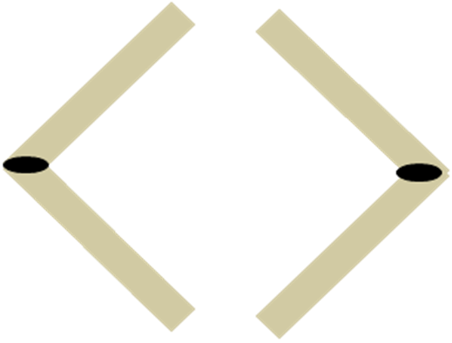

Normal gametes: 4 each with one X; Gametes: XX, XX, no X, no X (2)

4. (10 marks) A black female mouse with normal ears is crossed with a brown male with small ears. All the F1 are black with normal ears. All the F1 are self-crossed (5 crosses) and the following F2 are obtained:
62 black females with normal ears
18 brown females with normal ears
31 black males with normal ears
30 black males with small ears
10 brown males with normal ears
9 brown males with small ears
How are the traits black and brown fur and small and normal ears inherited? Support your answer by showing the genotypes of the original parents, F1 and the F2 (be sure to define your alleles). Show the F1 x F1 cross in a Punnett square.
Black is dominant (B), brown is recessive (b) 2 marks
Normal ears is X-linked dominant XE), small ears is X-linked recessive (Xe) 2 marks
P1 BB XE XE x P2 bb Xe Y 1 mark
F1 females Bb XE Xe 1 mark; males Bb XE Y 1 mark
1 mark for gametes; 1 mark for genotypes in Punnett square; 1 mark for phenotypes in Punnett Square

female  male | B XE | B Xe | b XE | b Xe
B XE | BB XE XE  black normal♀ | BB XE Xe  black normal♀ | Bb XE XE  black normal♀ | B b XE Xe  black normal♀
b XE | Bb XE XE  black normal♀ | BB XE Xe  black normal♀ | bb XE Xe  brown normal ♀ | bb Xe Xe  brown normal ♀
BY | B B XE Y black normal♂ | BB XeY  black small♂ | Bb XEY  black normal♂ | Bb Xe Y  black small ♂
bY | Bb XEY  black normal♂ | Bb XeY  black small ♂ | bb XEY  brown normal♂ | bb Xe Y  brown small♂
Ratio as above
Can also do two crosses separately and multiply probabilities

5. (14 marks) Two species of fish that live around Caribbean reefs have a unique type of interaction. The Caribbean cleaning gobies (Elacatinus evelynae) eat parasites (gnathiids) found on the skin of the longfin damselfish (Stegastes diencaeus).

a) What type of interaction is occurring between these two species? (1 mark)
mutualism

b) Explain specifically how each member benefits or is harmed in this interaction. (2 marks)
Caribbean cleaning gobies get food (the parasites)
longfin damselfish are rid of parasites

Karen Cheney and Isabelle Côte studied two aspects of this interaction. First they counted the number of parasites (gnathiids) on longfin damselfish in areas with or without cleaner fish. The results are shown in Figure 1.
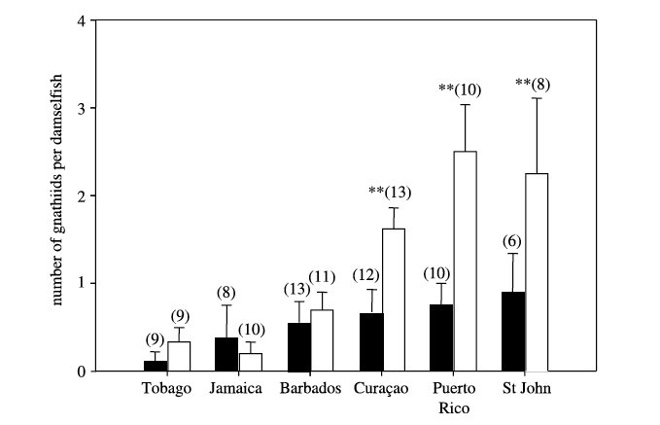
Figure 1. The number of gnathniids (parasites) per damselfish found at various locations in the Caribbean. Black bars indicate parasite numbers on damselfish in areas with cleaner fish. Open (white) bars indicate parasite numbers on damselfish in areas without cleaner fish. The numbers in brackets indicate the sample size. The stars (**) indicate where the number of parasites on damselfish significantly differed between treatments (cleaner fish present, cleaner fish absent).

c) Describe the results shown in Figure 1 above. (2 marks)
Damselfish have significantly fewer parasites in areas where there are cleaning gobies on Curacao (~.7 vs ~1.5), Puerto Rico (~.8 vs ~2.5) and St. John (~.9 vs ~2.2) (1) but not on islands where there are fewer (~1.5 or less) parasites: Tobago, Jamaica, Barbados (1).

d) What can you conclude from this graph about the effect of cleaner fish on the number of parasites found on damselfish. (2 marks)
The greater the number of parasites in an area (1) the greater the benefit from cleaner fish (1). There may be other valid answers.

In some situations, the cleaner fish also feed on scales, mucus and tissue from damselfish (rather than on the parasites). Cheney and Côte wanted to determine if the cleaner fish diet changed depending on the number of parasites present on damselfish. They counted the number of parasites on longfin damselfish and determined what material was being eaten by the cleaner fish. The results are shown in Figure 2. The letters indicate different locations. The dots indicate the % scales, mucus and tissue from damselfish ingested given the average number of parasites on the damselfish. The horizontal bars indicate the variation in parasite numbers on damselfish. The vertical bars indicate the variation in scales, mucus and tissue from the damselfish ingested by the cleaner fish. If bars do not overlap, the values can be considered significantly different.

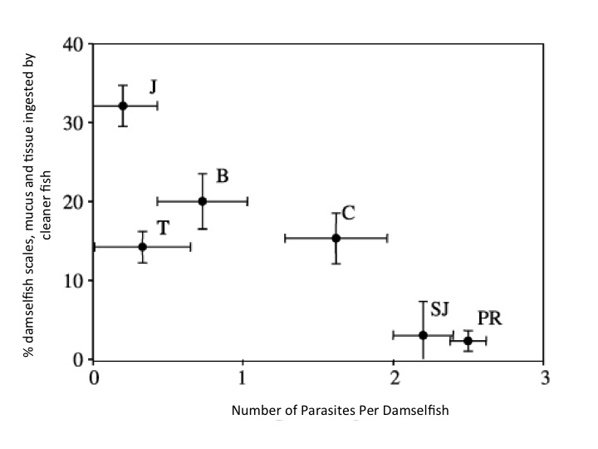
Figure 2. The % of damselfish material ingested when compared with the number of parasites on the damselfish.

e) How would you describe the type of interaction where the cleaner fish eats more scales, mucus and tissue from the damselfish than parasites? (1 mark)
Parasitism or consumerism or predation

f) Explain specifically how each member benefits or is harmed in the interaction described in e). (2 marks)
cleaner fish benefits as they have an alternate food source if the number of parasites is low, damselfish may be harmed by the cleaner fish consuming scales, etc.

g) Describe the results shown in Figure 2 above. (2 marks)
Where the number of parasite are low (less than 2 per damselfish) cleaner fish consume scales mucus and tissue (1); where the number of parasites is above 2 per damselfish, scales, mucus and tissue are not consumed (1).

h) How do parasite numbers on damselfish change the interaction between cleaner fish and damselfish? (2 marks)
When parasites are more plentiful the cleaner fish will consume the parasites and the interaction is a mutulism (1); when parasite numbers are low, they will consume material such as scales, mucus and tissue from the damselfish and the interaction become parasitism (1).

6. The following photo (Figure 3) appeared in the Vancouver Sun on Apr. 5 2010 along with a story about how the discovery of a new fossil in South Africa (between Australopithecus and Homo habilis in age) could provide new information about the evolution of humans. (7 marks)
a) Based on ideas about evolution presented in Biology 121, what is one problem with this representation? Suggest how you could correct the representation? (3 marks)
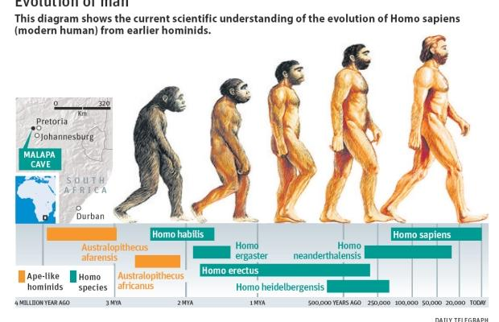
Figure 3 Human evolution

Evolution is not linear (1) – e.g., H. neanderthalensis did not evolve into H sapiens (1).

Correct by having a phylogenetic tree showing a common ancestor and branched evolution (1)

b) Describe one example of natural selection that was discussed in class. Include what was selected for (e.g., which morphological feature) as well as the agent of selection. (4 marks)
Any one of, e.g., finches, mockingbirds, antibiotic or insecticide resistance, etc. Description should include what was selected (2) e.g., beak size and the agent of selection (2) e.g., available food. Must be natural not artificial selection.

7. (7 marks) The following phylogenetic tree shows the relationship among terrestrial plants alive today.

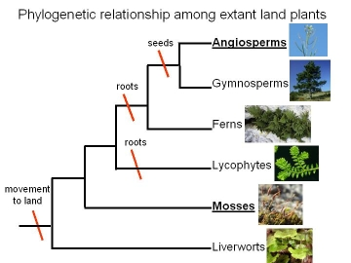
E
D
C

a) Which of the following groups form monophyletic clades (circle the number)? (2 marks)
i) Angiosperms, Gymnosperms
ii) Angiosperms, Gymnosperms, Ferns
iii) Ferns, Lycophytes
iv). Lycophytes, Mosses
i and ii 1 mark each Penalty for wrong answers. Right – ½ wrong – so if you check all of them you get 1 mark.

b) For one of the monophyletic groups you have identified, explain why it is a monophyletic group. (2 marks)
Angiosperms and Gymnosperms are the descendents of E; there are no other descendents of E.
(or Angiosperms, gymnosperms and ferns are the descendents of D; there are no other descendents of D.

- What is a synapomorphy for angiosperms and gymnosperms? (1 mark)
seeds

- Which group, ferns or gymnosperms diverged first? How do you know? (2 marks)
Ferns, because the ancestor D is closer to the root of the tree.

8. (9 marks) The cheetah is a large cat and the fastest land animal. It was once widely distributed in Africa and Asia (light pink) but is now very limited in its distribution (see Figure 4) and the total cheetah population in the wild is less than 10,000.
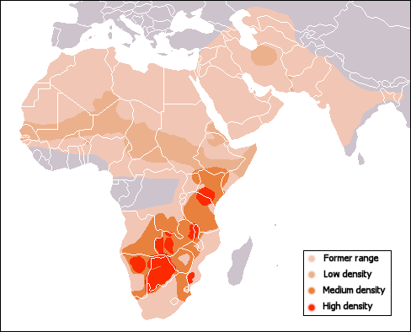
Figure 4. Distribution of cheetahs in Africa and Asia.

a) List one abiotic factor that could have caused this change in distribution and explain how it has affected the distribution of cheetahs (3 marks)
one of e.g. climate change (or any aspect of climate), habitat change, geography change (there may be some overlap) (1)
2 marks for explanation e.g., climate drier (warmer) which is too warm (dry) and thus range is limited – points made have to be relevant to climate changes in Africa.
b) Explain how the genetics of cheetahs could be a factor in declining population sizes after its distribution was reduced. (3 marks)

The population of cheetahs has declined and there are now patches of cheetahs in high density, but many areas with low density. These small populations likely have less genetic variation (1) therefore when a change in abiotic conditions occurs, there are fewer different allele combinations (1) in the population that might enable some cheetahs to withstand the new environmental conditions (1). Could get 1 or 2 marks if just answer in more general terms i.e., why genetic variation is important, or discuss problems such as inbreeding depression in small populations.

c) List one biotic factor that could have caused this change in distribution and explain how it has affected the distribution of cheetahs. (3 marks)
(1) for factor and (2) for explanation of e.g. loss of prey because of loss of vegetation or habitat for herbivores. Other biotic factors are also acceptable. Human impact is also acceptable as biotic – e.g. overhunting, urbanization, etc.

9. (25 marks) In the Lake Erie region of Ontario there are two kinds of non-poisonous water snakes (Nerodia). On the shores of the lake most of the snakes have a banded colouration, while on the islands in the lake most snakes are not banded. You have been hired by the Ontario government to work on a project designed to protect these threatened snakes from becoming endangered.
a) The first thing you have to do is to determine whether banded and unbanded snakes represent different morphological forms (morphs) of one species or are two separate species. What would you do to determine if they were one species with two morphs or two species? (2 marks)
Observe in the wild or capture them and keep them in the lab to see if they mate (1) and have viable offspring (1).
Could also suggest genetic analysis to assess degree of gene flow and mating in wild populations.

b) Suppose you determine that these two morphs are in fact one species. What could be causing the difference in distribution of the two morphs? (2 marks)
many answers are possible; they just have to be logical and biologically possible. e.g., perhaps the environment on the shore or on the island is such that the less common morph is more visible to predators (2)
Banded morphology confers more protection from predators because it acts as camouflage. There are few predators on the islands, so the selection pressure for bands is much lower.

c) Suppose you determine that they are in fact two species. What are two reproductive isolating mechanisms that could be causing them to remain separate species? (2 marks)
any two of: non-random mating, habitat isolation, behavioural isolation e.g. courtship behavior, temporal Isolation, d) mechanical isolation, e) gametic isolation, Postzygotic barriers such as reduced hybrid fertility

d) Your next task is to count the snakes in a 3 ha area along the shore and in a similar-sized area on one of the islands. What method would you use to count them? Why would you use this method? What is one drawback of using this method? (3 marks)

One of: marked recapture (1) use because: it is an accurate counting method (1)
Drawback: there are assumptions e.g., that the individuals don’t learn to avoid capture (1)
OR Count them all (1) because it may be possible to do this and it is the most accurate method (1). Drawback is that it is very difficult to be sure they have all been counted. (1)
OR sample in a given area (1) would save time and may be accurate (1) assumption is distribution is the same throughout the range. (1)

e) You were provided the following graph completed by previous summer students of the finite rate of increase in population growth (λ) of the banded snakes (on the shore).
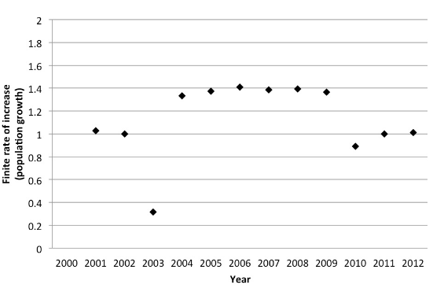
Figure 5 Finite rate of increase of Banded snakes along the shores of Lake Erie.

- In what time periods did the banded-snake population size:
Stay the same

Increase
Decrease

Be very specific and explain your reasoning for each. (6 marks)
Stayed same: 2000-2002; 2010-2012 (1) because λ = 1(1)
Increased: 2003-2009 (1) because λ > 1 (1)
Declined: 2002-2003; 2009-2010 (1) because λ < 1.

- What is one factor that could be important in the population decline in one of the periods you chose above. Is this factor density-dependent or density independent? Explain. (2 marks)
Any factor from any periods of decline above: 1 mark for factor and 1 for explanation. e.g. increase in predators which is density dependent (more prey).

- Based on the graph above, is this species threatened? Explain. (2 marks)
No (1) because population is maintaining numbers over the long term (1).

f) A similar species of snake has slithered in from Florida. You are concerned that this new species may become invasive and upset the balance between the original species. What are two things you would you have to consider to determine if the new species is a threat? For each, indicate why it is important. (4 marks)
two of (1 mark for item and 1 for importance), e.g. will they be competing for food nesting places, if not then they won’t likely be a threat
how many young do they produce, if fewer than native species they shouldn’t be a threat
does the new species have natural predators; if not they may be more of a threat

