UNIVERSITY OF BRITISH COLUMBIA

Biology 121 Section 224, Practice Final 2014

Concept Map Terms for the Final Exam
Evolution Natural Selection
Adaptation Fitness
Founder effect Bottle-neck effect
Genetic Drift Gene Flow
Sexual selection Hominin
Bipedalism Speciation
Prezygotic isolation Postzygotic isolation
Habitat fragmentation Disruptive selection
Morphospecies concept Species diversity
Fecundity Logistic growth curve

**Please note: The questions will be similar in format, but could test different concepts or be different kinds of questions or have different lengths. This is just an example.

The individual portion of the Final exam will be 2 hours long and will be cumulative for all of the materiel, but will focus on the final third of the class (Evolution and Population Ecology) but will also have questions that synthesize all three Themes (Ecology, Genetics and Evolution). You will be allowed to bring a non-programmable calculator with you during the exam. The group portion of the exam will be 50 minutes long.

UNIVERSITY OF BRITISH COLUMBIA

Biology 121 Section 224, Practice Final 2014

Name: ________________________ Student number: _______________
(Please print)

Instructions:

1. Answer all questions in the space provided.
2. Answers may be in sentences or point form. Illustrations are acceptable but must be annotated.
3. Students suspected of any of dishonest practices will be immediately dismissed from the examination and will be subject to disciplinary action.
4. Other than one side of one page for summary notes and one side of the same page for concept maps, no other memory devices are permitted.
5. Students may not speak or in any other way communicate with other students while in the examination room.
6. Students may not expose their written paper to other students. The excuse of accidental exposure, forgetfulness, or ignorance will not be accepted.

I have read and fully understand these instructions.
Student signature _________________________

Mark allocation:
 |  |  |  | Question | Marks possible | Your mark
 |  |  |  | 1. | 15
 |  |  |  | 2. | 9
 |  |  |  | 3. | 4
 |  |  |  | 4. | 10
 |  |  |  | 5. | 14
 |  |  |  | 6. | 7
 |  |  |  | 7. | 7
 |  |  |  | 8. | 9
 |  |  |  | 9. | 25
 |  |  |  | Total | 96
 |  |  |  | Concept Map | 1
 |  |  |  | Total | 97
1. (15 marks) Variegated porphyria (VP) is a disease caused by a dominant allele; it affects the nervous system and other organs. This disease is more common in South Africa than elsewhere in the world and its origins there can be traced back to a Dutch man, Gerrit Jansz who emigrated from Holland and married Ariaantje Jacobs in South Africa in 1688.

- A blood test has been developed to determine if individuals are homozygous dominant (VV), heterozygous (Vv) or homozygous recessive (vv). In a population of 100,000 there are 1 VV, 404 Vv and 99595 vv individuals. Is this population in HW equilibrium? Justify your answer. Show all your calculations to six decimal places and show all your work. (6 marks)

b) List two assumptions of the HW equilibrium that may have been violated in this example and indicate how each violation could account for the results obtained.
(4 marks)

c) What type of genetic drift is illustrated in this example? Explain. (2 marks)

d) Individuals with VP are sensitive to sunlight and develop skin ulcers as a consequence of ultraviolet light exposure. Explain how this illustrates that Phenotype = Genotype + Environment. (3 marks)

2. (5 marks) Consider a diploid (2n) plant. An F1 plant with the genotype Aa Bb was produced by crossing two pure-breeding parents with the genotypes aaBB and AAbb. From previous experiments you have determined that alleles of the A and B genes do not assort independently (i.e. they are linked, on the same chromosome).

Draw the chromosomes with these genes as they would appear in metaphase I of meiosis in one of the F1 plants if:
- Crossing over did not occur (2 marks)

- Crossing over occurred once (2 marks)

- How many different gametes are possible if crossing over occurs once? (1 mark)

3. (4 marks) In the nematode, Caenorhabditis elegans, females are XX and males are XO. Males arise by non disjunction during meiosis. Drawing only the sex chromosomes show how a nondisjunction event at meiosis I could result in the required eggs to produce males.

4. (10 marks) A black female mouse with normal ears is crossed with a brown male with small ears. All the F1 are black with normal ears. All the F1 are self-crossed (5 crosses) and the following F2 are obtained:
62 black females with normal ears
18 brown females with normal ears
31 black males with normal ears
30 black males with small ears
10 brown males with normal ears
9 brown males with small ears
How are the traits black and brown fur and small and normal ears inherited? Support your answer by showing the genotypes of the original parents, F1 and the F2 (be sure to define your alleles). Show the F1 x F1 cross in a Punnett square.

5. (14 marks) Two species of fish that live around Caribbean reefs have a unique type of interaction. The Caribbean cleaning gobies (Elacatinus evelynae) eat parasites (gnathiids) found on the skin of the longfin damselfish (Stegastes diencaeus).

a) What type of interaction is occurring between these two species? (1 mark)

b) Explain specifically how each member benefits or is harmed in this interaction. (2 marks)

Karen Cheney and Isabelle Côte studied two aspects of this interaction. First they counted the number of parasites (gnathiids) on longfin damselfish in areas with or without cleaner fish. The results are shown in Figure 1.
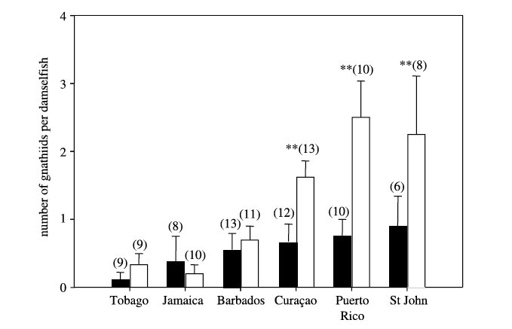
Figure 1. The number of gnathniids (parasites) per damselfish found at various locations in the Caribbean. Black bars indicate parasite numbers on damselfish in areas with cleaner fish. Open (white) bars indicate parasite numbers on damselfish in areas without cleaner fish. The numbers in brackets indicate the sample size. The stars (**) indicate where the number of parasites on damselfish significantly differed between treatments (cleaner fish present, cleaner fish absent).

c) Describe the results shown in Figure 1 above. (2 marks)

d) What can you conclude from this graph about the effect of cleaner fish on the number of parasites found on damselfish. (2 marks)

In some situations, the cleaner fish also feed on scales, mucus and tissue from damselfish (rather than on the parasites). Cheney and Côte wanted to determine if the cleaner fish diet changed depending on the number of parasites present on damselfish. They counted the number of parasites on longfin damselfish and determined what material was being eaten by the cleaner fish. The results are shown in Figure 2. The letters indicate different locations. The dots indicate the % scales, mucus and tissue from damselfish ingested given the average number of parasites on the damselfish. The horizontal bars indicate the variation in parasite numbers on damselfish. The vertical bars indicate the variation in scales, mucus and tissue from the damselfish ingested by the cleaner fish. If bars do not overlap, the values can be considered significantly different.

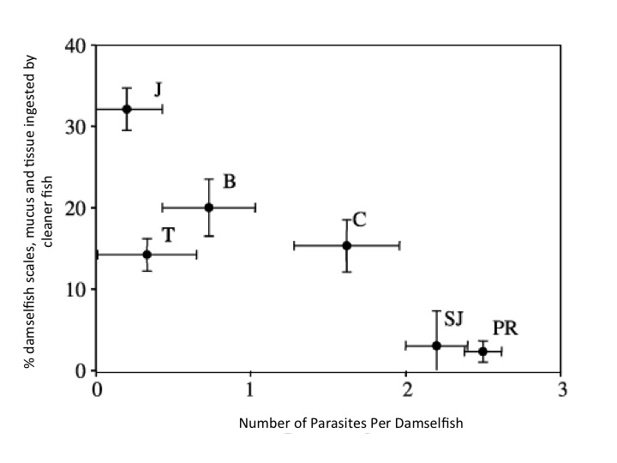
Figure 2. The % of damselfish material ingested when compared with the number of parasites on the damselfish.

e) How would you describe the type of interaction where the cleaner fish eats more scales, mucus and tissue from the damselfish than parasites? (1 mark)

f) Explain specifically how each member benefits or is harmed in the interaction described in e). (2 marks)

g) Describe the results shown in Figure 2 above. (2 marks)

h) How do parasite numbers on damselfish change the interaction between cleaner fish and damselfish? (2 marks)

6. The following photo (Figure 3) appeared in the Vancouver Sun on Apr. 5 2010 along with a story about how the discovery of a new fossil in South Africa (between Australopithecus and Homo habilis in age) could provide new information about the evolution of humans. (7 marks)

a) Based on ideas about evolution presented in Biology 121, what is one problem with this representation? Suggest how you could correct the representation? (3 marks)

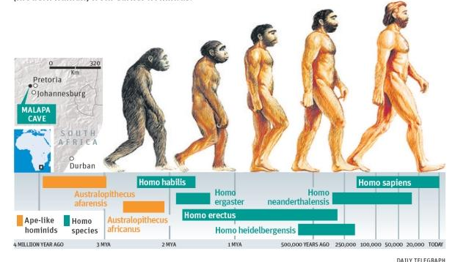
Figure 3 Human evolution

b) Describe one example of natural selection that was discussed in class. Include what was selected for (e.g., which morphological feature) as well as the agent of selection. (4 marks)

7. (7 marks) The following phylogenetic tree shows the relationship among terrestrial plants alive today.

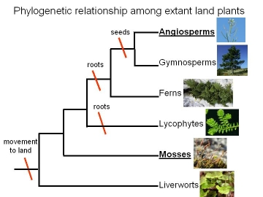
C

a) Which of the following groups form monophyletic clades (circle the number)? (2 marks)
i) Angiosperms, Gymnosperms
ii) Angiosperms, Gymnosperms, Ferns
iii) Ferns, Lycophytes
iv). Lycophytes, Mosses

b) For one of the monophyletic groups you have identified, explain why it is a monophyletic group. (2 marks)

- What is a synapomorphy for angiosperms and gymnosperms? (1 mark)

- Which group, ferns or gymnosperms diverged first? How do you know? (2 marks)

8. (9 marks) The cheetah is a large cat and the fastest land animal. It was once widely distributed in Africa and Asia (light pink) but is now very limited in its distribution (see Figure 4) and the total cheetah population in the wild is less than 10,000.
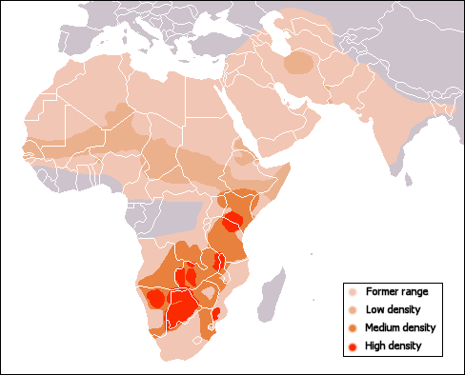
Figure 4. Distribution of cheetahs in Africa and Asia.

a) List one abiotic factor that could have caused this change in distribution and explain how it has affected the distribution of cheetahs (3 marks)

b) Explain how the genetics of cheetahs could be a factor in declining population sizes after its distribution was reduced. (3 marks)

c) List one biotic factor that could have caused this change in distribution and explain how it has affected the distribution of cheetahs. (3 marks)

9. (25 marks) In the Lake Erie region of Ontario there are two kinds of non-poisonous water snakes (Nerodia). On the shores of the lake most of the snakes have a banded colouration, while on the islands in the lake most snakes are not banded. You have been hired by the Ontario government to work on a project designed to protect these threatened snakes from becoming endangered.

a) The first thing you have to do is to determine whether banded and unbanded snakes represent different morphological forms (morphs) of one species or are two separate species. What would you do to determine if they were one species with two morphs or two species? (2 marks)

b) Suppose you determine that these two morphs are in fact one species. What could be causing the difference in distribution of the two morphs? (2 marks)

c) Suppose you determine that they are in fact two species. What are two reproductive isolating mechanisms that could be causing them to remain separate species? (2 marks)

d) Your next task is to count the snakes in a 3 ha area along the shore and in a similar-sized area on one of the islands. What method would you use to count them? Why would you use this method? What is one drawback of using this method? (3 marks)

e) You were provided the following graph completed by previous summer students of the finite rate of increase in population growth (λ) of the banded snakes (on the shore).
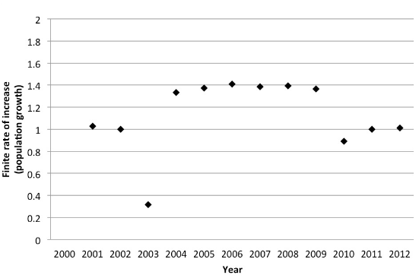
Figure 5 Finite rate of increase of Banded snakes along the shores of Lake Erie.

- In what time periods did the banded-snake population size:
Stay the same
Increase
Decrease
Be very specific and explain your reasoning for each. (6 marks)

- What is one factor that could be important in the population decline in one of the periods you chose above. Is this factor density-dependent or density independent? Explain. (2 marks)

- Based on the graph above, is this species threatened? Explain. (2 marks)

f) A similar species of snake has slithered in from Florida. You are concerned that this new species may become invasive and upset the balance between the original species. What are two things you would you have to consider to determine if the new species is a threat? For each, indicate why it is important. (4 marks)

