LECTURE 2
- A cell is the fundamental unit of life, and every organism consists of cells or is itself a single cell.
- Cell theory is:
  - All organisms consist of one or more cells.
  - The cell is the basic unit of structure for all organisms.
  - All cells arise only from pre-existing cells (they are the basic unit of reproduction).
- Cells have a huge diversity, in form, function and size.
  - 200 nm – 13cm diameter.
- ATP is the energy currency of all cells.
- Microfilament is made up of proteins.
- Cells are small due to the surface area / volume. The surface area is the area where exchange can take place. You need to have enough surface area over which exchange can occur to match the cell volume.
  - Limitation #1: The ratio of SA: V goes down as cells become larger. Harder to get nutrients in / waste products out. Instead of having a large organism with few but large cells, you break it down and have an organism made up of smaller cells.
  - Limitation #2: Rate of diffusion, the way things move around in cells. Distances should be small.
  - Limitation #3: The need to achieve adequate concentrations of substrates. The larger the cell, the more it has to synthesize molecule substrates, and it might not be able to do them all.
- Prokaryotic and eukaryotic cells differ in size
- Prokaryotes stay small, around 1 – 5 microns, and very simple cells lacking nucleus.
  - Consists of: a cell membrane bounded by cell wall. Inside the membrane, there is a semi-liquid fluid called the cytoplasm. The cytoplasm includes ribosomes for protein synthesis, and the genetic material of the cell in the form of a single circular chromosome WITHOUT structural proteins (a naked DNA chromosome). Folded on itself and is called the nucleoid.
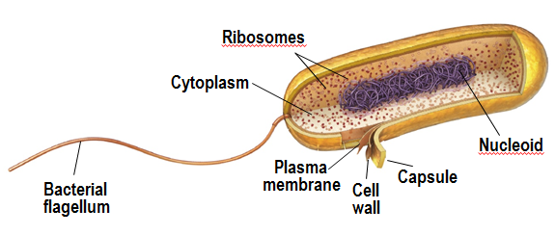
  - Prokaryotes fall into 2 groups: bacteria, and archaea.

  - Archaea are extremophiles, adaptive to very extreme conditions and climates.
  - Bacteria are very large and diverse group. The model bacteria that we know most about are E.Coli.
- Eukaryotes have 4 basic types: single-celled organisms (protists), fungi, animals, multicellular plants.
  - It increases the areas of membrane within the cell which can in turn:
    - By compartmentalization of cellular functions it reduces the need to fill the whole cell with substrates.
    - Is good for transport systems, and so are not reliant on diffusion alone to transport around the cell.
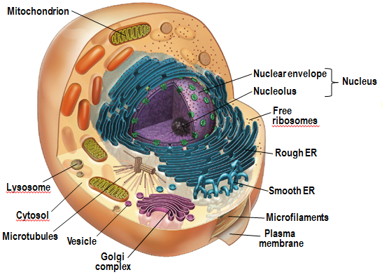
  - Arabidopsis thaliana is a plant, looking like a weed, and is a large advantage to research because it has small genomes compared to most plants that have large, and can reproduce quickly and even in a growth chamber.
  - C. Elegans is good for research because it’s small, about 1cm, and has exactly 959 cells and thus because is so small and simple, can map out development easily.
- Now, let’s look into the cell organelles of the eukaryotic cells (MUST ALSO LABEL ABOVE PICTURE^)
- Major structural features:
  - Plasma membrane
  - Nucleus (membrane-bound)
  - Membrane-bound organelles: part of the cytoplasm, suspended in the cytosol.
  - Cytosol (vs cytoplasm): Cytosol is the aqueous solution of salts and organic molecules. Cytoplasm is the cytosol and everything you find it (ribosomes, organelles, cyto-skeleton).
- Cytosol is the same in eukaryotic and prokaryotic cell, and cytoplasm is not.
- Table of difference in what each have in cytoplasm.
Prokaryotes | Eukaryotes
-Ribosomes | -Ribosomes  -Organelles  -Cyto-skeleton.

- Non-membrane bound organelles
  - Cytoskeleton
    - Is the support/shape, internal organization, and controls movement of cell / movement within cell (transport systems).
    - 3 filamentous structures:
      - Microtubules, microfilaments, and intermediate filaments.
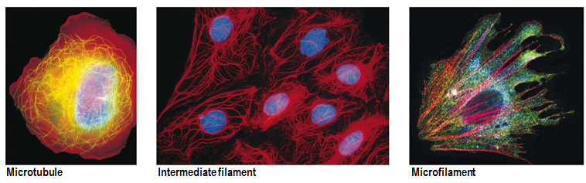
  - Ribosomes: function for protein synthesis.
- Another major difference between prokaryotic and eukaryotic is the NUCLEUS.
- In prokaryotic cells, the genetic material is in the form of a single naked DNA chromosome, free-floating in CYTOPLASM.
- In eukaryotic cells, the genetic material is CONTAINED WITHIN nucleus.
  - Nucleus is bound by a double membrane layer, called Nuclear envelope.
  - Nuclear pores in the envelope allow things like bits of ribosomes to move in and out, which are synthesized in the
  - Nucleolus (structure inside nucleus).
  - Within the eukaryotic cells, DNA and protein are organized into chromosomes (chromatin – refers to DNA and protein; not in prokaryotic cell).
  - The OUTER LAYER of the nuclear envelope is continuous with: THE ENDOPLASMIC RETICULUM.
- TO READ:
  - Chapter 2 (except 2.5)
  - Chapter 3

LECTURE 3
- Endoplasmic reticulum: series of flattened sacs and tubes.
  - Tubular membranes and cisternae.
  - Comes in 2 types:
    - Rough Endoplasmic Reticulum – Walls are studded with ribosomes, serves for major site of membrane protein and secreted protein synthesis.
    - Smooth Endoplasmic Reticulum – No ribosomes, and for lipid and steroid synthesis, detoxification (breaking down noxious chemicals, like liver).
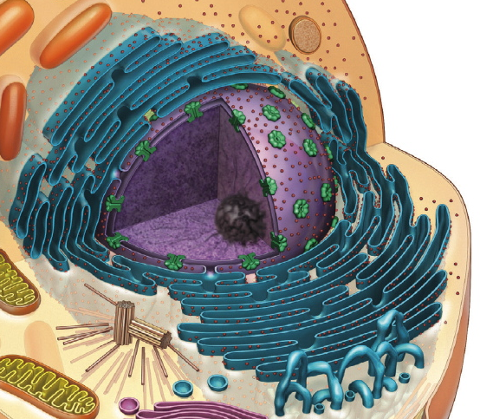
- Proteins that are synthesized in the ROUGH endoplasmic typically move to another membrane structure: golgi complex, by means of small membrane vesicles.
- Golgi complex is also a set of falltened sacs and vesicles.
  - Golgi complex is involved in sorting, modification and packing of proteins (like breaking them down, or adding tags to send them to particular areas).
- Vesicles: small single membrane bound organelles that shuttle proteins to different structures in the cell.
- In addition to vesicles, there are other small single membrane bound organelles throughout the cytoplasm, some of them involved in breaking down compounds by breaking down different bonds using specific enzymes
  - Lysosomes contain hydrolases.
  - Peroxisomes contain catalases.
  - They serve a variety of functions in term of breakdowns.
- Vacuole is a similar-looking organelle that serves in temporary storage, and is better known in plant cells.
- In plant cells, we have a large vacuole which helps with the Tugor pressure.
  - When a plant is short on water, central vacuole stops putting pressure on cells contents, making them withered. When watered, vacuole fills up with water, and exerts pressure on the other contests of the cell, called TURGOR PRESSURE, giving it a firm posture.
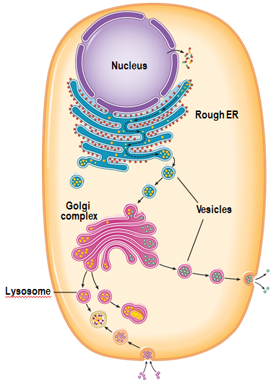
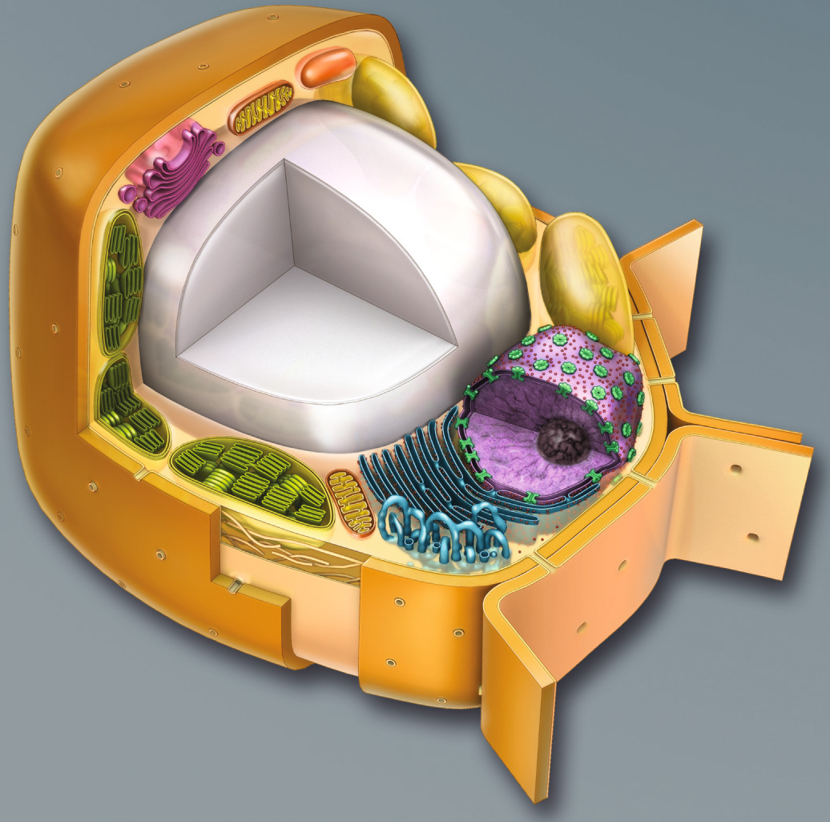 White thing is central vacuole.
- More organelles:
- Mitochondrion and chloroplast have common features. Both are relatively large, and BOTH bounded by a double membrane. They both have their own DNA, both a circular chromosome with naked proteins. Also, they have ribosomes to synthesize their own proteins, and these ribosomes are smaller fewer complexes than the ones found in cytoplasm of cell. These cells can’t be synthesized, only reproduce by binary fission, reproducing from pre-existing mitochondrion chloroplasts.
- Mitochondria: Inner membrane is highly folded, serving as an anchor for proteins involved in ATP synthesis. “The power house” of the cell, where ATP is synthesized through oxidative metabolism. mDNA
  - Around 2 microns.
  - Double membrane, cristae.
  - Oxidative metabolism yielding ATP.
  - Circular mDNA.
- Chloroplast: within double membrane, there’s a third layer of sacs called thylakoids, filled with chlorophyll, where LIGHT energy can be absorbed and turned into chemical energy (carbohydrates). cpDNA.
  - Around 5 microns.
  - Double membrane + thylakoids.
  - Conversion of light energy to chemical energy (complex carbohydrates).
  - Circular cpDNA.
  - Reproduce by fission.
- Mitochondrion chloroplasts remind us of prokaryotes.
MITOCHONDRIA | CHLOROPLAST | COMMON
-Around 2 microns.  -Inner membrane highly folded to anchor proteins involved in ATP synthesis through oxidative metabolism.  -Own genetic: mDNA. | -Around 5 microns.  -Layers of sacs called thylakoids in the double membrane filled with chloropgyll, which absorb light energy and convert it into chemical energy (carbohydrates).  -Own genetic: cpDNA. | -Both relatively large and bounded by double membrane.  -Both have their own types of DNA, circular chromosome with naked proteins.  -Both have smaller ribosomes than the ones in cytoplasm, used to synthesize their own proteins.  -Both reproduce by binary fission, from pre-existing mitochondrion chloroplasts.

- Endosymbiont theory
  - Mitochondria from incorporation of aerobic prokaryote.
  - Chloroplast from the later incorporation of cyanobacteria.
  - Evidence supporting this theory?
- Relationship between prokaryotic and eukaryotic cells.
- Prokaryotic cells arose before eukaryotic.
- Evidence that mitochondria and chloroplasts started from bacteria.
- Theory:
  - The cell probably gained food by ENGULFING things coming across environment, and probably engulfed smaller prokaryotic cells that were smaller aerobic bacteria.
  - Instead of breaking down the bacteria, they instead established a stable SYMBIOTIC relationship with the host cell. The bacteria probably provided the host cell with energy, and bacteria received a more stable and safer environment.
  - This incorporation came to become what we know now as mitochondria.
  - The prokaryotic cells that incorporated mitochondria then split up into two types of eukaryotic cells:
  - A second endosymbiont event happened to eukaryotic cells, where photosynthetic bacteria became chloroplasts for cells of plants and some protists. And the animal cells developed differently without chloroplast.
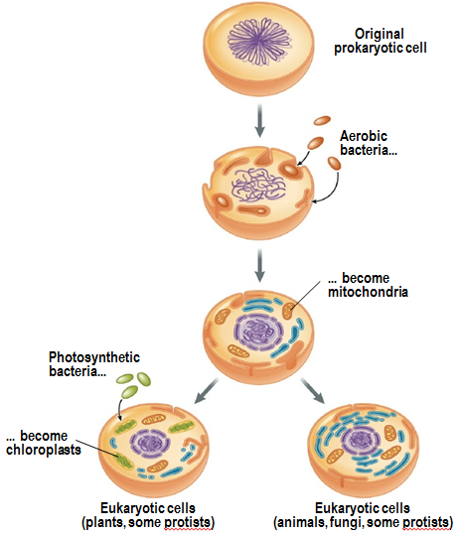
- Evidence:
  - 1- The fossil records showing who came first and such.
  - 2- The similarities between chloroplasts and mitochondria, and prokaryotic cells (similarities in size, DNA, protein synthetic machinery).
  - 3- The existence of present day examples of endo symbiotic relationships: animals living in symbiotic relationships with plants, like the Solar-powered Sea-slug, called Elysia chlorotica. Chloroplast got incorporated into the cells of the animal from the algae that it eats. They start off brown, but after feeding on algae they become green. Made possible by kleptoplasty, klepto meaning stealing, and thus carbohydrates can fuel the chloroplasts and make them functional in the cells of these animals.
- How does kleptoplasty in the sea slug differ from the endosymbiosis origin of chloroplasts?
    - In the sea slug, the chloroplasts are not passed on from generations. Born brown and turn green from eating algae.
    - In the case of endosymbiosis, it was a photosynthetic bacterium that was engulfed and had a two way relationship with the host cell. The sea slug takes chloroplast already as chloroplast, there’s no transformation like the case of endosymbiosis earlier on.
    - The mechanism in digestion is different. In sea slug, multi-cellular animal, it has to rip out algae to rip out the chloroplast. In the case of the origin, one prokaryotic cell that engulfed another.
- Answer the question: what is a cell?
- Describe the cell theory
- Describe the basic properties of cells
- Explain why cells are small
- Contrast and compare prokaryotes and eukaryotes
- List and briefly describe the organelles of eukaryotic cells
- Describe, with support, one theory on the origins of eukaryotic cells

- Topic 2, cell membranes.
- Fluid mosaic model coined by Singer and Nicolson and 1972. Same year as Bob Barker and price is right started. Fluid lipid layer with a mosaic of proteins.
- Functions:
  - 1. Membranes define the boundaries of the cell itself, and the boundaries of the organelles in the cell. At the same time, it makes a selectively permeable barrier, not everything can cross.
  - 2. Once membranes are in place, they are useful as organizing tools, organizing enzymes on membranes for activities like ATP.
  - 3. Membranes are also involved in regulating the transport / movement of solutes in and out of the cell and in and out of organelles. Examples like Na, K – ATPase.
  - 4. Membrane is the first point of contact between the cell and its environment, and so the membrane contains receptors, proteins, that allow it to respond to environmental signals. Takes the form of DETECTING the signal, and turning it into a cellular response, signal transduction.
  - 5. In a multi-cellular organism, membrane is an important spot for recognizing other cells in the environment. Linking of cells happens are membrane. They have to recognize each other and have an attachment, and have a way to exchange materials, making communication junxions through the membrane structures.

- 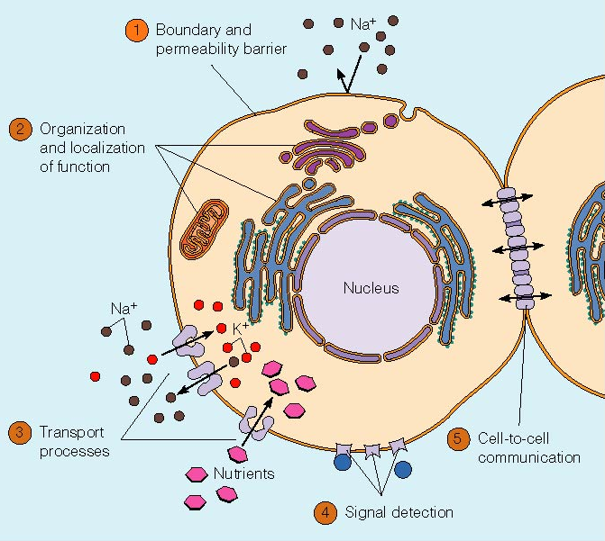
- Proteins are just floating around the fluid lipid layer.
- In one sense, all membranes are the same in basics structures and constituents.
- Membranes can be tailored in terms of structure, to the function they’re carrying out.

- Inner membrane of mitochondrial membrane is rich in protein, as a result of the proteins involved in the electron transfer chain.
- 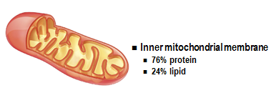
- On the other extreme, the plasma membrane of the Schwann cell (MYELIN SHEATH) that form an insulating layer around neurons, are enriched in lipid. A generic membrane is usually about 50/50 split.
- 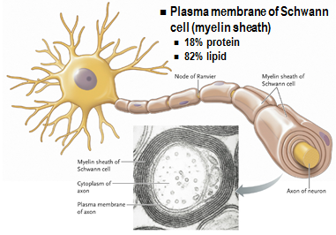
- In fluid mosaic model, we have a double layer of lipids, held together by non-covalent interactions, allowing it to be highly fluid, and this lipid bilayer forms the structural basis of the membrane and is the basis of the permeability barrier, because not everything can get through lipids.
- Then studded into the lipid bilayer is the unique compliment of proteins of the particular membrane, and they are responsible for the specific functions of the membrane.
- The whole thing is 10 nanometers thick. (1)
- To show the fluid nature of the membrane, there are a couple of ways:
  - 1. An experiment. They took two cell lines (one human, one mouse), and they labeled proteins in those cell lines with different colors of fluorescent labels (mouse got green, human red). They then fused the cells together, (if membrane is not fluid, we would expect membrane would be half red and half green) but what they actually found, in a short period of time, the signals were mixed all over the fuzed cell. (2)
  - Lateral diffusion, when a protein or lipid moves around within the membrane itself.
  - 2. Second technique is used to assess how mobile a membrane constituent is, called FRAP (fluorescence recovery after photobleaching). You take a cell, and you label membrane components of interest with a fluorescent marker (could be proteins or lipids etc.). Then you direct a strong, highly focused laser at part of the cell, and you bleach the fluorescence by over-exposing it to light. Then you see how quickly the fluorescence re-appears. The component labeled is mobile, it will move to bleached area and fluorescence comes back. If it’s NOT mobile, the bleached spot will remain. (3)
- (1)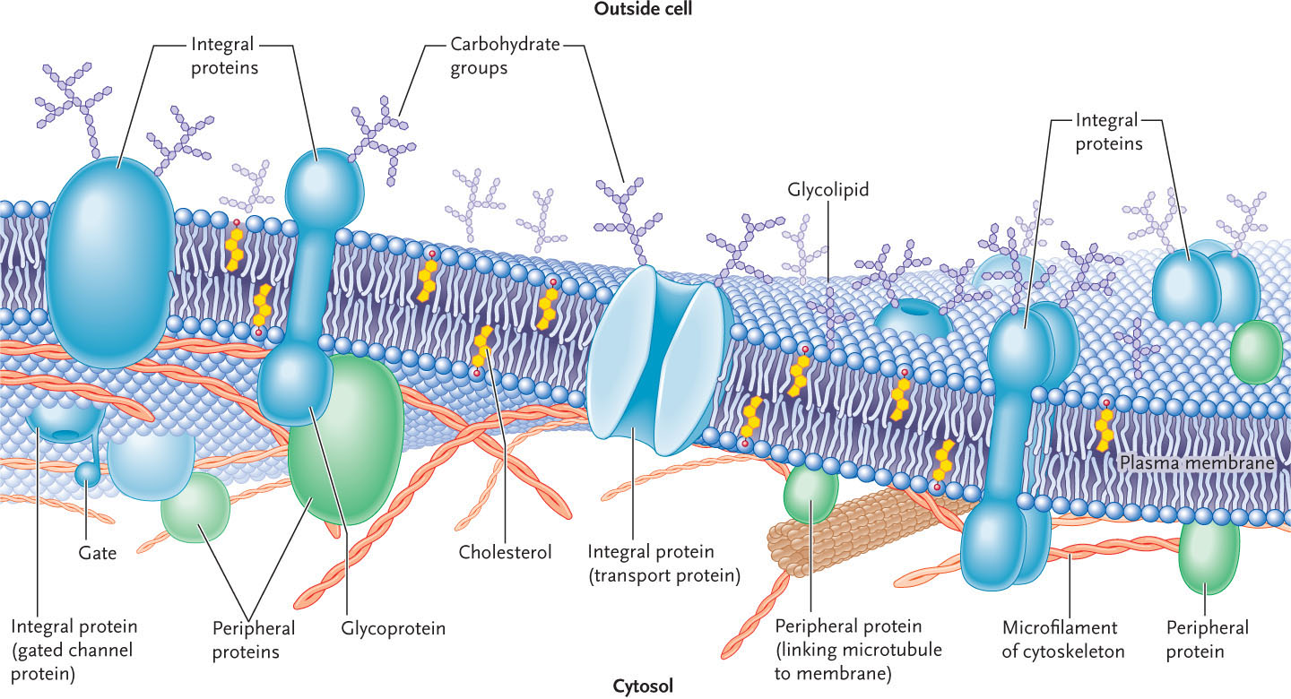
- (2)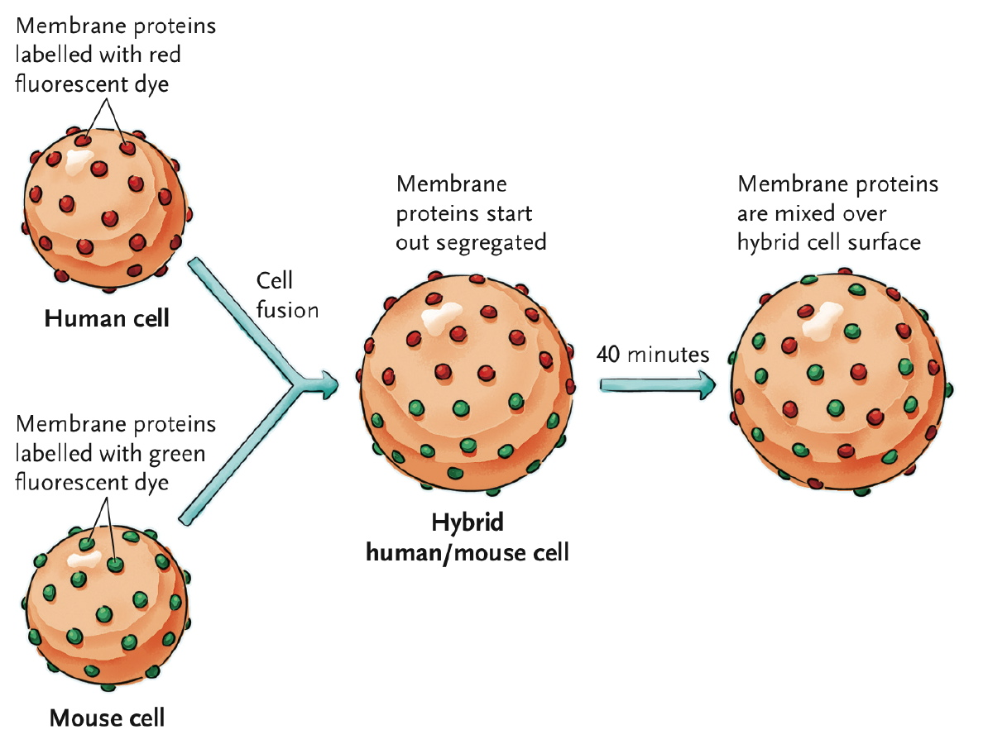
- (3)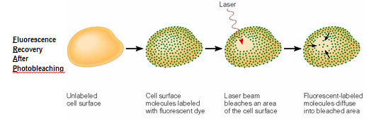
- Thus, here’s an overview: Fluid mosaic model has a double layer of lipids, which are pretty much the backbone structure and are held by non-covalent interactions. The proteins inside hold specific functions and the movement of proteins within the membrane are called lateral diffusion.
- What makes up lipid bilayer?
- Gorter and Grendel, in 1925, measured the area of the cell and predict how much lipid you would expect to have on that area, and then they measured the amount of lipid they actually recovered, and found the amount was 2x as much as predictions, suggesting membrane is made of two layers of lipids, a lipid bilayer, becoming the backbone structure.
- 3 broad types of lipids found in it:
  - Most prominent, bulk of membrane, phospholipids. Two main kinds of phospholipids:
    - Phosphoglycerides (amphipathic) – Build on a glycerol backbone, a 3-carbon molecule. 2 separate fatty acid chains (hydrocarbon chains) are linked to 2 of the glycerol carbon backbone. If every carbon is occupied by the maximum number of hydrogen allowed, they are called saturated with a series of single bond. If there are double bonds, it is unsaturated. Saturated are straight, linear fatty acids. Unsaturated fatty acid has a kink everywhere there is a double bond, a “bend”.
      - The 3rd carbon of the glycerol backbone is linked through a phosphate group, a “polar head group” called “R group”. There are 4 main polar head groups: serine, choline, ethanolamine, and inositol. The head, once again, is polar, and thus hydrophilic. The hydrocarbon chains of fatty acids are NON POLAR, and hydrophobic. Because it has both ends like that, it’s an amphipathic molecule.
- 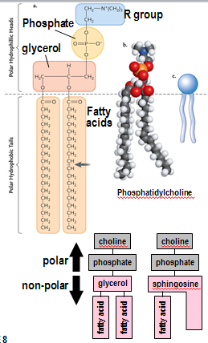
    - Sphingolipids or sphingomyelin – Slightly different structure. Built on a sphingosine backbone. Sphingosine has a long hydrocarbon chain as part of the molecule itself. Sphingolipids have only ONE fatty acid attached. The backbone provides the other hydrocarbon chain.
      - Sphingomyelin is an important sphingolipid, and the head group is phosphate and choline. Sphingomyelin is an important constituent of animal cell membranes, and is absent from plants and bacteria.
      - Both have amphipathic nature. Head groups of both give Polar Regions, and the hydrocarbon chains of fatty acids / sphingosine give a non-polar hydrophobic region.
      - If these molecules were dumped into water, they would form structures based on the amphipathic nature. Because of this, you get a lipid bilayer.

- What organelle(s) might be particularly abundant in a cell that produces digestive enzymes for secretion into the intestine? Maybe rough endoplasmic reticulum. Lysosomes have digestive enzymes in them, but it’s for its own use, not for export. Golgi complex is one as well as endoplasmic reticulum.
- What evidence supports the hypothesis that mitochondria originated as free-living aerobic bacteria? Mitochondria have their own DNA, single circle DNA chromosome similar to that of bacteria. They have naked DNA, no protein associated with the chromosome. They’re small, fewer subunits, resemble bacteria ribosomes. Mitochondria can’t be synthesized, they come from pre-existing mitochondria. Similar in size to prokaryote, double membrane, fossil record. How they reproduce- binary fission, same method as bacteria.
- What is kleptoplasty? Why is it significant**? An organism extracts chloroplasts from an algae organism to use it as food. Talking about sea slug particularly, that extracts chloroplasts from the algae it eats and incorporates into cell to make food. Why is it important*? Symbiotic relationship, led to the evolution of chloroplasts and mitochondria.
- Who proposed the fluid-mosaic model of membrane structure? When? Singer and Nicholson in 1972.
- Sketch a phosphoglyceride and use your sketch to illustrate its amphipathic nature*.
- 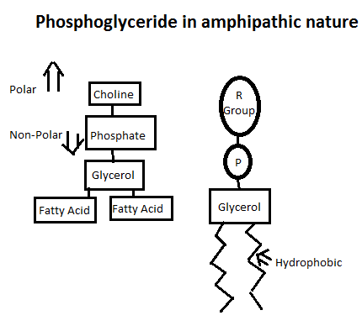

LECTURE 4
- Hydrophobic interactions:
- 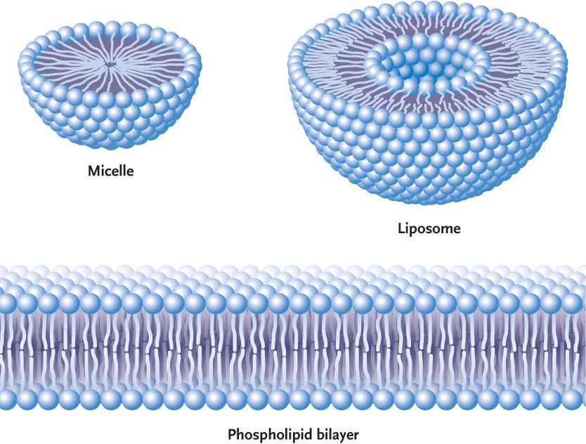
- Polar head groups facing aqueous environments, and non-polar are facing inwards.
- In addition to phospholipids, there are 2 other types of lipids found in membrane:
  - Glycolipids – Similar to phospholipids in structure, but main difference is instead of phosphate and R group, they have SUGAR. They can have single sugar units, or strings of sugar units (oligosaccharides). Carbohydrates extending outside of cell, commonly used as antigens, or “recognition signals”, like the A-B-O blood groups.
    - 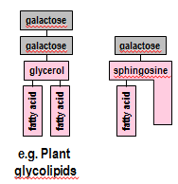

  - Sterols (steroids) – Particular type of steroid. Steroids as a group are characterized by the presence of a 4-ringers hydrocarbon skeleton, 4 hydrocarbon rings linked together. In the case of sterols in particular, on the 4-ring framework, there is a hydroxyl group at one end (polar) and a hydrocarbon chain at the other end (non-polar). As a whole, this molecule is quite non-polar except for the small OH group, and because of that it inserts into the membrane in a particular fashion: The hydrocarbon rings are buried in the fatty acid chains, and the small polar hydroxyl group is oriented toward the polar head groups of the phospholipids. Sterols vary in different groups:
    - Absent from prokaryotes. Found in membranes of eukaryotic cells only.
    - In some protists and all animal cells, the main sterol is cholesterol.
    - Plants have their own version of sterol, called phytosterol.
    - And fungi also have their own, called ergosterol.
  - This 4 ringed structure is quite rigid compared to fatty acid tails/chains on phospholipids.
- 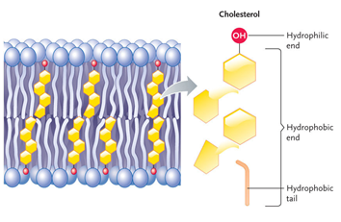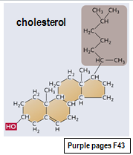
Test your knowledge: could be on midterm.
- The lipid bilayer functions as a permeability barrier because…
  - The lipids are held together by covalent bonds that prevent unwanted movement across the membrane.
  - It is difficult for hydrophilic molecules to traverse the hydrophobic core of the lipid bilayer.
  - The lipid bilayer is thick, so that the diffusion distance becomes too great for rapid transit across the lipid bilayer.
  - The glycolipids of the lipid bilayer recognize and bind molecules that the cell wishes to exclude.
  - None of the above.
- Explain your answer.

Test your knowledge 2
- Which of the following remedies is likely to be most effective against athlete’s foot, a fungal infection of the human foot?
  - Oseltamivir, an anti-viral agent better known as Tamiflu.
  - Micronazole, an inhibitor of ergosterol synthesis.
  - Penicillin, an inhibitor of peptidoglycan (bacterial) cell wall formation.
  - Sodium azide, an inhibitor of oxidative metabolism.
  - None of the above.
- Explain your answer. (B)
  - Micronazole would kill the bacteria only, not the foot too like sodium azide.

- Now let’s talk of properties.
- Lipid bilayer: The two halves are NOT the same, membrane asymmetry.
  - There are two halves, and lipids are distributed unequally. Happens by the way the membrane is synthesized, membrane biogenesis.
  - 3 forms of diffusion:
    - FLIP-FLOPS (rare because it’s hard for polar head group to pass through polar centre).
    - ROTATION.
    - LATERAL DIFFUSION.
  - 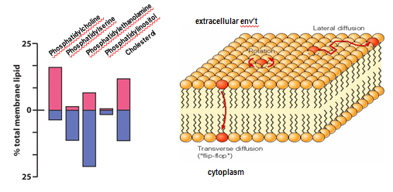
- ^ Add a bar for glycolipids with bigger purple bar because they face the extracellular environment more.

- Now, properties of Membrane Fluidity: The fluid nature of membrane is essential for function. Fluidity reflects:
  - Carbon chain length and saturation.
  - Head group polarity.
  - Buffering effect of sterols.
  - Temperature.
- You can’t have a membrane TOO fluid, it won’t be organized enough. Nor can it be too RIGID, because the function depends on it on being mobile. Temperature is very influent on membrane.
  - As temperature falls, the phospholipids of the membrane pack together, leaving you with a structure that’s fairly stiff or rigid.
  - At warmer temperatures, they are looser and more dynamic, having a more fluid-like structure.
  - It’s like keeping butter in the fridge where the lipids get packed together, vs. keeping it on the counter where they are no longer packed tightly, being more fluid.
- 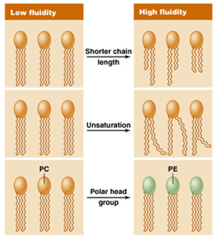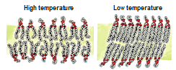
- The chemical composition of the membrane also affects how they pack together. Saturate fatty acids give less fluid membrane than unsaturated fatty acids with double bonds; get packed more tightly and faster.
- The lengths of the hydrocarbon chains in fatty acids help determine fluidity. Mix of long and short chains, they don’t pack as tightly and are more fluid, thus increasing it.
- Another thing affecting fluidity is the nature of the head group. Phosphatidylcholine is circular so it gets packed more and more rigid, less fluid.
- The head group of Phosphatidylethanolamine is more of a cone, so more fluid.
- Another thing affecting fluidity is the effect of sterol. When you insert a 4 ring structure into a membrane, at cold temperature the structure prevents it from packing tightly and keeps it fluid.
- However, at higher temperatures, when they are most fluid, structure acts as stability for it now.
- Low temp – sterols increase fluidity. High temp – sterols lower fluidity.
- Sterols buffer the effect of temperature, and keep the right degree of fluidity.
- It is important in maintaining the correct degree of fluidity. Membrane fluidity has to be kept in a fairly narrow range for an organism to survive.
- When temperature changes, organism goes through a CHANGE in membrane composition to maintain the desired fluidity, called homeoviscous adaptation, adjusting the chemical composition in the membrane to maintain fluidity at different temperatures.
  - It makes alterations in lipid composition to maintain membrane fluidity at different temperatures.
  - Responses can happen within an individual organism, like the example below, rainbow trout. It can live at temperatures between 5 – 20 degrees. A fish living in 5 degrees was moved to 20 degrees. The increase in temperate makes the membrane more fluid. To compensate, there was an increase in PC/PE decrease to reduce fluidity and counteract the effect of increase in temperature. Can also have increase sterols to buffer effect of temperature, etc.
  - Evolutionary responses.
- 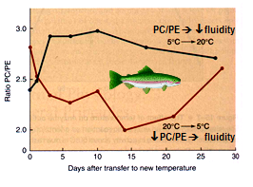
- Dietary adjustments of fluidity in semi-palmated sandpiper:
  - Migratory flight from summer to winter habitat includes 2-week stop-over at Bay of Fundy before a trans-oceanic journer.
  - Feed on mudshrimp high in PUFA.
- PUFA: Polly unsaturated fatty acids.
  - PUFA-rich diet increases PUFA in membranes and fatty acid mobilization for flight indurance.
- Intrigued Webber and Maillette. They hypothesized that the value of eating mud shrimp was to make it easier to add fatty acids into them for the exercise they will be doing.
- They measured the activity of the enzyme citrate synthase (CS), a mitochondrial enzyme involved in ATP regeneration. The bird setting off on a 3 day flight wants to maximize on these.
- They found increases in enzyme activity, but also it correlated with the increase in fat in the animal and they suggested this might be a causal relationship that the increase in body fat through membrane signaling might be the cause of increase of CS.
- But not enough data to prove the relationship data. Only a theory that perhaps they were linked.
- 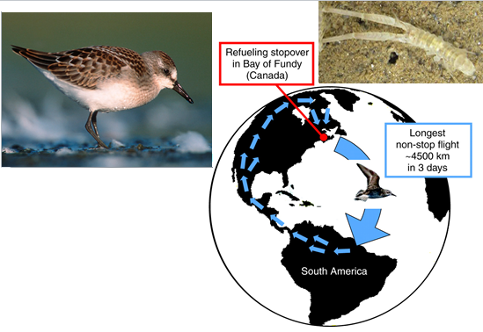
- 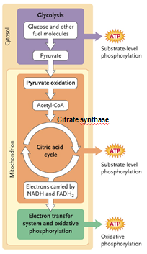
- Later on, someone took an experimental approach to show that this was causative, in other words it was the increase in fat causing the increase in enzyme activities.
- She needed a bird that does not normal show an increase in enzyme activity, choosing the quail, “couch-potatoe”.
- What they did was feed the birds with diets rich in fatty acids, to see if it increased CS activity. And it did.
- They were able to take Quails and turn them into endurance athletes by feeding them unsaturated fats. This changed the composition of the membranes as well as acts as a signal to train the muscles for endurance activity, to increase key enzymes for this activity.
Test your knowledge...
- A protist (Giardia) is suddenly expelled from a warm human intestine into cold water. Which of the following adjustments might the protist make to maintain membrane fluidity following this change in temperature?
  - Decrease the length of the hydrocarbon tails in its membrane phospholipids.
  - Decrease the proportion of unsaturated hydrocarbon tails in its membrane phospholipids.
  - Decrease the amount of cholesterol in the membrane.
  - Decrease the proportion of phosphatidyl-choline relative to phosphatidylethanolamine.
  - Both (a) and (d) would be appropriate responses for the protist to make to maintain the same level of membrane fluidity following the change in environmental temperature. Explain your answer. (E)
What I should have learned:
- By the end of this lecture you will be able to...
  - Describe the fluid mosaic model of membrane structure
  - List and explain the functions of cell membranes
  - Distinguish, with examples, among phosphoglycerides, glycolipids and sterols
  - Explain, with examples, membrane asymmetry
  - Define homeoviscous adaptation and explain several mechanisms through which it is accomplished
  - Describe the benefits of a PUFA-rich diet to birds
  - Describe a technique used to investigate mobility in membranes
  - Distinguish between correlation and causation
Membrane proteins
- Mosaic component of the fluid mosaic model.
- Functions include:
  - Transport
  - Enzymes
  - Signal transduction
  - Attachment / recognition
  - 3 types: integral membrane proteins (buried in membrane), peripheral membrane proteins (attached to one side by non-covalent linkages), lipid-anchored proteins (covalently attached to membrane through lipids).
  - Proteins are responsible for the functions of the membrane.
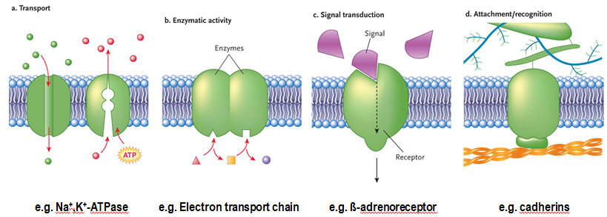
- If membrane is involved in solutes, it is (a) Transport.
- If involved in reactions with enzymes, and enzymes attached to membranes, an example is the proteins of the electron transport chain, (b) Enzymatic activity.
- Membrane proteins responsible for detecting signal and transducing signal into cellular response (c) Signal Transduction.
- If involved in attachment, either between cells or between cells & extracellular structures surrounding it (d) Attachment / recognition, example of cadherins.
Integral membrane proteins
- They are proteins embedded in membrane, amphipathic, with hydrophilic components in aqueous environments on the sides, with the hydrophobic component extending through membrane holding it in place. Amphipathic with one or more hydrophobic regions.
- Single pass trans-membrane protein (one protein going) and multiple trans-membrane domains, a multi pass trans-membrane proteins. Example below, where multiple domains or piece going from one side to the other.
- Transmembrane domains have a characteristic structure. Usually 20-30 amino acids long, usually all hydrophobic. They often adopt an alpha helix confirmation, meaning
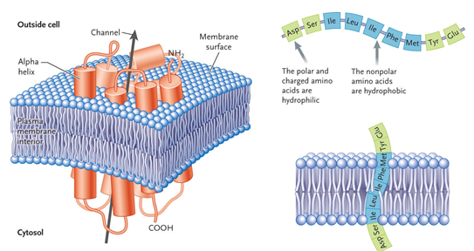
- Recall amino acid, polypeptides and protein structure.
- To get a protein, amino acids have to be linked together by peptide bonds, and that peptide chain has to fold into the native confirmation of the protein.
- 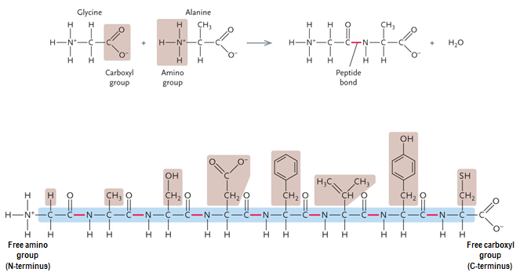
- The types of R groups determine the properties of the proteins and amino acids. They can be non-polar, polar but uncharged, polar and charged, occasionally reactive and react with other groups.

For lectures 3 and 4, read CHAPTER 5
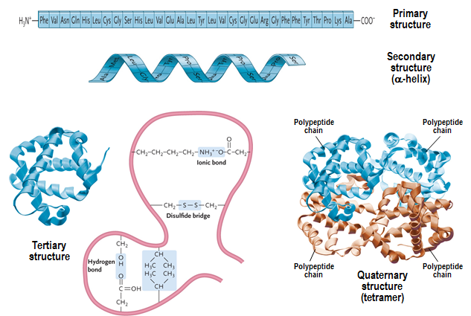
LECTURE 5
- Info in [Chapter 5], [page 320 figure 14.2], [Chapter 35.2b, c, figure 35.4].
- Referring to the picture above. Going from a peptide chain to a protein.
- The string of amino acids is referred to as the primary structure of protein. Then the polypeptide chain folds to give you the native confirmation of the protein. Can happen at different levels. There can be minor areas of the peptide chain to fold into structures of an alpha helix. Occurs of hydrogen bonding along backbones of protein, in variety of areas within polypeptide chain, and alpha helix is an example of secondary structure.
- Polypeptide chain as a whole fold into the final confirmation of the protein, called tertiary structure, and is occurred from interaction between the various R-groups in the amino acid residues making up the polypeptide chain. Example: ionic bonds can form between positively and negatively charged R-groups. Hydrophobic bonds can form where there are 2or more non-polar R-groups. We can get hydrogen bonding, where polar R-groups get together. One type of covalent linkage that can occur, the disulfide bridge, occurs when 2 reactive sulfhydryl groups form a covalent bond.
- These types of interactions among the R-groups determine the overall structure / confirmation of protein, and this tertiary structure is important when talking about functions of protein.
- For completeness, many proteins are made up of many polypeptide subunits, and how the polypeptide chains fit together is called quaternary structure (tetramer). 4 polypeptide chains come together, and the way they come together is ^. And when they form as 4, its called a tetramer, having 4 subunits.
- 3 types of membrane proteins: Integral, Peripheral and lipid-anchored. Both are found on the surface of the membrane.
- Peripheral membrane proteins
  - Held on external or internal surface of membrane by means of non-covalent interactions between the peripheral protein, and the membrane. Can be between peripheral protein and lipids in membrane, or between integral membrane proteins. Can be hydrophobic interactions, hydrogen bonding, etc. Because held by non-covalent interactions, can be quite easy to remove from membrane, and have dynamic relations with membrane.
  - Small changes in pH, or ionic strength, tends to move proteins off membrane. And can be put back in place quite easily, thus why they’re dynamic.
  - Peripheral proteins are important as “linking protein” between membrane itself and cytoskeleton, one type being proteins linking membrane proteins to cytoskeleton underneath.
  - Example: membrane-cytoskeleton “linking” proteins.
- 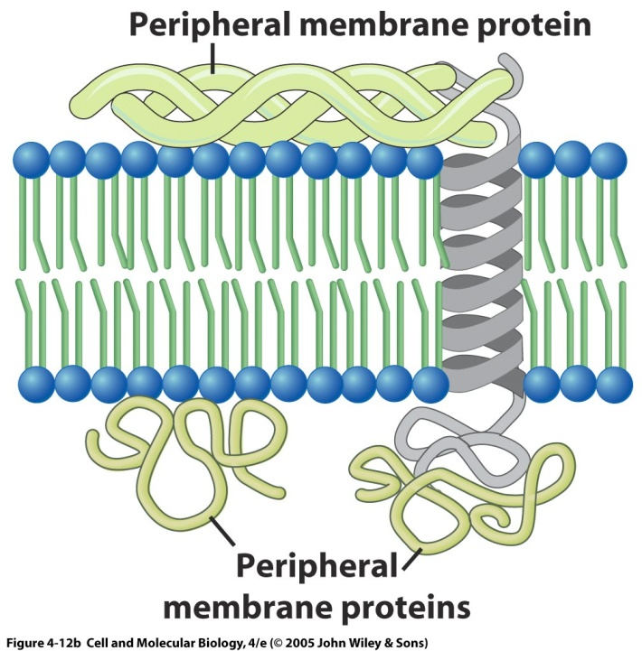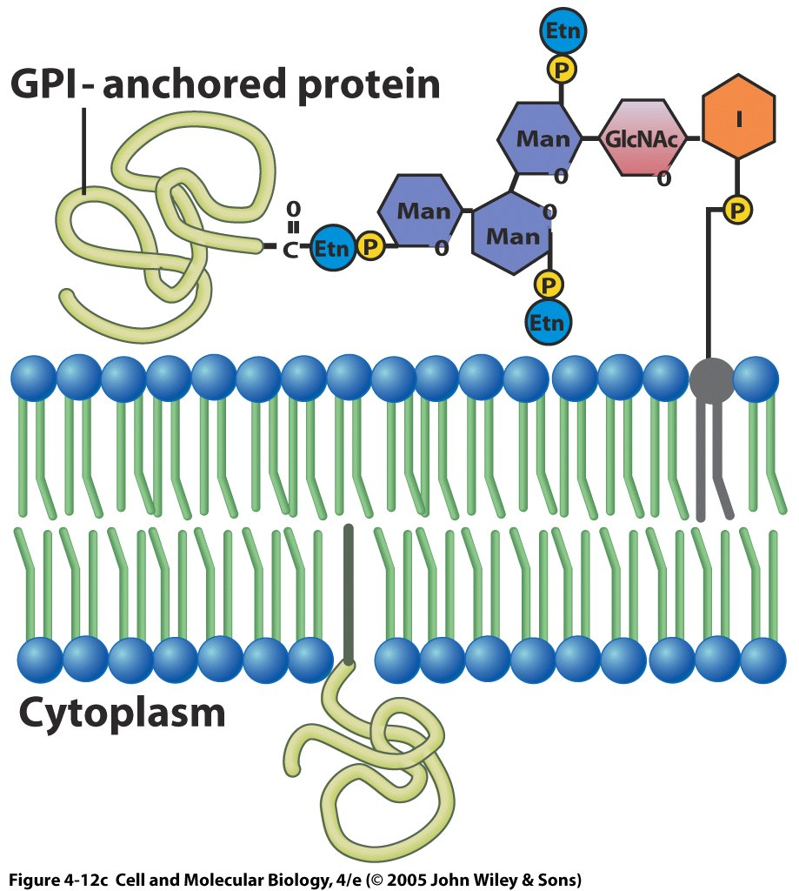
- Lipid-anchored membrane proteins are found on one surface of the membrane or the other, but in this case are held by means of covalent interaction with lipids present in membrane. There are 2 types:
  - On cytosolic side, you find fatty acid anchored proteins, covalently bonded between protein and fatty acid. Acid is inserted into membrane, by hydrophobic interaction, and then attaches protein to membrane, extending out on surface.
  - These fatty acid anchored proteins always have a cytosolic orientation, “inner leaflet” of membrane.
  - Membrane-associated through covalent linkages to phospholipids.
  - Fatty acid anchored intracellular orientation, like G proteins:
  - GPI anchor: (glycosyl [carbohydrates group attached] phosphatidlinositol)
    - Extracellular orientation.
    - Cleaves with phospholipase C (enzyme that will cleave GPI linkages, freeing protein from membrane).
    - Example: type 4 carbonic anhydrase. Found in kidneys helping reabsorption of solutes, and in other places of your body.
    - GPI anchored because proteins are attached by covalent linkages to the carbohydrate / glycosylated phospholipid. Protein extends into external environment.
  - GPI outward, fatty acid inward.
  - How can the different properties of membrane proteins be used to distinguish among integral, peripheral and GPI-linked (lipid-anchored) proteins experimentally? (looking at all proteins how can you distinguish what kind of protein it is)
    - Raise pH, play ionic bonds, use detergent. Use phospholipase C, if it’s not GPI, must be integral. Must go inside and take it out of membrane.
- Phospholipid bilayer is a permeability barrier, but can be overcome by proteins, the idea of movement across membranes. Remember the phospholipid bilayer is only a permeability barrier for things that can’t cross through the hydrophobic center of it. NONPOLAR molecules are able to cross it easily, especially if small like oxygen, can easily diffuse across.
- Overview:
  - Importance of size, polarity/charge, gradient.
- Problem comes for molecules that are POLAR / CHARGED. Molecules that are polar and small, like water, are still able to get through hydrophobic core of the membrane. But… Anything that is LARGE, and/or charged, cannot get across membrane.
- Anything that carries a charge, ions, is unable to get across membrane, because although it is small, when it’s charged it gathers water molecules around it. Below 100 Daltons can get through, above 100 they can’t.
- How?
- Based on how easily a particular compound moves across membrane, and DIRECTION of movement, with or against gradient, we can distinguish among different types of transport.
  - Passive transport: transport of molecule with the gradient. Typically molecules are more abundant on one side than other. If they move to less abundant side, downhill movement, they can move by passive transport, having 2 diffusions:
    - Simple diffusion: molecules that can simple move through membrane.
    - Facilitated diffusion: some type of protein transporter is involved.
  - To move solutes AGAINST the gradient, going from where they are less to more abundant, requires the INPUT OF ENERGY, bring on active transport.
  - Active transport: uphill movement ^, requires transport protein AND expenditure of energy.
    - Primary
    - Secondary
- Passive transport:
  - Relies on diffusion:
    - Molecule of interest is moving DOWN its diffusion gradient, from more abundant to less. Simple diffusion.
    - Depending on molecule, different types can be distinguished of driving forces/gradient. Example: for solutes without charge, diffusion gradient is a concentration gradient. Solutes without charge concentration gradient.
    - For gasses partial pressure gradient.
    - For ions electrochemical gradient.
    - For water osmotic gradient/
- 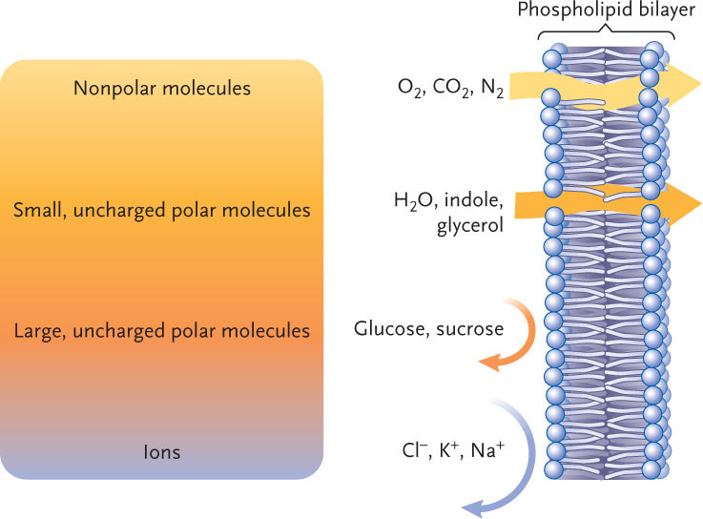
- Solution is hypertonic when shrivelled, because solution is more concentrated than the cell.
- Solution is hypotonic when swelled, because solution is less concentrated than the cell.
- Isotonic solution is perfect.
- Whether movement down gradient needs transport protein or not, membrane permeability determines if diffusion is simple or facilitated diffusion.
- Simple diffusion: molecule can cross membrane WITHOUT TRANSPORT PROTEIN. Either lipophilic, or small POLAR molecule, can get through membrane without transport protein.
- Facilitated diffusion needs transport protein. Molecule can’t get across membrane, polar and larger and/or hydrophilic molecules. In graph, when approaches maximum rate when all transporters occupied, its saturation kinetics.
- 2 basic types of transport proteins:
  - Channel proteins
  - Carrier proteins
- Channels are 1 mechanism, integral membrane proteins, through which facilitated diffusion can occur. They are integral, and also trans-membrane. Outside of protein, there are hydrophobic residues that hold the channel in the membrane, but in the center of the protein there is a hydrophilic pathway, and is highly selective for the typical solute transported, and is usually an ion. There is also a channel for water, called aquaporin. (*_
- You can get inhibitors that bind to protein and inhibit facilitated diffusion.
- Leak channels are ones open all the times. Gated once are open/closed, and can be gated according to: membrane potential and ligands. (Example: Voltage-gated, and ligand-gated). (**)
- Voltage gated potassium channel, closed under normal conditions, but when membrane depolarizes and thus changes membrane potential, then channel opens allowing potassium ions going through it.
- In ligands, a chemical messenger binds to channel and tells it to open or close.
- 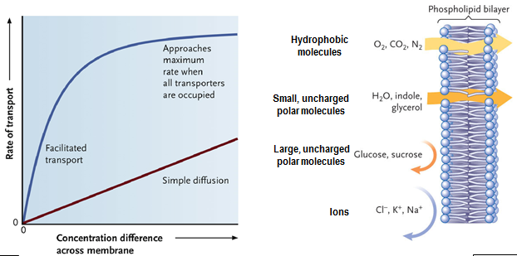
- (*)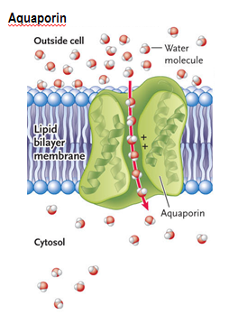(**)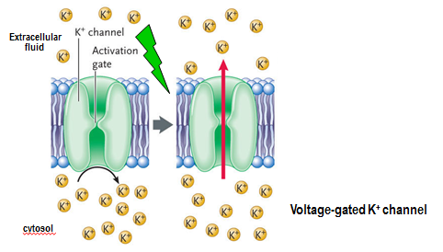

- The facilitated diffusion carrier proteins: share many of same properties as channels. Also integral and trans-membrane proteins.
  - Ions, larger and/or polar molecules.
  - Highly selective of particular solute they move.
  - UNIporter, CO-TRANSporter (symporter), EXCHANGER (antiporter).
  - Inhibitors can block role in transport.
  - Direction of solute movement driven by gradient. If outside to in, operates one direction. If you flip it, so it’s inside to out, it will go in the opposite direction.
  - Mechanism of action is a little different than channels. Carrier protein is a protein that has 2 stable confirmations, and it flip flops back and forth between them, depending on whether solute of interest is bound to them. By flip flopping, it moves solute across membrane. (1)
    - Carrier protein is in resting state solute binds to it changes confirmation then releases solute back to starting confirmation.
    - Net effect of confirmation changes is a molecule of solute is moved from one side of membrane to the other.
- (1)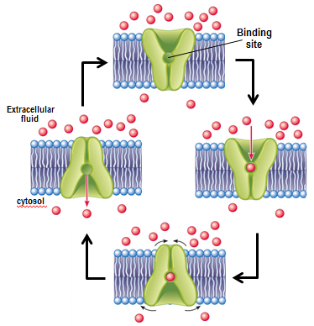
- UNIporter, CO-TRANSporter (symporter), EXCHANGER (antiporter). (2)
  - These are the types of carrier proteins.
  - UNIPORTER: single solute moved across membrane.
  - CO-TRANSPORTER: transport two solutes in SAME direction.
  - EXCHANGER: transport two solutes in OPPOSITE DIRECTION.
- (2)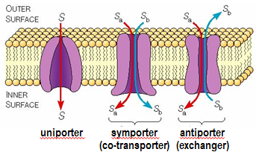
- To move solute UPHILL, against its active gradient, we go to active transport. ^ This was all passive.
- Active transport:
  - Carrier-mediated movement AGAINST gradient by coupled input of energy “pumps”. Expenditure of energy to move against gradient. Requires integral membrane proteins that undergo confirmation changes moving the solute across the membrane as it cycles through confirmations. In this case, part of the process is the hydrolysis of ATP. These types of proteins are called PUMPS.
    - Highly selective and UNIdirectional.
  - Primary active transport: Expenditure of energy, hydrolysis of ATP BY the transporter, to move solute against gradient.
    - ATP HYDROLISIS directly coupled to transport of solute AGAINST its gradient. These can be used by sodium pumps. 2 types of pumps:
    - Several types: P-type and V-type.
    - P-type: Phosphorilation type pump.
      - Move cations (Na+…) and unique that when ATP is hydrolyzed, the phosphate group taken off ATP is temporarily ATTACHED to the transport protein.
      - Become reversibly phosphorylated (example: Na+, K+ - ATPase).
    - V-type: Vacuolar type pump.
      - Move H+
      - Originally discovered on vacuoles but are also on plasma membranes. Same idea as other pump, hydrolyze ATP, to move protons against diffusion gradient, but there is no temporary attachment of phosphate to pump.
    - 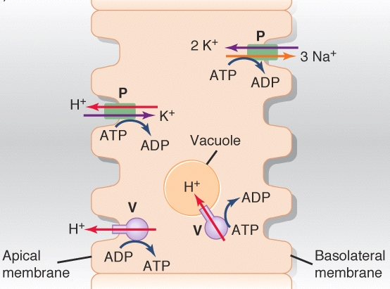
  - 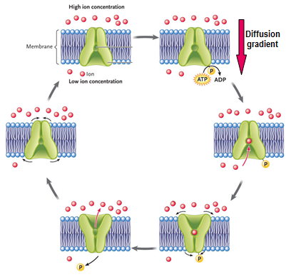

- Secondary active transport
- There is a primary pump that creates a gradient by pumping the solute AGAINST diffusion gradient, and the energy of that gradient is then used to get a SECOND solute into the cell, AGAINST its diffusion gradient.
- (2). In this picture, hydrogen ions are pumped out of cell by primary pump, creating gradient of HIGH H+ outside, LOW H+ inside. Hydrogen ions then move BACK into the cell, DOWN that gradient, and the movement is coupled to a second solute in an UPHILL fashion, called secondary active transport, where the second solute is being moved into the cell through the use of a gradient generated by a primary pump.
  - Simultaneous transport of two solutes.
  - Downhill transport along gradient established by primary transport allows uphill transport of second solute.
    - Na+ gradient in animal cells.
    - H+ gradient in plant cells.
  - (1)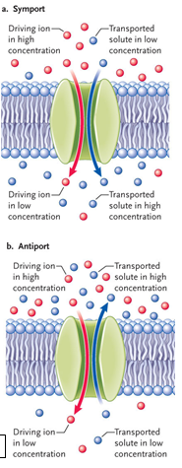(2)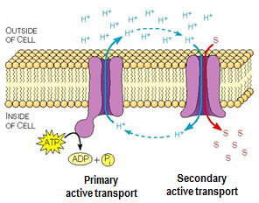

- Highlights:
- Membrane proteins
  - Integral (amphipathic, transmembrane), peripheral (associated with membrane via noncovalent interaction), lipid-anchored [fatty acid anchored (intracellular) or GPI anchor (extracellular) – covalent linkages]
- Transport
  - Passive transport – down diffusion gradient.
    - Simple diffusion – lipophilic solutes.
    - Facilitated diffusion – Channel or carrier proteins (highly selective, can be inhibited, show saturation kinetics). Channels are integral proteins that form hydrophilic core. May be open (leak) or open/close according to membrane potential (voltage-gated) or chemical signals (ligand-gated). Carries are transport proteins that undergo conformation changes with binding of solute.
  - Active transport – carrier mediated (so shows saturation kinetics) against diffusion gradient with expenditure of energy; pumps are selective, can be inhibited and pump only in one direction.
    - Primary – pump hydrolyzes ATP, 2 types [P-type (N,K, ATP), V-type (proton pumps)]
    - Secondary – gradient established by primary pump is used to move a second solute across the membrane against its gradient.
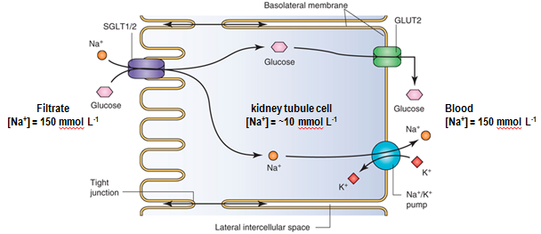

- ^ Example of kidney cell (kidney filters blood). In kidney cells there is a filtrate on one side of kidney cells, and thing in filtrate that need to be kept, have to be MOVED across kidney tubule into the blood. There are many transporters in kidney tubules that recover/reabsorb solutes from the filtrate into the blood, using a variety of different mechanisms.
- Example above is the secondary active transport mechanism. Identify 1) pump involved 2) ion being used to generate gradient (drive movement) and 3) the second transport protein involved (what is the solute of interest)?
  - Sodium/potassium ATPase. Pump is operating to move sodium out of cell (uphill movement) concentration of sodium inside of cell is lower than that of blood.
  - Cell is pumping sodium in order to reabsorb glucose. Glucose is the FOCUS of this secondary active transport mechanism. Through the sodium-glucose co-transporter. A pump creating a gradient keeping sodium LOW in cell, sodium can thus move into the cell, DOWN the gradient, and as it does so, it carries glucose in with it. A secondary active transport mechanism – expenditure of energy to create the sodium gradient, entry of glucose, ALONG that sodium gradient.
  - Now we have glucose in the cell, against gradient (low to high), how does it get out again into the blood. Through the uniporter, a carrier protein, facilitated diffusion mechanism. Moves WITH diffusion gradient, just needs help getting across the membrane.
Can you differentiate between …?
- A peripheral membrane protein and a fatty-acid anchored membrane protein?
  - Peripheral is easily removed by change in temperature or pH because they are bonded by non-covalent bonds.
  - Fatty-acid: Only removed by membrane through actions from the enzyme because they are bonded by covalent bonds.
- Passive transport and simple diffusion?
  - Passive: Involves carriers or channels (transport proteins) and refers to simple diffusion AND facilitated diffusion. Pretty much anything that’s moving across membranes with its diffusion gradient.
- An integral membrane protein and a channel protein?
  - Integral membrane protein is a broad category, like channels, carriers, receptors.
  - Channel is a certain TYPE of integral membrane protein. Hydrophilic pore through it.
- A channel and a carrier?
  - Both are transporters.
  - Solutes simply pass through a channel.
  - Solutes bind to carriers and are brought along.
- A co-transporter and an exchanger?
  - Exchanger acts as a pump. Sodium goes out, potassium goes in.

Secondary active transport
- Be able to identify:
  - Pump.
  - Ion used to generate gradient.
  - Second protein involved / solute of interest.
- Glucose is important in this mechanism. Pump creates a gradient that keeps sodium low in the cell. Sodium moves around cell down the gradient, carrying glucose with it.
- Glucose is too big to cross the membrane on its own.
- Identify all mechanisms in the mammalian kidney.
- How can we show experimentally that binding of the signal molecule to a surface receptor is what triggers the cellular response, i.e. that the signal molecule itself does not enter the cell?
  - The signal has to bind to the receptor. Having the signal on the inside of the cell is no good.
Properties | Simple diffusion | Facilitated diffusion | Active transport
Direction of movement relative to diffusion gradient (uphill or downhill) | With gradient | With gradient | Against gradient
Metabolic energy required (ATP) | No | No | Yes
Intrinsic directionality (if you reverse diffusion gradient, would you reverse direction – yes = no) | Yes | Yes | No
Membrane protein required | No | Yes | Yes
Saturation kinetics (anything with membrane protein is yes) | No | Yes | Yes
Competitive inhibition (inhibited) | No (no transport protein involved) | Yes | Yes (things can bind to proteins to stop)
Solutes transported | Non-polar molecules | Polar, large, ions | Polar, large, ions.
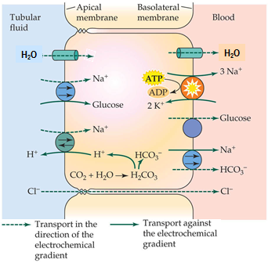
- Transport in mammalian kidney (filtration followed by reabsorption; transport maximum for glucose and diabetes mellitus). Identify all mechanisms
- Can you identify…?
  - A uni porter? Glucose moving across membrane by means of a uniporter.
  - A co-transporter? Sodium – glucose co-transporter and sodium bicarbonate co-transporter.
  - An exchanger? Sodium proton exchanger. Sodium pump, of ATPase going through exchange.
  - Facilitated diffusion via channel? Water, through aquaporin’s
  - Facilitated diffusion via a carrier? Glucose moving out across membrane, and transported in the direction of gradient, thus facilitated.
  - Primary active transport? Sodium – potassium ATPase. Hydrolyzing ATP, thus pump.
  - Secondary active transport? The gradient established by the sodium-potassium ATPase brings glucose into the cell. So primary pump and that working together gives you secondary active transport.
- Kidney cells have lots of transporters.
- Can you design an experiment to distinguish between facilitated diffusion and secondary active transport?
  - Secondary active transport needs ATP, so I would try to block ATP synthesis by removing mitochondria, and predict that if solute is moving by secondary active transport, it would stop. If movement was facilitated diffusion, it would continue.

- Membranes and cell-to-cell signalling
- Many solutes cannot cross membrane, and anything hydrophilic has difficulty. Hydrophobic solutes can cross membrane readily.
- Any chemical signal, that cannot cross the membrane, has to interact with a receptor on the SURFACE of the cell, to exert its effects.
  - Can have hydrophilic signals that have to interact with signal on cell surface, and those receptors are membrane proteins.
  - Can have hydrophobic signals that can cross membrane and interact with receptors inside cell.
  - Example: fight or flight response, induced by the hormone adrenaline. Water-soluble molecule, and thus cannot cross membrane and has to bind to a surface receptor.
  - The stress hormone cortisol, also found in fish, is a steroid that can cross the membrane and it interacts with the cell inside the cell.
- Water-soluble vs. lipid-soluble signal.
  - Location of receptor.
  - Example of stress hormones
    - Adrenaline (hydrophilic – interact with receptor on surface of cell)
    - Cortisol (hydrophobic – interact with receptors inside)
- 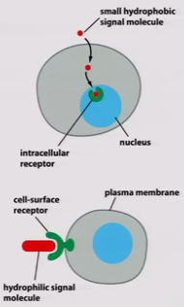

- Steps in a signalling pathway
  - Reception
    - Ligand-binding site
    - Only cells with receptor respond to signal.
  - Transduction
    - Conversion of signal to cellular response
    - Amplification.
  - Cellular response
    - Changes in gene expression.
    - Changes in protein activity.
    - Responses can be cell type-specific.
  - Termination.
- 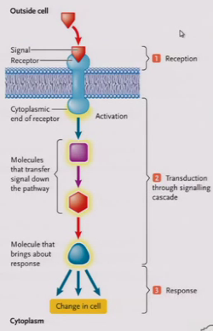
- Regardless of whether it’s hydrophilic or hydrophobic, there’s a set sequence of events that occurs when a signalling molecule binds to a receptor.
- In order for cell to respond, has to have receptor, and has to be specific for the signal of interest.
- Someplace on that receptor, there is a ligand-binding site, part of a receptor that binds the chemical signal, specifically so only that chemical signal can activate receptor. Only cells with that receptor will bond to signal. Step 1 – reception – signal binding to receptor.
- Binding to receptor then has to be converted into a cellular response, called signal transduction.
- Converting signal bound to receptor into a cellular response. Typically what happens is the signal binds to the receptor, causing receptor to CHANGE SHAPE, and activated it to carry things around cell.
  - Usually involves AMPLIFICATION, so that small numbers of signal molecules can generate significant cellular responses. Step 2 – signal transduction. Now cellular response itself.
- A change in gene expression, change in protein activity, all kinds of possibilities, and they are typically cell-specific. Example: adrenaline on heart cells make heart beat rapidly. But same hormone, adrenaline, used on liver cell, causes glucose release in blood stream. SAME HORMONE – SAME RECEPTOR – DIFFERENT CELLULAR PATHWAYS / RESPONSES. Step 3 – cellular response. Importance in now ending a transduction pathway.
- Need for termination at the end.
- How can we show experimentally that binding of the signal molecule to a surface receptor is what triggers the cellular response, ie. That the signal molecule itself does not enter the cell? (showing whether signal is interacting with surface receptor, signal itself not going into the cell, how can we show that it’s not the signal itself going into the cell turning on a cellular response, but binding to membrane receptors).
  - If you injected signal compound directly into cell, if it’s a cell surface receptor that matters, injecting it will be without effect. In order to get response, signal has to bind to receptor. If it’s on the outside of cell, injecting signal is no good.
- Now, focussing on the receptors INSIDE cell membrane. Membrane receptor signalling systems.
- Membrane receptors are integral membrane proteins.
  - Ligand-gated channels.
  - Enzyme-coupled receptors.
  - G protein-coupled receptors,
- 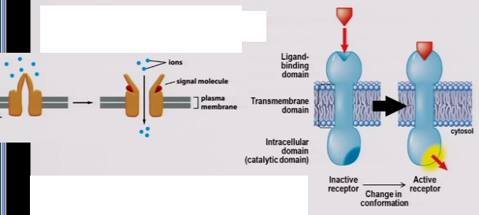
- Receptors in this case are integral membrane proteins, and they are trans-membrane proteins (can have one or more trans-membrane domains). But on outside of cell, there must be a ligand-binding domain, someplace for signal molecule to bind. On the inside of cell, must have something to ‘activate’ cellular machinery. A ligand-binding domain externally and some type of intracellular or cytosolic domain that can turn on cellular responses. What happens is when the signal molecule binds to that receptor, changes the conformation of receptor to activate it, turning on the intracellular domain to do what it does. Gives us 3 types of integral membrane protein receptors:
  - Ligand-gated channels (already covered) – transport, channel protein, equally they are receptors. Have some site on the channel that binds the signal molecule, and opens or closes channel as a result of this binding. ^^
  - Enzyme-couple receptors – Activated enzyme activity. (1)
    - Example of receptor tyrosine kinases
      - Activation of cytoplasmic protein kinase domain
      - Phosphorylation (tyrosine residues)
    - Tyrosine Kinases – Single trans-membrane domain, a ligand-binding domain on extracellular side. Inside, it’s a tyrosine protein kinases, which are enzymes transferring a phosphate group from ATP onto a protein. In other words, they phosphorylate proteins, transferring phosphate group from ATP to protein. They normally do this on the hydroxyl group of the amino acid. A protein, side chain sticking out with hydroxyl group, phosphate interacts with hydroxyl group to bind to amino acid residue. 3 amino acids that have hydroxyl groups: tyrosine, threonine, serine.
    - Tyrosine kinase is a kinase that phosphorylates tyrosine residues. In other words, receptor tyrosine kinase is a receptor that when it’s activated, it phosphorylates tyrosine residues, transferring ATP phosphate onto tyrosine residue. When signal molecule binds to ligand-binding domain, it activates this specific tyrosine kinase domain, which then phosphorylates tyrosine residues.
- (1) 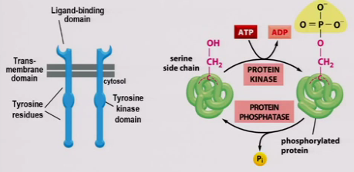
  - When the signalling molecule binds to that ligand domain, two of these receptors come together, they dimerise, dimer formation (two protein structure). The act of dimerization contributes to changes in protein that activate the protein kinase domain. (2)
    - First thing the protein kinase does is phosphorylate the tyrosine residues, auto-phosphorylates, phosphorylate itself. Once this has happened and the domain is active and phosphorylated, the receptor is now ready to initiate downstream pathways, by phosphorylating other proteins OR allowing other proteins to bind the activated receptor to activate large signalling complexes. These signalling complexes initiate various pathways in the cell, usually pathways that regulate cell growth and division. (Growth factors). Important to terminate at the end.
- (2)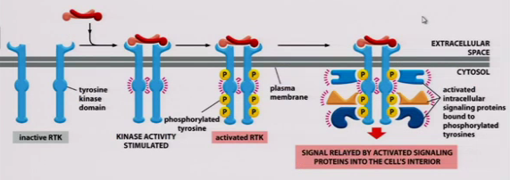
  - G protein-coupled receptors – 3rd type of membrane receptor signalling system
    - Trans-membrane / integral membrane proteins. They have 7 trans-membrane domains. Belongs to superfamily of 7 TMD families (trans-membrane domains)
    - Have a ligand-binding domain extracellular; activated by water-soluble signals that can’t enter the cell. On the intracellular side, instead of having an enzyme, they have a binding site for G protein (nickname for GTP-binding protein).
    - GTP-binding proteins activate receptors (g-protein).
    - With g-protein couple receptors, when it is activated, it activates g-protein, and the protein then activates further steps in the cell, USUALLY involving a second messenger, usually a chemical in the cell that initiates the actions of the first messenger, the original signal.
    - G proteins are an example of a fatty acid anchored protein, proteins that are COVALENTLY attached to fatty acids, and then inserted into cytosolic leaflet of membrane. (1)
    - Also heterotrimers(3 different subunits that together make up g-protein)
      - Alpha subunit (binds GTP or GDP)
      - Beta subunit and Gamma subunit, together.
    - When g-protein binds GDP, this activates g-protein. When they are activated, they split into 2 pieces.
    - An alpha unit with GDP bound to it, and beta and gamma subunit.
    - These two pieces (alpha unit on its own or beta-gamma complex) can go and initiate things in the cell, thus having two elements.
    - When GTP binds to g-protein, it turns its ON. GTP must be hydrolyzed, to GDP, turning it OFF. (2)
    - When receptors bind g-protein, it allows it to get rid of any GDP bound to it, and to pick up a molecule of GTP. Once g-protein picks up GTP, it is activated and ready to go out and start cellular activities. Role of receptor in this is to TURN ON g-protein by making it possible for g-protein to bind GTP. Role for g-protein is to BIND GTP.
    - G proteins are diverse.
- (1) 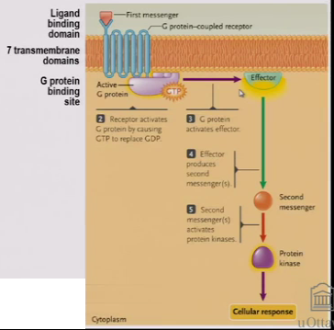
- (2) 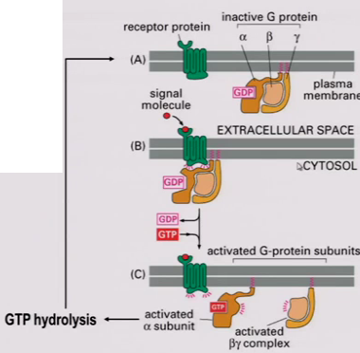
- A common G protein signalling pathway uses **cAMP as a 2nd messenger.
  - cAMP is a derivative of ATP. It is cyclic.
  - G protein activates the enzyme adenylyl cyclase, catalyzes this conversion.
  - cAMP activates protein kinase A, PKA.
  - AMP, where phosphate group is detached, is not a messenger.
- 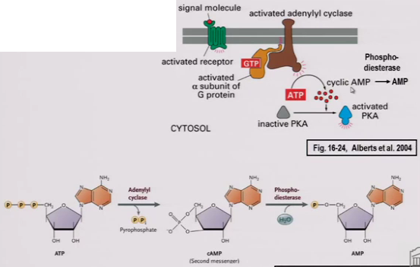
- What is the advantage of a phosphorylation cascade? Easier to fix one small step than a big one.
- Contrasting and comparing RTK and G protein-coupled receptor signalling pathways.
Point of comparison | Receptor tyrosine kinase | G protein-coupled receptor
Receptor structure | -1 Trans-membrane domains | -7 TMD
Intracellular on-off switch | -Receptor tyrosine kinase | -G protein
Enzyme | -Receptor itself | -Adenylyl cyclase
2nd messenger | -No | -cAMP
Phosphorylation cascade | Yes | Yes
Cellular responses | -Cell growth and division | -Glucose release from cell.
Chemical messengers |  | -Adrenaline.

- Lipid-soluble signals and intracellular receptors
  - 1. Signals enter the cells by diffusion (steroid hormones)
  - 2. Receptors are ligand-activated transcription factors
    - Ligand-binding domain
    - DNA-binding domain
  - 3. Regulate gene expression
    - Activated receptor binds to a response element
  - 4. Cellular response
    - Reflects genes regulate by the response element.

