Part 1:

Stores
Store ID | Store Name | StoreType | Store Revenues | Franchise | Square Footage | Price Per Square Foot | Lease Start Date | Lease End Date | Manager | Phone | Web Address | E-mail Address
S0001 | Golden Market | Restaurant | $2,500,000.00 | Yes | 1,500.00 | $2.50 | 01/02/2009 | 31/01/2016 | Irene Pijuan | (305) 668-7765 | www.chezitalia.com | chezitalia@restaurant.com
S0002 | Fedder's Wearhouse | Clothing | $1,500,000.00 | Yes | 900.00 | $3.00 | 01/01/2006 | 31/12/2015 | Kim Jacobs | (305) 888-6789 | www.fedderswearhouse.com | info@fedderswearhouse.com
S0003 | Diamonds Delight | Jewelry | $4,000,000.00 | No | 1,200.00 | $3.00 | 01/04/2008 | 31/03/2014 | Matt Goodrich | (305) 666-2355 | www.diamondsdelight.com | dd@bestjewelry.com
S0004 | Nancy's Fish House | Restaurant | $750,000.00 | Yes | 2,000.00 | $2.25 | 01/09/2006 | 15/12/2014 | Keith Fletcher | (305) 666-7965
S0005 | Accessorize | Home Accessories | $850,000.00 | No | 1,800.00 | $2.50 | 01/06/2009 | 30/05/2016 | Leyla Alman | (305) 888-3523 | www.accessorize.com | leyla@accessorize.com
S0006 | Modernaire | Furniture | $1,750,000.00 | No | 3,000.00 | $2.50 | 01/05/2009 | 30/04/2014 | Tim Ekhlassi | (305) 666-6787
S0007 | YourLastName's Den | Books | $600,000.00 | No | 1,200.00 | $3.00 | 01/04/2008 | 31/03/2014 | Luke Evans | (305) 888-6797
S0008 | Athlete's Corner | Shoes | $900,000.00 | Yes | 1,800.00 | $2.75 | 01/08/2006 | 30/11/2013 | Peter Gryn | (305) 666-4455 | www.athletescorner.com | pete@athletescorner.com
S0009 | Widmark's | Shoes | $500,000.00 | No | 1,500.00 | $2.50 | 01/09/2008 | 31/08/2015 | Steve Spann | (305) 888-6573
S0010 | Marilyn's Closet | Clothing | $650,000.00 | No | 950.00 | $2.75 | 15/01/2009 | 14/01/2016 | Devon Soodan | (305) 666-2248 | http://www.marilynscloset.com | marilyn@marilynscloset.com
S0011 | Midnight Antiques | Furniture | $1,800,000.00 | Yes | 4,000.00 | $2.00 | 15/07/2007 | 30/06/2014 | Lily Olivier | (305) 666-0080
S0012 | Gala's | Furniture | $400,000.00 | No | 1,500.00 | $2.75 | 01/08/2009 | 30/07/2016 | Ron Klinger | (305) 888-4234 | www.gala.com | ron@gala.com
S0013 | Indian Arts | Jewelry | $2,000,000.00 | No | 1,800.00 | $2.25 | 31/05/2006 | 30/05/2014 | Corey Rollner | (305) 666-6894 | www.indianarts.com | crollner@indianarts.com

Stores Query
Store Name | Manager | Lease Start Date | Store Revenues | MonthlyRent
YourLastName's Den | Luke Evans | 01/04/2008 | $600,000.00 | $3,600.00
Diamonds Delight | Matt Goodrich | 01/04/2008 | $4,000,000.00 | $3,600.00
Indian Arts | Corey Rollner | 31/05/2006 | $2,000,000.00 | $4,050.00
Modernaire | Tim Ekhlassi | 01/05/2009 | $1,750,000.00 | $7,500.00

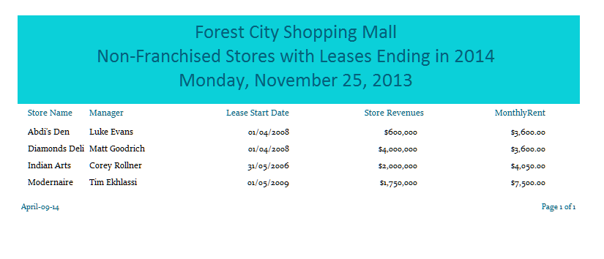

Part 3:
- SELECT Employee.[Name], Employee.[Address]
FROM Employee
WHERE (((Employee.[Salary])<50000))

- SELECT Employee.ENumber, Employee.Name AS Employee_Name, Employee.Address, Department.Name AS Department_Name, Department.Location
FROM Department INNER JOIN Employee ON Department.[DNumber] = Employee.[DNumber]
WHERE (((Department.Name)="Sales"))

- UPDATE Employee SET Employee.[Name] = "Your Name", Employee.[Address] = "Your address", Employee.[Birthdate] = #1/01/1900#, Employee.[Gender] = "M"
WHERE (((Employee.[ENumber])="789324"))

- SELECT Project.Location, Project.Name AS Project_Name, Employee.Name AS Employee_Name
FROM Employee INNER JOIN (Project INNER JOIN [Projects-Worked-On] ON Project.[PNumber] = [Projects-Worked-On].[PNumber]) ON Employee.[ENumber] = [Projects-Worked-On].[ENumber]
WHERE (((Employee.Salary)>50000))

- SELECT Count(Project.PNumber) AS CountOfPNumber
FROM Department INNER JOIN (Project INNER JOIN [Projects-Worked-On] ON Project.[PNumber] = [Projects-Worked-On].[PNumber]) ON Department.[DNumber] = [Projects-Worked-On].[DNumber]
GROUP BY Department.Location
HAVING (((Department.Location)="Toronto")

- SELECT Department.Name AS Department_Name, Department.Location, Project.Name AS Project_Name
FROM (Department INNER JOIN Employee ON Department.[DNumber] = Employee.[DNumber]) INNER JOIN (Project INNER JOIN [Projects-Worked-On] ON Project.[PNumber] = [Projects-Worked-On].[PNumber]) ON Department.[DNumber] = [Projects-Worked-On].[DNumber]
WHERE (((Employee.Name)="Your Name"))

Part 4:
Name change:
PROF
PID | Lastname | Firstname | Office | Phone-Ext | Salary | Hired-On
001289230 | Your name | Your Last name | MC 378 | 6893 | $77,578.23 | 28/10/2000

Relationships:
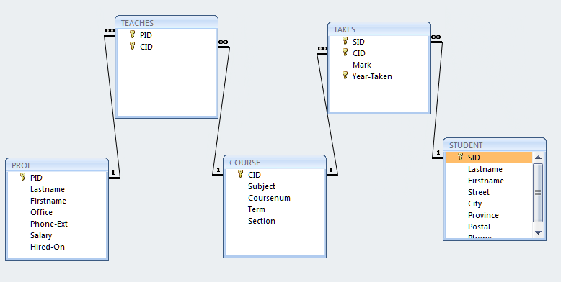

Quaries:
QueryA
Subject | Coursenum | Term | Section
Economics | 2133 | B | 001
French | 2127 | B | 001
Geology | 2200 | B | 001
Kinesiology | 2201 | B | 001
Mathematics | 2203 | B | 001

QueryB
CID | Subject | Coursenum | Term
1020011 | Computer Science | 1032 | A
1050002 | History | 1020 | E
1050012 | History | 1025 | E
1080001 | Mathematics | 1017 | A
1080003 | Mathematics | 1028 | A

QueryC
SID | Firstname | Lastname | Coursenum | Term
0236744 | Hope | Clark | 1025 | A
0340014 | Orval | Pretty | 1025 | A
4589620 | Wai-Chi | Wong | 1026 | A
5689302 | Teresa | Luscombe | 1026 | A
0000131 | Daniel | Ward | 1026 | A
3023495 | Krista | Hinds | 1026 | A
0789234 | Jan | Poortinga | 1027 | B
3023495 | Krista | Hinds | 1027 | B
0004785 | Jozef | Warchol | 1027 | B
2378422 | Deborah | Koudys | 1027 | B
0340014 | Orval | Pretty | 1027 | B
4387510 | Lisa | Djurfeldt | 1027 | B
1118934 | Shiva | Singh | 1028 | A
4785642 | Topher | Beck | 1028 | A
1118934 | Shiva | Singh | 1028 | B
4785642 | Topher | Beck | 1028 | B
1003469 | Miroslaw | Pryciak | 1028 | B
1118934 | Shiva | Singh | 1028 | B
0000131 | Daniel | Ward | 1028 | B
4589620 | Wai-Chi | Wong | 1028 | B
0056348 | Perry | Snelgrove | 1032 | A
3336660 | Clare | Clifford | 1032 | A
6582332 | John | Prout | 1032 | A
1458973 | Yisheng | Zhang | 1032 | A
3023495 | Krista | Hinds | 1032 | A
0236744 | Hope | Clark | 1032 | A
6743500 | Jason | Snelgrove | 1032 | A
3336660 | Clare | Clifford | 1032 | A
4589620 | Wai-Chi | Wong | 1032 | A
2258743 | Hope | Clarke | 1032 | B
3336660 | Clare | Clifford | 1032 | B
2986574 | Erin | McFalls | 1032 | B
6582332 | John | Prout | 1032 | B
2986574 | Erin | McFalls | 1032 | B
4906278 | Brad | Drake | 1032 | B
0000131 | Daniel | Ward | 1032 | B
5689302 | Teresa | Luscombe | 1032 | B

QueryD
Total number of students
37

QueryE
SID | Firstname | STUDENT_Lastname | Coursenum | Term | Mark
4906278 | Brad | Drake | 1032 | B | 57
3023495 | Krista | Hinds | 1032 | A | 92
3023495 | Krista | Hinds | 1027 | B | 81
2986574 | Erin | McFalls | 1032 | B | 76
0789234 | Jan | Poortinga | 1027 | B | 87
1003469 | Miroslaw | Pryciak | 1028 | B | 54
1118934 | Shiva | Singh | 1028 | B | 67
1458973 | Yisheng | Zhang | 1032 | A | 83

