Chapitre 11
11.1 What is a Venture?
Ventures are a range of different ways of developing innovations, alternative to conventional internal processes for new product or service development.
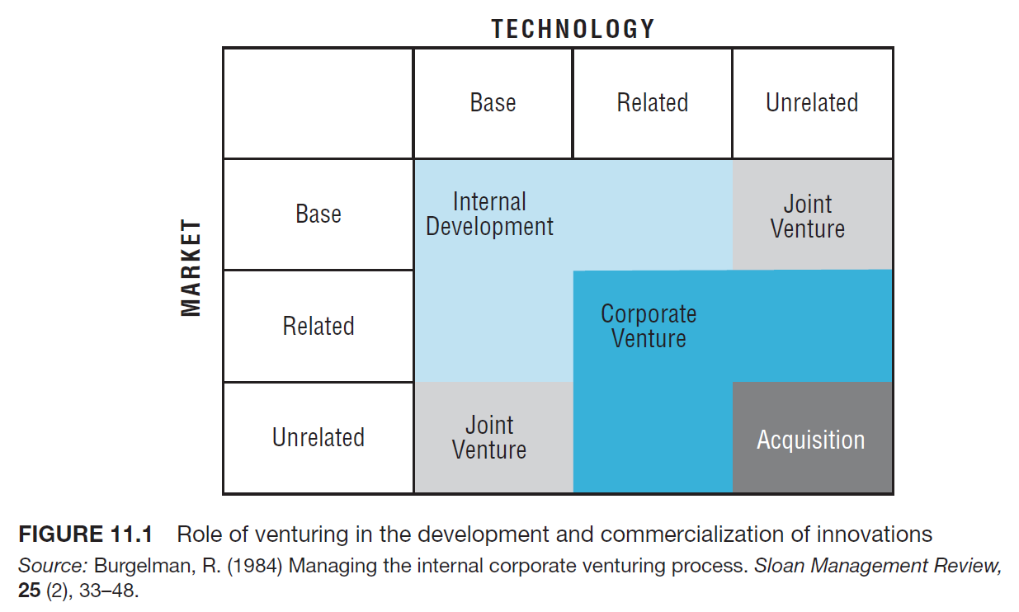

Profile of a Venture Champion
Factors influencing the decision to establish a new venture (figure 11.2 p.507)
Venture Business Plan (p.509)
Funding
p.510 for cash flow profiles for types of ventures
Stages of dev with different financial requirements :
- Initial financing for launch
- Second-round financing for initial development and growth
- third-round financing for consolidation and growth
- maturity or exit
Initial funding is the hardest to receive due to high risk and low potential return, 3rd round finance is the easiest to obtain due to a proven track record
Initial funding is necessary to purchase accommodation, equipment, start-up costs, salaries, utilities, etc. Venture capitalists don't generally fund at this stage.
VCs provide funding for a venture with a proven track record and a good business plan, but in return require equity or management involvement. They want gains within 5 years.
Corporate Venture Funding
Corporations like to fund ventures in the same sector and expect a lower return than professional VCs would (20-30% return vs 75%).
They also would rather fund expansion ventures rather than fund start-ups.
Most like to invest directly into the high-tech sector, and they do this to increase the probability of technological success, which is likely to impact the product pipeline in the near term.
Indirect investments are concerned more with gaining windows on a range of early-stage techs with the potential to impact the future direction of the product pipeline.
This funding is usually for strategic reasons rather than for financial reasons.
Venture Capital
The criteria VCs deem most important in order to invest in a venture :
- entrepreneur's personality
- entrepreneur's experience
- characteristics of the product
- characteristics of the market
- financial factors
Being described as a high-tech venture was rated very low in importance in the US and also had a negative influence on funding in Europe and Asia. Same thing with creating an entirely new market.
VCs have a strong influence on the success of NTBFs. They play two distinct roles : identify and select the NTBFs that have the best potential for success, and to help develop the chosen ventures, to be their coach.
Read last paragraph p.517

11.2 Internal Corporate Venturing
The most effective organization and management of a new venture will depend on two dimensions : the strategic importance of the venture for corporate development; and its proximity to the core techs and business.
Checklist used to assess the strategic importance of a new venture :
- Would the venture maintain our capacity to compete in new areas?
- Would it help create new defensible niches?
- Would it help identify where not to go?
- To what extent could it put the firm at risk?
- How and when could the firm exit from the venture?
A new venture may be driven by newly developed skills and capabilities : consistent with an incremental strategy in which diversification is a consequence of evolution.
A new venture may drive the dev of new skills and capabilities : consistent with a rational strategy which begins with the identification of new market opportunity.
Checklist used to assess the proximity of the venture proposal to existing skills and capabilities :
- What are the key capabilities required for the venture?
- Where, how and when is the firm going to acquire the capabilities, and at what cost?
- How will these new capabilities affect current capabilities?
- Where else could they be exploited?
- Who else might be able to do this, perhaps better?
Strategic importance will determine the degree of administrative control required. The greater the strategic importance, the stronger the administrative linkages between the corporation and venture.
The closer the skills and capabilities are to the core activities, the greater the degree of operational integration necessary for reasons of efficiency.
Motives for establishing corporate ventures p.520
Managing Corporate Ventures
The management challenge is to create an environment that encourages and supports entrepreneurship, and to identify and support potential entrepreneurs. The venturing process consists of identifying an opportunity for a new venture, evaluating that opportunity and providing adequate resources to support the new venture.
6 stages divided between definition and development p.525 top
Venturing should be the responsibility of the entire corporation and top management should demonstrate long-term commitment to venturing by making available sufficient resources and implementing the appropriate processes.
Peter Drucker argues that the SEARCH process shuold be systematic rather than relying on serendipity. Seven common sources of opportunities which should be monitored on a routine basis :
- demographic changes
- new knowledge
- incongruities (gaps between expectations and reality)
- changes in industry or market structure
- unexpected successes or failures
- process needs
- changes in perception
In the case of new business ventures, 4 primary sources of ideas (p.526) :
- the bright idea
- customers requesting a new product or service
- internal analysis of a company's competencies and business processes
- scanning of external opportunities in related techs, markets or services
The bright idea is the least common and most risky. A business venture based on a customer request has the highest chance of success. The two most promising corporate ventures are the result of systematic scanning of the internal and external environments.
Barriers for corporate entrepreneurs p.526 bottom
To overcome these barriers, a potential venture manager and product champion must have political and social skills in addition to a viable business plan, must be able to work effectively in a non-programmed and unpredictable environment, requires dedication, flexibility and luck to manage the transition from product concept to corporate venture in addition to sound technical and market knowledge.
Key roles must be filled when a new venture is established p.527 point form
Difficult to make the project managers become the venture managers since they might not be able to communicate the right information to the masses or maximize cost/price differential.
Components of a typical business plan for a new venture table 11.3 p.530

Structures for Corporate Ventures
Design options for corporate ventures include (p.531) :
- direct integration with existing business
- integrated business teams
- a dedicated staff function to support efforts company-wide
- a separate corporate venturing unit department
- divestment and spin-off
Learning Through Internal Ventures
Four factors characterize firms that are consistently successful at corporate venturing p.536
Two main causes of failure of internal ventures :
- Strategic reversal : occurs because of a conflict between the timescales o the new venture and the parent organization
- Emergence trap : as a venture expands, it may lead to internal territorial infringements, and success leads to jealousy and may result in attempts to undermine the venture.

11.3 Spin-Outs and New Ventures
University incubators p.542
Spin-off stages of development p.546
Growth and Performance of Innovative Small Firms p.549

