Chapitre 10
10.1 Joint ventures and alliances
Why collaborate?
- to reduce the cost of technological development or market entry
- to reduce the risk of development or market entry
- to achieve scale economies in production
- to reduce the time taken to develop and commercialize new products
- to promote shared learning
A firm is likely to have many motives for an alliance. (figure 10.1 p.462)
The R&D function is forced to achieve greater financial efficiency and to examine whether in-house development is the most efficient approach. One company's peripheral technologies are usually another's core activities. Usually makes more sense to source such technologies externally rather than incur the risks, costs and timescale associated with in-house development.
Two factors to be taken into account when deciding whether to make or buy a tech : transaction costs and strategic implications.
- Transaction costs : cost analysis focuses on organizational efficiency, specifically transactions with significant uncertainty. Firms are often prepared to trade potentially high returns for a reduction in uncertainty. Transaction costs are increased where a potential purchaser of tech has little knowledge of the tech.
- Strategic implications : the optimal tech acquisition strategy will depend on the maturity of the tech, the firm's technological position relative to competitors and the strategic significance of the tech. Collaboration is necessary when tech is novel, complex or scarce. On the other hand, subcontracting or licensing is more appropriate when tech is mature, simple or widely available. However, the cumulative effect of outsourcing tech due to lower transaction costs may limit future technological options and reduce competitiveness.
- In practice, transaction costs are not the most significant factors. Competitive advantage, market expansion and extending product portfolios are more important. Adopting a strategic perspective focuses on long-term organizational effectiveness rather than short-term efficiency. Acquisition of external tech should complement internal R&D rather than substitute it. Strategic considerations suggest which techs should be developed internally, and transaction costs influence how the remaining techs should be acquired. (p.464) Transaction costs will be lower when dealing with a firm with who you are familiar since they are likely to have some degree of mutual trust, shared technical and business info and existing personal social links.

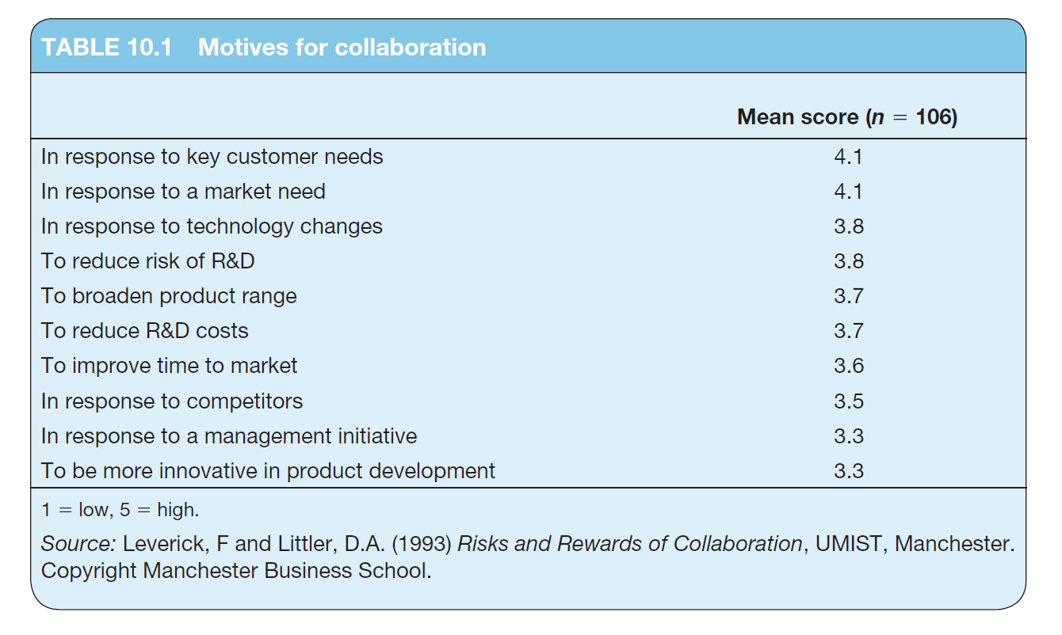
Note for table : firms that formed alliances in order to reduce cost or time of development achieved this, whereas firms that formed it for other reasons complained that the cost or time were increased.
The study also identifies a number of potential risks with creating alliances :
- leakage of information (difficult to isolate the joint venture from the rest of the business, inevitable that partners will gain access to additional knowledge and skills)
- loss of control or ownership
- divergent aims and objectives, resulting in conflict
- product and process tech from external sources provides immediate advantages but in the long term makes it harder to differentiate their offerings and difficult to achieve or maintain any positional advantage in the market

Forms of collaboration
Take the form of an agreement between two or more firms to co-develop a new tech or product.
- Formal : joint venture (a new company formed by two or more organizations which allocate ownership based on shares of stock controlled, OR, a simple contractual basis for collaboration)
- Informal : strategic alliance (has a specific end goal and timetable and does not normally take the form of a separate company)
- Co-option : a company seeks to group together other relatively weak companies from the same industry to challenge a dominant competitor. Common where scale or network size is important, such as mobile telephone and aerospace (symbian and lynux vs microsoft). Once the market position has been achieved, one partner may seek to take control through acquisition or go unilateral.
- Co-specialization : Partners are from different sectors of specialization. Partners bring together unique competencies to create the opportunity to enter new markets, develop new products or build new businesses. Common in systems or complex products and services. (p.466)
Reasons for a huge switch over the years from formal joint ventures to informal alliances (p.468) :
- Speed
- Partner fit
- Partner type
- Commitment
- Focus
Patterns of collaboration
In general, large firms use joint ventures to acquire tech, whilst smaller firms place greater emphasis on the acquisition of market knowledge and financial support. (read p.470-71 for stats and data)
Effects of tech and organization (table 10.2 p.473)
Two dimensions which affect companies' attitudes towards tech acquisition (all described from p.472-77) :
-Characteristics of the tech :
- competitive significance of the tech
- complexity of the tech
- codifiability, or how easily the tech is encoded
- credibility potential, or political profile of the tech
-Organization's inheritance :
- corporate strategy, for ex, a leadership versus follower position
- capabilities and existing technical know-how
- culture of the firm, including receptivity to external knowledge
- 'comfort' of management with a given technical area

Managing alliances for learning
Alliances can also be used as an opportunity to learn new market and technological competencies, in other words to internalize a partner's know-how.
Table 10.3 p.478 for reasons for failure of alliances.
There is a difficulty in measuring the success of an alliance if the objectives aren't clear. If both organizations want to create a successful alliance, they must have an even balance of strength and define LEARNING as a major goal. Both partners must be strong financially and in the technological, product or market contribution they make to the venture.
Firms must learn to design alliances : by design, we mean the need to select a partner which can contribute what is needed, needs what is offered, of which there is sufficient prior knowledge or experience to encourage trust and communication to reduce potential conflicts.
Failure of an alliance is most likely due to strategic divergence.
Success of an alliance is due to people-related factors such as communication, agreeing on a business plan, goal and structure flexibility. (table 10.5 p.480)
Factor analysis confirms that people-related factors are more significant than either the economic or technological considerations, specifically creation of trust, informal networking and learning.
Other success factors and bases of trust in an alliance. (p.481)
Three factors that affect learning through alliances : intent, transparency and receptivity. (table 10.6 p.483)
Tactical alliances are most appropriate to obtain migratory or explicit knowledge, but more strategic relationships are necessary to acquire embedded or tacit knowledge.
-Alliances for explicit knowledge focus on trades in designs, techs or products, but provides only temporary advantages
-Alliances for embedded knowledge involves the transfer of skills and capabilities which requires personnel to have direct, intimate and extensive exposure to staff, equipment, systems and culture with the partnering organization.
Most significant factor influencing knowledge creation and learning in an alliance is the use of formal environmental scanning. Two reasons for the importance of scanning : the need to identify relevant knowledge in the environment and to ensure that the developments continue to be relevant to the changing environment.
Ex of learning through culture p.485

10.2 Collaborating with suppliers to innovate
The last section was for horizontal relationships, such as cross-licensing, consortia and collaboration. This section focuses on vertical relationships, such as subcontracting and alliances with suppliers and customers.
The primary motive is cost reduction. Most subcontracting or outsourcing arrangements are based on the potential to save costs through suppliers.
Table 10.8 p.486 types of horizontal and vertical collab.
The Japanese or partnership model is based on long-term relationships with the supplier, whom make a significant contribution to the dev of new products.
Figure 10.3 is explained on p.488-489

10.3 User-Led Innovation
The lead user demands new requirements ahead of the general market of other users. They can help to co-develop innovations and are early-adopters of these innovations.
- Recognize requirements early
- Expect high level of benefits
- Develop their own innovations and applications
- Perceived to be pioneering and innovative
Two implications : those seeking to develop innovative complex products should identify potential lead users to contribute to the co-development and early adoption of the innovation, and that leader users can provide insights to forecasting the diffusion of innovations.

10.4 Benefits and Limits of Open Innovation
The open innovation model emphasizes that firms should acquire valuable resources from external firms and share internal resources for new product/service development, but the question of when and how a firm sources external knowledge and shares internal knowledge is less clear.


