Chapter 4- Competing in World Markets
World’s Top 10 Nations
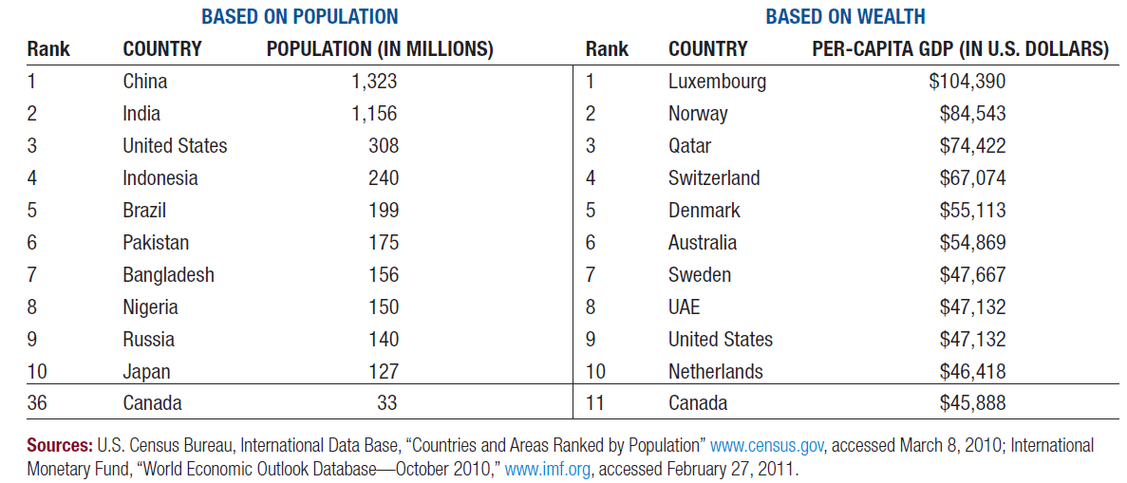
Why Nations Trade
- Boosts economic growth
- Expands markets
- More efficient production systems
- Less reliance on the economies of home nations

Canada exports mainly to the U.S. and the E.U, and imports mainly from the U.S. and China
Exchange Rates
Currency rates are influenced by:
- Domestic economic and political conditions
- Central bank intervention
- Balance-of-payments position
- Speculation over future currency values
Currencies values change depending on their supply & demand

Barriers to International Trade
- Social and Cultural- language, different values
- Economic- infrastructure; fluctuating currency values
- Legal and Political- political climate; climate of corruption; tariffs
- Free Markets

Types of Trade Restrictions
- Tariffs: taxes, surcharges, or duties on foreign products
  - Revenue tariffs generate income for the government.
  - Protective tariffs raise prices of imported goods to level the playing field for domestic competitors.
- Nontariff barriers: also called administrative trade barriers
- Quota: A limit set on the amounts of particular products that can be imported
- Dumping: Selling products in other countries at prices below production costs or below typical prices in the home market
- Embargo: A total ban on importing specific products or a total stop to trading with a particular country

