Chapter 12
Conflict and Stress

1. WHAT IS CONFLICT?

Conflict:
- process that occurs when one person, group, or organizational subunit frustrates the goal attainment of another
- involves antagonistic attitudes (dislike each other) and behaviors (name calling, sabotage, etc)

Causes of Organizational Conflict:

1. Group Identification and Intergroup Bias
- people have the tendency to develop more positive view of their own “in-group” and less positive view of the “out-group”
- identifying with the successes of one’s own group and disassociating oneself from out- group failures boosts self-esteem and provides comforting feelings of social solidarity

2. Independence
- conflict occurs when individuals/subunits are mutually dependent on each other to accomplish their own goals
- it necessitates interaction between the parties so they can coordinate interests
- each party has some power over the other

3. Differences in Power, Status and Culture
- Power: causes conflict if the dependence is one-way and not mutual
- Status: conflict when lower-status gives orders to higher-status individuals
- Culture: clash in beliefs/values can result in overt conflict

4. Ambiguity
- ambiguous goals, jurisdiction, or performance criteria can lead to conflict
- formal/informal rules that govern interaction break down
- difficult to accurately assign praise for good outcomes

5. Scarce Resources
- limited budget money, secretarial support, or lab space can contribute to conflict

Types of Conflict:

Relationship Conflict | Interpersonal tensions among the relationships of ppl, not the task at hand
Task Conflict | Disagreements about the nature of the work to be done (ex: technical matters)
Process Conflict | Disagreements about how work should be organized/accomplished (ex: res. allocation)

Conflict Dynamics
- When conflict begins:
- winning the conflict is more important than good solution
- conceal/distort information from each other
- each side becomes more cohesive
- contact with opposite party is discouraged
- opposite party is negatively stereotyped
- image of one’s own position is boosted
- more aggressive people who are skilled at conflict may emerge as leaders

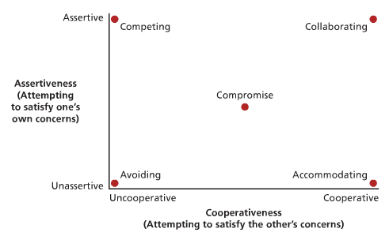
Modes of Managing Conflict
- none of the five styles are superior to each other
- each style depends on the situation that the conflict occurred in

TYPE | CHARACTERISTIC | USE WHEN
Avoiding | ↓ assertiveness, ↓ cooperation | - issue is trivial  - info is lacking  - opponent is powerful/hostile  - people need to cool down
Accommodating | ↓ assertiveness, ↑ cooperation | - you are wrong  - issue is more important to other party  - you want to build goodwill
Competing | ↑ assertiveness , ↓ cooperation | - you have a lot of power  - you are sure of your facts  - situation is truly win-lose  - no interaction with other party in future
Compromise | ≈ assertiveness , ≈ cooperation | - not useful when resoling conflicts that stem from power asymmetry  - good fall back position if all other strategies fail
Collaborating | ↑ assertiveness , ↑ cooperation | - attempt for a win-win resolution  - conflict is not intense  - each party has info useful to the other

Conflict: Good or Bad?
- conflict can be functional when it promotes necessary organizational change:
CONFLICT CHANGE ADAPTATION SURVIVAL
- for organizations to survive, they must adapt to their environments
- this requires changes in strategy that may be stimulated through conflict

Conflict Stimulation
- a strategy of increasing conflict to motivate change
- the causes of conflict, such as scarcity and ambiguity, can be manipulated by managers to achieve change

2. STRESS

Stress:
- a psychological reaction to the demands inherent in a stressor that has the potential to make a person feel tense or anxious because the person does not feel capable of coping with these demands

Model of a Stress Episode
- Individual personality often determines the extent to which a potential stressor becomes a real stressor and actually induces stress

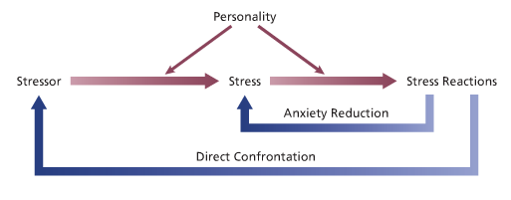

Personality and Stress
- personality can affect both the extent to which potential stressors are perceived as stressful and the types of stress reactions that occur

Locus of Control: internals (they control behavior), externals (behavior controlled by luck, fate)
Type A: aggressiveness, ambitiousness, competitiveness, hostility, impatience, sense of time urgency
Negative Affectivity: view the world and other people in a negative light

Locus of Control | - Externals = more likely to feel anxious in the face of potential stressors  - Internals = more likely to confront stressors directly (they assume that this response will make a difference)
Type A Behavior Pattern | - report heavier workloads, longer hours, more conflicting work demands  - encounter more stressful situations than Type B  - likely to exhibit adverse physiological reactions in response to stress
Negative Affectivity | - report more stressors in the work environment  - likely to feel stressed in response to the demands of a heavy workload  - predisposed to perceive stressors  - hypersensitivity to existing stressors  - tendency to gravitate to stressful jobs  - tendency to provoke stress  - use passive coping styles that avoid the real sources of stress

Stressors in Organizational Life
- common source of stress for people is workplace stress

Three types of organizational stressors
Managerial | - Role overload (too many tasks in a short period of time)  - Heavy responsibility (decision can have important consequences for organization)
Operative-level | - Poor physical working conditions (excessive heat, noise, pollution, accidents)  - Poor job design (job scope levels that are too high or too low)
Boundary Role | - positions where organizational members are required to interact with members of other organizations or with the public  - experience burnout (emotional exhaustion, cynicism, reduced self-efficacy)

Burnout vs. Work Engagement
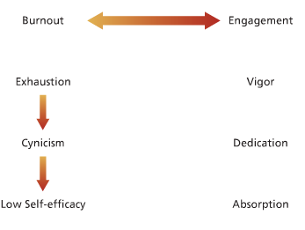

Some General Stressors
Experienced equally by occupants of all roles include:
- Interpersonal conflict (ex: workplace bullying)
- Work-family conflict (work duties interfere with family like or vice versa)
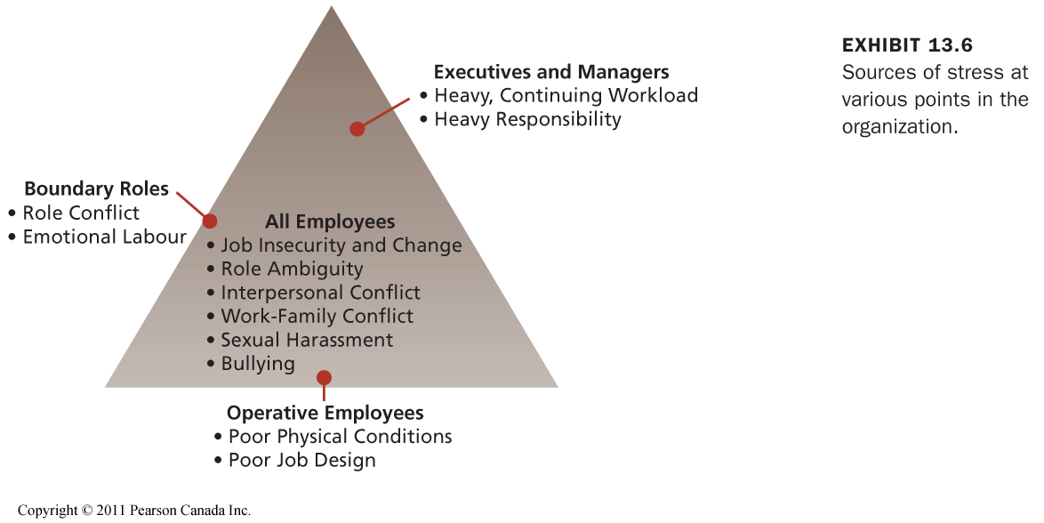
- Job insecurity and change
- Role ambiguity
- Sexual harassment

Reactions to Stress

1) Behavioral Reactions
- problem solving, seeking social support, reduced job performance, withdrawal, substance abuse

2) Psychological Reactions
- Rationalization (attributing socially acceptable reasons or motives to one’s actions)
- Projection (attributing one’s own undesirable ideas and motives to others so that they seem less negative)
- Displacement (directing feels of anger at “safe” target rather than “punishing” target)
- Reaction formation (expressing oneself in the opposite way that you’re feeling)
- Compensation (applying skills in one area to make up for failure in another area)

3) Physiological Reactions
- high blood pressure, cholesterol, cardiovascular problems, various diseases

Organizational Strategies
- job redesign
- “family-friendly” human resource policies
- stress management programs
- work-life balance, fitness, and wellness programs

