Chapter 9
Leadership

What is Leadership?

Leadership:
- a person who exerts influence on the goal achievement of others in an organizational context
- effective leadership: exerts influence in a way that achieves organizational goals by enhancing the productivity, innovation, satisfaction, and commitment of the workforce.

Implications:
- has a strong effect on organization’s strategy, success and survival

TWO TYPES:

1) Strategic Leadership
- involves the ability to anticipate, envision, maintain flexibility, think strategically, and work with others to initiate changes that will create a viable future for the organization
- sustain competitive advantage by: competing in turbulent/unpredictable environments & exploiting growth opportunities

2) Formal Leadership:
- individuals with titles such as manager, executive, supervisor, and department head occupy formal/assigned leadership roles
- individuals are expected (because of their titles) to influence others

Leadership Traits

Assumption: Those who become leaders and do a good job possess a special set of traits (however, traits are not alone sufficient for successful leadership)

Traits associated with leadership effectiveness:
- intelligence, energy, self-confidence, dominance, motivation to lead, emotional stability, honesty and integrity, need for achievement

Personality traits related to leadership behaviors:
- agreeableness, extraversion, and openness to experience

Limitations to the trait approach:
- difficult to determine whether traits make the leader or opportunity for leadership make the traits
- little information on how to train and develop leaders
- failure to take into account the situation in which leadership occurs

The Behavior of Leaders

TWO TYPES OF LEADERSHIP BEHAVIOR

1) Consideration
- extent to which a leader is approachable and shows personal concern and respect for employees
- friendly/egalitarian, expresses appreciation and support, protective of group welfare

CONSEQUENCES:
- employee motivation
- job satisfaction (increases when goals/methods are very clear/certain)
- leader effectiveness
- job performance

WHEN TO USE IT:
- goals and methods of performing task are very clear and certain

2) Initiating Structure
- degree to which a leader concentrates on group goal attainment
- clearly defines/organizes their role and the roles of followers, stresses standard procedures, schedules the work to be done, assigns employees to particular tasks

CONSEQUENCES:
- employee motivation
- job satisfaction (increases when employees are under pressure)
- leader effectiveness
- job performance (increases when employees are under pressure)

WHEN TO USE IT:
- high degree of pressure
- lack knowledge as to how to perform a task
- task is ambiguous

*Leader could be high, low, or average on one of both dimensions
*Effects of consideration/initiating structure depend on the task, the employee, and the setting
*Task is intrinsically satisfying need for high consideration/high structure is reduced

House’s Path-Goal Theory (Situational Theory)
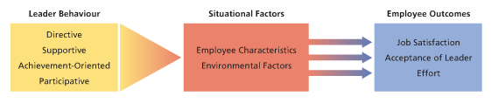
- concerned with situations under which various leader behaviors are most effective
- the effective leader forms a connection between employee goals and organizational goals
- to provide job satisfaction and leader acceptance leader behavior must be perceived as immediately satisfying
- to promote employee effort leaders must make rewards dependent on performance

Leader behavior:
- directive (schedule work, maintain performance standards, sets expectations)
- supportive (friendly, approachable, promote better interpersonal relationships)
- participative (consult employees about work and consider their options)
- achievement-oriented (encourage employees to exert high effort)

Situational Factors:
1) Employee Characteristics
- employees who are high need achievers achievement-oriented
- employees who are told what to do directive
- employees with low task abilities directive/coaching approach
2) Environmental Factors (task structure & organizational characteristics)
- tasks are clear and routine not directive or participated
- tasks are challenging/ambiguous directive & participative
- tasks that are frustrating/dissatisfying supportive

Participative Leadership
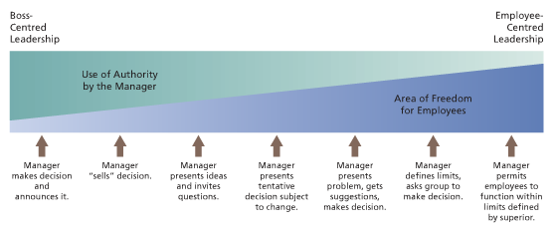

Advantages and Potential Problems of Participative Leadership

ADVANTAGES:
- Motivation
- Quality (higher-quality decisions, employee empowerment)
- Acceptance (increase employees’ acceptance of decisions)

PROBLEMS:
- time and energy (specific behaviors on the part of leader require time and energy)
- loss of power/influence
- lack of receptivity or knowledge from employees
Situational Model for Participation (Vroom and Jago)

- attempts to specify in a practical manner when leaders should use participation and to what extent they should use it

Which strategy is more effective?
- depends on the situation/problem at hand
- leader’s goals should be to make high quality decisions to which employees will be adequately committed without undue delay

Leader Member Exchange or LMX Theory is a theory of leadership that focuses on the quality of the relationship between a leader and an employee. High quality relationships or high LMX involve a high degree of mutual influence and obligation as well as trust, loyalty, and respect between a leader and an employee. Low-quality relationships or low LMX is characterized by low trust, respect, obligation, and mutual support. The quality of LMX is related to employee job performance, overall satisfaction, satisfaction with supervision, commitment, role conflict, role clarity, and turnover intentions.

Transactional Leadership

Transactional Leadership:
- based on a straightforward exchange relationship between the reader and the followers

Two types of behaviors:

1) Contingent reward behavior
- employees perform well, leader rewards them
- leader uses a participatory style, employees come up with good ideas

2) Management by exception
- degree to which leaders take corrective action on the basis of results of leader- follower transactions
- monitor follower behavior, anticipate problems, take corrective actions before behavior gets worse/creates problems

Transformational Leadership

Transformational leadership:
- provides vision, instills true commitment, change the beliefs/attitudes of followers, motivates followers to achieve beyond expectations

Four types of behaviors:
1) Intellectual Stimulation
- people are stimulated to think about problems, issues and strategies in new ways
- leader challenges assumptions, takes risks, solicits followers’ ideas

2) Individualized motivation
- treating employees as distinct individuals, indicating concern for their needs and personal development, and serving as a mentor or coach when appropriate

3) Inspirational motivation
- communication of visions that are appealing and inspiring to followers

4) Charisma
- command strong loyalty/devotion from followers and this have the potential for strong influence among them
- often act to create an impression of personal success/accomplishment

Transformational Leadership: Research Evidence

• Strongly related to follower autonomous motivation and satisfaction, leader performance, leader effectiveness, and group and organization performance.
• Especially effective during times of change because it promotes employees’ commitment to change.

• Instrumental in developing high-quality relationships, identification with one’s work unit, and self-efficacy.

• Enhances employees’ perceptions of the five core job characteristics of the job characteristics model.

