Chapter 7
Groups and Teamwork

1. What is a Group?
Group:
- 2+ people interaction interdependently to achieve a common goal
- interaction: who is in the group and who is not (does not need to be face to face/verbal)
- interdependence: group members rely to some degree on each other

Group memberships are important for two reasons:
1) social mechanisms where we can acquire beliefs, values, attitudes, behaviors
2) provide context in which we are able to exert influence on others

TYPES:
1) Formal work groups
- organizations establish to facilitate the achievement of organizational goals
- designed to channel individual effort in an appropriate direction
- ex: manager and employees
- task forces: temporary groups that meet to achieve particular goals
- committees: permanent groups that handle recurrent assignments outside work

2) Informal groups:
- emerge naturally in response to the common interests of organizational members
- seldom sanctioned by the organization
- membership cuts across formal groups

2. Tuckman’s Stages of Group Development

Stages of Group Development:
- groups develop through a series of stages over time
- each stage presents a series of challenges members must master to get to next stage
1) Forming
- members orient themselves
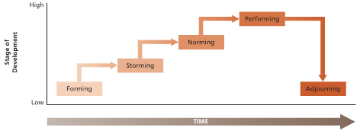
- situation is ambiguous
- members are aware of dependency on each other

2) Storming
- conflict emerges (confrontation + criticism occur)
- issue sorting out roles/responsibilities

3) Norming
- resolve issues in storming (through compromise)
- develop social consensus + info flows freely
- interdependence is reorganized, norms are agreed to, group becomes more cohesive

4) Performing
- devotes energy toward task accomplishment (achievement, creativity, assistance)
5) Adjourning
- rites/rituals that affirm previous successful development are common
- exhibit emotional support for each other

3. Punctuated Equilibrium Model (when groups have a deadline for problem-solving tasks)

Definition:
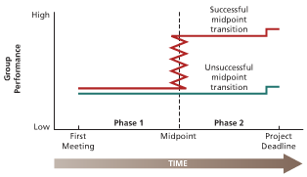
- model of group development that describes how groups with deadlines are affected by their first meetings and crucial midpoint transitions

Phase 1:
- first meeting midpoint
- gather info, hold meetings, set agenda
- group makes little visible effort progress toward the goal

Midpoint transition:
- halfway point in time toward the group’s deadline
- change in group’s approach (management of change is critical to progress)
- seek outside advice to move forward

Phase 2:
- decisions/approaches from midpoint are played out in this phase
- final meeting + burst of activity + concern for evaluation

Advice for managers:
- Prepare carefully for the first meeting.
- As long as people are working, do not look for radical progress during Phase 1.
- Manage the midpoint transition carefully.
- Be sure that adequate resources are available to actually execute the Phase 2 plan.
- Resist deadline changes.

4. Group Structure

Defn:
- characteristics of the stable social organization of a group (way group is put together)
- groups vary through: size, member diversity, norms, roles, cohesiveness

1) Group Size and Satisfaction
- larger groups report less satisfaction with group membership
- opportunities for friendship ⬆, chance to develop opportunities ⬇
- larger groups prompt conflict/dissension (larger groups have diff. viewpoints)
- many people are inhibited about participation in large groups
- members identify less easily with success/accomplishments of group

2) Group Size and Performance
- relationship between group size/performance depends on task and how we define good performance

Additive Tasks
- group performance is dependent on the sum of the performance of individual group members (ex: building a house)
Disjunctive Tasks:
- potential for performance of group depends on performance of best member
- group wants to include a superior performer for complicated tasks
- increases with group size since there is more chance of getting a superior person

Conjunctive Tasks:
- performance of group is limited by its poorest performer (ex: assembly line)
- performance decreases as group size goes up

Process Losses
- performance difficulties that stem from the problems of motivating/coordinating larger groups
- as groups get bigger, they suffer from process losses
- problems of communication/decision making increase
ACTUAL PERFORMANCE = POT. PERF. – PROCESS LOSSES

3) Group Size, Productivity, and Process Losses

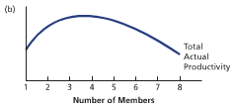
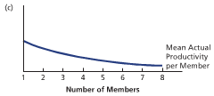
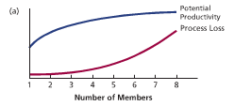

4) Diversity of Group Membership
- Initially:
- more difficulties with communication/cohesiveness
- spend more time forming, storming, and norming
- Once diverse groups develop:
- equally cohesive/productive
- might perform better on cognitive/creative/problem-solving tasks
- Surface diversity
- negative effects in age, gender, race wear off over time
- Deep diversity
- attitudes toward work/how to accomplish a goal = damage cohesiveness
5) Group Norms

What are norms?
- collective expectations that members of social units have regarding the behavior of each other

Why do norms develop?
- to provide regularity/predictability to behavior
- provides psychological security/permits us to carry out daily business

What do norms develop about?
- develop to regulate behaviors that are considered important to supporters

How do norms develop?
- shares attitudes (related beliefs+values) form the basis for norms
- collectively held expectations
Why do individuals comply with norms?
- norm corresponds to privately held attitudes
- they often save time and prevent social confusion

TYPES: dress norms, reward allocation norms (equity, equality, reciprocity, social responsibility), performance norms

6) Roles
- positions in a group that have a set of expected behaviors attached to them
- represent “packages” of norms that apply to particular group members
1) Assigned roles
- formally prescribed as a means of dividing labor/responsibility to facilitate task achievement (who does what, and who can tell others what to do)

2) Emergent roles
- developed naturally to meet the social-emotional needs of group members
- to assist in formal job accomplishment

Role Conflict. Role conflict exists when an individual is faced with incompatible role expectations. There are several different types of role conflict.
- Intrasender role conflict occurs when a single role sender provides incompatible role expectations to a role occupant.
- Intersender role conflict occurs when two or more role senders provide a role occupant with incompatible expectations.
- Interrole conflict occurs when several roles held by a role occupant involve incompatible expectations.
- Person-role conflict occurs when role demands call for behaviour that is incompatible with the personality or skills of the role occupant.
The most consistent consequences of role conflict are job dissatisfaction, stress reactions, lowered organizational commitment, and turnover intentions. Managers can help prevent role conflict by avoiding self-contradictory messages, conferring with other role senders, being sensitive to multiple role demands, and fitting the right person to the right role.

E. Status
Status is the rank, social position, or prestige accorded to group members. It represents the group’s evaluation of a member. Organizations have both formal and informal status systems.
Formal Status Systems. The formal status system represents management’s attempt to publicly identify those people who have higher status than others. This is accomplished by the application of status symbols. Status symbols are tangible indicators of status. Status symbols might include titles, particular working relationships, the pay package, the work schedule, and the physical working environment. The criteria for achieving formal organizational status includes seniority in one’s work group and one’s assigned role in the organization.
Informal Status Systems. Informal status symbols also exist in organizations and can operate just as effectively. Sometimes, job performance is a basis for the acquisition of informal status. So a good hitter or a good performer will be accorded status, although status symbols might be lacking.
Consequences of Status Differences. Status affects the ways in which people communicate with each other. Most people like to communicate with others at their own status or higher, rather than with people who are below them. As a result, communication is likely to move up the status hierarchy in organizations. As well, higher status people do more talking and have more influence.
Reducing Status Barriers. Although status differences can be powerful motivators, status differences also tend to inhibit the free flow of communication in organizations and can make it more difficult to foster a culture of teamwork and cooperation. As a result, many organizations are doing away with status symbols such as executive dining rooms, and reserved parking in an attempt to foster a culture of teamwork and cooperation across the ranks. The use of e-mail has also been found to level status barriers, thus facilitating communication between people at all levels of the organization.

7) Group Cohesiveness
- degree to which a group is especially attractive to its members
- members are desirous of staying in the group because of attractiveness
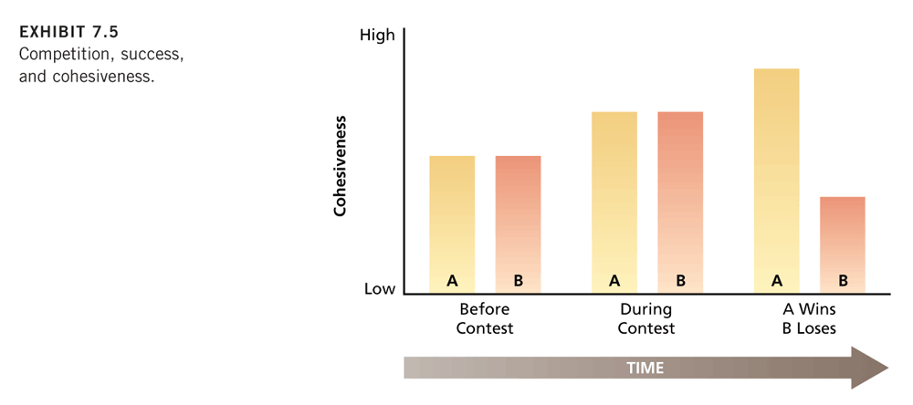
- factors that influence cohesiveness: threat/competition, success, member diversity, size, toughness of initiation

- Competition, Success, and Cohesiveness:
- external threat to survival + honest competition of group increases cohesiveness
- need to improve communication/coordination
- seen as more attractive capable of doing what has to be done
- attractiveness increases when members successfully accomplish important goal

- Consequences of Cohesiveness:
- more participation in group activities (members like being with each other)
- more conformity (induce conformity to group norms)
- more success (cohesiveness is reciprocally related to performance)

- Hypothetical Productivity Curves for Group Varying in Cohesiveness
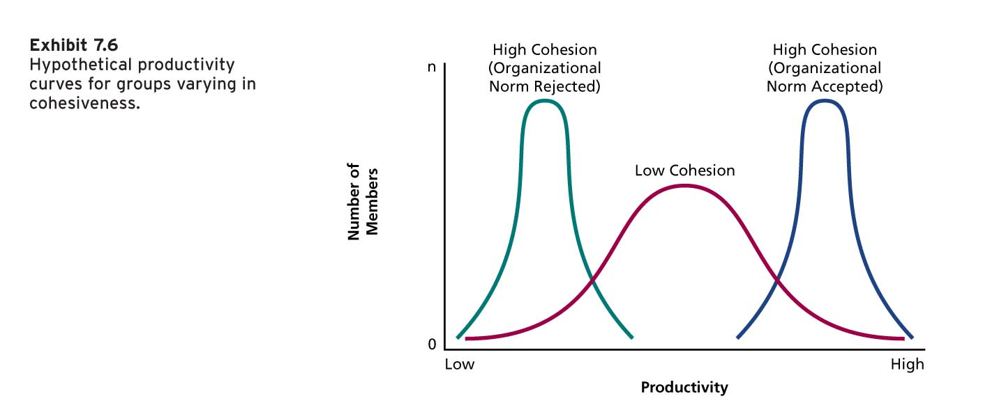

5. Social Loafing

Definition:
- tendency to withhold physical/intellectual effort when performing a group task
- other people were there to take up the slack
- reduced effort because others were not pulling their weight
- social loafing is a motivation problem

FORMS:
Free Rider Effect | - People lower their effort to get a free ride at the expense of their fellow group members
Sucker Effect | - People lower their effort to restore equity in the group
* free riders start slacking off and then the suckers follow suit performance suffers badly

Counteracting Social loafing
- Make individual performance more visible
- Make sure that the work is interesting
- Increase feelings of indispensability
- Increase performance feedback
- Reward group performance

VI. What Is a Team?
Some writers have suggested that a “team” is different from a “group” because in a team a synergy develops such that the group’s efforts are greater than the sum of its parts. However, the term “team” is more generally used to describe “groups” in organizational settings and the terms can be used interchangeably. Many organizations now use team-based work arrangements in an attempt to improve efficiency, quality, customer satisfaction, innovation, and/or the speed of production.
VII. Designing Effective Work Teams
According to J. Richard Hackman, a work group is effective when (1) its physical or intellectual output is acceptable to management and to the other parts of the organization that use this output, (2) group members’ needs are satisfied rather than frustrated by the group, and (3) the group experience enables members to continue to work together. Group effectiveness occurs when high effort is directed toward the group’s task, when great knowledge and skill are directed toward the task, and when the group adopts sensible strategies for accomplishing its goals.
A. Self-Managed Work Teams
Self-managed work teams are work groups that have the opportunity to do challenging work under reduced supervision. The general idea is that the group regulates much of its own members’ behaviour. Critical to the success of self-managed teams are the nature of the task, the composition of the group, and various support mechanisms.
Tasks for Self-Managed Teams. Tasks for self-managed teams should be complex and challenging and require high interdependence among team members for task accomplishment. Group members adopt roles that will make the group effective, not ones that are simply related to a narrow specialty.
Composition of Self-Managed Teams. A fast answer to how organizations should design effective self-managed teams is that they should be stable, small and smart. The composition of self-managed teams needs to consider a number of factors.
- Stability. Self-managed teams require considerable interaction and high cohesiveness among their members. To achieve this, group membership must be fairly stable.
- Size. The team should be as small as is feasible. The goal is to keep coordination problems and social loafing to a minimum.
- Expertise. Team members should have a high level of expertise about the task at hand. The group as a whole should be very knowledgeable about the task. All members should possess some degree of social skills.
- Diversity. The team should have members who are similar enough to work well together with enough diversity to bring a variety of perspectives and skills to the task.
Supporting Self-Managed Teams. A number of support factors can assist self-managed teams in becoming and staying effective.
- Training. To insure the effectiveness of self-managed teams, organizations need to provide extensive training in areas such as technical skills, social skills, language skills, and business training.
- Rewards. The general rule here is to try to tie rewards to team accomplishment rather than to individual accomplishment while still providing team members with some individual performance feedback.
- Management. The most effective managers in a self-management environment encourage groups to observe, evaluate, and reinforce their own task behaviour.
Research has found that the task characteristics are related to group effectiveness. In terms of group composition, teams perceived as too large for their tasks were rated as less effective than teams perceived as an appropriate size or too small. Managerial support and group processes have been found to be the best predictors of group effectiveness. Overall, research has shown improvements in team productivity, quality, customer satisfaction, and safety following the implementation of self-managed work teams.
B. Cross-Functional Teams
Another kind of team that contemporary organizations are using with increasing frequency is the cross-functional team. Cross-functional teams bring people with different functional specialties together to better invent, design, or deliver a product or service. The general goals of cross-functional teams include some combination of innovation, speed, and quality that come from early coordination among the various specialties.
Principles for Effectiveness. Research has discovered a number of factors that contribute to the effectiveness of cross-functional teams.
- Composition. All relevant specialties must be part of the team, including labour representatives or suppliers where appropriate.
- Superordinate goals. Conflict may sometimes arise from the colliding cultures of different functions. Superordinate goals are attractive outcomes that can only be achieved by collaboration. They help to override potential functional level conflicts.
- Physical proximity. Team members must be located close to one another to facilitate informal contact.
- Autonomy. Cross-functional teams need some autonomy from the larger organization, and functional specialties need some authority to commit their function to project decisions.
- Rules and procedures. Some basic decision procedures must be laid down to prevent anarchy.
- Leadership. Because of the potential for conflict, cross-functional team leaders need especially strong people skills in addition to task expertise.
C. Virtual Teams
Virtual teams are work groups that use technology to communicate and collaborate across time, space, and organizational boundaries. Along with their reliance on computer and electronic technology, the primary feature of these teams is the lack of face-to-face contact between team members due to geographic dispersion.
Advantages of Virtual Teams. Virtual teams have a number of advantages.
- Around-the-clock work. Globally, using a virtual team can create a 24-hour team that never sleeps.
- Reduced travel time and cost. Virtual teaming reduces travel costs associated with face-to-face meetings.
- Larger talent pool. Virtual teams allow companies to expand their potential labour markets and to go after the best people, even if they have no interest in relocating.
Challenges of Virtual Teams. Virtual teams also face several challenges.
- Miscommunication. The loss of face-to-face communication presents certain risks for virtual teams.
- Trust. Trust is difficult to develop between virtual team members.
- Isolation. The lack of casual interactions with co-workers can lead to team members having feelings of isolation and detachment.
- High costs. Savings in areas such as travel must be weighed against the costs of cutting-edge technology. Initial set-up costs can be substantial.
- Management issues. For managers, virtual teams create new challenges in terms of dealing with employees who are no longer in view.
A study of 65 virtual teams at Sabre Inc., concluded that trust was still possible through team member responsiveness, consistency, and reliability. Training and team building exercises were also found to be helpful to build trust and clarify communication standards. Virtual communication reduced instances of stereotyping, discrimination, personality conflicts, and the formation of cliques.
Lessons Concerning Virtual Teams. A number of lessons are beginning to emerge about what managers must do or keep watch for when developing virtual teams.
- Recruitment. Choose team members carefully in terms of attitude and personality. Find people with good interpersonal skills, not just technical skills.
- Training. Invest in training for both technical and interpersonal skills.
- Personalization. Encourage team members to get to know each other, either through informal communication using technology or by arranging face-to-face meetings.
Goals and ground rules. Virtual team leaders should define goals clearly, set rules for communication standards and responses, and provide feedback to keep team members informed of progress and the big picture.

