Chapter 6
Motivation in Practice

1. Money as a Motivator

- Money = pay + fringe benefits

How effective is pay as a motivator?
- Can satisfy lower-level, social, self-esteem and self-actualization needs
- Should be highly valent
- Pay should be clearly tied to performance (instrumentality)

* Financial incentives/pay-for-performance plans have been found to increase performance and lower turnover

1.1 Production Jobs

Use “Piece-Rate”:
- a set up so that individual workers are paid a certain sum of money for each unit of production they complete (ex: paid $2 for every dress you sew)
- also: paid hourly + piece-rate

Wage Incentive Plans:
- various systems that link pay to performance on production jobs
- improves productivity

Problems with Wage Incentive Plans:
- Lowered Quality
- Differential opportunity
- Reduced Cooperation (pressure to produce makes workers not want to do other things)
- Incompatible job design (some jobs are difficult to implement wage incentives)
- Restriction of productivity (artificial limitation of work output)

1.2 White-Collar Jobs

Use “Merit pay plans”:
- systems that link pay to performance on white-collar jobs (clerical, professional, managerial)
- evaluate performance of employees and recommend an amount of merit pay to be awarded

Problems with merit pay plans:
- Low discrimination (unwilling/unable to discriminate between good/poor performers)
- Small Increases (increases are too small to be effective motivators)
- Pay secrecy (employees cannot compare own merit treatment to others)

1.3 Team Work

Profit Sharing:
- the return of some company profit to employees in the form of a cash bonus of a retirement supplement
Problem: too many factors beyond the control of the workforce can affect profits

Employee Stock Ownership Plans (ESOPs):
- allow employees to own a set amount of the company’s shares
- employees purchase shares at a fixed price and companies match contributions
- provide employees with a stake in a company’s future earnings and success and help to create a sense of ownership
- believed to increase employees’ loyalty and motivation
- they align employees’ goals and interests with those of organization
Problems: hard to see link to performance & profit and is unmotivational when economy is slow shares go down

Gainsharing:
- group incentive plans that are based on improved productivity/performance over which the workforce has some control

Skill-Based Pay (pay for knowledge):
- system in which people are paid according to the number of job skills they have acquired
- use this to encourage employees flexibility in task assignments
- increase in productivity, lower labor costs per part
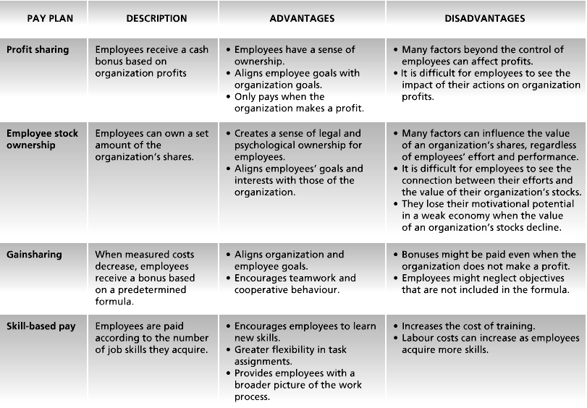

2. Job Design as a Motivator

Goal of job design:
- identify the characteristics that make some tasks more motivating than others
- to capture these characteristics in the design of jobs

Types of Job Design:
- Scientific Management
- Job Scope
- Job Characteristic Model
- Job Enrichment
- Work Design

2.1 Scientific Management

Until the 1960s, Taylor’s principles of Scientific Management were the prevailing philosophy of job design
- Job Simplification
- Extreme division of labor and specialization
- Careful standardization and regulation of work activities and rest pauses
- Motivational strategies: close supervision and piece-rate pay

2.2 Job Scope

Job Scope:
- breadth and depth of a job
- breadth: number of different activities performed on the job
- depth: degree of control the worker has over how these tasks are performed

*Broad jobs = workers do a number of different tasks
*Deep jobs = emphasize freedom in planning how to do the work

High Scope Jobs = great breadth and depth (ex: professor, and management jobs)
- provide more intrinsic motivation
Low Scope Jobs = low breadth and depth (ex: assembly line job)
high breadth and little depth
low breadth and high depth

To Increase the Scope of a Job:
1) Stretch assignments offer employees challenging opportunities
2) Job rotation rotating employees to different tasks and jobs in company

2.3 The Job Characteristics Model (Hackman and Oldham)

- Several core job characteristics that have a certain psychological impact on workers
- the psychological states induced by the nature of the job lead to certain outcomes that are relevant to the worker and the organization
- several factors (moderators) influence the extent to which these relationships hold true

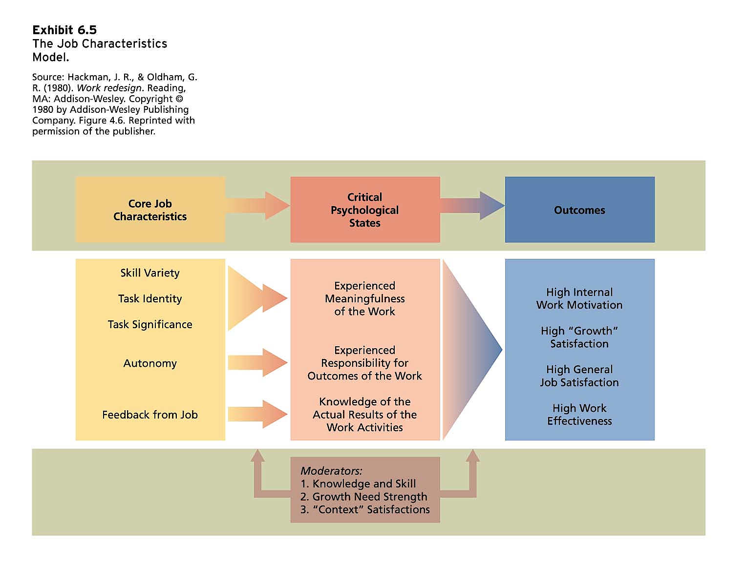

Core Job Characteristics (high levels = favorable outcomes):
1. Skill variety (job breadth)
2. Task identity (completing job from beginning to end)
3. Task significance (impact job has on others)
4. Autonomy (job depth)
5. Job Feedback (info about performance)

Motivating Potential Score
- Job diagnostic survey to measure the core characteristics of jobs

Skill Task Task
MPS = variety + identity + significance x Autonomy x Feedback
3

2.4 Job Enrichment Procedures

Job enrichment:
- design of jobs to enhance intrinsic motivation, the quality of working life, and job involvement
- job design to increase the MPS
- involves increasing the motivating potential of jobs via the arrangement of their core characteristics

Job involvement:
- cognitive state of psychological identification with one’s job and the importance of work to one’s total self-image
- challenging/enriched jobs = higher levels of job involvement

PROCEDURES:
- Combining tasks
- Establishing external client relationships (in touch with people outside company)
- Establishing internal client relationships (in touch with people who depend on product)
- Reducing supervision or reliance on others
- Forming work teams
- Making feedback more direct

PROBLEMS:
- Poor diagnosis (ex: job enlargement – more tasks, same work level)
- Lack of desire/skill
- Demand for Rewards (workers ask for greater extrinsic rewards)
- Union resistance
- Supervisory Resistance

2.5 Work Design

Work Design Characteristics:
- attributes of the task, job, and social/organizational environment
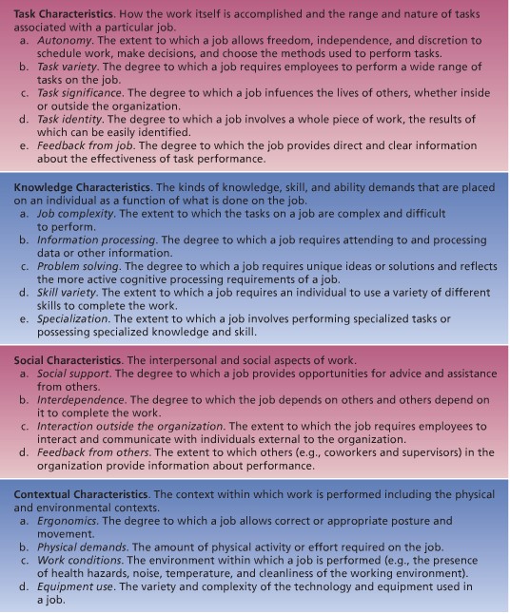

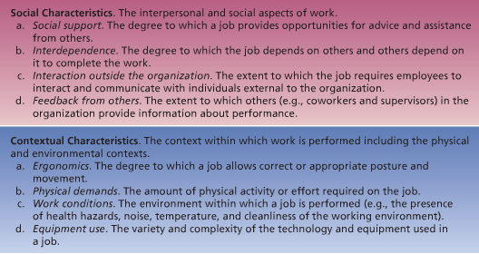

Management by Objectives (MBO)

MBO:
- elaborate, systematic, ongoing management program designed to facilitate goal establishment, goal accomplishment, and employee development

Alternative Working Schedules

Purpose: meet diverse workforce needs and promote job satisfaction

Alternatives:

1) Flextime:
- alternative work schedule where arrival and departure times are flexible
- reduces absenteeism
- signals a degree of prestige and trust

2) Compressed Workweek:
- employees work fewer than the normal five days a week by still put in a normal number of hours per week (4-10hr days each week)

3) Job and work sharing
- job sharing: two part-time employees divide the work of a full-time job
- work sharing: reducing # of hrs employees work to avoid layoffs

4) Telecommuting
- employees are able to work at home by stay in touch with their offices through the use of communications technology (computer network, voicemail, and messaging)

