Chapter 5
Theories of Work Motivation

What is Motivation?

Motivation:
- extent to which persistent effort is directed toward a goal

Basic Characteristics of Motivation
1) Effort
- strength of person’s work-related behavior & amount of effort you put into job
2) Persistence
- applying effort into their work tasks
3) Direction
- do workers channel persistent effort in a direction that benefits the organization?
4) Goals
- all motivated behavior has a goal or objective to which it is directed

Factors Contributing to Individual Job Performance
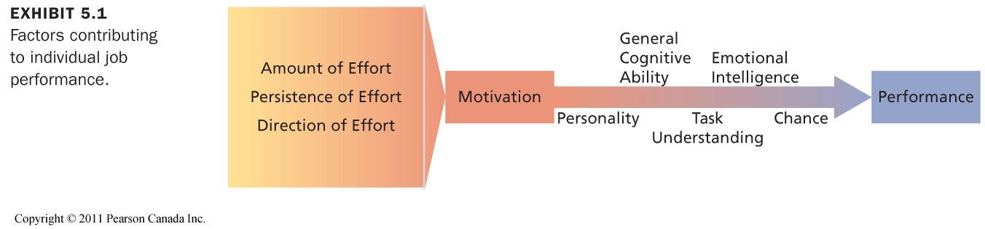

Emotional Intelligence
- the ability to understand and manage one’s own and other’s feelings and emotions
- high EI = able to identify and understand the meanings of emotions and try to manage and regulate their emotions as a basis for problem solving, reasoning, thinking and action

Perceiving Emotions Using Emotions Understanding Emotions Managing Emotions

Self-Determination Theory (Deci & Ryan)

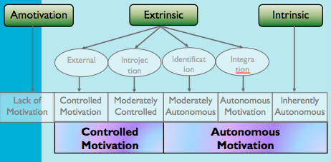

- Theory of motivation that considers whether people’s motivation is autonomous or controlled
- autonomous motivation facilitates effective performance, especially on complex tasks

Autonomous motivation:
- When people are motivated by intrinsic factors, they are in control of their motivation

Controlled motivation:
- when people are motivated to obtain a desired consequence or extrinsic reward, their motivation is controlled externally

What are the Consequences of Autonomous Motivation?
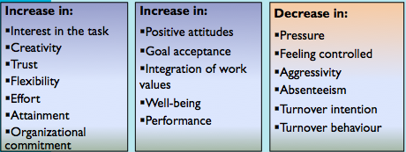

Basic Psychological Needs
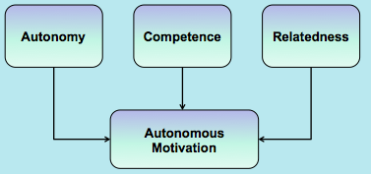

Need Theories of Work Motivation
- attempt to specify the kinds of needs people have and the conditions under which they will be motivated to satisfy these needs in a way that contributes to performance
- Need theories: WHAT motivates people

Needs:
- psychological and physiological wants or desires
- individuals can satisfy by acquiring certain incentives or achieving particular goals

NEEDS BEHAVIOR INCENTIVES AND GOALS

McClelland’s Theory of Needs

Theory:
- nonhierarchical need theory of motivation that outlines the conditions under which certain needs result in particular patterns

Three needs that reflect relatively stable personality characteristics:

1) Need for achievement:
- high: strong desire to perform challenging tasks well

2) Need for affiliation:
- high: strong desire to establish and maintain friendly, compatible interpersonal relationships
- like to like others, and want others to like them
- learn social networking quickly and tendency to communicate frequently with others

3) Need for power:
- high: strong desire to have influence over others
- wish to make significant impact/impression on other poepl

Implications for McClelland’s Theory of Needs

nAch | Sales jobs or entrepreneurial positions
nAff | Social work or customer relations
nPower | Journalism and management

- Managers must evaluate employees’ needs and offer goals and incentives accordingly

Process Theories of Work Motivation

Process Theories:
- concentrate on HOW motivation occurs

Three Important Process Theories:
1. Expectancy Theory (Vroom)
- belief that motivation is determined by the outcomes that people expect to occur as a result of their actions on the job
- based on the perceptions of individual worker
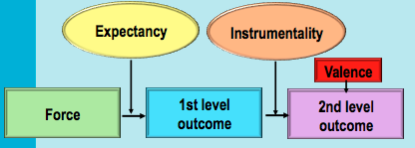

Outcomes:
- consequences that follow work behavior
- first-level: interest to organization (ex: high productivity vs average productivity)
- second-level: consequences that follow the attainment of a first-level outcome

Instrumentality:
- probability that a particular first-level outcome will be followed by a particular second-level outcome

Valence = Σ instrumentalities × second-level valences
- the expected value of work outcomes
- the extent to which they are attractive or unattractive

Expectancy:
- probability that the worker can actually achieve a particular first-level outcome

Force = first-level valence × expectancy
- the end product of the other components of the theory
- represents the relative degree of effort that will be directed toward various first-level outcomes

The Premises of Expectancy Theory

• Will my effort produce the desired performance?

• Will my performance lead to desired outcome?
– People will be motivated to perform in those work activities that they find attractive and that they feel they can accomplish.
– The attractiveness of various work activities depends on the extent to which they lead to favorable personal consequences.

Managerial Implications of Expectancy Theory:

Boost Expectancies:
- Ensure that employees expect to be able to achieve first-level outcomes.

Clarify Reward Contingencies:
- Employees should be convinced that first-level outcomes are clearly instrumental in - obtaining positive second-level outcomes
- avoiding negative outcomes.

Appreciate Diverse Needs:
- Analyze the diverse preferences of employees and attempt to design individualized “motivational packages”.

2. Equity Theory (Adams)
- process theory that states that motivation stems from a comparison of the inputs one invests in a job and the outcomes one receives in comparison with the inputs and outcomes of another person or group

Ratios are equal = worker should feel that a fair and equitable exchange exists with the employing organization (contributes to job satisfaction)

Ratios are unequal = workers perceive inequity and experience job dissatisfaction

* Individuals are motivated to maintain an equitable exchange relationship

Tactics for Reducing Inequity

- Perceptually distort one’s own inputs or outcomes
- Perceptually distort the inputs or outcomes of the comparison person or group
- Choose another comparison person or group
- Alter one’s inputs or alter one’s outcomes
- Leave the exchange relationship

3. Goal Setting Theory (Locke & Latham)

Theory:
- states that goals are motivational when they are specific, challenging, and when organizational members are committed to them and feedback about progress toward goal attainment is provided

Positive effects are due to 4 mechanisms:
- they direct attention toward goal-relevant activities
- they lead to greater effort
- they increase and prolong persistence
- they lead to the discover and use of task-relevant strategies for goal attainment



Managerial Implication

• Set specific and challenging goals and provide ongoing feedback.
• Enhancing Goal Commitment
–Participation
–Rewards
–Management support

Research Support for Goal Setting Theory

• Specific, difficult goals lead to improved performance and productivity on a wide variety of tasks and occupations.

• The effects of goal setting on performance depend on a number of factors.
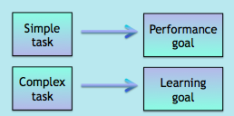

Do Motivation Theories Translate Across Cultures?

- Self-determination theory is effective in different culture

- Need theories face some cultural limitations.

- Equity theory will be constrained by what is considered “fair” in a particular culture (e.g., equity versus equality).

- Because of its flexibility, expectancy theory is very effective when applied cross-culturally.

- The goal setting process must be adjusted to the culture (e.g., individual versus group goals).

