Chapter 4
Values, Attitudes, and Work Behavior

What are Values?

Values:
- broad tendency to prefer certain states of affairs over others
- what we consider to be good or bad
- they are motivational
- tend to hold values structures around achievement, power, autonomy, conformity, tradition, and social welfare

Four Generations in Today’s Workplace

Generation | Percentage of Workforce | Assets in the Workplace | Leadership style preferences
Traditionalists | 8% | Hardworking, stable, loyal, thorough, detail-oriented, focused, emotional maturity | Fair, consistent, clear, direct, respectful
Baby boomers | 44% | Team perspective, dedicated, experienced, knowledgeable, service-oriented | Treat as equals, warm and caring, mission-defined, democratic approach
Generation X | 34% | Independent, adaptable, creative, techno-literate, willing to challenge the status quo | Direct, competent, genuine, informal, flexible, results-oriented, supportive of learning opportunities
Millennials | 14% | Optimistic, able to multitask, tenacious, technologically savvy, driven to learn and grow, team-oriented, socially responsible | Motivational, collaborative, positive, educational, organized, achievement-oriented, able to coach

Cultural Differences in Values

- there are basic differences in work-related values across cultures
- a lack of understanding of cross-cultural differences can cause foreign assignments and business to terminate early and business negotiations to fail

Work Centrality Questionnaire

It was found that work itself is valued differently across cultures:
- Japan had very high work centrality
- Belgians and Americans exhibited average work centrality
- British had low work centrality
- People with more work centrality would work even if they won the lottery
- People high more work centrality worked more hours

Hofstede’s Study

Five basic dimensions along which work-related values differed across cultures:

1) Power Distance
- Extent to which people accept an unequal distribution of power

2) Uncertainty Avoidance
- extent to which people are uncomfortable with uncertain and ambiguous situations

3) Masculinity/Femininity
- masculine cultures: clearly differentiate gender roles, support male dominance
- Japan, Austria, Mexico, Venezuela
- feminine cultures: fluid gender roles, stress sexual equality
- Scandinavian countries

4) Individualism/Collectivism
- Individualistic societies: stress independence, individual initiative, privacy
- Collective societies: favor dependence and loyalty to family or clan

5) Long-term/Short-term orientation
- LT orientation: stress persistence, perseverance, thrift, and close attention to status differences
- ST orientation: personal steadiness, stability, face saving, social niceties

Implications of Cultural Variation

- Organizational behavior theories, research, and practices from North America might not translate well to other societies

- Organizations need to tailor management practices to the home culture’s concerns

- An appreciation of cross-cultural difference in values is essential to understanding the needs and tastes of customers or clients around the world

- Companies need to select, train, and develop employees to have an appreciation of differences in cultural values and the implications

What are Attitudes?

Attitude:
- fairly stable evaluative tendency to respond consistently to some specific object, situation, person, or category of people
- more specific than values
- not always consistent with behavior
- provide useful info over and above the actions we can observe

Attitudes involve:
- Evaluations directed toward specific targets (evaluative aspects)
- tendencies to respond to the target of the attitude

Attitude behavior
(attitudes often influence our behavior toward something or someone)

Attitude come from:
- a function of what we think and what we feel
- the product of a related belief and value

BELIEF + VALUE ➔ Attitude Behavior

Examples of beliefs, values and attitudes:
- Belief: my job is interfering with my family life
- Value: I dislike anything that hurts my family
- Attitude: I dislike my job

What do organizations do with attitudes?

- Organizations often attempt to change employee attitudes
- initiated by a communicator who tries to use persuasion to modify beliefs/values
- Organizations use persuasion (usually emotionally oriented or rational persuasion) to change values and modify certain beliefs

What is job satisfaction?

Job satisfaction:
- collection of attitudes that people have about their jobs

Two Aspects:
1) Facet satisfaction
- tendency for an employee to be more or less satisfied with various facets of the job
- Ex: “I love my work but I hate my boss”

2) Overall Satisfaction:
- an overall or summary indicator of a person’s attitude toward his or her job that cuts across the various facets
- Ex: “On the whole, I really like my job, although a couple of aspects could stand some improvement”

Measures of Job Satisfaction:
- Job Descriptive Index (JDI)
- designed around five facets and respondents answer yes, no, or ? to describe a particular work or phrase of particular facets of their job
- Minnesota Satisfaction Questionnaire (MSQ)
- respondents indicate how happy they are with various aspects of their job on a scale ranging from “very satisfied” to “very dissatisfied”

What Determines Job Satisfaction?

1) Discrepancy
- discrepancy between outcomes people receive and those they want
- job satisfaction stems from the discrepancy between the job outcomes wanted and the outcomes that are perceived to be obtained
- might differ in their perception concerning the actual nature of the job
- differ in what they want from the jobs
- Ex: satisfaction of one’s pay is high when there is a small gap between the pay received and the perception of how much pay should be received

2) Fairness (Organizational Justice)
- affect both what people want from their jobs and how they react to the inevitable discrepancies of organizational life

Distributive Fairness (outcomes we perceive)
- fairness occurs when people receive the outcomes they think they deserve from their jobs
- individuals want what is fair
- equity theory is used to develop out conception of what is fair
- the equitable distribution of work outcomes contributes to job satisfaction by providing for feelings of distributive fairness

Equity Theory
- states that the inputs that people perceive themselves as investing in a job and the outcomes that the job provides are compared against the inputs and outcomes of some other relevant person/group
- INPUTS: anything that someone considers relevant to their exchange with the organizations (ex: education, training, seniority, hard work, high-quality work)
- OUTCOMES: factors that the organization distributes to employees in return for their inputs (ex: pay, career opportunities, supervision, etc.)

My outcomes = Other’s outcomes
My inputs Other’s inputs

Procedural Fairness (process that led to those outcomes)
- fairness occurs when individuals see the process used to determine outcomes as reasonable
- relevant to outcomes: performance evaluations, pay raises, promotions, layoffs, work assignments

To promote procedural fairness:
- follow consistent procedures over time, across people
- use accurate info and appear unbiased
- allow 2-way communication during allocation process
- welcome appeals of the procedure allocation

Interactional Fairness (how these matters were communicated to us):
- fairness occurs when people feel they have received respectful and informative communication about an outcome
- important because it is possible that fair outcomes/procedures to be perceived as unfair when they are inadequately explained
- procedural and interactional fairness can offset the negative effects of distributive unfairness

3) Disposition
- Some people are predisposed by virtue of their personalities to be more or less satisfied despite changes in discrepancy or fairness
- Research suggests that disposition contributes to job satisfaction

4) Mood and Emotion
- Role of affect (feelings) as a determinant of job satisfaction
- Emotions: intense, short-lived, caused by a particular event
- Moods: less intense, longer-lived, more diffuse feelings

Affective Events Theory:
- jobs consist of a series of events and happenings that have the potential to provoke emotions or to influence moods depending on how we appraise these events and happenings
- a person’s disposition can interact with job events to influence satisfaction

Emotional Contagion and Regulation:

Emotional Contagion:
- tendency for moods and emotions to spread between people or throughout a group
- People’s moods/emotions tend to converge with interaction

Emotional regulation:
- requirement for people to conform to certain “display rules” in their job behavior in spite of their true mood or emotions
- consequences: the frequent need to suppress negative emotions takes a toll on job satisfaction and increases stress

How Discrepancy, Fairness, Disposition, Mood and Emotion affect Job Satisfaction

Satisfaction if a function of:
- certain dispositional factors
- discrepancy between the job outcomes a person wants and the outcomes received
- mood and emotion

People experience greater satisfaction when
- they meet or exceed the job outcomes they want
- perceive the job outcomes they receive as equitable compared with those others receive
- believe that fair procedures determine job outcomes

- The outcomes that people perceive themselves as receiving from the job represent their beliefs about the nature of that job
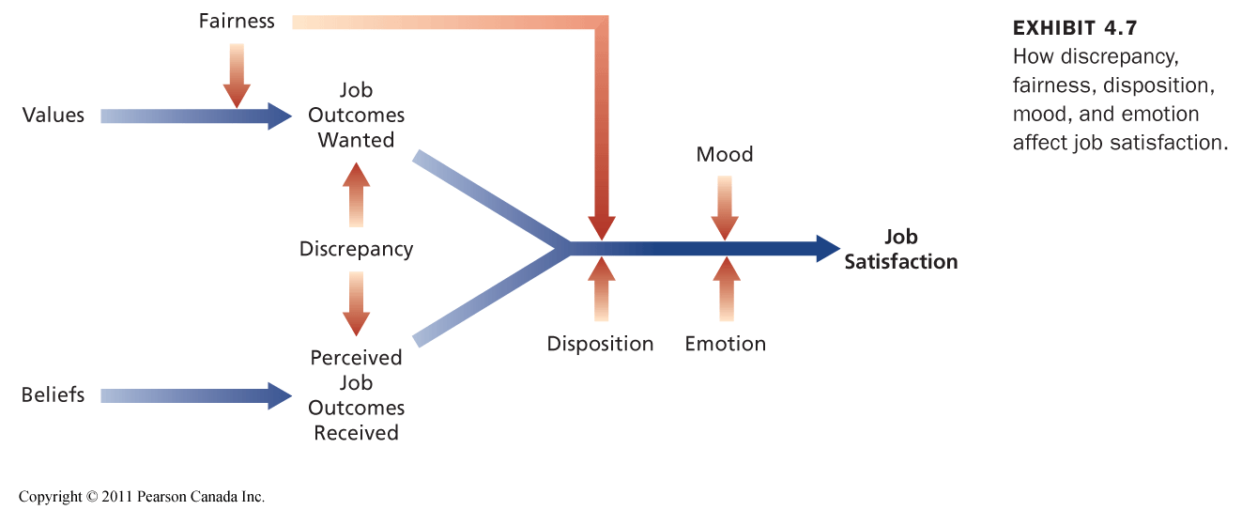

Other Contributors to Job Satisfaction

1) Mentally challenging work
- tests employees’ skills and abilities and allows them to set their own working pace
- employees perceive such work as personally involving and important
- provides worker with clearer feedback regarding performance

2) Adequate compensation
- pay and satisfaction are positively related
- some people are willing to accept less responsibility/fewer hours for less pay

3) Career Opportunities
- availability of career opportunities
- promotions contain a number of valued signals about a person’s self worth

4) People
- friendly, considerate, good-natured superiors and co-workers contribute to job satisfaction
- tend to be satisfied in the presence of people who help us attain job outcomes that we value

Consequences of Job Satisfaction

1) Absence from Work
- less-satisfied employees are more likely to be absent
- satisfaction with the content of the work is the best predictor of absenteeism

2) Model of Employee Turnover
- moderately strong connection with less satisfied workers being more likely to quit

Exhibit 4.9
- circles represent attitudes, ovals represent elements of the turnover process, squares denote situational factors
- shows that job satisfaction as well as commitment to the organization and various “shocks” can contribute to intentions to leave

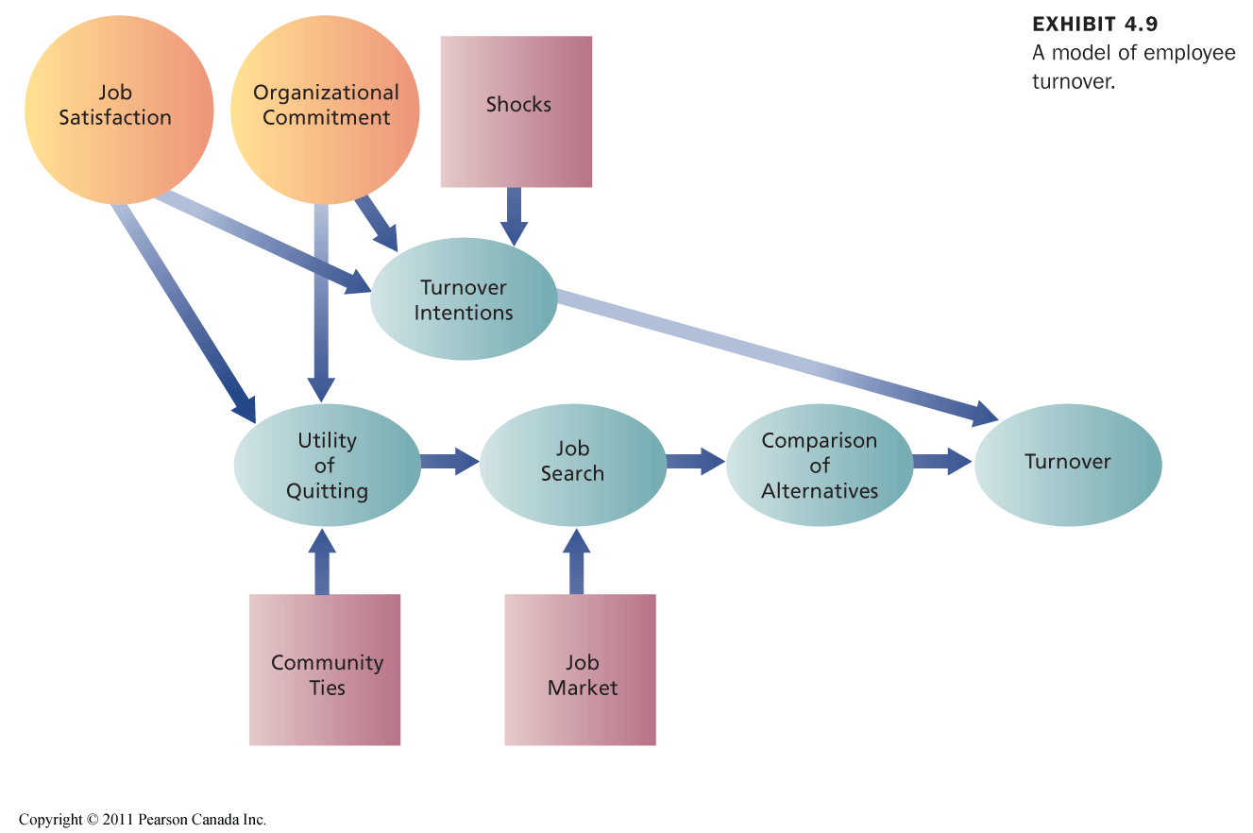

The Honeymoon-Hangover Effect
- a decrease in job satisfaction often precedes turnover and those who quit experience a boost in satisfaction on their new job
- BOOST Honeymoon effect
- the bad facets of the old job are gone
- the good facets of the new job are apparent
- the bad facets of the new job are not known yet
- over time, the bad facets are recognized (hangover effect occurs) and overall satisfaction with new job decreases
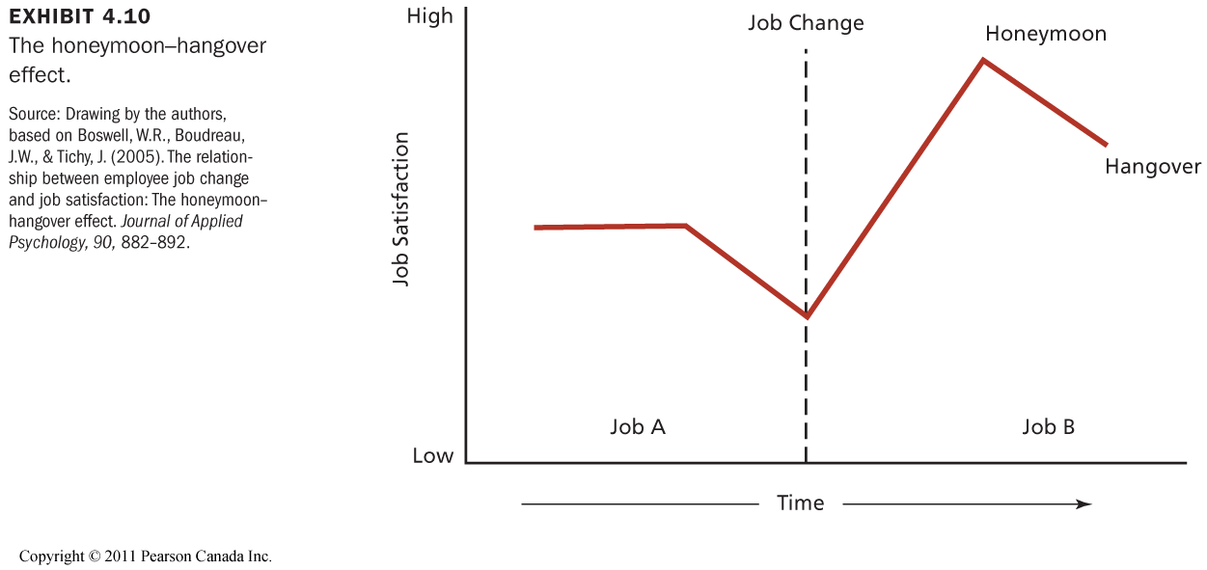

3) Performance
- Job satisfaction is associated with higher job performance.
- However, it’s complicated; many factors influence motivation and performance.
- The most important factor is the content of the work itself.
- Performance could also contribute to job satisfaction.

4) Organizational Citizenship Behavior
- OCB is a voluntary, informal behaviour that contributes to organizational effectiveness.
- unlikely to be rewarded by the performance evaluation.
- Job satisfaction contributes greatly to OCB.
- OCB contributes to organizational productivity and efficiency and to reduced turnover.

Defining characteristics of OCB:
- Behavior is voluntary
- Behavior is spontaneous
- Behavior contributes to organizational effectiveness
- Behavior is likely to be explicitly picked up and rewarded by the performance evaluation system

Forms of OCB:
- helping behavior
- conscientiousness to the details of work
- good sport when the inevitable frustrations of organizational life crop up

5) Customer Satisfaction and Profit

⬆ Employee satisfaction
- ⬆ customer satisfaction
- ⬆ organizational effectiveness
- ⬆ profitability

How does it work?
- Reduced absenteeism and turnover contribute to the seamless delivery of service.
- OCBs stimulate good teamwork.
- A good mood among employees can be contagious for customers.

6) Organizational Commitment

Organizational commitment:
- attitude that reflects the strength of the linkage between an employee and an organization

Three Types of Organizational Commitment:
1) Affective commitment (WANT TO)
- commitment based on a person’s identification and involvement with an organization
- interesting, satisfying work of the type found in enriched jobs
- positively related to performance focuses attention on goals and enhances motivation
- High affective commitment stay because they want to

2) Continuance commitment (HAVE TO)
- based on the costs that would be incurred in leaving an organization
- people feel that leaving the organization will result in a personal sacrifice
- obtaining rapid promotions can lock employees into organizations
- increases with the time a person is employed by an organization
- negatively related to performance people locked into organizations that they hate
- high continuance stay because they have to

3) Normative commitment: (SHOULD)
- based on ideology/feeling of obligation to an organization
- fostered by benefits that build a sense of obligation and strong identification with organizations products or services
- high normative commitment stay because they should

Consequences of Organizational Commitment
- reduce turnover intentions and actual turnover
- high levels of commitment can cause conflicts between family life and work life
- very high levels of commitment have often been implicated in unethical and illegal behavior
- high levels of commitment to a particular form/style of organization can cause a lack of innovation and lead to resistance when a change in the culture is necessary

Changes in the Workplace

- Employees are losing commitment to their organizations
- People view careers as a series of jobs with a variety of potential employers

Impact of changes in the workplace on employee commitment:

1) Changes in the nature of employees’ commitment to the organization

2) Changes in the focus of employees’ commitment
- as companies increase in size, employees are likely to shift their commitment to smaller organizational units

3) The multiplicity of employer-employee relationships within organizations
- Employees who do not have guaranteed job security may be unwilling to be as flexible as the company wants them to me

