Chapter 3
Perception, Attribution, and Diversity

What is perception?

Perception:
- the process of interpreting the messages of our sense to provide order and meaning to the environment
- helps sort out and organize the complex and varied input received by our senses of sight, smell, touch, taste and hearing

Components of Perception

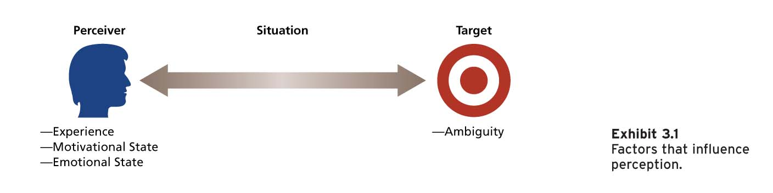

1) Perceiver
- experience, needs, and emotions can affect his or her perceptions of a target
- Past experiences lead the perceiver to develop expectations and these expectations affect current perceptions

2) Target
- perception involves interpretations and the addition of meaning to the target
- ambiguous targets are especially susceptible to interpretations and addition

3) Situation
- Perception occurs in some situations context, and this context can affect what one perceives
- the situation can add information to the target
- the perception of the target changes with the situation

Perceptual defence:
- the tendency for the perceptual system to defend the perceiver against unpleasant emotions
- “see what you want to see”, “hear what you want to hear”

Brunner’s Model of the Perceptual Process (p.76)
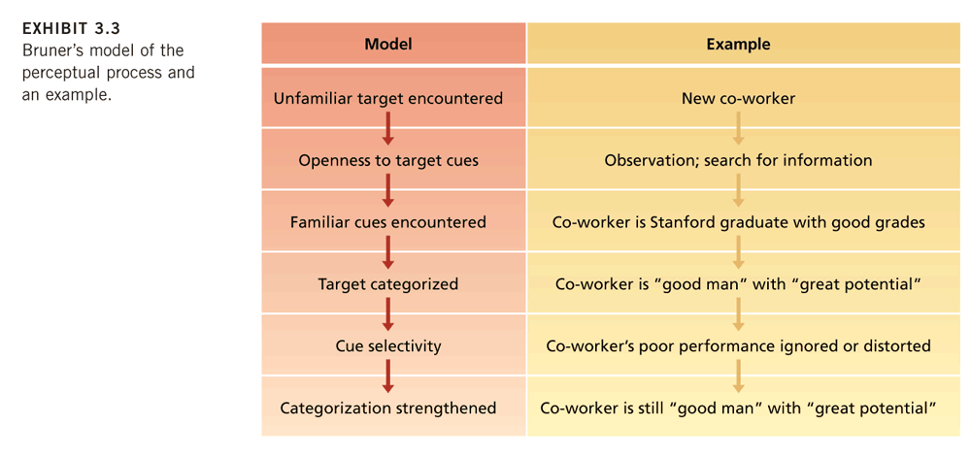

Perceptual Tendencies:

1) Selective (don’t use all cues + give special emphasis to some)
- perceivers do not use all the available cues, and those they do use are this given special emphasis
- our perception is efficient and this efficiency can both aid and hinder our perceptual accuracy

2) Constancy
- the target is perceived the same way over time or across situations

3) Consistency
- tendency to select, ignore, and distort cues in such a manner that they fit together to form a homogenous picture of the target

Basic Biases in Person Perception

1. Primacy effect
- the reliance on early cues or first impressions
- often has a lasting impact
- form of selectivity and long-lasting effects illustrate consistency tendency

2. Recency effect
- reliance on recent cues or last impressions

3. Central Traits
- personal characteristics of the target that are of special interest to the perceiver
- ex: attractive is seen as “good”

4. Implicit personality theories
- personal theories that people have about which personality characteristics go together
- ex: you expect hardworking people to also be honest

5. Projection
- Tendency to attribute one’s own thoughts and feelings to others
- projection can serve as a form of perceptual defence

6. Stereotyping

- the tendency to generalize about people in a certain social category and ignore variations among them
- Categories include: race, age, gender, ethnic background, social class, education and occupation
- not all stereotypes are unfavorable

Three specific aspects to stereotyping:

1) We distinguish some category of people (college professors)

2) we assume that the individuals in this category have certain traits (absent-minded, disorganized)

3) We perceive that everyone in this category possesses these traits (“all my professors this year will be absent-minded and disorganized”)

Attribution: Perceiving Causes and Motives

Attribution:
- the process by which causes or motives are assigned to explain people’s behavior

Goal: to determine whether the behavior is caused by dispositional or situational factors

1) Dispositional attributions
- suggest that some personality or intellectual characteristic unique to the person is responsible for the behavior
- the behavior reflects the “true person”
- ex: explaining behavior as a function of intelligence, greed, friendliness, or laziness

2) Situational attributions
- suggest that the external situation or environment in which the target person exists was responsible for the behavior
- person had little control over the behavior
- ex: explaining behavior as a function of bad weather, good luck, proper tools, or poor advice

Three implicit questions/cues to guide behavior as dispositional or situational:

- Does the person engage in the behavior regularly and consistently? (consistency cues)

- Do most people engage in the behavior, or is it unique to this person? (consensus cues)

- Does the person engage in the behavior in many situations, or is it distinctive to one situation? (distinctiveness cues)

Consistency cues: how consistent a person engages in a behavior
Consensus cues: how a person’s behavior compares with that of others

Distinctiveness cues: the extent to which a behavior occurs across a variety of situations

Attribution Process

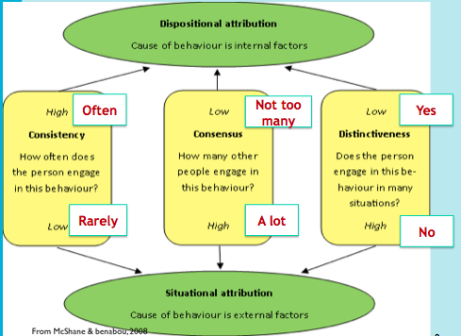

Disposition attribution = high consistency + low consensus + low distinctiveness

Situational attribution = low consistency + high consensus + high distinctiveness

Biases in Attribution

1) Fundamental Attribution Error
- Tendency to overemphasize dispositional explanations for behavior at the expense of situational explanations
- discount the strong effects that social roles can have on behavior
- fail to realize that the observed behavior is distinctive to a particular situation
- ex: laziness or low aptitude might be cited while poor training or bad sales territory is ignored

2) Actor-Observer Effect
- the propensity for actors and observers to view the causes of the actor’s behavior differently
- ACTORS: Sensitive to those environmental events that led us to be late or absent
- OBSERVERS: More likely to invoke dispositional causes

3) Self-serving Bias
- Tendency to take credit for successful outcomes and to deny responsibility for failures
- suggests that people will explain the very same behavior differently on the basis of events that happened after the behavior occurred

Person Perception and Workforce Diversity

Workforce diversity:
- refers to differences among employees or potential recruits in characteristics such as gender, race, age, religion, cultural background, physical ability, or sexual orientation
- Two broad facts: workforce is becoming more diverse and there is growing recognition that many organizations have not successfully managed workforce diversity

The Changing Workplace
- The workforce is becoming more diverse:
- The number of visible minorities in Canada is expected to double by 2017.
- In less than a decade, 48 % of the working-age population will be between the ages of 45 and 64.
- Many organizations are seeking to recruit more representatively.
- Many employees are required to interact with one another or work in teamwork.

Valuing Diversity
- Improved recruiting
- Improved marketing
- Improved competitiveness in global markets
- Resource-Acquisition
- Improved Creativity
- Improved Problem-Solving
- System Flexibility

Stereotypes and Workforce Diversity

- A major barrier to valuing diversity is the stereotype.

- The tendency to generalize about people in a certain social category and ignore variations among them.

- Common workplace stereotypes are based on gender, age, race, and ethnicity.

- Stereotypes can have negative effects on how individuals are treated in organizations.

Stereotype Threat:
- Members of a social group feel they might be judged or treated according to a stereotype
- their behavior or performance will confirm the stereotype
- the activation of a salient negative stereotype threat in a testing situation has been found to result in lower cognitive ability and math test performance scores of minorities and women

Racial and Ethnic Stereotypes:
- Racial and ethnic stereotypes are pervasive, persistent, frequently negative, and often contradictory.
- Whites have been found to advance further in the hiring process than blacks.
- Career tracking based on racial or ethnic stereotyping is common.
- Organizations are reflections of the environments of which they are a part.

Gender stereotypes:
- Women are underrepresented in managerial and administrative jobs.
–14.4 percent of corporate officer positions.
- Stereotypes of women do not correspond well with stereotypes of businesspeople or managers.
- Successful managers are perceived as having traits and attitudes that are generally ascribed to men (leadership ability, competitiveness, self-confidence, ambitiousness, and objectivity)

Age Stereotypes:
- Older workers are seen as having less capacity for performance:
- They are perceived as more rigid and dogmatic, and less adaptable to new corporate cultures.
- They are perceived as more honest, dependable, and trustworthy.
- These stereotypes are inaccurate:
–Age seldom limits the capacity for development until post-employment years.
–Research has found that age and job performance are unrelated.

Managing Workforce Diversity

- Select enough minority members to get them beyond token status.
- Encourage teamwork that brings minority and majority members together.
- Ensure that those making career decisions about employees have accurate information about them.
- Train people to be aware of stereotypes.

Managing Workforce Diversity at Boeing Canada Technology

• Diversity days.
• Diversity training.
• Language and ASL training.
• Monthly awareness campaigns.
• Aboriginal recruitment.
• Job shadowing.
• Volunteer employment equity and diversity team.

Diversity Training Programs (BCDEE)

- Awareness training should be accompanied by skills training relevant to the needs of the organization.
- Build senior management commitment and accountability.
- Conduct a thorough needs assessment.
- Develop a well-defined strategy tied to business results.
- Emphasize team-building and group process training.
- Establish metrics and evaluate the effectiveness of diversity initiatives.

