Chapter 2
Personality and Learning

Chapter 1 Review:

History of Organizational Behavior:
- began in the time of the Industrial Revolution
- organizations wanted to discover the correct way to manage and achieve their goals

Scientific management:
- Frederick Taylor’s system for using research to determine the optimum degree of specialization and standardization of work tasks.

Hawthorne studies:
- Research conducted at the Hawthorne plant of Western Electric near Chicago in the 1920s and 1930s that illustrated how psychological and social processes affect productivity and work adjustment.

Contingency approach:
- an approach to management that recognizes that there is no one best way to manage, and that an appropriate management style depends on the demands of the situation.

What is Personality?

Personality
- the relatively stable set of psychological characteristics that influences the way an individual interacts with his/her environments and how he/she feels, thinks, and behaves.
- people have a variety of personality characteristics

Personality and Organizational Behavior

“Person-situation debate”
- has led to 3 organizational behavior approaches
- argues about the importance of dispositions versus the situation

1. Dispositional Approach (traits = behavior):
- business organizations use personality tests to select employees in the 1950s/1960s
- focuses on individual dispositions and personality
- individuals possess traits/characteristics that influence their attitudes and behaviors (predisposed to behave a certain way)

2. Situational Approach (environment = behavior):
- factors in the work environment that might predict and explain organizational behavior
- characteristics of the organizational settings, such as reward and punishment, influence people’s feelings, attitudes, and behavior

3. Interactionist Approach (traits + environment = behavior):
- organizational behavior is a function of both dispositions/traits and the situation
- to predict and understand organizational behavior, one must know something about an individual’s personality and the setting in which they work
- currently the most widely accepted perspective within organizational behavior

Personality and the Situation

*The extent to which personality influences people’s attitudes and behaviors depends on the situation

Weak situations:
- not always clear how a person should behave
- personality has the most impact in weak situations
- in these situations there are loosely defined roles, few rules, and weak reward and punishment contingencies

Strong situations:
- clear expectations for appropriate behavior
- have more defined roles, rules, and contingencies
- personality tends to have less impact

Implications of the Interactionist Approach

- Some personality characteristics are useful in certain organizational situations

- There is no one best personality manager’s must embrace the advantages of employee diversity

- Fit: putting the right person in the right job, group, or organization and exposing different employees to different management styles

The Five-Factor Model of Personality

- Psychologists have discovered that there are about five basic but general dimensions that describe personality Five-Factor Model
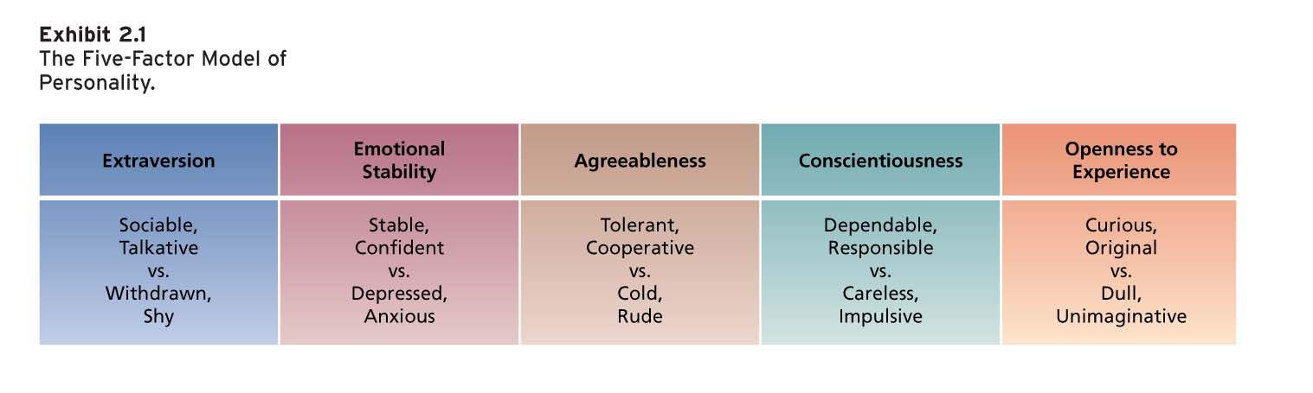

Extraversion:
- extent to which a person is outgoing versus shy
- high score = sociable, outgoing, energetic, joyful and assertive
- low score = introverts, shy
- good for jobs that require a lot of interpersonal interaction

Emotional stability (or neuroticism):
- degree to which a person has appropriate emotional control
- high score: low neuroticism, self-confident, high self-esteem
- low score: anxious, hostile, impulsive, depressed, insecure, and more prone to stress

Agreeableness:
- extent to which a person is friendly and approachable
- high score: warm, considerate, friendly, sympathetic, cooperative, eager to help
- low score: cold, aloof, argumentative, inflexible, uncooperative, uncaring

Conscientiousness:
- degree to which a person is responsible and achievement-oriented
- high score: dependable, positively motivated, orderly, self-disciplined, hard-working
- low score: irresponsible, lazy, impulsive

Openness to experience:
- extent to which a person thinks flexibly and is receptive to new ideas
- high score: creative, innovative, intellectual, curious, imaginative
- low score: favor the status quo

Personality & Job Fit

Extraversion | Emotional Stability | Agreeableness | Conscientiousness | Openness to Experience
Social interactions, being assertive, energetic, and ambitious | Social interactions | Interacting, helping, nurturing, teamwork, cooperating | Most jobs | Learning and creativity

Locus of Control

Locus of control:
- a set of beliefs about whether one’s behavior is controlled mainly by internal or external forces
- high internals: believe that the opportunity to control their own behavior resides within themselves
- high externals: believe that external forces determine their behavior

What is Learning?

Learning:
- occurs when practice/experience leads to a relatively permanent chance in behavior potential

What do employees learn in organizations?
- practical skills: job-specific skills, knowledge, technical competence
- intrapersonal skills: problem solving, critical thinking, risk taking
- interpersonal skills: interactive skills (communicating, teamwork, conflict resolution)
- cultural awareness: learning of social norms and expectations of organization

How do employees learn in organizations?

1) Operant Learning Theory (Skinner)
- subject learns to operate on the environment to achieve certain consequences
- behavior is controlled/learned by the consequences that follow it
- ex: salespeople learn to sales techniques to make commissions/avoid criticism
- can be used to increase the probability of desired behaviors and to reduce or eliminate the probability of undesirable behaviors

Increasing the Probability of Behavior

Reinforcement:
- process by which stimuli strengthen behaviors

1) Positive reinforcement
- increases or maintains the probability of some behavior by the application or addition of a stimulus to the situation in question
- positive reinforcers tend to be pleasant things such as food, praise, money, or business success
- whether or not something is a positive reinforcer depends only on whether it increases or maintain the occurrence of some behavior by its application

2) Negative Reinforcement
- increases or maintains the probability of a behavior by the removal of a stimulus from the situation
- aversive or unpleasant stimuli (we will learn to repeat behaviors that remove this stimuli)
- ex: manager’s nagging to work hard only way employees can stop the nagging is to work hard

Organizational Errors Involving Reinforcement

Confusing rewards with reinforcers:
- rewards can fail to serve as reinforcers because organizations do not make them contingent (reliant) on specific behaviors

Neglecting diversity in preference for reinforcers:
- organizations fail to appreciate individual differences in preferences for reinforcers

Neglecting important sources of reinforcement:
- managers often neglect reinforcers that are administered by co-workers or are intrinsic to the jobs being performed
- two important sources of reinforcement that managers often ignore are performance feedback and social recognition

Performance feedback:
- providing quantitative or qualitative information on past performance for the purpose of changing or maintaining performance in specific ways
- most effective when it is positive, immediate, visual, and specific (pivs)

Social recognition:
- informal acknowledgement, attention, praise, approval, or genuine appreciation for work well done from one individual to another
- positive feedback/pat on the back is a positive reinforcer (reinforce desirable behavior)

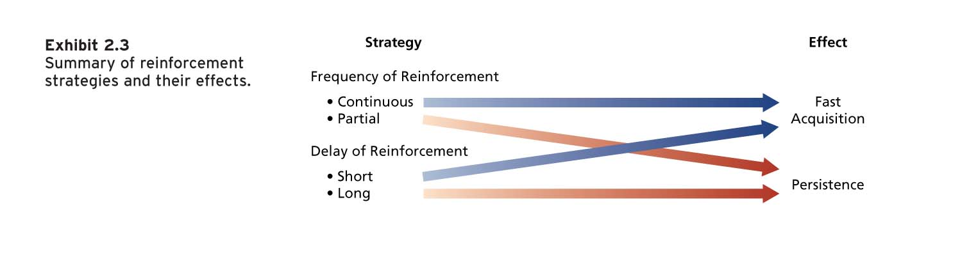
Reinforcement Strategies

To obtain fast acquistion continuous and immediate reinforcement should be used

To obtain persistence partial and delayed reinforcement (not all the time)

Reducing the Probability of a Behavior

Two strategies that can reduce the probability of learned behavior:

1) Extinction
- terminating the reinforcement that is maintaining some unwanted behavior
- works best when coupled with reinforcement
- behaviors that have been learned under delayed/partial reinforcement schedules are more difficult to extinguish

2) Punishment
- following an unwanted behavior with some unpleasant, aversive stimulus
- when a person learns that a behavior leads to unwanted consequences, this should reduce the probability of the response

What do we want to do?

Situation/Action | Add/Remove Stimulus | Consequence
Promote a behavior | Add  Remove | Positive Reinforcement  Negative Reinforcement
Stop/Decrease behavior | Add  Remove | Punishment  Extinction

Social Cognitive Theory (Bandura)

- emphasizes the role of cognitive process in regulating people’s behaviors
- ex: people learn by observing the behavior of others

Triadic reciprocal causation:
- personal factors and environmental factors work together and interact to influence people’s behaviors
- people’s behaviour also influences personal factors and the environment

Three components of social cognitive theory:

1) Observational learning
- the process of observing and imitating the behavior of others
- Involves self-reinforcement.
- Attractive, credible, competent, high-status people are most likely to be imitated.
- It is important that the model’s behaviour result in positive consequences and that it is vivid and memorable.

2) Self-efficacy
- beliefs people have about their ability to successfully perform a specific task
- influenced by one’s experiences and success performing the task in question (performance mastery), observation of others performing the task, verbal persuasion and social influence, and one’s physiological or emotional state
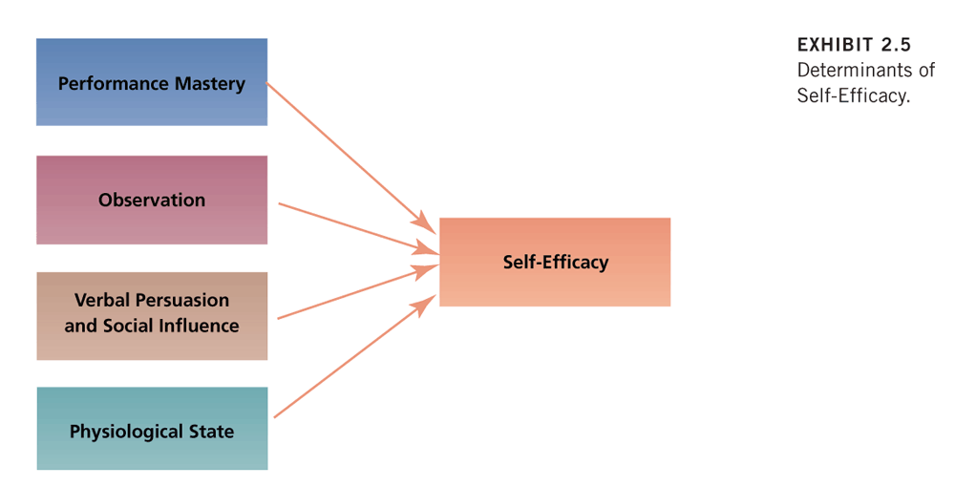

3) Self-regulation
- The use of learning principles to regulate one’s own behaviour.
- A key part of the process is people’s pursuit of self-set goals that guide behaviour.
- Discrepancy reduction and discrepancy production lie at the heart of the self-regulatory process.
- Self-regulation involves the following activities:
Collect self-observation data,
Observe models,
Set goals, Rehearse,
Reinforce oneself

