Molecular Genetics: DNA Markers

genetic markers – inherited variations that are used to test genetic hypotheses
- tell us something about genes
- tells us something about the DNA
Limitations
- you don’t know if you are looking at one gene or gene interations
- control of environment (environment can effect genotypes)
- individual can have wild type phenotype but may have heterozygous genotype
- visible markers are limited compared to DNA markers (not based on gene expression)

molecular markers – variation in DNA sequence
- used instead of observable traits
- enough to track generation to generation
polymorphic – are the primary types of markers used in contemporary genetics studies

polymorphic molecular marker
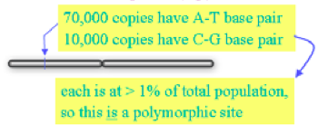
- a polymorphic site or locus
- shows variance same as genetic markers
- a location in the genome where at least two versions of the sequence exist in the population, each at a frequency of at least 1%
- variance in a population at a specific site & WE CAN USE THAT !
ex.
uOttawa student population – N ~ 40 000
2N = 80 000 copies of (eg) chromosome 2

Molecular Markers
There are 5 conditions that characterize a suitable molecular marker:
- must be polymorphic
  - if there is no polymorphism, nothing can be used for differentiation (no variation) can’t be tracked
- co-dominant inheritance
  - how will you see the phenotype?
  - when detecting DNA, we are not dealing with gene expression, but if mom and dad give a marker, we will see both thus they are co-dominant
  - ie. A from mom B from down, AB bands will both be seen
- randomly and frequently distributed throughout the genome (landmarks)
- easy and cheap to detect
  - expensive to process millions of samples
- reproducible
  - ran gels from multiple members in a family, repeated many times and was confident in results
Main points: polymorphic, co-dominant and reproducible

Types of Polymorphic Molecular Markers
- Singlue Nucleotide Polymorphisms (SNPs)
. . TCTTGATC . .
. . TCTCGATC . .
- mutation, change in nucleotide, is a marker (there is a way to detect it)
- that marker could be within a gene, but not necessarily
- if it is in a gene, that marker could also be a mutation that influences the phenotype (at that particular locus it shows polymorphism)
- Insertion/ Deletions (Indles)
. . TCTTGATC . .
. . TCTTTGATC . .
- lengthens or shortens DNA resulting in polymorphism
- ex. Gene for enamel is on X and Y but shorter on Y so can determine if gene of a male or female
- Variable Number of Tandem Repeats (VNTRs)
. . CCGCAGCAGCAGCAGCAGATTC . .
. . CCGCAGCAGCAGCAGCAGCAGATTC . .
. . CCGCAGCAGCAGCAGCAGCAGCAGATTC . .
- depending on number of repeats will result in varying lengths of the DNA
- can match for specific VNTRs ex. If match for 13 markers will be related (likely)
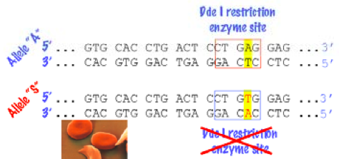
- Restriction Fragment Length Polymorphisms (RFLPs)
- differences in DNA fragment lengths after cutting with one or more restriction endonucleases
- bands that come out in the gel have a specific profile
- enzyme that recognizes a very specific sequence of DNA and cuts it at that spot is a restriction enzyme

ex. From hemoglobin B
- A for regular, S for sickle cell
- Restriction enzyme recognizes and cuts, in sickle cell the nucleotide sequence is not recognized and thus not cut
- One allele is cute while one is not, and that becomes the profile of the gene under RFLP conditions
- Take the persons DNA cut it with this enzyme and then look at the profile to determine the type of hemoglobin (should see 2 bands in Allele ‘A’ and just one in Allele ‘S’)
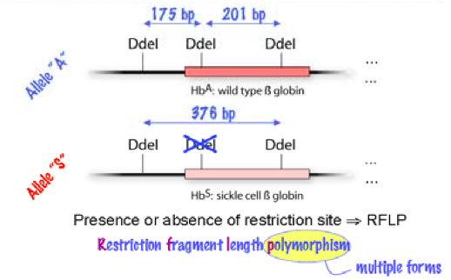
How can we genotype RFLPs?
- based on hybridization with a labeled probe “southern blot”
- based on PCR

Molecular Markers
- RFLP & Nucleic Acid Blotting
- blots can be used to ascertain the size and sequence organization of a gene or DNA sequence of interest; or the presence or absence of alleles
- run DNA in a gel and transfer to paper and hybridize to a probe
- use of gene or allele specific probes
- Southern and Northern blots – look for DNA markers!

Restriction Fragment Length Polymorphism (RFLP analysis)
- restriction digests (alleles = specific digest pattern)
- profile pattern exhibits an allele (one received from mom and dad)
- presence/absence of restriction sites (do you have the mutation or not) generates fragments of variable lengths of DNA fragments
- hybridize with probes (Southern analysis)
- alleles (SNPs, VNTRs, STRs, genes) have unique patterns
- can detect genes if we have a profile for it

Restriction Digests
- a restriction enzyme binds to DNA at a specific recognition sequence and cleaves the DNA to produce restriction fragments
- most recognition sequences are palindromic, and restriction enzymes often cleave these sequences in an offset manner
- enzymes will generate different profiles, and can be in pairs or triplets
- usually cut into an area that is palindromic
- generates a very specific profile

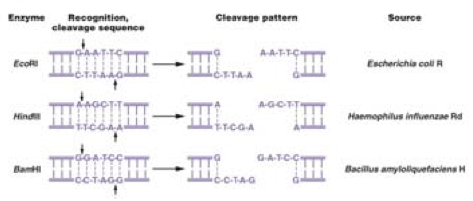

- Biochemical Techniques – Restriction Digests
Identifying Hb Genotype by a Southern Blot
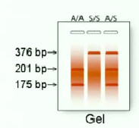
  - digest human DNA sample with D del
  - run gel
  - blot to filter, hybridize with probe (a probe that recognizes that sequence; single stranded piece of DNA complimentary to the DNA you are trying to detect)
  - wash off excess probe, expose film
3 bands is homozygous recessive, one band is wild type and two bands is a heterozygote

Nucleic Acid Blotting:
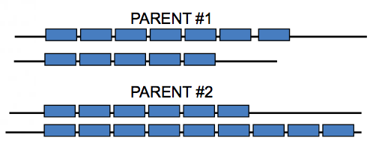
VNTRs & STRs
- repetitive DNA
- VNTRs (minisatellite markers)
- STRs (microsatellite markers – dinucleotide repeats)
- for a given VNTR or STR we may have a given number of repeats
- most of these repeatable sections have restriction sites at the beginning and the end
- go in at these sites and cut the VNTRs giving specific lengths
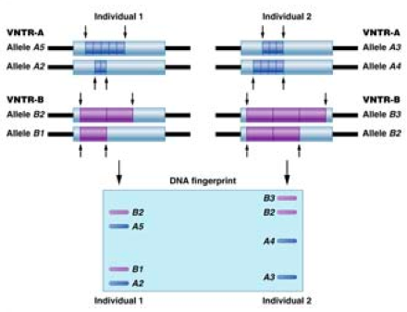
RFLP Analysis
VNTRs
- person’s VNTRs donated by parents
- different possible genotypes
Detection: RFLP Analysis
- doesn’t use one marker but multiple

Single Nucleotide Polymorphism:
- 1 in every 300 – 1000 bp has a single nucleotide polymorphism
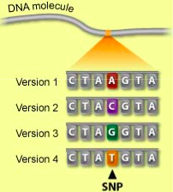
- ~3 million SNPs
- look across the genome in any given spot and might find a variance in the population
- SNPs may be in genes or not
- Could be in the gene, the one nucleotide change could be recessive or dominant; could also be outside of gene (doesn’t matter point is it is there and could be tracked
- may affect phenotype
- depending on mutation can create restriction site, which could allow use of restriction enzymes
- detection:
  - Northern, Southern analysis
  - Sequencing
  - RFLP analysis (if you know it is causing a restriction site)
- Ex. In DNA sequence different versions at locus can have A, C, G or T; this becomes a DNA marker

. . TCTTGAATCGGACGTATGCTCAATTACGATC . .
. . TCTCGATTCGGACGTATACTCAATTACGATC . . two snps

- have to be stable snps, not an area with constant mutations
- needs to be able to track generation to generation (stable markers)
- if it was possible to sequence your own genome, we would expect to find ~ 1 SNP per 1000 bp 3 million
- stable genetic markers: mutation rate ~ 2 x ${10}^{-8}$/ site/gen
  - you carry ~3 x ${10}^{9}$ x 2 x ${10}^{-8}$ x 2 = 120 new SNPs * you’re a mutant*
  - genotyping methods hybridization

Distinguishing Between SNP Alleles by Hybridization
- best way is to look at it with probes
- SNPS are short sequences of DNA
- allele specific oligonucleotides (very few) , we can detect a difference of one nucleotide using a probe geared to detecting this change in the sequence
- depending on the probe you are using (for wild type or mutant) geared toward detecting what specific allele you might have

- if conditions are stringent and difficult for probe to bind it will only bind to the complementary area
- hybridization with Allele-specific oligonucleotides (olig = few)
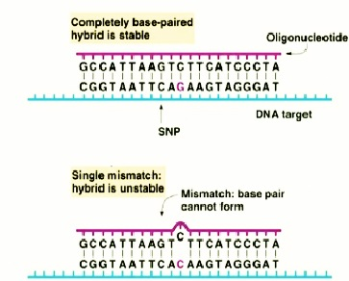
- small probes (25 – 30 bases) can work if conditions (salt, temperature) are adjusted. Mismatches much more significant for small probes !
- strategy hybridize with small oligo (17 – 20 bases long)
- hybridization is seen only if target and probe match perfectly
- the shorter the probe the greater the challenge for it to stay, high temperature and low salt are ideal conditions for the probe to stay.

SNP Allele Identification by Allele-specific Oligonucleotides

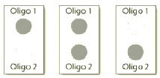
- parents (1,1) and (2,2) child is (1,2)
- rather than run a gel we can use dot blotting
- on our membrane at these two little circles we can hybridize the probe
- add the target DNA to the dot and then hybridize and look for the radioactivity
- whatever lights up will tell you the allele present
- if it does not light up, it does not have that allele

SNP Genotype Identification
- ASO are our probes
- the probes for the normal and mutant gene
- CF is autosomal recessive, if you look at their profiles, mom and dad both light up with the probes telling us they are heterozygous
- In the child only the dot for the mutant shows up (because they have two copies it stains darker)

High Throughput SNP Genotyping
Label genomic DNA, hybridize to oligos for a set of SNPs
- simultaneous identification of genotype at all those SNPs
- can look for thousands of alleles at a time
- put your chip into a computer and it scans it and spits out all of the results at once
- well of probes, hyprids appear red

Microsatellite/ VNTR Genotyping
- repetitive sequences
- Make lots of copies of the DNA between the invariant sequences
- polymerase chain reaction (PCR)
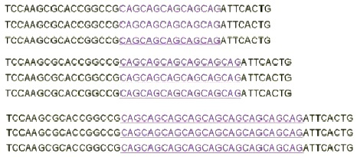

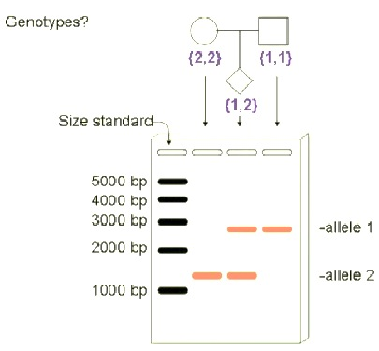
- Measure the size of the DNA you’ve made
- gel electrophoresis
- can do PCRs or RFLPs on it again
- polymorphism is ALL ABOUT THE LENGTH

Polymerase Chain Reactions (PCRs)
- the polymerase chain reaction makes DNA copies without host cells
- we want to amplify a certain area of our DNA to detect length polymorphism
- you start with very low amounts of DNA and want to make more copies of a given gene OR you want to amplify a certain region to clone and sequence it. This concept is very versatile and capable (all about amplifying a region of DNA)
- the polymerase chain reaction (PCR) copies a specific DNA sequence or through in vitro reactions that can amplify target DNA sequences present in very small quantities
- can start with one copy of DNA and end up with billions of copies
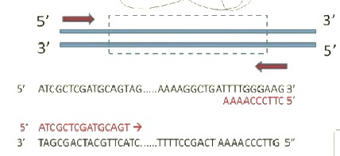
- PCR requires two oligonucleotide primer, one complementary to the 3’ end of one strand of the DNA to be amplified and one complementary to the 3’ end of the other strand
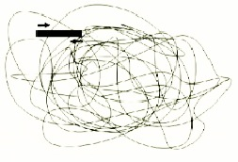
- without primers nothing will happen
amplifying a particular region
- primer in the 5’ end you’re looking for and the 3’ end
- primers constantly amplify this area
- primers need to bind to the DNA

- no longer need probes: amplify genes directly from genomic DNA (any type of DNA templates)
- need:
- two primers (sense and antisense) start the reaction
- excess of nucleotides (dATP, dTTP, dGTP, dCTP) for synthesizing DNA
- taq polymerase (enzyme to add nucleotides to a growing chain)
- buffer with Mg${Cl}_{2}$ (salt, helps taq)
- thermocycler

Thermocycling
- Denaturation at 94°C
  - open up the DNA so primers can reach their targets
- Primer annealing at 37°C to 65°C
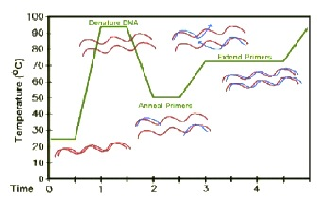
  - cooled down, timing is too quick for DNA to re-nature
  - good range for primers to anneal (choice of temp, is based upon specific binding requirements)
- Extension at 72°C
  - Need to get taq polymerase to do its work
  - taq polymerase loves this temperature, so it activates and extends the strand

Gel Electrophoresis
- separation of charged molecules in an electrical field
- DNA is charged negatively
- small fragments migrate faster than bigger fragments
- run the DNA on the gel to separate them according to size
- subject to a DNA strand to see the band
- need size markers
- the difference in brightness is because there is more of one DNA fragment
- the farther they travel the greater their size

example: Amelogenin Gene
- tooth enamel development
- copies on X and Y chromosome
- X copy is different from Y copy
--- indicates missing bases
- in homologous area on X and Y chromosome there is a gene for enamel different in males and females (the difference is length polymorphism)
- there is added sequence information on the Y chromosome that is lacking on the X chromosome
- thus X is shorter than Y, detecting the length of the enamel gene can allow us to make an inference about gender

Brief Summary:
- variant forms of DNA sequence (polymorphisms) can be used to map gene locations
- polymorphisms include single nucleotide polymorphisms and length polymorphisms (may or may not be in genes)
- alleles of polymorphic sites show Mendelian Inheritance
  - they’re co-dominant and obey law of segregation because they are on chromosomes and need to segregate
- alleles of polymorphic sites can be detected using methods including DNA hybridization, PCR and gel electrophoresis

DNA Analysis – DNA Sequencing
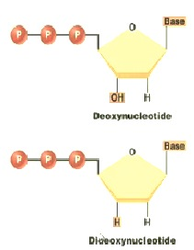
DNA Sequencing
- the most common method of DNA sequencing is dideoxy chain termination sequencing, developed by Sanger
- template = any DNA fragment (from PCR, plasmid with insert etc..)
- dideoxy lacking the oxygen means that polymerases cannot add a nucleotide to that location
- if a nucleotide cannot be added to this spot and we make it fluorescent we will have a way of knowing what has been added to this spot

- primer is bound to template strand (primer has to be 5’ to 3’), using a 3’-5’ template
- primer (sense) binds
- reaction ingredients added
- DNA polymerase
- dATP
- dCTP
- dGTP
- dTTP
- small amount of ddATP * (reactive)
- dideoxynucleotide

- Primer extension, chain termination when a ddATP is inserted
- when you start the reaction, the primer binds and allows nucleotides to be added to the growing chain of DNA
- in this mixture we have dideoxy atps
- just by chance if the polymerase adds a ddATP the reaction is going to stop
- this is a radioactive A so we have a way to detect it
- if instead it added a normal dATP it continues as normal (reaction proceeds)
- we are going to have many copies of growing chains, but wherever there is an A there is always a chance the reaction has stopped, this will result in fragments of different lengths
- all of these fragments will end with this radioactive ddATP
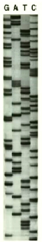
- the fact that these fragments are different lengths will allow us to perform a gel analysis to see how they separate
- Newly synthesized strands recovered, loaded on gel in the A lane. The primer is shown as a black block

Perform sequencing reactions with:
1. ddATP
2. ddTTP
3. ddGTP
4. ddCTP
electrophorese each reactions in a different lane of a gel
- each one of these bands (for example in the A lane) represents a fragment that ended with ddATP
- given that it is run with the four different ddnucleotides, the gel results give us an actual understanding of the DNA sequence
- as we synthesize the fragments get bigger and bigger
- and we synthesize in the 3’ direction (start at the bottom)
- comparing all four lanes
the sequence exhibited in this sample of DNA is 5’-CGCTTTCATGTCAGC-3’
- with the overlapping bands at the top, in order to clarify you perform ‘walking the DNA’, you just go over more and more of it
- length and radiation limit the gel, limiting the amount of base pairs you can read (>50 base pairs in the example above)

A faster more modern method ! :
- instead of using four separate tubes and four separate reactions, we start off with a primer, add all the nucleotides for synthesis, and we add all four ddoxynucleotides that have unique fluorescent probes that fluoresce at different wavelengths
- when a ddoxynucleotide is added, the reaction is stopped and the fluoresce will be visible
- it goes through electrophoreses in the gel in the computer and they separate according to size; when the products fall off of the gel, the smallest ones fall off first
- at this point there is a laser waiting that detects the falling gel, hits it and a colour is reflected, distinguishing the dd-oxynucleotide
- the result from this is a chromatogram (rather than a gel) that has multiple coloured peaks
- if the chromatogram is unclear and overlapping, there must be multiple templates, and it is contaminated (the sequence results will show all kinds of jumbled templates)

Pejvakin Gene – Introduction of a Stop Codon
- a paper on the creation of mouse lines that are death (autosomal recessive allele for death)
- using markers they were able to pin point where the gene was in the genome and sequenced it
- in this particular spot there was an introduction of a stop codon
- the sirtaki allele: instead of an A there is a T thus introducing an early stop codon

Linkage Analysis with Molecular Markers

DNA Polymorphisms are Genomic Landmarks
- “mile markers” throughout the genome
- we know where they are and can detect (FRLP or SNPs etc)
- we don’t know where the gene for our trait of interest lies but if we can show that our trait is linked to a DNA polymorphism we would know roughly where the gene is located !!

example. coding for eye colour in flies
- the polymorphism tells us there is a DM$1^{T}$ version and a DM$1^{c}$ version, (c or t based on the nucleotide in the allele loci)
- conclude:
- one homologue had DM$1^{T}$ allele, one homologue had DM$1^{C}$ allele, this fly is heterozygous for this DNA marker
- get heterozygote and cross with homozygous (recessive) to test for linkage in general
- have to consider what is recessive and what is dominant with respect to markers (doesn’t matter they are co-dominant!)
- have to make sure the genetic marker is also homozygous (testing with a marker)

Steps:
- generate the heterozygous flies
- true breeding red eye and true breeding purple eye creating a heterozygote
- those two markers are the phenotype at that locus
- independent law of segregation and assortment (if linked less than 50% recombination) = do a test cross
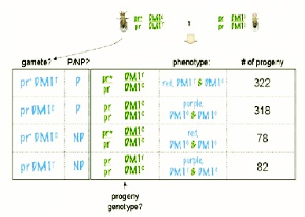
- do a test cross
- trying to determine the recombination
- Score the progeny
- for each progeny fly:
- what is the eye colour
- which alleles are at DM1 locus
- they are independently assorting (thus can predetermine the four gametes)
- each individual has the mutation for the allele PR
- look at what the F1 parent gave
- 1:1 ratio after parental cross means independent assortment ( not seen here)
- interpret the results
- the eye colour gene is linked to the DM1 locus
- Map distance = (78+82)/(322+318+78+82) = 20 cM

Forward genetics screen in mice identifies recessive deafness traits and reveals that Pajvakin is essential for outer hair cell function
- mice have all been test crossed
- question is with which other marker is this condition being transferred?
- they pin pointed the condition to that area of the genome (revealing where the stop codon is)

Brief Summary :
- genes can be mapped relative to each other based on linkage (helps resolve maps even better)
- genes can also be mapped relative to known DNA positions (“DNA markers” or polymorphic sites) along chromosomes
- … and thus these DNA markers serve as landmarks to establish the physical locations of genes in the genome

Recombinant DNA Technology:
(Transgenesis, Knock-outs and Knock-ins)

Forward vs. Reverse Genetics
- question about a phenomena and finding out if there is a genetic basis
Forward:
- phenomena
- question its genetic bases: if there is no polymorphism (no differences with respect to the phenomena) you induce the variation
- cause mutation and changes in gametes to see if they are inherited
- if you already have the variation just confirm transmission and map it ie. linkage analysis
- indications it is genetically based:
- classic Mendelian ratios (3:1, 1:1)
- once you’ve pin pointed the location you begin to sequence it (mapping it) – PCR the area so you can sequence it
- you look for an open reading frame ( it starts with a ATG in the DNA sequence) you need a stop codon in frame with your start codon
- this is how you know you have a gene (potentially)
- you have to now determine you have the RIGHT gene
Reverse
- if you know the gene, you can induce mutations in it and then plug this gene in the organism
- once we know something about the gene, we can mess with the system (mRNA) in charge of expressing it and see what happens

FOXP2 & Speech: Gene Expression
FOXP2 is a transcription factor involved in speech development. In humans it helps in the development of the jaw and ears.
- hearing and development is impaired resulting in their disorder
- when they identified the human gene, they translated it into a protein sequence
- they found out the human gene and mouse gene sequences were different
- the protein sequence had 3 different amino acid changes between the human and the mouse
- scientists wanted to find out what the human protein FOXP2 actually does
- thought that if putting the human version of FOXP2 gene into the mouse it will ‘talk’ ok and if the mutated gene was put in they would lose that function

Mouse Development
- have pups in a month and a half (9 months in humans)
- secondary mature oocyte enters fallopian tube, sperm goes out sperm duct and fertilizes egg
- once the two nuclei merge together (back to diploid #) the cells start to divide (zygote)
- grows into a ball of cells through mitosis
- 4 days later blastocyst is formed, implants in the wall and we have pregnancy
Transgene Solution
- microinject a pseudopregnant female
- we implant a fertilized egg (blastocyst) into the mouse uterus
- no sexual act
- egg fertilized invitro and implanted in the uterus
- now to create a transgenic animal
  - take a fertilized egg (oocyte)
- through microinjection technique transgene solution is added to the nucleus of the egg
- the DNA being added to the nucleus enters the genome and the 2 nuclei fuse (diploid number)
- implanted in mouse uterus after a few cycles of mitosis
Method for making “humanized” FOXP2 mouse that has the transgene in every single cell:
- the best way is to inject the human FOXP2DNA into a fertilized egg
- injecting the human FOXP2 protein into both cells at the 2 cell stage wouldn’t really work because proteins are unequally distributed after mitosis and can degrade in the process
- injecting the human FOXP2RNA into they zygote wouldn’t quite work because after mitosis the RNA is all gone (it isn’t very stable)
- injecting the human FOXP2RNA into the blastocyst cavity, might get a cell to express the gene associated, but it will again be degraded, RNA is not very stable
- injecting DNA in some way into the blastocyst would be another way of creating a transgenic animal
- after injecting DNA into the egg, how is it incorporated into the genome?

Recombinant DNA Technology
DNA transport vehicle = plasmid
- piece of DNA from a bacteria (plasmids – chromosomal DNA in the bacteria that replicates independently from its actual bacterial chromosome, they also have genes for antibiotic resistance which gives us a mechanism to test is the experiment succeeded aka a visible marker)
- plasmids have 3 main characteristics
- antibiotic resistant gene (they all have one)
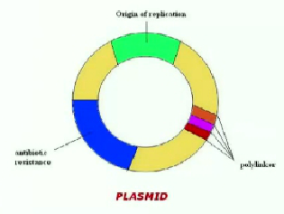
- origin of replication (the area of the chromosome that says ‘start transcription process here); chromosome says you can start gene expression
- polylinker region is full of restriction sites
- replicate independently of the chromosomal DNA
- carry antibiotic resistance genes
- polylinkers allow insertion of DNA fragments
- restriction enzymes will cut the DNA and open it up allowing us to insert a foreign piece of DNA
- ex. Creating corn that can produce insulin or fish that have antifreeze proteins (grown in cold Atlantic ocean, the can grow larger)

Step 1. Amplify your DNA of interest using PCR (Polymerase Chain Reaction)
- getting your fragment of interest through PCR reactions
- or use restriction enzymes to cut the genome and get the piece of DNA you are interested in

Step 2. Digest your DNA of interest by restriction enzymes (doing the same thing to your plasmid)
- cut double stranded DNA at specific nucleotide sequence
- produce sticky ends (overhanging pieces waiting for a complementary end to bind to)
- restriction enzymes recognize a specific sequence and cut the DNA to produce the sticky ends (some restriction enzymes cut into a way that does not produce sticky ends
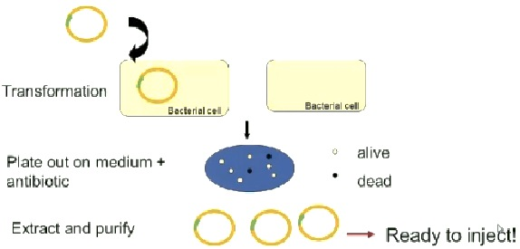
- requires a restriction enzyme that will not cut through the DNA sequence that is needed in the gene

Step 3. Ligation of DNA
- plasmid is cut with same restriction enzyme
- fragment of DNA is inserted into our plasmid
- DNA molecules with compatible ends can be joined together by DNA ligase

Step 4. Transformation and Selection
- need more of the plasmid, so it is placed into the bacteria that will amplify the area of interest
- the bacteria at the very least incorporates it and may also express it
- take your plasmid and transform bacterial cells (not always 100% effective, some cells take up the plasmid while others do not)
- thus we need to determine which cells are a clone of this plasmid
- the cells are put on a plate with the antibiotic (some will be living and growing while others are dead)
- you know the cell actually picked up the plasmid because the only living ones have the gene for antibiotic resistance
- you know the plasmid has taken up the DNA by doing a PCR reaction or southern probe just to see if its there (visual markers also)
- can sometimes use a second antibiotic to test if your insert interrupted with the gene
- propagation of recombinant DNA
- only bacteria containing recombinant DNA grow on medium + antibiotic
- the plasmid is then injected into the sperm or the egg which will join and form the new individual (for transgenic mouse example)

Gene Targeting Technologies – Site Directed Mutagenesis
- how to create a mutation prior to injecting the specimen
Steps:
1. clone gene of interest
2. design oligonucleotide – introduce mutation
3. transform E. coli with the plasmid (wild type allele in one, mutation in place in other) inject into fertilized egg
- transferred over into genome and replaced the gene
4. transgenesis, knock-in

Gene Knockout
- form of transgenesis, insert knock outs into embryonic stem cells ie from an agouti mice
- get a fragment and disrupt the desired gene somehow (introduce an antibiotic resistant gene) thus disrupting gene of interest so it cannot do its work
- inserting KO into ES (stem) cells from agouti mice
- put the stem cells on a plate
- now there is an antibiotic resistance inside the gene
- the gene of interest can then be introduced but if introduced into the wrong place, the gene plus the TK gene gets transferred in there
- when we put the cell on the plate that has the antibiotic, which ever cells integrated the gene will be ‘killed’
- the disrupted gene then knocks out the other gene, thus it can grow on the plate without being killed this is the ‘knock out’
- these stem cells are now implanted into a blastocyst of a black mouse
- let this grow and you will get a chimeric mouse (black and agouti hair)
- now cross F1 mice with each other in hopes that some of the stem cells became gonads
- agouti mice are heterozygote so they have the knock out gene (they were crossed with a black mouse)
- then cross chimeric mice again to get homozygous mouse with a knock out: at this point study how the gene of interest and the phenotypes have changed

Applications of Transgenic Organisms
- Alzheimer’s Pig: A transgenic pig with Alzheimer’s Disease (AD) for medical research
- Bt cotton: Produce toxins that kill pests

Brief Summary:
The order of techniques/substances used in cloning is:
- PCR (polymerase Chain Reaction)
- Restriction enzymes
- DNA ligase
- Introduce DNA into bacterial cells
- Medium + antibiotics

Genomics & BionInformatics

Forward vs. Reverse Genetics
- once you’ve done forward genetics analysis and mapped it the point is through linkage analysis we use genetic markers to pin point it in the genome isolate it, PCR it or sequence the gene itself etc.
- how do we find it in the first place?

FOXP2
- identification of the “speech gene”
- through linkage analysis they identified and sequenced it showing that the human sequence codes for a protein that has 3 amino acid differences with that of the mouse
- also helped to establish evolutionary tree with respect to this protein
- once they identified the sequence they went into the ‘gene bank’ to find if there is a match

DNA Analysis
Genomics, the study of genomes, encompasses:
- structural genomics
- functional genomics (ie. promoters)
- comparative genomics
structural genomics focuses on genomes and analyzing nucleotide sequences to identify genes and other important sequences as regulatory elements
- the genome sequence is annotated to identify:
- genes
- their regulatory sequences
- their functions
- identification of open reading frames requires translation of all three reading frames
- translate and predict the protein sequence and compare to others to see what it might do

genomic libraries
- using recombinant DNA technology, in order to find out the DNA sequences and structures
- take any cell in the body and isolate all the genomic DNA
- cut it with restriction enzymes (into pieces)
- get a plasmid and cut it open with the same enzyme used to cut the DNA
- the fragments created with genomic DNA are put into the plasmid
- for every plasmid you use it will incorporate one fragment; for every fragment generated with genomic DNA it is taken up by a plasmid
- take a plasmid transform the bacteria and grow it on a plate (grows colonies representing a part of the genome)
- go clone by clone and sequence every one of the fragments (position to sequence the entire genome)
- use DNA markers to determine which plasmids got the fragment of interest

cDNA libraries
- a cDNA library is prepared by :
- isolating mRNA from cells (reverse transcribe into DNA
- from this mRNA template we get a primer (poly tail primer) and by using reverse transcriptase we complete the DNA strand
- introns removed from the mRNA giving us the coding part of DNA
- cDNA from whatever cell you used, the library represents the genes that are expressed in that cell
- next we digest the RNA and complete the strand with DNA polymerase
- synthesizing the complementary DNA using reverse transcriptase
- cloning the cDNA molecules into vector

recovering clones
probes complementary to part of a gene are used to screen a library to recover clones of a specific gene
- colonies of the library are overlaid with a DNA-binding filter
- colonies are transferred to filter, then lysed, and DNA is denatured
- filter is placed in heat-sealed bag with a solution containing the labeled probe; the probe hybridizes with denatured DNA from colonies
the colony corresponding to the one the probe identified on the filter is identified and recovered
- filter is rinsed to remove excess probe, then dried; X-ray film is placed over the filter for autoradiography
- using the original plate, cells are picked from the colony that hybridized to the probe
- cells are transferred to a medium for growth and further analysis

- take a filter paper stamp the colonies and put it in a Ziploc bag and subject the sequence to probes; once you develop the film, one of the clones or colonies lights up
- hybridization of the probe to one colony from the original plate is indicated by a spot on the X-ray film
- now that you have a replica of this you know this colony is the same as the one on the plate and you can grow it in a media
- another technique for identifying a clone of interest is PCR reactions
- lift our colonies and one by one PCR to see the bands
- we can actually get the bacteria to show these DNA fragments ie. insulin production

DNA Sequencing & Analysis (DNA fragments)

Animal specimen extract total RNA (trizol reagent) cDNA synthesis cDNA amplification (PCR reactions) cloning sequencing (ABI 310 genetic analyzer)
- lamprey (latch onto another fish and suck on it scrubbing against the tissue until it gets into the meat)
- they made their way into the great lakes (1960s when St. Laurence opened)
- funding was spent to eradicate this species
- wanted to determine what drives their hunger (if they aren’t hungry, don’t feed, don’t mate, die early)
- another species was found that they suck on rocks so wanted to see if there was a difference in gene expression between the two
- extracted brains and RNA
- performed cDNA synthesis to create a library and PCR’ed the fragments thought to be obesity factors
- went into the cDNA library to observe other factors in other species
- developed probes and primers

Genetics as an Investigative Tool
- started off with an observation
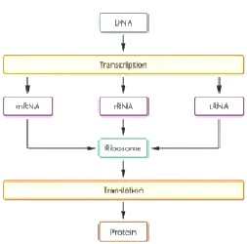
- looked for a polymorphism
- started accumulating evidence for genetic bases
- crosses
- map, and sequence

how can we differentiate between individuals?
How can investigators estimate the probability of matches?
What concepts and experimental approaches allow us to draw conclusions about inheritance of genetic traits? (predicting outcomes; determining genotypes; genome manipulations)

