Chapter 10 – New-Product Development and Product Life-Cycle Strategies

1) New Product Development Strategy:

A firm can obtain new products in two ways:

- Acquisition – Buying a whole company, patent, or a license to produce someone else’s product

- New-product development efforts – The development of original products, product improvements, product modifications, and new brands through the firm’s own product development efforts (own R&D).

Ex: Canadian inventors – Reginald Fessenden invented amplitude modulation (AM) radio

Advantages of new products:
Customers – Bring new solutions and variety to their lives
Companies – Key source of growth

Innovation can be risky and expensive – “80% of all new products fail or dramatically underperform”
- Why do so many new products fail?
  - Company may overestimate market size
  - Actual product may be poorly designed
  - Incorrectly positioned
  - Launched at the wrong time
  - Priced too high
  - Poorly advertised
    - Ex: Cucumber antiperspirant spray, Premier smokeless cigarettes

2) The New-Product Development Process

To create successful new products, a company must understand its consumer, markets, and competitors and develop products that deliver superior value to customers.

Eight Major Steps in the Process:

- Idea Generation

Def’n – The systematic search for new product ideas
- Hundreds/thousands of ideas lead to a few good ones
- Sources of new product ideas include: internal and external sources
(customers, competitors, distributors, and suppliers)

  - Internal Idea Sources:
    - Research and Development (33% of companies rated this as a leading source of innovative ideas)
    - Customers (41%)
    - Heads of company business units (35%)
    - Employees (33%)
    - Sales Force (17%)
      - Ex: Twitter’s Hack Week – Employees form teams to work on a variety of independent projects focusing on the improvement of Twitter

  - External Idea Sources:
- Distributors – Possess information on consumer problems and new-product possibilities
- Suppliers – Advise the company about new concepts, techniques, and materials that can be used to develop new products
- Competitors – Analyze competing new products
- Others – Trade magazines, shows, seminars, govt agencies, advertising agencies, marketing research firms, university and commercial laboratories, and inventors
- Customers – Analyze customer questions and complaints or offer them to suggest their own ideas
- Ex: My Starbucks Idea – Customers can share/discuss/vote on new product ideas

  - Crowdsourcing:
- Invites broad communities of people into the new-product innovation process
- Ex: NetflixPrize.com – Netflix wanted to improve the accuracy of its Cinematch online recommendation system therefore, rather than hiring computer scientists it promised a $1 million prize to anyone who can submit the best solution to improving accuracy by at least 10 percent.

- Idea Screening

Def’n – Screening new-product ideas to spot good ideas and drop poor ones asap (Prod.
costs rise quickly in later stages – which products are most profitable?)

R-W-W (Real, Win, Worth Doing?):
- Real: Must determine if there is a real need for the product
- Win: Does the product offer sustainable competitive advantage
- Worth Doing: Is there sufficient profit potential? Does the product fit the company’s growth strategy?

- Concept development and testing

Distinguish between:
Product idea – Idea for possible product that the company can offer
Product concept – Detailed version of the idea stated in consumer terms
Product image – The way consumers perceive an actual/potential product

  - Concept Development:
- Placing a product into alternative product concepts
- Finding out how attractive each concept is to customers
- Ex: Tesla’s initial all-electric roadster – Can be used as:
  - Second family car
  - Sports car for young singles
  - “Green” car
  - Utility vehicle/love space

  - Concept Testing:
- Testing new-product concepts with groups od target customers to find out if the concepts have strong consumer appeal
- Word/Picture description of product
- Physical representation of the concept
- Consumers may be asked to react by answering questions

- Marketing strategy development

Def’n – Designing an initial marketing strategy for a new product based on the product
concept chosen

The marketing strategy statement consists of three parts:
- Describing the target market (planned value proposition, sales, market share, and profit goals for the first few years)
- The product’s planned price, distribution, and marketing budget for the first year
- The planned long-run sales, profit goals, and marketing mix strategy

- Business Analysis

Def’n – A review of the sales, cost, and profit projections for a new product to find out
whether these factors satisy the company’s objectives
- Estimate sales by looking at sales history of similar products
- Estimate expected costs and profit of marketing, R&D, operations, accounting
and finance used to analyse product’s financial attractiveness

- Product Development

Def’n – Developing the product concept into a physical product to ensure that the
product idea can be turned into a workable market offering
- R&D department will develop and test one or more physical versions of the
product concept (develop prototypes)
- Companies can do their own product testing or involve actual customers in this
process
- Ex: New Balance Tester School – Consumers can test out New Balance’s shoe designs by attending the Tester School and learning how to properly analyze the fit, function, and durability of their shoes. During 8 weeks, they can log on their Wear Test account and answer surveys and provide feedback
- Ex: At Gillette, volunteers come in unshaven to test out the products

- Test Marketing

Def’n – The stage of new-product development in which the product and its proposed
marketing program are tested in realistic marketing settings
- Gives the marketer experience with marketing a product before going to the
great expense of full introduction

Types of Test Markets:
- Standard Test Markets: Small representative markets were the firm conducts marketing campaigns, surveys, to receive feedback on product performance (extensive and costly)

- Ex: Starbucks VIA instant coffee – Tested the product in Chicago and Seattle Starbucks shops, offerred coupons and free samples, and created a Taste Challenge to drum up interest on the new product

- Controlled Test Markets: Allowing panels of stores to carry new products for a fee. Less expensive and faster than standardized tests but gives competitors access to the new product.

- Ex: SymphonyIRI’s Behavior Scan – In each Behavior Scan market, Symphony IRI maintains a panel of shoppers who report all of their purchases by showing an ID card when checking out at participating stores. BehaviorScan reports the sales of tested products and the impact of in-store and in-home marketing efforts.

- Simulated Test Markets: Researchers measure consumer responses to new products and marketing tactics in laboratory stores or simulated shopping environments (Advantages: less expensive, fast, restricts access by competitors and Disadvantages: not as reliable and accurate)

- Ex: Decision Insight’s SimuShop online shopping environment – Test shoppers reactions to different brand extensions, shelf placements, pricing and packaging.

- Commercialization

Def’n – Introducing a new product into the market, which is very costly
- Timing: Look at the economy, other competitors
- Where: Single location, region, national market, or international market
- Planned Market Rollout: Introducing the product over time rather than launching it in national markets from the get-go

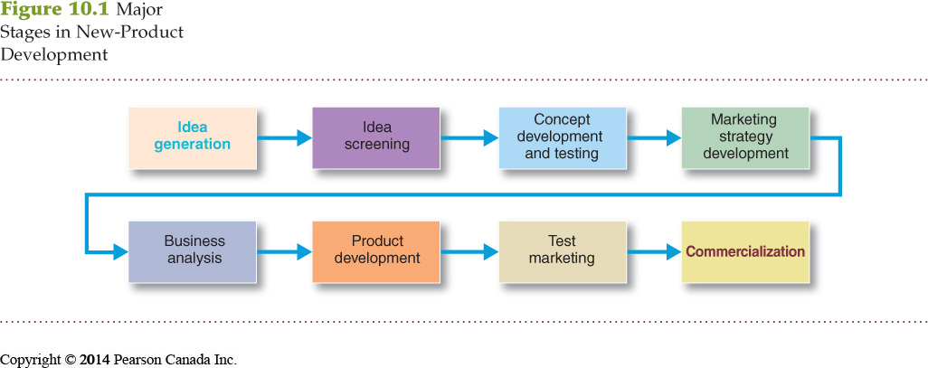

Managing New-Product Development

- Customer-Centered New-Product Development

Def’n – Focuses on finding new ways to solve customer problems and create more customer-satisfying experiences

- Team-Based New-Product Development

Def’n – An approach to developing new products in which various company departments work closely together, overlapping the steps in the product development process to save time and increase effectiveness

- Systematic New-Product Development

Def’n - Innovative development approach that collects, reviews, evaluates, and manages new-product ideas (innovative-oriented culture, large # of new product ideas)

3) Product Life-Cycle Strategies (**)

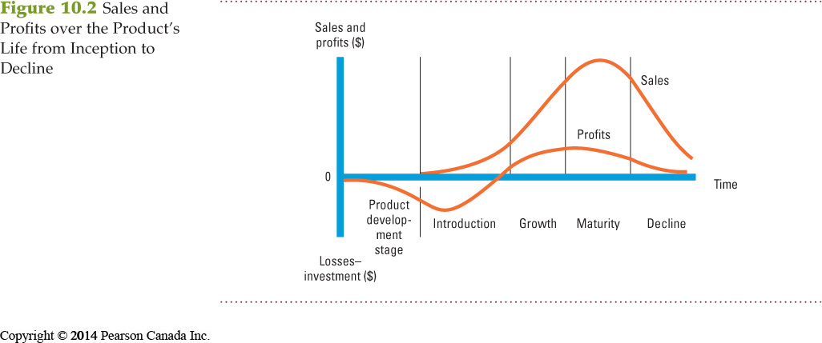

Not all products follow through with all five stages of the PLC – they quickly die out
Some products last a really long time Coca Cola, Gillette, Budweiser, and LifeSavers
PLC can describe a product class, product form or a brand

PLC can also be applied to:

- Style: A basic and distinctive mode of expression, once a style is invented it may last for generations
- Ex: Formal clothing, realist art, colonial home styles
- Fashion: A currently accepted or popular style in a given field
- Ex: Business attire, business casual
- Fad: A temporary period of unusually high sales driven by consumer enthusiasm and immediate product or brand popularity
- Ex: Pet rocks

Each Product has a life cycle, there are 5 distinctive stages:

- Product Development – Sales are zero and investment costs begin to mount

- Introduction – Slow sales growth and zero profit (negative)

Def’n – The PLC stage in which a new product is first distributed and made available for purchase
- Ex: Frozen foods and HDTVS lingered for many years before sales grew
- Profits are low because of low sales and high distribution/promotion expenses
- Promotion spending is high to inform customers of the new product

- Growth – Rapid market acceptance and increasing profits

Def’n – The PLC stage is which a product’s sales start climbing quickly
- Early adopters continue to buy
- Later buyers will start following their lead
- New competitors enter the market
- Promotion spending is the same or higher
- Sales increase as well as profits

- Maturity – Slowdown in sales growth and profits level off or decline

Def’n – The PLC stage in which a product’s sales growth slows or levels off
- This stage lasts the longest compared to previous stages
- Most products are in this stage
- Overcapacity leads to competition
- Competitors mark down prices therefore this leads to a profit drop
- Company’s will try to modify the market by finding new users and new market segments for its brands
- Modifying the product involves changing characteristics such as quality, features, style or packaging to attract new users and inspire new usage
- Modifying the market mix involved improving sales by changing one or more marketing mix elements Offer new and improved services to buyers, cut prices, launch a better advertising campaign, aggressive sales promotions and new marketing channels

- Decline – Sales fall off and profits drop

Def’n – The PLC stage in which a product’s sales decline
- Sales decline for many reasons including technological advances, shifts in consumer tastes, and increased competition
- Companies need to pay attention to their aging products by reviewing sales, market shares, costs and profit trends
- Companies must decide with to do with the declining products:
  - Maintain the brand without change in hopes that competitors will leave the industry
  - Harvest the product by reducing various costs and hoping that sales hold up
  - Drop the product from the line

Chapter 11 – Pricing

1) What is a Price?

- Price – The amount of money charged for a product or service; the sum of all values that customers exchange for the benefits of having or using the product or service
- Major factor affecting buyer choice
- Most important in determining firm’s market share and profitability
- Price is the only element in the marketing mix that produces revenue; all other elements represent cost (Only P that generates profit)
- Flexible -> can be changed quickly
- Has direct impact on a firm’s bottom line

2) Major Pricing Strategies

- A price that a company charges can either fall somewhere that it too high (no demand) or too low (no profit)
- Customer’s perceptions of the product set the ceiling for prices (If they perceive the price greater than the value, they will not buy the product)
- Product costs set the floor for prices (If company prices products below costs, the profits will suffer)
- There are TWO major pricing strategies: customer value-based pricing, and cost-based pricing

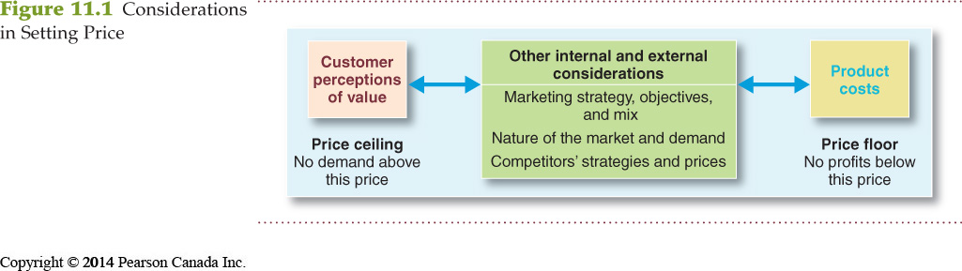

  - CUSTOMER VALUE-BASED PRICING

    - In the end, the customer will always decide whether a product’s price is right
    - Effective customer oriented pricing involves: Understanding how much value consumers place on the benefits they receive from the product and setting a price that captures that value
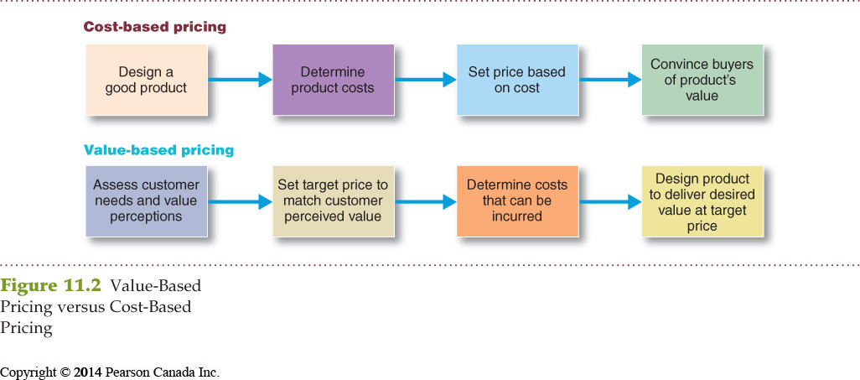

      - Customer value-based pricing:

      - Setting prices based on buyers’ perceptions of value rather than on the sellers cost.
      - Price is considered before the marketing program is set
      - Value-based pricing is customer driven
      - Cost-based pricing is product driven

      - Cost-Based Pricing strategy:
        - Company designs a product
        - Adds up costs of making the product plus a target profit
        - Must convince buyers that the product’s value justifies the price
        - If the price is too high, the company will suffer in disappointing profits

      - Value-Based Pricing strategy (reverse):
        - Company reviews customers needs and value perceptions
        - It then sets a price based on the values of customers
        - The company then determines which costs can be incurred to create the product based on target value and price
        - The price is set to match perceived value
          - Ex: Steinway piano – costs a lot but to those who own one, a Steinway is a great value

      - If a seller charges too much for a product – company sales will suffer
      - If the seller charges less – sales will be well, but they produce less revenue than they would have if they charged at the level of perceived value

- Good-value pricing:

- Offering the right combination of quality and good service at a fair price
- Introducing less expensive versions of established brand-name products
  - Ex: Armani offers a less expensive, more casual Armani Exchange fashion line

- Redesigning a brand to offer more quality for a given price, or the same quality for less price
  - Ex: Ireland’s Ryanair – Low prices for a seat on the plane but they will charge for extras such as baggage check-in, selling perfumes and games, and also the sales of bus and train tickets into town

- Everyday low pricing (EDLP) – Charging a constant everyday low price with few or no temporary discounts
  - Ex: WalMart

- High-low pricing – Charging higher prices on an everyday basis but running frequent promotions to lower prices temporarily on selected items
  - Ex: Department stores such as, Sears and The Bay

- Value-added pricing:

- Attaching value-added features and services to differentiate a company’s offers and charging higher prices
  - Ex: Luxury cinemas such as, AMC cinema suites – Offering features such as, online reservations, leather rocking chairs, latest in digital sound and super-wide screens, dining and drinks, and even valet parking

- Pricing Power – the ability to escape price competition and justify higher prices and margins without losing market share

  - COST-BASED PRICING

- Setting prices based on the costs of producing, distributing, and selling the product plus a fair rate of return for effort and risk
- Company’s costs are a very important element in the pricing strategy
  - Ex: Walmart and Ryanair work to be low-cost producers in their industries so that they can offer the lowest prices in their industries and Apple and BMW pay higher costs to claim higher prices and margins.

- Types of Costs:

- Fixed costs (overhead) – The costs that do not vary with production or sales level (always constant)
  - Ex: Rent, heat, interest, executive salaries

- Variable costs – The costs that vary with the level of production
  - Ex: HP computer chips, wires, plastic and other inputs prices’ vary with the number of units produced

- Total costs – The sum of the fixed and variable costs for any given level of production
- Average cost – The cost associated with a given level of output

- Costs as a Function of Production Experience:

- Experience (learning) curve – The drop in the average per-unit production cost that comes with accumulated production experience (the more your produce, the less it costs to produce)

- Cost-Plus Pricing:

- Adding a standard markup to the cost of the product
  - Ex: Construction companies submit job bids by estimating the total project cost and adding a standard markup for profit
- Benefits:
  - Sellers are certain about costs
  - Prices are similar in industry and price competition is minimized
  - Consumers feel it is fair
- Disadvantages:
  - Ignores demand and competitor prices

3) Other Internal and External Considerations Affecting Price Decisions

- ORGANIZATIONAL CONSIDERATIONS

- Management must decide who sets the prices
- Small companies – Prices are set by top management
- Large companies – Prices are handled by divisional or product line managers
- Industrial markets – Salespeople may be allowed to negotiate with customers within certain price ranges (top management still sets pricing objectives, and must approve the prices proposed by lower-management/salespeople)
- Influence on pricing – Pricing departments, sales managers, production managers, finance managers, and accountants

- THE MARKET AND DEMAND

- Before setting prices, the marketer must understand the relationship between price and demand for its products

- Pricing in Different Types of Markets:

- Pure competition – The market consists of many buyers and sellers trading in a uniform commodity (no single buyer has an effect on the market price – one single price)
  - Little use of marketing strategies
  - Ex: wheat, copper, financial securities

- Monopolistic competition – The market consists of many buyers and sellers who trade over a range of prices, rather than one single price
  - Sellers try to differentiate their products – use branding and advertising

- Oligopolistic competition – The market consists of a few sellers who are highly sensitive to each other’s pricing and marketing strategies

- Pure monopoly – The market consists of one seller
  - Ex: Gov’t monopoly (Canada Post), Power monopoly (Hydro-Quebec), Private non-regulated monopoly (DuPont – introduced nylon)

- Analyzing the Price-Demand Relationship:

- Demand Curve – Shows the number of units the market will buy in a given period at different prices
- Demand and price are inversely related (Higher price = lower demand)
- Budgeted consumers will buy less of a product that is priced too high
  - Ex: ConAgra’s Banquet Frozen Dinners – Rose the price of a meal from 1$ to 1.25$ and sales dramatically dropped
- For luxury goods, higher prices may be perceived as higher quality

- Price Elasticity of Demand:

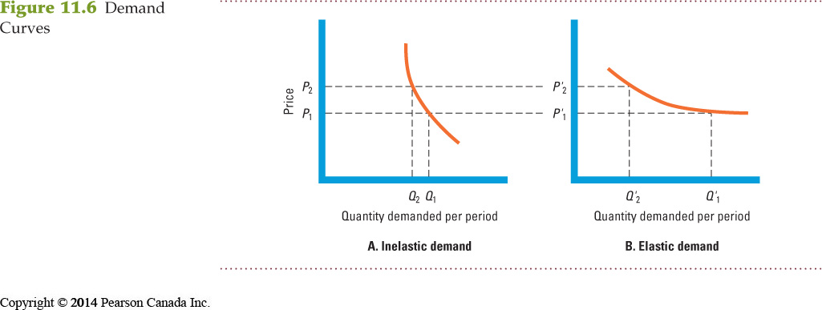

- Price elasticity – A measure of the sensitivity of demand to changes in price
- Inelastic demand – Demand hardly changes with a small change in price (Figure 11.6A)
- Elastic demand – Demand changes greatly with a small change in price (Figure 11.6B)
- Formula – [% change in quantity demanded / % change in price]
- Buyers are less price sensitive to products that are:
  - Unique, high in quality, prestigious, or exclusive
  - When substitutes are hard to find or do not exist
  - When the cost of the product is low compared to total income
  - When the costs are shared by another party

- Other External Factors:
- Economic conditions
- Reseller’s response to price
- Government
- Social concerns

4) New-Product Pricing Strategies

- Pricing strategies change as the product passes through its life cycle
- Companies can choose to price their products according to TWO strategies: market-skimming pricing and market-penetration pricing

- MARKET-SKIMMING PRICING

- Setting a high price for a new product to skim maximum revenues layer by layer from the segments willing to pay the high price; the company makes fewer but more profitable sales
  - Product quality and image must support the price
  - Buyers must want the product at the price
  - Costs of producing the product in small volume should not cancel the advantage of higher prices
  - Competitors should not be able to enter the market easily
    - Ex: Apple – Apple first introduced the iPhone at a high price for those who really wanted the sleek new gadget. Within a year they began dropping the price of the iPhone to skim the maximum amount of revenue from various segments of the market

- MARKET-PENETRATION PRICING

- Setting a low price for a new product to attract a large number of buyers and a large market share
  - Penetrate the market quickly and deeply
  - Market must be highly price sensitive
  - High sales volume results in falling production and distribution costs
  - Low price must help keep out competition
    - Ex: IKEA in China – IKEA slashed its prices in China to the lowest in the world.

The penetration pricing strategy worked. IKEA now captures a 43 percent market share of China’s fast-growing home wares market.

5) Product Mix Pricing Strategies

- The strategy for setting prices often has to be changed when a product is part of a product mix
- The firm looks for a set of prices that maximizes its profits on the total product mix
- FIVE product mix pricing situations: product line pricing, optional product pricing, captive product pricing, by-product pricing, and product bundle pricing

- PRODUCT LINE PRICING

- Setting the price steps between various products in a product line based on cost differences between the products, customer evaluations of different features, and competitors’ prices
  - Ex: iPod Nano/Shuffle/Touch

- OPTIONAL PRODUCT PRICING

- The pricing of optional or accessory products along with a main product
  - Ex: Car buyer may choose to add Bluetooth wireless communication, interiors, etc.

- CAPTIVE PRODUCT PRICING

- Setting a price for products that must be used along with a main product
  - Ex: Blades for a razor, games for a video game,

- BY-PRODUCT PRICING

- Setting a price for by-products to make the main product’s price more competitive
- Producing products and services often generates by-products
- If the by-products have zero value and getting rid of them is costly – this will affect the pricing of the main product (Producers seek little or no profit other than the cost to cover storage and delivery)
  - Ex: Toronto Zoo – Its major by-product (animal feces) is an excellent source for revenue as it is being transformed into power in a biogas plant

- PRODUCT BUNDLE PRICING

- Combining several products and offering the bundle at a reduced price
- Price bundling can promote the sales of products consumers might not otherwise buy
  - Ex: Fast-food restaurants (McDonald’s Trio), Bath & Body Works offers “three-fer” deals on its soaps and lotions

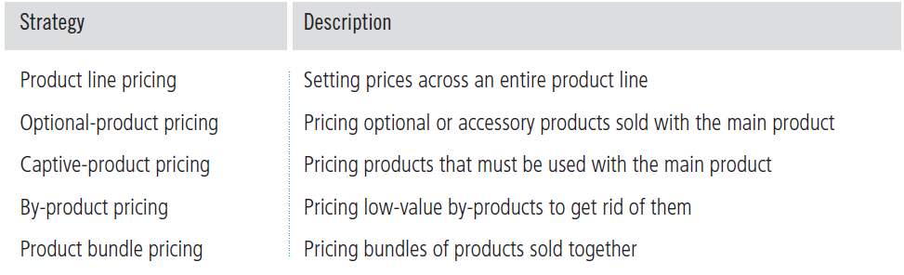

6) Price Adjustment Strategies

- SEVEN price adjustment strategies are discount and allowance pricing, segmented pricing, psychological pricing, promotional pricing, geographical pricing, dynamic pricing, and international pricing

- DISCOUNT AND ALLOWANCE PRICING

- Reduces prices to reward customer responses such as paying early or promoting the product
- Discount – A straight reduction in price on purchases during a stated period of time or of larger quantities
  - Ex: “2/10, net 30” means that although payment is due in 30 days you get a 2% discount if the bill is paid in 10 days

  - Quantity discount – Price reduction to buyers who buy large volumes
  - Competition Act – Quantity discounts must be offered equally to all customers and must not exceed the sellers cost savings associated with selling large quantities
  - Seasonal discount – Price reduction to buyers who buy merchandise or services out of season

- Allowance – Promotional money paid by manufacturers to retailers in return for an agreement to feature the manufacturer’s products in some way
  - Trade in allowances – Price reductions given for turning in an old item when buying a new one (common in the automobile industry)
  - Promotional allowances – Payments or price reductions to reward dealers for participating in advertising and sales support programs

- SEGMENTED PRICING

- Selling a product or service at two or more prices, where the difference in prices is not based on differences in costs
- Different types of segmented pricing are as follows:
  - Customer segment pricing – When different customers pay different prices for the same product or service.
  - Product-form segment pricing – When different versions of the product are priced differently but not according to differences in cost.
  - Location pricing – When the product sold in different geographic areas is priced differently even though the cost is the same.
  - Time pricing – Varies by the season, the month, the day, and even the hour.

- For segmented pricing to be effective, certain conditions must exist:
  - The market must be segmentable
  - Segments must show different degrees of demand
  - Costs of segmenting and reaching the market cannot exceed the extra revenue obtained from the price difference.
  - The market must be legal.

- PSYCHOLOGICAL PRICING

- Pricing that considers the psychology of prices and not simply the economics; the price says something about the product
- Consumers usually perceive higher-priced products as having higher quality
  - Ex: Clive Christian No. 1 – #1 most expensive perfume at $215K
- Reference Prices – Prices that buyers carry in their minds and refer to when looking at a given product.
  - Noting current prices
  - Remembering past prices
  - Assessing the buying situations

- PROMOTIONAL PRICING

- Temporarily pricing products below the list price, and sometimes even below cost, to increase short-run sales
  - Loss leaders – Are products sold below cost to attract customers in the hope they will buy other items at normal markups.
    - Ex: Maxi $1 event

  - Special event pricing – Used to attract customers during certain seasons or periods.
    - Ex: Selling TV’s in Nov/Dec to attract holiday shoppers

  - Cash rebates – Given to consumers who buy products within a specified time.
    - Ex: Popular with producers or cellphones and small appliances

  - Low-interest financing, longer warrantees, and free maintenance – Lower the consumer’s “total price.”
    - Ex: Favored in auto industry

- GEOGRAPHICAL PRICING

- Setting prices for customers located in different parts of the country or world
  - Ex: Big Mac in Canada ($3.57) vs. Big Mac in Russia ($5.00)

- DYNAMIC PRICING

- Adjusting prices continually to meet the characteristics and needs of individual customers and situations
- Often works to benefit the consumer
  - Ex: Amazon – Tailoring products to fit the consumers’ behaviors and desires, and eBay’s RedLaser – mobile app allowing consumers to scan barcodes while shopping to receive product reviews, information, and comparison prices for online and nearby stores

- INTERNATIONAL PRICING

- When prices are set in a specific country based on country-specific factors
  - Economic conditions
  - Competitive conditions
  - Laws and regulations
  - Infrastructure
  - Company marketing objective
  - Consumer perceptions and preferences

Chapter 12: Marketing Channels Delivering Customer Value

1. The Nature & Importance of Marketing Channels

- Few producers sell their goods directly to the final users. Instead, most use intermediaries to bring their products to market through channels.

- Marketing (Distribution) Channels: sets of independent organizations that help make a product or service available for use or consumption by the consumer or business user.
  - Many companies have used imaginative distribution systems to gain a competitive advantage, ex: FedEx’s creative distribution system made it a leader in express delivery.
  - Distribution channel decisions usually involve long-term commitments to other firms; they cannot be replaced with company-owned stores or websites.

Producers use:
- Intermediaries because they offer producers greater efficiency in making goods available to target markets. Through their contacts, experience, specialization, and scale of operations, intermediaries usually offer the firm more than it can achieve on its own.
- They transform the assortment of products into assortments wanted by consumers by buying large quantities from many producers and breaking them down into smaller quantities and broader assortments.
  - Ex: Instead of having a customer buy 2 pens and 4 rulers from the manufacturer, the manufacturer sells a big quantity of pens and rules to Bureau En Gros and then they sell to the customers.
  - Producer Intermediaries Final Consumer

- How Channel Members Add Value
- Done so by bridging the major time, place, and possession gaps that separate goods and services from those who would use them.

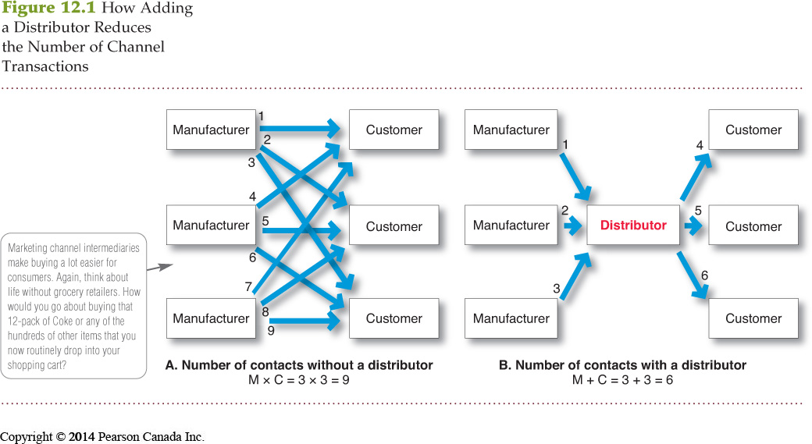

12.1 A: 3 manufacturers, using direct marketing to reach 3 customers = requires 9 contacts
12.1 B: 3 manufacturers, working through 1 distributor, contacting 3 customers = requires 6 contacts
- In this way, intermediaries reduce the amount of work that must be done by both producers and consumers.

Members of the marketing channel perform many key functions:

Help to complete transactions:
- Information: Gathering and distributing marketing research and intelligence information about actors and forces in the marketing environment needed for planning and aiding exchange
- Promotion: Developing and spreading persuasive communications about an offer
- Contact: Finding and communicating with prospective buyers
- Matching: Shaping and fitting the offer to the buyer’s needs, including activities such as manufacturing, grading, assembling, and packaging
- Negotiation: Reaching an agreement on price and other terms of the offer so that ownership or possession can be transferred

Help to fulfill completed transactions:
- Physical distribution: Transporting and storing goods
- Financing: Acquiring and using funds to cover the costs of the channel work
- Risk taking: Assuming the risks of carrying out the channel work

*New Item has been added to the list of functions Environmental Sustainability (to reduce its environmental footprint in supply chain carbon intensity, packaging, recycle of waste and distribution center management)

Number of Channel Levels
- Chanel Level: a layer of intermediaries that performs some work in bringing the product and its ownership closer to the final buyer.
  - Because the producer and the final consumer both perform some work, they are part of every channel.
  - The number of intermediary levels indicates the length of a channel

- There are two kinds on channels:
  - Direct marketing channel: it’s a marketing channel that has no intermediary levels
  - Indirect marketing channel: it’s a marketing channel containing one or more intermediary levels (business distributors,

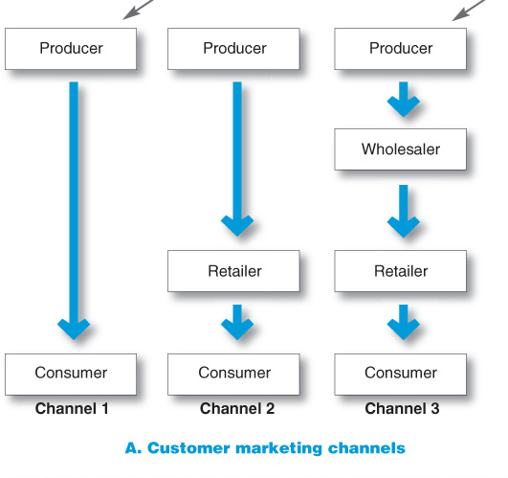

- Channel 1, called a direct marketing channel, has no intermediary levels; the company sells directly to consumers.
- The remaining channels in Figure 12.2A are indirect marketing channels, containing one or more intermediaries.
- From a producer’s point of view, a greater number of levels means less control and greater channel complexity. All of the institutes in the channel are constituted by several types of flows
  - Physical Flow of products
  - Flow of ownership
  - Payment Flow
  - Information Flow
  - Promotion Flow
    - These flows can make even channels with only one or a few levels very complex.

2. Channels Behaviour & Organization
- A marketing channel consists of firms that have partnered for their common goods. Each channel member depends on the other
  - Ex: Ford dealer depends on Ford to design cars that meet customer needs, and Ford depends on the dealer to attract consumers).

- Each channel member plays a specialised role in the channel- therefore the channel is most effective when each member is assigned the task it can do best
  - Ex: Samsung’s role is to produce electronic products that consumers will like and to create demand through advertising, Future Shop’s role is to display these Samsung products in convenient locations, answer buyer’s questions to complete sales.

- Because the success of individual channel members depends on overall channel success, all channel firms should work together smoothly. They should understand and accept their roles, coordinate their activities and cooperate to attain overall channel goals.
- However, they often disagree on who should do what and for what rewards. Such disagreements over goals, roles and reward generate Channel Conflict, disagreements among marketing channel members on goals and roles- who should do what and for what rewards.

We have two types of channel conflict:
1- Horizontal Conflict: among firms at the same level of the channel.
  - For example, some Ford dealers in Vancouver might complain about the other Ford dealers in the city because their prices are too low or they are advertising too aggressively.

- 2- Vertical Conflict: between different levels of the same channel.
  - For example, Goodyear created hard feelings and conflict with its premier network of independent Goodyear dealers when it began selling through mass-merchant retailers such as Sears and Wal-Mart.

- Some conflict in the channel takes the form of healthy competition. Without this competition conflict, the channel could become passive and non innovative.
- But severe or prolonged conflict, as in the case of Goodyear, can disrupt channel effectiveness and cause lasting harm to channel relationships.

Multichannel Distribution System

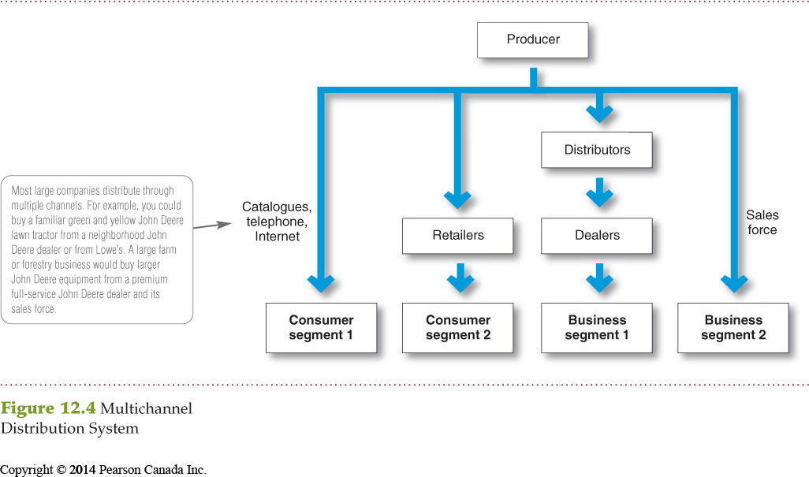

- Occurs when a single firm sets up two or more marketing channels to reach one or more customer segments. Almost every large company and many small ones distribute through multiple channels.

- In the figure, the producer sells directly to consumer segment 1 using direct mail catalogues, telemarketing and the Internet and reaches consumer segment 2 through retailers. It sells indirectly to business segment 1 through distributors and dealers and to business segment 2 through its own sales force.
  - Ex: John Deere sells its outdoor products in their own stores, Home Depot stores and online.

Advantages: Disadvantages:
- Increased sales & market coverage - Hard to control
- New opportunities to tailor products & - Create channel conflict as more channels
services to specific needs of diverse compete for customers & sales
customer segments

Changing Channel Organization
- Disintermediation: occurs when product or service producers cut out intermediaries and go directly to final buyers, or when radically new types of channel intermediaries displace traditional ones (mainly due to technological advances, the Internet)
  - Ex: Airline Canada is selling directly to final buyers and cutting travel agents from marketing channels altogether.
  - Ex: online marketing is growing rapidly (Expedia.ca, Travelzoo.com, Amazon.ca)
- To help keep both company and channel partners happy, they can advertise their products on the website but refer them to a retailer store to make purchase.

3. Channel Design Decisions

- In designing marketing channels, manufacturers struggle between what is ideal and what is practical. The problem is how to convince one or a few good intermediaries to handle the line of products.

Marketing Channel Design
- Designing a channel system calls for (1) analyzing consumer needs, (2) setting channel objectives, (3) identifying major channel alternatives and (4) evaluating them.
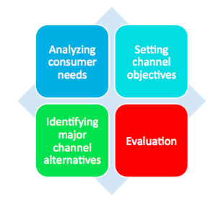

- Analyzing Consumer Needs - adding value to the customer,
- Deciding the marketing channel starts by finding out what target customers want from the channel.
  - Do consumers want to buy from nearby locations or are they willing to travel more distant centralized locations?
  - Would they buy in person, over the phone, or via the Internet?
  - Do they value breadth of assortment or do they prefer specialization?
  - Do consumers want many add-on services or will they obtain it elsewhere?
    - Providing higher levels of service results in higher costs for the channel and higher prices for the consumers. Therefore, the company must balance customer needs as well as their price preferences.
    - Customers will often accept lower service levels in exchange for lower prices.

- Setting Channel Objectives
- The company should decide which segments to serve and the best channels to use in each case. In each segment, the company wants to minimize the total channel cost of meeting customer service requirements.
- Objectives are influenced by the nature of the company, marketing intermediaries, competitors, and the environment.
- Identifying Major Alternatives
- When the company has defines its channels objectives, it should next identify its major channel alternatives in terms of types of intermediaries, the number of intermediaries, and the responsibilities of each channels.

  - Types of Intermediaries: a firm should identify the types of channel members available to carry out its channel work.

  - Responsibilities of Channel Members: The producer and intermediaries need to agree on the terms and responsibilities of each channel member. Should decide on a list price and fair set of discounts for intermediaries. Also on price policies, conditions of sales, territorial rights and specific services to be performed by each party.

  - Number of Marketing Intermediaries (used at each level)

- Intensive distribution: stocking the product in as many outlets as possible
- Products must be available where and when the customers want them, ex: toothpaste, candy

- Exclusive distribution: giving a limited number of dealers the exclusive right to distribute the company’s products in their territories
- Often found in luxury automobiles or prestige clothing, ex: Rolex watches
- More control on prices, promotion, enhances brand image

- Selective distribution: the use of more than one but fewer than all of the intermediaries who are willing to carry the company’s products
- Most television, furniture and home appliance brands ex: Whirlpool
- More market coverage control and less cost than intensive

- Evaluating the Major Alternatives
- Now that the company has decides which channel alternative he wants, they have to select the one that will best satisfy its long run objectives

- Each alternative should be evaluated against economic criteria (compares the likely sales, costs and profitability of different channel alternatives.
- Also must consider control issues (company prefers to keep as much control as possible over the products and not let intermediaries have more)
- The company must apply adaptive criteria as well. The company wants to keep the channel flexible so that it can adapt to environmental changes.

Designing International Distribution Channels
- Channel systems can vary from country to country
- Must be able to adapt channel strategies to existing structures within each country

Chapter 14 – Communicating Customer Value:

Integrated Marketing Communications Strategy

1) The Promotion Mix

- Promotion Mix (Marketing Communications Mix) – The specific blend of promotion tools that the company uses to persuasively communicate customer value and build customer relationships
- FIVE major promotion tools:

- Advertising – Any paid form of non-personal presentation and promotion of ideas, goods, or services by an identified sponsor
  - Broadcast
  - Print
  - Internet
  - Outdoor

- Sales promotion – Are the short-term incentives to encourage the purchase or sale of a product or service
  - Discounts
  - Coupons
  - Displays
  - Demonstrations

- Personal Selling - The personal presentation by the firm’s sales force for the purpose of making sales and building customer relationships
  - Sales presentations
  - Trade shows
  - Incentive programs

- Public relations – Involves building good relations with the company’s various publics by obtaining favorable publicity, building up a good corporate image, and handling or heading off unfavorable rumors, stories, and events
  - Press releases
  - Sponsorships
  - Special events
  - Webpages

- Direct marketing – Involves making direct personalized connections with carefully targeted individual consumers to both obtain an immediate response and cultivate lasting customer relationships—through the use of direct mail, telephone, direct-response television, email, and the Internet to communicate directly with specific consumers
  - Catalogues
  - Telemarketing
  - Kiosks

2) A View of the Communication Process

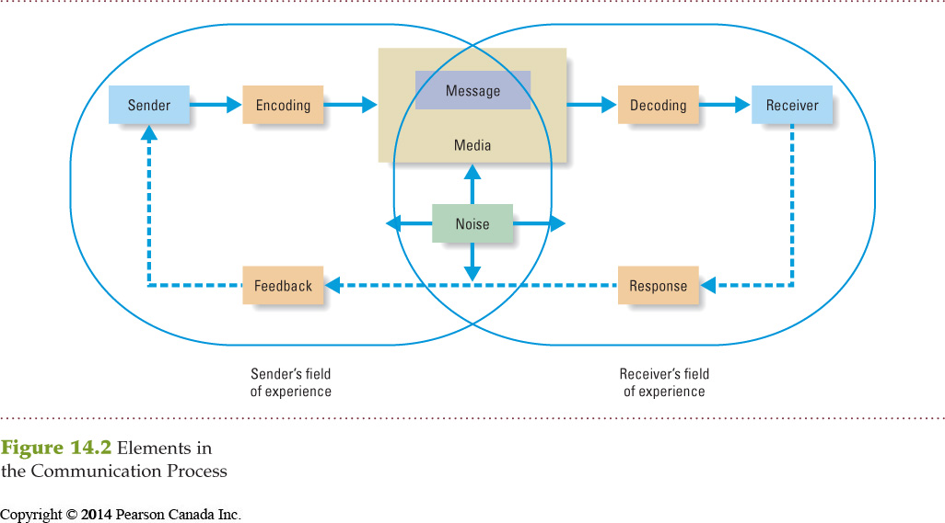

- Marketers are moving toward viewing communications as managing the customer relationship over time
- Communication programs need to be developed for specific segments, niches and individuals

- Elements of the Communications Process:

- Sender – The party sending the message to another party
- Encoding – The process of putting thought into symbolic form
- Message – The set of symbols the sender transmits
- Media – The communications channels through which the message moves from sender to receiver
- Decoding – The process by which the receiver assigns meaning to the symbols
- Receiver – The party receiving the message sent by another party
- Response – The reaction of the receiver after being exposed to the message
- Feedback – The part of the receiver’s response communicated back to the sender
- Noise – The unplanned static or distortion during the communication process, which results in the receiver’s getting a different message than the one the sender sent

- To be effective the sender’s encoding process must mesh with the receiver’s decoding process
- Best messages: words and symbols that are familiar with the receiver
- To communicate effectively, the marketing communicator must understand the customer’s field of experience

Steps in Developing Effective Marketing Communication:

- IDENTIFYING THE TARGET AUDIENCE

- Marketing communicator must begin with a clear target audience in mind
- Audience may be current users or potential buyers (those who make buying decisions and influence it)
- Target audience affects the communicator’s decisions on:
  - What will be said
  - How it will be said
  - When it will be said
  - Where it will be said
  - Who will say it

- DETERMINING THE COMMUNICATION OBJECTIVE

- Marketers must determine the desired response they want from their target audience
- Marketers will seek a purchase response, however purchase will only result after a consumer decision-making process
- Target audience can find themselves in any one of the six…

  - Buyer-readiness stages – The stages consumers normally pass through on their way to making a purchase, including awareness, knowledge, liking, preference, conviction, and the actual purchase
    - Awareness and Preference – Proctor & Gamble used a massive $150 million marketing campaign to introduce Tide Pods called “Pop in. Stand out”
    - Liking – Feeling favorable about Tide Pods
    - Preference – Preferring Tide Pods to regular detergents and competing pod products
    - Conviction – Believing Tide Pods are the best laundry product for them
    - Purchase – Product must provide superior customer value for the customer to purchase

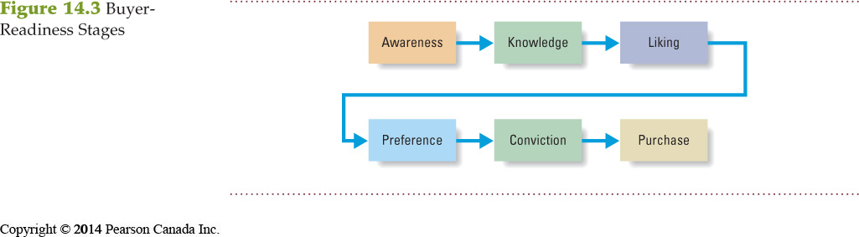

- DESIGNING A MESSAGE

- A message should hold attention, hold interest, arouse desire, and obtain action (AIDA model)
- Few messages take a consumer from awareness to purchase

  - Message Content

- An appeal or theme that will produce the desired response
- Rational appeal – Relates to the audience’s self-interest
  - Ex: Messages that show a product’s quality, economy, value, or performance

- Emotional appeal – An attempt to stir up positive or negative emotions to motivate a purchase
  - Ex: Michelin sells its tires using mild fear appeals – family is everything

- Moral appeal – Directed at the audience’s sense of right and proper
  - Ex: Earth Share ad urges environmental involvement by reminding people that “We live in the house we all build. Every decision we make has consequences… We chose the world we live in, so make the right choices…”

  - Message Structure

- Deals with how the message is put across
- Marketers must decide how to handle three message structure issues
  - Whether to draw a conclusion or leave it to the audience?
    - Research suggests advertisers should ask questions and let buyers come to their own conclusions
  - Put forth the strongest arguments first or last?
    - Presenting first gets strong attention but may lead to a disappointing end
  - Present a one (strengths)-or two-sided (both sides) argument?
    - One-sided arguments can be more effective however, two-sided messages can enhance an advertiser’s credibility

  - Message Format

- Deals with how the message is put across
- Every detail of the ad, from the colour of the print ad to the body language of a TV commercial, requires planning to communicate the right message

- CHOOSING MEDIA

  - Personal Communication Channels

- Involves two or more people communicating directly with each other
  - Face-to-face
  - By phone
  - By mail
  - By email
  - Through Internet “chat”

- Effective because it allows for personal addressing and feedback

- Personal communication channels are controlled by the company
  - Company sales people contact business buyers

- Channels not connected with the company
  - Independent experts – consumer advocates, online buying guides

- Word-of-mouth influence – Personal communication about a product between target buyers and neighbors, friends, family members, and associates

- Personal communication channels are difficult for the company to control as independent experts and word-of-mouth influence overtake the company message

- Opinion leaders – People within a reference group who, because of their special skills, knowledge, personality, or other characteristics exert social influence on others

- Buzz marketing – Involves cultivating opinion leaders and getting them to spread information about a product or service to others in their communities

  - Ex: Vocal point network – Crest weekly clean used moms to share their honest opinions about the product

  - Non personal Communication Channels

- Refers to media that carry messages without personal contact or feedback, including major media, atmospheres, and events that affect the buyer directly

- Major media – Include print (newspaper), broadcast (television/radio), display (billboards/signs), and online media (email, company websites)

- Atmospheres – Designed environments that create or reinforce the buyer’s leanings toward buying a product

- Events – Staged occurrences that communicate messages to target audiences.
  - Press conferences
  - Grand openings
  - Exhibits
  - Public tours

- SELECTING THE MESSAGE SOURCE

- The message’s impact on the target audience is affected by how the audience views the communicator
  - Celebrities
    - Ex: Sarah Jessica Parker speaks for Garnier
  - Athletes
  - Entertainers
  - Professionals
    - Ex: Doctors, dentists will recommend specific food products to their patients
  - Health-care providers

- “Ninety-nine percent of celebrities do a strong job for their brand partners, and 1 percent goes off the rails”
  - Ex: Kellogg’s dismissed Michael Phelps as a spokesperson after he got caught smoking marijuana

- COLLECTING FEEDBACK

- Involves the communicator understanding the effect on the target audience by measuring behavior resulting from the message.
  - How many people bought a product?
  - How many people talked about it with others?
  - How many people visited the store?

3) Setting the Total Promotion Budget and Mix

- SETTING THE TOTAL PROMOTION BUDGET

- FOUR common methods to set a total budget for advertising: affordable method, percentage-of-sales method, competitive-parity method, and objective-and-task method

- Affordable Method

- Sets the budget at an affordable level
  - Small businesses use this method
  - Ignores the effects of promotion on sales
  - Places promotion last among the spending priorities
  - Results in under spending

- Percentage-of-Sales Method

- Sets the budget at a certain percentage of current or forecasted sales or unit sales price
  - Easy to use and helps management think about the relationship between promotion, selling price, and profit per unit
  - Wrongly views sales as the cause of promotion rather than the result of promotion
  - Based on the availability of funds rather than on opportunities
  - The budget varies from year-to-year

- Competitive-Parity Method

- Sets the budget to match competitor outlays and industry average
- Argument: Represents collective wisdom of the industry and prevents promotion wars
- Except: Companies differ greatly, each has its own special promotion needs, and there is no practical evidence suggesting it successfully prevents promotion wars

- Objective-and-Task Method (most logical)

- Sets the budget based on what the firm wants to accomplish with promotion and includes:
  - Defining specific objectives
  - Determining tasks to achieve the objectives
  - Estimating costs of performing tasks (sum of these costs is the promotion budget)
- It forces management to spell out assumptions about the relationship between dollars spent and promotion results, but is difficult to use

- SHAPING THE OVERALL PROMOTION MIX

- The Nature of Each Promotion Tool

- Advertising – Reaches masses of geographically dispersed buyers at a low cost per exposure, and it enables the seller to repeat a message many times
  - Very expressive: Dramatize products through artful use of visuals, print, sound and color
  - Shortcomings: Impersonal, one-way communication, and costly
    - Ex: Television – Super bowl commercials, commercials during popular programming like American Idol/Academy Awards

- Personal Selling – The most effective method at certain stages of the buying process, particularly in building buyers’ preferences, convictions, actions, and developing customer relationships
  - Keeps customers interest at heart
  - Unique qualities come at a cost: Very expensive

- Sales Promotion – Includes coupons, contests, cents-off deals, and premiums that attract consumer attention and offer strong incentives to purchase, and can be used to dramatize product offers and to boost sagging sales
  - Sales promotion says “buy it now”
  - Effects are short-lived and not as effective as advertising or personal selling in building long-run relationships

- Public Relations – A very believable form of promotion that includes news stories, features, sponsorships, and events
  - The message gets to buyers as “news” rather than a sales-directed communication
  - Ex: Avon walk for breast cancer

- Direct Marketing – Non-public, immediate, customized, and interactive promotional tool that includes direct mail, catalogues, telemarketing, and online marketing

