Chapter 3 – defining life and its origins

What is life?
- Types of elements and atoms found in living things are also found in non-living things
- living/non living things have same fundamental laws of physics
  - ex biochem reactions of living cells are reactions that take place outside the cell
- **NOTE: cell theory
  - All organisms composed of one or more cells
  - 2. The cell is the smallest unit that has all the properties of life.
  - 3. Cells arise only from the growth and division of preexisting cells.
- 7 characteristics shared by all life forms
  - Swans Only Eat Hay Early + Grown Right
  - S= stimuli
    - Organisms can make changes to their structure, behavior and function in response to the change in their environment
  - O= order
    - All forms of life are arranged with a specific cell order
  - E= energy use
    - All forms of life acquire energy and use it to maintain their order
  - H= homeostasis
    - Organisms can regulate their internal environment
  - E= evolution
    - Organisms change ove time in order to adapt to their environment
  - G= growth
    - All organisms increase their size by inceasing their number of cells over time
  - R= reproduction
    - All organisms have the ability to make more of their own kind
  - Viruses straddling the line between living and non living because they reproduce and evolve over time but they cant reproduce alone, they have to hijack living cells, so some scientists consiter them non-living
- Characteristics are emergent
  - Means that they emerge from simpler processes
  - Ex. The ability to take in and produce energy doesn’t happen because of one single bunch of molecules, it happens using molecules and proteins and membranes
  - Ex. Cathedral (termite nest) emerges from the simple work of thousands of termites put together (picture pg 53)

The chemical origins of life
- All cells come from pre existing cells but there had to be a time when life started
- To understand that we need to find out when/how the solar system came up
- Panspermia
the idea that Asteroids and comets could have brought organic matter to Earth
- ALH84001
  - was an asteroid who’s Origin was planet Mars
  - Polycyclic aromatic hydrocarbons
    - Formed when microorganisms die
  - Bacterial like structures??
- Earth formed 4.6 billion years ago (timeline picture pg 53+54)
- Universe formed 15 billion years ago (Big Bang)
- Galaxies formed from stars, dust and gas
- Oldest Fossils 3.5 billion years ago
- Eukaryotic fossils 2.2 billion years ago
- Spontaneous regeneration first cells arose where there had been no life before
  - Experiment open beacker with broth, closed beaker
  - When he closed off the air it didn’t spoil but when he didn’t close it off it spoiled which proves to us that things grow from other things in our air, but the whole point is that life in the air must’ve originated from somewhere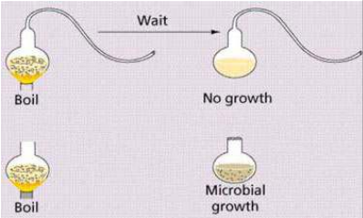

Earth orbits around the sun
- All components of the solar system were formed at the same time
- The sun was formed by intense heat and pressure generated in the middle of an interstellar cloud
- The leftover dust from the cloud formed the solar system and the stars
- Earth took an estimated 500 million years to cool before it could support life
- Earth is the only planet that can support life because earth is in a position where the heat from the sun allows water to exist in liquid form.
- Found water on mars therefore life could potentially have lived there, we know this because of the habitable zone, the area around a star where water can exist in a liquid state, mars is very close to that region (chart page 55)
- 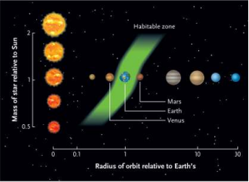

Biologically important molecules
- Major macro molecules: nucleic acids, proteins, lipids, carbohydrates
- These were all derived from simpler molecules (except for lipids), such as nucleotides, sugars, and amino acids
- Early atmosphere
  - Reducing atmosphere - No free oxygen (O2)
  - Free hydrogen (H2) and hydrides (CH4 NH3 and H2O)
  - Energy -electric discharge in storms or solar energy (no ozone layer)
  - The Earth’s surface temperature probably hotter than today.
- Those are the products of metabolic pathways, so how were they formed with the absence of life 3 hypotheses
- 3 hypotheses
  - 1. Reducing atmosphere
    - called this because in the 1920’s Oparin and Haldane proposed that organic molecules that are essential to human life existed with the absence of life
    - molecules were thought to be hydrogen, methane, and ammonia which contain large amounts of electrons
    - reducing atmospherelots of electrons= lots of reactions with each other which prevented larger/ more complex molecules and therefore reducing the complexity of the atmosphere
    - today’s atmosphere oxidizing atmosphere
    - high concentrations of oxygen in the environment reduces the production of electron-rich molecules because it can accept the extra electrons itself and be reduced to water
    - Oparin and Haldane also hypothesized that since there wasn’t a lot of O2 at the beginngin of the atmosphere, there was no ozone layer
    - since there was no ozone layer, ultraviolet light/heat form things like lightning and volcanoes was able to reach the lower bit of the atmosphere which provided the energy needed to create biologically important molecules
    - Miller did experiment using particles in isolated system
      - Was the first experiment to demonstrate abiotic formation of molecules critical to life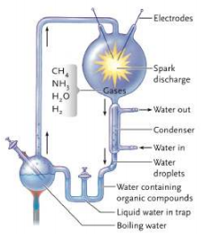
      - Obtained :
        - Urea
        - Amino acids
        - Lactic, formic and acetic acids
        - Nucleotides
        - All these are the building blocks of genetic material
      - Re did experiment and found that they could produce many organic molecules
  - 2. Deep-sea vents
    - states that molecules necessary for life originated on the ocean floor at the site of deep-sea or hydrothermal vents
    - the cents/cracks are found around the world nea volcanoes where the soil is rich and the water is boiling
    - things that exist in these areas are interesting because of their ability to survive in places with out sunlight and with extreme pressure
  - 3. ET origins
    - the belief that life originated from space
    - each year many meteorites hit that are rich in organic molecules
    - ex. Murchison meteorite, landed in Murchison, Victoria, Australia in 1969

synthesis of polymers
- polymers are made up of chained monomers
- they are made using enzymes
- so how were there polymers without the proper enzymes in primordial earth?
  - We assume that the earliest forms of life must have been very simple (monomers)
- Scientists believe that polymers were very short, not complex like today, in order to be sufficient for a specific function that would benefit an organism
- It is doubtful that polymers existed in an aqueous environment because monomers wouldn’t interact precisely enough
- Clay hypothesis hypothesis that polymers were formed on a surface of clay because it is rich in minerals
- Amino acids polypeptides
  - could have occurred when dry or highly concentrated monomers are heated
- Condensation reactions peptide bonds
  - between amino acids or phosphodiester bonds form between nucleotides.
- Polysaccharides (F20 – F23)
  - Monosaccharides linked together
  - Glucose, ribose, mannose, glyceraldehyde
- Proteins (F24 – F28)
  - Amino acids (20)
- Nucleic Acids (F29 – F31)
  - Nucleotides (5)

Catalysts
- molecules adsorb to the clay mineral particles
  - they become concentrated (stick/are attracted to the surface particles)
- clay particles may have been essential catalysts in the formation of polymers
- Could produce small polymers (50 aa)
- recall: Clay hypothesis hypothesis that polymers were formed on a surface of clay because it is rich in minerals
- Enzymes serve this function today

From macro molecules to life
- Evolution of 3 key attributes of a modern cell:
  - 1. A membrane defined compartment (the cell)
  - 2. A system to store genetic info + use the info to guide synthesis of proteins
  - 3. Energy transforming pathways to bring in energy and use it for life

the development of cells
- *REACALL: cell theory
  - All organisms composed of one or more cells
  - 2. The cell is the smallest unit that has all the properties of life.
  - 3. Cells arise only from the growth and division of preexisting cells.
- protobiont term given to a group of molecules that were produced abiotically and are surrounded by a membrane/membrane-like structure
  - Probiont – organic molecules separated from the environment
  - Allows for an internal environment
  - Concentration of key nutrients
- given the conditions of primordial earth, lab experiments show that protobionts could have been formed spontaneously (without energy)
- early protobionts were similar to liposomes (a lipid vesicle where the molecules form a bilayer similar to the cell membrane can be made in a lab, are selectively permeable, can swell and contract)
  - important because lipids could have potentially had some other substances within the layers that could provide for life forms oil in water, if you shake it up you see little oil particles and some f those bubbles will have water inside them
- jack szostak (Harvard) showed that presence of clay speeds up the formation of lipid vesicles and catalyses polymerization

RNA (information storage)
- RNA first hereditary molecule having the ability to copy itself
- RNA enzymic (catalytic) properties
  - called ribozymes ( an enzyme implies protein, but a ribozyme is a piece of RNA inside a obosome)
- Polynucleotides are very good molecules at storing and transmitting information
- lack the versatility for all the chemical functions of a cell
- Polynucleotides
  - Once formed polynucleotides show a tendency to copy themselves using complementary base pairing
  - This was probably catalysed by the presence of clay particles and metal ions
  - These single stranded polynucleotides would have been the equivalent of RNA
- So we can conclude that RNA leads to the production of RNA which starts the process:
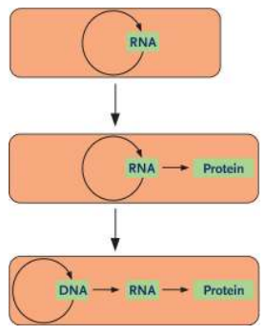
- RNA wasn’t the main genetic material because it doesn’t last long, DNA has more advantages to it
- DNA
  - hereditary information was probably stored in the form of DNA which is more stable than RNA
  - passage of information from RNA to DNA is possible in nature
  - reverse transcriptase enzyme of the retro viruses shows this.
- RNA carries info, catalyzes reactions
- carries genetic instructions necessary to function
- DNA copies to RNA which directs protein synthesis on ribosomes (this process= central dogma)
  - 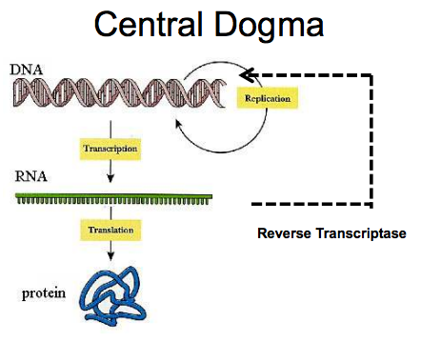
  - 20 building blocks for protein, only 4 for DNA
  - reverse transctiptasereduce RNA and produce DNA
- Enzymes needed to catalyze transcription of DNA into RNA
- So how did this evolve if the products of it (proteins) are needed for it to happen which came first the chicken or the egg type thing
  - 1979 Thomas Cech found group of RNA molecules that could act as catalysts ribozymes
  - they can synthesize themselves (picture pg 59) allowing enzymes to evolve on their own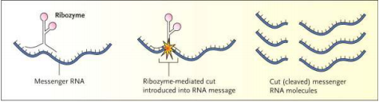
- life form fossils inside structures that live near bacteria
- chemosynthetic bacteria (extremophiles)
  - Chemosynthesis:
    - 02 + 4H2S + C02 CH20 + 4S +3H20
- Stromatolites (bacteria & cyanobacteria)
- Oldest fossils found in western Australia and southern Africa ~ 3.5 byo
- Photosynthesis:
  - 6H2O + 6CO2 + nutrients + light energy C6H12O6 + 6O2

Origins of a virus
- Do not know phylogenic relationship of viruses to cells
- Escaped gene hypothesis – selfish genetic elements that left genome
- Reduction hypothesis – reduction of parasites
- Relics of RNA world
- More than one of these ideas may be correct
- Structure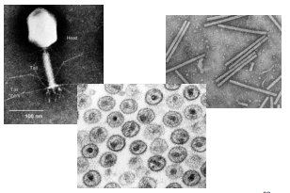

photosynthesis
- All organisms auxotrophs prior to O2
- O2 came in 1.5 bya from photosynthesis
- Present atmosphere: 78% N2, 21% O2, 0.04% CO2, + trace gasses

Origins of Eukaryotes
- Arose from symbioses and genetic exchange between prokaryotes
- 2.2 – 2.7 billion years ago??
- endosymbiosis both mitochondria and chloroplast possess their own genomes
- HGT (horizontal gene transfer) outcome= imports of proteins into mitochondria

Chapter 4 – energy and enzymes
- Bioenergetics: The study of energy in living systems (environments) and the organisms (plants and animals) that utilize it

energy and the laws of thermodynamics
- energy
  - energy= the ability to do work
    - work= anything that forces you to use enegy
    - ex. Active transport forces you to use energy because you are moving stuff against its concentration gradient
  - energy is the goal of cellular respiration
  - kinetic energy
    - motion
    - performs work by making other objects move
    - ex. Heat, light energy the sun
    - water falls have kinetic energy, runners have kinetic energy
  - potential energy
    - stored energy (all our compounds store energy in their bonds)
    - energy of position
    - ex water behind a dam, chemical energy
  - bond energy
    - energy it takes to break bonds/ energy release when bonds are formed
    - dif types of bonds have have specific amounts of energy in them
    - this is called their bond energy
- laws of thermodynamics
  - 3 different types of systems
    - 1. Isolated
      - does not exchange matter or energy with its surroundings
      - ex. A thermos, but eventually the liquid inside cools down
    - 2. Closed
      - can exchange energy but not matter with its surroundings
      - we consider earth a closed system
    - 3. Open
      - both energy and matter can be exchanged between the system and its surroundings
      - the ocean is an open system, ecosystems, plants, animals
  - 1. Energy can be transferred but not created or destroyed
    - the amount of energy in the universe is constant
    - can be conserved (law of conservation of energy)
    - when we lose energy its not being destroyed/ when we gain energy its not being created, it comes from somewhere else
  - 2. Energy transformations increase disorder (all energy transformations are inefficient)
    - idea that the world is moving towards disorder (entropy)
    - greater disorder= greater entropy
    - we naturally move towards disorder because its easier
  - life goes against the second law of thermodynamics!
  - We need to repair our cells, so we eat things that give us vitamins and protein to help them
  - This means that we are turning disorder into order and therefore going against the natural cycle of life according to the second law of thermodynamics
  - But we give off CO2 which is more disordered then ordered so technically we are not going against the natural way of things
- Biological work why?
  - Biosynthesis
    - Nucleotides DNA or RNA
    - Amino acids proteins
    - CO2 + H2O CHO (glucose)
  - Transport
    - Passive and active
    - Cells need active to pish the cells against their concentration gradient
  - Free energy
- Entropy
  - Entropy measures energy that is no longer available to perform useful work within the current environment
  - The entropy can also be understood as the "quality" of heat flowing between two bodies.
  - One of the ideas involved in the concept of entropy is that nature tends from order to disorder in isolated systems

free energy and spontaneous reactions
- free energy
  - energy available to do work
  - concept developed by Gibbs
  - endergonic reactions
    - when free energy is +, that means the energy within the molecule is greater then its surroundings
    - this means it is endergonic because energy was absorbed
    - gone from disorder to more order
    - more energy is put in therefore more order and not spontaneous
    - ex. Photosynthesis, ∆G>0
  - exergonic reactions
    - lost energy moves to surroundings/somewhere else
    - disorder increased, net release of energy
    - since universe is naturally moving towards disorder, these reactions happen naturally, or spontaneously
    - ex. Cellular respiration (getting more ATP which is energy), ∆G<0
  - 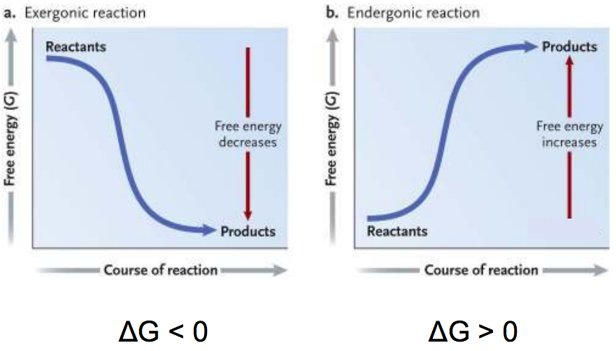
  - change in free energy:

∆G (change in free energy)= ∆H (change in enthalpy) - T(temp)x∆S(change in entropy)
  - the free energy change is the sum of changes in energy content and entropy
- spontaneous reactions will occur
- enthalpy the potential energy of a system
- in a reaction, if entropy of the products is greater then entropy of the reactants, the reaction will occur spontaneously (∆G must be negative)
- ex. Ice has low entropy because it is solid, it gains entropy when it melts because it is becoming water which is less ordered, same thing for when water turns into gas
- chemical equilibrium
  - the point when there is no more overall change in the concetration of products and reactants
  - rate or forward reaction = rate of backward reaction
  - lowest point of free energy
  - no capacity to do work
  - ∆G=0
- Metabolism sum of all chemical reactions within a system (catabolic + anabolic reactions)
- Catabolic pathways energy release by breakdown of complex molecules (cellular respiration)
  - Break down reactions
  - exergonic
- Anabolic pathways consuming energy to build up more complex molecules from simpler ones (photosynthesis)
  - Synthesis reaction
  - endergonic

ATP is the energy currency of the cell
- ATP is the energy molecule of the cell
- we make ATP during cellular respiration therefore ATP is the molecule that is able to do WORK in the cell
- made up of nucleotide, sugar, 3 phosphate groups
- has potential energy because it has the energy to do work or store energy
- coupled reactions
  - the energy released from one reaction is absorbed by another reaction
  - 2 reactions where you have en exergonic and endergonic reaction happening simultaneously
  - we can create order in our own system but only at the expense of more disorder elsewhere
  - if you are going from smaller to bigger, you are increasing order/decreasing energy
    - why? a single molecule can rearrange itself in a million different ways, therefore there is more opportunity for disorder
  - ex glutamine: glutamic acid + NH3 (ammonia) glutamine + H2O, ∆G= +3.4kcal/mol
  - used in the assembly of proteins
  - is a donor of nitrogen
  - ex ATP cycle
- redox reactions
  - reaction that involves the complete or partial transfer of electrons
    - ex. Ions electrons are being transferred completely
    - covalent share bonds but they share them unequally (partial)
  - LEO the lion goes GER
    - Lose electrons oxidized
    - Gain electrons reduced
  - The reduced form of a compound has more energy then the oxidized form
  - Electron carriers can take electrons from high energy compounds to low energy compounds
    - NAD+, FAD
    - 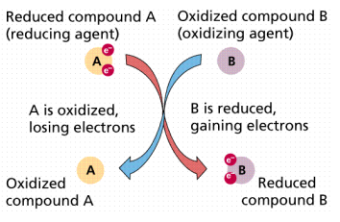
    - ETC uses redox reactions
  - In biology photosynthesis- reduction of CO2 in to sugar and the oxidation of waster into molecular O2
  - Reverse reaction, respiration, oxidizing sugar to produce CO2 + H2O

Biological organic molecules
- Composed of subunits (building blocks)
- Monomers= one, combine to make polymers
- Large organic molecules called macromolecules
- Common combining reactions
  - Dehydration synthesis, hydrolysis reaction (grade 12 binder in detail)
  - 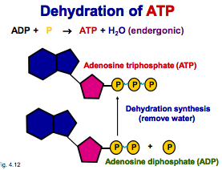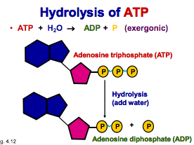
- How to make ATP grade 12 binder
- Energy coupling when the free energy of a molecule changes from endergonic to exergonic

The role of enzymes
- If ∆G<0 then the reaction is thermodynamically unstable
- When reactants are rapidly converted into products, it is kinetically unstable
- **defining a reaction as spontaneous says nothing about the speed of the reaction
- Activation energy (Ea)
  - The minimum amount of energy needed to start a reaction
  - Spontaneous reaction
  - At the activation energy stage, molecules are in the transition stage (when the bonds are weak enough to be broken)
  - 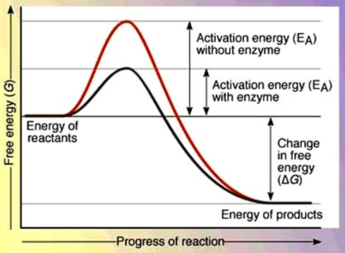
  - with enzyme black, without enzyme red
  - activation energy happens using energy in the form of heat from environment
  - sometimes molecules will not reach activation energy and just stay as they are, but if many molecules around them reach it, the free energy given off can cause them to react
  - ex. Propane can sit for years doing nothing but once you put a flame to it the entire thing will combust
  - for some processes barrier isn’t high and thermal temp at room temp is enough to stat a reaction, others like gas need something stronger like a spark
- enzymes accelerate reactions by reducing the activation energy
  - we can potentially use temperatue to speed up reactions but this is bad because
    - 1. Can destroy structural components of the cell may kill it
    - 2. Metabolic pathways can be lost because the chemical reactions would be all messed up
  - so we use a catalyst instead an enzyme is a catalyst
  - so in this case, activation energy is a kinetic barrier that prevents spontaneous reactions, the greater the barrier the slower the reaction, so enzymes decrease the barrier
  - enzymes do not alter the rate of free energy (∆G), free energy is the same, the only difference is the path it takes to get there
- enzymes combine with reactants and remain unchanged
  - enzyme substrate the reactant that the enzyme acts on
  - when a substrate binds to an enzyme the enzyme catalyzes the conversion of the substrate to the product
  - active site the site on an enzyme that the substrate binds to and catalysis takes place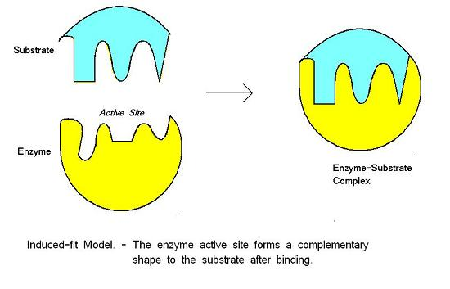
  - lock & key model the induced fit model (above)
    - before bonding the enzyme changes its shape in order to provide a better fit
  - coenzyme/cofactor
    - 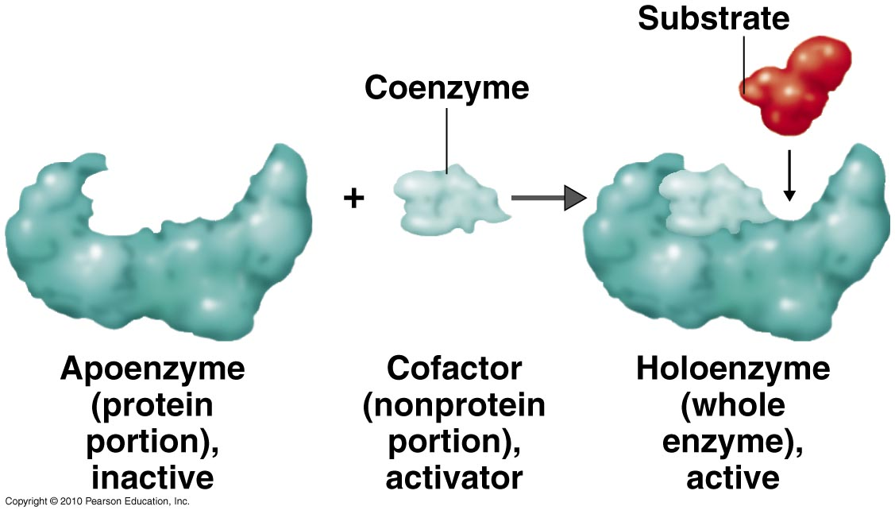
- how enzymes do their job
  - 1. Bringing many molecules together
    - high concentration= greater opportunity for collision, more effective collisions as well
  - 2. Bringing down the activation energy
    - means activation energy is less therefore quicker products
  - 3. Changing the shape of the substrate
    - allowing the substrate to fit onto the active site of a cell allowing it to react easier

factors that effect enzyme activity
  - with access substrate, the rate of products are proportional to the rate of enzymes
  - this means reaction will proceeds slowly because not enough substrate is binding to enzyme
    - on a graph, rate of reaction increases with enzyme concentration
    - rate of reaction increases as substrate concentration increases, but soon the substrate concentration increases and the rate of reaction levels off saturation level
- enzyme inhibition
  - competitive inhibition
    - inhibitor competes with substrate for the active site
  - noncompetitive inhibition
    - inhibitor binds to other critical sites changing the shape of the active site so the substrate cant get in
  - reversible inhibition vs irreversible
    - reversible means the binding is weak so its easy to get the inhibitor out but that’s not the case for irreversible it’s the opposite
    - irreversible can only be overcome by the cell synthesizing more enzymes
- regulating enzyme activity
  - if all cells were active at the same time, they would all function simultaneously and the reactions of certain cells would cancel each other out
  - 2 things that regulate it
  - 1. Allosteric regulation
    - 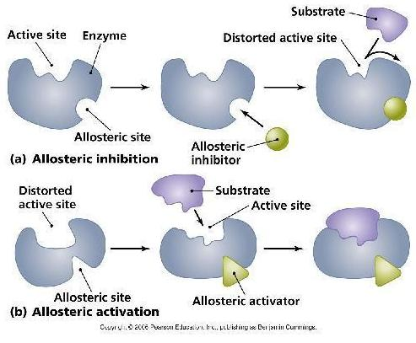
    - inhibition allosteric inhibitor binds to the allosteric site and inhibits the substrate from binding to the enzyme
      - converts allosteric inhibitor from high to low affinity state (substrate binds loosely or not at all)
    - activation allosteric activator binds to the allosteric site allowing the substrate to bind to the enzyme
      - from low to high affinity state (substrate binds stongly)
    - feedback inhibition
      - 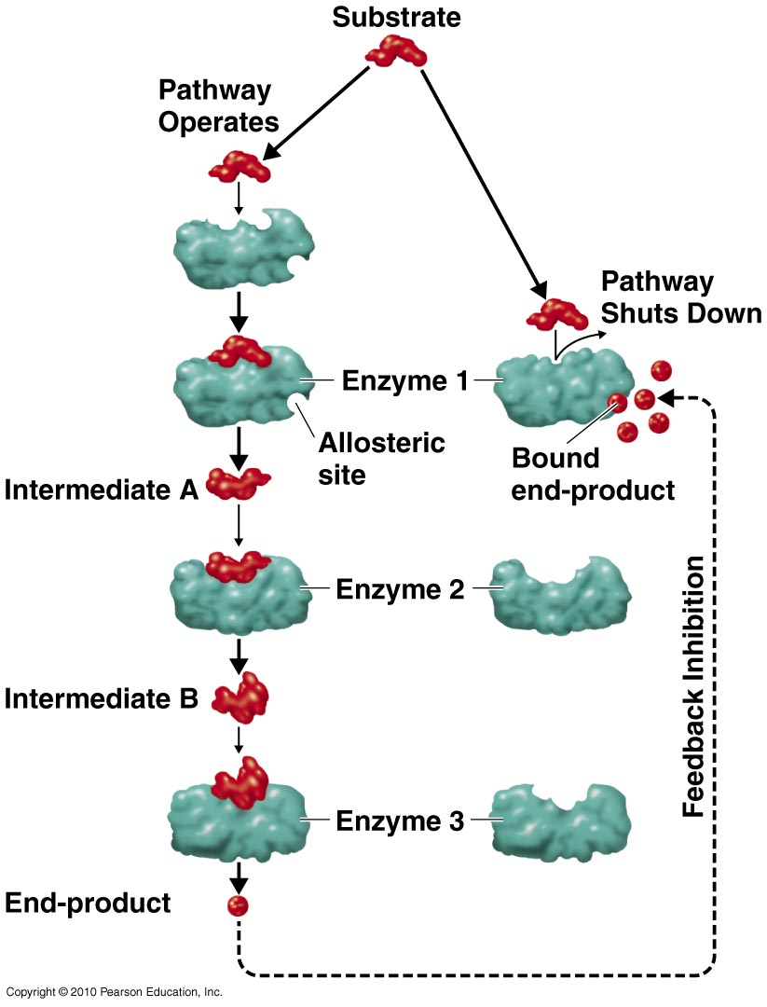
      - if the product of a metabolic pathway is producing access product, it will go through feedback inhibition where the product turns into the allosteric inhibitor and slows the excess production of the product
      - can come back as an activator (positive) or an inhibitor (negative)
      - positive feedback
        - oxytosin a hormone produces when a woman is giving birth, causes muscle contractions to push the baby out which sends a signal to the brain to make more
      - negative feedback
        - ATP an inhibitor stops the production of ATP so we use it up but then we need more so we start producing it again when we need it
        - Class example Threonine turns into isoleucine, isoleucine acts as the inhibitor
  - 2. Covalent modification
    - when the covalent attachment of a molecule modifies the activity of an enzyme
    - some enzymes are inactive and only become activated using covalent modification
    - ex. Phosphorolation phosphate group is added ( makes it easier to break bonds makes the thing you add it to a little more unstable)
dephosphorolation phosphate group taken away
    - ex. Proteolytic cleavage
  - all enzymes reach maximal activity within a narrow range of temp/PH
  - effects of PH
    - rate of catalyzed reactions decreases with alteration of PH
    - effects and structure of enzyme becomes more extreme
    - most enzymes are sitting at PH7
  - effects of temp changes
    - as temp rises, rate of reactions increases
    - more frequent and stronger collisions
    - these disturbances can become strong enough to denature the enzyme
    - reaction rate doubles with every 10 degree increase of temp
    - peaks between 40-50 degrees
    - rate of reactions peaks at whatever temp the kinetic motion is greatest so not technically between 40-50 degrees, it all depends
- enzyme facts
  - typically large proteins
  - lowers activation energy
  - enzyme is unchanged by reaction
  - difference in speed between enzyme reaction and sans-enzyme reaction is 10^10 to 10^15
  - team of enzymes a multi enzyme complex

enzymes have suffix -ase

Chapter 5 – membranes and transport

Phospholipids
- they are amphipathic
  - polar phosphate group, non polar fatty acid
  - phosphate heads are polar and are attracted to eachother and they like water so they’re on the outside
  - hydrophobic fatty acids are non polar stay on the inside
  - 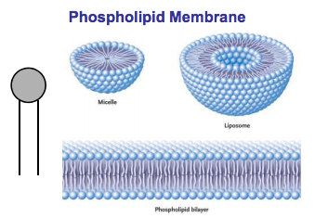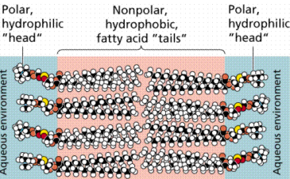
- made up of:
  - glucerol
  - 2 fatty acids
  - a phosphate group
  - 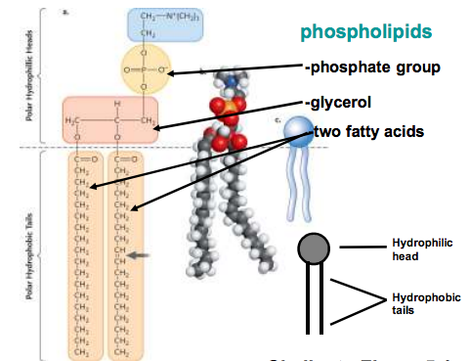
- In 1972, S.J. Singer and G. Nicolson
  - model that proposed that the membrane proteins are dispersed and individually inserted into the phospholipid bilayer
  - In this fluid mosaic model, the hydrophilic regions of proteins and phospholipids are in maximum contact with water and the hydrophobic regions are in a nonaqueous environment.

fluid mosaic model
- composed of :
- phospholipid-bilayer
  - intermolecular forces
    - majority is hydrophobic tail so theyre only help together with London dispersion bonds and its therefore a weak force so molecules wont form strong bonds and it will be fluid
    - constantly moving
  - double bonds
    - double bonds kink and therefore molecules cant physically get closer together which forms weak bonds causing it to be fluid like
- movement
  - Most of the lipids and some proteins can drift laterally in the plane of the membrane
  - rarely flip-flop from one layer to the other
  - The lateral movements of phospholipids are rapid
    - 2 microns per second.
  - Many larger membrane proteins move more slowly but do drift.
    - Some proteins move in very directed manner, perhaps guided/driven by the motor proteins attached to the cytoskeleton
    - Other proteins never move, anchored by the cytoskeleton
  - Membrane fluidity is influenced by temperature and by its constituents.
    - Cooling, membranes switch from a fluid state to a solid state as the phospholipids are more closely packed.
  - membrane must be fluid, about as fluid as salad oil to function
  - Membranes rich in unsaturated fatty acids are more fluid that those dominated by saturated fatty acids
    - Saturated thick
      - only singe C-C bonds
      - if there are only single bonds, every other bond is surrounded by hydrogen and therefore get closer to each other and form stronger bonds
    - unsaturated fluid
      - mono unsaturated one double bond
      - polyunsaturated multiple double bonds
      - cis orientation hydrogen’s are on the same side, H cant bond with eachother so molecule will bend it will be harder to get close together
      - trans orientation hydrogen’s on both sides, H can bond, easier to get close together
      - 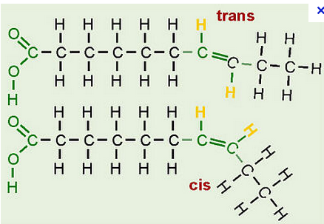
  - Cells can alter the lipid composition of membranes to compensate for changes in fluidity caused by changing temperatures.
    - cold-adapted organisms, such as winter wheat, increase the percentage of unsaturated phospholipids in the autumn.
- proteins
  - cell membrane is selectively permeable, so proteins help things that weren’t selected get into the cell membrane
  - some things move around the cell but some things stay in place transport proteins would be the things that stay in place because they need to transfer molecules
  - integral
    - penetrate the hydrophobic core of the lipid bilayer (extends throughout the cell membrane)
    - embedded in the cell membrane
    - Where they contact the core, they have hydrophobic regions with nonpolar amino acids - alpha helices.
    - Where they are in contact with the aqueous environment, they have hydrophilic amino acids.
  - peripheral
    - associated with other areas of the membrane
    - not embedded
    - loosely bound to the surface, often connected to other population of membrane proteins
  - functions include
    - signal transduction (gets message from outside cell inside cell)
    - cell recognition receptors look for specific type of sugar (carb)
    - transport
    - enzyme activity
    - intercellular joining
    - attatchment to the cytoskeleton and extracellular matrixt (ECM)

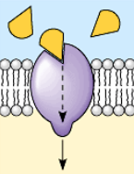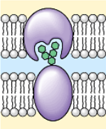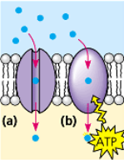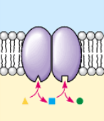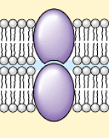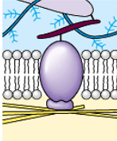
  - One role of membrane proteins is to reinforce the shape of a cell and provide a strong framework.
    - On the cytoplasmic side, some membrane proteins connect to the cytoskeleton.
    - On the exterior side, some membrane proteins attach to the fibers of the extracellular matrix
- cholesterol
  - Important in maintaining optimal fluidity of the membrane
    - We don’t want the bilayer to me so loose that it lets everything in but we don’t want it to be so strong that it lets nothing in so cholesterol creates the barrier
  - Binds to phosphate heads of the phospholipids and extends in between the fatty acid tails
  - At high temps
    - Keeps phosphate groups together which prevents membrane from falling apart because of the stronger polar interactions
  - At low temps
    - The phosphate heads/the fatty acid tails could bond directly together so cholesterol provides a barrier between them to prevent this

Thickness
- Approx. 8 nm thick (7 – 9)
  - 8000 staked would be the thickness of a page in our text book

Carbohydrates
- The membrane plays the key role in cell-cell recognition.
  - Cell-cell recognition is the ability of a cell to distinguish one type of neighboring cell from another.
    - important in cell sorting and organization as tissues and organs in development.
    - basis for rejection of foreign cells by the immune system.
  - Cells recognize other cells by keying on surface molecules, often carbohydrates, on the plasma membrane.

Permeability
- A steady traffic of small molecules and ions moves across the plasma membrane in both directions.
  - sugars, amino acids, and other nutrients enter a muscle cell and metabolic waste products leave.
  - absorbs oxygen and expels carbon dioxide.
  - regulates concentrations of inorganic ions, like Na+, K+, Ca2+, and Cl, by shuttling them across the membrane.
- Substances do not move across the barrier indiscriminately; membranes are selectively permeable
- Permeability of a molecule through a membrane depends on the interaction of that molecule with the hydrophobic core of the membrane.
  - Hydrophobic molecules, CO2, and O2, can dissolve in the lipid bilayer and cross easily.
  - Ions and polar molecules pass through with difficulty.
  - Proteins can assist and regulate the transport

Cell transport
- passive transport movement of molecules with their concentration gradient and without the use of energy
  - diffusion the movement of particles from high concentration to low concentration
  - facilitated diffusion still moving from high concentration to low concentration but now with the help of proteins, also specific channel (triangles can get through but circles cant)
    - 1. Channel proteins
      - has a channel/opening through which water molecules or specific solute can pass
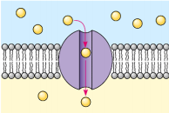
      - aquaporin transport protein that facilitates massive amounts of diffusion
    - 2. Carrier proteins
      - constantly changing shape to allow molecules to move
      - only changes shape when it binds to a certain substance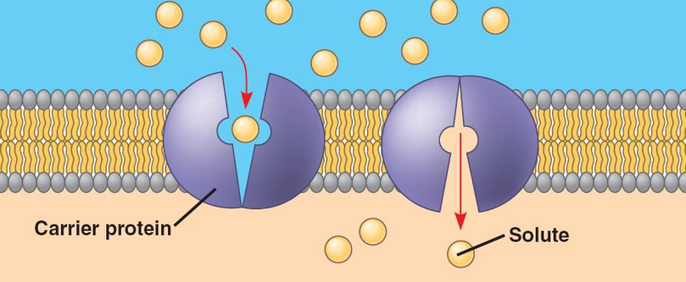
  - osmosis the specific name used for the diffusion of water molecules (still from high to low concentration)
    - isotonic concentration inside and outside cell are equal
    - hypertonic high solute concentration outside cell, water will move outside cell to dilute outside solution, cell with shrivel
    - hypotonic low solute concentration outside cell, water will move inside cell to dilute cell, cell will grow and possibly burst
    - ex blood cells explode if you put them in pure water
- active transport the movement of molecules against their concentration gradient with the sue of ENERGY
  - often uses our nerves to send signals
  - transport proteins
    - 2 types one doesn’t need energy because it has a chennel, the other uses ATP to move molecules against their concentration gradient
    - same as other transmembrane proteins but they use energy
    - Some transport proteins have a hydrophilic channel that certain molecules or ions can use as a tunnel through the membrane
    - Others bind to these molecules and carry their passengers across the membrane physically
    - Each transport protein is specific as to the substances that it will translocate (move)
    - For example, Paramecium, a protist, is hypertonic when compared to the pond water in which it lives.
      - In spite of a cell membrane water still continually enters the Paramecium cell.
      - Paramecium have a specialized organelle, the contractile vacuole, that functions as a bilge pump to force water out of the cell.
    - have much in common with enzymes.
      - specific binding sites for the solute.
      - can become saturated when they are translocating passengers as fast as they can.
      - can be inhibited by molecules that resemble the normal “substrate.”
        - When these bind to the transport proteins, they outcompete the normal substrate for transport.
    - 3 types:
      - 1. Uniport – single solute carried across membrane by transport protein use cahnnel
      - 2. Symport – two different solutes carried across membrane at same time in same direction by transport protein don’t use channel
      - 3. Antiport – two different solutes carried across membrane in opposite direction by transport protein doesn’t use channel
      - ** all of these only talking about small malecules so it doesn’t relate to endocytosis
- membrane assisted transport the movement of molecules using vesicles
  - exocytosis taking particles out of the cell
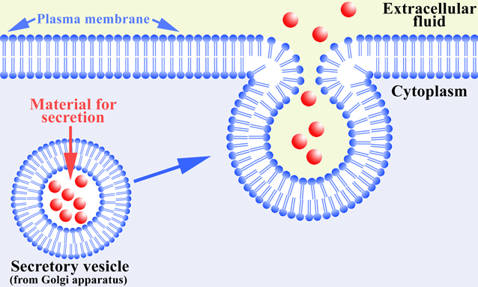
  - endocytosis bringing things into the cell
    - phagocytosis cell eating large solid particles
    - pinocytosis cell drinking: taking in dissolved solutes with the fluid they’re in
    - receptor mediated receptor proteins grab onto the prtiles , when the proteins grab onto them, they proteins send signals to the membrane telling it to fold/close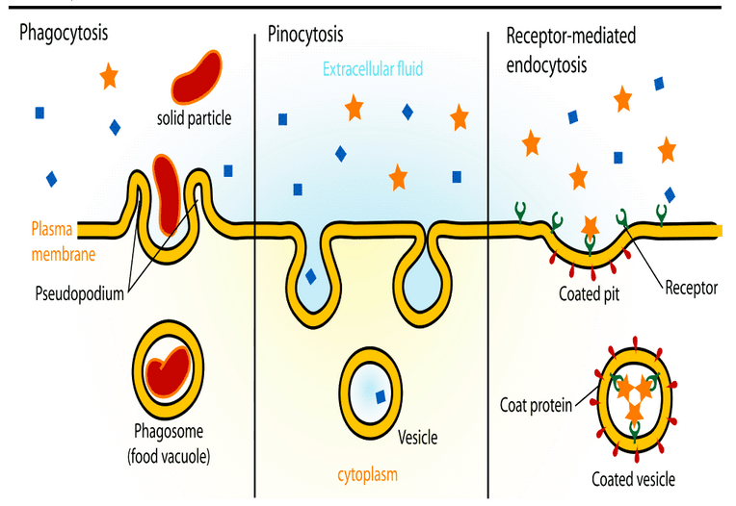

chapter 6 – cellular respiration

Intro
- Overall equation
  - C6H12O6 + 6 O2 6 CO2 + 6 H2O + energy (ATP)
- Is a combustion reaction (exergonic) and a catabolic (taking things apart)
- Uses energy taken from macromollecules (glucose) to produce ATP and water
- Delta G is negative!
- Rapid combustion vs. controlled combustion
  - Rapid combustion is an exergonic reaction, but when reactions happen this quickly, we cant keep the energy in our bodies
  - So our bodies use controlled oxidation so that our bodies can harness the energy in the form of ATP and we can use it as apposed to it being rapidly released as heat
  - 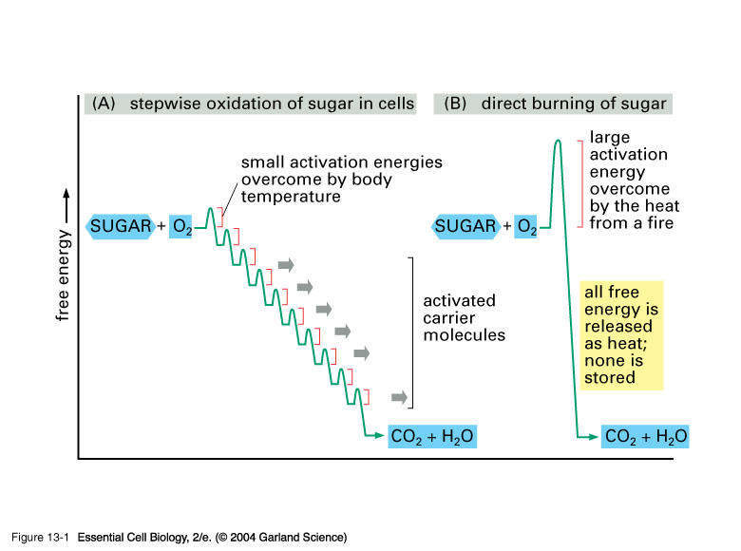
- ATP – Rechargeable Battery
  - An analogy between ATP and rechargeable batteries
  - Recharged batteries can be used only after the input of additional energy
  - The input of additional energy (plus a phosphate group) "recharges" ADP into ATP (as in my analogy the spent batteries are recharged by the input of additional energy).
- Organisms
  - Bacteria autotrophic or heterotrophs
  - Plants autotrophs (self producers)
  - Fungi heterotrophs (consumers)
  - Protists can be both
  - Animals heretotrophs
- Aerobic cellular respiration using oxygen
  - Glycolysis
    - 10 steps, 10 reactions
    - occurs in the cytoplasm
  - pyruvate oxidation
    - 1 step/reaction
    - occurs in the matrix
  - citric acid cycle (krebs cycle)
    - cyclical series of reactions
    - 8 reactions / turn
    - occurs in the matrix
  - ETC and chemiosmosis
    - 2 different things
    - occurs along the inner membrane
- mitochondria
  - powerhouse of the cell (where energy is produced)
  - majority of ATP production occurs here (there is some production outside of it)
  - has a double membrane
  - intermembrane space plays an important role in electron trading
  - matrix
  - 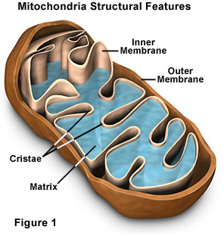

glycolysis
- glyco latin for sugar
- lys means its involved with splitting something (we are splitting sugar)
- occurs in the cytoplasm
- 10 steps to it
- glucose is split into 2 pyruvate molecules
  - each pyruvate has 3C molecules split 6C molecule into 2 3C molecules
- requires input of energy (this is the only stage that requires an input
- energy is produced in the form of
  - ATP
  - NADH
- Steps
  - Start with glucose
  - Priming reactions
    - Energy is put in to produce fructose 1,6 bisphosphate
  - Cleavage reaction
    - Splits t o G3P and DHAP (which also turns into G3P)
  - Energy harvesting
    - Redox reaction NADH is being made so something is oxidized and something is reduced
    - Turns into 2 pyruvate molecules
  - Equation:
- Glucose + 2ADP + 2Pi + 2NAD+ 2 pyruvate + 2ATP + 2NADH + 2H+
- Now theres 2 parallel tracks so you get 2 NADH and 2 ATP net
  - We actually get 4 ATP but 2 were used at the beginning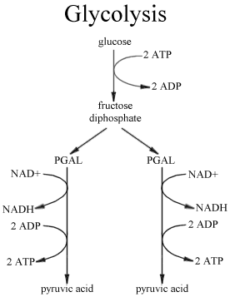

Pyruvate oxidation
- (transition process)
- Occurs in the matrix
- 1 step
- pyruvate (reactant) is converted into acetyl-CoA (product)
- one carbon is removed we see this because pyruvate is 3C btu acetyl-CoA is only 2C
- energy produced in the form of NADH not ATP
- occurs twice per glucose
- redox reaction oyruvic dehydrogenase enzyme moves CO2 from pyruvic acid and produces NADH
- overall equation:
2 pyruvate + 2 NAD+ + 2CoA 2 CO2 + 2 NADH + 2 acetyl-CoA + 2H+
- 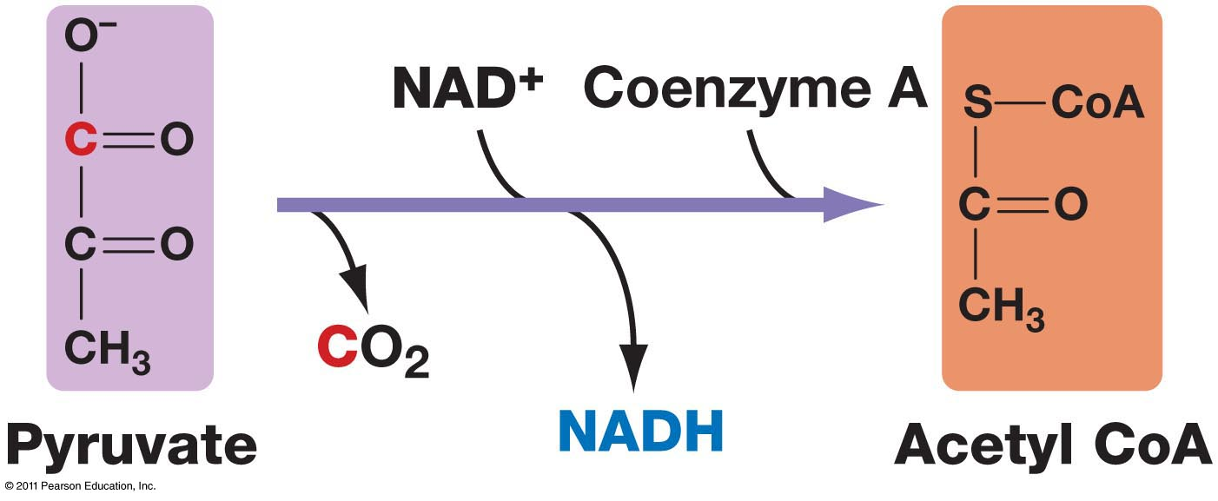

krebs cycle
- occurs in the mtrix
- 8 steps
  - 1: Condensation
    - unstable bond of acetyl CoA breaks, and 2 carbon acetyl group bonds to 4 carbon oxaloacetic acid to form 6 carbon compound
    - citrate is produced and that’s why its called the citric acid cycle, because citrate is the first thing produced
    - 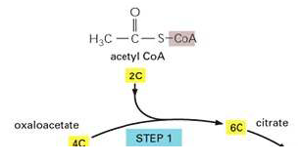
  - 2-3: Isomerization
    - 2 citric acid is isomerized (compounds that have the same molecular formula but different structures and properties)
    - 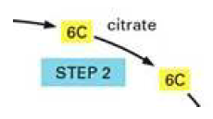
    - 3 two major events
      - 6 carbon to a 5 carbon compound
      - 5 carbon compound oxidized and NAD+ reduced
    - 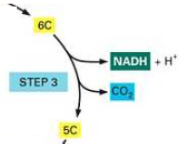
  - 4: First oxidation
    - removal of carbon dioxide
    - oxidation of remaining 4 carbon compound and reduction of NAD+
    - 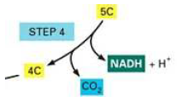
  - 5: Second oxidation
    - substrate level phosphorylation
    - phosphate group transferred to GDP to make GTP
      - GTP donates a phosphate group to ADP to make ATP
    - 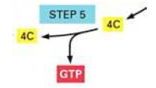
  - 6: Substrate-level phosphorylation
    - oxidation of the 4 carbon compound and FAD reduced
    - two hydrogens transferred to FAD to make FADH2
    - 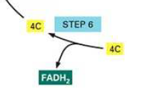
  - 7: Third oxidation
    - water is added to rearrange the chemical bonds
    - 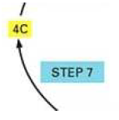
  - 8-9: Regeneration and oxaloacetate
    - the 4 carbon malic acid is oxidized and NAD reduced
    - molecule of NADH produced
    - oxaloacetic acid is regenerated to begin cycle again
    - 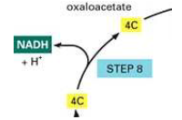
- Energy is produced (all 3 forms of ATP)
- Occurs twice per glucose
- Overall equation:
acetyl-CoA + 3 NAD+ + FAD + ADP + Pi + oxaloacetate + 3 H2O
2 CO2 + 3 NADH + 3 H+ + FADH2 + ATP + CoA

ETC
- Location: inner mitochondrial membrane.
- Uses ETC (cytochrome proteins) and ATP Synthase (enzyme) to make ATP.
- ETC pumps H+ (protons) across
- innermembrane (lowers pH in innermembrane space).
- Glycolysis and Krebs Cycle produce only 4 ATP molecules per glucose molecule
  - Substrate level phosphorylation
  - 2 ATP from glycolysis and 2 from Krebs
- NADH and FADH2 account for most of the energy extracted from food
  - These molecules link glycolysis and Krebs to the machinery of oxidative phosphorylation
- Glycolysis and Krebs Cycle produce only 4 ATP molecules per glucose molecule
  - Substrate level phosphorylation
  - 2 ATP from glycolysis and 2 from Krebs
- NADH and FADH2 account for most of the energy extracted from food
  - These molecules link glycolysis and Krebs to the machinery of oxidative phosphorylation

Chapter 7 – photosynthesis

intro
- uses light energy from the sun to transform CO2 and H2O into chemical energy (glucose)
  - 6CO2 + 6H2Olight/energy6O2 + C6H12O6
- occurs in photosynthetic organisms (not just plants, also bacteria algae (protist) etc…)
- RECALL law of thermodynamics
  - Energy cant be created or destroyed, it comes from somewhere else
  - Cellular respiration gets its energy from beaking bonds of glucose (organic) turns it into inorganic
  - Photosynthesis takes inorganic energy (from the sun) and turns it into organic energy (glucose)
  - No net production of ATP
- Chloroplast organelle responsible for photosynthesis
  - Double membrane organelle (outer/inner membrane)
  - Disc like structures called thylakoids are found within the chloroplast
  - A stack of thylakoids is called granum, (grana is multiple stacks)
  - Fluid surrounding thylakoids is the stroma
  - Thylakoids are membrane bound structures that contain a fluid called lumen (if you cut a disc in half the fluid inside is the lumen)
  - Similar to mitochondria
    - Double membrane in matrix
    - Dif structure but based on where things take place you’ll notice similarities and differences ex, inner membrane isn’t folded
    - Both have ribosome’s inside and DNA
  - Membrane around central vacuole tonoplast
- Chlorophyll
  - Pigment required for photosynthesis
    - Electrons found within it are able to absorb light
    - It is not the only pigment, its just the one required to absorb light
    - Another example of one is a carotenoid carrots have this instead of chlorophyll, many other fruits have it too so it has a wide range of absorption
    - Spectrophotometer used in a lab to check the level of absorption
    - action spectrum allows us to measure photosynthetic rate using its rate of absorption
    - some plants get by without photosynthesis
    - tissue localization
      - any green tissue leaves stems roots (occasionally)
      - compartments leaves
        - placement and localization of leaf for maximum efficiency
  - Located within the membrane of the thylakoids
  - Molecule that’s able to absorb energy from light
  - R group on molecule can either be CH3 (chlorophyll A) or CHO (chlorophyll B)
  - Chlorophyll c brown algae, chlorophyll d red algea
  - Electrons found within the alternation double and single bonds in the porphyrin ring are able to absorb light energy
  - When the electrons become excited to a high enough energy level, they can leave the chlorophyll molecule and begin the process of photosynthesis
  - Hydrophobic so that It can be anchored to the membane
- Light
  - Light from the sun is in the form of electro magnetic radiation which is energy that travels in the form of waves called photons (almost like a packet of light
  - Distance between crests of electromagnetic waves calles a wavelength
  - The electro magnetic spectrum shows the different forms of EM radiation
  - Both chlorophyll A and B absorb wavelengths in the blue-purple range and the red-orange which reflects green wavelengths (that’s why plants appear green)
  - Photosynthetic pigments are organized into groups called photosystems (protein complexes containing photosynthetic pigments)
    - Differ based on the wavelengths they absorb
    - Photosystem I peaks absorption at 700nm
    - Photosystem II peaks absorptions at 680nm
    - Peak not talking about photosystem, just the chlorophyll molecule within it
  - Q: why are leaves generally so thin
  - A: if they were thick, the pigments wouldn’t have max. access to sunlight, the light would never reach the pigments at the bottom of the stack and it would be inefficient
- Life is solar powered
  - Autotrophic
    - Self feeding
    - Don’t eat other organisms as another energy source
    - Light energy source
    - Also called photoautotrophs
  - Heterotrophic
    - Eat other organisms as food source
- History
  - 1648 – van Helmont – grew 5lb. willow until it was 200 lb.
    - when the experiment was done he took off all the soil and replaced it and reweighed it
    - there wasn’t much difference so he concluded that the thing that made it so heavy and allowed it to grow was the water not the soil
  - 1772 – Joseph Priestley – noted that if plant was in a container where oxygen was able to get in it would grow, if it was in a closed container it would die
  - 1778 – Ingen-Housz showed Priestley’s result only occurred if plant was illuminated
- limiting factors of photosynthesis
  - light
  - CO2
  - Temperature
  - Water
- Light compensation point
  - The point of light intensity where the plant is making just enugh sugar to run
  - 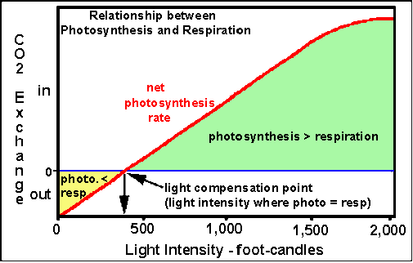

Stage 1- light dependent reactions
- Can be broken down into 3 steps
  - Photoexcitation
  - Non-cyclic/cyclic electron flow
  - Chemiosmosis
- Photoexcitation
  - Electrons going from a ground state to an excited state using a photon of light
  - Occurs in the photosystems
  - Photosystems composed of:
    - Antenna complex
      - Accessory pigments
        - Absorbing wave lengths of light and passing on the energy
        - Accessory pigments are any pigments other then chlorophyll A
      - Proteins
      - Surrounds reaction center
    - Reaction center
      - Contains:
      - Chlorophyll A
      - Primary electron accepter pheophytin
        - Removes an excited electron from chlorophyll A which starts the light reactions
      - Proteins associated with reaction center are different in the 2 photosystems
  - 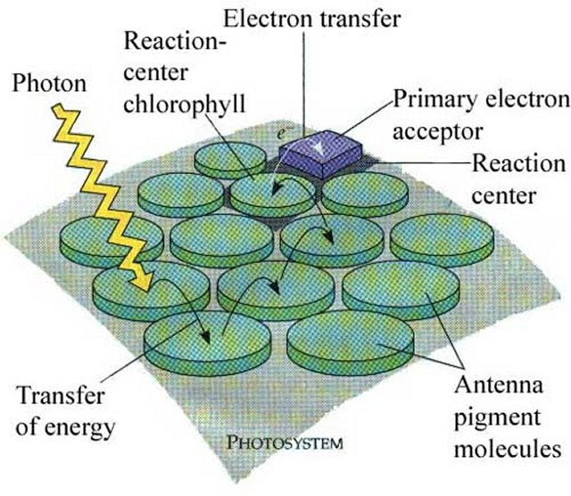birds eye view
  - 2 photosystems
    - photosystem I p700
    - photosystem II p680
  - theres a ton of photosystems in the membrane
- non-cyclic electron flow
  - where electrons go through from component 1 to component 5 and ends at PS1, meanwhile H+ are being pumped into the lumin from the stroma
  - components of the ETC
    - 1. Photosystem II (p680)
    - 2. Plastoquinone (PQ)
    - 3. cytochrome complex
    - 4. plastocyanin (PC)
    - 5. Photosystem I (p700)
    - 6. Feredoxin (FD)
    - 7. NADP+ reductase
    - 2,4,6 small shuttles, 1,3,5,7 transmembrane proteins
  - 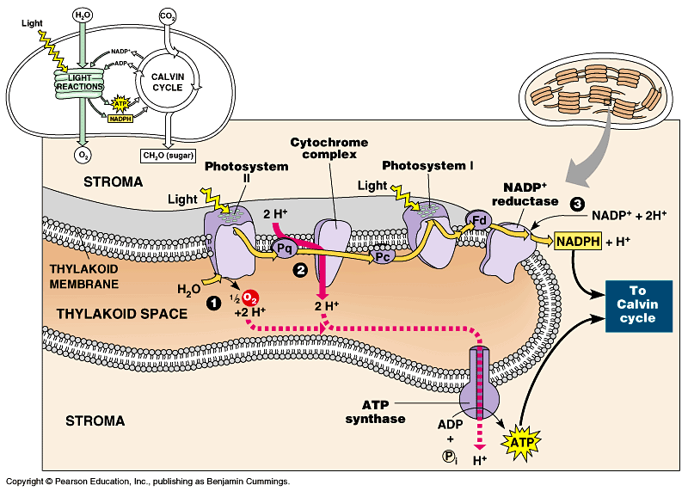
  - steps:
    - 1. Electron flow part 1
    - 2. Second photoexcitation
      - more light absorbed by PS1
    - 3. Electron flow part 2
      - movement of electrons through feradoxin to NAD+ reductase
    - 4. Reduction of NADP+
      - NAD+ + H+ + 2e- NADPH
    - 5. Photolysis
      - splitting of H2O
      - 2 proteins split it
      - H2O ½O + 2H+ + 2e-
      - O2 goes to cellular respiration, H+ goes into the gradient
  - Z-scheme: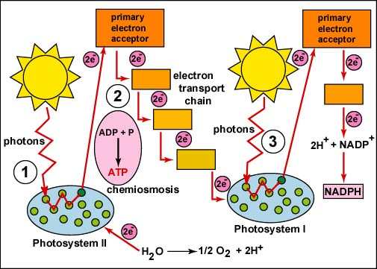
- Cyclic electron flow
  - Alternative pathway
  - Steps:
    - 1. Photoexcitation (only PS1)
    - 2. Electron flow
  - 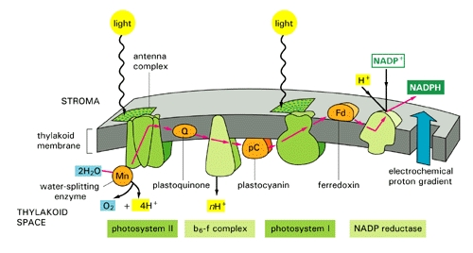
    - e- never leave the ETC therefore:
      - no NADPH being made
      - no water being split
      - of electrons are never leaving ETC, then theres no need for water to replace electrons, but we’re still pumping H+ ions into the lumin so we can still make ATP
    - 2 benefits
      - next stage= sugar making process
      - goal of photosynthesis is to make sugar (not energy)
      - we’re only making energy so we can make sugar in the next stage, and the next stage needs more ATP then NADPH, so we make extra during the cyclic process
      - benefit 1 we make extra ATP
benefit 2 we can use the excess ATP for other cellular functions
- Chemiosmosis
  - Electrical gradient created by
    - 1. Active transport of H+ ions into lumin
    - 2. Photolysis splitting of water (happens in lumin)
    - 3. Reduction of NADP+
      - using up H ions from stroma therefore making gradient greater
    - electrical gradient created
    - 1+2 increasing H ion concentration in lumin
    - 3 decreasing H ion concentration in the stroma
  - proton motive force
    - provides energy for ATP synthase
  - ATP synthase photophosphorylaion
    - linking a phosphate group to ATP so that it forms ATP
    - Making ATP using light
  - Protons are pumped into the umin providing a high concentration so they want to leave the lumin, they find their way out and then concentration is uneaven again so they come back in
  - Summary:
    - 1 photon excites 1 electron
    - 2 photons get 1 electron though the ETC
    - each electron pumps 2 H ions
    - 2 electrons=
4 H ions= 1 ATP
4 photons=
    - splitting of water provides 2 electrons and 2 H ions
  - application: how many photons of light need to be absorbed to produce a single molecule of O2
    - H2O ½O + 2H+ + 2e-
    - So we double it: 2H2O O2 + 4H+ + 4e-
    - 2 photons per electron 2 x 4= 8 photons
  - how did we figure this out?
    - Isolated a chloroplast
    - Protons entered chloroplast through stroma and lumin
    - Then the concentration is too high so they leave but then they leave, ATP was produced
    - So this proves that it’s the motive force of these protons that makes ATP

stage 2- light independent reactions
- the calvin cycle
  - the energy created in the light dependant reactions is used to generate the calvin cycle
  - occurs in the stroma
  - Melvin Calvin and Andy Benson discovered the pathway for glucose biosynthesis
    - They put radio active CO2 into biological molecules
    - Followed how the processes carried out
  - can be separated into 3 stages
    - 1. Carbon fixation
    - 2. Reduction reactions
    - 3. RUBP regeneration
- 1. Carbon fixation
  - carbon dioxide combines with ribulose 1, 5-bisphosphate (RuBP)
    - RuBisCO (RuBP caboxilase) an enzyme that catalyzes the first step; can act as an oxigenase and a carboxylase
    - 30% of protein in leaf
    - most abundant protein on earth
  - Unstable 6 carbon molecule breaks down into 3-phosphoglycerate (PGA)
    - 2 molecules of PGA, then ATP is reduced into 1,3 bisphosphoglycerate, then NADPH is reduced to NADP+
  - this type of carbon fixation is done by C3 plants
    - called C3 because their first intermediate produced is a 3c molecule
- 2. Reduction reactions
  - 1 ATP and 1 NADPH are used per PGA molecule
  - the reduction of PGA forms a glyceraldehyde 3-phosphate (G3P) sugar
  - at the end of phase 2, a G3P molecule leaves the Calvin Cycle ans the remainder continue to phase 3
    - the fixation of 3CO2 molecules produces 1 G3P molecule
  - almost like we are doing the reverse of glycolysis!!
- 3. RuBP regeneration
  - G3P molecules rearranged to form RuBP molecules
    - breaking bonds + reforming them but in this process, ATP is used
    - # of ATP used = # of RuBP you are regenerating and NOT the # of G3P
  - in order to regenerate RuBP, 1 ATP is required oer RuBP regenerated
- summary:
  - 3 CO2 + 3 RuBP 6 PGA
  - 6 PGA + 6 ATP + 6 NADPH 6 G3P
  - 5 G3P + 3 ATP 3 RuBP (which is what we started with!)
  - basically 6 CO2 can generate 1 6-c sugar (glucose)
  - G3P transported to cytosol from the stroma
  - with this we can make
    - glucose- to use now
    - sucrose- to be transported (most is turned into this)
    - cellulose- as a structural component (cell wall)
    - starch- for storage for later
  - example problem: how many ATP and NADPH do we need to synthesize one molecule of glucose
    - glucose= 6 carbon molecule so we multiply everything by 2
    - 12 + 6 ATP, 12 NADPH
- 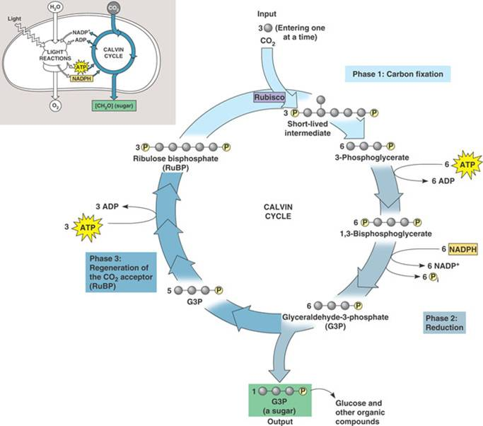
- summary for imput of 3 CO2
  - 9 ATP consumes, 9 ADP produced
  - 6 NADPH oxidized, 6 NADP+ produced
  - ½ glucose (C3) produce, 3CO2 consumed
  - so 2 turns of calvin cycle produces one glucose
  - endergonic reaction
- photosynthesis= anabolic endergonic reaction

alternative mechanisms to carbon fixation
- in leaves (C3 plants)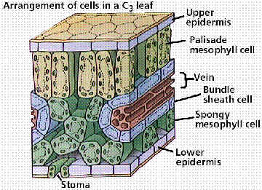
- Mesophyll cells
  - Primary location for photosynthesis
- Epidermal Cells
  - Usually 1 cell layer thick
  - Colorless (allows light to transfer through)
- Cuticle
  - Wax coating you find on plants to prevent water loss
- Guard cells
  - Specialized epidermal cells that control gas exchange
  - Only epidermal cell that has chloroplast but doesn’t photosynthesize
- Stomata
  - Openings created by guard cells
  - Pores in the leaf, mostly the undersurface
  - Each pore is surrounded by a pair of guard cells
  - Guard cells can change shape to open/close stomata
  - 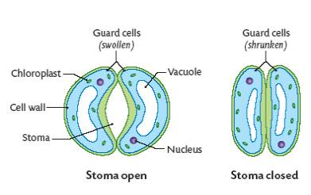
- problems
  - 1. Water loss
    - when the stomata opens for gas exchange it loses water so it stays closed during the day because it needs water for photosynthesis
  - 2. Competition with water
    - during the day the plant absorbs sun so photosynthesis still happens so its still intaking O2 which leads to a build up of O2 so O2 and CO2 need to compete for RuBisCO
    - the whole point is carbon fixation right? So since RuBisCO can be both an oxydase and a Carboxylase, that means it can fix O2 as well, so they compete with eachother but this is a bad thing because if there’s more O2 then CO2, we don’t fix carbon!
    - Instead we produce another molecule that uses up CO2 AND RuBisCO so it’s a huge waste
    - this is called photorespiration
    - under conditions where the concentration of O2 is less then CO2, CO2 wins and photo respiration doesn’t happen
    - RuBP + O2 1 PGA + 1 phosphoglycollate to peroxisomes + metabolized CO2
    - 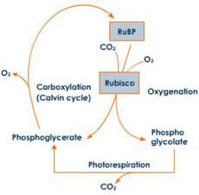
    - detrimental for plants ability to make food
    - these are only problematic in hot conditions or where water is hard to come by
- C4 plants
  - Carbon fixation taking out CO2
    - Mesophyll cells
      - Carbon fixation happens here but not by RuBisCO because we cant use its since its busy taking up O2 so CO2 will join with phosphoenylpyruvate (PEP) instead using the enzyme PEP carboxylase
    - Oxaloacetate
      - 4C molecule
    - Malate
      - Oxaloacetate is converted into this
      - Found in calvin cycle before oxaloacetate is ceated
      - Uses an NADPH
      - Still 4C molecule
    - After these steps we now have malate in the mesophyll cells
  - Decarboxylation
    - Malate moves out of mesophyll cells and into the bundle sheath cells
      - Cells that line leaf
      - They pull CO2 out and make it available for RuBisCO
    - Converted into pyruvate releasing CO2 (its DECARBOXYLATED)
  - PEP regeneration
    - Pyruvate converted back into PEP in the mesophyll cells to fix more CO2
  - 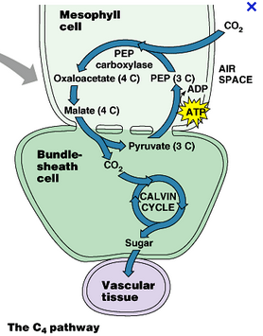
  - there is an energy cost but it is still more efficient and less wasteful then photorespiration
  - so in the summer when its dry and hot crab plants grow, those crab plants are C4 plants!
  - So why do thye nt take over?
    - They cost energy!
- cam plants
  - same pathway at C4
  - only occurs in mesophyll cells
  - carbon fixation occurs at night
  - decarboxylation and PEP regeneration occur during the day
  - difference:
    - cam plants only open their stomata at night and undergo the same pathway s C4 plants
    - they fix CO2 into malate at night and store it b/c at night theres no light therefore theres not enough energy for the calvin cycle
    - as the sun comes up the cell starts to photosynthesize again
    - does this because cam plants live in dry climates so they don’t want to risk opening their stomata during the hottest time to prevent losing water so they only open them during the cooler night
    - this prevents the water loss issue
    - they fix the carbon but they don’t have light reactions which means there’s no build up of O2 but photo synthesis is still taking place which means the build up of CO2 that will be released in the morning
  - 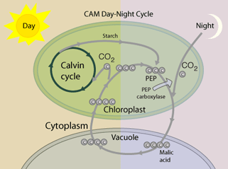
  - compare: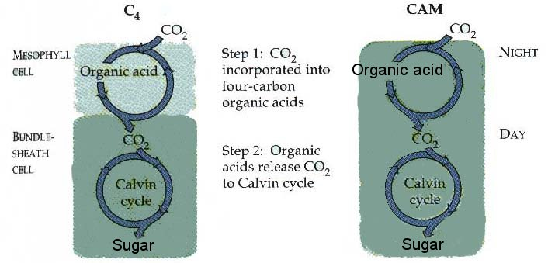

comparison
- Organelles
  - Chloroplast vs mitochondria
    - Chloroplast no folded membrane but stacks of thylakoids that increase surface area and therefore increase energy production
    - Mitochondria inner membrane folded
  - Both have double membrane
- ATP production
  - ETC
  - Electro chemical gradient
  - ATP synthase
    - Photosynthesis ATP made in stroma
    - Cell resp ATP made in matrix
- Electron carriers
  - Cell resp NAD+, FAD
  - Photosynthesis NADP+
- Carbon cycles
Fixing vs. releasing

