Lab BCM2333
Section: 10 (Wednesday morning 2nd week)
LAB 4: Lipids and Membranes
TA: Vian Peshdary

Purpose
During this experiment two membrane fractions were formulated from a rat liver tissue sample. This sample provided two different fractions, a microsomal enriched fraction along with a mitochondrial enriched fraction. The lipids from the microsomal fraction were separated and analyzed via TLC plates. The microsomal fraction was compared against the whole lipid sample extracted from the tissue. Following this experiment the lipid and protein ratio in the mitochondrial fraction was analyzed.

R1
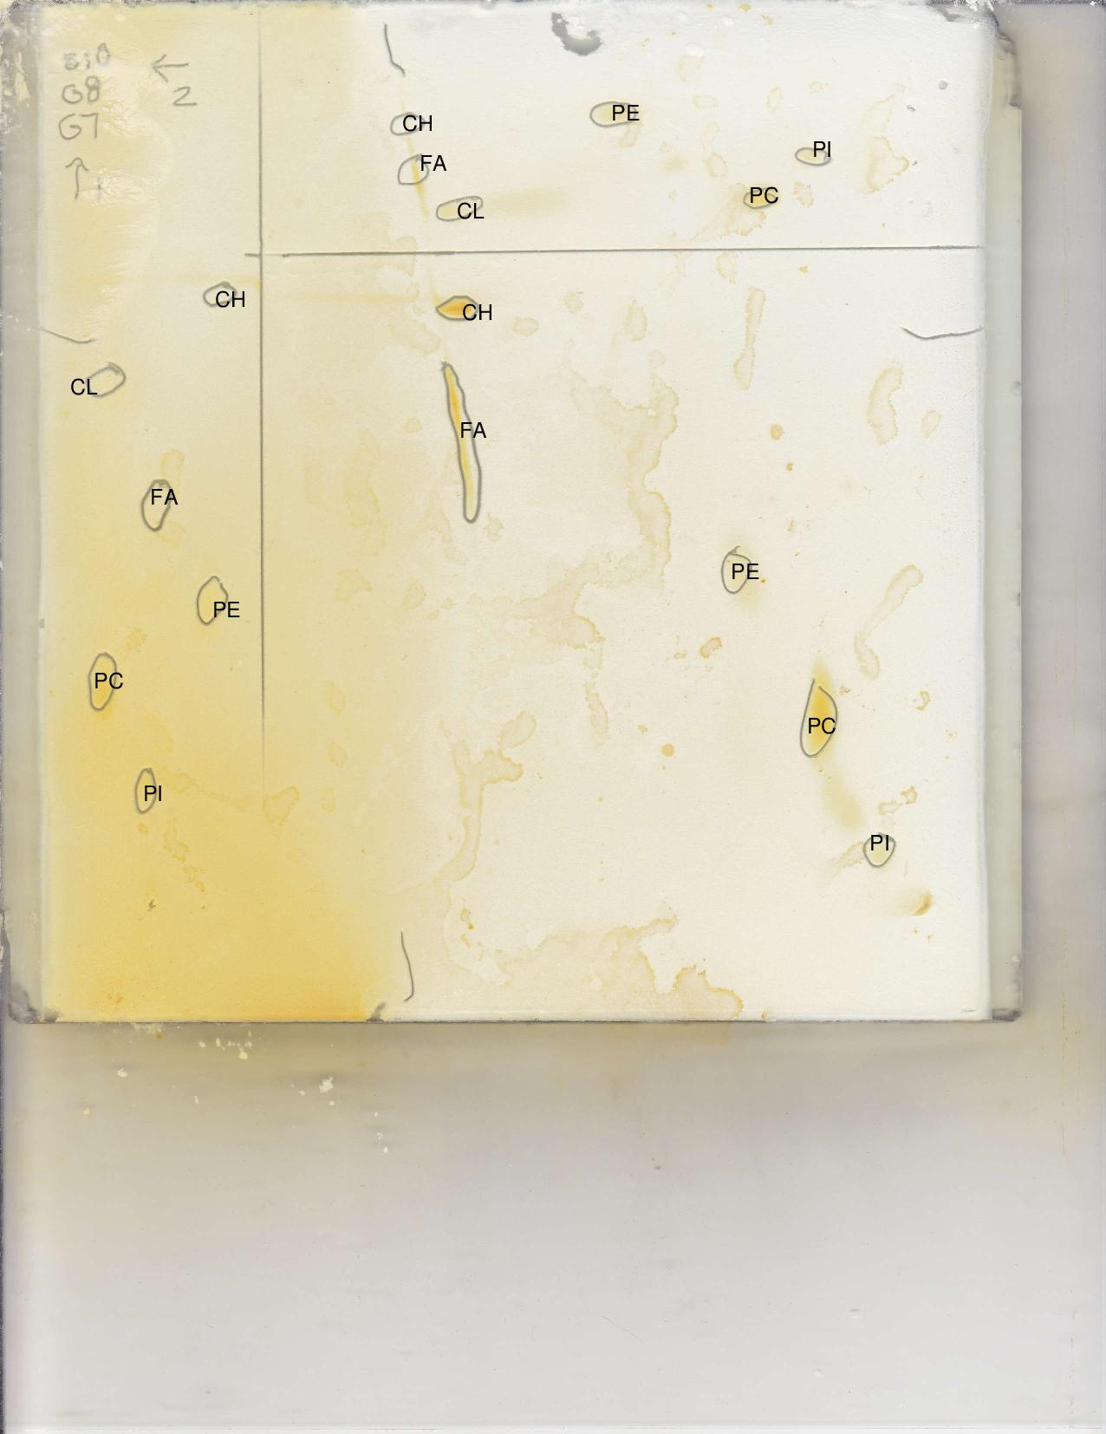
Figure 1. 2D TLC of lipid standards. This figure shows the 2D analysis of three different lipid standards. Standard one was composed of cardiolipin and phosphatidylcholine. Standard two was composed of fatty acid and phosphatidylinositol. The third standard was composed of cholesterol and phosphatidylinositol. 5 microliters of each standard was pipetted onto both the acid and the base sections, were as 10 microliters of the sample solution was positioned in the bottom right hand corner. Were The first dimension contained a basic solvent (CHCL₃-MeOH-ammonia, 65:35:5V/V), whereas the second dimension contained an acidic solvent ( CHCL₃-acetone-MeOH-acetic acid-H₂O, 10:4:2:2:1; V/V). The first dimension is represented on the left of the TLC plate; the second dimension is represented at the top of the TLC plate. Short forms were used to represent the components of the lipid standards. CL stands for cardiolipin, PC stands for phosphatidylcholine, FA stands for fatty acid, PI stands for phosphatidylinositol, CH stands for cholesterol, PE stands for phosphatidylethanolamine. The standards increase from one to three going left to right for both the first and the second dimension.
Table 1. First and Second dimension Rf Values for Lipid Standards. This table shows the different Rf values for the first and second dimension. The first dimension represents a basic solvent, whereas the second dimension represents the acidic solvent. 5 microliters of each standard was pipetted onto both the acid and the base sections as shown in figure 1. Standard one was composed of cardiolipin and phosphatidylcholine. Standard two was composed of fatty acid and phosphatidylinositol. The third standard was composed of cholesterol and phosphatidylinositol.
First Dimension |  | Second Dimension
Lipid | Rf | Lipid | Rf
Cardiolipin (CL) | 0.871 | Cardiolipin (CL) | 0.677
Phosphatidylcholine (PC) | 0.548 | Phosphatidylcholine (PC) | 0.194
Fatty Acid (FA) | 0.658 | Fatty Acid (FA) | 0.761
Phosphatidylinositol (PI) | 0.226 | Phosphatidylinositol (PI) | 0.116
Cholesterol (CH) | 1.00 | Cholesterol (CH) | 0.774
Phosphatidylethanolamine (PE) | 0.516 | Phosphatidylethanolamine (PE) | 0.432

Rf=Distance spot moved/Distance solvent moved
Rf for 1D CL=Distance moved by lipid spot/distance moved by solvent=13.5/15.5cm=0.871
Therefor the Rf value for cardiolipin used in the basic solvent was 0.871.
Rf for 2D CL=Distance moved by lipid spot/distance moved by solvent=10.5cm/15.5cm=0.677
Therefor the Rf value for cardiolipin used in the acidic solvent was 0.677.
Rf for 1D PC =Distance moved by lipid spot/distance moved by solvent= 8.5cm/15.5cm= 0.548
Therefor the Rf value for phosphatidylcholine used in the basic solvent was 0.548.
Rf for 2D PC =Distance moved by lipid spot/distance moved by solvent= 3cm/15.5cm=0.194
Therefor the Rf value for phosphatidylcholine used in the acidic solvent was 0.194.
Rf for 1D FA =Distance moved by lipid spot/distance moved by solvent=10.2cm/15.5cm=0.658
Therefor the Rf value for the fatty acid used in the basic solvent was 0.658.
Rf for 2D FA =Distance moved by lipid spot/distance moved by solvent=11.8cm/15.5cm=0.761
Therefor the Rf value for the fatty acid used in the acidic solvent was 0.761.
Rf for 1D PI =Distance moved by lipid spot/distance moved by solvent=3.5cm/15.5cm=0.226
Therefor the Rf value for phosphatidylinositol used in the basic solvent was 0.226.
Rf for 2D PI =Distance moved by lipid spot/distance moved by solvent=1.8cm/15.5cm=0.116
Rf for 1D CH =Distance moved by lipid spot/distance moved by solvent=15.5cm/15.5cm= 1.00
Therefor the Rf value for cholesterol used in the basic solvent was 1.00.
Rf for 2D CH=Distance moved by lipid spot/distance moved by solvent=12cm/15.5cm=0.774
Therefor the Rf value for cholesterol used in the acidic solvent was 0.774.
Rf for 1D PE=Distance moved by lipid spot/distance moved by solvent=8cm/15.5cm=0.516
Therefor the Rf value for Phosphatidylethanolamine l used in the basic solvent was 0.516.
Rf for 2D PE=Distance moved by lipid spot/distance moved by solvent=6.7cm/15.5cm=0.432
Therefor the Rf value for Phosphatidylethanolamine l used in the acidic solvent was 0.432.
As shown in Table 1, the Rf values for the lipids in the first and second dimension are different. The first dimension shows a trend of having higher Rf values for all the lipids with the exception of the fatty acid. The reason why the lipid standards have a lower Rf value in the second dimension is because a acidic solvent is used. The acidic solvent will protonate compounds making them more polar thus causing a lower Rf value because the molecules are more attracted to the silicon on the TLC plate. The basic solvent will deprotonate the compounds making them less polar, thus causing them to have a higher Rf Value because they are more stable and are less attracted to the silicon on the TLC plate. The fatty acid is the exception because it only contains a carboxyl group at the end of the molecule. When this is protonated it becomes more stable making the molecule less polar. This means that when the fatty acid is in presence of the acid solvent it will travel further up the TLC plate, because it is less polar in an acid solution.
R2
Cardiolipin

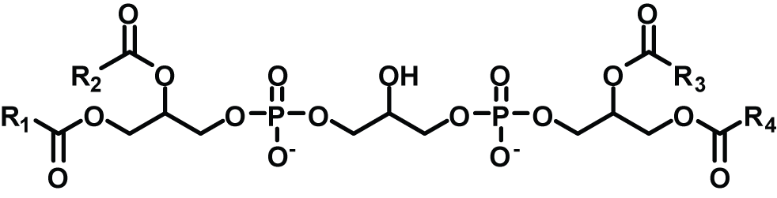
Figure 2. Structure of Cardiolipin. This image represents the structure of cardiolipin. As seen in this image this molecule is very symmetric. The phosphate ions are very dense and present polar molecules along with several carboxylic acid molecules this molecule would be polar if not for its symmetry. The symmetry of this molecule renders it a non-polar molecule. This image was obtained from ChemSpider(2014)

Cholesterol
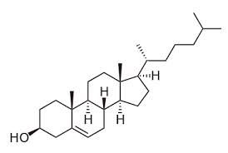
Figure 3. Structure of Cholesterol. This image represents the structure of cholesterol. Cholesterol only has one polar group, and that is the alcohol at the end of the benzene ring. The steroid group followed by the hydrocarbon chain is relatively non-polar. This image was obtained from ChemSpide (2014).
Fatty acid
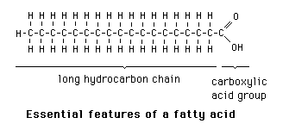
Figure 4. Structure of Fatty Acid. This image represents the structure of a fatty acid. As show in the image the fatty acid molecule has a polar tail composed of a carboxylic acid molecule. The hydrocarbon chain remains relatively non-polar. This image was obtained from Baggott (1998).
Phosphatidylcholine
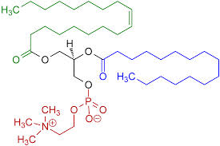
Figure 5. Structure of Phosphatidylcholine. This image represents the structure of phosphatidylcholine. This molecule contains a polar region composed of a glycerol, carbonyl oxygen atoms, phosphate groups and the polar head group containing a nitrogen rich zone. The non-polar region of this molecule is composed of the hydrocarbon tails of fatty acids. This image was obtained from Diwan (2007).
Phosphatidylethanolamine
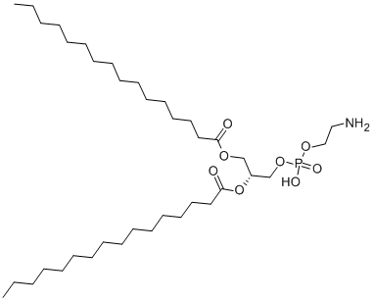
Figure 6. Structure of Phosphatidylethanolamine. This image represents the structure of phosphatidylethanolamine. This molecule has a polar amine group at the head of the molecule along with a polar phosphate group. The hydrocarbon chains of this molecule remain nonpolar. This image was taken from ChemBook (2010).
Phosphatidylinositol
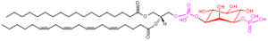
Figure 7. Structure of Phosphatidylinositol. This image represents the structure of phosphatidylinositol. This molecule contains a polar inositol head group attached to a polar phosphate group. The glycerol backbone and the two non-polar fatty acid chains contribute little to the polarity of the molecule because they are relatively neutral. This image was obtained from Lipidomics Gateway (2011)
The ranking of the standard lipids in increasing polarity for the 1st dimension is as follows: Cholesterol is the least polar, followed by cardiolipin, then the fatty acid, then the phosphatidylethanolamine, then the phosphatidylcholine, and the most polar molecule is phosphatidylinositol. This is shown in Figure 1, where the more polar molecules stay closer the bottom of the TLC plate because they are attracted to the silicon whereas the non-polar molecules continue to rise with the solvent.
The ranking of the standard lipids in increasing polarity for the 2nd dimension is as follows: Cholesterol is the least polar, followed by the fatty acid, then the cardiolipin, then the phosphatidylethanolamine, then the phosphatidylcholine, and the most polar molecule is phosphatidylinositol. This is shown in Figure 1, where the more polar molecules stay closer the bottom of the TLC plate because they are attracted to the silicon whereas the non-polar molecules continue to rise with the solvent.
For the first lipid standard of the 1st dimension TLC the cardiolipin is less polar then the phosphatidylcholine molecule. This is because the phosphatidylcholine molecule contains a polar positively charged choline molecule along with a polar phosphate molecule at the head. The cardiolipin molecule is very symmetric so it has little polarity across the molecule. For the second lipid standard of the 1st dimension TLC the fatty acid molecule is less polar then the phosphatidylinositol molecule. This is because the fatty acid molecule contains a polar head carboxylic acid group at its head, but a long chain of non-polar hydrocarbons. The phosphatidylinositol molecule contains a extremely polar inositol molecule along with a polar phosphate molecule at its head. The inositol group is more polar then the carboxylic acid molecule on the fatty acid. For the third lipid standard of the 1st dimension TCL the Phosphatidylethanolamine is more polar then the cholesterol molecule because the phosphatidylethanolamine molecule contains a polar amine along with a polar phosphate group whereas the cholesterol only has a weakly polar hydroxyl molecule at its head. The 2nd dimension TLC standards show the same trends where the phosphatidyl molecules are all more polar then there respected pair. This is because these molecules contain more polar head groups composed of phosphates attached to another very polar molecule. The other molecules are somewhat symmetric which reduces there polarity, thus in each standard the phosphatidyl molecules are more polar for the 2nd dimension TLC.
R3
Figure 8. Total lipid TLC. This TLC represents the one and two dimensional analysis with a sample containing all the lipids tested during this laboratory.
Yes there are significant differences between figure 8 and figure 1. The microsomal lipid shown in figure 1 does not contain cardiolipin, whereas figure 8 shows the presence of cardiolipin. Cardiolipin is a component of the inner mitochondrial membrane thus would not show up on the TLC analysis of microsomal lipids.
R4
A=εCL A=Absorbance (nm), ε=the extinction coefficient in cm⁻¹M⁻¹, C=concentration in M, L=Length in cm.
First the Concentration of the Brilliant Blue R dye needs to be solved.
V₁C₁=V₂C₂ V₁C₁ represent the initial volume and concentration of Brilliant blue
V₂C₂ represents the final volume and concentration of Brilliant Blue
C₁=density/MW=(1.5g/L)/825.97g/mol=0.001816M
V₁C₁=V₂C₂=0.050ml*0.001816M=2ml*C₂=0.0000454M
Thus the final concentration of Brilliant Blue R is 0.0000454M
A=εCL εL=A/C=0.0000559cm/(0.0000454M)=1.23Lcm⁻¹M⁻¹
Thus the absorptivity of Brilliant Blue R dye at PH 11 is 1.23Lcm⁻¹M⁻¹
R5
Table 2. Lipid Assays. This table shows the absorbance along with the dilution factor of the lipid assay trials. 5 assay tubes were created containing increasing amounts of the mitochondrial membrane suspension in 2ml of 0.1M phosphate buffer, pH 11. The five assays in order of increasing dilutions were the blank, 1/250 dilution, 1/125 dilution, 1/40 dilution, and 1/25 dilution. The mitochondrial membrane was created by mincing 2g of rat liver followed by adding it to a homogenization buffer composed of 10mM tris, 0.25M sucrose, 1mM EDTA, 1mM DTT, PH7.5. this solution was then centrifuged at 1000xg for 10min. The supernatant was separated and centrifuged at 25 000xg for 10min. The pellet from this was then resuspended and diluted into individual flasks followed by the addition of 50microliters brilliant blue R.
Sample | Dilution fraction | Phosphate PH11, 0.2M (ml) | Water (ml) | Membrane suspension (µL) | Brilliant blue R 1.5g/L (µL) | A559
1) control | 0 | 1 | 0.95 | 0 | 50 | 0.963
2) 1/250 | 0.004 | 1 | 0.942 | 8 | 50 | 0.796
3)1/125 | 0.008 | 1 | 0.936 | 16 | 50 | 0.716
4)1/40 | 0.025 | 1 | 0.9 | 50 | 50 | 0.439
5)1/25 | 0.04 | 1 | 0.87 | 80 | 50 | 0.361

Figure 9. Absorbance Vs. Dilution Factor for the Lipid Assay. This graph shows the negative linear relationship between the absorbance of the lipid assay at 559nm and dilution factor for the lipid assays. This means that as the dilution factor increases the absorbance decreases. The linear region of the graph is found within the second, third, and fourth sample.
Table 3. Protein Assays. This table shows the absorbance along with the dilution factor of the protein assay trials. Four assay tubes were created containing 1/20, 1/50, and 1/200 dilutions of the mitochondrial membrane suspension, and a blank in 2ml of 0.1 M phosphate buffer, pH 11. These were mixed well and the absorbance was read at 280nm in order of increasing concentrations. The solution was the same solution used for table 2, so the procedure for producing it is the same.
Sample | Dilution fraction | Phosphate pH 11, 0.2M(ml) | Water(ml) | Membrane suspension (ml) | A280
1)blank | 0 | 1 | 1 | 0 | 0
2)1/200 | 0.005 | 1 | 0.99 | 0.01 | 0.033
3)1/50 | 0.02 | 1 | 0.96 | 0.4 | 0.103
4)1/20 | 0.05 | 1 | 0.9 | 0.1 | 0.253

Figure 10. Absorbance Vs. Dilution Factor for the Protein Assay. This graph sows the positive linear relationship between the absorbance of the protein assay at 280nm and dilution factor for the protein assays. This means that as the dilution factor increases the absorbance of the molecule increases. no samples were excluded from this graph.
R6
A=εCL A=Absorbance (nm), ε=the extinction coefficient in cm⁻¹M⁻¹, C=concentration in M, L=Length in cm.
C=A/εL A=y=4.9918(1)+0.0037=4.9955 ε=2.oL/gcm
C=4.9955/2.0L/gcm*1cm=2.4959g/L
Therefor the concentration of protein in the membrane preparation was 2.4959g/L.
R7
Linear regression was used to find the absorbance
Y=-16.79x+0.8574=-16.79(1)+0.8574=-15.9326
Subtract from control
0.963-(-15.9326)=16.8956
Since absorbance decreases 0.011 per 1µg/ml increase in lipid concentration
(Absorbance of solution of unknown concentration)/(Unknown concentration)=(Absorbance of solution of 1µg/ml)/(concentration of 1µg/ml)
16.8956*1µg/ml=0.011*unknownconcentration=1535.9639µg/ml*1000ml/L*1g/1000000µg =1.5359639g/L
Therefore the concentration of the lipids in the mitochondrial enriched fraction is 1.526g/L
R8
Multiply each ratio by the volume found in supernatant 1, which had a value of 9.75ml=0.00975L
Ratio = lipids/protein= (1.526g/L*0.00975L)/(2.4959g/L*0.00975L)=0.6114g/g
Therefor the mass ratio of lipids/protein was 0.6114g/g
R9
Milligrams mitochondrial proteins/grams of liver tissue 2g of liver tissue was used
Since supernatant 1 produced 9.75ml=0.00975L the amount of protein= 2.4959g/L*0.00975L=0.0243g
Thus 24.3mg mitochondrial proteins/2g liver tissue=12.15mg/g
Therefor the yield for the mitochondria preparation was 12.15mg/g of liver tissue.
Concluding Statement
The results of this lab provided precise and accurate data that correlates with literature values. The TLC plate that was analyzed in this laboratory showed that the Rf values for each individual lipid was greater using the base solvent then the acidic solvent with the exception of the Fatty Acid molecule. Furthermore, the TLC showed that cardiolipin was not present in the sample that was analyzed. The analysis of lipid and protein ratios provided interesting results. As the dilution factor of lipid increased the absorbance of the lipid solution decreased, this is shown in figure 9. However as the dilution factor of protein increased the absorbance also increased, as shown in figure 10. In conclusion the results that were obtained in this lab represent accurate and precise data and a reproducible. This lab was preformed adequately.

Works Cited
Baggott, J. (1998). General Features of Fatty Acid Structure. Retrieved March 15, 2014, from Fatty Acid Synthesis and Modification: http://library.med.utah.edu/NetBiochem/FattyAcids/3_1.html
ChemBook. (2010). Phosphoethanolamine. Retrieved March 15, 2014, from Chemical Product Property: http://www.chemicalbook.com/ChemicalProductProperty_EN_CB7742028.htm
ChemSpider. (2014). Cardiolipin. Retrieved March 16, 2014, from ChemSpider: http://www.chemspider.com/Chemical-Structure.395642.html
ChemSpider. (2014). Cholesterol. Retrieved March 12, 2014, from ChemSPider: http://www.chemspider.com/Chemical-Structure.5775.html?rid=2394b70c-e21b-452c-a8f2-81a582fd5276
Diwan, J. (2007). Lipids and Membrane Structure. Retrieved March 15, 2014, from Molecular Biochemistry: https://www.rpi.edu/dept/bcbp/molbiochem/MBWeb/mb1/part2/lipid.htm
Lipidomics Gateway. (2011, March 23). Phophatidylinositol. Retrieved March 15, 2014, from Lipidomics Gateway: http://www.lipidmaps.org/update/2011/110401/full/lipidmaps.2011.8.html

