LAB 5: Nucleic Acids

Purpose
In this laboratory four experiments will be performed. In experiment one the DNA of E.Coli will be extracted. For experiment two, a stock solution of E. coli DNA from a commercial source will be analyzed with melting curves. Melting curves involve the analysis of the transformation of DNA from double stranded DNA to single stranded DNA with the addition of heat. The type of DNA is identified through absorbance. The melting curves will show the effects of salt and DMF on the stability of the commercial E. Coli DNA. The same melting technique will compare the homogeneity and the integrity of an in-lab prepared DNA with a Commercial source of E. Coli DNA. The unknown plasma used in this laboratory was unknown plasma 42. Experiments three and four introduce the techniques of restriction digestion and DNA electrophoresis on agarose.
R1
Ultraviolet spectrophotometry is used to quantitate the amount of DNA and its purity. Proteins absorb UV light with a maximum absorbance at 280nm due to the presence of the aromatic amino acids tryptophan (Trp) and tyrosine (Tyr). UV light with a maximum absorbance at 260nm is due to characteristics of the bases (purines and pyrimidines) along with nucleic acids (both DNA and RNA). An A₂₆₀/A₂₈₀ ratio shows the relative amount of the different nucleotides in a specific DNA sample. An A₂₆₀/A₂₈₀ ratio between 1.8 and 1.9 shows a pure double stranded DNA sample higher ratios are due to RNA contamination. Lower ratios of the A₂₆₀/A₂₈₀ function are caused by contamination by proteins. An indicator of protein contamination is shown by the ration A₂₃₄/A₂₆₀. Nucleic acids have an absorbance minimum at 234 nm; protein causes an increase of the absorbance at this wavelength. A A₂₃₄/A₂₆₀ ratio higher than 0.50 shows protein contamination.
A₂₆₀/A₂₈₀ Ratio Calculation
A₂₆₀=0.542
A₂₈₀=0.312
A₂₆₀/A₂₈₀=0.542/0.312=1.7372
Therefor the A₂₆₀/A₂₈₀ ratio was 1.7372. Since a ratio between 1.8 and 1.9 shows pure double stranded DNA there was contamination of the sample from proteins. This could have occurred when the upper aqueous phase was removed after centrifuging the sample. If part of the lower phase was transferred to the 15ml falcon tube the A₂₆₀/A₂₈₀ ratio would be less than 1.8-1.9 optimal range due to protein contamination
A₂₃₄/A₂₆₀ Ratio Calculation
A₂₆₀=0.542
A₂₃₄=0.234
A₂₃₄/A₂₆₀=0.234/0.542=0.432
Therefor the A₂₃₄/A₂₆₀ ratio was 0.432. Since the ratio is less than 0.5 the protein contamination isn’t as detrimental as previously found with the A₂₆₀/A₂₈₀. The A₂₃₄/A₂₆₀ is a better indicator of protein contamination because nucleic acids have a absorbance minimum at 234nm, protein causes an increase of the absorbance at this wavelength. With a A₂₃₄/A₂₆₀ value of 0.432 there is some protein contamination, but it is not detrimental to the sample because the value is not greater than 0.5.
R2

Figure 1. Commercial E. coli DNA with no additives. The following graph represents the absorbance and the derivative of the commercial DNA sample. The point at which the absorbance graph begins to change is the point in which the DNA starts to denature and change from double stranded DNA to single stranded DNA. The graph shows that as the temperature increases the DNA begins to denature even further. The peak of the derivative points shows the point at which 50% of the DNA is single stranded and the other 50% is double stranded. This data came from team 1, and the DNA was submerged in 15mM citrate buffer, pH7.

Figure 2. Commercial E.Coli with NaCl Additive. The following graph represents the absorbance and the derivative of the commercial DNA sample. The point at which the absorbance graph begins to change is the point in which the DNA starts to denature and change from double stranded DNA to single stranded DNA. The graph shows that as the temperature increases the DNA begins to denature even further. The peak of the derivative points shows the point at which 50% of the DNA is single stranded and the other 50% is double stranded. The peak of the derivative graph appears at a later point or a higher temperature then in figure 1. This suggests that the DNA doesn’t denature until a higher temperature. The data from this graph came from team 4 and the DNA was submerged in a 15 mM citrate, along with a 0.1M NaCl solution.

Figure 3. Commercial E.Coli DNA with DMF. The following graph represents the absorbance and the derivative of the commercial DNA sample. The point at which the absorbance graph begins to change is the point in which the DNA starts to denature and change from double stranded DNA to single stranded DNA. The graph shows that as the temperature increases the DNA begins to denature even further. The peak of the derivative points shows the point at which 50% of the DNA is single stranded and the other 50% is double stranded. The peak of the derivative graph appears at a earlier point or a lower temperature then in figure 1. This suggests that the DNA doesn’t denature until a lower temperature. The data from this graph came from team 7 and the DNA was submerged in a 15 mM citrate, along with at pH 7, 25% DMF.

Figure 4. Extracted DNA composition. The following graph represents the absorbance and the derivative of the commercial DNA sample. The point at which the absorbance graph begins to change is the point in which the DNA starts to denature and change from double stranded DNA to single stranded DNA. The graph shows that as the temperature increases the DNA begins to denature even further. The peak of the derivative points shows the point at which 50% of the DNA is single stranded and the other 50% is double stranded.
Table 1. DNA Melting results for the Commercial DNA and the Extracted DNA. The following chart displays trends of temperature relating to DNA denaturing and the purity of the DNA samples. T_{m} represents the characteristic melting temperature of the DNA strands. ΔT represents the small temperature range or the total increase in absorption through the decrease in quantity of double stranded DNA. The H% value represents the hyperchromicity of the DNA solutions which is a value that represents purity. The h/ ΔT is a more specific method for determining DNA purity.
DNA Sample | T_{m} (°C) | ΔT(°C) | h(%) | h/ ΔT(1/°C)
a)Commercial | 78.02 | 11.97 | 30.09 | 2.514
b)Commercial+0.1M NaCl | 89.72 | 14 | 24.79 | 1.771
c)Commercial + 25% DMF | 62.02 | 36 | 65.72 | 1.826
d)Extracted DNA | 83.97 | 12 | 9.36 | 0.78

T_{m} represents the characteristic melting temperature of the DNA strands. The T_{m} is defined as the temperature in which 50% of all molecules of a given DNA sequence are in double stranded DNA whereas the other 50% are present as single strands. This value was obtained from the max point on the peak of the derivative graph.
ΔT represents the small temperature range. This is the total increase in absorption throughout the decrease in double stranded DNA. This value is calculated from the difference between T_{i} (the initial temperature in which the DNA starts to denature) and T_{f} (the end point where the temperature levels off, or when the DNA stops denaturing.)
ΔT=T_{f}-T_{i}
ΔT for solution A (commercial solution)= T_{f}-T_{i}=86.94°C- 74.97°C=11.97°C
ΔT for solution B (commercial+0.1M NaCl)= T_{f}-T_{i}=95.52°C-81.52°C=14°C
ΔT for solution C (Commercial + 25% DMF)= T_{f}-T_{i}= 95.02°C -59.02°C=36
ΔT for solution D (Extracted DNA)= )= T_{f}-T_{i}= 89.02°C -77.02°C=12°C
There for the small temperature range for solution A, B, C, and D are 11.97°C, 14°C, 36°C, and 12°C respectively. The solution C had the largest temperature range; this means that solution C was partially denatured or shortened the DNA leading to a broader temperature profile. Solution C had the largest temperature range, followed by solution B, then solution D, and solution A had the smallest temperature range.
h% represents the hyperchromicity. The hyperchromicity is calculated using the following equation:
h%=100(A_{s}-A_{d})/A_{d}=100ΔA/A_{d}
Where A_{d} and As represent the absorbance for the double and single strand DNA respectively. Hyperchromicity represents the increase of absorbance of the DNA as it is denatured. A hyperchromic shift of less than 40% indicates impure DNA.
h% for solution A (commercial solution) =100(A_{s}-A_{d})/A_{d}=100ΔA/A_{d}
=100(0.67364nm-0.517829nm)/ 0.517829nm
=30.09%
h% for solution B (commercial+0.1M NaCl)=100(A_{s}-A_{d})/A_{d}=100ΔA/A_{d}
=100(0.356547nm- 0.28572nm)/ 0.28572nm
=24.79%
h% for solution C (Commercial + 25% DMF)=100(A_{s}-A_{d})/A_{d}=100ΔA/A_{d}
=100(0.888132nm- 0.535913)/ 0.535913nm
=65.72%
h% for solution D (Extracted DNA) =100(A_{s}-A_{d})/A_{d}=100ΔA/A_{d}
=100(0.694607- 0.635142)/ 0.635142nm
=9.36%
Therefor the h% for solutions a, b, c, d is 30.09%, 24.79%, 65.72%, and 9.36% respectively. This means that solutions a, b, and d have impure DNA in them because there Hyperchromicity was less than 40%. Solution c contains relatively pure DNA because the hyperchromicity was greater then 40%.
h/ ΔT represents a pure and intact DNA characterized by a steep melting curve. A pure DNA sample will have a high h/ ΔT. In this ratio the h stands for hyperchromicity which and ΔT represents the temperature range both of which were previously calculated.
h/ ΔT ratio for solution a= h/ ΔT=30.09%/11.97°C =2.514°C⁻¹
h/ ΔT ratio for solution b= h/ ΔT=24.79%/14°C =1.771°C⁻¹
h/ ΔT ratio for solution c= h/ ΔT=65.72%/36°C =1.826°C⁻¹
h/ ΔT ratio for solution d= h/ ΔT=9.36%/12°C =0.78°C⁻¹
Therefor the h/ ΔT ratio for solutions a, b, c, and d is 2.514°C⁻¹, 1.771°C⁻¹, 1.826°C⁻¹, and 0.78°C⁻¹ respectively. This means that the solutions a, b, and c all contained relatively pure DNA because of their high hyperchromicity to temperature range ratio. Solution d contains impure DNA because of its low hyperchromicity to temperature range ratio. This could be explained because some of the protein assay was added to the DNA solution increasing its impurity. This would have occurred following the centrifugation of the solution and separation of the DNA (top phase) from the protein (bottom phase).
R3
Table 2. Temperature, Entropy and Enthalpy of the DNA solutions. The following graph represents the trends related energy consumption inorder to denature the DNA from double stranded to single stranded. T₁ and T₂ correspond to the low and high points of the linear part of the absorbance curve. The ΔH° value represents the enthalpy of the solutions and ΔS° represents the entropy of the solutions.
DNA Sample | T₁ (K) | T₂ (K) | K₁ | K₂ | ΔH°(Kcal/mol) | ΔS°(Kcal/mol)
- Commercial | 349.97 | 355.97 | 0.2076 | 0.667 | 48.129 | 0.1371
- Commercial +0.1M NaCl | 356.47 | 366.62 | 0.1618 | 6.36842 | 93.917 | 0.2589
- Commercial + 25% DMF | 333.97 | 366.02 | 0.0573 | 24.29 | 45.823 | 0.1368
- Extracted DNA | 358.02 | 361 | 2 | 10.765 | 144.978 | 0.4061

The K value is the fraction in the single strand state divided by the fraction in the double strand state. It is defined by the following formulas
K₁=(A₁-A_{d})/(A_{s}-A₁)=(T₁-T_{i})/(T_{f}-T₁)
K₂=(A₂-A_{d})/(A_{s}-A₂)=(T₂-T_{i})/(T_{f}-T₂)
Where A₂ represents the absorbance at T₂ and A₁ represents the absorbance at T₁. T₁ and T₂ represent the initial and the final temperature respectively for the constant linear trend during the dissociation of DNA. These are the beginning and ending points at which the dissociation of DNA is happening at a constant pace presenting a linear trend. T_{i} and T_{f} represent the temperatures at which DNA initially starts to dissociate and is at the point of full dissociation.
Conversion of T₁ and T₂ from °C to K
Sample a T₁ =76.97°C+273=349.97 K T₂= 82.97°C+273= 355.97 K
Sample b T₁ =83.47°C+273= 356.47K T₂=93.62°C+273= 366.62 K
Sample c T₁ =60.97°C+273= 333.97 K T₂=93.02°C+273=366.02 K
Sample d T₁ =85.02°C+273=358.02 K T₂=88.0°C+273=361 K
K₁ and K₂ for solution a
T₁=349.97 K T₂=355.97 K
Conversion of T_{i} and T_{f} from °C to K
T_{f}= 86.94°C+273=359.94K T_{i}= 74.97°C +273=347.97K

K₁=(A₁-A_{d})/(A_{s}-A₁)=(T₁-T_{i})/(T_{f}-T₁)=( 349.97 K-347.97K)/( 359.94K-349.97 K)=0.2076
K₂=(A₂-A_{d})/(A_{s}-A₂)=(T₂-T_{i})/(T_{f}-T₂)=( 355.97 K-347.97K)/( 359.94K -347.97K)=0.667
K₁ and K₂ for solution b
T₁=356.47K T₂=366.62 K
Conversion of T_{i} and T_{f} from °C to K
T_{f}= 95.52°C +273=368.52K T_{i}= 81.52°C +273=354.52K

K₁=(A₁-A_{d})/(A_{s}-A₁)=(T₁-T_{i})/(T_{f}-T₁)=( 356.47K -354.52K)/( 368.52K -356.47K)=0.1618
K₂=(A₂-A_{d})/(A_{s}-A₂)=(T₂-T_{i})/(T_{f}-T₂)=( 366.62 K -354.52K)/( 368.52K -366.62 K)=6.36842

K₁ and K₂ for solution c
T₁=333.97 K T₂=366.02 K
Conversion of T_{i} and T_{f} from °C to K
T_{f}= 95.02°C +273=368.02K T_{i}= 59.02°C +273=332.02K

K₁=(A₁-A_{d})/(A_{s}-A₁)=(T₁-T_{i})/(T_{f}-T₁)=( 333.97 K -332.02K)/( 368.02K -333.97 K)=0.0573
K₂=(A₂-A_{d})/(A_{s}-A₂)=(T₂-T_{i})/(T_{f}-T₂)=( 366.02 K -332.02K)/( 368.02K -366.62 K)=24.29
K₁ and K₂ for solution d
T₁=358.02K T₂=361 K
Conversion of T_{i} and T_{f} from °C to K
T_{f}= 89.02°C +273=362.02K T_{i}= 77.02°C +273=350.02K

K₁=(A₁-A_{d})/(A_{s}-A₁)=(T₁-T_{i})/(T_{f}-T₁)=( 358.02K -350.02K)/( 362.02K -358.02K)=2
K₂=(A₂-A_{d})/(A_{s}-A₂)=(T₂-T_{i})/(T_{f}-T₂)=( 361 K -350.02K)/( 362.02K -361 K)=10.765

The Enthalpic contribution, ΔH, is obtained from the equation
ΔH°=Rln(K₁/K₂)/(1/T₂-1/T₁)
Where T₁ and T₂ correspond to two well separated points on the linear part of the curve around the T_{m} and are expressed in kelvin. R is equal to the gas constant with a value of 1.986e⁻³ kcal K⁻¹mol⁻¹.
ΔH° for solution a
K₁=0.2076 K₂=0.667
T₂=355.97K T₁=349.97K
ΔH°=Rln(K₁/K₂)/(1/T₂-1/T₁)= 1.986e⁻³kcalK⁻¹mol⁻¹ln(0.2076/0.667)/(1/355.97K-1/349.97K)
=48.129 Kcal/mol

ΔH° for solution b
K₁=0.1618 K₂=6.36842
T₂=366.62K T₁=356.47K
ΔH°=Rln(K₁/K₂)/(1/T₂-1/T₁)=1.986e⁻³kcalK⁻¹mol⁻¹ln(0.1618/6.36842)/(1/366.62-1/356.47)
=93.917 Kcal/mol

ΔH° for solution c
T₂=366.02K T₁=333.97K
K₁=0.0573 K₂=24.29
ΔH°=Rln(K₁/K₂)/(1/T₂-1/T₁)=1.986e⁻³kcalK⁻¹mol⁻¹ln(0.0573/24.29)/(1/366.02-1/333.97)
=45.823 Kcal/mol

ΔH° for solution d
T₂=361K T₁=358.02K
K₁=2 K₂=10.765
ΔH°=Rln(K₁/K₂)/(1/T₂-1/T₁)=1.986e⁻³kcalK⁻¹mol⁻¹ln(2/10.765)/(1/361-1/358.02)
=144.978Kcal/mol

ΔS° is the entropic change. It represents the number of ways a thermodynamic system may be arranged and is calculated with the following equation:
ΔS°= ΔH°/T_{m}
As the solutions temperature increase more microstates are available to the system so the entropy of the system should increase.
ΔS° for solution a
ΔH°=48.129 Kcal/mol T_{m}=78.02+273=351.02K
ΔS°= ΔH°/T_{m}=48.129 Kcal/mol/351.02K=0.1371 Kcal/mol
ΔS° for solution b
ΔH°=93.917 Kcal/mol T_{m}=89.72°C+273=362.72K
ΔS°= ΔH°/T_{m}=93.917 Kcal/mol/362.72K=0.2589 Kcal/mol
ΔS° for solution c
ΔH°=45.823 Kcal/mol T_{m}=62.02°C+273=335.02K
ΔS°= ΔH°/T_{m}=45.823 Kcal/mol/335.02K=0.1368 Kcal/mol
ΔS° for solution d
ΔH°=144.978 Kcal/mol T_{m}=83.97°C+273=356.97K
ΔS°= ΔH°/T_{m}=144.978 Kcal/mol/356.97K=0.4061 Kcal/mol
R4
The effect of salt on DNA is shown by solution b. Solution a represents the control group, which has neither the addition of salt or the addition of DMF. The salt solution causes and increase in the T_{m} solution which means that it takes more energy to dissociate the DNA. The h value is decreased when comparing solution a and solution b in table 1 were solution b has a value of 24.71%. This represents the hyperchromic shift, since this is less than 40% there is impurities in the DNA. This means that the DNA is partially denatured from the addition of the salt. The ΔH° value is increased with the addition of salt as seen in table 2. This means that more heat is required to be added to the solution in order for it to fully denature, Thus the salt solution partially stabilizes the solution. The ΔS° value also increases through the addition of salt. This means that the solution is in a greater state of disorder thus it is less stable.
DMF has the opposite effect on DNA compared to salt as shown when comparing sample c (the solution with DMF) to solution a (the controlled sample). The DMF causes a decrease in the T_{m} of the solution which means that it takes less energy to dissociate the DNA. The addition of DMF leads to an increased h, with a value of 65.72%. This represents the hyperchromic shift, since this value is greater than 40% the DNA remains relatively pure. The ΔH° value is decreased with the addition of DMF as seen in table 2. This means that less heat is required to be added to the solution in order for it to fully denature, thus the salt solution partially destabilizes the solution. The ΔS° value is decreased through the addition of DMF, this means that there is less disorder in the solution thus it is more stable than the controlled sample.
R5
The integrity of the extracted DNA can be determined when the values of T_{m}, h, ΔS°, ΔH° are analyses in-depth. Table one is used to determine the values of T_{m} and h. The h value of the extracted DNA lies below 40% with a value of 9.38%. This means that the DNA is not very pure and possibly contains protein in the solution. this could have happened during the transfer of the DNA phase after centrifugation. The T_{m} value is high with a value of 83.97K which means that the DNA solution takes a lot of energy and heat to fully dissociate. This means that the solution is stable. The ΔS° and ΔH° of the solution are observed in table 2. Both of these values are significantly increased compared to the commercial solution. The increase in ΔS° means that the solution is in a high state of disorder. This means that the solution is not stable at its dissociation point. The increase in ΔH° means that more energy is needed to cause dissociation of the DNA. This means the solution is stable and takes a lot of energy to dissociate the double stranded DNA to single stranded DNA.
R6
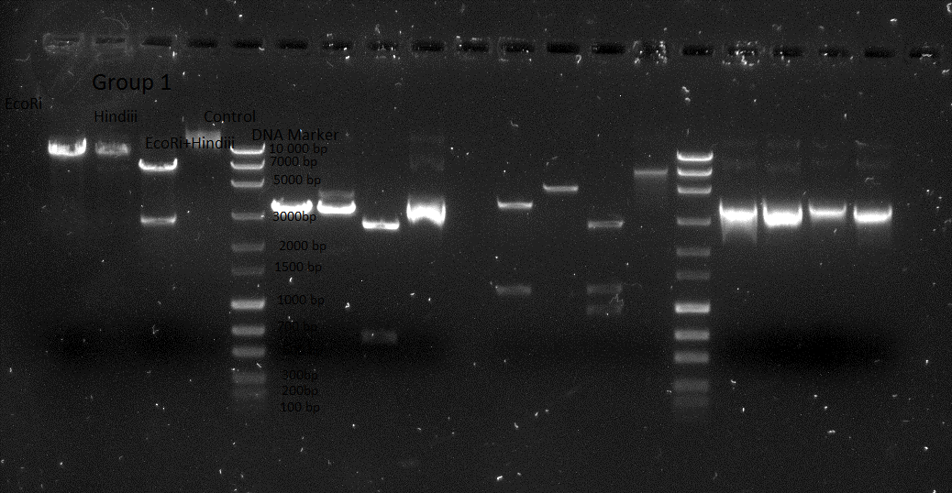
Figure 5. Agarose Gel Electrophoresis of DNA. Four solutions were analyzed from electrophoresis. The first solution contained EcoRi, the second contained Hindiii, the third was a combination of EcoRi and Hindiii, and the fourth was a control solution. The points that were used for analysis was group ones data as highlighted in the chart. As shown there is one point for the pure EcoRi, the control, and the pure Hindiii. There is two points for the combination of the EcoRi and the Hindiii solutions.
Table 3. Mobility and weight of the DNA samples from electrophoresis. The following table shows the mobility which was obtained by measuring the distance from the base to the point of the line for the DNA markers. The log(bp) was obtained by using the log of the weight for each of the DNA markers.
Mobility (cm) | Log(bp)
2.9cm | 4
3.5cm | 3.845
3.9cm | 3.799
4.7cm | 3.477
5.4cm | 3.301
6.2cm | 3.176
7.2 | 3
7.9 | 2.845
8.5 | 2.7
9.2 | 2.477
9.6 | 2.301
9.9 | 2

Estimated MW (bp) of all DNA fragment
EcoRi=9900bp
Hindiii=10 000bp
EcoRi and Hindiii first line= 7000bp Second line=2900bp
Control=10000bp

Figure 6. Log Length vs Mobility from electrophoresis of DNA. The following data was obtained by analyzing the mobility at which the DNA markers were located on the gel. This graph shows a linear trench with a R² value of 0.9906 this means that the data has a high correlation. This graph also shows a negative linear trend. the last two points were removed because they slanted the slope decreasing the R² value.
R7
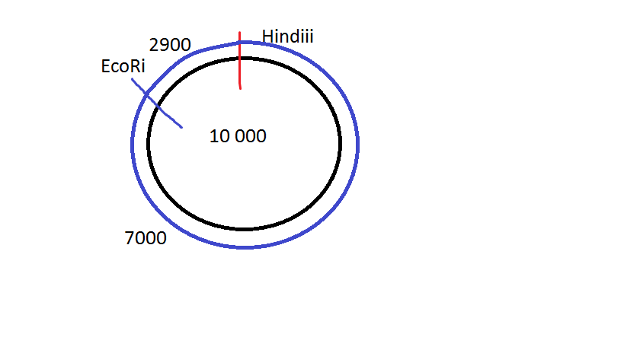
Figure 7. Plasmid Map of the Electrophoresis of the DNA samples. The following shows the approximate location of the EcoRi and the Hindii DNA samples on a plasmid map. The total distance is 10 000bp, and there is a cut at 7000bp in which ecoRi is located. After another 2900bp the map leads back to the Hindii molecule.
R8
Using figure 5 I am able to determine if the solutions a fully digested or partially digested. A strong bright band means that the enzyme was digested and a faint colored band means that the enzyme was partially digested. From this I can conclude that all three of the solutions were digested. They all show bright bands and the combination of the solutions display two distinct bands and not three or one. This means that the combination of the solutions displays that same amount of bands as the hindiii plus the EcoRi individual solution bands. Both the individual ecoRi sample and the hindiii sample display a nicked or open circle conformation based on the location of their marker. The mixed hindiii and ecoRi sample displays two bands, a nicked or open circle band closer to 7000bp along with a linear conformation closer to 3000.
Conclusion
In conclusion the results of this lab provided results that were both precise and accurate. This laboratory showed that salt increasing the melting temperature of DNA whereas the DMF decreased the required melting temperature of DNA. The unknown plasma 47 was analysed and contained some protein contamination but still provided precise results. The electrophoresis experiment showed the Plasma map of Hindiii and EcoRi with little error.

