Chapter 11: Learning, Memory and Amnesia

Learning & Memory

- Learning – the brain’s ability to change in response to experience
- Memory – the brain’s ability to store and access the learned effects of experiences
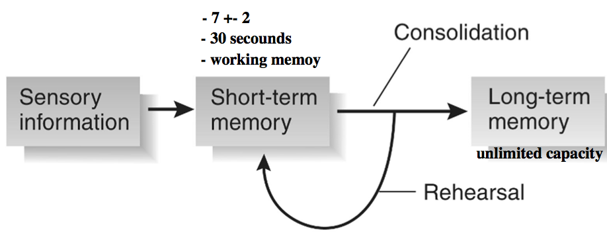
WHAT IS MEMORY?

- 3 stages of processing in memory
- Encoding – acquisition of info; “learning”
- Storage – retention and consolidation of info
- Retrieval –recovery of info; “remembering”

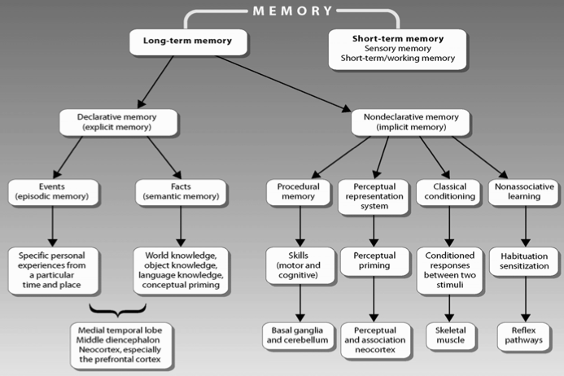
A simple model of the learning process

Different types of Memory

Neurological conditions that can produce amnesia:

- Traumatic head injury (blow to head)
- herpes simplex encephalitis (viral infection of brain) • Stroke
- Korsakoff’s syndrome (vitamin B1 deficiency) typically in association with chronic alcoholism
- Alzheimer’s disease (degenerative disease of brain)
- Epilepsy surgery (removal of brain structures)

History of Memory Study

- In 1953 a 27 year old man, H.M., underwent brain surgery to alleviate epilepsy
- He had around one generalized convulsion every week and a number of partial convulsions every day
- Medications weren’t working
- EEGs suggested the convulsions originated from foci in the medial portions of his left and right temporal lobes
- Normal, bright, good language and social skills
- Could discuss childhood and teens
- HM lost ability to form new memories that he could consciously recall until his death at age 82
  - Eg. Meeting new people, eating, reading magizines
  - His favorite uncle had dies and he would continually relieve the event each time he was told

Bilateral Medial Temporal Lobectomy (MTL)

- Unilateral medial temporal lobectomy was effective for patients with epileptic focus in one medial temporal lobes
- So both lobes were removed in H.M.

Bilateral Medial Temporal Lobectomy

- Involves removal of medial portion of both temporal lobes
  - The hippocampus, amygdala, and adjacent (rhinalcortex)
- In terms of epilepsy the surgery was successful
  - Generalized convulsion almost completely eliminated, incidence of partial seizures greatly reduced
  - Disposition remained relatively unchanged
- IQ increased from 104 – 118
- However severe amnesia resulted
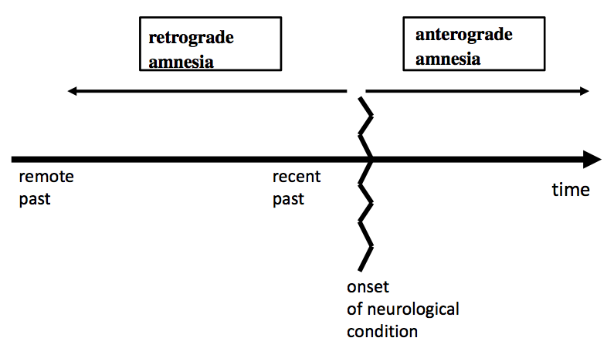
Type of amnesia according to time period affected

Different Tests Used to Assess H.M.’s Amnesia

- H.M. received many tests to assess his particular deficits
- Breda Milner, McGill
  - Studied with Wilder Penfield
- ◦ Understanding brain function by assessing patients during and following brain surgery

Digit Span +1 Test (digits read at one second intervals)
- 7, 8, 1, 4, 2 (presented until repeated correctly)
- 7, 8, 1, 4, 2, 3 – 7, 8, 1, 4, 2, 3, 6 etc.
- Normals?
  - After 25 trials normal people would have been able to repeat 15
- HM?
  - After 25 trials H.M could not repeat the 8-digit sequence

Block-Tapping Memory-Span Test
H.M.’s anterograde amnesia not limited to verbal material
- 9 blocks spread out on a board
- Neuropsychologist taps out a sequence of 5 blocks
- Subject must correctly repeat the sequence of tapped blocks
- HM?
  - Could learn a sequence of 5 but could never learn a sequence of 6 (no matter how many times repeated)
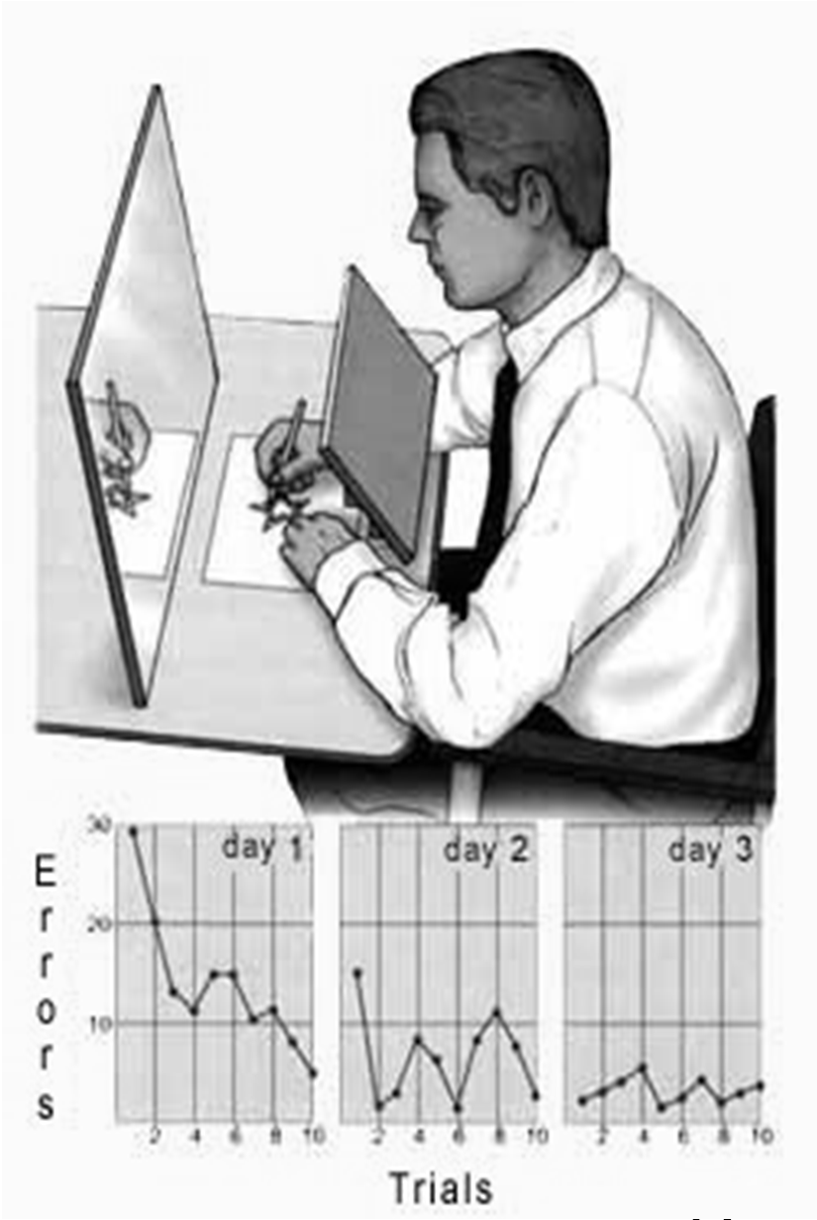
- Global Amnesia – for info presented in all sensory modalities

Mirror-Drawing Test
- Showed that H.M.’s anterograde amnesia not for all types of long term memories
- Tracing task
  - 10 sessions per day
  - 3 days of sessions
- H.M
  - Sucked the fist time making many mistakes but got better as the day progressed
  - Performance on the task improved over the days never remembering having done the task before

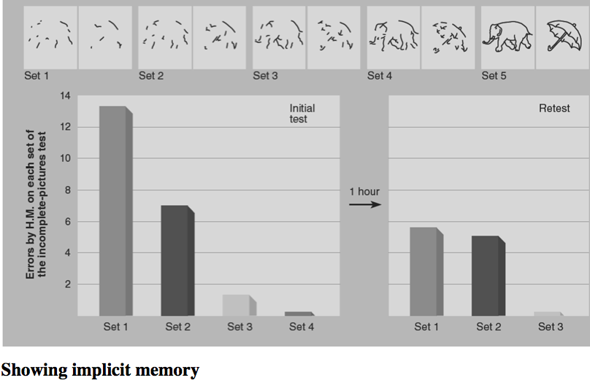
Pavlovian Conditioning
- Tone sounded before puff of air administered to one eye
  - Eventually tone alone elicits eyeblink
- HM?
  - Learned the task; had an eyeblink response 2 years later
  - But never recalled the initial training session

- Incomplete Pictures Test recognition of severely fragmented pictures improves without conscious recollection
- He di better 1 hour later with the same pictures even though he doesn’t ever remember seeing those the first time

Three Major Scientific Contributions of H.M.’s case

- Medial temporal lobes are involved in memory
- STM and LTM are distinctly separate
  - H.M. is unable to move memories from STM to LTM, a problem with memory consolidation
- Memory may exist but not be recalled –
  - H.M. can exhibit a skill he does not know he has learned Explicit vs. Implicit)

- Explicit
  - Conscious memories
- Implicit
  - Unconscious memories, as when H.M. shows the benefits of prior experience

Explicit Memory

- Somantic memory
  - Knowing about things learned in the past (“I know that”) ( I know how to get to that place)
  - Memory for word knowledge
  - Timeless; does not rely on “mental time travel”
  - Does not involve conscious recollection

- Episodic
  - Remembering the past (“I remember that”) (I remember it was a sunny day went I went last week)
  - Memory for episodes distinct in time and space
  - Associated with “mental time travel”
  - Conscious recollection of personal past experience “Me-ness”

Medial Temporal Lobe Amnesia
- Not all patients with MTL amnesia are unable to form new explicit long-term memories
- Somantic memory may function normally while episodic memory does not
- MTL amnesiacs may have trouble imagining future events

Case Study – Clive Wearing

- Successful musician
- Herpes Encephalitis in 1985 – 46 yrs old
- Left with profound anterograde amnesia
- STM?
  - Intact up to 30 seconds
Unable to consolidate any memories into LTM

Amnesia of Korsakoff’s Syndrome

Most commonly seen in severe alcoholics (or others with a thiamine deficiency)
- Characterized by amnesia, confusion, personality changes, and physical problems
- Damage in the:
  - Medial diencephalon, medial thalamus, and medial hypothalamus
- Amnesia comparable to MTL amnesia in the early stages (anterograde)
- Differs in later stages retrograde amnesia

Amnesia of Alzheimer’s Disease (AD)

- Begins with slight loss of memory and progresses to dementia
- General deficits in predementia AD:
  - Major anterograde and retrograde amnesia in explicit memory tests
  - Deficits in STM and some types of implicit memory, verbal and perceptual
  - Implicit sensorimotor memory is intact

Cause of Memory Damage in Alzheimer’s Disease?
- Decreased ACH
- Due to basal forebrain degeneration
- Medial temporal lobe and prefrontal cortex also involved
- Damage is diffuse

Posttraumatic Amnesia

- Concussions – may cause retrograde amnesia for the period before the blow and some anterograde amnesia after
- The same is seen with comas, with the severity of the amnesia correlated with the duration of the coma
- Period of anterograde amnesia suggests a temporary failure of memory consolidation

Memory Consolidation

- Concussions disrupt consolidation (storage) of recent memories
- Hebb’s Theory
  - memories are stored in the short term by neural activity
- Interference with this activity prevents memory consolidation. Examples:
  - Blows to the head (eg. Concussion)
  - ECS (electroconvulsive shock)

Animal Models of Amnesia

- Early attempts to develop MTL amnesia unsuccessful
- Why?
  - At first didn’t know HM’s amnesia restricted to explicit LTM - most animal memory tests were implicit (classical conditioning)
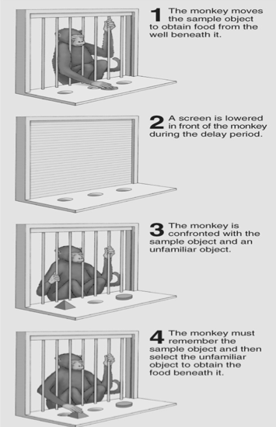
- focused only on hippocampus, ignoring contribution of other areas damaged in HM’s surgery
  - they were the standard tests but they were the wrong ones for looking at MTL amnesia

Neuroanatomy of Object- Recognition Memory

- Delayed Non-Matching-To-Sample Test (DNMTS); type of explicit LTM
  - Intact Monkeys = 90% correct
  - Monkeys with MTL lesions? –major deficits
- Like H.M., performance was normal when memory needed to be held for only a few seconds (within the duration of STM)

Object Recognition Memory

- Delayed non-match to sample (rats)
  - Mumby Box
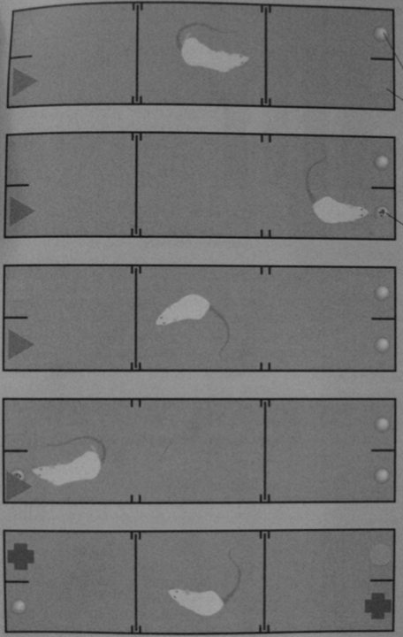
- More specific lesion methods with rats
- In monkeys - aspiration lesions of hippocampus – results in additional cortical damage
- In rats – more specific lesions (excitotoxic and electrolytic) - extraneous damage is limited
- So let’s lesion all parts of the MTL – alone and in combination ...

Neuroanatomical Basis of the Object-Recognition Deficits Resulting from Medial Temporal Lobectomy

- Bilateral removal of hippocampus = little/no effects on object recognition
- Bilateral removal of amygdala = no effect on object recognition
- Bilateral removal of the rhinal cortex = significant deficits in object-recognition deficits
  - Getting information in; explicit object recognition
- When looking at post-surgery and pre-surgery when the rhinal cortex was cut there was a significant decrease in object recognition whereas for the hippocampus and amygdala this was not the case
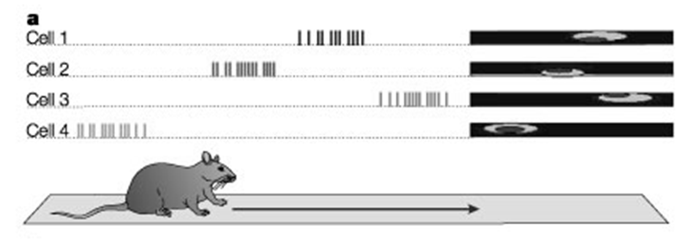
- Hippocampus plays a key role in special memory
- Lesions = lower performance in:
  - Radial arm maze and Morris water maze

Hippocampal place cells – neurons that respond only when a subject is in a specific location

Dr. David E Sherry – at western and study’s birds

- Hippocampus is larger in Food Storing birds vs Non-Food Storing birds
  - Those that need to store food need a good special memory in order to find there food later on

- Hippocampus is larger in animals that depend on spatial memory for reproduction
  - Those that go out to find there mate need to have a larger hippocampus

Comparative studies in Humans
- London taxi cab drivers with more than 20 years of experience had significantly more posterior hippocampal gray matter than normal controls (Maguire et al 1998)
  - Larger posterior hippocampus than controls
  - Hippocampus volume ↑ with time on job

Where Are Memories Stored?

- Amygdala
  - Memory for emotional significance of experiences
- Inferotemporal Cortex
  - Role in storing memories of visual patterns
- Prefrontal
  - Temporal order of events and working memory
  - Tasks involving a series of responses
- Cerebellum
  - Stores memories of sensorimotor skills
- Striatum (basal Ganglian)
  - Habit formation

Infantile Amnesia
- Normal inability to remember events from early childhood
- But do we have implicit memory?
  - Skin conductance response changes when viewing familiar photos of classmates; regardless of explicit recognition
- Incomplete - Pictures Test (3y.old):
  - Previously seen pictures that were seen were recognized sooner(implicit memory) then the novel pictures whether the old pics were explicitly recognized ort not

Smart Drugs: Do they work

- Smart drugs = Nootropics
  - e.g. Gingko biloba, ginseng, multivitamins, glucose, cholinergic agonists
- Limited research
  - Low quality, small ‘n’, poor controls, based on ‘testimonials’
  - No evidence that nootropics have memory enhancing effects in normal people

Brain Changes in Learning
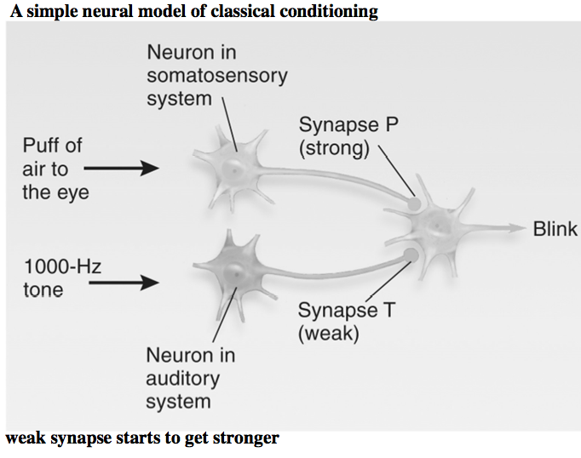
- According to the Hebb Rule, if the axon of a presynaptic neuron is active while the post-synaptic neuron is firing, the synapse will be strengthened.
- Long-Term Potentiation (LTP)
  - LTP = increase in synaptic strength that occurs when presynaptic and postsynaptic neurons are both activated.
It has been studied most in the hippocampus, but it appears to be characteristic of much of neural tissue

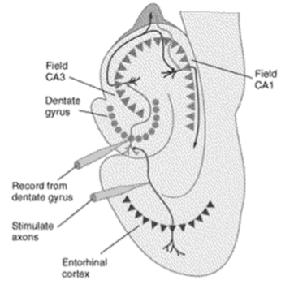
- A greater response is elicited following high - intensity, high-frequency stimulation

LTP as a Neural Mechanism of Learning and Memory

- Elicited by levels of stimulation that mimic normal neural activity
- Learning can produce LTP-like changes
- LTP effects are greatest in brain areas involved in learning and memory
- Drugs that impact learning often have parallel effects on LTP

