Chapter 7: Mechanisms of Perception: Hearing, Touch, Smell, Taste and Attention
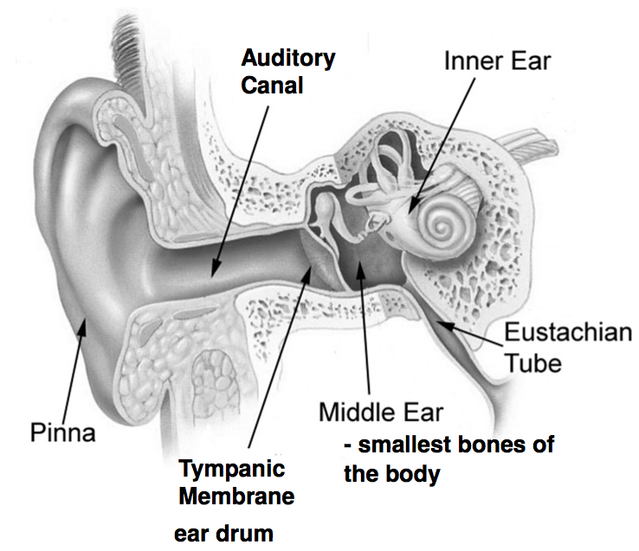
Amplitutude = loudness
Frequency = pitch
Complexity = Timbre – (complexity of the sound)

Audition
- Sound wave > eardrum > ossicles (malleus, incus, stapes) > oval window
- Vibration of the oval window sets in motion the fluid of the cochlea
- The cochlea’s internal membrane, the organ of corti, is the auditory receptor organ

Organ of Corti
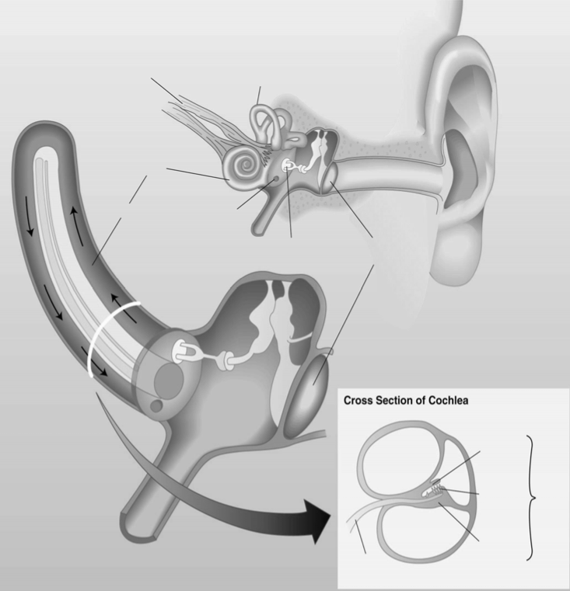
- Composed of 2 membranes
- Basilar Membrane - auditory receptors, hair cells, are mounted here
- Tectorial Membrane - rests on the hair cells
- Stimulation of hair cells triggers action potentials in the in the auditory nerve (cranial nerve)

Cochlear Coding
- Organization of the organ of corti is tonotopic
- Different frequencies produce maximal stimulation of hair cells at different points along the basilar membrane (different frequencies/ pitches of tone)

Auditory Pathways

- Auditory nerve
- Cochlear nuclei
- Inferior colliculus
- Medial geniculate nucleus (thalamus)
- Primary auditory cortex
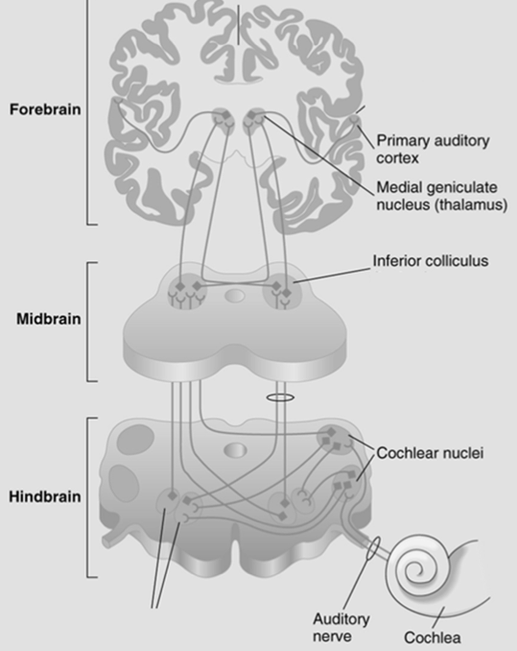
Auditory Cortex
- Primary auditory cortex = lateral fissure: temporal lobe
- Tonotopic organization to simple tones • Secondary areas respond best to
complex tones
  - Strokes tend to be on the outside and this is deep in the fissure
therefore not likely to be affected

Two Streams of Auditory Cortex
•Anterior pathway (to prefrontal cortex) = involved in identifying sounds
•Posterior pathway (to posterior parietal cortex) = involved in locating sounds

Sound Localization

- Mediated by the lateral and medial superior olives
- Both structures react to differences in what is heard by the two ears
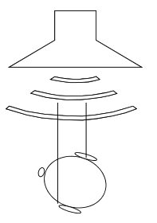
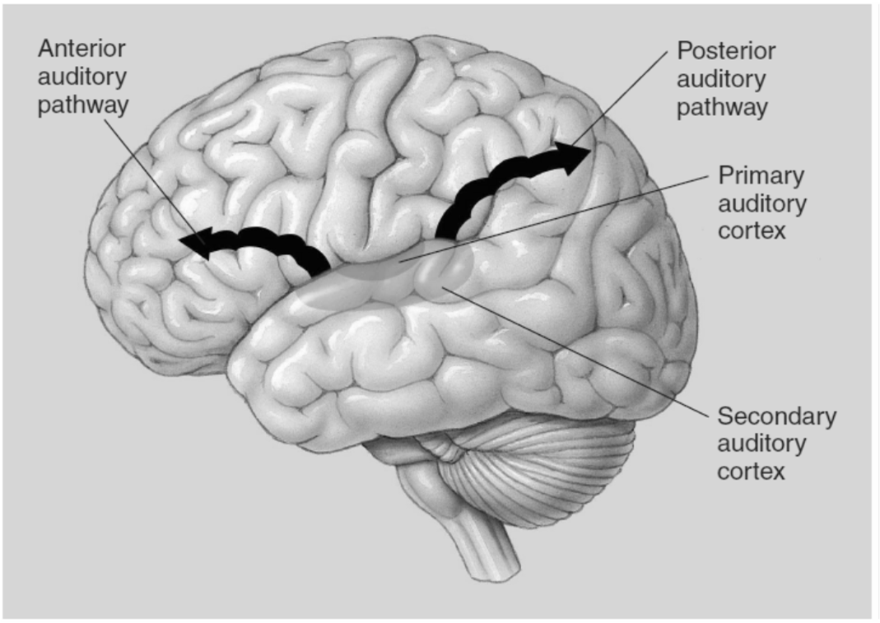
  - Medial – arrival time differences
  - Lateral – amplitude differences

Hearing Loss

- Conduction deafness – mechanical system
  - Punctured eardrum, loss of functio of bones of middle ear
- Nerve deafness - damaged receptors
  - Exposure to loud sounds, congenital

Age Related Hearing Loss
- Usually deficit in hearing high frequencies
- Elderly people often problems with “s”, “f” and “t”
  - Often friends and family do not realize that much of the confusion displayed by elderly people stems from difficulty of distinguishing sounds

Somatosensation 7.3

- Somatosensory system is 3 separate and interacting systems
  - Exteroreceptive – external stimuli
  - Proprioceptive – body position
  - Interoceptive – body conditions (e.g., temperature and blood pressure)

Exteroreceptive System
- Touch (mechanical stimuli)
- Temperature (thermal stimuli)
- Pain (nociceptive stimuli)
  - Specialized receptors respond to the various stimuli

Cutaneous Receptors
- Slow vs Fast adapting receptors
- We respond to change – when there is no change, no sensation

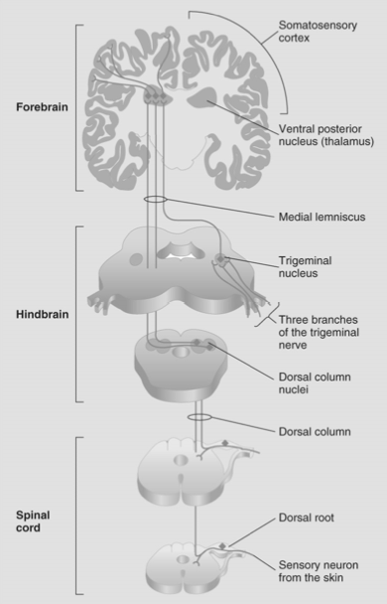
- Stereognosis – identifying objects by touch
- Free nerve ending
  - temperature and pain
- Pacinian corpuscles
  - adapt rapidly, large and deep; onion like
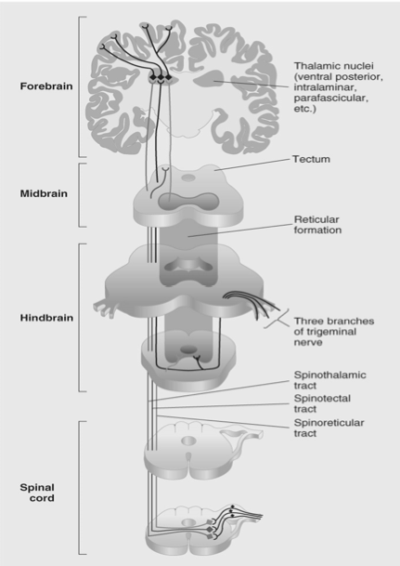
  - sudden displacements of the skin
- Merkel’s disks – gradual skin indentation
- Ruffini endings – gradual skin stretch

Ascending Somatosensory Pathways
- Dorsal-column medial-lemniscus system
  - Touch and proprioception
  - 1st synapse in the dorsal column nuclei
  - Decussate, ascend in ML to VPN
  - VPN to S1

- Anterolateralsystem
  - Pain and temperature
  - Synapse upon entering the spinal cord
  - 3 tracts – spinothalamic, spinoreticular, spinotectal

Somatosensory cortex

- Primary somatosensory cortex (SI)
  - Postcentral gyrus
  - Somatotopic
  - More sensitive, more cortex
  - Input largely contralateral
- SII–mainly input from SI
  - Somatotopic, input from both sides of the body
- Much of the output from SI and SII goes to association cortex in posterior parietal lobe

Somatosensory Agnosias
- Asterognosia – inability to recognize objects by touch
- Asomatognosia – the failure to recognize parts of one’s own body

The Paradoxes of Pain

- Despite its unpleasantness, pain is adaptive and needed
- No obvious cortical representation
  - SI and SII activated; but removal doesn’t alter perception
  - anterior cingulate gyrus involved in emotional component
- Descending pain control – pain can be suppressed by cognitive and emotional factors

Identifying a Descending Pain Control Circuit

- 3 discoveries made this possible:
  - Electrical stimulation of the periaqueductal gray (PAG) has analgesic (pain-blocking) effects
  - PAG and other brain areas have opiate receptors
  - Existence of endogenous opiates (natural analgesics) - endorphins

The Chemical Senses
- Olfaction(smell) – detects airborne chemicals
- Gustation(taste) – Responds to chemicals in the mouth
  - Food acts on both systems to produce flavor

The Olfactory System
- Detecting chemicals in the environment
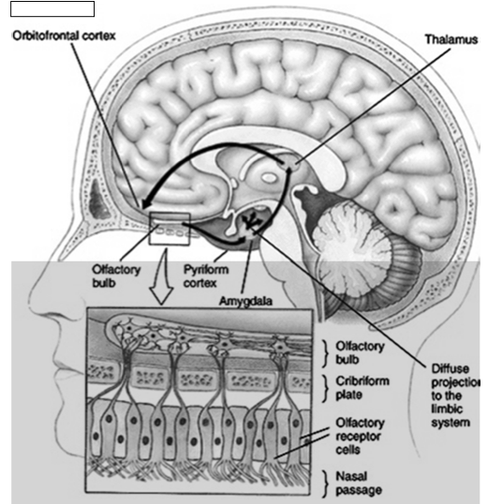
- Olfactory stimuli = chemicals in the air
- Shape of the molecule determines its smell, (odorants)
- Receptors embedded in olfactory mucosa of nose
- New receptors are created throughout life
- Info carried via olfactory nerve (CN1)

Anatomy of the Olfactory System
- Olfactory tract
- Piriform cortex (primary olfactory cortex) & amygdala
- Limbic system
  - Memory + emotion to smells (that reminds me of their perfume)
- Orbitofrontal cortex
  - Conscious perception of odors (“oh that’s chocolate”)
- If you bump your head those olfactory receptors can shear off

Gustation
- • Receptors in tongue and oral cavity
- • Occur in clusters of 50 Taste buds
- • Located on papillae

Anatomy and Function of the Taste System
- When taste stimuli come in contact with these microvilli
  - initiates a receptor potential, which excites neurons sending info about taste stimuli to the brain

Gustation
- At least 5 primary tastes
  - Sweet
  - Sour
  - Salty
  - Bitter
  - Umami --> meat and savory (5th)

Many tastes also exist that are not created by combining primaries
- Salty and sour don’t have receptors, they merely act on ion channels
- How tastes are encoded is not yet clear
- Info carried by 3 cranial nerves
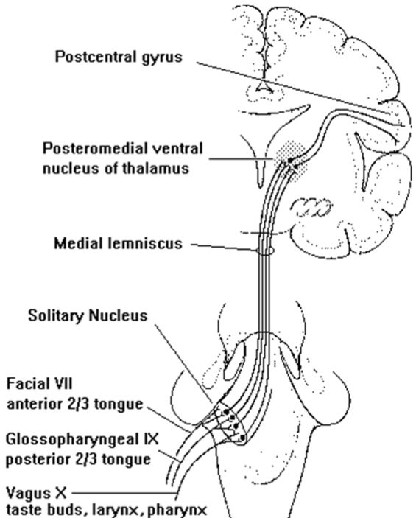
  - Facial – 7th
  - Glossopharyngeal – 9th
  - Vagus – 10th

Gustatory Pathway

- Gustatory receptors
- Solitary nucleus (medulla)
- Ventral posterior nucleus (thalamus)
- Primary gustatory cortex (Postcentral gyrus)

Brain Damage and the Chemical Senses

- Anosmia – inability to smell
  - Most common cause is blow to the head that damages olfactory nerves
  - Incomplete deficits seen with a variety of disorders

- Ageusia – inability to taste
  - Rare due to multiple pathways carrying taste information

