Chapter 6: The Visual System

Light Enters the Eye

- Properties of light contribute to our perception of images
- Wavelength – Perception of color
- Intensity – Perception of brightness
- Sensitivity – the ability to see when light is dim
- Acuity–the ability to see details

What Do We See?
- Distorted and upside-down 2-D retinal image is transformed into the 3-D world we perceive
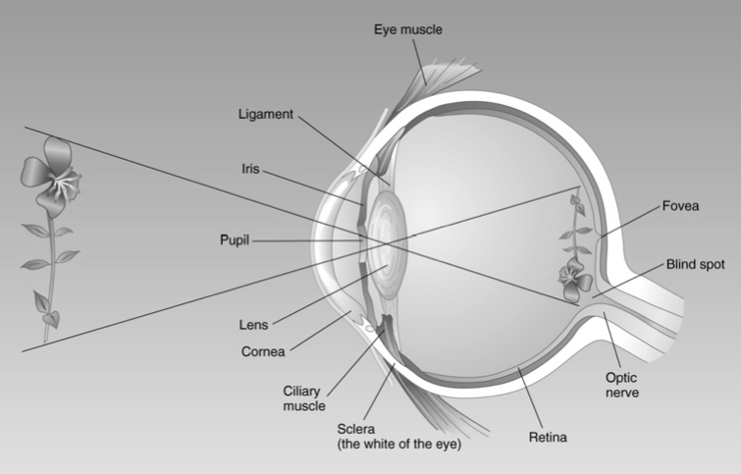
The Eye

- Light enters the eye through the pupil
  - Dilates and constricts; iris (colored part)
- Light then passes through the lens
- Lens focuses (becomes fatter/skinnier) image on retina
  - Inverts the image
- Ciliary muscle – adjusts the tension on the ligament holding the lens in place (focusing)
- Accommodation – the process of fucosing an object in our vision

Anatomy of Visual System

- Myopia
  - Nearsightedness - Difficulty seeing far away objects
  - Eyeball is longer back-to-front
  - Lens focuses light in front of retina
- Hyperopia
  - Farsightedness - Difficulty seeing close–up objects
  - Eyeball is too short
  - Lens focuses light behind retina
  - As you get older this tends to happen

Eye Position and Binocular Disparity
- Convergence – eyes must turn slightly inward when objects are close
- Binocular disparity – difference between the images on the two retinas
- Both are greater when objects are close – provides brain with a 3-D image and distance information
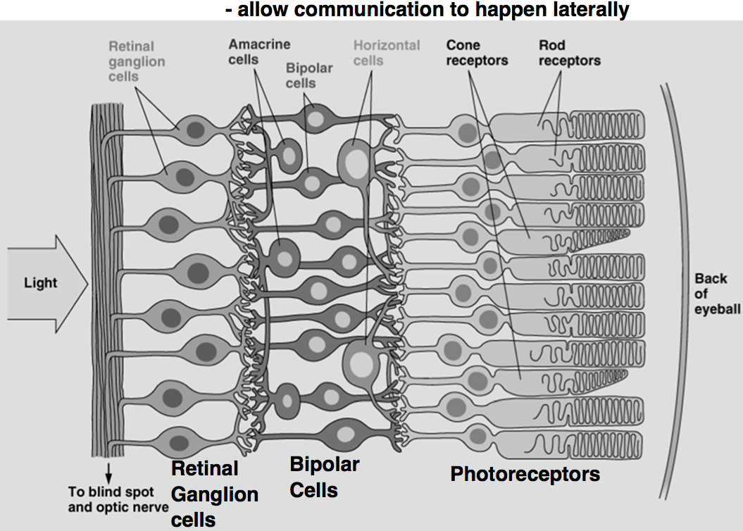
The Retina
Light then passes through lens
  - Focuses light on area of retina of highest visual acuity = Fovea
  - Thinning – provides less distortion
The retina = “inside-out”
  - Light passes through several cell layers before reaching its receptors

Blind spot
- Axons of retinal ganglion cells exit forming optic nerve
  - No receptors
- But no perceived gaps in vision!!! Why?!
- Completion - Brain uses information from cells around the blindspot to fill in missing info

Cone and Rod Vision
- Cones – fovea (colour)
- Rods – highest in the periphery (excellent for seeing movement)

- Duplexity theory of vision - cones and rod mediate different kinds of vision
  - Originated after blind spot observation and completion

Photoreceptor | Cone | Rod
Location | Fovea | Periphery
Lighting | Bright | Dim
Qualities | Detail Colour | Sensitivity Motion perception
Type of vision | Photopic – need good lighting | Scotopic – need dim light
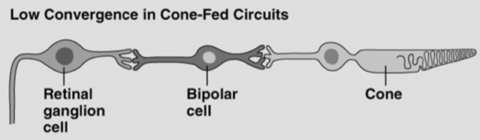
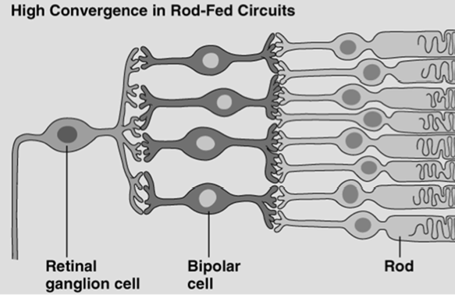
“Wiring” = Convergence
- Rods
  - big funnel down to a single ganglion cell
  - not going to give you high acuity
  - not able to tell exactly what rod is activated
  - High convergence, High Sensitivity, low acuity
- Cones
  - Low convergence, Low Sensitivity, High acuity

Purkinji effect
- This is because cones work better with lots of light and they see brighter object better then (opposite for rods)
- yellow flowers were brighter during the day, blue flowers were brighter then yellow at night

Eye Movement

- Saccades – we continually scan the world with small and quick eye movements
  - If you were to inject your eye to stabilize them you would be temporarily blind
- These bits of information are then integrated • Stabilize retinal image – see nothing
- Visual system responds to change

Dr. Stefan Everling, UWO Studies saccades
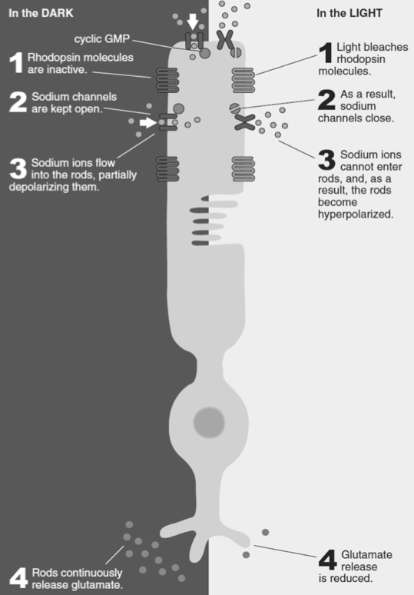
- How they are generated by the brain (normal subjects)
- What happens when they are disturbed (e.g. schizophrenia)

Visual Transduction
- Pigments within rods and cones absorb light
- Transduction – conversion of one form of energy to another
- Receptors that respond to light instead of neurotransmitters
  - Rhodopsin (rods)
  - Iodopsin- 3 types (cones)

Visual Transduction - The inhibitory response of rods to light

Retina to Primary Visual Cortex (Retinal-Geniculate-Striate Pathway)
Eye --------------------Retina
Thalamus ------------Lateral Geniculate nucleus
Occipital Lobe -------Primary visual (striate) cortex

Retinotopic Organization
- 2 stimuli excited in adjacent areas excite adjacent neurons
- Each level of system = map of retina
  - Map outside is also mapped inside
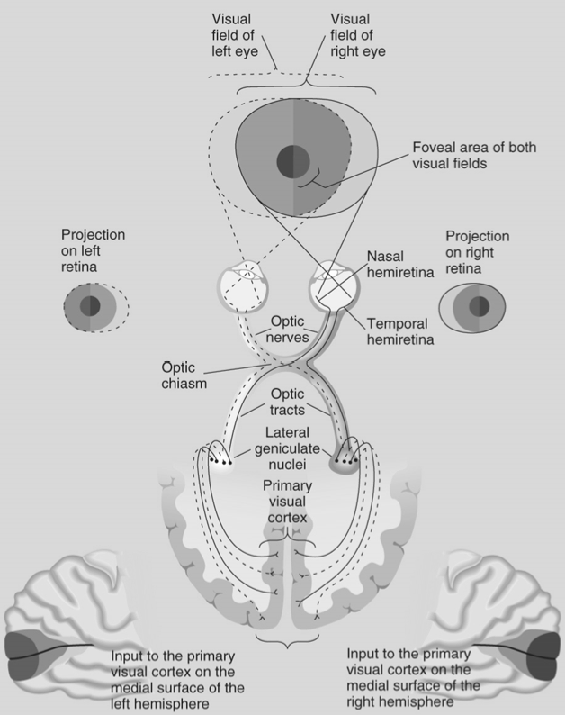
- Disproportionate representation of fovea (25% of cortex)
  - Fovea takes up a lot of brain cortex space
- What you actually see is how the brain is being stimulated

Magnocellular Layers
- Big cell bodies, bottom two layers of LGN (lateral geniculate nucleus)
- Particularly responsive to movement
- Input primarily from rods
Parvocellular layers
- Small cell bodies, top four layers of LGN
- Color, detail, and still or slow objects
- Input primarily from cones

Seeing Edges
- Contrast enhancement – every edge we look at is highlighted
- Visual system is tuned to detect change
- Contains mechanisms to enhance contrasts and make edges easier to see
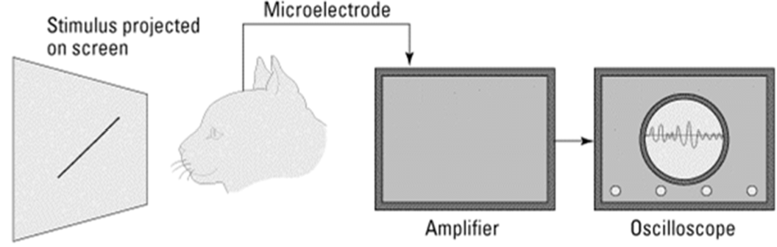
- Lateral inhibition
  - when a receptor fires it inhibits neighbors via the lateral neural network; spreads laterally across the array of receptors
  - Allows us to enhance edges
  - Main neural mechanism that our brain has to enhance images
  - Brain is enhancing things that aren’t actually there

Receptive Fields
- Receptive field – area of the visual field whithin which it is possible for a visual stimulus to influence the firing of that neuron
- What does the visual system respond to?
- Hubel & Wiesel’s Experiment

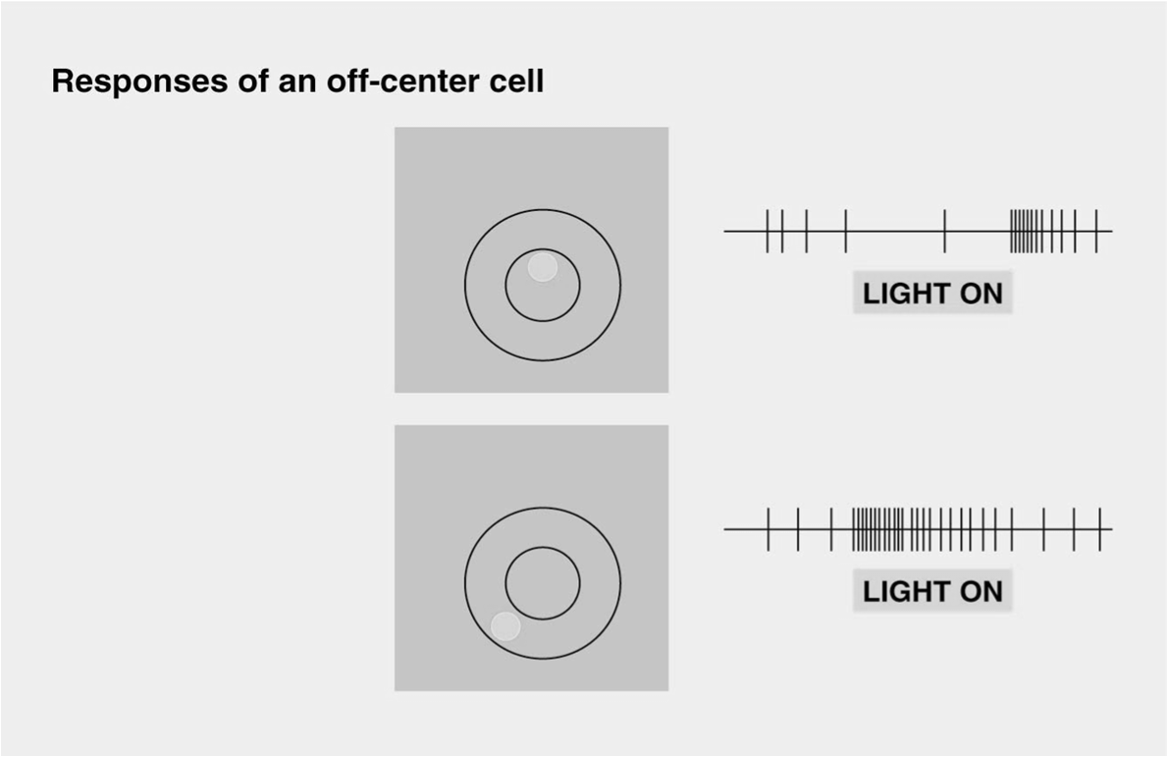
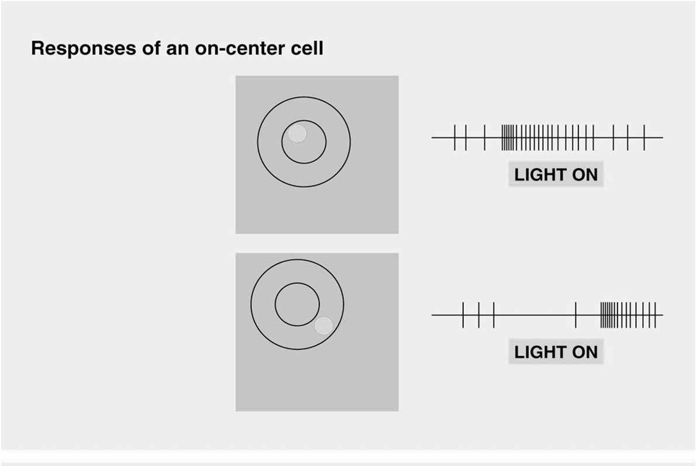
On-center cell
• Light on center EXCITES cell
• Light on surround INHIBITS cell

Off-center cell
- Light on center INHIBITS cell
- Light on surround EXCITES cell
- Center effects are slightly stronger then the surround
- When the entire thing is eliminated, activity is just above baseline

- In the striate cortex, neurons with circular receptive fields are rare
Most are either:
Simple | Complex
- Rectangular  - “On” and “off” regions, like cells in layer 4  - Orientation and location sensitive  - All are monocular | - Rectangular  - Larger receptive fields  - Do not have static “on” and “off” regions  - Not location sensitive  - Motion sensitive  - Many are binocular – these were activated in the cat experiment

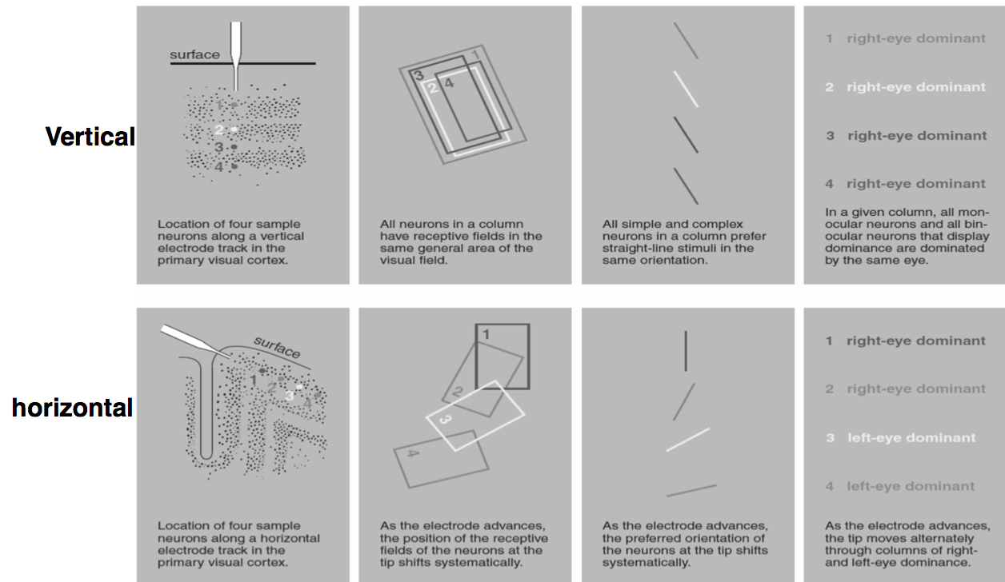
Columnar Organization of Primary Cortex
- As visual information flows through hierarchy, receptive fields
- become larger
- respond to more complex and specific stimuli

- things start to become more complex
- specific receptors for specific signals

Seeing Colour

- Component theory/ Trichromatic Theory
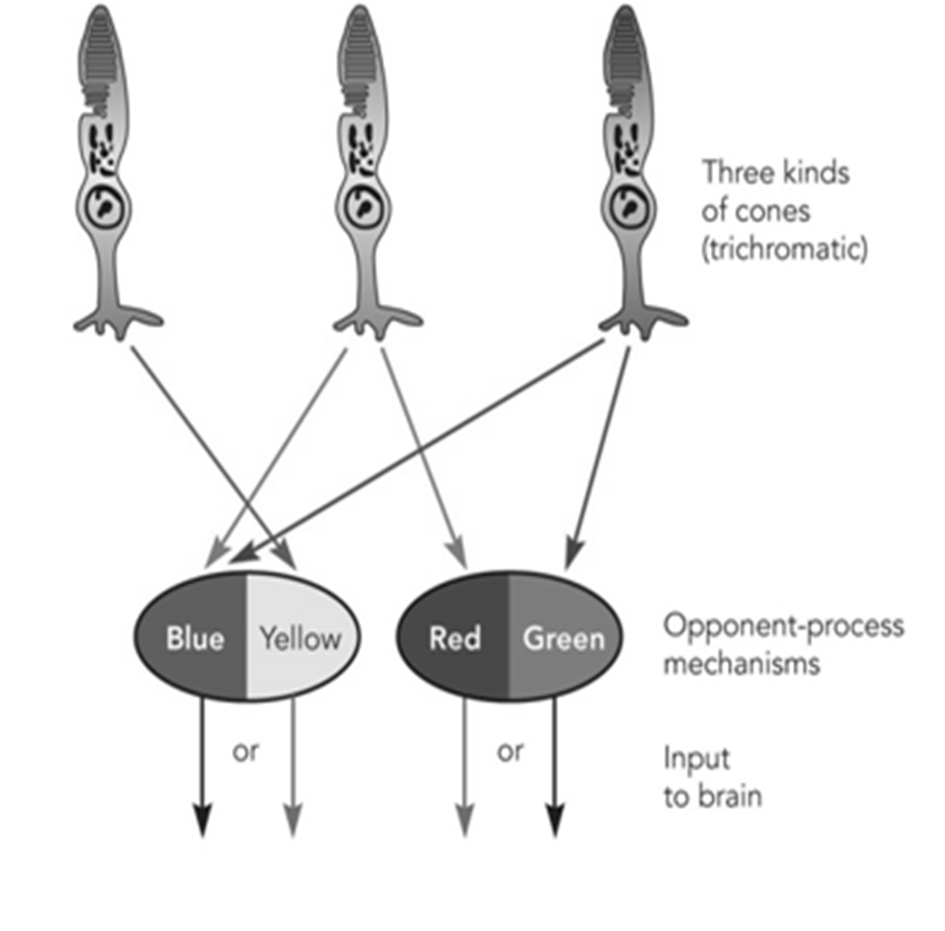
- 3 different kinds of cones: red, green, blue
- Every colour is a combination of cone responses
Component theory cannot explain:
- Red-green colour blind individuals should not be able to perceive yellow (red + green = yellow)
  - Suggests a different means of perceiving yellow
  - Suggest a different means of perceiving yellow

- Opponent-Process theory
  - Three cone types
  - Each responds to two different wavelengths
    - Red or green; Blue or yellow; Black or white
- Explains Afterimages
  - Stare at certain colour and the neural processes become fatigued
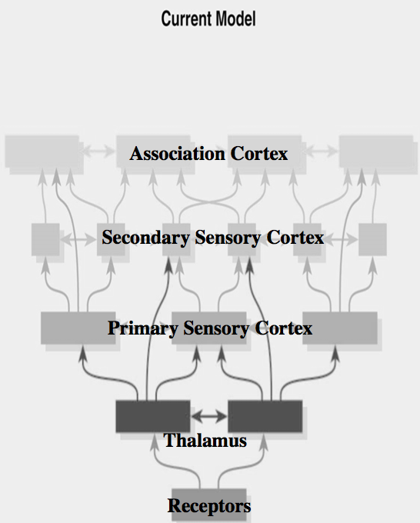
  - Rebound effect; receptor responds in opposite reaction

- Dual process theory
  - Combines component & opponent-process theories
  - 3 types of cones in retina
  - Opponent processes occur higher up (ganglion cells, thalamus & visual cortex)

Principles Guiding the Interactions of Sensory Cortex
- Hierarchical Organization - Specificity and complexity increases with each level
- Functional Segragation - Organized so different parts of structures specialize in
different kinds of analysis
- Parallel Processing - Info flows between different structures simultaneously along
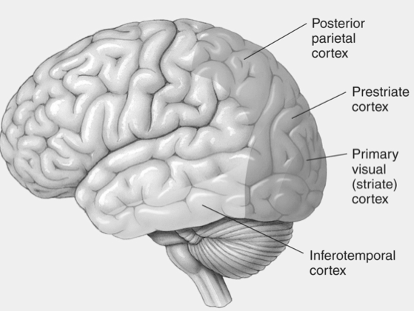
multiple pathways

- Cortical Mechanisms of Vision
- Thalamus (lateral geniculate nucleus, LGN)
- Primary visual cortex (Sriate)
- Secondary visual cortex (Prestriate)
- Visual association cortex (Posterior parietal; inferotemporal cortex)

Damage to V1?
- Scotoma
  - Blind in corresponding contralateral visual field of both eyes
  - Often deficit may not readily detected – Why?
  - Completion (friend had no head when standing in the damaged guys vision, background was filled in
- Perimetry test – head is mounted on a chin rest and a dot is shown on a screen
  - The patient will press the button every time they see the dot

Damage to Primary Visual Cortex
- Blindsight
  - Response to visual stimuli without conscious awareness of “seeing”
  - i.e. catch ball tossed toward them while claiming not to see it

Patient TN
- suffered 2 major strokes, weeks apart
- profoundly blind by most normal measures
- PET and fMRI scans showed no activity in V1
- Why?
  - May still be connections in V1, allowing for reactions without awareness?
  - Message by passes the scotoma ( ie. LGN to V2) - importance of parallel models


Dorsal and Ventral Streams
Dr. Melvyn Goodale, UWO
Control of behavior…
- 2 major streams from primary visual cortex to secondary and association cortex
1) Dorsal stream – “Where” (where objects are)
2) Ventral stream – “What” (consciousness, recognition)

“Control of Behaviour” vs “Conscious Perception”
Visually guided behaviour
Dorsal stream = control of behaviour
Damage = disrupts visually guided behaviour

Dorsal Stream (Red)
- Primary visual cortex
- Dorsal prestriate cortex
- Posterior parietal cortex

Ventral Stream (Blue)
- Primary visual cortex
- Ventral prestriate cortex
Conscious visual pattern recognition
- Inferotemporal cortex

2 Important Case Studies

Patient A. T.
- She could accurately recognize objects
- She could demonstrate the size of objects with fingers
- But she made awkward grasps; could not preshape her hand for objects (object ataxia)
  - Could reach out and grab the object but could describe it easily
Patient D.F
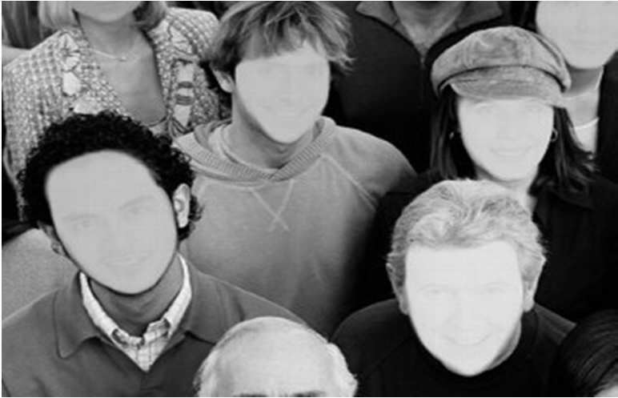
- Unable to recognize size, shape or orientation of visual objects (Visual agnosia)
- But if asked to place object through a slot she could do so with ease

Prosopagnosia
- Can readily recognize objects (e.g.chairs,tables) but are unable to recognize particular faces
- Sometimes can recognize a face as a face –but problems recognizing whose face it is – see a jumble of individual face parts
- Due to damage in fusiform face area (in the ventral/”what” stream)

- BUT >>> these patients also have an inability to recognize specific objects belonging to a complex class of objects

Greeble Experiment?
- FMRI was used and pictures of faces of greebles were shown
- Later showed the pictures of the greebles again
- fusiform area lit up as they were able to recognize the individual greeble's

Tranel & Damasio (1985)
- Since FFA in the ventral “what”/conscious stream - is there unconscious recognition?
- yes - altered skin conductance responses to familliar vs unfimiliar faces
- when a face came up that the individual knew there skin conductance increased even though they didn’t recognize them
  - this would not happen for images of people they did not know

Akinetopsia

- deficiency in the ability to see movement
- damage to the mid temporal region of the cortex

