9/10 Cytoskeleton

Learning Objectives:
- QUESTION – How is cellular movement achieved?
  - Cellular trafficking of organelles
  - Cell migration

- Intricate network of protein filaments that extend throughout the cytoplasm
- Microtubules 25nm (largest)
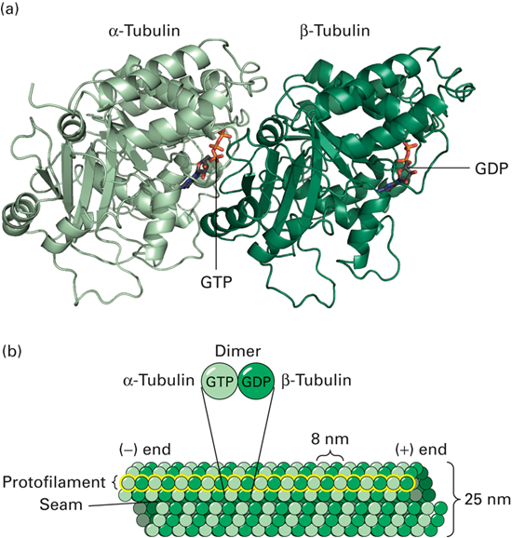
- Microfilaments 7-9nm (smallest)
- Intermediate filaments 10nm

Microtubules: Structure

- 25 nm diameter, up to 100s of μm long
- Polymer of α and b tubulin
  - Both Monomers 55kDa each
  - αβ dimer is basic “subunit” (building block of microtubules)
  - When you build or dismember the microtubule its at the level at the dimer
- Have polarity – one side is different then the other (ones the α end and the other is the β)
  - These dimers can polymerize (form a chain)
  - This chain is called a protofilament (αβαβαβαβ)
- A bunch of protofilaments come together to form a hollow tube (25nm in diameter)
  - A = - end
  - B = + end (grows faster)
- Each dimer is 8nm in size
  - Know from this that if an actin takes a step every 4 nm that its going from polymer to the next αβαβ

Dimeric Tubulin Subunit
- Tubulin is very abundant, We know the structure, therefore we know what it can and cant bind to

- Dimer VERY stable (cell will never take it apart at the level of the monomer)
- α binds permanently to GTP
- β can hydrolyze GTP so can be bound to GTP or GDP
- As the polymer (protofilament) grows, β’s GTP is hydrolyzed

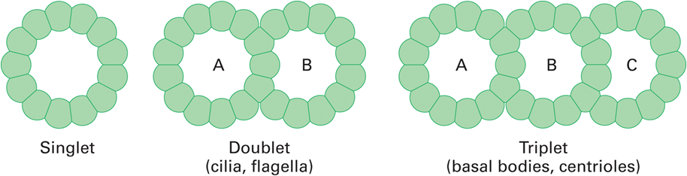
Arrangement of MT Protofilaments

- Singlets - most common
  - 13 protofilaments forming a single tube of 25nm diameter.
- Doublets and Triplets (stable) can also be formed
  - By adding an additional 10 protofilaments on
- Singlets tend to be dynamic (grow and shrink in size)
- Doublets and triplets tend to be stable

Singlet Microtubules

- Microtubules organize the interior of the cell
- 2 “types”
  - Cytoplasmic - found in the cytoplasm (microtubules of the nerve cell)
  - Axonemal (cilia etc) – means cilia or flagella

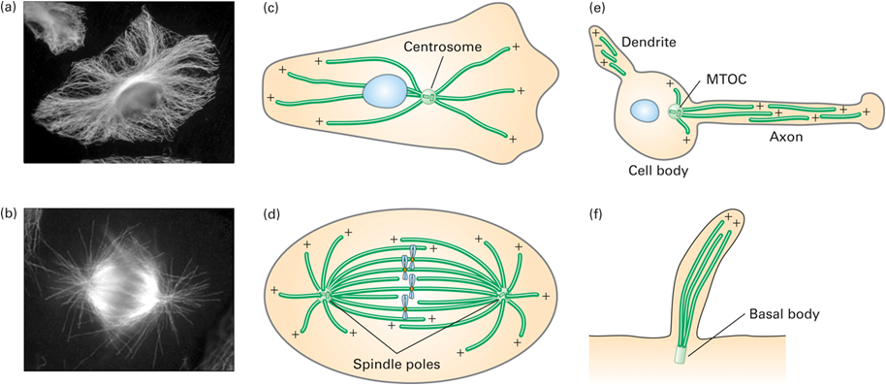
Microtubule Organization

- The MTOC (microtubule organizing center) functions to nucleate the assembly of microtubules. Dynamic process.
  - Eg. Centrosome, basal body, spindle poles
- Nucleus here – is a starting point of something
  - (Where microtubules grow from)
- Dynamic – growing and shrinking – happens at the + end
- All + ends are moving away from the MTOC
- Minus (-) ends of microtubules are associated with MTOC (note dendrites)
  - This doesn’t’t hold in dendrites of nerves (e)
  - Some are lying with their – end some with + towatds the cells
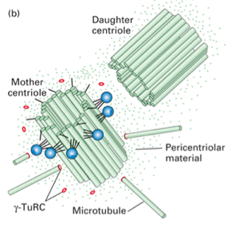
Microtubules Organization - Centrosome

- The centrosome is the major (but not only) microtubule-organizing center (MTOC) in animal cells
  - Centrosomes contain centrioles
- Centrosomes not found in plants – (means that they don’t have centrioles)
- Centrioles are made of triplet microtubules
- Each one of the triplet microtubules (about 9 of them) that form a barrel shape
  - 2 centrioles that are perpendicular to each other
- Microtubules grow from the away from the centrioles n=but are not bound to them

- Pericentriolar matrix – stuff around the centrioles (proteins)
- These proteins that help polymerize the microtubules
- 2 proteins
  - γ-tubulin
  - augmin complex
- Centrioles play a role in the replication of the centrosome (not polymerization)
  - One is the mother centriole and one is the new one
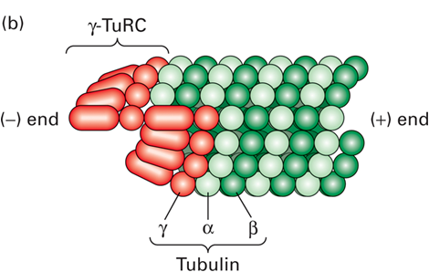
  - Centrioles do not polymerize

γ-Tubulin Nucleates Polymerization

- γ-tubulin forms a ring complex (γTuRC) (many proteins) provides nucleating sites for microtubules to grow from
- γTuRC caps the – (α) end and the + end is going to grow away

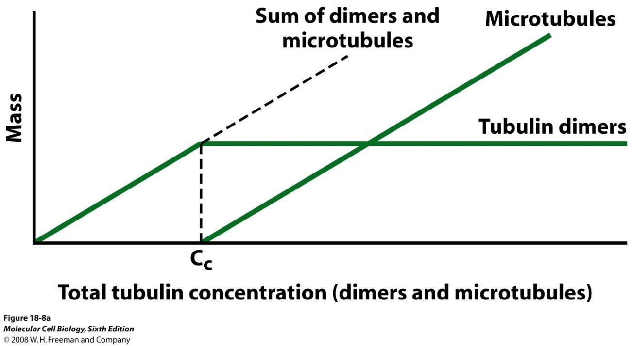
Microtubule Formation- (understand graph!!)

- MTs assembly and disassembly is important to their function.

- Critical concentration - At a certain point you’ll get to a concentration where there will be enough dimmers that polymerization will occur
  - As long as you add more dimers and are above the critical concentration you will continue to cause polymerization to occur and the microtubules will grow
- Polymerization is temperature dependent (Microtubules disassemble when chilled to 4°C)
  - In mammals are body temperatures are always the same so this does not play a role

- This process also depends on if you have a nucleating factor or not
- If you only have dimers present your not going to be able to make MT right away the process will be much slower
  - If you have γ-tubulin and you reach the critical concentration then you start making a MT
  - If you don’t have a nucleating factor you need to make small nuclei first

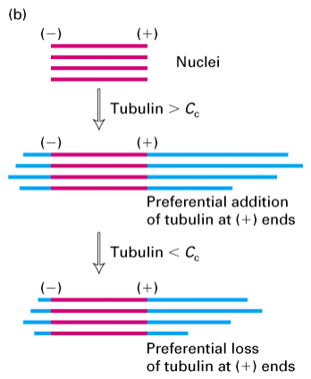
Polarity of Tubulin Polymerization

- Flagella nucleolus – piece of microtubule that is stable
  - Can add dimers to go above the Critical Concentration to get polymerization
- Polymerization occurs faster at the + end
- Depolymerization also occurs faster on the + end
- Both happen at the – end ONLY if it is free
  - usually capped by γ-tubulin

Dynamics of Microtubules

- Oscillations in length is common - classically termed Dynamic Instability
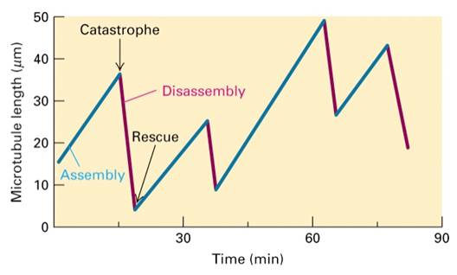
- Cells use these microtubules to transport things in the cells so they need to be able to grow and shrink really quickly to be able to move things around
  - Different microtubules do different things (each one is independent of each other)
- Each MT + end are in different microenvironments
- When the + end is in an area with a above CC of dimers it will polymerize
- As its growing it will end up in a area below CC and a catastrophe occurs (disassembly)
- Disassembly will then occur until “Rescue” occurs, area above CC of dimers again
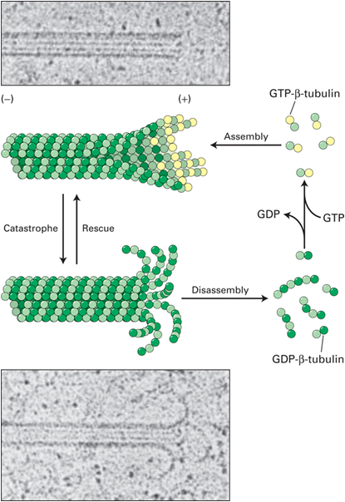
- This cycle will continue to occur and the cell can control where these dimers are so as to control the process

- Dynamic instability depends on the presence (or absence) of a GTP-β-tubulin cap.
- GTP-β provides for lateral cohesion = smooth (+) end
  - Protofilaments are attracted to one another and forms a smooth MT
  - As long as there is GTP-β subunits at the + end that + end is stable
- GTP to GDP hydrolysis occurs in the middle of the MT and this goes towards the + end
  - When it reaches the + end the GDP- β subunits at the (+) end weakens cohesion between protofilaments
  - Smooth ends fray during depolymerization
  - If you keep on adding GTP-β subunits faster then your hydrolyzing it will keep on growing
- In order for recue to occur you need a Critical concentration of subunits in the GTP form
- Exact mechanism of assembly is unclear, as is the role of the seam.

Microtubule Disrupting Drugs

- colchicine: depolymerize
- taxol: stabilizes
  - Stay at that state (not going to grow or shrink)
- These are useful research tools and anti cancer drugs
  - Need microtubules to be unstable in order to grow and go through mitosis
  - Therefore with taxol the cell will die if the microtubules are stabilized

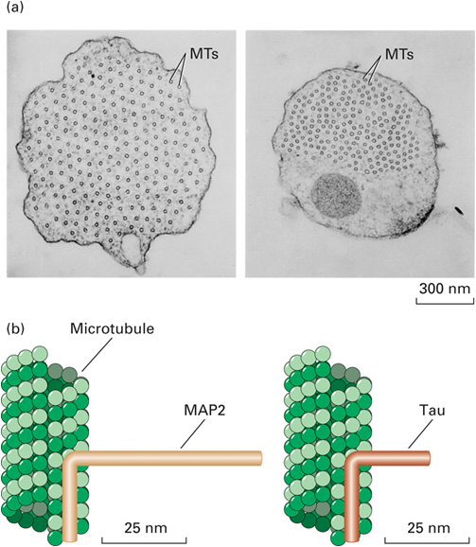
Microtubule Associated Proteins (MAPs)

- MAPs are just proteins that bind to the microtubules (doesn’t tell you what that protein does)
  - MAP 2 is only found in microtubules
  - Also MAPs that bind MT but do many different things
- MAPs can alter microtubule stability, or MAPs bundle microtubules.
  - Places like nerve cell axons need there microtubules stabilized and bundled
- Contain MT binding domain & “projection” domain.
  - MAP 2 has longer projection which will result in less tightly packed MTs and effect its function

- Can be regulated -phosphorylated can promote disassembly, eg. CDK in cell cycle
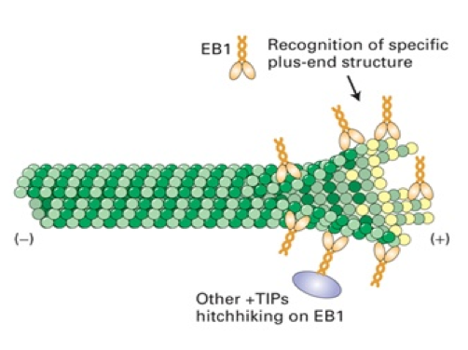
  - During mitosis you cannot have microtubule systems present and so they need to be dissembled
  - CDK helps regulate this by surprising the MAPs that provide stability

Special MAPS are associated with (+) end of MTs, called +TIPs.
- EB1 is a +TIP that binds to unique structures found only on growing (+) end.
  - Can possibly stabilize & reduce catastrophe. (not just critical concentration and GTP-β subunits
  - Not found when the MT is depolymerizing
  - Can also faccilitating binding of other MAPs that may help with stabolization

MT End Binding and Severing Proteins

Examples of protein mechanisms that contribute to the destabilization of MT ends.
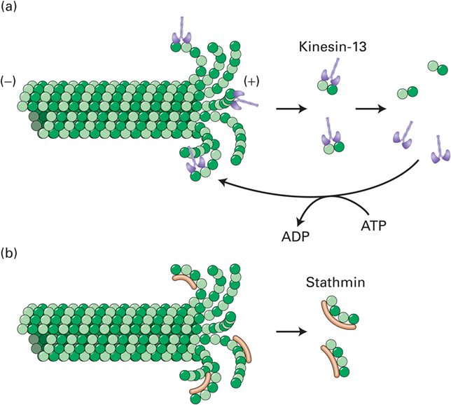
- Binding of kinesin-13
  - Uses ATP hydrolysis to rip off dimers from the + end
  - Regardless of CC and GTP with enough kinesin-13 depolymerization will occur
    - Can be inactivated by removing ATP
- Stathmin – doesn’t require energy
  - binds tubulin dimers in the curve and may promote GTP hydrolysis
  - This will cause GDP-β subunits to be present at the + end and it will start fraying
    - Can be inactivated by phosphorylation

