11-12 Microtubules: Tracks for Transport

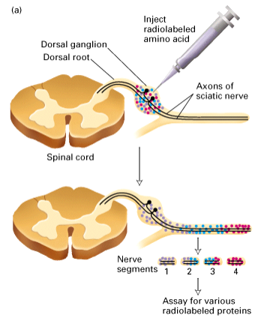
- Vesicle transport (bi-directional)
- Motor proteins require energy (ATP)

Axonal Transport
- Squid axons are a model system
- Inject radioactive amino acids that will be used to create proteins that can now be observed
  - These proteins will then be transported with the microtubules
- Can take axon and divide it up into segments which will have your radiolabeled proteins
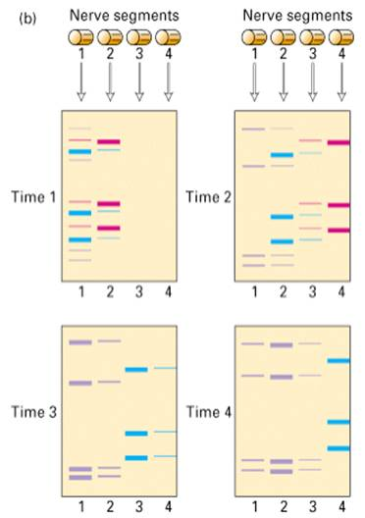
- Isolate those proteins and run them on a gel (separating them according to size)
- See black signals from radioactive amino acids allowing you to detect where they are

- Isolate the same 4 fragments at a different times (10, 20, 30 and 40min)
- Banding pattern will be similar because the same proteins with same size are present
- The same proteins that were in segment 1 at the first time interval are in segment 2 a little later
- Groups of proteins moving together and at a certain rate
- This isn’t random - Labeled proteins travel at different speeds in cells (not diffusion)
- These proteins can then be sequenced and it is this way motor proteins can be found
  - First one to be found was kinesin

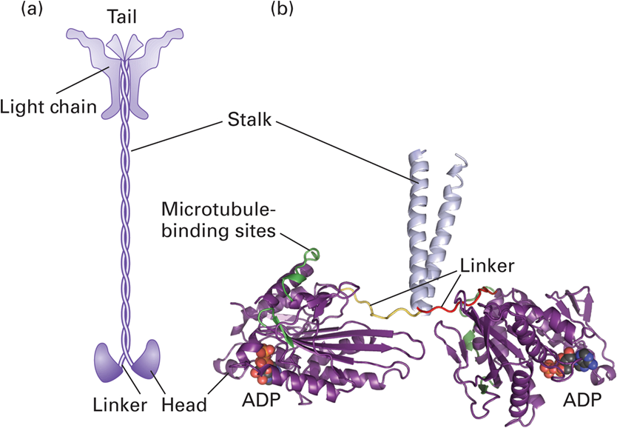
Kinesin
- MT’s plus (+) end directed motor protein
- Many types (14 known classes, 45 genes in humans)
  - 2 Heavy chains – head, flexible neck and stalk domains
  - 2 Light chains (variable)
- Heavy chain heads have ATPase activity and MT binding ability
  - Hydrolyzing ATP as energy for movement in + end direction
- Light chains stick to the tail of the stock
  - recognize cargo
  - there are different light chains that can recognize different cargos

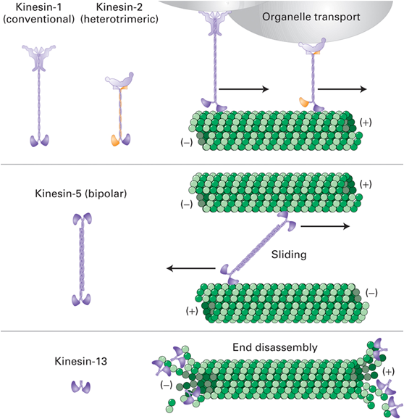
Structures of Selected Kinesin Members.
- Need to memorize 3 types of kinesin

- Kinesin 1
  - Has 2 light chains and 2 heavy chains
  - Binds to an organelle the light chain recognizes it and moves it towards the + end of the MT
- Kinesin 13
  - No light chains and No stack or tail only has the head and neck region
  - Still has MT binding and ATPase activity but Not involved in transport
  - Helps depolymerize + end (take apart the dimer)
- Kinesin 5
  - No light chains, 2 heads at both ends
  - 2 kinesin molecules come together to make a bipolar structure using their stocks and tails to bind to each other
  - Head domains can use ATP to move to the + end
  - If a Kinesin 5 is in between 2 MT it will bind to both and both ends will try to move to the + end
  - As they try to move to both ends they will cause a sliding action

- Anterograde movement – means transport towards the (+) end of the MT
- ATP hydrolysis is required for movement - causes conformational changes in kinesin allowing for movement to occur
- ATP is hydrolysed as each head moves 16 nm
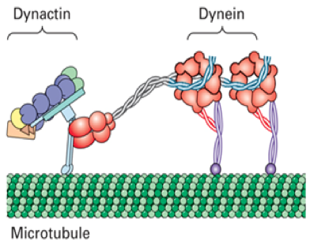
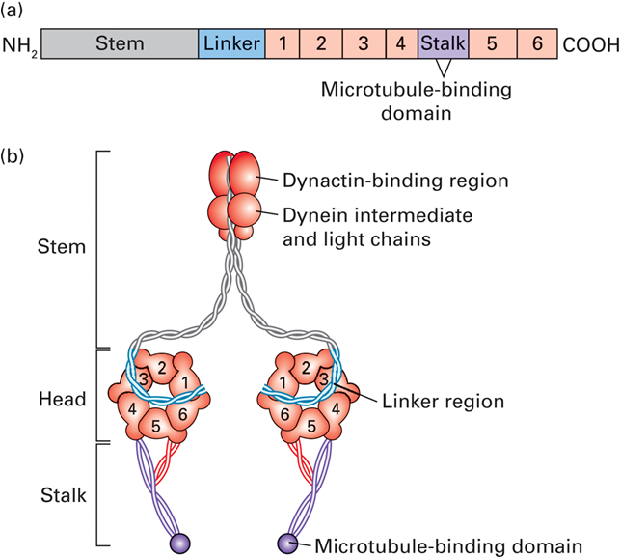
Dynein, MT minus end directed motor protein

- Retrograde transport – movement towards the (–) end of the MT
- Has a head domain and a tail domain
- Head domain – binds to the MT and has ATPase activity
- Stem domain does not bind to cargo. It binds to Dynactin
- Dynactin is a molecule that can be made up of different kinds of proteins called a “Dynactin hetero complex”
  - This is what binds to cargo (depending on the proteins it is made off it will bind to different cargo)
- ATP hydrolysis causes linker shape changes that drives movement.
- Dynactin is linked to the dynein, cargo and MT but gets dragged along the MT

The (-) is at the interior area of the cell and the (+) end projects towards the cell membrane
- To move things towards the cell wall you would use Kinesin
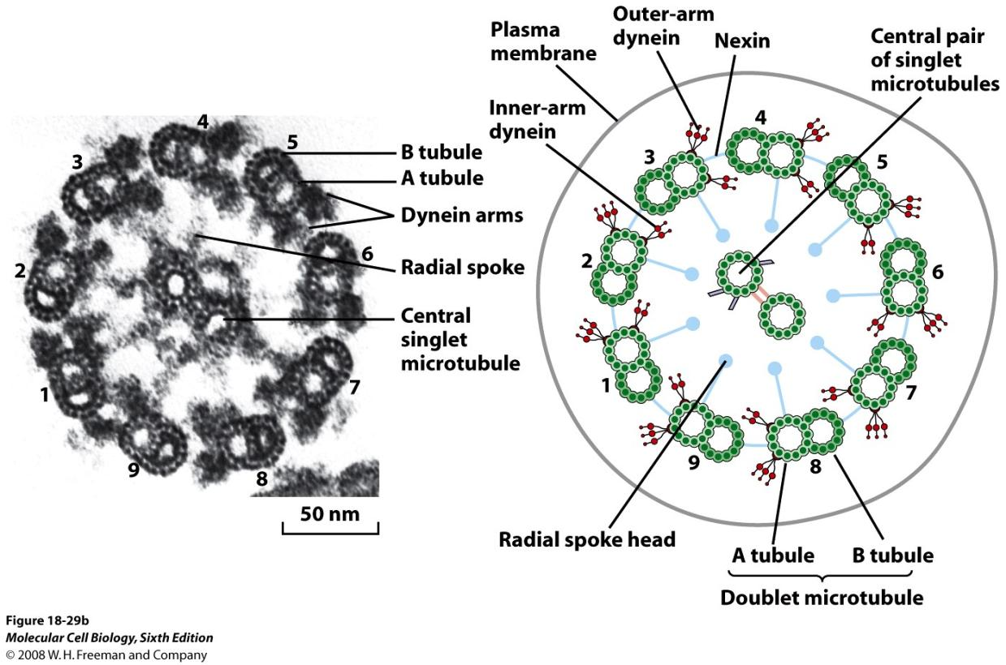
- To move things toward the interior of the cell you would use Dynein

Cilia and flagella

These are Axonemal microtubules
- cilia 2-10 μm, sweep material across tissue (many of them)
- flagella 10-2000 μm, propel cells (few of them)

Axoneme: the underlying structure of cilia and flagella
- Over 250 proteins
- 9 doublet microtubules and 2 singlets in the middle (others exist)
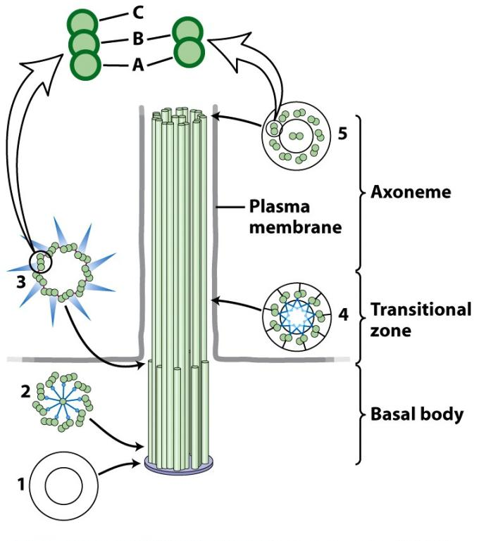
- This shape is very stable because things are holding it together
  - Nexin is in between the doublets holding them together
  - Dynein is coming of the A ring of each doublet reaching to the next
- Axonemal dynein – which causes sliding of the MTs (not transport)

Basal Body
- Basal body similar to centriole
- 9 basal body triplet MTs (A and B pass through transition zone, C does not)
- As the MT reaches the cell surface it comes to the transition zone where it looses the C tubule
- Always have the same number of triplet MTs in the basal body as you do dublets in the Axoneme because the A and B sections continue.
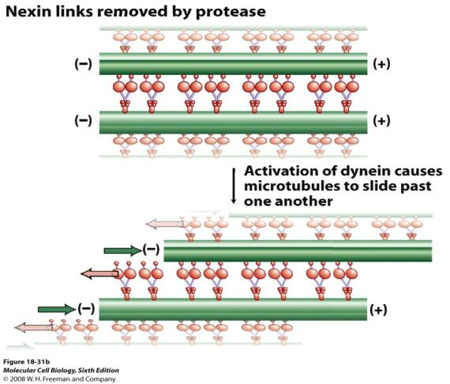
When looking at 2 flagella coming from a cell surface their basal bodies are 90⁰ to each other which is very similar to centrioles (but centrioles don’t play a direct role in polymerizing microtubules and basal bodies 2 – A+B becomes axoneme)

Ciliary Beating

- Generated by sliding of microtubules against each other - powered by dynein
- "A" tubule of one doublet "walks" along neighbor “B”
- Result = MTs slide past each other – but linked to basal and nexin

- Microtubules are fixed – because of basal body
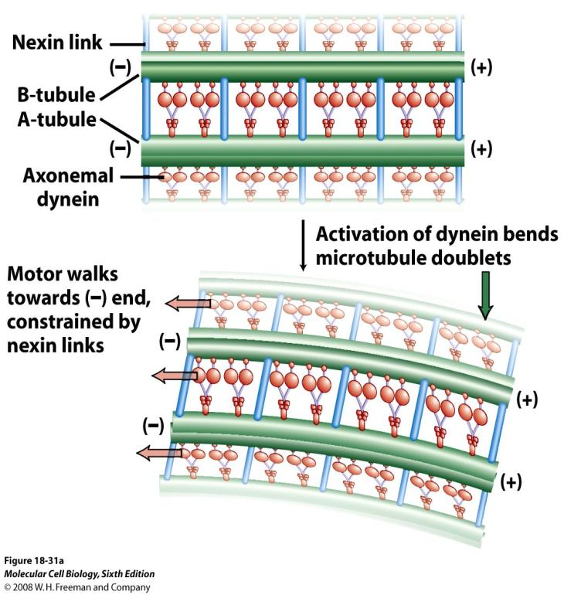
  - nexin is also present along the whole thing that stops sliding from occuring
- At different regions there is localized bending (everything cant bend at once)
- For bending to occur it can only occur at area and on one side of the Axoneme
  - Therfore this sliding has to be well regulated (probably the purpose of the other 250 proteins)

Intraflagellar transport moves material up and down.
- Therefore there are other Kinesin and dynein that are responsible for transport along the Axoneme
  - This movement is not related to bending.
- May be related to stability and signalling events.

Many interphase cells contain a non-motile primary cilium.

- Most embryonic cells have these non-motile cilia in them
- The job of these cilia are to receive signals
- Mutations in cilia structure (or transport mutations) can have embryonic consequences.
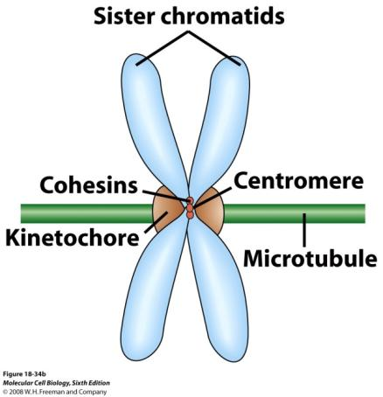
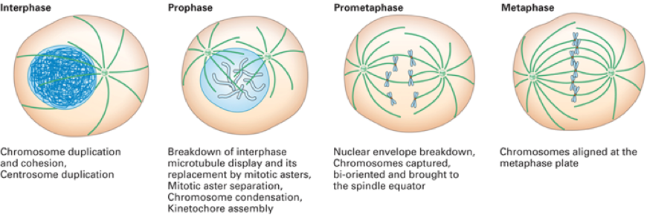
Karyokinesis and Cytokinesis

- Mitosis involves 2 things
- Karykinesis – separating the Chromosomes by microtubules
- Cytokinesis – seperating of the cytoplasam involves actin
- Note: Different cells do things differently (get general idea)
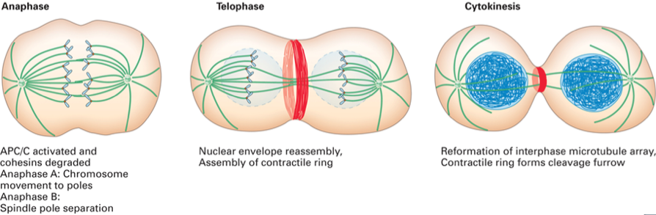
- Interface microtubule organization needs to be broken down for mitosis
- Need to duplicate the Centrosome witch will then become the 2 spindle poles called the “mitotic apparatus”
- Mitotic apparatus has to capture all the chromosomes
- The chromosomes need to be lined up during metaphase
- Have to separate all of them before cytokinesis occurs
- When mitosis is finishing you are getting rid of the mitotic apparatus, and the spindle pole that was making MT for mitosis is now going to change back into a centrosome and make new MT for interphase

The logical order of things with respect to the MT is what you need to know
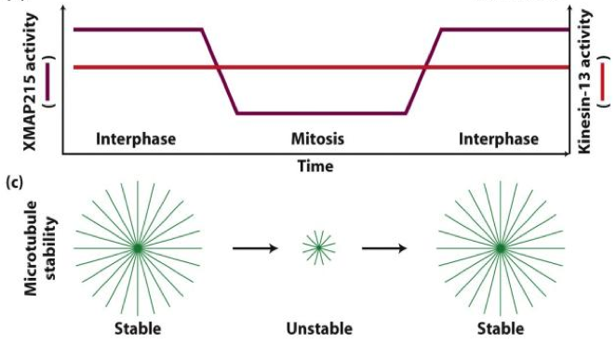
Centrosome Duplicates

- AND facilitates novel mitotic MT dynamics.
  - Interpahse MT half-life of about 5 mins
  - half-life drops to about 15 seconds during mitosis (very dynamic)
- XMAP 215 activity regulates stability of the MT
  - Kinesin 13 is present all the time and works to depolymerize the MTs
  - In Interphase XMAP 215 activity is high and inhibits the ability of kinesin 13 to depolymerize MTs therefore making the MTs more stable
  - During Mitosis XMAP 215 activity decreases and Kinesin 13 is able to depolymerize the MT more readily therefore making the MTs unstable
  - When Mitosis is over XMAP 215 activity increases once again to inhibit kinesin 13 and the MTs become stable again

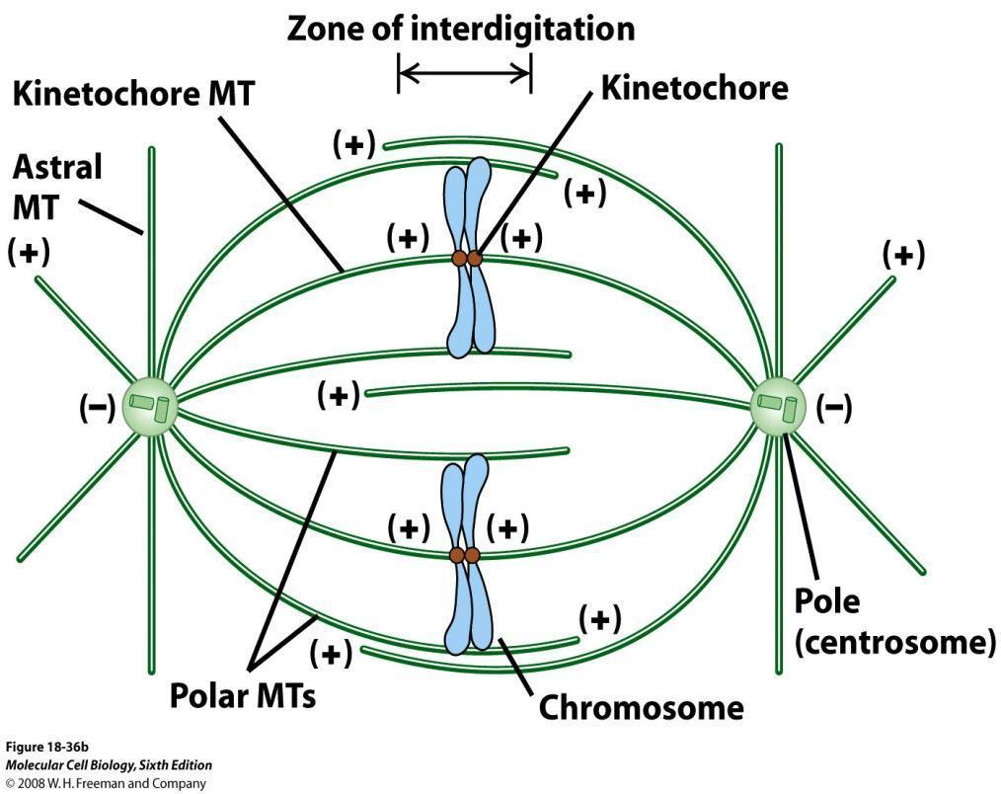
Mitotic Apparatus
- 2 Poles (not centrosomes)
- Components; (polar + kinetochore MTs make up the Spindle)
  - Polar – MTs reaching from one pole to the other without attaching to a kinetochore
  - Kinetochore MTs – MTs reaching from one pole to the other and attaching to a kinetochore
  - Aster (astral) – MTs not going towards the pole and radiating out (Star like shape)

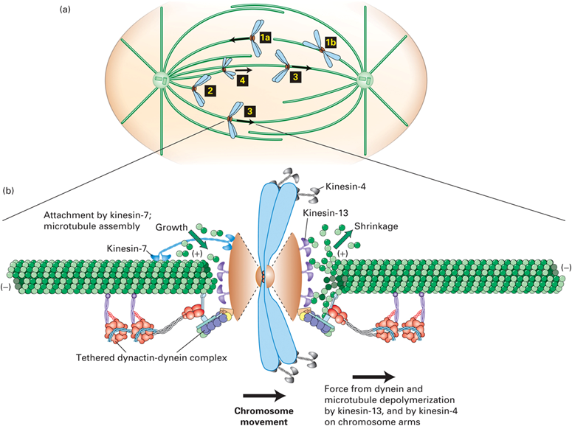
Centromere: attachment site for microtubules

- Kinetochore proteins mediate attachment of chromosomes to MTs
- + Ends are still free because there are proteins that stick out from the kinetochore that hold the + end and keep it free (can grow and shrink)

- Spindle Formation (some will be polar others kinetochore)
  - Has to capture all of the chromosomes
  - Then all of them have to be aligned at the metaphase plate
- Both MTs are capturing kinetochore with their + ends
  - And these MTs have free + ends
- There are kinesins and dyneins present
  - Kinesin 13 sitting on the kinetochore which can use ATP to depolymerize the + end (on both sides)
  - Other kinesins and dyneins present that are (+ & -) end directed motors
- both sides binding the kinetochore to the microtubule

- To align the chromosomes on the metaphase plate you use polymerization and depolymerization of the + ends
  - Motor proteins (kinesin and dynein) can then move the chromosome in the direction it needs to go

Chromosome Capture
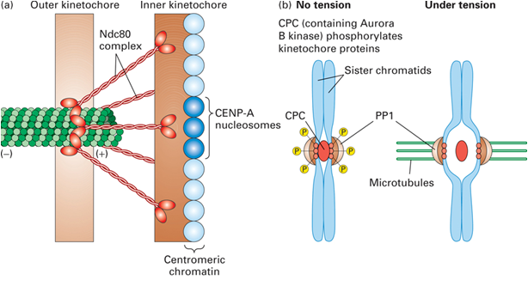
- Before the movement of the chromosome can occur it needs to be captured from both sides
  - Tension assures bi-orientation - that the chromosome is attached to spindle poles from both sides

- With no MTs attached the Ndc80 proteins are phosphorylated
- When just one MT is attached to the kinetochore the Ndc80 proteins remain phosphorylated resulting short lived stability (MT will depolymerize)
- When the Chromosome is captured by MTs from both side it provides tension and the kinetochore can sense that there are MTs on both sides and it then dephosphorylates Ndc80
  - MT interactions are now stable

- Can now be moved to the metaphase plate via polymerization, depolymerization and motor proteins

Anaphase A requires MT shortening

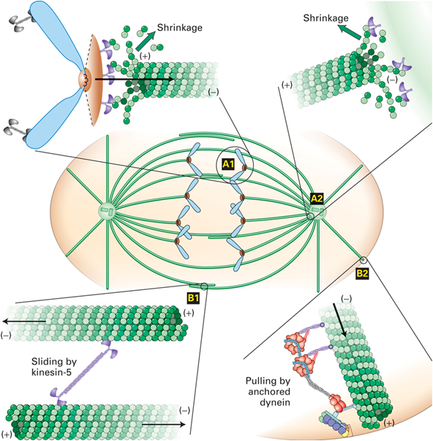
- bringing the Chromosome towards the pole

- Depolymerization is occurring at the (+) dynein is pulling the chromosome towards the (-) pole
- The (-) end is also depolymerizing but this is almost insignificant as the (+) end depolymerizes much faster
  - But this points out a difference with this MTOC (Pole not centrosome)
  - In a centrosome depolymerisation would never occur because proteins hold it in place
  - In a pole there are other proteins and this allows polymerization to occur

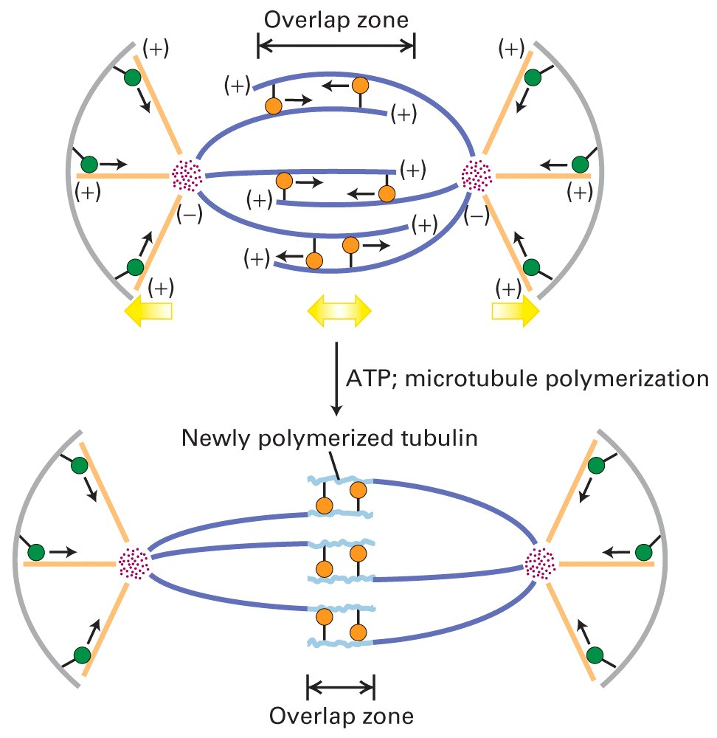
Anaphase B (pole separation) requires motors

- The Polar MTs (don’t attach a kinetochore) play a role in anaphase B

- At this point Kinesin 5 is being used
  - This is a bipolar motor protein with heads at both sides which want to go to the + end
- When Kinesin 5 is put in the middle of two overlapping MTs the Top head will want to go to the plus end on the left and the bottom head will go to the + end on the right
  - This will cause a relative sliding motion and undoing the overlap of the Polar MTs
  - This will push the MTs apart and thereby pushing the poles apart

- At the same time the Astro MTs are pulling the pole towards the plasma membrane (PM)
  - + end of Astro MTs are fixed to the PM by dynein
  - Dynein is a (-) end directed motor and goes towards the (-) end
  - but dynein is fixed so the Pole moves towards the PM
- As the dynein is pulling the MT, the + end is depolymerized (preventing the MT from going through the PM)

- As you get rid of the overlap the + ends start to get closer together
- Because they are the + ends you can polymerize them even further
  - Therefore you can polymerize new tubulin and create more overlap and push the poles even further apart

How to tell which end of the MT is polymerizing faster

- You label the microtubules fluorescently and then look at the kinetochore microtubules
- Then you bleach an area of the microtubules which will act as a fixed reference (will not be fluorescent)

- Then during Anaphase A you can see that the distance between the bleached area and the end of the MT is shortening
  - Specifically the distance between the bleached area and the positive end
- This means most of the depolymerization is happening there
- One the (-) end you cannot observe a change in the distance because of how insignificant it is
- but depolymerization is still happening there


