Bio 1000 Midterm Notes

Chapter 1: Light and Life

- Light: portion of electromagnetic spectrum detected by our eyes
  - Particle-wave duality: light has properties of a wave & of photons. Wave of photons
  - Photon: stream of energy particles

Absorption of Light

- Photon energy -> e- in molecule -> excited e- moves from ground state to excited state. Photon can only be absorbed if photon energy = | ground state – excited state |
- Eye -> mechanism to sense light
- Vision: interprets information
- Cone: colour
- Rod: sensitive -> dim light
- Chlorophyll A & B: absorption of light
- Pigments: molecules that are good at absorbing photons. Conjugated system (delocalized e-. Alternating single & double bonds)
  - A pigment’s color = photon of light it does not absorb (reflect to eyes)

Light as a Source of Information

- Photoreceptor: light-sensing system
  - Most common in nature -> rhodopsin
  - Each rhodopsin molecule = protein opsin bonded to pigment retinal
  - Photoreceptors are cells (have basic organelles)
  - Rods -> disk -> light absorbing -> rhodopsin here

- Absorption of photon -> retinal changes shape -> triggers changes in opsin -> triggers other stuff
  - Retinal… Cis -> kink in conformation. In the dark. Tran -> straight conformation. In the light
- Cells in front of the retina are transparent. This is why light is not disturbed
- Compound eye: built of units (ommatidia)
- Camera eye (single lens eye): light enters through cornea -> lens concentrates light -> light is focused on the retina (photoreceptors @ back of eye) ->info sent to brain through optic nerve
- Trichromats: 3 kinds of opsin proteins
- Dichromats: 2 kinds of opsin proteins
- Sequence of an organisms opsin proteins determines the spectral sensitivity of its cone cells
- Short wave sensitive(SWS). Medium wave sensitive (MWS). Long wave sensitive (LWS). SWS & MWS = dichromatic vision. SWS, MWS and LWS = trichromatic vision.
- Absorbance spectrum: how well specific pigments absorb different wave lengths of light.
- Dichromats -> trichromats because of ramdom genetic mutation. Strived because of selection
- Region without photoreceptors -> our blind spot
  - Having two eyes compensates for this
  - Optic nerve creates this by going through the retina
- Bacteria do not have histones (basic proteins found in chromatin, positively charged)

Light Damage

- Photo-oxidative damage: absorption of excess light energy (photons). O2 + excited e- -> reactive O which is damaging
- Ionizing radiation: photons energetic enough to remove an e- from an atom. Such radiation is emitted with the decay of radioactive nuclei
  - Ex: UV light
  - DNA is susceptible to this. Thymine dimers can be formed (2 bases covalently bond can change shape of DNA, form kinks. Prevents SNA replication @ this point).
  - Melanin (a pigment) absorbs UV light. Prevents damage

Using light To Tell Time

- Circadian rhythms: governed by biological clock
  - Sleep-wake cycles, body temperature, metabolic processes, cell division
  - Free running: can run independently of external conditions
- Photoperiod: the day length
- The SCN (suprachiasmatic nucleus) receives light inputs through optic nerve to reset. Release of melatonin from the pineal gland helps this resetting (occurs when light is sensed).
- Jet lag proves that biological clock does not automatically adjust to external environment

Life in the Dark

- Night: we lose ability to see colour then ability to distinguish shapes. Rods (do not distinguish colour) are 100x are sensitive as cones
- The blind mole rate is still able to detect light to reset its biological clock
- Bioluminescence
  - Used to attract mate/prey, camouflage & for communication
  - Photon absorption reversed. ATP excites an e- from ground state to excited state -> energy is released as photon of ight when e- returns to ground state
    - Photon absorption reversed since energy is released instead of absorbed. ATP excited e- in bioluminescence. Photon excites e- in light absorption.

Chapter 3: Defining Life and Its Origins

- Darwin’s theory of evolution” need competition to promote selection. Need more offspring than environment can sustain
- Relating cell theory & theory of evolution
  - All organisms are descended from a common ancestor
  - All cells come from pre existing cells (common ancestor)
- All cells
  - Contain hereditary information (DNA) & mechanisms to pass it from cell to cell
  - Have a plasma membrane
  - Transcription-translation machinery
  - E- transport chain
    - Protein complex in mitochondrial membrane includes ATP synthase. Creates ATP
  - Energy flow (metabolism & biochemistry) occurs within cells
- Protobions: system that was precursor to cells
- Heterotroph: consumes organisms to produce organic carbon
- Autotroph: synthesize organic carbon by using inorganic carbon CO2
- Phototrophs: use light as a source of energy for photosynthesis
- Chemotrophs: oxidation of organic/inorganic substances
- Chemoautotroph: Oxidation & inorganic carbon.
- Photoautotroph: Light and inorganic carbon.
- Chemoheterotroph: Oxidation and organic carbon.
- Photoheterotroph: Light and organic carbon.
- Bacteria have a cell wall: composed of sugars and amino acids
- Lysis: cell breaking opened
- Polysaccharide: a carbohydrate (e.g., starch, cellulose, or glycogen) whose molecules consist of a number of sugar molecules bonded together.
- Cytoplasm: cytosol & organelles (except nucleus)
- Cytosol: cell contents excluding organelles
- Lumen: interior of organelle

- Endomembrane system
  - Rough ER
  - Golgi complex
  - Nuclear envelope
  - Lysosomes & vesicles
  - Plasma membrane
  - Endomembrane was derived from plasma membrane
  - Secretory vesicles bud off trans face of golgi
  - Lysosomes bud off golgi -> autophagy
  - Central vacuole
    - Fusion of smaller vacuoles
- Nuclear lamina: inside nucleus. Made up of intermediate filaments. Gives cell structure
- ER: interconnected network of cisternae (membrane that surrounds ER lumen)
- Golgi: stack of flattened membranous saces -> cisternae
- Chromatin: DNA + proteins (histone & non histone proteins)
- Euchromatin: loosely packed. Active in RNA transcription
- Heterochromatin: densely packed. Inactive (cannot be transcribed)
- Chromosome: one complete DNA molecule

3.4 Earliest Forms of Life

- Heterotrophs came before autotrophs
- Oxygenic photosynthesis: relies on the oxidation of H2O as the source of e-
- Panspermia: hypothesis that simple life from other planets may have seeded early Earth
- LUCA: last universal common ancestor
- Endosymbiosis: prokaryotic ancestors of mitochondria & chloroplasts were engulfed to form a mutually advantageous relationship (symbiosis)
  - Horizontal gene transfer: genes from mitochondria/chloroplast -> nucleus. This + gene deletion is the reason # of genes in mitochondria & chloroplasts don’t match up with ancestors
  - Chloroplasts and mitochondria have two membranes since they were engulfed by a vesicle. Ancestors could not break down vesicle
- Membranes — Mitochondria have their own cell membranes, just like a prokaryotic cell does.
- DNA — Each mitochondrion has its own circular DNA genome, like a bacteria's genome, but much smaller.
  - Reproduction — Mitochondria multiply by pinching in half — the same process used by bacteria. Every new mitochondrion must be produced from a parent mitochondrion in this way; if a cell's mitochondria are removed, it can't build new ones from scratch.
- Genome: all of an organism’s genetic material. Nuclear genome, mitochondrial genome, etc.
- DNA helix packing with histone octamers
  - H1, H2, H3, H4 histones form an octamer unit
  - Nucleosome is formed when octamer connects to DNA. DNA wrapped around octamer.
  - Nucleosomes stack on top of each other to form chromatin. Other proteins further coil the chromatin to condense it

- Rough ER -> protein synthesis -> ribosomes
- Smooth ER -> lipid & steroid synthesis. Detoxification. Important to phospholipid bilayer since it synthesizes lipids.
- Sarcoplasmic reticulum -> smooth ER in skeletal muscle cells. Ca+ released upon nerve impulse to cause muscle cell to contract
- Vesicles from rough ER fuse with cis face of golgi & are released from trans face
- Lysosomes -> digestion. Animals not plants
- Autophagy: eating yourself. Macromolecules (polymers) -> monomers. Released to cytosol. The process of self-digestion by a cell through the action of enzymes originating within the same cell.
- Phagocytosis: ingestion of bacteria or other material to break them down. By phagocytes (white blood cells -> immune system)
- Macrophage: type of white blood cell
- Glycolipid: lipid with carbohydrate attached. Provide energy & serve as markers for cellular recognition

Chapter 2: The Cell

- Plasma membrane: bilayer of lipids with embedded protein molecules
- Gene: segment of DNA codes for individual proteins
- Cytoskeleton: protein-based framework helps maintain cell shape
- Nuceloid: no boundary membrane -> prokaryotes
- Plasmid: a linear or circular double-stranded DNA that is capable of replicating independently of DNA. Found in bacteria
- Cell theory: The ideas that all living matter consists of cells, cells are the structural and functional units of life, and all cells come from preexisting cells.
- Redox reactions: Redox reaction involves oxidation where there is an increase in oxidation number, and reduction where there is a decrease in oxidation number. It is involved in many important biological processes, such as cellular respiration and photosynthesis. In cellular respiration, for instance, redox reaction occurs when glucose is oxidized to carbon dioxide whereas oxygen is reduced to water.
- Metabolic diversity in archaea. Extremophiles
  - Halophile: salty environments
  - Thermophile: heat
  - Psychrophile: cold
- Metabolic diversity in bacteria
  - Phototrophs. Derive their energy fro sunlight
  - Lithotrophs. Derive energy from the reduction of inorganic substrate
  - Organotrophs. Derive energy from reduction of organic compounds.

2.2 Prokaryotic Cells

- DNA: single circular molecule that unfolds when released -> prokaryotic chromosome
- Genes in DNA encode info to make proteins -> copied to mRNA -> ribosomes use info to assemble amino acids into proteins
- Prokaryotes have a cell wall
- Ribosomes made of rRNA, mRNA, tRNA
- Capsule/glycocalyx: layer of polysaccharides. Sugar coating. Protection
- Slime layer: when glycocalyc is loosely associated with cell
- Capsule: when glycocalyx is firmly attached to cells
- Bacterial flagellum rotates in a socket. Does not have 9+2 complex. Made up of protein flaggellin
- Pilli: attach the cell surface to other cells. Sex pilus.
- 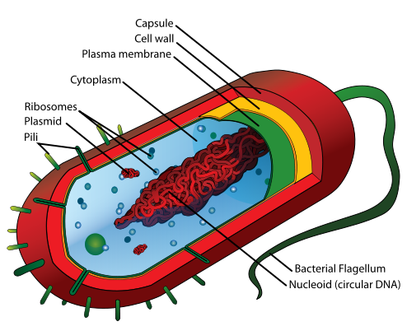
2.3 Eukaryotic Cells
- Pathogen: disease causing
- Nuclear envelope: two membranes + nuclear pore complex.
- Lamins: network of protein filaments
  - Line & reinforce inner surface of nuclear envelope. Animal cells. Type of intermediate filament
- Nuclear pore complex: octagonally symmetrical, cylindrical structure formed by nucleoporins (proteins). Transports large molecules.
- Nuclear localization signal -> mark proteins to be imported
- The nucleolus helps make ribosomes by containing the directions on how to make them in their RNA.
  - Info on rRNA genes is copied onto RNA molecules -> combine with proteins to form ribosomal subunits -> Leave through pores -> join mRNAs to form complete ribosome
- Endomembrane system
- Mitochondira -> cellular respiration. ATP released. Outer mitochondrial membrane: smooth, covers outside of organelle. Inner mitochondrial membrane: expanded by cristae (folds). Mitochondrial matrix: innermost compartment

- Cytoskeleton made up of microtubules, intermediate filaments & microfilaments. Plant cells do not have intermediate filaments. Not static constantly being taken apart & rebuilt.

- 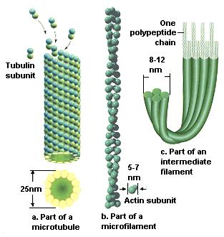
- Microtubules
  - Largest element
  - Made from tubulins (protein)
  - Polar dynamic structures: change length as required. Tublin dimers are added/removed as needed to/form + end
  - No tublin -> no microtubules -> dyenins & kinesin do not have a pathway -> no organelle transport
  - Linked to mitosis
- Intermediate filaments
  - Tissue specific in protein composition
  - Provide structural support
  - Only in multicellular organisms
  - Nuclear lamina
  - Hair (keratin)
- Microfilaments: Smallest & polar
- Mysosin Dyenin & Kinesin (Motor Proteins)
  - Myosins: motor proteins that walk along actin microfilaments.
  - Dyenins & kinesins walk along microtubules. Kinesins move towards + end. Dynesins move towards - end
  - Dyenin: involved with cilia and flagella movement
  - Take part in cytokinesis (spindles) mitosis -> separating cytoplasm
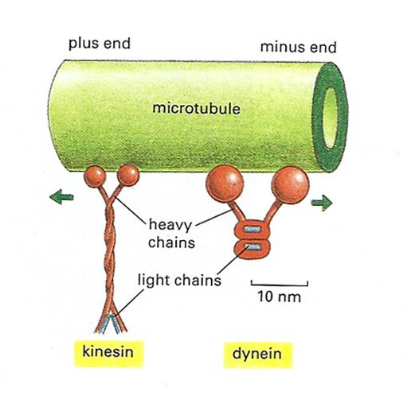
- Flagellum & Cilium structure
  - Bundle of microtubules
  - 9 +2 complex
  - Waving & bending -> produced by dynein motor proteins that slide the microtubule doublets over each other
  - Formed from centrioles. Centriole remains at innermost end of a flagellum/cilium as the basal body of the structure
  - Cillia move liquid across membrane
  - Flagella of prokaryotic and eukaryotic cells are analogous structures. Same function, evolved separately
  - Microtubules & dyneins

2.4 Specialized Structures of Plant Cells
- Chloroplasts are part of a family of plant organelles, plastids
- Amyloplasts: colorless plastids. Store starch (a product of photosynthesis)
- Chromoplasts: contain red & yellow pigments; responsible for color ripening fruits/autumn leaves. Plastids.
- Chloroplast anatomy
  - Outer boundary membrane
  - Inner boundary membrane
  - Stroma: inner compartment
    - Third membrane inside stroma containing thylakoids
      - Thylakoid: flattened closed sacs
      - Grana: stack of thylakoids
- Central vacuoles
  - Pressure within central vacuole supports the cell
  - Tonoplast: membrane that surrounds central vacuole
- Cell walls
  - Protect & support
  - Perforated by plasmodesmata
    - Cytosol filled channels lined by plasma membranes
    - Passage of small things

2.5 The Animal Cell Surface
- Cell adhesion molecules: glycoproteins embedded in plasma membrane. Helps maintain body form & structure
- Glycoproteins serve as markers. Work for immune system identifying cells are self or non-self
- Anchoring junctions: “weld” adjacent cells together.
  - Desmosomes: intermediate filaments anchor the junctions in cytoplasm
  - Adherence junctions: microfilaments are anchoring cytoskeletal component
  - Anchoring junctions are common in tissues subject to stretching. Skin, heart muscle, etc
- Tight junctions: formed by direct fusion of proteins on outer surfaces of the two plasma membranes of adjacent cells
- Gap junctions
- Open direct channels for small things
- Hollow protein cylinders embedded in plasma membranes of adjacent cells
- Plasmodesmata: like gap junctions but for plants
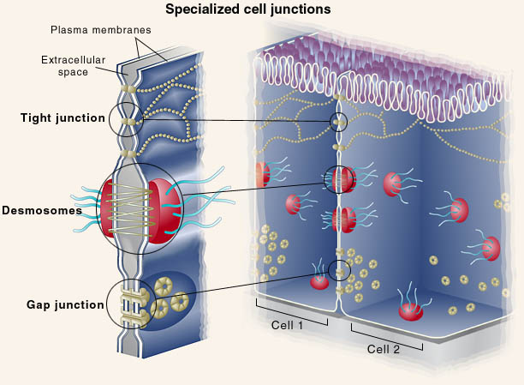
- Extracellular matrix: the network of proteins and carbohydrates that surround a cell or fill the intercellular spaces.
- Sacromere contraction. Sarcoplasmic reticulum
  - Myosin moves to positive end of microfilament pushing negative ends of actin together
  - Actin filaments coming closer together = muscle contraction
  - Smooth ER in skeletal muscle cells
  - Stores CA++. Released upon nerve impulse to cause muscle contraction
- Carbohydrate tags -> markers to cells that they are the same & can join. Attached to glycoproteins & glycolipids
- High SA & low V facilitates transport
- SA:V optimal ratio is 6:1
- Inner membranes allow eukaryotes to have bigger cells

Chapter 5

- Fluid mosaic model: membranes are not rigid. Consist of proteins + mixture of lipid molecules with consistency of olive oil
  - Mosaic because there is an assortment of proteins
  - Components and proteins of one half of the bilayer are different from those that make up the other half
- Plasma membrane: selectively permeable barrier
- Lipid: water-insoluble molecules; fats, phospholipids, steroids
- Phospholipid: a head group attached to two chains of carbon and hydrogen (a hydrocarbon) called a fatty acid
  - Amphipathic: hydrophobic & hydrophilic
  - Fatty acid chains: nonpolar. Hydrophobic
  - Phosphate head: polar. Hydrophilic.
  - Saturated phospholipid: all carbons bonded to max # of hydrogens
  - Unsaturated phospholipid: double bonds
    - Kink -> no close packing -> more fluid
    - Too much fluidity: membrane leakage, less structural organization & mechanical support.
    - Too rigid -> Not enough mobility
    - Desaturase: enzyme that catalyzes a reaction to form double bonds
    - Temperature is inversely proportional to # of desaturase
    - At high temperature sterolds (like cholesterol) help restrain movement of lipids which reduces fluidity of membrane
    - At low temperatures sterols disrupt fatty acids from associating by occupying space between lipids
- Phospholipids in membrane depend on cell functions and the cell’s stage in its cycle
  - If two cells have the same function their phospholipid arrangement will be similar but not identical
- Lipid micelle: spontaneous formation in aqueous solution
- Lateral diffusion: phospholipids switch spots, rotate, flex within a monolayer.
- Flip-flop: switching monolayers. This requires an enzyme. Does not occur spontaneously. Rare.
- More temperature -> more movement of phospholipids -> more vicious membrane
  - Phospholipids do not become unsaturated

- Integral membrane proteins: embedded in phospholipid bilayer
  - Transmembrane protein: transverse entire lipid bilayer
- Peripheral membrane protein: on surface form noncovalent bonds with exposed ends of integral proteins and membrane lipid molecules
- Neutrophil: white blood cell
- Large cells are very thing so that things can pass easily
  - Many small projections to increase surface area. Some have folds
- Amino acid: made of an amine (N terminus) + carboxyl group (C terminus) + R group. R group determines function
- Protein structure
  - Primary structure
    - Joining of amino acids with peptide bonds to form protein strand. Peptide bonds are formed by dehydration
  - Secondary structure
    - Hydrogen bonding between amino acid backbones
    - A helix -> coiled structure
    - B pleated sheet -> folded structure

  - Tertiary structure
    - Deals with side chains; R groups
    - All types of bonds are possible
    - Makes 3D structure
  - Quaternary structure
    - Made of polypeptides
    - Creates functional protein

- Polymerization: assembly of monomers to extend length -> added to plus end
- Depolymerization: disassembly of filament. Monomers removed from + end
- transcription -- a simple copying of the desired information in DNA into RNA through the action of enzyme RNA polymerase
- translation -- the complex formation of a chain of amino acids

